Diagnostic strategies and strain typing for Johne’s disease in wood bison (Bison bison athabascae)
Hernandez-Reyes A, De Buck J, Davies JL, Eshraghisamani R, Martins L, Orsel K. J Wildl Dis. 2025;61(2):285-296.—Summary by ALD

The following histopathology was obtained from a wood bison (Bison bison athabascae) with diarrhea. If you were testing another animal in this herd, what sample should you obtain and what method of testing should you use for the highest likelihood of obtaining a positive result?
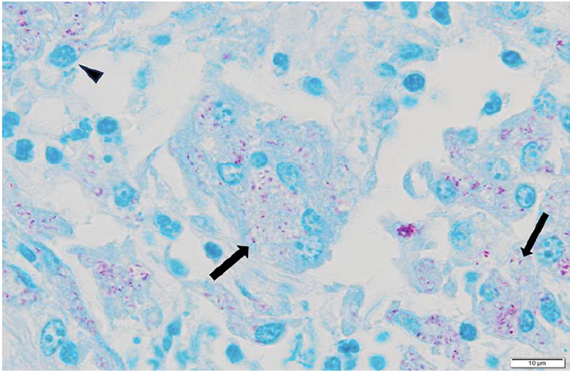
Answer: This is Mycobacterium avium subsp. paratuberculosis (Johne’s disease) in a wood bison. Culture of the distal jejunal lymph node has been associated with the highest percentage of positive results in this species, regardless of autolysis. qPCR can also be used despite autolysis, though this method had a lower percentage of positive results than culture (43.1% compared to 62.5%).

Journal of Wildlife Diseases, 60(2), 2024, pp. 537–541
Summarized by MR

Bovine Tuberculosis in Wild Boar (Sus scrofa) in Slovenia
Mateja Pate,1 Urška Zajc, Tina Pirš, Matjaz Ocepek, and Brane Krt

In a recent paper evaluating for the presence of Mycobacterium bovis in wild boar (Sus scrofa) in Slovenia, which of the following testing methods were employed and which is also considered an indirect testing method?
- Acid fast staining
- M. bovis ELISA
- Tissue PCR, rRNA sequencing
- Tuberculin skin test of the ear
- Mass spectrometry
Answer: B. ELISA – serology is considered an indirect testing method, was utilized in this paper with the benefit of being rapid, simple, inexpensive in wildlife.
Explanation:
- A direct test confirms the actual presence of a Mycobacterial organism, whereas an indirect test demonstrates exposure.
- A. Acid fast staining is considered direct. AF staining was not used for blood smears in the study (making this an unlikely boards question, but rather a study question), also typically described to have low SN/SP.
- C. Tissue PCR + sequencing utilized in this paper but considered direct
- D. Tuberculin skin tests in swine are done on the ear rather than the caudal fold in bovids. This was not performed in this study, but is also considered an indirect method.
- E. Mass spec utilized in this paper but considered direct due to identification of ribosomal proteins from the cultured mycobacterial colonies.
Note: mycobacterial culture had to be performed prior to PCR, sequencing, and mass spec, and is considered a direct method, I did not include that as an answer since it is lumped in the methods as a precursor to other diagnostics.

Which of the following statements is true regarding nontuberculous mycobacterial infections in cold-stunned Kemp’s ridley sea turtles (Lepidochelys kempii)?
A. Mycobacterium chelonae was the most commonly identified NTM species in the study, and pulmonary disease was the most common clinical manifestation.
B. Mycobacterium syngnathidarum was the most commonly identified NTM species in the study, and pulmonary disease was the most common clinical manifestation.
C. Fluoroquinolone monotherapy is the recommended treatment for M. chelonae infection in Kemp’s ridley sea turtles
D. For all turtles with NTM infection, antimicrobial selection was guided by susceptibility testing, and all were successfully treated and released.
E. NTM infections were treated on average for 1 month duration with a combination of antimicrobials and an antifungal
Answer: A
Which diagnostic approach is most appropriate for confirming a nontuberculous mycobacterial infection in a Kemp’s ridley sea turtle with clinical signs?
A. Serum antibody testing, because mycobacterial infections consistently produce a detectable humoral response
B. Respiratory sampling (TL, BLL, biopsy) for mycobacterial culture, with molecular identification of the recovered organism
C. PCR of peripheral blood as bacteremia is common with disseminated NTM disease in sea turtles
D. Routine bacterial culture of tracheal samples, which reliably differentiates NTM species from other respiratory bacteria
E. Thoracic radiography or CT scan, as characteristic pulmonary lesions are pathognomonic for NTM infection

Answer: B

2024 JZWM 54.4
Seroconversion Can Precede Culture Confirmed Diagnosis Of Mycobacterium Tuberculosis Infection In Asian Elephants (Elephas Maximus) By Decades
Michele A. Miller, Paul P. Calle, Jackie Gai, Carlos Sanchez, and Lydia Young,

In a study evaluating Mycobacterium tuberculosis infection in Asian elephants (Elephas maximus), which of the following statements is correct?
a) Trunk wash culture is a highly sensitive method for detecting M. tuberculosis infection in elephants.
b) Most elephants in the study were calves or juveniles at the time of first seroconversion.
c) Seroconversion typically occurred within a few months of exposure to a positive elephant.
d) Elephants could remain seropositive for decades prior to a positive culture results.
e) All M. tuberculosis–positive elephants were diagnosed antemortem with a positive culture.

Answer: D; A - trunk wash cultures are insensitive method for diagnosis; B - most elephants adults; C - could be years between exposure and seroconversion; D - could be years between seropositive and culture positive; E - some were only positive postmortem on isolation

Journal of Wildlife Diseases 61(4):1090-1095, 2025
Summarized by JEN

A free-ranging Mexican long-nosed nine-banded armadillo (Dasypus mexicanus) from Missouri is screened for Mycobacterium leprae using real-time PCR targeting the RLEP repetitive element. Liver tissue is PCR-negative. Which of these conclusions is most accurate?

- The negative liver PCR result does not exclude M. leprae infection because different tissues from the same animal may yield differing PCR results, and relying on a single tissue type may therefore result in false-negative animals and underestimation of population prevalence.
- The negative liver PCR result makes current M. leprae infection unlikely because the liver is a preferred site of bacterial growth in armadillos; therefore, additional tissue testing would be expected to have minimal diagnostic benefit.
- The negative liver PCR result does not exclude M. leprae infection because bacterial DNA may be distributed unevenly among tissues; however, spleen PCR would be expected to have sufficiently high sensitivity that a negative spleen result would effectively exclude infection.
- The negative liver PCR result is most consistent with prior rather than active infection because tissue PCR primarily identifies advanced disseminated disease, whereas earlier or resolved infections would be expected to be identified only through serologic testing for PGL-1 or LID-1 antibodies.

Correct answer: A
The study demonstrated differing PCR results between tissues from the same animal - the Greene County armadillo had a PCR-positive spleen but a PCR-negative liver. The authors mentioned that M. leprae may not be detected uniformly among tissues and that sampling only one tissue type could underestimate prevalence or produce false-negative results.

B - negative liver PCR can occur in an infected animal (though liver is a preferred site for M. leprae growth
C - single-organ testing alone (including spleen) is not enough to rule out infection
D - study didn’t show that PCR-negative animals represent prior or resolved infection

