Diagnostic strategies and strain typing for Johne’s disease in wood bison (Bison bison athabascae)
Hernandez-Reyes A, De Buck J, Davies JL, Eshraghisamani R, Martins L, Orsel K. J Wildl Dis. 2025;61(2):285-296.—Summary by ALD
Abstract: Cattle diseases are considered a major threat to wood bison (Bison bison athabascae) conservation. Johne’s disease (JD) is a chronic infectious enteritis caused by Mycobacterium avium subspecies paratuberculosis (Map), that affects domestic and wild ruminants globally and could negatively impact wood bison health. Clinical manifestation of JD in free-ranging or captive wood bison has not been documented. We studied animals in a captive wood bison herd in Alberta, Canada 1) to detect Map in bison clinically suspected of Johne’s disease, by histopathology, quantitative PCR (qPCR), and isolation by culture; 2) to identify optimal tissue samples for Map detection; and 3) to identify the strain(s) of Map isolated. Six wood bison were evaluated with clinical signs suggestive of JD. We performed necropsies within 24–48 h after euthanasia and collected 24 tissue samples from each bison. At necropsy, no evidence of thickening or corrugation of the intestinal mucosa was observed in any bison. On histopathologic examination, granulomatous lesions with acid-fast bacilli were more frequent in the paracortex of the midjejunal lymph node (LN) and distal jejunal LN, followed by ileal LN, in comparison to the rest of the tissue samples evaluated. In general, tissue culture had the highest proportion of positive samples, with 62.5% (90/144) of positive samples, followed by F57/IS900 qPCR with 43.1% (56/130), and histopathology with 29.0% (38/131). We concluded that distal jejunum and its associated lymph nodes were the most reliable tissue samples for detecting Map, regardless of tissue autolysis or the absence of visible gross lesions. Finally, using IS1311 PCR-restriction enzyme analysis and single-nucleotide polymorphisms, we identified a type II (cattle) strain, secondary clade, in tissue samples. These findings have practical relevance for field necropsies as they provide evidence to direct selection of preferred sampling sites to detect Map in wood bison and to choose appropriate diagnostic techniques.

Background:
- Johne’s disease (JD): Mycobacterium avium subsp paratuberculosis (Map), chronic infectious enteritis in ruminants; progressive weight loss and diarrhea in cattle; CS seen 2-5y post-infection
- Map has been detected in healthy wood bison in fecal samples

Key Points:
- Objective: detect Map in clinically suspected bison by histo, qPCR, and culture; identify optimal tissues for Map detection; identify strain isolated
- 0.6 bison in a herd with confirmed JD euth b/t 2021-2022 based on CS of weight loss and diarrhea and qPCR results; fecal samples collected prior to euth and necropsies performed; samples obtained and culture, histo, and qPCR performed for positivity
- No thickening or corrugation of mucosa seen in any bison; 3 had markedly large mesenteric lnn
  - Corrugation only seen in 11% of plains bison with JD
- Mod-severe autolysis, so only reported if granulomas present with AF bacilli on histo
  - Histo positive sites varied from 13-42% (29%) of the sites per bison; better seen with ZN stain
  - 62.5% of culture samples positive (17-75%); qPCR positive from 43.1% (18-63%) of samples
- All samples consistent with type II strain (cattle)
- Distal jejunal ln most reliable for detection (100%), then midjejunal ln (89%), then distal jejunum (88%), then ileal ln (83%) for all dx sites

Take Homes:
- Culture was test with highest percentage positive samples (then qPCR, then histo)
- Distal jejunum and associated lnn should be used for test, culture and qPCR + regardless of autolysis
- Typical gross signs not seen, but this could be due to autolysis
  - 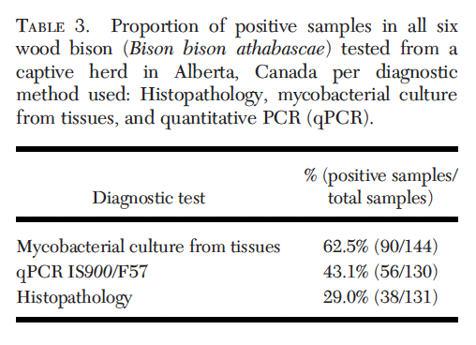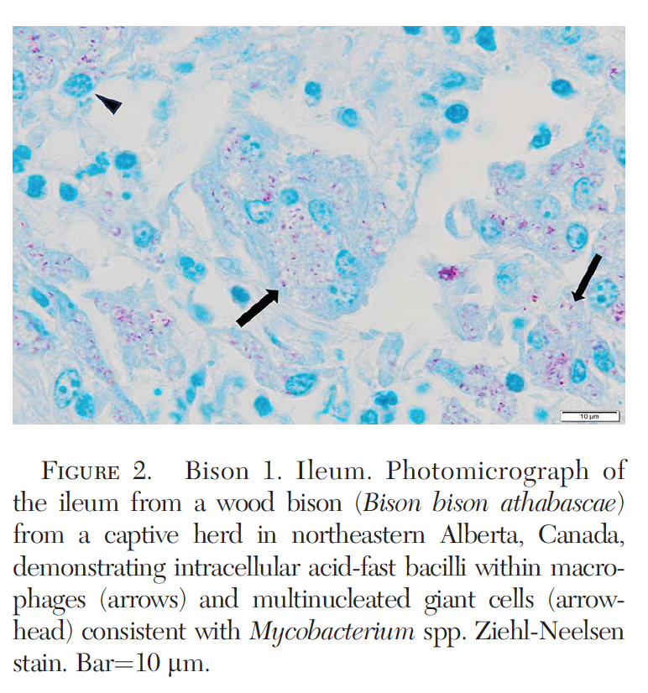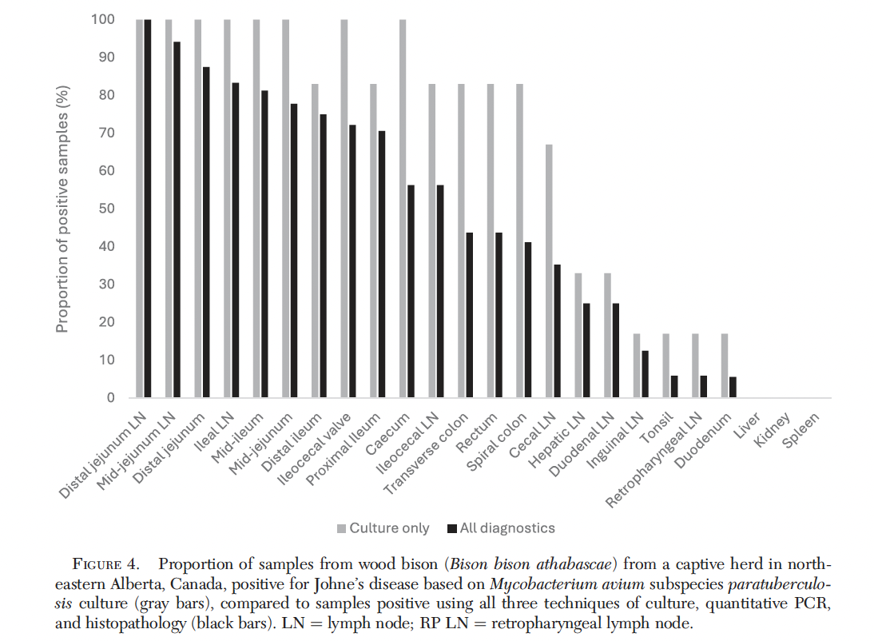

Journal of Wildlife Diseases, 60(2), 2024, pp. 537–541
Summarized by MR

Bovine Tuberculosis in Wild Boar (Sus scrofa) in Slovenia
Mateja Pate,1 Urška Zajc, Tina Pirš, Matjaz Ocepek, and Brane Krt

Abstract: Mycobacteria of the Mycobacterium tuberculosis complex (MTC) are capable of infecting a wide variety of animals. Wild boar (Sus scrofa) has been recognized as an important wildlife reservoir for bovine tuberculosis. We screened wild boar in Slovenia for the presence of (1) Mycobacterium bovis in tissues and (2) antibodies to M. bovis in blood samples. In 2016 and 2017, 1284 tissue samples from 676 wild boar were subjected to cultivation. In 2018 and 2019, blood samples from 132 wild boar were examined using an ELISA kit. None of the MTC species were isolated from the tissue samples, and no antibodies to M. bovis were detected in the blood samples. Several nontuberculous mycobacteria (NTM), identified by 16S rRNA sequencing and/or matrix-assisted laser desorption ionization time-of-flight mass spectrometry, were found in the tissues of 9.8% of the wild boar: Mycobacterium nonchromogenicum, Mycobacterium peregrinum/Mycobacterium septicum, Mycobacterium avium, Mycobacterium engbaekii, Mycobacterium arupense, Mycobacterium algericum, Mycobacterium bohemicum, Mycobacterium confluentis, Mycobacterium flavescens, Mycobacterium fortuitum, Mycobacterium thermoresistibile, and Mycobacterium vaccae. Species-level identification was not possible for 21.2% of the isolates. At the time of the study, wild boar in Slovenia were not at risk from bTB; the significance of the presence of NTM in wild boar remains to be clarified and evaluated from a One Health perspective.

Background:
- Bovine tuberculosis (bTB) caused by M. bovis and M. caprae
  - Chronic, global, multi-host, zoonotic
- Wildlife role in epidemiology of disease
  - Eradication efforts less effective in areas where cattle are extensively managed but share habitat with wildlife
- Prevalence of bTB in EU cattle 0.61%
- Culture remains gold-standard, serology (ELISA) increasingly used in wildlife = rapid, simple, inexpensive

Summary:
- Objective: 4yr study on detection of mycobacterial infx in wild boar based on bacteriology and serology
- 1284 samples from 676 wild boar, state surveillance thru hunting, collected liver and LN
- PCR + rRNA sequencing, mass spectrometry
  - Mass spec used as a first-line ID tool, selected isolates then subjected to sequencing
- Blood samples from 132 annually culled wild boar in 2018 and 2019 for antibodies to M. bovis
  - performance of serological tests is mainly influenced by the irregular and generally late pattern of antibody production observed in the humoral response against bTB
- Mycobacteria of the MTC were not detected in the tissue samples examined.
- Tissues from 9.8% (66/676) of the animals contained nontuberculous mycobacteria (NTM)
- No antibodies to M. bovis were detected in blood samples.
- % of tuberculin positive cattle herds in Slovenia over the last 45 yr were 0.07-0.08%
  - Cases documented in neighboring Italy and Hungary, growth of wild boar population, low incidence but reports occur in wild boars (last case in 2019).
- This study ID’ed some new NTM in this species
  - ID to the species level not successful in 21.2% of isolates, and whole genome sequencing was not available.

Take Home Points:
- Mycobacteria of MTC not detected in wild boars by PCR or serology
  - Seroprevalence varies widely by country in EU
- Wild boar in Slovenia are not at significant risk from bTB at the time of this study
- Continued comparative surveillance due to risk factors
- Recognize the patterns of diagnostic use – pros/cons of serology vs. culture. (see below)

MTC Diagnostics
A direct test confirms the actual presence of a Mycobacterial organism, whereas an indirect test demonstrates exposure.
 | Pros | Cons
Serology (humoral immunity - indirect) | - Rapid  - Simple  - Inexpensive | - Irregular and late pattern of antibody production observed in humoral response
PCR + sequencing - direct | - Rapid  - SN varies – not ideal for screening populations  - Confirms presence of organism | - ID to species level (important to ID if NTM) not always successful, whole genome sequencing may be needed
Culture - direct | - Gold standard confirmatory diagnostic  - Confirms presence of organism | - Long incubation (6 - 8 wks)

Intradermal tuberculin skin test (indirect) – evaluates cell-mediated immunity, delayed type hypersensitivity (IV) reaction to purified protein derivative (PPD)
- cell-mediated immunity: Previously sensitized T helper cells recognize PPD → release IFN-γ → macrophage recruitment → induration at 48–72 hours

Acid-fast staining – direct, but very low SN/SP

Mass spectrophotometry as described in this paper would be considered indirect.

2024 JZWM 54.4
Seroconversion Can Precede Culture Confirmed Diagnosis Of Mycobacterium Tuberculosis Infection In Asian Elephants (Elephas Maximus) By Decades
Michele A. Miller, Paul P. Calle, Jackie Gai, Carlos Sanchez, and Lydia Young,

Abstract: Mycobacterium tuberculosis (M. tb) infection was diagnosed in 16 human-managed Asian elephants (Elephas maximus) at four different US facilities. A retrospective review was performed to collate information on serological test results and describe the timelines from exposure to an elephant known to be positive for M. tb, detection of antimycobacterial antibodies in the exposed elephant, and M. tb isolation from the exposed elephant to confirm diagnosis. Seroconversion was defined by a positive test result using ElephantTB STAT-PAK, multiantigen print immunoassay, or DPP VetTB assay for elephants (Chembio Diagnostic Systems, Inc). Fifteen elephants were adults (age ≥24 yr) at first seroconversion and 26 yr or older when confirmed by a positive M. tb culture. Six animals were diagnosed postmortem, and 10 were diagnosed antemortem by positive trunk wash (TW) culture. The interval between last known exposure to an M. tb–positive elephant and serological conversion was 8.5 yr (median; range 0–18 yr) in the eight animals that had not already seroconverted. The median time from seroconversion to isolation of M. tb was 2.8 yr in elephants diagnosed by TW culture (antemortem) compared with those diagnosed postmortem (median 1.2 yr). Of the 10 elephants diagnosed antemortem, four were seropositive for 14 or more yr (range 0–33 yr) prior to the M. tb–positive culture. The median number of negative TW samples submitted between seroconversion and diagnosis by culture was 16 (range 0–151 samples). In contrast, a median of 48 negative TW cultures and 10 yr elapsed (range 0–41 yr) between exposure and culture diagnosis. Although this descriptive report has limitations, these findings are useful for veterinarians faced with an M. tb–seropositive elephant. This report supports the recommendation of increasing TW surveillance if an elephant has a history of exposure to an M. tb–positive elephant and has multiple seropositive results.

Review
- M. tuberculosis – zoonotic; typically thought human/elephant transmission but elephant/elephant possible
- Tuberculin skin test unreliable in elephants; interferon gamma release assay possible but definitive diagnosis requires culture/speciation; Serology and PCR also utilized
- Research initially on cell-mediated immunity but growing recognition of role of B lymphs + Ab response
- False-positive serology has been associated w/ arthritis, other chronic inflammatory issues
- Most elephants with M. tb infection do not exhibit clinical signs until advanced disease → antemortem diagnosis by TW culture can be delayed due to intermittent shedding, infrequent sampling → why validation of positive immunological test results in truly infected individuals lacking
Summary
- Elephants in US facilities had confirmed diagnosis either antemortem or postmortem culture and speciation and had seropositive results
- All had been housed with at least one known M. tb culture positive elephant in the past
- Most were adults at exposure, though all were adults at time of culture diagnosis
- 8 alive at time of review; 6 first diagnosed postmortem; 2 culture positive by TW and postmortem
  - 10 diagnosed based on positive TW; two of them had postmortem M. tb isolation from tissue
- Avg 10 years between last exposure & diagnosis by culture; med 48 neg TW cultures before diagnosis
  - Most animals had long periods between exposure and seropositive and then long periods between seropositive and culture positive; then long periods prior to clinical signs
- All 16 positive animals had Ab prior to onset (at least 1 seropositive test) or at time of culture diagnosis
- Seroconversion preceded M. tb positive culture in 15 animals; one had positive TW same day as seropos
  - Median 2.7 years between seroconversion to M. tb isolation
  - Elephants remained seropositive (up to 33 yr) despite negative TW culture – Hx of prior exposure + multiple seropositive tests should raise suspicion on infection in Asian elephants
- Antemortem culture may require repeated TW samples over years or decades since often neg for a while
- Post-mortem confirmation should be pursued in all seropositive individuals
- Definitive detection of M. tb in TW samples is an insensitive method for diagnosing infection in elephants
  - Recommend increasing frequency of TW cultures in seropositive elephants
- Elephants with longest interval between seroconversion and culture diagnosis had received abx
  - Recommend continuing to monitor serology + TW culture in treated animals to detect intermittent shedding, tx failure or reactivation

Takeaways: The study supports the hypothesis that Asian elephants (Elephas maximus) with multiple seropositive results for Mycobacterium tuberculosis are infected and maintain antibodies, oftentimes for many years. They can be negative on trunk wash culture for a long time but can eventually turn positive. Elephants with exposure to a M. tb positive elephant should have increased surveillance including TW cultures to confirm diagnosis and prevent further transmission.

2024 JZWM 54.4
Seroconversion Can Precede Culture Confirmed Diagnosis Of Mycobacterium Tuberculosis Infection In Asian Elephants (Elephas Maximus) By Decades
Michele A. Miller, Paul P. Calle, Jackie Gai, Carlos Sanchez, and Lydia Young,

Abstract: Mycobacterium tuberculosis (M. tb) infection was diagnosed in 16 human-managed Asian elephants (Elephas maximus) at four different US facilities. A retrospective review was performed to collate information on serological test results and describe the timelines from exposure to an elephant known to be positive for M. tb, detection of antimycobacterial antibodies in the exposed elephant, and M. tb isolation from the exposed elephant to confirm diagnosis. Seroconversion was defined by a positive test result using ElephantTB STAT-PAK, multiantigen print immunoassay, or DPP VetTB assay for elephants (Chembio Diagnostic Systems, Inc). Fifteen elephants were adults (age ≥24 yr) at first seroconversion and 26 yr or older when confirmed by a positive M. tb culture. Six animals were diagnosed postmortem, and 10 were diagnosed antemortem by positive trunk wash (TW) culture. The interval between last known exposure to an M. tb–positive elephant and serological conversion was 8.5 yr (median; range 0–18 yr) in the eight animals that had not already seroconverted. The median time from seroconversion to isolation of M. tb was 2.8 yr in elephants diagnosed by TW culture (antemortem) compared with those diagnosed postmortem (median 1.2 yr). Of the 10 elephants diagnosed antemortem, four were seropositive for 14 or more yr (range 0–33 yr) prior to the M. tb–positive culture. The median number of negative TW samples submitted between seroconversion and diagnosis by culture was 16 (range 0–151 samples). In contrast, a median of 48 negative TW cultures and 10 yr elapsed (range 0–41 yr) between exposure and culture diagnosis. Although this descriptive report has limitations, these findings are useful for veterinarians faced with an M. tb–seropositive elephant. This report supports the recommendation of increasing TW surveillance if an elephant has a history of exposure to an M. tb–positive elephant and has multiple seropositive results.

Review
- M. tuberculosis – zoonotic; typically thought human/elephant transmission but elephant/elephant possible
- Tuberculin skin test unreliable in elephants; interferon gamma release assay possible but definitive diagnosis requires culture/speciation; Serology and PCR also utilized
- Research initially on cell-mediated immunity but growing recognition of role of B lymphs + Ab response
- False-positive serology has been associated w/ arthritis, other chronic inflammatory issues
- Most elephants with M. tb infection do not exhibit clinical signs until advanced disease → antemortem diagnosis by TW culture can be delayed due to intermittent shedding, infrequent sampling → why validation of positive immunological test results in truly infected individuals lacking
Summary
- Elephants in US facilities had confirmed diagnosis either antemortem or postmortem culture and speciation and had seropositive results
- All had been housed with at least one known M. tb culture positive elephant in the past
- Most were adults at exposure, though all were adults at time of culture diagnosis
- 8 alive at time of review; 6 first diagnosed postmortem; 2 culture positive by TW and postmortem
  - 10 diagnosed based on positive TW; two of them had postmortem M. tb isolation from tissue
- Avg 10 years between last exposure & diagnosis by culture; med 48 neg TW cultures before diagnosis
  - Most animals had long periods between exposure and seropositive and then long periods between seropositive and culture positive; then long periods prior to clinical signs
- All 16 positive animals had Ab prior to onset (at least 1 seropositive test) or at time of culture diagnosis
- Seroconversion preceded M. tb positive culture in 15 animals; one had positive TW same day as seropos
  - Median 2.7 years between seroconversion to M. tb isolation
  - Elephants remained seropositive (up to 33 yr) despite negative TW culture – Hx of prior exposure + multiple seropositive tests should raise suspicion on infection in Asian elephants
- Antemortem culture may require repeated TW samples over years or decades since often neg for a while
- Post-mortem confirmation should be pursued in all seropositive individuals
- Definitive detection of M. tb in TW samples is an insensitive method for diagnosing infection in elephants
  - Recommend increasing frequency of TW cultures in seropositive elephants
- Elephants with longest interval between seroconversion and culture diagnosis had received abx
  - Recommend continuing to monitor serology + TW culture in treated animals to detect intermittent shedding, tx failure or reactivation

Takeaways: The study supports the hypothesis that Asian elephants (Elephas maximus) with multiple seropositive results for Mycobacterium tuberculosis are infected and maintain antibodies, oftentimes for many years. They can be negative on trunk wash culture for a long time but can eventually turn positive. Elephants with exposure to a M. tb positive elephant should have increased surveillance including TW cultures to confirm diagnosis and prevent further transmission.

Journal of Wildlife Diseases 61(4):1090-1095, 2025
Summarized by JEN

Leprosy in Missouri, USA: Are Armadillos (Dasypus mexicanus) Carrying the Causative Agent Mycobacterium leprae?
Robbins et al. 2025.

Taxonomy: Dasypodidae (Long-Nosed Armadillos)

Abstract: The Mexican long-nosed nine-banded armadillo (Dasypus mexicanus) has continued to expand its range northward in the United States and is a recognized wildlife reservoir for Mycobacterium leprae, the causative agent of leprosy (Hansen's disease). A 2021 leprosy case in a lifelong Missouri resident with no international travel history, but frequent contact with dead armadillos, raised concern for local zoonotic transmission. The authors sampled tissues from 64 wild adult armadillos from southwestern and central Missouri during summer 2022 and tested extracted DNA by real-time PCR targeting the M. leprae-specific RLEP repetitive element. Two armadillos were PCR positive, providing the first evidence of M. leprae in wild Missouri armadillos and supporting the possibility that the pathogen is expanding northward along with its armadillo host.

Background:
- Dasypus mexicanus can be naturally infected with M. leprae and infected armadillos are an established zoonotic source of leprosy in the southern United States.
- Human leprosy is most commonly transmitted through prolonged close contact with an infected, untreated person, but molecular and epidemiologic evidence also supports transmission following contact with infected armadillos.
- Infected armadillo populations have historically been concentrated in the southeastern United States; prior surveys from Illinois and Tennessee at the northern edge of the range were negative for anti-PGL-1 antibodies.
- Armadillos have progressively expanded northward into Missouri and neighboring states. Colder winters and less humid soils have been proposed as possible limits to M. leprae survival and transmission.
- A 2021 Missouri patient had PCR-confirmed leprosy, no history of travel outside the United States, and frequent exposure to dead armadillos brought into the yard by dogs.
- Study goal: determine whether wild armadillos in Missouri carry M. leprae and estimate local prevalence near the suspected autochthonous human case.

Summary:
- N = 64 adult armadillos sampled from 10 counties in southwestern and central Missouri between 25 May and 25 September 2022:
  - 39 road-killed animals
  - 25 fresh hunter-killed/culled animals from Gasconade County
- Liver and spleen were prioritized because they are preferred sites of M. leprae growth; heart, peripheral muscle, ear, and other available tissues were also tested according to carcass condition. No blood samples were collected.
- DNA was extracted at the National Hansen's Disease Program laboratory and tested by real-time PCR targeting the M. leprae-specific RLEP element; cycle threshold values <35 were considered positive.
- 2/64 armadillos were PCR positive (apparent detection rate ~3.1%):
  - Greene County: spleen PCR positive; liver from the same animal PCR negative
  - Benton County: heart PCR positive
- All 25 armadillos from Gasconade County were PCR negative, suggesting infection may be uncommon and/or unevenly distributed among local populations.
- Discordant tissues within a positive animal demonstrate that testing only one tissue type can miss infection and may underestimate prevalence.
Key findings and interpretation:
- This is the first evidence that M. leprae is present in wild armadillos in Missouri and suggests that leprosy may now be established farther north than previously recognized.
- The two positive armadillos, together with the suspected locally acquired 2021 human case, make a local zoonotic source plausible, but the study does not prove armadillo-to-human transmission.
- Whole-genome sequencing or strain typing could not be performed because the amount of M. leprae DNA in both the human biopsy material and armadillo tissues was too low.
- Previous negative surveys in Illinois and Tennessee could represent true absence of infection, founder populations that arrived without the pathogen, very low prevalence, or differences in test sensitivity.
- The nearest previously confirmed M. leprae-positive armadillos were approximately 400 km southwest in eastern Arkansas, leaving a substantial unsurveyed region between known positive populations.
Clinical and public health relevance:
- Locally acquired Hansen's disease should be considered in patients with compatible clinical signs even when there is no international travel history, particularly when there is a history of armadillo exposure.
- Direct handling of armadillos, especially dead animals or tissues, represents a potentially avoidable exposure route; public education should emphasize minimizing contact.
- Future surveillance should combine RLEP PCR with serology for anti-PGL-1 and LID-1 antibodies to improve detection and prevalence estimates.
- Whole-genome sequencing or strain typing of future positive armadillos and human cases would be important for assessing whether specific Missouri strains are shared and for strengthening evidence of zoonotic transmission.

Take Home Points:
- Wild Missouri armadillos can carry M. leprae; 2 of 64 animals in this surveillance study were PCR positive.
- The findings support the possibility that M. leprae is expanding northward along with the geographic range of D. mexicanus.
- A locally acquired human case linked by exposure history to armadillos is plausible, but direct transmission was not proven because strain comparison was not possible.
- Single-tissue PCR may underestimate infection because different tissues from the same animal can yield discordant results.
- Broader surveillance using multiple tissue types, serology, and molecular typing is needed to define prevalence and zoonotic risk in the Midwest.

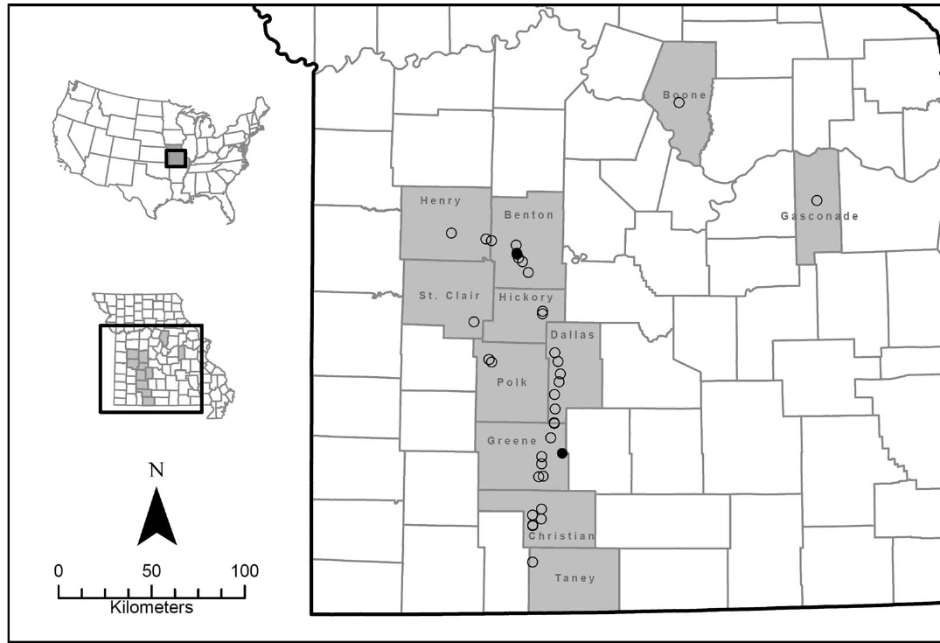
Figure 1. Missouri sampling locations. Closed circles represent the two armadillos that were PCR positive for Mycobacterium leprae (Robbins et al. 2025).

