2024 The Journal of Wildlife Diseases 60.4: 970-973.
Effect of pregnancy on mercury concentration in the body of free-living small rodents
Jankovská, Ivana, et al.

Question: You come across a pregnant wild vole. What element do you expect to be higher compared to nonpregnant females? And how would you check to see if you are correct?

Answer: Expect mercury levels to be elevated in pregnant wild rodents. Check liver and kidney samples.

2024 Journal of Zoo and Wildlife Medicine 55.2: 502-510.
Three Cases Of Clinical Leptospirosis In Patagonian Maras (Dolichotis Patagonum).
Wells, Taylr, et al

Question: A Patogonian mara at your zoo presents for lethargy, hyperemic conjunctiva, and inappetence. You find elevated kidney and liver values on bloodwork. What is the most likely differential (be specific)? What is the most likely transmission of disease?

Answer: Leptospirosis kirschneri serovar Grippotyphosa, most likely came from a racoon on zoo grounds

Journal of Wildlife Diseases, 59(4), 2023, pp. 734–742
Summarized by MR

Rabies in Rodents and Lagomorphs in the USA, 2011–20
Langley, Ricky & Hareza, Dariusz & Ma, Xiaoyue & Wallace, Ryan & Rupprecht, Charles

Amongst rodents and lagomorphs, which species has been found to be most commonly associated with rabies in the United States?
- Groundhogs (Marmota monax)
- Eastern cottontail rabbits (Sylvilagus floridanus)
- North American Beavers (Castor canadensis)
- Eastern grey squirrels (Sciurus carolinensis)
- Alaska marmots (Marmota broweri)

Answer: A. Groundhogs

Journal of Wildlife Diseases, 59(3): 504-508 (2023)
Summarized by MR

Significance of Intestinal Helminth Infection and Animal Sex for Mercury Concentrations in Two Rodent Species
Jankovská I, Karešová V, Michlová T, et al.
In a study pertaining to the effects of intestinal helminth infection and sex on mercury concentrations in two rodent species, yellow-necked mice (Apodemus flavicollis) and bank voles (Myodes glareolus), which of the following is true?

- Mercury concentrations were significantly higher in rodents infected with intestinal helminths than in uninfected rodents.
- No statistically significant difference in mercury concentrations was detected between infected and uninfected rodents overall.
- Male, yellow-necked mice had significantly higher mercury concentrations than female mice.
- Bank voles consistently had lower mercury concentrations than yellow-necked mice regardless of infection status.
- Intestinal helminth infection eliminated all species-level differences in mercury concentration.

Answer B. No statistically significant difference in mercury concentrations was detected between infected and uninfected rodents overall.

Comparison of ketamine-midazolam and ketamine-midazolam-butorphanol premedication prior to sevoflurane anesthesia in woodchucks (Marmota monax)
Freedman M, Aymen J, Beaufrere H, Delnatte P. J Zoo Wildl Med. 2023;54(2):262-271.—Summary by ALD

Which of the following was seen with butorphanol, midazolam, and ketamine premedication in comparison to butorphanol and midazolam premedication in woodchucks (Marmota monax)?
- Decreased heart rate
- Decreased blood glucose
- Increased body temperature
- Increased respiratory rate
- Decreased partial pressure of CO2

Answer: A. Decreased heart rate, decreased body temperature, decreased respiratory rate, increased blood glucose, increased PvCO2, and decreased pH were noted in KMB in comparison to KM.

Novel Simplexvirus (Simplexvirus Dolichotinealpha1) associated with fatality in four Patagonian mara (Dolichotis patagonum)
Freeman ME, Goe A, Ferguson SH, Lee JK, Struthers JD, Buczek J, Black A, Childress AL, Armién AG, West G, Wellehan JFX. J Zoo Wildl Med. 2024;55(2):490-501.—Summary by ALD

An adult female Patagonian mara (Dolichotis patagonum) presents to you with acute onset of a wide based stance, ataxia, depressed mentation, and hyperthermia. Which of the following diagnostic tests should you prioritize first to help obtain diagnosis in this animal?
- Serum biochemistry panel
- Complete hematology profile
- PCR of nasal and oral swabs
- Whole body radiographs
- Trace mineral panel

Answer: A. This animal potentially has DolAHV1, though you should rule out rhabdomyolysis. Chemistry panel can help rule out rhabdomyolysis due to the absence of elevated muscle values, though PCR of CSF was suggested to diagnose DolAHV1. Antemortem diagnosis for DolAHV1 was difficult in a previous study, and nasal and oral swabs were negative on PCR. Blood work was unhelpful in obtaining a diagnosis, though one case did have a leukocytosis and neutrophilia on CBC (not seen in other cases). Herpesviruses are normally associated with leukopenia and lymphopenias. Whole body radiographs were unremarkable in all animals. Histopathology could be helpful in a deceased animal due to the presence of inclusion bodies, though these were rare and could be easily overlooked. A trace mineral panel was performed on liver one of the cases and was unremarkable.

Ji, Na, et al. "Tacheng tick virus 1 and songling virus infection in great gerbils (Rhombomys opimus) in Northwestern China." The Journal of Wildlife Diseases 59.1 (2023): 138-142.- reviewed by HSS
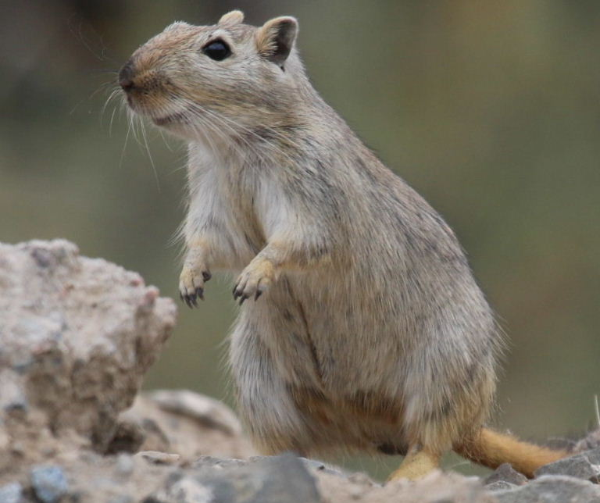

Question: Which of the following statements is correct regarding the detection of tickborne orthonairoviruses in greater gerbils (Rhombomys opimus)?

- Tacheng tick virus 1, Songling virus, and Tamdy virus were detected in the spleens of gerbils
- Tacheng tick virus 1 and Songling virus were detected in the spleens of gerbils, but Tamdy virus was not
- Tacheng tick virus 1 and Tamdy virus were detected in the spleens of gerbils, but Songling virus was not
- Songling virus and Tamdy virus were detected in the spleens of gerbils, but Tacheng tick virus 1 was not
- Neither Tacheng tick virus 1, Songling virus, nor Tamdy virus were detected in the spleens of gerbils

Answer: B

Kinnunen, Riikka P., et al. "Survey of Toxoplasma gondii in urban and rural squirrels (Sciuridae) in Manitoba, Canada." The Journal of Wildlife Diseases 59.1 (2023): 149-154.- reviewed by HSS

Question: Which of the following species is uniquely susceptible to Toxoplasma gondii?

- Otocolobus manul
- Puma concolor
- Felis margarita
- Acinonyx jubatus
- Lynx rufus

Answer: A

Journal of Zoo and Wildlife Medicine, 56(1): 169-174, 2025
FIRST REPORT OF TUMORS IN GARDEN DORMICE (ELIOMYS QUERCINUS)
Posautz et al – Summarized by LMM
Question: What was the most frequently reported tumor type in a case series of neoplasia in Garden Dormice (Eliomys quercinus)?
Answer: Sarcoma

Journal of Wildlife Diseases, 59(1): 71-83, 2023
FLEA CONTROL ON PRAIRIE DOGS (CYNOMYS SPP.) WITH FIPRONIL BAIT PELLETS: POTENTIAL PLAGUE MITIGATION TOOL FOR RAPID FIELD APPLICATION AND WILDLIFE CONSERVATION
Matchett et al – Summarized by LMM
Question: Name a major advantage of FipBits (fipronil baits) over pesticides, such as deltamethrin, for flea control in free-ranging prairie dogs.
Answer: Less impact on non-target species

