J Am Vet Med Assoc. 2023;261(6):865-873.
Summarized by MR

Epidemiological, clinical, radiographic, echocardiographic findings and outcome in client-owned guinea pigs (Cavia porcellus) with cardiac disease: 80 cases (2010-2021).
Rosas-Navarro J, Gaillot H, Agoulon A, et al.

In an epidemiological survey of cardiovascular disease in guinea pigs (Cavia porcellus), what was the most common type of cardiomyopathy diagnosed via echocardiography?
- Hypertrophic
- Restrictive
- Dilated
- Ischemic
- Obstructive
Answer: B

Quesenberry, Orcutt, Mans, Carpenter (eds). 2020. Ferrets, Rabbits and Rodents - Clinical Medicine and Surgery (4th ed). United States: Elsevier Health Sciences.

A privately-owned black-tailed prairie dog (Cynomys ludovicianus) presents in respiratory distress with open mouth breathing. During triage, you note poor body condition (2/9). After stabilization in oxygen, you obtain the following radiograph. What is the top differential for the structure indicated by the purple arrows?
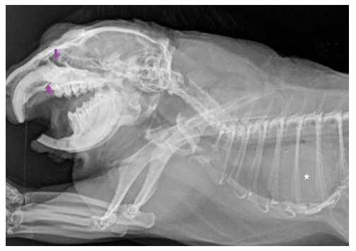

Answer: Elondontoma (additional acceptable terms: odontoma, pseudo-odontoma, hamartoma) – dysplastic malformation of (typically) maxillary incisors (sometimes mandibular), and folding of continuously growing tooth – severe apical mass-like deformity.

A newly acquired, privately-owned 2 YO MI black-tailed prairie dog (Cynomys ludovicianus) is referred to you in November for suspected bilateral cryptorchidism. What is the next step to discuss with the owner?
Answer: Male prairie dogs have open inguinal rings, and in the non-breeding season (breeding season: Jan – April), testes are normally located intra-abdominally. This is likely a normal finding, and if intended for breeding, no further action is required. (There was not context provided in this book chapter on when a castration would be recommended if not intended for breeding).

What viral etiology has been associated with hepatocholangiocarcinoma in the Sciuridae family (prairie dogs, woodchucks, ground squirrels)?

Answer: woodchuck hepatitis virus, a hepadnavirus. This is similar to humans infected with hepatitis B virus.

2025 Journal of Zoo and Wildlife Medicine 56.3: 621-627.
The Static Electrocardiogram Of Zoo-Kept Naked Mole-Rats (Heterocephalus Glaber) Under Alfaxalone–Ketamine Anesthesia
Boyd, Nathan, et al.

Question: During atrial depolarization in naked mole rats, which lead has a negative polarity?
- Lead I
- Lead II
- Lead III
- Lead aVL
- Lead aVR

Answer: Atrial depolarization (P wave) with positive polarity in leads I, II, aVL; negative polarity in lead aVR – consistent w/ impulse arising from sinoatrial node in right atrium, propagating from R to L. Ventricular depolarization: positive polarity in leads I, II and net negative polarity in lead aVR – polarity of QRS complex in lead II coincides with greater mass of left ventricle compared to right

2024 American Journal of Veterinary Research 85.10
Physiologic and behavioral effects of long-acting subcutaneous and transdermal buprenorphine in rats."
Collins, Elijah J., et al.

Question: In a study evaluating the physiologic and behavioral effects of two long-acting buprenorphine formulations in adult male rats, which of the following findings was associated with only transdermal buprenorphine and not subcutaneous buprenorphine?

A. Significant sedation scores compared to the control group
B. Significant hyperthermia compared to the control group
C. Significant reduction in food intake compared to the control group
D. Significant reduction in fecal output compared to the control group
E. Significant increase in self-injurious behavior compared to the control group

Answer
A. Significant sedation scores compared to the control group at 12 and 24 hours post-treatment.
Explanation: While both long-acting formulations produced several similar untoward effects, the study specifically noted that sedation only reached statistical significance following the administration of the transdermal formulation (TB), occurring between 12 and 24 hours post-application,,. In contrast, hyperthermia reduced food intake, reduced fecal output, and self-injurious behavior during the 4–12 hour window were statistically significant findings for both the TB and SB treatment groups when compared to controls

Evaluating the utility of radiographic vertebral heart score and left atrial heart size for diagnosis of dilated cardiomyopathy in marmot species as a potential model for other rodent species
Le S, Coffin CS, Whiteside DP. J Zoo Wildl Med. 2025l56(4):747-755.—Summary by ALD

Which of the following is true regarding radiographic vertebral heart scores (VHS) and vertebral left atrial size (VLAS) in Vancouver Island marmots (Marmota vancouverensis)?
- The mean VHS in Vancouver Island marmots was significantly higher than that seen in healthy woodchucks (Marmota monax)
- The mean VHS in Vancouver Island marmots was noted to be smaller than that seen in black tailed prairie dogs (Cynomys ludovicianus)
- A significant difference was seen in ventrodorsal (VD) VHS measurements in Vancouver Island marmots with heart disease and those without
- The mean VHS in Vancouver Island marmots was noted to be smaller than that seen in guinea pigs (Cavia porcellus) of both sexes
- There was no significant difference in scores when measuring a right lateral VHS score between novice and experienced observers

Answer: A. Vancouver Island marmots had significantly higher VHS scores than woodchucks, and they had higher VHS scores than black tailed prairie dogs and female guinea pigs. Male guinea pigs had larger VHS scores than Vancouver Island marmots. A significant difference was seen in right lateral VHS scores and VLAS scores between Vancouver Island marmots with heart disease and without, but no significant difference was seen in ventrodorsal VHS scores. There was no significant difference among observer scores between a novice and experienced observer when measuring RL-VHS, VD-VHS, and VLAS in Vancouver Island marmots and woodchucks, and no significant difference when measuring RL-VHS and VLAS in Vancouver Island marmots with heart disease and those without. A significant difference in VD-VHS scores was noted between observers when measuring the score in Vancouver Island marmots with heart disease.

Investigation of carditis and an associated Helicobacter sp. in common degus (Octodon degus)
Mack ZE, Alex CE, Nightingale BR, Moody J, McAloose D, Seimon TA. J Wildl Med. 2025;56(2):272-280.—Summary by ALD

You are performing a necropsy on a common degu and note that the animal has endocarditis. The following is noted on histopathology analysis (arrow head, inset 100X). What is the most likely etiological agent, and what are two other species found to have the same etiologic agent and associated cardiac disease? What other species have the closest phylogenetically-related bacteria been isolated in with similar disease manifestations?

Answer: Helicobacter sp. ‘degu’ has been found to be associated with carditis in common degus. This species has also been found to cause carditis in black tailed prairie dogs and a house mouse, and the most closely-related phylogenetically-related bacteria have been isolated from reptiles with cardiac disease include a pancake tortoise and Grand Cayman blue iguanas.

Anatomy Questions

An adult female rat is presented to you with the physical exam finding below. What is the most likely cause of this abnormality, and how could you distinguish this finding from other potential causes of disease?
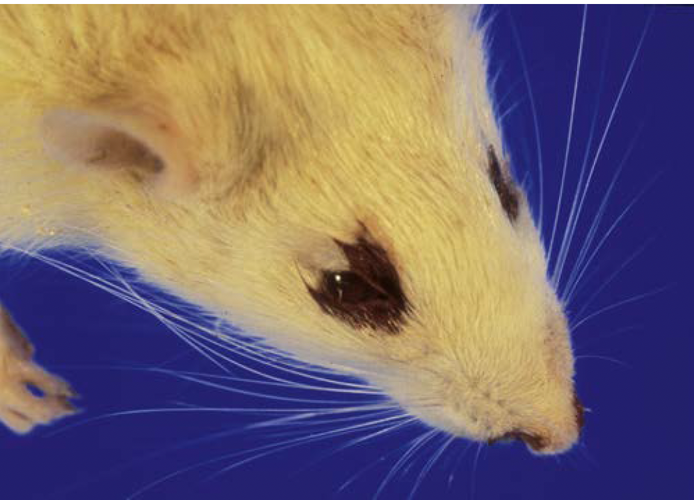
Answer: Chromodacryorrhea, due to accumulation of porphyrin pigments on the fur produced by the Harderian gland and is usually due to stress or disease (non-specific finding). Porphyrins fluoresce under ultraviolet light, so a Wood’s lamp can be used to distinguish this from blood.

A 1.5 year old intact male rat has presented to you for examination of a mass. On physical examination, a firm, approximately 0.5cm in diameter mass is palpated at the right lateral aspect of the skull, immediately ventral to where the pinna meets the skull. What are two potential causes of this mass?

Answer: Otitis externa +/- media leading to swelling of the external ear canal or carcinoma of the Zymbal’s gland.

Waxman, Samanta, et al. "Agreement between noninvasive oscillometric and invasive blood pressure measurements in isoflurane-anesthetized guinea pigs (Cavia porcellus)." Veterinary Anaesthesia and Analgesia 48.2 (2021): 252-25
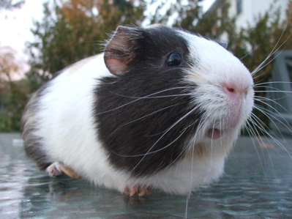

Question: Which of the following statements is correct regarding noninvasive oscillometric blood pressure (NIBP) monitoring compared to invasive blood pressure measurements in guinea pigs?

- There was good agreement for SAP but not DAP or MAP
- There was good agreement for SAP and DAP but not MAP
- There was good agreement for SAP and MAP but not DAP
- There was good agreement for DAP and MAP but not SAP
- There was good agreement for DAP but not MAP or SAP

Answer: D

Cook, Shannon ML, et al. "LINEAGE-ASSOCIATED IRON OVERLOAD IN CAPTIVE FEMALE AMARGOSA VOLES (MICROTUS CALIFORNICUS SCIRPENSIS)." Journal of Zoo and Wildlife Medicine 56.3 (2025): 639-649. - reviewed by HSS
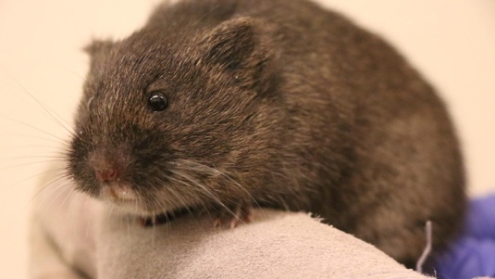

Question: Which of the following was associated with iron-overload in a population of captive Amargosa voles?

- Age
- Sex
- Parity
- Diet
- Housing

Answer: B

Explanation: Female sex and lineage were risk factors. All six voles with elevated hepatic iron as measured by digital analysis or mass spectroscopy or both were female. Excluding affected voles, females had a significantly higher hepatic Prussian blue–positive signal than males.
Journal of Zoo and Wildlife Medicine, 56(1): 169-174, 2025
FIRST REPORT OF TUMORS IN GARDEN DORMICE (ELIOMYS QUERCINUS)
Posautz et al – Summarized by LMM
Question: What was the most frequently reported tumor type in a case series of neoplasia in Garden Dormice (Eliomys quercinus)?
Answer: Sarcoma

Journal of Wildlife Diseases, 59(1): 71-83, 2023
FLEA CONTROL ON PRAIRIE DOGS (CYNOMYS SPP.) WITH FIPRONIL BAIT PELLETS: POTENTIAL PLAGUE MITIGATION TOOL FOR RAPID FIELD APPLICATION AND WILDLIFE CONSERVATION
Matchett et al – Summarized by LMM
Question: Name a major advantage of FipBits (fipronil baits) over pesticides, such as deltamethrin, for flea control in free-ranging prairie dogs.
Answer: Less impact on non-target species

