J Am Vet Med Assoc. 2023;261(6):865-873.
Summarized by MR

Epidemiological, clinical, radiographic, echocardiographic findings and outcome in client-owned guinea pigs (Cavia porcellus) with cardiac disease: 80 cases (2010-2021).
Rosas-Navarro J, Gaillot H, Agoulon A, et al.

Abstract:
OBJECTIVE: To characterize epidemiological, clinical, radiographic, and echocardiographic features of cardiac diseases in guinea pigs examined at a referral exotics center.
ANIMALS: 80 guinea pigs.
PROCEDURES: Medical records of guinea pigs that had echocardiography performed between June 2010 and January 2021 were reviewed.
RESULTS: The percentage of guinea pig patients with cardiovascular disease was 2.8%. Clinical signs included dyspnea (46/80), lethargy (18/80), and anorexia (10/80). The most common physical examination finding was heart murmur (10/80). Radiographic abnormalities included subjective cardiomegaly (37/67), pleural effusion (21/67), and increased lung opacity (40/67). Median (range) vertebral heart score on right lateral (48/67) and ventrodorsal (39/67) projections was 9.0 vertebrae (6.6 to 13.2 vertebrae) and 10.8 vertebrae (7.9 to 13.2 vertebrae), respectively. The most common echocardiographic diagnosis was cardiomyopathy (30/80), categorized as restrictive (11/30), hypertrophic (10/30), or dilated (9/10). Other cardiac diseases included cor pulmonale (21/80), pericardial effusion (18/80), congenital heart disease (6/80), acquired valvular disease (3/80), and cardiovascular mass (2/80). Congestive heart failure was present in 36 of 80. Median survival time from diagnosis was 2.5 months (95% CI, 1.1 to 6.2 months). Animals that died from heart disease had a significantly shorter survival time than those that died from a noncardiac disease (P = .02).
CLINICAL RELEVANCE: On radiographs, cardiomegaly, pleural effusion, and alveolar or interstitial lung pattern should be considered as indications for echocardiography in guinea pigs. Cardiomyopathy (restrictive, hypertrophic, or dilated), cor pulmonale, and pericardial effusion were the most common echocardiographic diagnoses. Further studies on diagnosis and treatment of cardiovascular diseases in guinea pigs are needed.

Background:
- Previous reports limited to small case series, previous 1.2% prevalence, increasing with age
- Objectives: describe features of CV disease and clinical outcomes/survival times

Summary:
- Medical records review – inclusion: guinea pigs with echocardiogram and available report between June 2010 – Jan 2021. Two authors reviewed and excluded cases for which echo revealed no abnormalities
  - Included two-view radiographs taken within 7 days of echo
  - Standardized echo procedure between 2 radiologists or 1 cardiologist
- N = 80 met inclusion, even sex distribution
- Prevalence 2.8% of CV disease (80/2864)
- Eight different types of cardiac disease ID’ed: DCM, HCM, restrictive CM, acquired valvular, pericardial effusion, neoplasia, congenital heart dz, cor pulmonale
- Median age at time of echo: 4.3 yrs
- C sx: dyspnea, lethargy, anorexia.
- PE: Only 10/80 cases had a murmur appreciated, other findings included weight loss, edema, and gallop rhythm in one animal
- Median RL-VHS: 9.0 vertebrae (range 6.6-13.2)
- Most common diagnoses by echo: cardiomyopathies - restrictive (11/80), hypertrophic (10/80), dilated (9/80). Cor pulmonae in 26% (21/80)
- Echo parameters provided
- CHF present in 45% (36/80), equal sex distribution, median age 4.3 yrs – all GPs with restrictive CM had CHF at presentation
- Common medical therapies were as expected: furosemide, pimobendan, ACE inhibitor. Antibiotic therapy commonly employed if there was suspicion of pneumonia or pericardial effusion of unknown origin.
- Death was related to cardiac disease in 46 of 74 (62.2%) animals and was either spontaneous (35/46 [76%]) or by euthanasia (11/46 [24%]).
- Overall median survival time was 2.5 months, no significant associations between survival time from diagnosis and any demographic characteristics, presence of CHF, final diagnosis.

Take-Home Points:
- Most common clinical signs: dyspnea, lethargy, and anorexia
- Most common radiographic abnormalities: cardiomegaly, pleural effusion, and increased lung opacity
- Most common heart diseases: cardiomyopathies (categorized as restrictive > hypertrophic > dilated), cor pulmonale, and pericardial effusion
- Overall median survival time (MST) = 2.5 months
  - MST for animals with heart-related death was significantly shorter than that of those that died of non-cardiac disease
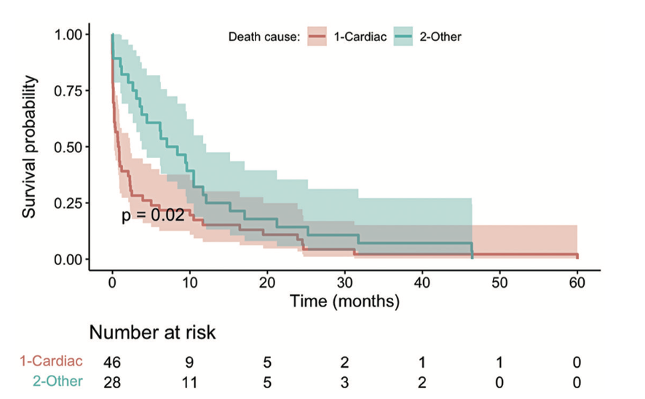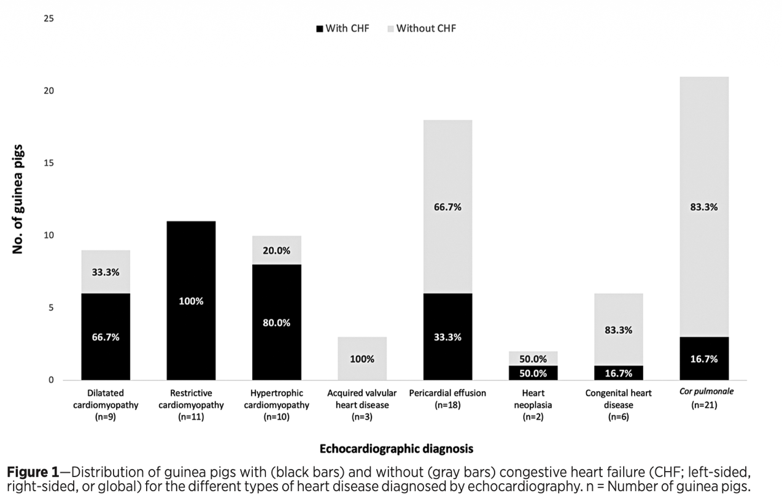

J Am Vet Med Assoc. 2022;261(4):562-565.
Summarized by MR

Organomegaly, lethargy, and hind limb trembling in a 3-year-old intact male Syrian hamster (Mesocricetus auratus)
Powers CM, Akingbade GM, Phillips IL, Etzioni AL, Gilbreath E.

Case Summary:
- 3 yo MI Syrian hamster with hx of trembling and weakness, eyelid mass, resolved then recurred four months later. Developed abdominal organomegaly, lethargy, respiratory distress and was euthanized
- Necropsy: multilobular liver masses, retrobulbar mass
- Histopathologic diagnosis: polycystic liver disease (PLD), membranous glomerulonephropathy with interstitial nephritis, left atrial thrombosis
- Hepatic cysts common in older hamsters (occurs due to separation of biliary structures during hepatic development)
- PLD is a common age-related pathology in hamsters, can eventually replace hepatic parenchyma. Tx is supportive care, typically causes anorexia
- Atrial thrombosis and glomerulonephropathy also common in older hamsters

Take-Home Points:
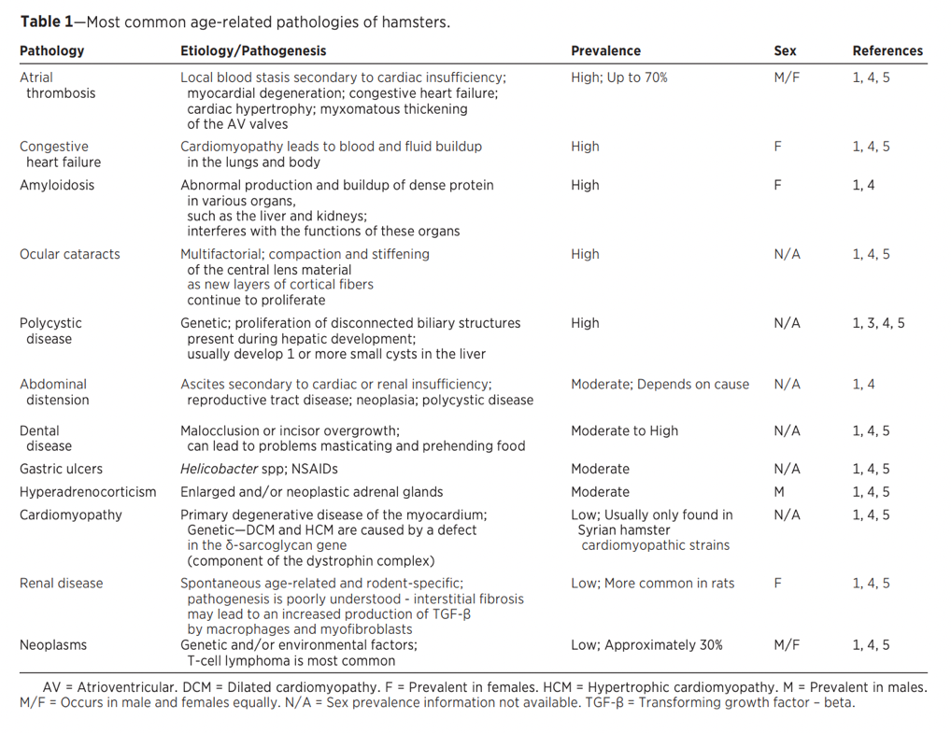
- Case summary of a geriatric hamster with polycystic liver disease, atrial thrombosis, and glomerulonephropathy
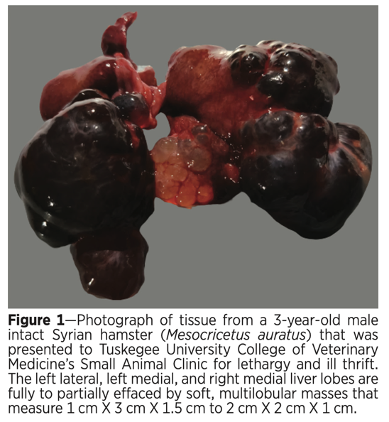
2025 Journal of Zoo and Wildlife Medicine 56.3: 621-627.
The Static Electrocardiogram Of Zoo-Kept Naked Mole-Rats (Heterocephalus Glaber) Under Alfaxalone–Ketamine Anesthesia
Boyd, Nathan, et al.

Abstract: The naked mole-rat (Heterocephalus glaber) has become a subject of interest in cardiovascular
research due to its unique biological properties. However, the ECG of this species has not been thoroughly described. The objective of this study was to characterize the ECG of ten clinically healthy naked mole-rats. Each animal was anesthetized with ketamine and alfaxalone, and ECGs were recorded in sternal recumbency using a hexaxial lead system. ECG resembled those of other rodents with a median heart rate of 174 beats/min (range: 131–202 beats/min), positive Q wave, R wave, and S wave (QRS) complexes in lead II, and absence of an isoelectric ST segment. All P waves were low amplitude (range: 0–0.05 millivolts (mV)) and ,40 milliseconds (ms) in duration (26–33 ms) while the median PR interval was 85 ms (76–100 ms). Peak R wave amplitudes ranged from 0.26–1.15 mV depending on filter settings and QRS complex durations were 26–44 ms. The QT intervals ranged from 168–254 ms. An arrhythmia characterized by sinus rhythm with first- and second-degree atrioventricular block was noted in one animal. Collectively, these results provide baseline values in clinically healthy naked mole-rats, which will be relevant to clinical and research situations.

Background
- Naked mole rats have altered expression of sarcomeric proteins including Beta myosin heavy chain and troponin I
Methods
- Anesthetized with alfaxalone and ketamine; ECG completed with neonatal electrode patches
Results / Discussion
- Lead 1 provided most reliable tracing (out of 6 lead ECG) – sinus rhythm, median HR 174 bpm
- Atrial depolarization (P wave) with positive polarity in leads I, II, aVL; negative polarity in lead aVR – consistent w/ impulse arising from sinoatrial node in right atrium, propagating from R to L
- Atrial depolarization consistently followed by isoelectric PR interval - slow conduction period through the AV node and His-Purkinje system; known to be HR dependent so some variability and can be affected by type of anesthesia in rats
- Ventricular depolarization short in duration with positive polarity in leads I, II and net negative polarity in lead aVR – polarity of QRS complex in lead II coincides with greater mass of left ventricle compared to right
- Specific morphology of QRS complex varied between individuals: four of the NMR exhibiting lead II QRS complexes with Rs morphology, three with qRs morphology, and one each with R, qR, and rs morphology
- Ventricular repolarization waves (T waves) arose directly from the R or S waveform of the QRS complex in all animals, with no isoelectric ST segment visualized – in rats, lack of T wave represents differences in ion channel type of distribution; they rely on K current for ventricular repolarization rather than delayed rectifier K channel that predominates humans, dogs, pigs
  - Longer QT interval - suggest longer monophasic action potential duration; also related to HR and slower HR of NMR can be adaptation to living in hypoxic env
- Arrhythmia detected in one animal (first and 2:1 and 3:1 second degree AV block)

2024 American Journal of Veterinary Research 85.10
Physiologic and behavioral effects of long-acting subcutaneous and transdermal buprenorphine in rats."
Collins, Elijah J., et al.

Objective: To investigate thermoregulation, thermal antinociception, food/kaolin intake, fecal output, and behavior following long-acting buprenorphine preparations in rats.
Animals: 8 adult male rats (Rattus norvegicus) were administered long-acting SC buprenorphine (SB; 0.65 mg/kg), transdermal buprenorphine (TB; 10 mg/kg), and controls in a randomized, cross-over design.
Methods: Body temperature, self-injury, sedation, food/kaolin intake, fecal output, and thermal withdrawal latencies were measured 1, 4, 8, 12, 24, 48, and 72 hours posttreatment. Data analysis was performed with mixed linear models.
Results: Self-injury was present between 1 and 12 hours and 4 and 12 hours following TB and SB, respectively; sedation was associated with TB at 12 to 24 hours. Withdrawal latencies were longer in both TB and SB groups than in the control group. Food intake decreased with time in all groups but was significantly lower 24 to 48 hours after TB and 24 to 72 hours after SB versus controls. Kaolin intake decreased from baseline 48 to 72 hours in the control group. Fecal output decreased from baseline 24 to 72 hours in all groups but was significantly lower than controls 24 hours following TB and 24 to 48 hours in SB. Body temperature increased from baseline at 1 hour, 1 to 12 hours, and 1 to 24 hours in the control, TB, and SB groups, respectively, and was significantly higher than the control group 1 to 72 hours following TB and 4 to 24 hours after SB. Transdermal buprenorphine and SB in normal rats produced antinociception, self-injurious behavior, hyperthermia, and decreased food/fecal output. Clinical Relevance: Although these buprenorphine preparations may produce antinociception, untoward effects such as hyperthermia, self-injurious behavior, and reduced food intake/fecal output may be seen

Background
- Conventional buprenorphine: partial mu-opiod receptor agonist 25-40x more potent than morphine; half-life 2.1-3hr; rats current dosing 0.05-0.1mg/kg SC q6-8hr
- New extended release buprenorphine FDA approved rodents/ferrets: Bound in lipid capsule and suspended in fatty acid triglycerides, allowing analgesia for 72hr (called SB, Ethiqa XR)
- Novel long-acting transdermal solution approved in cats (called TB, Zorbium)
Methods
- Rats given 1 of 4 treatments: SB, TB, control for SB, control for TB
- Evaluated self-injurious behavior, sedation, nociceptive (hind limb withdrawal time after exposure to radiant heat stimulus), food intake, kaolin intake (to monitor for pica since nonnutritive substance), fecal output
- Rats had implants placed SQ for identification and SC body temperature evaluation
Results
- 10mg/kg vs 20mg/kg TB: both showed antinociception between 1-4 hrs, but 20 mg/kg showed hyperalgesia by 48 hours; fecal output decreased after administration but was higher in 10mg/kg group; greater self-injurious behavior at 20mg/kg → elected to use 10 mg/kg for study
- Self-injury present between 1 and 12 hours after TB administration & between 4 & 12 hrs for SB
- Sedation was associated with TB at 12 to 24 hours
- Withdrawal latencies were longer in both TB and SB groups than in the control group
- Food intake decreased with time in all groups; significantly lower 24 to 48 hours after TB and 24 to 72 hours after SB versus controls.
- Kaolin intake decreased from baseline 48 to 72 hrs in the control group. Compared to TB, control and SB groups were lower at 48 hrs → kaolin can be used to evaluate nausea; suggest maybe mild from buprenorphine administration (extrapolation)
- Fecal output decreased from baseline 24 to 72 hours in all groups but was significantly lower than controls 24 hours following TB and 24 to 48 hours in SB → likely decreased GI motility
- Body temperature increased from baseline at 1 hr for control, 1 to 12 hrs for TB, 1 to 24 hrs for SB Groups; temp significantly higher than control 1 to 72 hours after TB, 4 to 24 hrs after SB
Discussion
- Both TB & SB associated w/ self-injury, reduced food intake, reduced fecal output, hyperthermia
- TB also had increased sedation and kaolin intake
- Study shows undesirable side effects can be present if treat rats with these formulations
- Overall, TB and SB had greater antinociception than control rats, but significant thermal antinociception was only seen after TB at 1 and 8 hours in this present study

Takeaway: Long-acting buprenorphine formulations can have benefits such as reduced nociception but also have side effects including concerns with GI motility, hyperthermia, self-injurious behavior, and mild sedation.

Evaluating the utility of radiographic vertebral heart score and left atrial heart size for diagnosis of dilated cardiomyopathy in marmot species as a potential model for other rodent species
Le S, Coffin CS, Whiteside DP. J Zoo Wildl Med. 2025l56(4):747-755.—Summary by ALD

Abstract: Dilated cardiomyopathy is the leading cause of mortality among Vancouver Island marmots
(Marmota vancouverensis) >5 yr of age under human care. In addition, other marmot species, such as the woodchuck (Marmota monax), can develop cardiomyopathies. Vertebral heart score (VHS) and vertebral left atrial size (VLAS) are objective radiographic measurements that screen for cardiac silhouette enlargement. There are no reported studies exploring the use of VHS or VLAS for the diagnosis of cardiac disease in marmot species. The objective of this retrospective and prospective cross-sectional study was threefold: (1) establish reference intervals for VHS and VLAS for Vancouver Island marmots (VIM) and woodchucks without evidence of heart disease, (2) compare the VHS and VLAS between VIM with and without heart disease, and (3) assess interobserver variability between VHS and VLAS recorded by a novice versus and experienced reviewer. While under anesthesia, right lateral (RL) and ventrodorsal (VD) radiographic views of adult healthy VIM without heart disease (n=21), adult VIM with heart disease (n=13), and adult healthy woodchucks (n=27) were evaluated. The 90% reference intervals for healthy VIM established were RL-VHS (7.45–9.41), VD-VHS (7.66–9.72), and VLAS (1.10–1.90). In woodchucks, 90% reference intervals were determined for RL-VHS (6.79–9.20), VD-VHS (6.63–11.15), and VLAS (0.53–1.71). Comparing RL-VHS and VLAS in VIM with and without heart disease revealed a significant difference between the two groups (P=0.015 and P=0.028, respectively). No significant difference was observed for VD-VHS in VIM with and without heart disease (P=0.089). There was no significant difference between values obtained from two observers (novice versus experienced) for healthy woodchucks or VIM by using RL-VHS, VD-VHS, or VLAS. In VIM with heart disease, a significant difference was noted between VD-VHS values obtained from two observers (P=0.03), whereas no significant difference was noted between RL-VHS and VLAS in VIM with heart disease.

Background:
- VIM: Sciuridae family, cardiovascular disease (esp DCM) leading cause of mortality in >5yo
- Woodchuck hepatitis virus (WHV): model for human hepatitis B virus infection, lesions: enlarged and dilated heart w/multifocal myocardial degeneration and necrosis

Key Points:
- Objectives: establish reference intervals for VHS and VLAS for VIM and woodchucks (WC) with and without cardiac disease, compare VHS and VLAS between VIM with and without heart disease, assess interobserver variability b/t novice and experienced evaluator
- Study: 18 VIM for prospective part, 16 VIM rads retrospectively; 27 WC rads retrospectively, all >1y
  - Anesthetized with iso, all had PE, rads, ECG, CBC, chem, cTnI, (not in WC) and echo
  - VHS and VLAS calculated: 21 VIM no evidence of heart dz, 13 had heart dz per rads
- No significant difference between observers for VIM or WC w/ RL-VHS, VD-VHS, and VLAS and RL-VHS and VLAS in VIM with heart dz; significant difference with VD-VHS in VIM with heart dz
- Significant difference in RL-VHS and VLAS in VIM with and without heart dz, not with VD-VHS
- Mean VHS/VLAS significantly higher in VIM than WC; female guinea pigs VHS was smaller, male guinea pigs larger, and black tailed prairie dogs was smaller than VIM and WC

Take Home:
- RL-VHS (not VD) and VLAS can be used to support heart disease in VIM, species specific reference ranges needed for these measurements as significant differences between VIM and WC—VHS and VLAS significantly higher in VIM than WC, also higher than in BTPD and female g pigs
- Novices can perform VHS/VLAS calculations comparably to people with more experience
  - 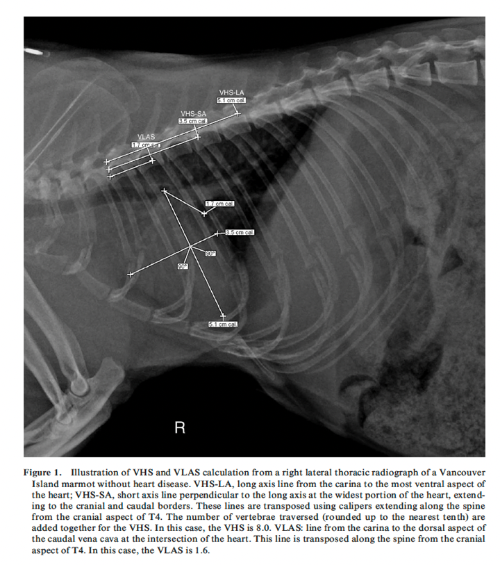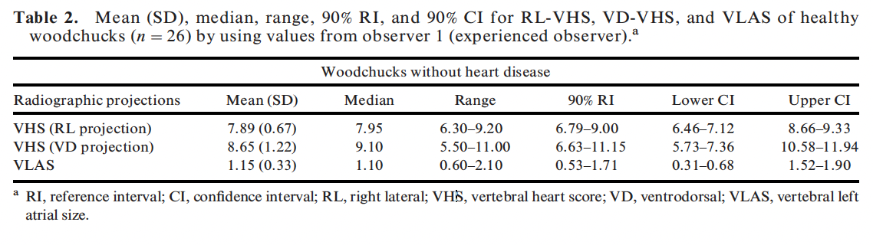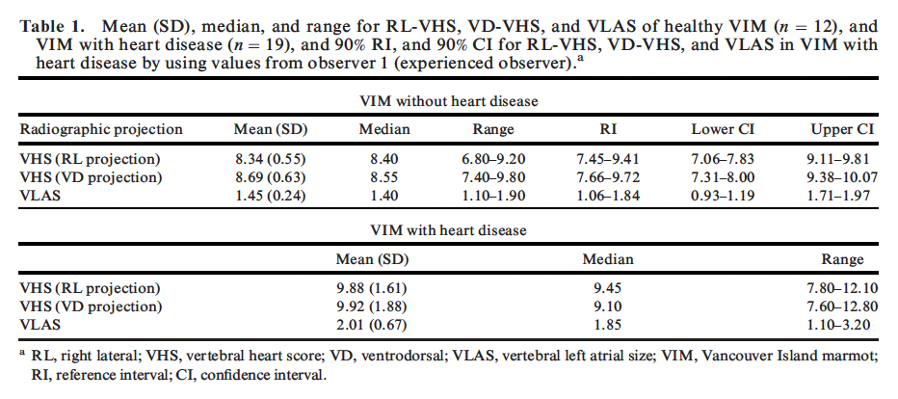

Investigation of carditis and an associated Helicobacter sp. in common degus (Octodon degus)
Mack ZE, Alex CE, Nightingale BR, Moody J, McAloose D, Seimon TA. J Wildl Med. 2025;56(2):272-280.—Summary by ALD

Abstract: This study investigated a previously unreported species of Helicobacter and associated cardiac inflammation in common degus (Octodon degus) at the Bronx Zoo. Lymphohistiocytic and/or lymphoplasmacytic cardiac inflammation was identified in 109 of 242 degu necropsies between 2000 and 2022. Polymerase chain reaction (PCR) targeting the Helicobacter 16S gene was performed on frozen cardiac tissue from 50 degus with (n=27) or without (n=23) carditis. Testing was positive in 16 degus with moderate or severe carditis, negative in 11 degus with minimal or mild carditis, negative in 22 degus without carditis, and positive in one degu without carditis. A positive correlation between PCR positivity and cardiac inflammation was identified from a Fisher’s exact test (P=0.01). Steiner staining was positive for intralesional spiral-shaped bacteria in cardiac tissue from PCR-positive degus (n=10) and negative in PCR-negative degus (n=33). Three nondegu rodents with carditis were also PCR positive for the novel Helicobacter. Chromogenic in situ hybridization (CISH) analysis targeting Helicobacter sp. nucleic acid in cardiac tissue was positive in 16 PCR-positive degus with carditis, negative in 33 PCR-negative degus, and positive in the three PCR-positive nondegu rodents. DNA sequencing, sequence alignment and comparison with known Helicobacter spp. through phylogenetic analysis showed that this bacterium, provisionally named Helicobacter sp. ‘degu’, is likely novel and forms a unique branch point within a larger clade that contains Helicobacter spp. from reptile hosts. Further studies are needed to elucidate a causative role for this bacterium as a pathogen in degus and assess implications for captive animal management and disease risk for degus and other Rodentia species.

Background:
- Helicobacter: spiral-shaped, Gram negative, fastidious; H. hepaticus=hepatitis and H. bilis=typhlocolitis in mice
- H. pylori associated with heart disease in humans, suspect d/t endothelial dysfunction; cardiac inflammation seen with Helicobacter in reptiles previously (thought d/t sepsis)

Key Points:
- Objective: Investigate novel Helicobacter sp. diagnosed in degus with carditis further w/DNA sequencing and phylogenetic analysis to see if associated with cardiac inflammation
- Study: Retrospective review from Jan 2000-Dec 2022; 242 total degu necropsies, carditis in 109 (significant contributor to death in 76) picked 50 cases for histo review (27 with pancarditis, 23 without) and testing for Helicobacter 16S rRNA gene via PCR (all with mod-severe carditis were positive); tested some for eubacteria 16S rRNA gene (no other bacteria suspected to contribute to carditis), herpesvirus DNA polymerase gene (all negative), and encephalomyocarditis virus (all negative)
  - Also tested house mouse and 2 black tailed prairie dogs w/cardiac inflammation for eubacteria 16S rRNApositive with same (or 99.8% match in BTPD) strain as degus
  - Chromogenic in situ hybridization (CISH)—positive in 16 of 17 PCR positive cases tested, can be systemic but seems to be mostly in heart; phylogenetic analysis (didn’t cluster w/other Helicobacter in rodents, closer to reptiles but not very closely related)
- Common comorbidity with carditis: lymphocytic inflammation in other organscould be immune response to infection; also saw Bowman’s capsule hemorrhage—unsure if related to Helicobacter
- Strong association with carditis and adult age

Take Home:
- Helicobacter sp. is associated with mononuclear carditis in degus, and this species of Helicobacter may be cardiotropic
  - Was found in other organs too, suggesting it can go systemic
  - Also was found in other rodents, suggesting it can infect multiple species with similar lesions, though hasn’t been reported in rodents before and is more closely related to Helicobacter spp. isolated from reptiles that were found to have heart disease (but still not very close)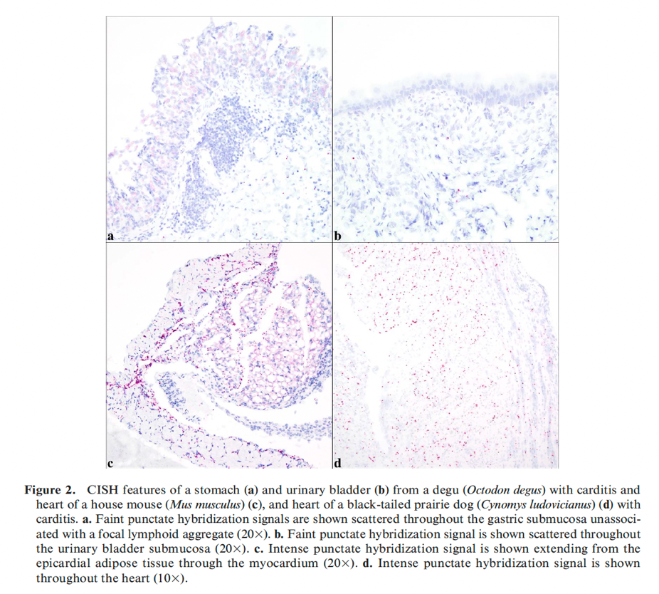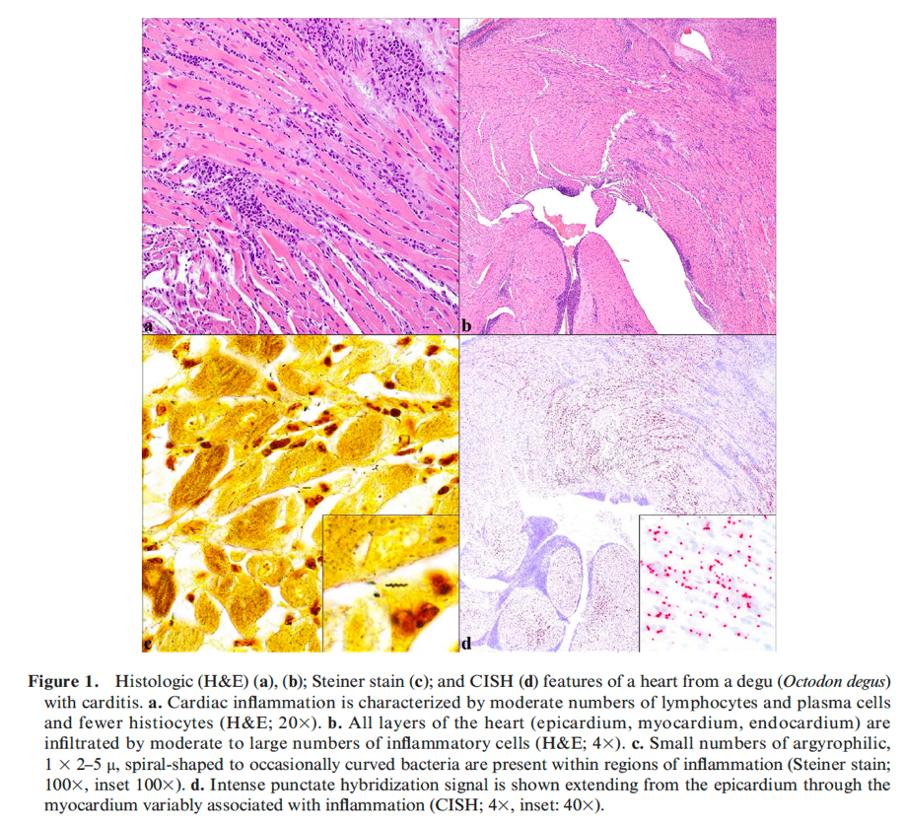

Waxman, Samanta, et al. "Agreement between noninvasive oscillometric and invasive blood pressure measurements in isoflurane-anesthetized guinea pigs (Cavia porcellus)." Veterinary Anaesthesia and Analgesia 48.2 (2021): 252-25. - reviewed by HSS
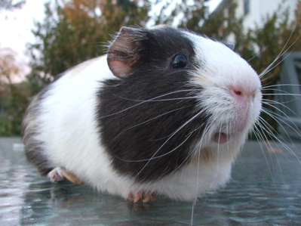
Abstract:
Objective
To assess the agreement between an oscillometric device and invasive blood pressure (IBP) measurements in anesthetized healthy adult guinea pigs.
Study design
Prospective experimental study.
Animals
A total of eight adult Hartley guinea pigs.
Methods
All animals were anesthetized; a carotid artery was surgically exposed and catheterized for IBP measurements. A size 1 cuff placed on the right thoracic limb was connected to an oscillometric device for noninvasive blood pressure (NIBP) assessment. Concurrent pairs of systolic (SAP), diastolic (DAP) and mean (MAP) arterial pressures were recorded simultaneously with both methods every 3 minutes for 30 minutes. Agreement between IBP and NIBP measurements was determined using the Bland–Altman method, considering the recommended standards for the validation of NIBP measurement devices proposed by the American College of Veterinary Internal Medicine (ACVIM).
Results
The bias and the 95% limits of agreement were: –14 (–31 to 3) mmHg, –2 (–14 to 10) mmHg and –1 (–13 to 11) mmHg for SAP, DAP and MAP, respectively.
Conclusions and clinical relevance
The oscillometric device used in this study to measure NIBP did not meet ACVIM criteria for validation. It showed good agreement for DAP and MAP but not for SAP measurements. Considering the small size of these animals and the resulting difficulty in performing percutaneous arterial catheterization, this device might be a useful tool to assess MAP and DAP during anesthetic procedures in adult guinea pigs.

Key Points:
- SAP, MAP and DAP were 64 ± 22, 52 ± 17 and 44 ± 12 mmHg, and 78 ± 22, 53 ± 16 and 44 ± 14 mmHg for IBP and NIBP, respectively
- The results of this study showed good agreement for DAP and MAP measurements; however, the validation criteria were not met for SAP. Correlation coefficients were ≥ 0.9 for all SAP, DAP and MAP paired measurements, but agreement between the SAP measurements was poor
- SAP measurements were overestimated by the oscillometric device
- A wider cuff produces artificially lower pressure measurements, whereas narrow cuffs produce artificially higher measurements

Take-Home Message:
- The oscillometric device used in this study to measure NIBP did not meet ACVIM criteria for validation. Good agreement for DAP and MAP measurements was obtained but not for SAP measurements. Considering the small size of these animals and the resulting difficulty in performing percutaneous arterial catheterization, this device may be useful for assessing MAP and DAP during anesthetic procedures in adult guinea pigs.

Cook, Shannon ML, et al. "LINEAGE-ASSOCIATED IRON OVERLOAD IN CAPTIVE FEMALE AMARGOSA VOLES (MICROTUS CALIFORNICUS SCIRPENSIS)." Journal of Zoo and Wildlife Medicine 56.3 (2025): 639-649. - reviewed by HSS
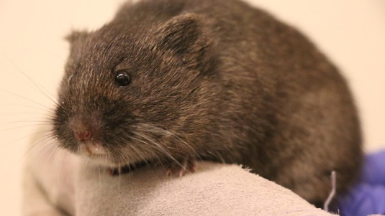
Abstract:
Within 1 yr, two cases of iron storage disease (hemochromatosis) were identified in a breeding colony of endangered Amargosa voles (Microtus californicus scirpensis). This study was designed to investigate the extent of excessive hepatic iron accumulation (iron overload with or without tissue damage) in the colony and identify risk factors such as age, sex, parity, lineage, diet, or housing that could influence management decisions for a population meant to propagate a vanishing species. The two affected voles had periportal to panlobular hepatocellular and Kupffer cell Prussian blue–positive pigment accumulation associated with hepatocellular degeneration and necrosis. By mass spectroscopy, hepatic iron content in the two affected voles was 34,000 and 6,100 parts per million (ppm) compared with 6,800 and 400 ppm in two unaffected voles. To determine the prevalence and identify risk factors, a study set of 45 voles from the pathology archives was selected within representative age groups and between sexes. The paraffin-embedded liver from study set voles was stained with Prussian blue for ferric iron. Prussian blue–positive staining was semiquantitatively scored and quantified using automated image analysis of binary pixels per region of interest. Four additional voles with excessive hepatic iron accumulation were identified within the study set. Age, diet, and types of housing were not risk factors, but female sex and lineage were risk factors. All six voles with elevated hepatic iron as measured by digital analysis or mass spectroscopy or both were female. Excluding affected voles, females had a significantly higher hepatic Prussian blue–positive signal than males. No association was identified between hepatic Prussian blue–positive signal and parity. Pedigree analysis revealed that five of six voles with elevated hepatic Prussian blue–positive signal were related to a single male founder (identification 4585). Excessive hepatic iron accumulation in this captive Amargosa vole colony is, thus, associated with female sex and was potentially heritable.

Key Points:
- Amargosa vole:
  - Federally endangered
  - Breeding colony at UC Davis
  - Subsist almost exclusively on bulrush or sedges and average lifespan is 3-4 months
  - Females are able to conceive year-round and are reproductively active as young as 25 days
  - Most common diseases in the colony are molar apical elongation, trichobezoars, chronic renal disease, chronic cardiomyopathies
- Iron overload (IO)/iron storage disease (ISD)
  - ISD/hemochromatosis = excessive tissue iron accumulation with organ damage and in the liver can include acute hepatic necrosis, hepatocellular dropout, and fibrosis and regenerative hyperplasia
  - IO/hemosiderosis = excessive tissue iron accumulation, most frequently in hepatocytes, without organ damage
    - IO can progress to ISD, though progression does not always occur, and the stepwise progression from IO to ISD is thought to be complex and affected by both genetic and acquired factors
  - Primary: genetic predisposition to accumulate iron
    - Humans, mynah birds, fruit bats
  - Secondary: consequence of an external factor (repeat transfusions, iron injections)
    - Black rhinos likely have both 1* and 2* component; polymorphism in the hemochromatosis gene and provision of a captive diet containing excessive dietary iron
- This study: confirm presence of IO in voles and investigate risk factors
  - IO was diagnosed on the basis of the presence of hepatocellular hemosiderosis and confirmed by Prussian blue–positive staining.
  - ISD was diagnosed on the basis of the presence of hepatocellular hemosiderosis with organ damage (hepatocellular necrosis, hepatocellular atrophy, and hemosiderin-laden aggregates of macrophages)
  - Female voles have infinitely greater odds of having excessive hepatic iron accumulation compared to males
    - May be either sex chromosome linked or estrogen dependent.
  - Voles related to the specific male founder have 185.0 greater odds of having excessive hepatic iron accumulation compared to those not related to this founder
  - Husbandry and dietary iron were NOT risk factors

Take-Home Message:
- Age, diet, and types of housing were not risk factors, but female sex and lineage were risk factors. IO is likely a heritable condition in this colony of Amargosa voles and is specifically linked to the female sex in the colony.

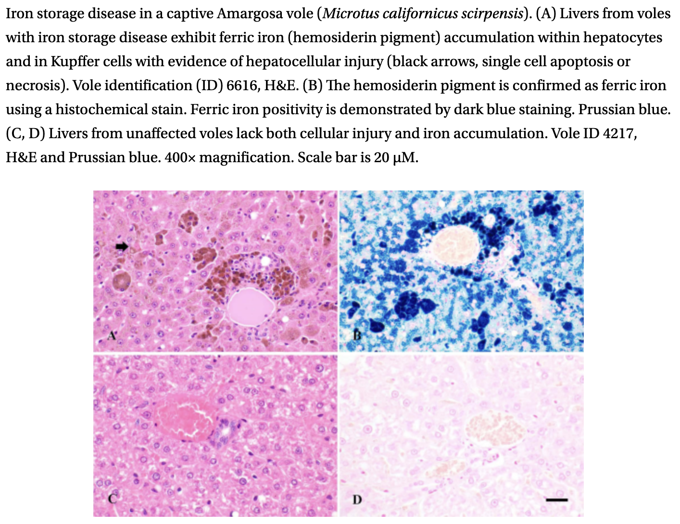

Journal of Zoo and Wildlife Medicine, 56(1): 169-174, 2025
FIRST REPORT OF TUMORS IN GARDEN DORMICE (ELIOMYS QUERCINUS)
Posautz et al – Summarized by LMM
Abstract: The garden dormouse is listed as “near threatened” on the IUCN Red List of threatened species. Research on this species concentrates primarily on their hibernating strategies and physiology. However, little is known about infectious entities in this species, even less about neoplastic diseases. This case series presents the first report of different neoplasms in a population of garden dormice (Eliomys quercinus) under human care. This report includes six animals (four males, two females, four to seven years old). Four animals were euthanized, and two were found dead in the enclosure. Tissues of the animals were stained with Hematoxylin and eosin. Special staining (methyl green pyronin, desmin, vimentin, and cytokeratin) was performed to confirm diagnoses. Tumors found in these animals consisted of a pancreatic adenocarcinoma, a plasma cell tumor, an osteosarcoma, and three sarcomas. Because of their declining population trend and efforts of reintroduction, knowledge about diseases is imperative, especially, if there might be a genetic influence, which could hinder the success of conservation efforts.
Key Points:
- Seasonal hibernators
  - May be an “anti-tumor” effect of hibernation or seasonal torpor on tumor development, but unclear at this time in this species (ongoing area of research)
- All animals in this case series were considered aged for the species; this is a potential explanation for neoplasia
- Unclear if inbreeding was a component of this case series and a potential cause for the observed neoplastic disease; Full pedigree could not be restored
Take Home Point: First published reports of neoplasia in Garden dormice.
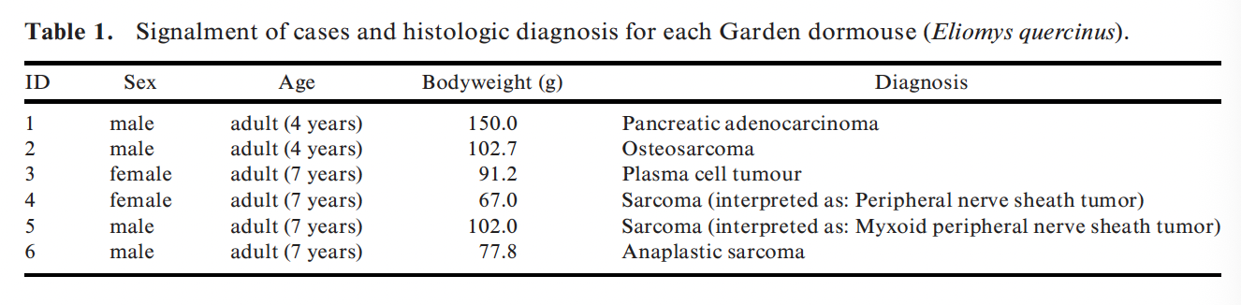
Journal of Wildlife Diseases, 59(1): 71-83, 2023
FLEA CONTROL ON PRAIRIE DOGS (CYNOMYS SPP.) WITH FIPRONIL BAIT PELLETS: POTENTIAL PLAGUE MITIGATION TOOL FOR RAPID FIELD APPLICATION AND WILDLIFE CONSERVATION
Matchett et al – Summarized by LMM
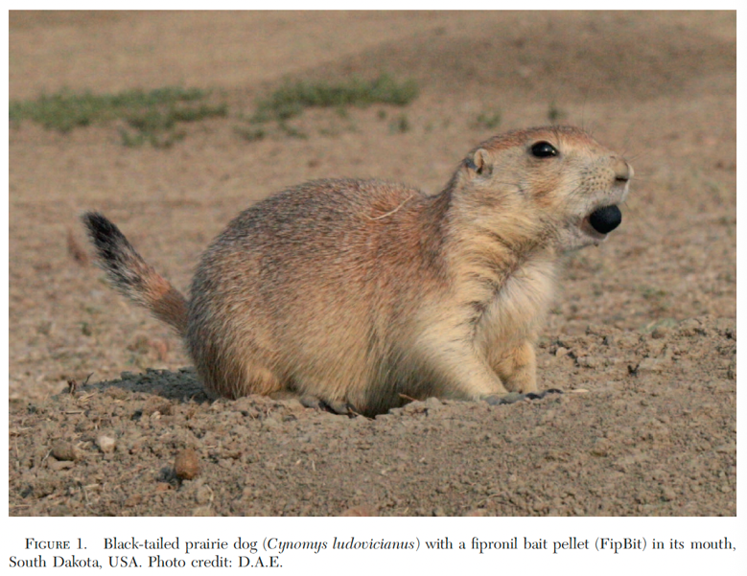
Abstract: Sylvatic plague is a widespread, primarily flea-vectored disease in western North America. Because plague is highly lethal to endangered black-footed ferrets (Mustela nigripes, BFFs) and the prairie dogs (Cynomys spp., PDs) on which BFFs depend for habitat and prey, minimizing the impacts of plague is a priority at BFF reintroduction sites. We developed a new, flour-based bait pellet containing 0.84 mg of fipronil and weighing ∼1.25 g (FipBits). We measured the degree and duration of flea control on black-tailed PDs (C. ludovicianus) in Montana and on Gunnison's PDs (C. gunnisoni) in Arizona, USA from 2018–2020. FipBits were distributed on treated plots one time at a rate of 125/ha. Fleas were virtually eliminated in Montana from 1 mo posttreatment to 1 yr later and remained substantially depressed 2 yr posttreatment. With the split colony design, we probably underestimated the degree of flea control achieved with FipBits due to crossover edge effects along the arbitrary line dividing the plots. Flea control in Arizona was significant from 1 mo posttreatment to 1 yr later, but flea abundance had recovered by 2 yr posttreatment. Flea control was evaluated from 2020–2021 in South Dakota, USA on four plots treated with three concentrations of fipronil in FipBits (0.68, 0.71, and 0.83 mg/FipBit). Fleas were essentially eliminated for 10 mo on the 0.83-mg plot and were substantially reduced on the two 0.71-mg plots. Fleas were reduced on the 0.68-mg plot, but the degree of control was less than observed on other treated plots. Impacts of plague on PDs and BFFs would probably be greatly reduced by the levels of flea control observed with FipBits. Options for expanded FipBit evaluations are being pursued for what may become a highly practical, affordable, and effective plague mitigation tool.
Key Points:
- Primary biologic challenge to recovery of endangered black-footed ferrets is sylvatic plague (Yersinia pestis) vectored primarily by fleas
- Plague highly lethal to both BFF’s and prairie dogs (species that BFF’s are obligate dependents on for habitat and prey)
- FipBits = molasses, peanut butter, and fipronil balls that can be distributed via “triple-shooters” for flea control and ideally prevention of Yersinia pestis in prairie dogs (with overarching goal to save the BFF)
- Investigated duration of flea control in prairie dogs using FipBits in Montana, Arizona, and South Dakota
  - Montana: Reduced fleas for at least 24 months
  - Arizona: Reduced fleas for at least 12 months
  - South Dakota: Efficacy of flea control appeared to increase with increasing fipronil concentration per bait
- Authors recommended fipronil bait treatment mid- to late summer and need to be completed before hibernation
- FipBits are a preferred management tool over others such as pesticides like deltamethrin that have more impacts on non-target species
Take Home Point: FipBits (fipronil baits) were effective for flea control on prairie dogs for 1-2 years. This may be an option ultimately for the conservation of Black-footed ferrets, that are dependent on prairie dogs for food and habitat but have exposure to sylvatic plague (Yersinia pestis) because of the fleas on prairie dogs.
