Occurrence of pathogenic chytrid fungi Batrachochytrium salamandrivorans and Batrachochytrium dendrobatidis in the Hong Kong newt (Paramesotriton hongkongensis) and other wild and importuned amphibians in a subtropical Asian region
Chen G, Lau A, Wan B, Shui Kei Poon E, Shing Fung H, Ho Lee W, Sung YH, Yung Wa Sin S. J Wildl Dis. 2023;59(4):709-721.—ALD Summary

You are presented with an adult, female Paramesotriton hongkongensis as a quarantine examination at your institution. The animal was recently imported from China and weighs 80 grams. Physical exam was unremarkable. What infectious disease diagnostic testing would you recommend for this animal prior to exiting quarantine.
- Testing for both Batrachochytrium dendrobatidis and B. salamandrivorans are recommended as this species has been known to carry both B. dendrobatidis and B. salamandrivorans without any overt clinical signs in the wild

Epizootic of Clinostomum marginatum (Trematoda: Clinostomidae) in Ambystoma tigrinum from Colorado, USA: Investigation through genomics, histopathology, and noninvasive imagery
Calhoun DM, Groves J, Schaffer PA, Achatz TJ, Greiman SE, Johnson PTJ. J Wildl Dis. 2025;61(2):448-460.—ALD Summary

A wild, premetamorphic tiger salamander (Ambystomma tirgrinum) presents to you in northern Colorado, USA. The animal is lethargic, with abnormal buoyancy, and covered with multifocal, 1-2 mm in diameter, white to tan nodules in the skin, especially focused around the gills. The animal is also noted to have significant scoliosis. Which of the following is the most likely etiologic agent?
- Clinostomum marginatum
- Echinostoma trivolvis
- Rhabdias bufonis
- Megalobatrachonema elongata
- Rhabdias fuelleborni

Answer: A. Clinostomum marginatum metacercaria have been found to cause white skin lesions in tiger salamanders, and metacercaria have been found in almost all organs including the spinal cord leading to scoliosis. Rhabdias bufonis has been shown to inhibit growth and survival in European toads and wood frogs, Echinostoma trivolvis has been shown to decrease growth and increase developmental time in wood frogs, and Megalobatrachonema elongata is an intestinal nematode. Rhabdias fuelleborni is a lung nematode that has been shown to reduce locomotor performance in Cururu toads. Both Ribeiroia ondatrae and Cephalogonimus americanus are trematodes that have also been reported in tiger salamanders.

Myiasis by the toad fly (Lucilia bufonivora; Calliphoidae) in amphibians in Montana, USA
Fischer LM, Hossack BR. J Wildl Dis. 2025;61(1):206-211.—ALD Summary

An adult western toad presents to you with the following lesion. What is the most likely infectious agent? Describe its life cycle.
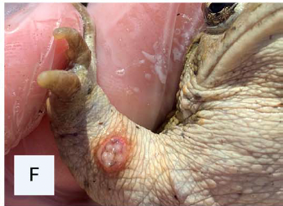

Answer: Lucilia spp., likely Lucilia bufonivora if this animal is located in Montana, USA. Adult fly lays eggs on the flank or dorsum of the toad, larvae burrow into skin and congregate into one lesion (to breathe through the lesion) and hatch 5-7d later, burrow into ground to pupate within 8-11d, adult flies emerge after 7-9d.

The Journal of Wildlife Diseases 61.4 (2025): 1057-1062.
Surveys for Three Pathogens Reveal No Chytrid Detections But First Detection of Ranavirus in Southern Torrent Salamanders (Rhyacotriton variegatus) in Northern California, USA.
Sandoval, Marilyn V., Jacob L. Kerby, and Karen M. Kiemnec-Tyburczy

Which of the following is correct regarding a study evaluating Southern torrent salamanders (Rhyacotriton variegatus) in the pacific northwest?
- Batrachochytrium dendrobatidis was identified in the population
- Batrachochytrium salamandrivorans was identified in the population
- Ranavirus (frog virus 3–like) was identified in the population
- Water temperature significantly increased viral and fungal load
- Some but not all individuals positive for disease had clinical signs

Answer: C A - not identified in population, B - not identified in population; D - water temp increase viral load only for ranavirus, did not identify any chytrid; E - no clinical signs noted on any animals regardless of whether they were positive for ranavirus

The Journal of Wildlife Diseases 61.3 (2025): 767-772.
Detection of bufonid herpesvirus 1 and Ranid herpesvirus 3 in native amphibians in Schleswig-Holstein, Germany, 2022–23
Leineweber, Christoph, et al.

Question: Which of the following clinical signs would you expect to see with Bufonoid herpesvirus 1 in common toads in Germany?
- Skin lesions
- Coelomic swelling
- No external clinical signs
- Respiratory distress
- Unilateral paresis

Answer: C - they did not see external clinical signs in any amphibian that tested positive for Bufonid herpesvirus 1 (BfHV1) or Ranid herpesvirus 3 RaHV3. However, the most common clinical sign would include skin lesions, just none noted here

2023 JWD 59.1
Prevalence Of Ranavirus In Spotted Salamander (Ambystoma Maculatum) Larvae From Created Vernal Pools In West Virginia, USA
Millikin, Alice R., Davis, Drew R., Brown, Donald J., Woodley, Sarah K., Coster, Stephanie, et al. (summary by MGF)

According to a study on ranavirus in spotted salamander (Ambystoma maculatum), which of the following findings is correct?
a) Ranavirus prevalence in spotted salamanders was strongly associated with pool size and vegetation cover.
b) Corticosterone levels were significantly higher in larvae infected with ranavirus compared to uninfected larvae.
c) Ranavirus infection was positively correlated with spotted salamander larval total length.
d) High levels of ranavirus were detected in most of the vernal pools and spotted salamanders sampled.
e) Viral load was strongly correlated to specific genetic parameters in spotted salamanders.

Answer: C; A - ranavirus was NOT associated with any habitat characteristic, B - ranavirus was NOT associated with corticosterone levels; D - there was actually low prevalence of ranavirus in spotted salamanders but high-ish (~45-75%) of ranavirus prevalence in the pools over different years; E - ranavirus was NOT associated with genetic parameters

Barnett, K. M., et al. "Fungal metabolites provide pre-exposure protection but no postexposure benefit or harm against Batrachochytrium dendrobatidis." The Journal of Wildlife Diseases 59.2 (2023): 217-223.- reviewed by HSS
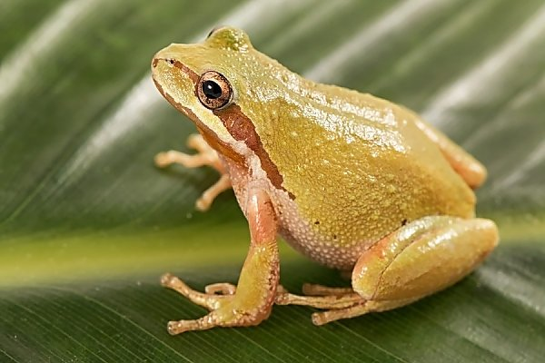
Question: Which of the following statements is most correct regarding use of fungal metabolites to induce resistance to Batrachochytrium dendrobatidis in tadpoles?

- Fungal metabolites significantly reduced Bd mortality when applied pre-exposure
- Fungal metabolites significantly reduced Bd infection intensity when applied pre-exposure
- Fungal metabolites significantly reduced Bd infection intensity when applied post-exposure
- Fungal metabolites significantly increased Bd infection intensity when applied pre-exposure
- Fungal metabolites significantly increased Bd infection intensity when applied post-exposure

Answer: B

Forrest, Matthew J., et al. "KEEPING THE HEAT ON: WEIGHTED SURVEILLANCE FOR CHYTRID FUNGUS (BATRACHOCHYTRIUM DENDROBATIDIS) IN DIXIE VALLEY TOADS (ANAXYRUS [= BUFO] WILLIAMSI)." The Journal of Wildlife Diseases 59.4 (2023): 557-568. reviewed by HSS
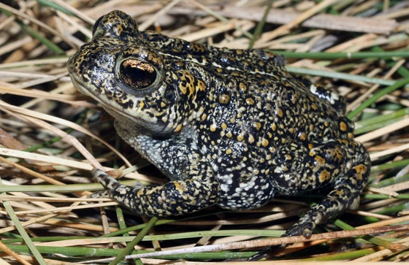
Question: Which of the following is true regarding the use of weighted surveillance for the detection of Batrachochytrium dendrobatidis (Bd) in the Dixie valley toad (Anaxyrus williamsi)?

- Surveillance weights were not significantly different between Dixie toads of all life stages and American bullfrogs of all life stages.
- American bullfrogs in the Dixie toad home range had high prevalence of Bd, but Dixie toads appear resistant to infection based on lack of detection of Bd.
- Larval bullfrogs had much higher surveillance weight compared to adult Dixie valley toads
- There was a low prevalence of Bd in the native population of Dixie valley toads, although the lack of lesions suggests resistance to development of clinical disease.
- American bullfrogs are present throughout most of the range of the Dixie valley toads, making them an appropriate surrogate for sampling.

Answer: C

Villamizar-Gomez, Andrea, et al. "Multi-year Occurrence of Ranavirus and Batrachochytrium dendrobatidis in Anurans from Central, Southeast, and Coastal Regions of Texas, USA, 2012–19." The Journal of Wildlife Diseases 61.3 (2025): 749-755.- reviewed by HSS

Question:
Which of the following trends in pathogen prevalence was observed in anurans from Texas between 2012 and 2019?

- Both Ranavirus and Batrachochytrium dendrobatidis (Bd) increased steadily over time
- Ranavirus prevalence increased, while Bd prevalence decreased
- Ranavirus prevalence decreased, while Bd prevalence increased
- Both Ranavirus and Bd remained constant across all years
- Co-infection rates increased dramatically and exceeded single infections

Answer: C

J Zoo Wildl Med. 2024;55(2):447-452.
Summarized by MR

CASE DEFINITION AND TREATMENT TRIAL OF TETANY SYNDROME IN PANAMANIAN GOLDEN FROGS (ATELOPUS ZETEKI)
Coyne SP, Barrett K, Shultz J, Flanders JA, Bronson E

Which oral treatment is reported to be the most effective at improving tetany syndrome in a Panamanian golden frog (Atelopus zeteki)?

- Calcium gluconate
- Magnesium chloride
- Supplemental gavage feeding
- Combo Ca, Mg, B vitamin complex
- Amphibian Ringers Solution

Answer: D

J Zoo Wildl Med. 2024;55(2):453-461.
Summarized by MR

PILOT STUDY OF INTRACOELOMIC TERBINAFINE IMPLANTS IN GREATER SIRENS (SIREN LACERTINA)
Towe AE, Hardman RH, Cox S, et al.

Which of the following statements best distinguishes Batrachochytrium salamandrivorans (Bsal) from Batrachochytrium dendrobatidis (Bd) based on current knowledge?

A. Bsal primarily affects anurans, whereas Bd primarily affects salamanders
B. Bd more commonly causes skin ulceration, while Bsal causes epidermal hyperplasia
C. Bsal caused population declines in fire salamanders, characterized by skin ulcerations
D. Bd was identified more recently and has a narrower host range than Bsal
E. Bsal does not impair amphibian skin function related to electrolyte balance

Answer: C

Journal of Wildlife Diseases, 59(3), 2023, pp. 442–452
Summarized by MR

MULTISYSTEMIC EMPHYSEMA (GAS BUBBLE DISEASE)- ASSOCIATED ACUTE MASS MORTALITY IN A FREE-RANGING POPULATION OF COMMON FROG (RANA TEMPORARIA) IN SWITZERLAND
Stephanie Borel and Francesco Origgi

In a described mass mortality event of Common frogs (Rana temporaria) in Switzerland, what macroscopic or microscopic features associated with presumptive Gas Bubble Disease were in direct contrast of what is commonly seen in fish?
- Emphysema within the brain
- Emphysema within the intestines
- Bilateral exophthalmos
- Tongue protrusion and prolapsed stomach
- Skin distention by discrete gas bubbles
Correct answer: D. tongue protrusion and prolapsed stomach. In the necropsies performed following this mass mortality event, multisystemic emphysema affected all organs except the brain and intestines (r/o A & B). Bilateral exophthalmos was not observed in common frogs and is seen in fish experiencing GBD (r/o C). The discussion notes that the emphysema of the skin was distinctly different than “discrete gas bubbles observed in fish” (r/o E). Tongue protrusion and prolapsed stomach was seen in these frogs, and prolapse is also seen in fish experiencing barotrauma, which is a DDx for gas bubble disease for fish under human care.

Journal of Wildlife Diseases, 59(1): 161-166, 2023
PREVALENCE AND MOLECULAR ANALYSIS OF HELLBENDER (CRYPTOBRANCHUS ALLEGANIENSIS) TRYPANOSOMES IN TENNESSEE
Baker et al
Question: What two tests are recommended for screening for trypanosomes in Hellbenders? Why both simultaneously?
Answer: Blood smear and PCR. If you just perform blood smears, then trypanosome infection can be missed, particularly during times of low infection intensity.

Journal of Wildlife Diseases, 59(3): 479-486, 2023
COCCIDIOSIS IN WILD EASTERN NEWTS (NOTOPHTHALMUS VIRIDESCENS): AN UNEXPECTED FINDING IN CONSECUTIVE MORTALITY EVENTS IN TENNESSEE, USA
Hardman et al
Question: What is surprising about a coccidiosis-associated mortality event in wild Eastern newts?
Answer: This is surprising because coccidiosis is usually considered a disease of crowded captive conditions.
Journal of Wildlife Diseases, 61(4): 1050-1056, 2025
RETROSPECTIVE ANALYSIS OF PARASITES IN WILD-CAUGHT EASTERN NEWTS (NOTOPHTHALMUS VIRIDESCENS) EXPERIMENTALLY EXPOSED TO BATRACHOCHYTRIUM SALAMANDRIVORANS
Demers et al

Question: Name the disease and etiologic agent responsible for devastating salamanders, particularly fire salamanders, in Europe. This agent has not been identified in North America.
Answer: Chytridiomycosis, Batrachochytrium salamandrivorans

