Water Quality Disinfection CBS, Greenfield-Feig

Questions

Describe how ozone disinfection works

Answer
- Ozone is a strong oxidizer
- Ozone generated by converting O₂ into O₃ by exposing oxygen to high AC voltage
- Ozone injected into material needing disinfection (but not directly into system; into side-stream contact chamber with water flowing through it) (oxidation process)
- Reaction contact and mixing time phase (must be outside animal enclosure); ozone dissolves and contacts microorganisms for sufficient contact time
- Ozone residual removal, convert from O₃ back to O₂ into air (important since free ozone can damage animal tissue)
  - Removed by increasing time in side-stream contact chamber, passing water through biofilter and/or activated carbon, exposure to UV light/intense heat, trickling ozonated water down column filled with nonreactive material as a fan blows air upward where most volatile residuals off gassed
  - Oxidation reduction potential < 400 millivolts (mV)

The USDA requires that the coliform count in habitats with marine mammals cannot exceed
- 250 MPN
- 500 MPN
- 1000 MPN
- 2000 MPN
- 5000 MPN

Answer C

The Nitrogen Cycle (Ammonia, Nitrite, Nitrate)—ALD Questions

An Atlantic salmon (Salmo salar) housed in a freshwater aquarium is presented to you with noted tachypnea. On physical examination, the fish is noted to be tachypneic and have brown gills but is otherwise unremarkable. Name three potential differentials for the fish’s noted clinical exam findings and two diagnostic tests to rule out some of these differentials.

- Answer: Potential differentials for this fish’s clinical signs and physical exam findings are Ichthyophthirius multifiliis infection, nitrite toxicity, nitrite toxicity, or chloramine toxicity. (Autolysis can also cause brown gills, but this fish is still alive. Other causes of tachypnea include other ciliate or monogenean infections and ammonia toxicity) To rule out I. multifiliis infection, a skin scrape and gill biopsy should be performed to evaluate for presence of the protozoa. Chloramines, nitrites, and nitrates can also be measured using colorimetric methods, and ammonia can be measured using the Nessler or ammonium salicylate methods. For the Nessler method, ensure that the tank has not been treated with formalin or other ammonia locking compounds within the last 24-72 hours.

Described the pathogenesis of nitrite toxicity in fish and why saltwater fish are generally less susceptible to disease.

- Answer: Nitrite crosses the gills and oxidizes hemoglobin to methemoglobin. Methemoglobin is less able to bind oxygen, thus leading to decreased oxygen transport through the body. This then leads to oxygen deprivation to tissues, manifesting clinically as brown to tan or dark red gills and tachypnea or dyspnea. Anemia can also then develop from nitrite-induced hemolytic anemia or damage to other porphyrin-containing proteins like cytochromes. Saltwater fish are generally less susceptible to disease as chloride ions inhibit uptake of nitrite.

Which tank with the water quality parameters listed do you expect to be the most affected by ammonia toxicity?
- pH 8.5, salinity 0.4ppt, temperature 30°C
- pH 7.5, salinity 35ppt, temperature 30°C
- pH 7.5, salinity 35ppt, temperature 15°C
- pH 8.5, salinity 0.4ppt, temperature 15°C
- pH 8.5, salinity 35ppt, temperature 15°C

- Answer: A. There is a higher proportion of unionized ammonia (toxic ammonia) in water that has a higher temperature and pH and lower salinity (warm freshwater).

Dissolved Gasses – Water Quality Questions
Question 1: Describe what time of day pH, DO, and CO2 concentrations are highest in an outdoor pond and explain why.
Answer: DO is highest at dusk, pH is highest at dusk and CO2 is highest at dawn. Plants/algae/phytoplankton photosynthesize and produce oxygen/absorb CO2 throughout the day; DO concentrations increase throughout the day and are highest at dusk, while CO2 is lowest at dusk. Plants then respire throughout the night, consuming O2 and releasing CO2; CO2 levels are therefore highest at dawn, and conversely O2 levels are lowest at dawn. CO2 is converted to H2CO3 (carbonic acid) when dissolved in water, decreasing pH. Therefore, pH is highest when CO2 is lowest at dusk.
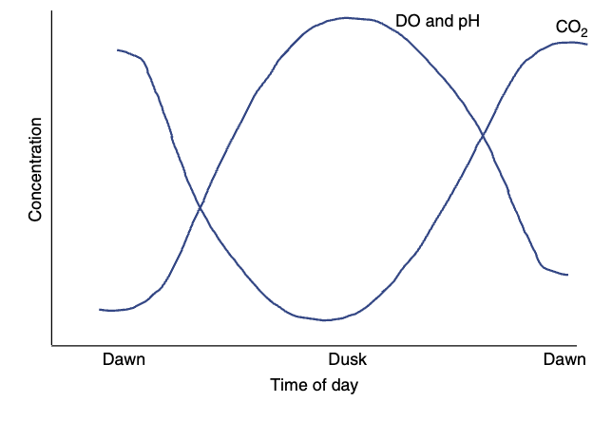
Question 2: An aquarist asks you to examine an Atlantic bigeye (Priacanthus arenatus) with a protruding eye. Visual examination reveals exophthalmia and small gas bubbles within the anterior chamber of the eye. Based on this, you suspect gas supersaturation. Which of the following gases is most likely to be the cause of the supersaturation event?
- Argon
- Carbon dioxide
- Hydrogen
- Oxygen
- Nitrogen
Answer: E. Nitrogen is the least soluble atmospheric gas and most likely to come out of solution. Carbon dioxide can sometimes cause gas bubble disease. Oxygen is unlikely to cause gas bubble disease.
- A large aquarium housing rays and sharks notes that many animals in a single system have begun repeatedly rubbing their rostrums against tank walls, darting, inappetant, and avoidant of one area of the exhibit. Standard water quality testing does not reveal abnormalities. What would be the next most appropriate step to identify the underlying problem?
- Perform a full cation analysis of dissolved minerals
B. Measure dissolved oxygen at multiple tank depths
C. Test for stray voltage using a multimeter probe
D. Perform a coliform count from aquarium surface
E. Assess USG fluctuations over a 24-hour period
Answer: C. Test for stray voltage using a multimeter probe

- Which of the following is true of the Ampullae of Lorenzini?
  - Dorsal and ventral pores are typically symmetric
  - Left and right pores are typically symmetric
  - Benthic elasmobranchs tend to have longer canals
  - Negative (anodal) stimuli increases neural activity
  - Elasmobranchs with keener vision have more pores
Answer: B. Left and right pores are typically symmetric.
- Dorsal and ventral pore distributions typically asymmetric
- Benthic elasmobranchs typically have shorter canals
- Negative stimuli decreases neural activity, conversely positive stimuli increases
- Elasmobranchs with keener vision have fewer pores, and vice versa

pH, Alkalinity, & Hardness
CBS 19 Feb 2026 – Summarized by LMM
Question: You have a tank of Lookdowns that are starting to act erratically. On quick check of the water quality, you immediately note that the pH is 6.5. What should be the next thing that you do in your triage of this situation?
- Immediate 20-30% water change.
- Immediate reduction in stocking density.
- Check the ammonia level.
- Check the alkalinity level.
- Immediately dose with calcium hydroxide.
Answer: D, This represents an inappropriately low pH for a marine fish (normal range 7.5-8.5). Do NOT immediately correct low pH if the ammonia level is high, as an increase in pH increases the amount of ammonia in toxic form. Must check and correct ammonia levels before correcting pH, or risk eliminating fish with ammonia toxicity.

Question: Explain the difference in pH requirements for anemones versus corals.
Answer:
Anemones
- Extreme pH plasticity – can have intracellular pH of 7.4 at night and 8.9 during day, adaptation to intertidal zone
Corals
- Extreme pH stability – natural variability <0.2 across all known reefs, one of the most static features of a reef system, recommend 8.2, minimize diurnal-nocturnal changes as much as possible

