Prevalence of and risk factors associated with atherosclerosis in psittacine birds
Beaufrère H, Ammersbach M, Reavill DR, Garner MM, Heatley JJ, Wakamatsu N, Nevarez JG, Tully TN. J Am Vet Med Assoc. 2013;242(12):1696-1704.

Abstract:
Objective—To estimate the prevalence of clinically relevant atherosclerotic lesions in birds and identify epidemiological variables and illness types associated with development of atherosclerosis.
Design—Retrospective case-control study.
Sample—Records of 7,683 psittacine birds, including 525 with advanced atherosclerosis.
Procedures—5 pathology centers provided databases and access to histopathology slides. Age and sex were collected for all birds of the Amazona, Ara, Cacatua, Nymphicus, and Psittacus genera. Databases were searched for atherosclerosis cases, and slides were reviewed for the presence of type IV through VI atherosclerotic lesions. Results were used to build several multiple logistic models to define the association between advanced atherosclerosis and age, sex, genus, illness type, and specific lesions. Prevalence was reported as a function of age, sex, and genus.
Results—In the first model including 7,683 birds, age, female sex, and the genera Psittacus, Amazona, and Nymphicus were significantly associated with clinically relevant atherosclerosis detected via necropsy. Subsequent models of 1,050 cases revealed further associations with reproductive disease, hepatic disease, and myocardial fibrosis, controlling for age, sex, and genus.
Conclusions and Clinical Relevance—Age, female sex, and 3 genera appeared to be positively associated with the presence of advanced atherosclerotic lesions in psittacine birds. This information may be useful in clinical assessment of the cardiovascular system and patient management. Reproductive diseases were the only potentially modifiable risk factor identified and could be a target for prevention in captive psittacine birds.

Key Points:
- Atherosclerosis: chronic inflammatory fibroproliferative vascular disease, build up of atheromatous materials (inflammatory cells, lipid, Ca, collagen) in luminal aspect of arteries
- Type IV lesion: atheroma, lipid core; type V: fibroatheroma, fibrous cap; type VI: fissures, hematomas, thrombosis
- Study only included type IV-VI lesions in brachiocephalic, pulmonary, carotid, and coronary arteries or aorta (clinically important lesions that may induce clinical signs in humans)
- Psittacines prone to forming spontaneous lesions in large arteries at heart base; prev 1.9-92.4% other studies, prev of 6.8% here
- Psittacus>Amazona>Nymphicus (all had higher prev than psittacines overall); female and older parrots had greater odds of having advanced lesions (male had 69% odds of advanced lesions)
  - Male Japanese quails have inc prevalence of athero when diet induced (not spontaneous athero like here where males w/similar prevalence of females were 4y older than females)
- Birds w/repro or hepatic dz at inc odds of having athero, less robust for hepatic dz than repro
  - Birds w/cardiac degenerative dz at inc odds, but not significant
- Significant inc for odds for myocardial fibrosis w/athero; no association w/ C. psittaci
- Couldn’t assess here, but cholesterol higher in athero parrots in another study, chol and LDL conc increased in response to 1-2% cholesterol feedings and induction of athero in Quakers and budgies (Amazons and greys have inc plasma conc of cholesterol, inc chol when fed high fat diet)

Take Homes:
- Age, female, Psittacus, Nymphicus, and Amazona associated with increased odds of developing clinically important athero lesions; overall prevalence of 6.8%
  - Dramatic inc in risk in birds 20-30yo
  - Different than mammals and humans w/sex: think estrogen protective in mammals but promotes atherogenesis in birds (inc plasma TCa, protein, chol, and trig and hepatic synthesis of vitellogenin and very LDL
- Significant positive association between athero and repro disease, mild positive association with hepatic disease or myocardial fibrosis and athero
  - Repro dz may be modifiable risk factor to lower prevalence
- 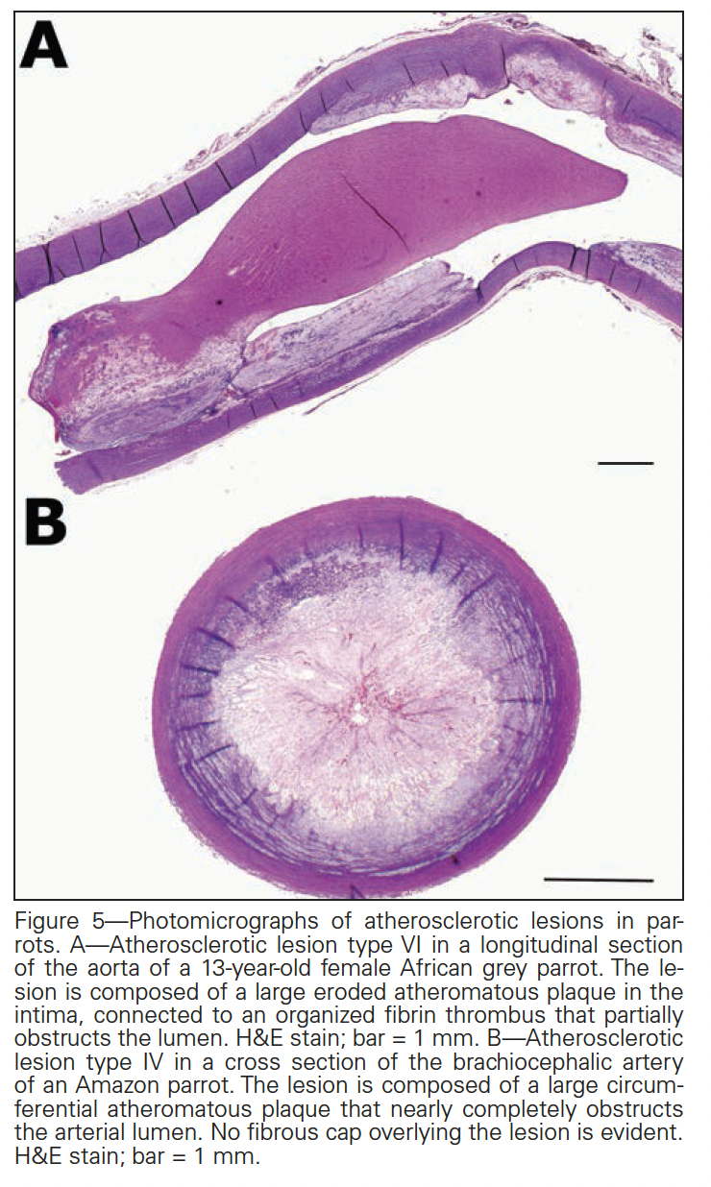
- 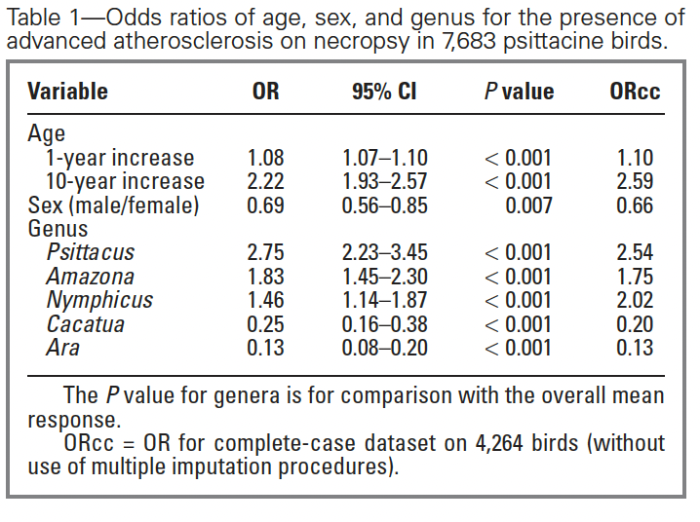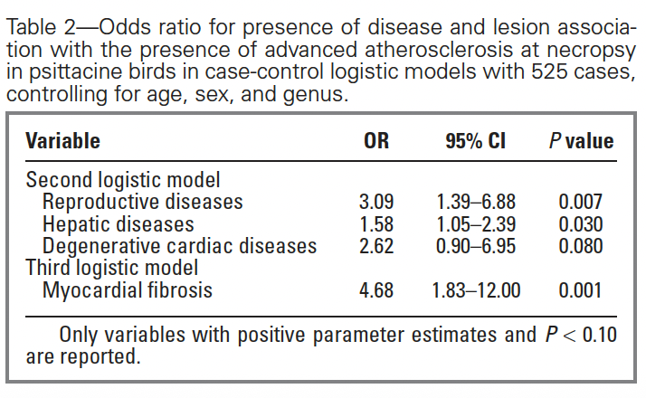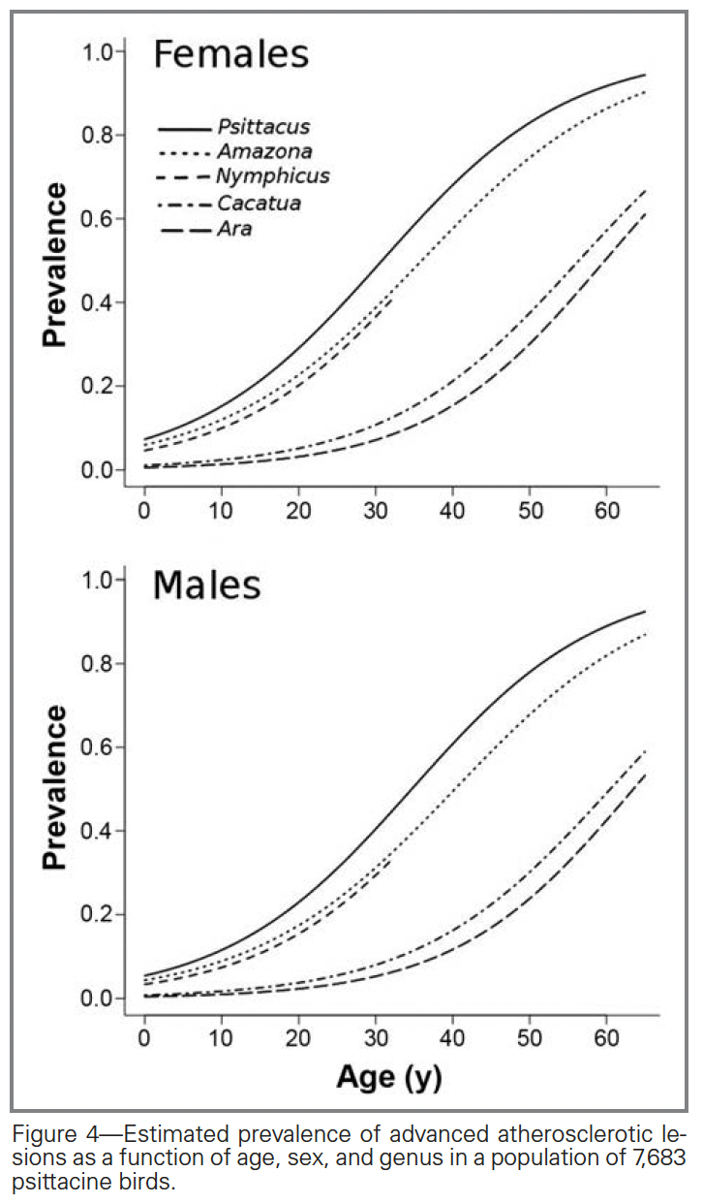
Risk factors for development of foot lesions in captive flamingos (Phoenicopteridae)
Nielsen AMW, Nielsen SS, King CE, Bertelsen MF. J Zoo Wildl Med. 2012;43(4):744-749.

Abstract: Foot lesions are highly prevalent in captive flamingos (Phoenicopterus spp.); however, the etiology of these lesions remains mainly speculative. The objectives of this study were to identify climatic factors (latitude, temperature, and housing) and surface factors influencing the risk of four different types of foot lesions (hyperkeratosis, nodular lesions, papillomatous growths, and fissures) in captive flamingos. The study was based on photos of 445 pairs of flamingo foot soles. Data originating from 337 birds in 10 different zoos were included. The odds of birds having hyperkeratosis, papillomatous growths, and fissures were higher for flamingos living north of the 53rd degree of latitude, for flamingos exposed to a mean temperature of 15C or less during the previous 4 wk, and for birds housed in indoor exhibits for at least 90% of the time during the previous 4 wk (compared to flamingos housed outdoor for at least 90% of the time in the same time period). Concrete-type floors increased the odds of flamingos having hyperkeratosis and fissures. Certain substrates increased the odds of one type of lesion while decreasing the odds of having other lesion types. In conclusion, both climate and substrate appear to affect the odds of developing different types of foot lesions.

Key Points:
- Podo risk factors in poultry: substrate, season, temp, indoor vs. outdoor
- Lesion types: hyperkeratosis, fissures, nodular lesions (NL), papillomatous growths (PG)
- ½ of the areas of the feet had hyperkeratosis, little difference among risk groups
- NL at 0.1-1.5% prevalence; PG 1-22% and fissures 14-29% b/t risk groups
- Lower prevalence of PG, hyperkeratosis, and fissures w/high temp, outdoor environment, and south; no effect of latitude and temp on NL, lower odds of NL if inside
  - Higher prevalence of lesions also seen in chickens in winter
- Lined concrete had higher odds of hyperkeratosis, PG, and fissures but not NLs; bare concrete no effect on NLs or PGs but inc odds of hyperkeratosis and fissures
- Grass inc odds of fissures but decreased odds of NLs; soil inc odds of NLs but decreased odds of fissures and PGs
- Latitude and temp had no significant effect on NLs, so NLs may have different etiology then other lesions

Take Home:
- Lined concrete and grass negatively affected feet which was unexpected
- Increased odds of lesions north of the 53rd latitude, at lower mean temps, and when housed indoors

Lesion | Hyperkeratosis | Nodular lesions | Papillomatous growths | Fissures
Bare concrete | Increase | No effect | No effect | Increase
Lined concrete | Increase | No effect | Increase | Increase
Wet or dry soil | No effect | Increase | Decrease | Decrease
Grass | No effect | Decrease | No effect | Increase
Higher temperature | Decrease | No effect | Decrease | Decrease
Indoor | Increase | Decrease | Increase | Increase
Latitude south of 53rd | Decrease | No effect | Decrease | Decrease

2000 JZWM 31.4
Canine distemper in terrestrial carnivores: a review.
Deem, Sharon L., et al. – summary by MGF

Canine distemper virus is a member of the genus Morbillivirus in the family Paramyxoviridae. Canine distemper has been recorded in domestic dogs for centuries. It is now recognized as a worldwide problem of carnivores and has the second highest fatality rate of any infectious disease, after rabies, in domestic dogs. The importance of this disease in nondomestic animals has become evident with vaccine-induced infections in a variety of species and large-scale epidemics in captive and free-ranging felids. To date, canine distemper has been reported in all families of terrestrial carnivores: Canidae, Felidae, Hyaenidae, Mustelidae, Procyonidae, Ursidae, and Viverridae. Veterinarians, including those working with nondomestic carnivores, should be familiar with the clinical signs, diagnosis, and clinical management of this disease.

Virus Background
- Canine distemper: single-stranded RNA virus; morbillivirus in family Paramyxoviridae
  - Other morbilliviruses: measles in primates, rinderpest in artiodactylids, peste des petits ruminants in small ruminants; phocine distemper virus, cetacean morbillivirus
- Transmission: aerosolization; highly contagious – viral shedding can follow infection for 60-90d
  - Transplacental infection has been documented
  - Usually short lived in env but can survive low temp (14d at 5C) → direct contact/fomite
- Enters respiratory tract → spreads in macrophages via lymphatics to tonsils/bronchial LN → replication 2-4d post infection → within 4-6d spreads to lymphoid organs → 8-9d epithelial and CNS tissues
Clinical Signs/Susceptibility By Species
- Respiratory, GI, integument, CNS most commonly affected across species
- Canidae: up to 70% subclinical; initial transient fever/leukopenia + pneumonia, diarrhea, dehydration, conjunctivitis → 1-3wk later neurologic dz +/- optic dz, myoclonus and hyperkeratosis “hard pads” highly suggestive of CD
- Felidae: reported sporadically; GI, respiratory, CNS dz → seizure = most common and culminated in acute death; those w/ minimal dz had high CDV titers; study with lions in Serengeti most common sign seizures and myoclonus up to half w/ clinical signs died
- Hyaenidae: study showed rise in antibodies w/o clinical signs or increased mortality during period of high domestic dog mortality associated with CD epidemic
- Muselidae: highly susceptible to dz with fatality rate close to 100%; ocular/nasal discharge, diarrhea, anorexia, seizures/myoclonus, severe hyperkeratosis of the foot pads, whole body erythema, chin/groin rash w/ associated pruritus.
- Procyonidae: clinical presentation resemble domestic dogs; cystitis with pyuria common, jaundice often associated; endemic in some North American racoon populations → might be reservoir for nondomestic zoo animals and domestic dogs
- Ursidae: reported in red panda, polar bear, giant panda, grizzly bear, Marsican brown bear (italy), some black bears; different clinical signs: purulent oculonasal discharge, anorexia, diarrhea, ascending paresis, terminal seizures and coma; can be fatal to captive panda and red panda
- Viverridae: binturong and masked palm civet; some vaccine-induced CD in captive binturong; dyspnea, local alopecia, convulsions, diarrhea
Diagnostic Procedures
- Digital, nasal, eyelid hyperkeratosis in infected ferrets/mink highly suggestive
- Jaundice in raccoons, foxes, ferrets
- Absolute lymphopenia, thrombocytopenia, regenerative anemia, decreased albumin, increased alpha and gamma globulins
- May see CDV inclusions in cytoplasm (occasional nuclei) of blood cells, especially lymphocytes
- Can also see inclusion bodies in conjunctival scrapings → but only in acute phase of infection
- Can see interstitial or alveolar lung pattern on rads
- CSF can show increased protein and cell count (predominance of lymphocytes)
  - Increased anti-CDV antibody in CSF is definitive evidence of neurologic CDV infection
- Serum IgM indicates recent CDV infection (unless vaccinated within 3wk of test); IgG can indicate vaccination or infection
- Viral persistence in skin/foot pads lasts 60d, good for immunohistocytochemistry
- Use PCR for antemortem detection
- Postmortem
  - Gross findings: pneumonia, depletion of lymphopoietic organs, hyperkeratosis of nose, foot pads, eyelids → In uncomplicated CDV, only consistent finding = thymic atrophy
  - Histo: hyperkeratosis of nose, foot pads, eyelids; eosinophilic inclusion bodies (mostly cytoplasmic occasional intranuclear in CNS, urinary bladder, bronchial epithelium), interstitial pneumonia, perivascular lymphoplasmacytic infiltration in area of demyelination and neuronal degeneration of CNS; syncytial giant cells in lungs/CNS white matter, anterior uvea, LN
    - Difference: lungs of large felids show diffuse alveolar type 2 cell hyperplasia with intracytoplasmic and intranuclear viral inclusion bodies; brain may lack typical canid pattern of demyelination w/ astrocytosis and vascular cuffing
Clinical Management
- Best prevented by vaccination (modified live CDV from egg-adapted or primate tissue, safer than modified live from canine tissue; reduces vaccine induced infection in non-domestic species)
- USDA-approved Fervac modified live egg-adapted has induced dz in red pandas and anaphylaxis in some mustelids and viverrids → don’t use in these species or other exotic carnivores
- Galaxy-D a modified live vaccine with simian cell substrate has shown promise in nondomestics
- Subunit vaccine may prove useful for phocid distemper virus 1
- Recombinant canarypox-vectored CDV vaccine has proven useful
- Vaccination schedule: between 6-16wk vaccinate every 3-4wk; give an additional vaccine to raccoons at 18-20 wk and after 10 wk in ferrets due to material antibody interference
  - Adults vaccinated twice 3-4wk apart + yearly vaccine boosters in nondomestic species
  - Not recommended to vaccine nondomestic felids

2013 JZWM 44.1
Use of butorphanol during immobilization of free-ranging white rhinoceros (Ceratotherium simum)
Michele Miller, Peter Buss, Jenny Joubert, Nomkhosi Mathebula, Marius Kruger, Laura Martin, Markus Hofmeyr, Francisco Olea-Popelka – summary by MGF

Forty free-ranging white rhinoceros (Ceratotherium simum) were anesthetized with etorphine, azaperone, and hyaluronidase in Kruger National Park, South Africa, between February and August 2009. Eighteen rhinoceros received butorphanol in the dart combination, and 22 rhinoceros had butorphanol administered intravenously within 15 min of darting. Body position, blood gas values, heart rate, respiratory rate, and temperature were measured at two time points after darting, approximately 10 min apart (sample 1 mean collection time after darting, 9.4 ± 2.7 min; sample 2 mean collection time, 18.6 ± 2.8 min). A significant number of field-captured rhinoceros remained standing at the first sample period when butorphanol was administered in the dart. Higher median values for arterial partial pressure of oxygen (PaO2) in combination with lower arterial partial pressure of carbon dioxide (PaCO2) in standing versus recumbent rhinoceros suggested improved ventilation in this posture (P < 0.05). When the effect of time, body position, and age was controlled, median values for respiratory rate, lactate, and pH were better in rhinoceros that received butorphanol in the dart (P < 0.05). There was also a trend toward higher median values for SO2 and bicarbonate in rhinoceros receiving butorphanol in the dart. Intravenous administration of butorphanol resulted in significantly decreased median PaCO2 and heart rate in recumbent rhinoceros (P < 0.05) without changes in PaO2 between sample periods 1 and 2. However, rhinoceros remained hypoxemic during the short anesthetic procedure despite butorphanol administration. Preliminary results suggest that administration of butorphanol (either in the dart or intravenously) improves some metabolic parameters in free-ranging recumbent white rhinoceros without significantly affecting ventilation. It is hypothesized that this may be due to a lighter state of immobilization. Addition of butorphanol to the dart provides handling and physiologic advantages because the majority of rhinoceros remain standing.

Background / Opioid Review
- Butorphanol: partial mu agonist and antagonist, full kappa agonist
  - Partial agonist-antagonist to alleviate some respiratory depressive effects of etorphine through antagonist at mu2 receptor as synergizing sedative/analgesia at kappa receptor
  - Prior to this study had not been used in field settings in rhinos
- Etorphine: mu, delta, and kappa agonist
- Azaperone: dopamine receptor antagonist
- Hyaluronidase: enzyme breaking down hyaluronic acid; allows injected drugs to absorb better
- Mu receptors primarily responsible for respiratory depression + some analgesia; Kappa responsible for sedation and analgesia
Methods
- 22 free-ranging rhinos received etorphine, azaperone, hyaluronidase dart IM then butorphanol IV within 15 min of darting
- 18 rhinos received etorphine, azaperone, hyaluronidase + butorphanol in a dart IM
- Received diprenorphine IV and zuclopenthixol acetate IM after being placed in crate
  - Diprenorphine: mu antagonist, partial delta and kappa antagonist
  - Zuclopenthixol: antipsychotic; dopamine antagonist
Results
- Rhinos receiving butorphanol in dart had longer induction time (6min) compared to those that received butorphanol postimmobilization IV (4.6 min) but there was no difference in distance travelled after dart → no increase likelihood of lactic acidosis/hyperthermia
- Butorphanol in dart group remained standing longer vs IV butorphanol
- Butorphanol in dart had lower lactate, higher respiratory rate and pH compared to butorphanol IV
  - Lower lactate in those darted before IV animals received butorphanol → reduces lactate
- In both groups, heart rate, PaCO₂, and lactate decreased and pH increased between first and second sampling period; trend towards a higher SaO₂ in second sampling period
  - Lower PaCO₂ indicates improved ventilation
- Recumbent rhinos in both groups had lower PaO₂, SaO₂ and higher PaCO₂ compared to standing → better for animal to be standing (suggests using butorphanol in dart better)
Discussion
- High dose opioids minimize potential for hyperthermia, lactic acidosis, capture myopathy but more likely to cause hypoventilation, hypoxemia, decreased tissue oxygenation → often receive partial agonist-antagonists, supplemental O2 to alleviate problems
- Butorphanol causes a milder plane of sedation (even if recumbent can stimulate to stand)

Takeaway: Butorphanol, a partial mu agonist and antagonist and kappa agonist, had a beneficial effect on metabolic parameters in free-ranging rhinos. Adding butorphanol to the dart seemed the best option to minimize metabolic disturbances associated with capture and facilitate longer standing and better ventilation.

Holz, Peter, et al. "The effect of the renal portal system on pharmacokinetic parameters in the red-eared slider (Trachemys scripta elegans)." Journal of Zoo and Wildlife Medicine (1997): 386-393.- reviewed by HSS
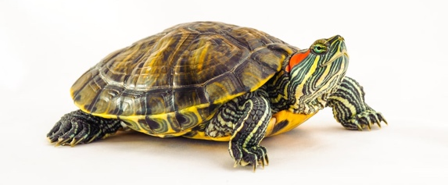
Abstract:

Key Points:
- A renal portal system is present in most fish and all amphibians, reptiles, and birds but is absent in mammals, except embryologically
- Within the kidneys, blood from the tail, HLs, and pelvis percolates through capillaries that surround the proximal and distal convoluted tubules of the nephrons only the "reptilian" nephrons in birds) and then exits into the postcaval vein, which transports it back to the heart
  - Perfuses only the tubule, not the glomeruli
- Can’t produce hypertonic urine due to lack of loop of Henle. When it is necessary to reduce water loss, GFR decreased via arginine vasotocin constriction of afferent glomerular arterioles decreased to absent blood flow through glomeruli. Renal portal system still perfuses tubules to prevent ischemic necrosis
- Venipuncture: hole drilled into plastron under anesthesia, plugged with epoxy, cardiocentesis performed through epoxy plug awake
- For gentamicin site of injection (forelimb vs. hindlimb) was not associated with a significant difference in any of the pharmacokinetic parameters evaluated
- Gentamicin doses of 2.5 mg/kg every 72 hr and 2.3 mg/kg every 72 hr should be used when treating red-eared sliders in the forelimb and hindlimb, respectively
- AUC was significantly lower following injection of carbenicillin in the hindlimb, compared with injection in the forelimb, at 1 hr {P = 0.03), 4 hr {P = 0.02), and 8 hr {P = 0.03) postinjection. No effect on other PK parameters
  - Statistically different, likely not clinically important
- Carbenicillin doses of 115 mg/kg every 24 hr and 120 mg/kg every 24 hr should be used when treating red-eared sliders in the forelimb and hindlimb, respectively
- The major concern regarding toxicity of gentamicin is in the persistence of trough levels above 2 ug/ml, which can lead to renal tubular necrosis
- Drugs excreted by routes other than renal tubular secretion can be administered in FL or HL
- A companion study demonstrated that blood from the caudal body may drain mainly via the abdominal veins, through the liver. This result has theoretical implications for drugs that are excreted predominantly via the liver

Take-Home Message:
- Injection site of gentamicin in red-eared sliders had no effect on any pharmacokinetic parameter. AUC was significantly lower following injection of carbenicillin in the hindlimb, compared with injection in the forelimb, at 1, 4, and 8 hours postinjection. While statistically significant, this finding is unlikely to be clinically significant.

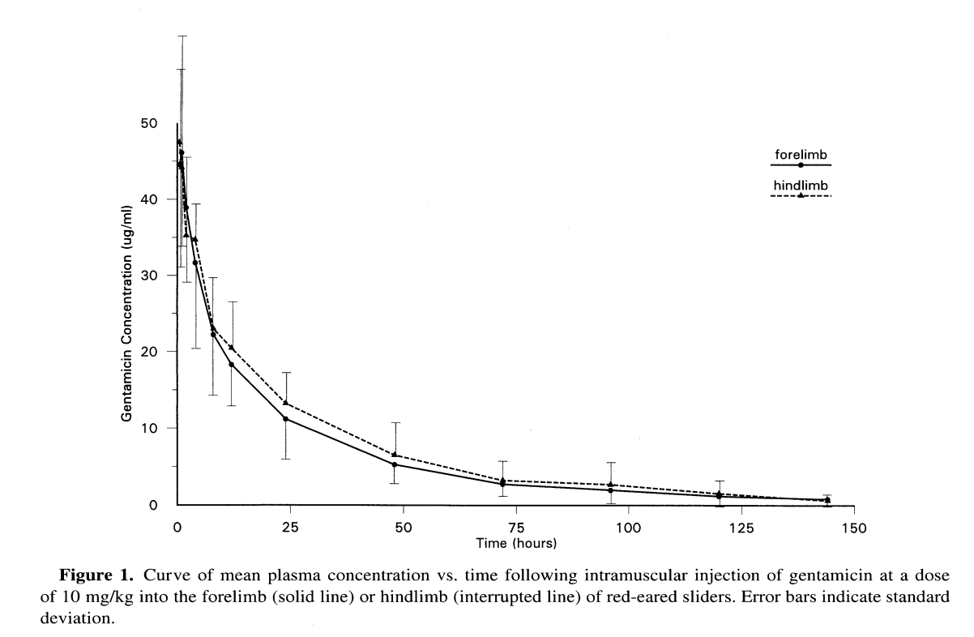
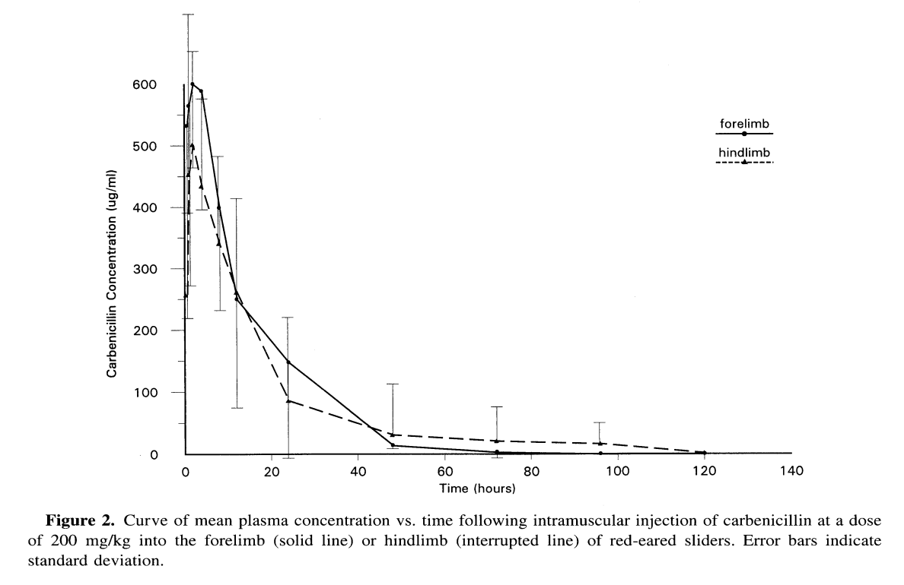
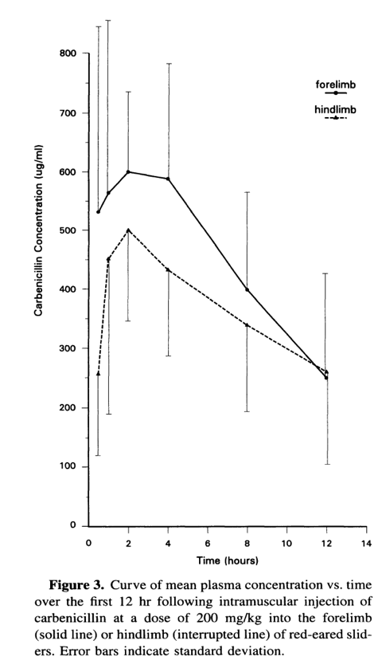

Holz, Peter, et al. "The anatomy and perfusion of the renal portal system in the red-eared slider (Trachemys scripta elegans)." Journal of Zoo and Wildlife Medicine (1997): 378-385.- reviewed by HSS
Abstract:
The anatomy of the renal portal system of the red-eared slider {Trachemys scripta elegans) is described, based on dissection of six double latex-injected specimens (three males, three females). The anatomy of these vessels, which had not previously been described in this species, was found not to differ significantly from the fundamental chelonian pattern. Fluoroscopic radioangiography revealed that venous blood returning from the hindlimbs flowed predominantly to the liver and bypassed the kidneys. Blood from the tail either flowed to the kidneys or bypassed them and flowed directly to the liver. A putative valve is described that governs venous blood flow from the caudal body to or around the kidneys.

Key Points:
- The dorsal coccygeal vein ran cranially over the dorsal aspect of the caudal vertebrae, splitting to form the two circumflex iliac veins, which continued cranially over the dorsal aspect of the left and right gluteal muscles. Shortly after its origin, each circumflex iliac vein received a lateral coccygeal vein, which ran cranially along the dorsolateral aspect of the caudal vertebrae.
- Each of the circumflex iliac veins bifurcated anteriorly. The medial branch formed the iliac vein. This vessel entered the afferent renal portal vein approximately two-thirds of the way caudal to the cranial pole of the kidney.
- The lateral branch of the circumflex iliac vein became the abdominal vein and coursed ventrally to a point just inside the plastron. The two abdominal veins, one from each side, then coursed superficially within the celomic membrane along the internal surface of the plastron, approximately 1 cm on either side of the midline, and entered the liver, one penetrating the right lobe and the other, the left lobe. Within the liver, they connected to the hepatic portal vein.
- As the abdominal veins were traced from their origin toward the liver, numerous veins entered them. The transverse abdominal vein, a vessel linking the two abdominal veins, was visible immediately anterior to the pelvis. The right and left femoral veins entered the celom where the respective hindlegs entered the shell. They ran in the groove formed by the biceps cruris muscle cranially and the semitendinosus and semimembranosus muscles caudally and entered their respective abdominal veins at the point where the latter contacted the plastron. The small ischiatic vein emerged from each femoral vein just caudal to the stifle and continued anteriorly along the caudal aspect of the hind leg. It anastomosed with the ipsilateral circumflex iliac vein, anterior to the origin of the gluteal vein. Cranial and medial to each femoral vein, the crural vein, a small vessel draining the hindlimb, entered the abdominal vein. It ran along the ventral aspect of the hindlimb, resting in the groove created by the sartorius and gracilis muscles anteriorly and the semimembranosus muscle caudally. The paired marginocostal veins coursed anteriorly along the inside of the carapace and entered the lateral aspect of the abdominal veins, cranial to the crural veins. At the point of entry, they are known as epigastric veins. These veins drain blood from the intercostal veins.
- The left and right hypogastric veins entered the caudal pole of the respective kidney. In the male they received blood from the [phallus] medially via the vena cavernosae, which were short veins of large diameter, and laterally from the obturator veins, which had a smaller diameter and drained the muscles of the pelvis. In the female, right and left oviductal veins were present, draining the oviducts into the respective hypogastric veins. These vessels were smaller than the vena cavernosae, their homologues in the male. A narrow gluteal vein carried blood from the circumflex iliac vein over the dorsal surface of the gluteal muscles, medial to the ilium, and then passed ventrally to connect to the respective hypogastric vein on each side. Once in contact with the kidneys, the hypogastric veins are known as the afferent renal portal veins and course along the ventral aspect of each kidney. The cranial end of each afferent renal portal vein received input from the ipsilateral vertebral veins, which originated dorsal to the costal arches.
- Three efferent renal portal veins emerged from the medial aspect of the right kidney. The anterior two were narrow vessels, whereas the third vessel was much larger. Two large efferent renal portal veins emerged from the medial aspect of the left kidney. These five veins fused in the midline to form the postcaval vein. This vein continued anteriorly and dorsally, in the root of the mesentery,traversing the right lobe of the liver, where it received hepatic venous drainage, before emptying into the right atrium of the heart.
- When the paths of the afferent and efferent renal portal veins were traced within each kidney, smaller venules were observed to emerge from these vessels and disappear into the substance of the kidney. However, some of these smaller venules within the kidney connected the two vessels directly, so that blood can flow directly into the efferent renal portal veins from the afferent veins bypassing the nephrons.
- No valve could be observed grossly or with the dissecting microscope within the iliac, circumflex iliac, femoral, and abdominal veins. However, when the vessels were examined histologically, small collagenous intimal projections, measuring 125-150 X 60-130 um and oriented across the direction of blood flow, were seen protruding into the lumen of the abdominal vein at the level of the junction with the femoral vein.
- Following injection of the radiopaque dye into the femoral vein, the bulk of the dye travelled through the femoral vein directly to the abdominal vein and bypassed the kidney. However, a small quantity of dye entered the ischiatic vein, which carried it to the kidney via the circumflex iliac vein. Dye also entered the transverse abdominal vein and flowed into the contralateral abdominal vein
  - Connection between abdominal vein and testes in males
- Once the bolus of dye injected into the femoral vein under constant pressure reached the liver, dye also began to move in a retrograde direction, entering the iliac vein and moving toward the kidney. Under these circumstances, in the male, the dye passed caudally in the afferent renal portal vein, entering the hypogastric vein and then the sinuses of the [phallus]
  - Hepatic resistance to the large volume of dye injected over a relatively short period of time likely caused hypertension in the abdominal vein and femoral vein, forcing dye retrograde toward the kidney via the iliac vein. This was likely not a natural event because the dye initially bypassed the kidney
- When dye was injected into the dorsal coccygeal vein, its path was variable. Blood from the tail either flowed to the kidneys or bypassed them and flowed directly to the liver.
  - In 2 sliders, dye stopped abruptly at the junction of the femoral vein with the abdominal vein and perfused the kidneys. A likely scenario is that a valve in the abdominal vein at this point, when closed, prevented blood from flowing to the anterior part of the abdominal vein. When closed, hydrostatic pressure increases to divert blood flow dorsally, against gravity, into the kidneys.
- The factors controlling this putative valve at the femoral/abdominal vein junction are not known.
  - The renal portal system presumably functions to perfuse the tubule cells during times of water conservation, and closure of the valve would direct more blood to the kidneys
  - Vasotocin has been observed to cause a marked constriction of the afferent arterioles, resulting in a cessation of blood flow through glomeruli
  - Vasotocin may act on the valve in the abdominal vein, causing it to close and force blood through the kidneys. Alternatively, the mechanism of control may be similar to that in birds, where adrenaline causes the valve to open [diverting blood around the kidneys] and acetylcholine causes it to close.

Take-Home Message:
- Blood from the caudal regions of the reptilian body does not necessarily flow directly to the kidneys through the renal portal system. Instead, there is a mechanism that appears to regulate blood flow through or around the kidneys under various circumstances. Because much of the blood draining from the caudal portion of the body perfuses the liver, in addition to, or instead of, the kidneys, the impact of hepatic metabolism at first pass on drugs injected into the posterior body of reptiles must be considered, in addition to the effects of renal perfusion

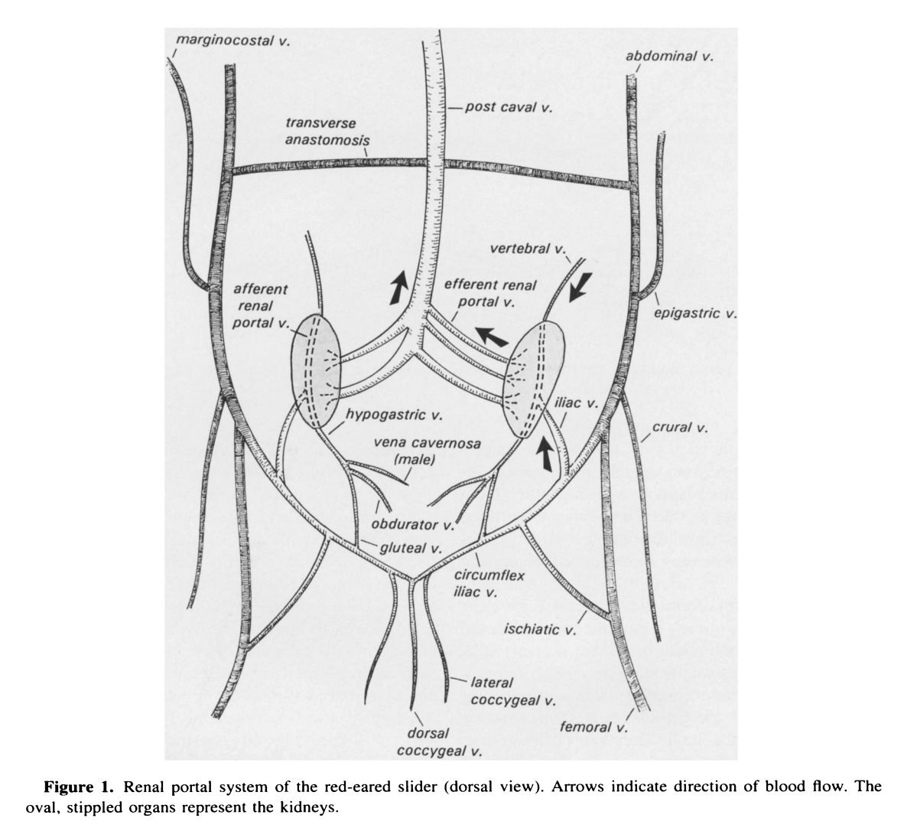
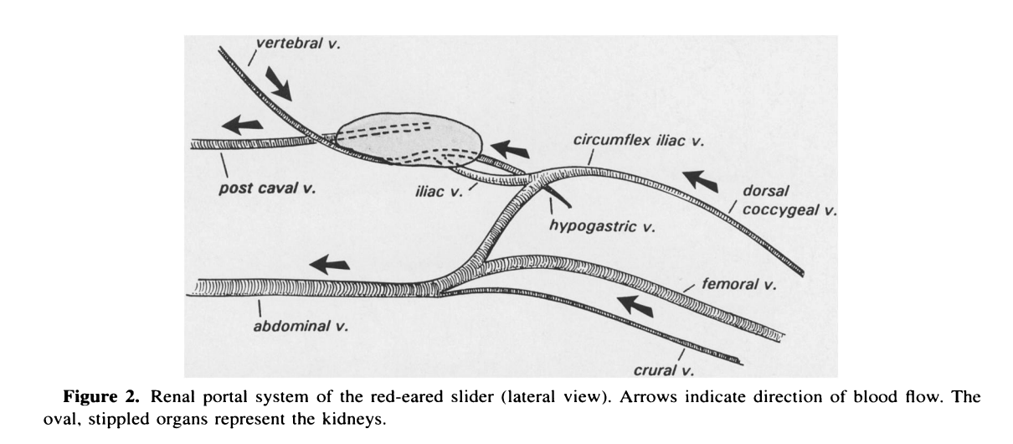
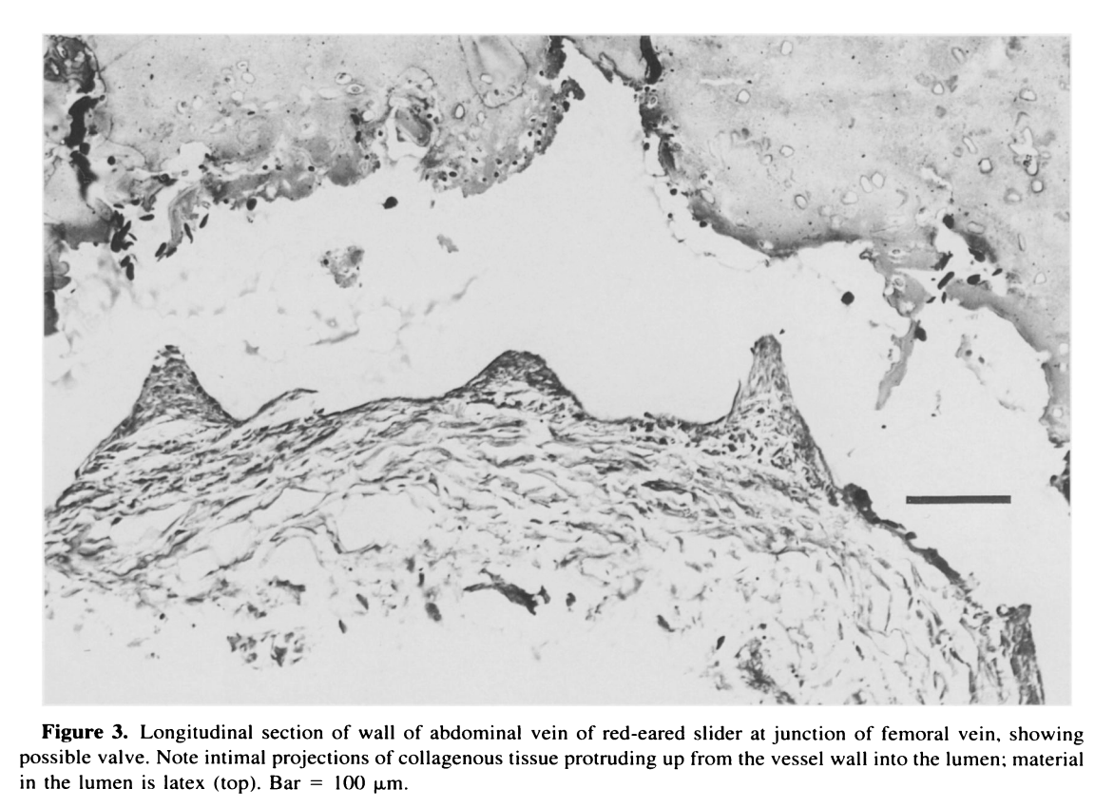
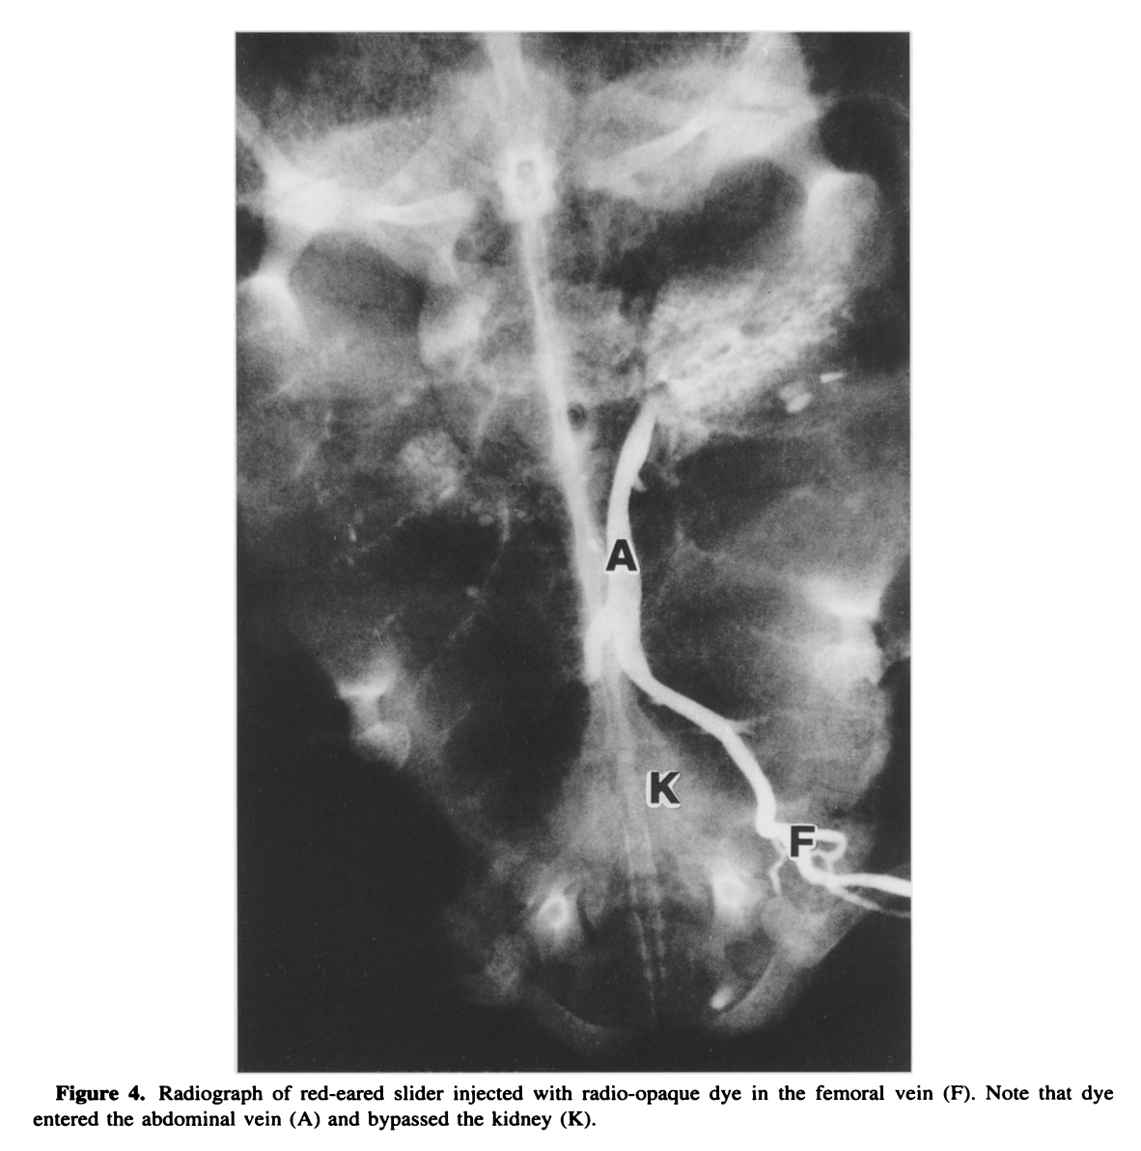
Vet Pathol 39:419–427 (2002)
Summarized by MR

Endometrial Hyperplasia and Mineralization in Zoo Felids Treated with Melengestrol Acetate Contraceptives
L. MUNSON, I. A. GARDNER, R. J. MASON, L. M. CHASSY, AND U. S. SEAL

Abstract: Melengestrol acetate (MGA) contraceptives are widely used in zoo felids to regulate fertility and may have deleterious effects on endometrial health. To determine whether MGA exposure was associated with endometrial disease, the genital tracts of 212 zoo felids (99 MGA treated and 113 control) representing 23 species were evaluated. Adenomatous and cystic hyperplasia were prevalent in both MGA-treated (85%) and control (61%) groups, and the risk of developing these lesions increased with age. Treatment with MGA further increased the risk of developing advanced hyperplasia regardless of dose, and treatment for >72 months significantly elevated that risk, whereas parous animals had a lower risk. Endometrial polyps, fibrosis, adenomyosis, and hydrometra occurred in both MGA-treated and control animals. MGA treatment was associated with an increased risk of hydrometra and mineralization but not of adenomyosis, polyps, or fibrosis after adjusting for advanced hyperplasia. Acute or chronic endometritis were associated with advanced hyperplasia but not with MGA treatment. These results indicate that proliferative and inflammatory endometrial lesions are common spontaneous diseases in zoo cats, and MGA contraceptives increase the risk of some diseases. The association of MGA with endometrial lesions that could impair fertility should be considered when using this contraceptive in genetically valuable felids.

Background:
- MGA implants provide sufficient concentrations to prevent pregnancy for 2 yrs in a majority of treated cats
- At the time of publishing, treatment for >4yrs was common with long-term exposure unstudied in non-domestic felids
- MGA is associated with endometrial hyperplasia and pyometra in domestic cats

Summary:
- Case control retrospective: 1988 – 1995: repro tracts from 212 felids housed in zoos; 99 MGA, 113 control, variable parity and wide species diversity within and outside of Panthera spp.
- L. Munson examined all repro tracts, blinded to demographic info
- Logistic regression modeling with odds ratios, as well as pairwise associations
- Most prevalent lesion was endometrial hyperplasia across groups (G1 – 3 in 72% of felds)
  - Represented across taxa except for in Felis spp., of which were represented by only a few young animals
- MGA-treated felids had a more than three- fold higher odds (OR = 3.6, 95% CI = 1.8–7.4) of EH and about a sevenfold higher odds (OR = 7.2, 95% CI = 3.8–14.4) of advanced EH than did control felids.
  - Younger occurrence in the MGA treatment group
- MGA treatment and age were associated with increased risk
- Parity associated with decreased risk
- Felid species group (big or other) was not a risk factor for advanced EH (OR = 0.82, 95% CI = 0.38–1.74) after accounting for MGA treatment status, age, and parity.
- Neither tertiary follicles nor CL were significant risk factors for advanced EH after MGA treatment, age, and parity were included in logistic models.
- Treatment duration was associated with advanced EH, but once duration was in the model, dose (either as categories or as a continuous variable), treatment constancy, parity, age, and cat group were not significant variables.
  - Only animals in the >72-month category had significantly elevated risk of developing advanced EH
  - Lack of dose effects suggest even low doses may be deleterious
- Polyps were highly associated with advanced EH (OR = 8.5), whereas hydrometra/mucometra were associated with MGA exposure (OR = 4.8)
- The distribution of mineral was regional or diffuse and was remarkably severe in some felids.
- Nonsuppurative endometritis and advanced EH were significantly associated (OR 3.9), and neutrophilic endometritis and advanced EH were less so (OR 2.8). There was no effect of parity or MGA treatment on inflammation.
  - In zoo felids, endogenous estrogens from ongoing folliculogenesis (that was not suppressed by MGA treatment) may sustain adequate uterine tone and minimized endometrial secretions, thereby limiting the development of pyometra.
  - other lesions such as polyps and endometritis were not directly linked to MGA exposure, their association with advanced hyperplasia make their occurrence in MGA-treated animals likely

Take Home Points:
- MGA- treated felids had 3x higher odds of EH and 7x higher odds of advanced EH
  - EH lesions occur in Felidae, but are exacerbated/accelerated by use of MGA
- ‘Use it or lose it’: parity associated with decreased risk, age and contraception increased risk
- Prolonged contraception (>72-mo) with MGA in Felidae is contraindicated
- Pyometra was not ultimately MGA-associated

Histopath Images are excellent, but in black and white. Terio (2026):

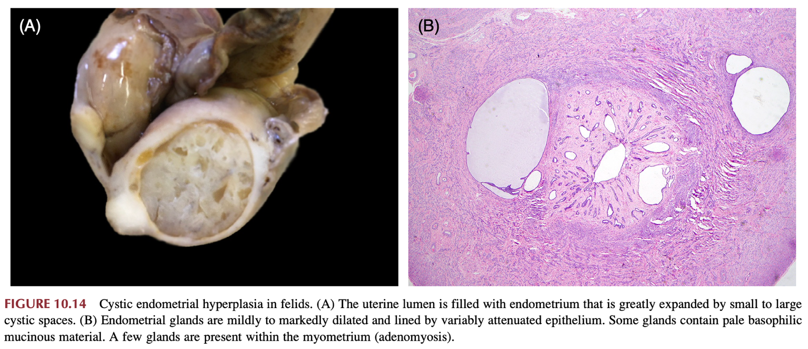
Terio: “The pathogenesis of MGA-associated EH is unclear; however, exposure of estrogen primed endometrium to prolonged progestins, the latter inducing secretory differentiation of epithelial cells, is suspected.”
- Key takeaways in terio are consistent with the take home points of this paper, particularly the bolded points.

Journal of Zoo and Wildlife Medicine 39(4): 517–526, 2008
Summarized by MR

CONCEPTS AND ISSUES WITH INTERSPECIES SCALING IN ZOOLOGICAL PHARMACOLOGY
Robert P. Hunter, M.S., Ph.D., and Ramiro Isaza, D.V.M., M.S., Dipl. A.C.Z.M.

Abstract: Zoologic medicine practitioners take approved agents (veterinary or human) and extrapolate their use to nonapproved species. The decision on dose, duration, and interval is often made with limited species-specific pharmacokinetic information. Because of the monetary value of these animals or their status as endangered species, this method of ‘‘trial and error’’ for therapeutic dosage selection is inappropriate. In zoologic medicine, various methods have been used in an attempt to extrapolate or predict safe and effective dosage regimens. The simplest and typical method of extrapolating a dosage to a nondomestic species is to use a mg/kg dose established for another domestic species or humans. However, this calculation results in a linear increase in the amount of drug administered as body weight increases. Although common, this method tends to overdose large animals and underdose small animals. The second method is similar, except that it takes the approved dose in a specific species and makes an additional assumption that links the dosage to a physiologic function or anatomic feature. Examples are the use of basal metabolic rate or body-surface area as the basis for dosage extrapolation. Allometric scaling of pharmacokinetic parameters is the final method of dosage extrapolation between species. This is commonly used in the pharmaceutical industry to establish the first dosage in human drug investigations. Adaptation of this method for zoologic medicine may enhance our ability to estimate therapeutic dosages for nondomestic species. This review discusses and compares these three methods for dosage selection and provides examples of extrapolation from the literature.

Background:
- Vital Energetics by Benedict (first comprehensive discussion) - basal metabolic rate could be allometrically scaled and does not scale linearly with respect to body mass
- Various physiologic processes, such as heart rate, blood volume, and glomerular filtration rate, can be predicted reasonably accurately for a wide variety of species
- It can be reasoned that, because drugs are ultimately regulated by physiologic functions, pharmacokinetic parameters and ultimately dosages would also follow a similar allometric scaling trend relative to body weight.

Methods of Scaling Drugs:
- Linear extrapolation – use of a single mg/kg dose established for one species applied across all species so that the total amount of drug increases linearly as body weight increases
  - For any given drug, a combo of PK and efficacy (PD/safety) studies are then used to obtain a dose/approved label claim
  - Cons: this assumes that species-specific PK/PD differences are not clinically relevant
  - Cons: tends to overdose large animals and underdose small animals
- Metabolic scaling – ratio of a known physiologic process (metabolic rate or BSA) of two species to estimate a dosage in a species in which there is limited PK data.
  - Forces an allometric (log-log) relationship, usually with an exponent of 0.6-0.8
  - Cons: this ALSO assumes that species-specific PK/PD differences are not clinically relevant, oversimplifies relationship between metabolic rate and PK
  - This method does however solve the second problem presented by #1 - provides a relatively smaller dose for the large animal and a higher dose for a small animal
- Sedgwick’s dosage extrapolation method (a common type of metabolic scaling used in zoo, a computer program exists) – all species are placed into one of the below Hainsworth energy groups for calculation
  - Hainsworth’s energy groups: passerine birds, non-passerine birds, placental mammals, marsupial mammals, or reptiles [predetermined K values used]
  - Then, each species can have a specific minimum energy constant (SMEC) calculated
  - A ratio of the target species SMEC to SMEC of a safe, effective dose in a known species is calculated
  - The article cites several instances in zoo in which this method has failed – citations are PK studies and descriptions of limitations in which presumably: the method was likely used to calculate a dose which then that dose did not have an appropriate PK profile… but I did not read the 4 primary references and the article does not go into further detail
  - This is not used in companion animal medicine or human medicine, and little validation of this method
- Allometric scaling - measure a pharmacokinetic parameter in multiple species and then to the plot the data against weight to derive a new allometric equation that can be used to estimate the pharmacokinetic parameter in an unknown species
  - Cons: this ALSO assumes that species-specific PK/PD differences are not clinically relevant, ALSO that PK have nonlinear relationship to weight
  - Novel: PK parameters, not simply the dosage, are allometrically scalable
  - ***Method of choice for interspecies extrapolation in the discovery and development of human pharmaceutical agents – specifically for selecting the first dose, typically using 3-5 species such as rodent, beagle, nonhuman primate
  - Standard allometric equation: Y = a(W)b
  - “The remainder of this article assumes this method is superior”

Practical Considerations when scaling between species:
- Assumes that the relationship between clearance and body weight is best described by an equation with a single slope and intercept
- Correlation coefficient? Even if the relationship is linear, a change in the slope of the line can occur by altering the weight range of the animal species
- allometry functions under the assumption that the variability of the pharmacokinetic parameter is identical across animal species
- Inclusion of at least one large animal can improve predictions, but the feasibility of this may impede research
- Drugs that have blood-flow–dependent clearance [GFR!] with limited hepatic metabolism seem to be the best candidates for allometric scaling – not all drugs are good candidates for scaling
  - ex. enrofloxacin as bad candidate due to hepatic metabolism, ketoprofen as a bad candidate because of enantiomer PK
  - ex. gentamicin as a good candidate because of GFR clearance
- The potential of toxic or undesirable drug effects is a contraindication for allometric scaling (ex of linear extrapolation of 0.2mg/kg to tortoises, despite dose being appropriate in many mammals)
Take Home Points (for the clinician):
- Allometric scaling is considered gold standard for new human drugs, specifically for the first dose
- What is allometric scaling? To measure a pharmacokinetic parameter in multiple species (example, for human allometric scaling they may use a rodent, a beagle, and a non-human primate in a lab setting) and then to the plot the data against weight to derive a new allometric equation that can be used to estimate the pharmacokinetic parameter in an unknown species
  - Drugs that have blood-flow–dependent clearance with limited hepatic metabolism seem to be the best candidates for allometric scaling
- There are many, many assumptions made no matter what method you use to determine a novel dose
- Not all drugs are good candidates for scaling due to features about their mechanism of action or their clearance

Journal of the American Veterinary Medical Association, 2010, 237(4): 429-436.
RISK FACTORS ASSOCIATED WITH CATARACTS AND LENS LUXATIONS IN CAPTIVE PINNIPEDS IN THE UNITED STATES AND THE BAHAMAS
Colitz et al. – Summarized by LMM
Abstract:
Objective—To determine risk factors for lens luxation and cataracts in captive pinnipeds in the United States and the Bahamas.
Design—Cross-sectional study.
Animals—111 pinnipeds (99 California sea lions [Zalophus californianus], 10 harbor seals [Phoca vitulina], and 2 walruses [Odobenus rosmarus]) from 9 facilities.
Procedures—Eyes of each pinniped were examined by a veterinary ophthalmologist for the presence of cataracts or lens luxations and photographed. Information detailing husbandry practices, history, and facilities was collected with a questionnaire, and descriptive statistical analyses were performed for continuous and categorical variables. Odds ratios and associated 95% confidence intervals were estimated from the final model.
Results—Risk factors for lens luxation, cataracts, or both included age ≥ 15 years, history of fighting, history of ocular disease, and insufficient access to shade.
Conclusions and Clinical Relevance—Diseases of the lens commonly affect captive pinnipeds. Access to UV-protective shade, early identification and medical management of ocular diseases, and prevention of fighting can limit the frequency or severity of lens-related disease in this population. An extended life span may result from captivity, but this also allows development of pathological changes associated with aging, including cataracts.

Key Points:
- Diseases of the cornea and lens are common in captive pinnipeds
- Environmental factors including water quality and salinity, light intensity, nutrition, and spatial characteristics (e.g. orientation of sun on wet and dry areas, depth, exhibit surface color [for reflected light], and animal loading per cubic meter [because of potential water-quality effects])
- Based on literature (Dunn et al IAAAM proceedings 1996), most captive pinnipeds are housed in saltwater rather than freshwater
- Major Findings
  - Pinnipeds in the following groups were significantly more likely to develop lens luxation, cataracts, or both
    - >/= 15 yo
      - Note: No pinnipeds <5 yo had cataracts and 100% of pinnipeds >26 had cataracts
    - History of fighting
      - Note: Neutered males had highest incidence of fighting (as compared to intact males, and intact females)
    - History of ocular disease
      - Particularly pinniped keratitis but other diseases as well
    - No access to shade (10x more likely to develop disease)
- Cataracts occur during aging in all species. Exact pathogenesis unknown but some contributing factors:
  - Oxidation of protein residues such as glutathione (an imp endogenous antioxidant)
  - Denaturation and aggregation of soluble lens proteins including crystallins
  - Protein cross-linking
  - High amount of cholesterol in lens fiber cell membranes, which increases rigidity
- Cataracts occur with excess UV exposure. Further details:
  - UV-B and UV-A target lens epithelial cells and can cause DNA damage, decrease antioxidants, and lead to lipid peroxidation and cross-linking of lens proteins; Overall, exposure to UV-A and UV-B is cataractogenic
- Note: Cataracts in pinnipeds are typically slightly or obviously brunescent (i.e. characterized by amber discoloration of the lens) likely secondary to photooxidation of lens proteins
- Pinniped lenses held in place by zonules as well as direct attachment to ciliary processes; UV exposure increases matrix metalloproteinases (MMP) that can cause degradation of zonularlike, fibrillin-rich structures that adhere the ciliary processes to the lens, resulting in lens instability and eventual luxation
- Adaptation Note: To maximize vision sensitivity under low light, pinnipeds evolved with large eyes, a highly developed tapetum lucidium, large ganglion cells, and a predominance of rods in the retina.

Take Home Point: Risk factors for development of lens luxation, cataracts, or both among captive pinnipeds include increasing age, insufficient access to shade, history of fighting, and history of ocular disease.

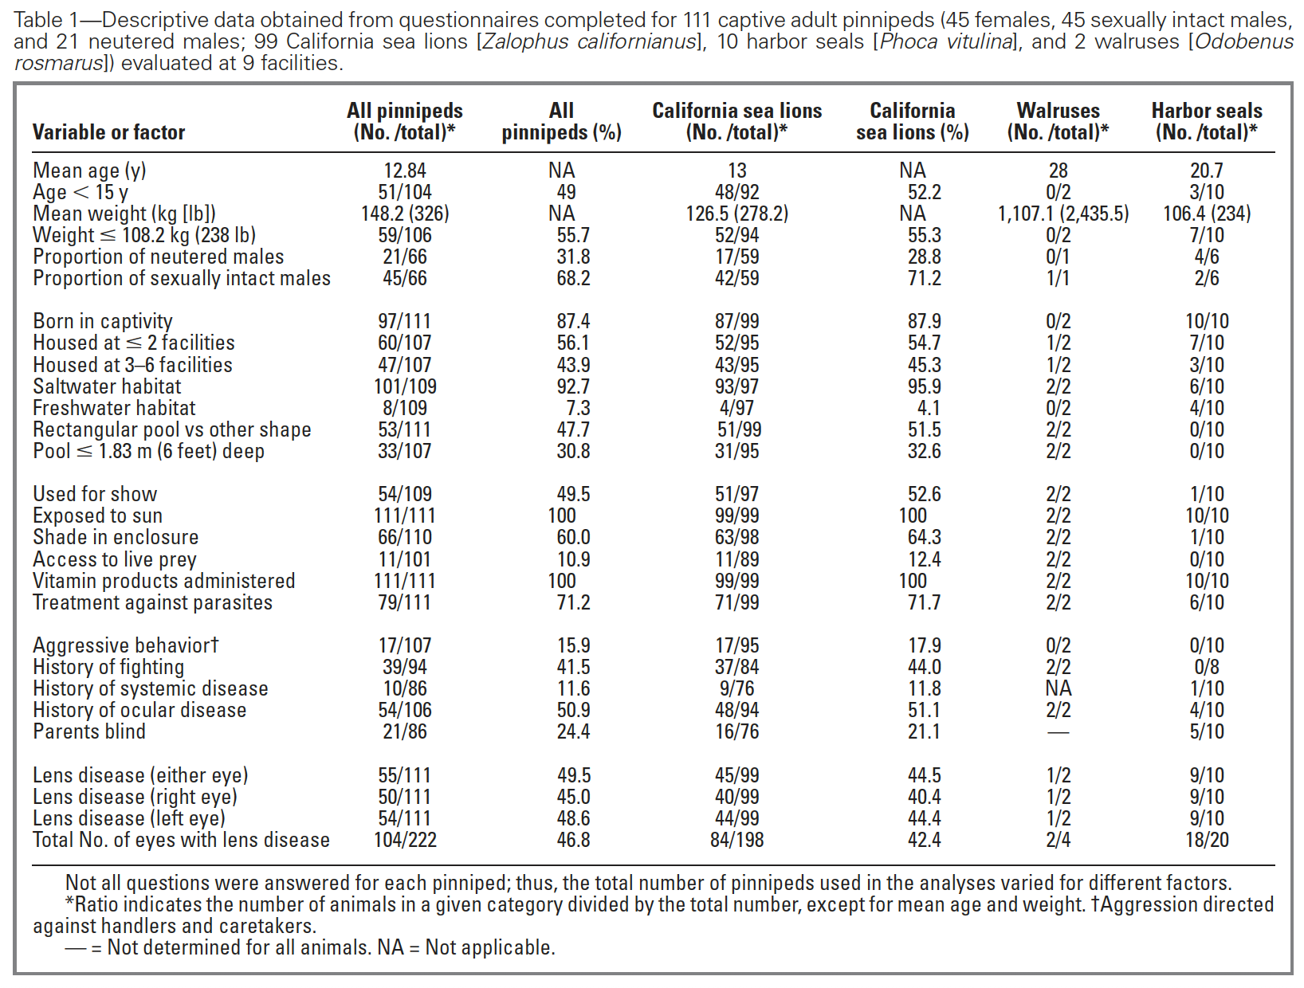
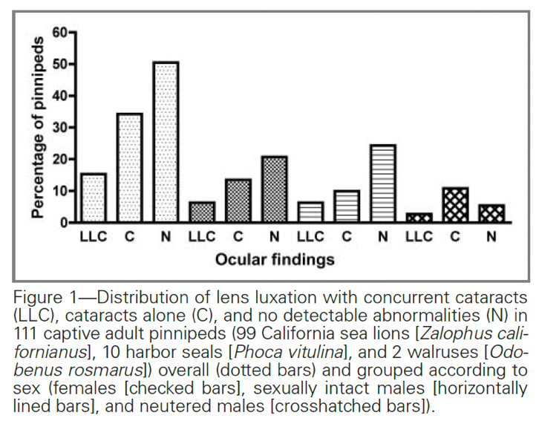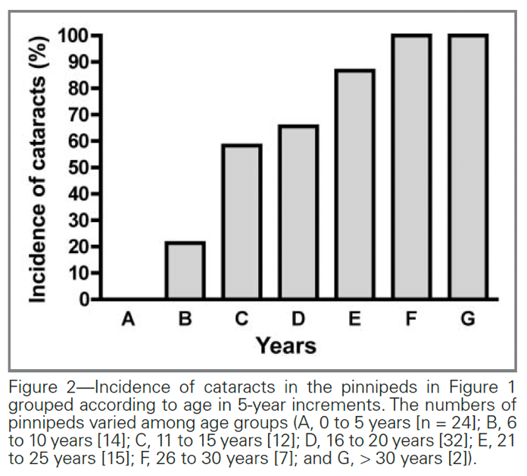
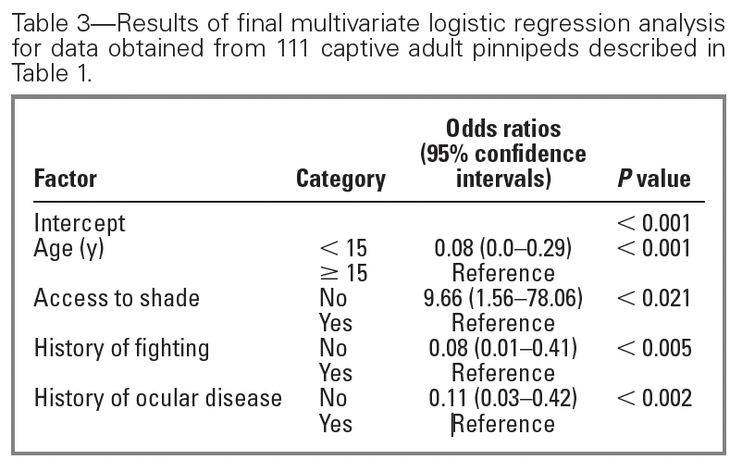

Journal of Wildlife Diseases, 2014, 50(1): 63-73.
LOW-RESIDUE EUTHANASIA OF STRANDED MYSTICETES
Harms et al. – Summarized by LMM

Abstract: Euthanasia of stranded large whales poses logistic, safety, pharmaceutical, delivery, public relations, and disposal challenges. Reasonable arguments may be made for allowing a stranded whale to expire naturally. However, slow cardiovascular collapse from gravitational effects outside of neutral buoyancy, often combined with severely debilitating conditions, motivate humane efforts to end the animal's suffering. The size of the animal and prevailing environmental conditions often pose safety concerns for stranding personnel, which take priority over other considerations. When considering chemical euthanasia, the size of the animal also necessitates large quantities of euthanasia agents. Drug residues are a concern for relay toxicity to scavengers, particularly for pentobarbital-containing euthanasia solutions. Pentobarbital is also an environmental concern because of its stability and long persistence in aquatic environments. We describe a euthanasia technique for stranded mysticetes using readily available, relatively inexpensive, preanesthetic and anesthetic drugs (midazolam, acepromazine, xylazine) followed by saturated KCl delivered via custom-made needles and a low-cost, basic, pressurized canister. This method provides effective euthanasia while moderating personnel exposure to hazardous situations and minimizing drug residues of concern for relay toxicity.

Key Points:
- Large, stranded whales that are not euthanized often experience slow cardiovascular collapse, severe skin blistering, live animal scavenging, hyperthermia, distress, or serious injury – for these reasons, finding humane way to end suffering is warranted
- Euthanasia Options:
  - Ideal is anesthetic drug combination (midazolam, acepromazine, xylazine) followed by intracardiac KCl
    - Midazolam and acepromazine had negligible residues in whale carcasses and do not present a concern for scavengers
    - Xylazine did leave a notable residue and authors recommend trimming out xylazine injection site and removing from beach for scavenger safety
    - Note: If alpha-2 agonist given prior to midazolam and acepromazine, an excitement phase has been seen (dangerous to those working on the whale), so it should always be given second or third in a staged protocol (example: midazolam IM, wait ~20 min, acepromazine IM, wait ~20 min, then give xylazine)
  - Relay toxicity is a concern for scavengers, particularly when using pentobarbital-containing euthanasia solutions
    - Pentobarbital is stable and persistent in aquatic environments
  - Ballistics are an option but not recommended for larger cetaceans
  - Explosives can be used and this has been a refined method in Australia but this method can be dangerous, requires specialized training, and access to explosives…in addition, it is not well-accepted publicly
  - Exsanguination can be used but only as an adjunct in an unconscious animal, not as a sole method (unless humane killing is the best option – see details on that in next bullet point)
- Note: Free-ranging wildlife field conditions do not always permit true euthanasia, and humane killing may be necessary (example: one of the cases in this series the animal had been stranded 3 days and drugs were no longer available and would not be attainable for at least another 1-2 days, the decision to exsanguinate the animal was made as it would be a quicker and more humane death than waiting – this would be considered “humane killing”

Take Home Point: The ideal method of euthanasia for large whales includes general anesthetic IM injections staged over time (midazolam, then acepromazine, then xylazine) followed by intracardiac injection with concentrated KCl using a specially designed needle.

