Plasma concentrations of amikacin during clincal use in Kemp’s Ridley sea turtles (Lepidochelys kempii)
Joblon MJ, Papich MG, Peloquin CA, Kennedy A, Tuxbury KA, Innis CJ. J Herpetol Med Surg. 2025;35(4):242-248.

What was a main complicating factor for dosing amikacin at 5 mg/kg intramuscularly in Kemp’s Ridley sea turtles?
Answer: Highly variable plasma concentrations were noted as some sea turtles had a max concentration before 0.5h, some had max concentrations at other time points, and some had low plasma concentrations at every time point.

Pharmacokinetics of metronidazole in green (Chelonia mydas), loggerhead (Caretta caretta), and Kemp’s ridley (Lepidochelys kempii) sea turtles after single oral and intravenous doses
Norton TM, Cox S, Manire CA, Zirkelbach B, Morrison I, Overmeyer R, Stowell S, Adelman L, Buttrey S, Marcialis T, Polyak MMR, Clark S, Gamby J, Hardman A, Gilbert I, Breshears K, Chadam M, Crowder W, Mirowski E, Hoover S, Page A. J Zoo Wildl Med. 2024;55(4):1049-1055.

Which of the following was noted to be a side effect with metronidazole administration when given intravenously at 20 mg/kg in loggerhead sea turtles (Caretta caretta)?
- Peripheral tremors
- Elevated liver enzymes
- Gastrointestinal upset
- Anorexia
- Circling

Answer: A. Peripheral tremors in the pectoral flippers were noted with IV administration over 30 minutes but not noted with IV administration over 40 minutes. Elevated liver enzymes has been reported in reptiles but not reported in loggerheads (per this study). No other side effects were noted, though metronidazole is excreted in the feces

Strobel, Megan M., et al. "Trismus in cold-stunned Kemp's ridley (Lepidochelys kempii) and loggerhead (Caretta caretta) sea turtles." American Journal of Veterinary Research 1.aop (2024): 1-10. - reviewed by HSS
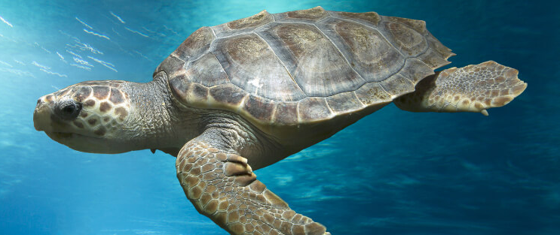

Question:
Two weeks following initial presentation, you evaluate a cold-stunned Kemp’s ridley sea turtle for difficulty eating. On physical examination, this animal cannot open its jaw > 1cm. This animal is currently being treated with parenteral antibiotics (ceftazidime) for pneumonia, which was diagnosed radiographically. Blood work reveals a mild heterophilic and monocytic leukocytosis as well as marked elevations in CK, AST, and LDH. CT scan reveals myositis of the dorsal cervical muscles. Provide a potential treatment plan for this animal including your rationale for implementing each treatment.

Answer: Based on physical examination and diagnostics, you diagnose this animal with trismus secondary to cervical myositis. This is a rare but reported disease in cold-stunned sea turtles. The etiology is unknown, but an infectious component is possible, so you continue antibiotics. As NSAIDs have not been shown to have a significant clinical effect in these patients, you elect to administer an intralesional steroid injection guided by the CT scan. You also begin vitamin E for muscular support against oxidative stress. As this turtle is not eating well, you continue subcutaneous fluid therapy to prevent dehydration. If necessary, tube feeding or total parenteral nutrition could be provided to supplement nutrition and treat hypoproteinemia secondary to anorexia. Finally, you initiate interventional therapies including acupuncture and physical therapy; while not well-studied in sea turtles, these therapies were well-tolerated and appeared to have clinical benefit in a recent case series on trismus in cold-stunned sea turtles.

Anton, Brian J., et al. "DIAGNOSIS AND MANAGEMENT OF NONTUBERCULOUS MYCOBACTERIAL INFECTIONS IN COLD-STUNNED KEMP'S RIDLEY SEA TURTLES (LEPIDOCHELYS KEMPII): 16 CASES (2008–2023)." Journal of Zoo and Wildlife Medicine 56.4 (2025): 790-803. - reviewed by HSS
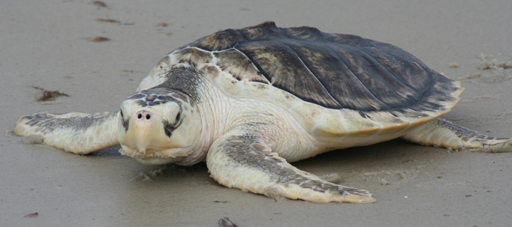

Question:
You perform a bronchoalveolar lavage on a cold-stunned Kemp’s ridley sea turtle with radiographic evidence of pneumonia. You obtain the following cytologic images from the sample using Ziehl-Neelsen stain. What is the most likely etiologic agent, what is your proposed treatment, and what is the prognosis with treatment?

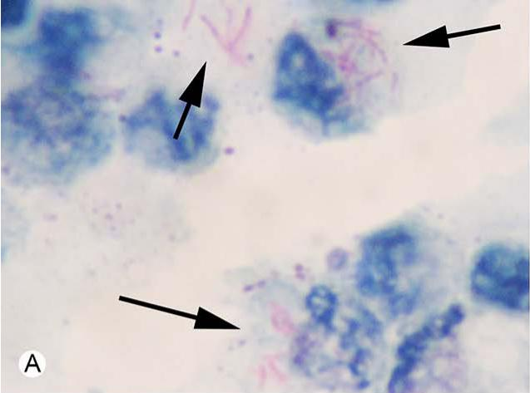

Answer: The cytology shows extracellular and phagocytized acid-fast bacilli, which is most consistent with mycobacteriosis. Non-tuberculin mycobacteriosis caused by M. chelonae is most likely. If treatment is pursued, animal should be treated with multimodal antibiotic therapy including tobramycin or amikacin and an additional antimicrobial agent, such as enrofloxacin, for a minimum of 3 months. In a recent retrospective review, the majority of cold-stunned Kemp’s ridley sea turtles treated for NTM survived to release.

2024 JZWM 54.4
Retrospective analysis of blood cultures and their association with clinical findings and outcome in green sea turtles (Chelonia mydas) at a Florida sea turtle rehabilitation facility, 2017–2020
Glassman et al

Question
In a retrospective study evaluating blood cultures in rehabilitated green sea turtles, which of the following is correct?
a) The majority of animals had positive blood cultures on intake into rehab
b) There were greater odds of positive culture if external injury was present
c) Positive culture animals had higher white blood cell counts but lower lymphocytes and total protein
d) There were no differences in days to natural death, euthanasia, release between positive and negative cultures
e) There were no differences in percentage of turtles released between positive and negative turtles

Answer: B; A - only 24% had positive cultures (26 different isolates cultured with most common: Vibrio alginolyticus, Shewanella algae, Achromobacter xylosoxidans, Photobacterium damselae, Sphingomonoas paucimobilis, Vibrio parahaemolyticus + one fungal species identified: Candida inconspicua; C - lower WBC, lymphocytes, monocytes, TP, albumin and globulins; D - almost all true but positive animals were more likely to die in rehab from natural death compared to negative, no difference in days to death, euthanasia, release; E - fewer positive turtles released than negative turtles

2024 JZWM 55.3
Aerobic blood cultures and comparison to clinical findings of free-ranging green turtles (Chelonia mydas) in east central Florida.
Glassman et al

Question
In a study evaluating blood cultures in green sea turtles (Chelonia mydas) which of the following was associated with positive blood cultures?
- Skin culture
- Fibropapillomatosis
- Non-healed traumatic injuries
- Time of collection
- Barnacles
Answer: A - sea turtles were 5.83 times more likely to have positive blood cultures if they also had a positive skin culture. However there were no other associations noted in the study apart from weight (lower weight associated with positive blood culture but they do not believe this should then be interpreted that smaller/younger animals had higher rate of positive blood culture).

In a study evaluating blood cultures in Chelonia mydas, what was the most common isolate identified?
Answer: Vibrio spp

Am J Vet Res. 2024;85(5):ajvr.23.12.0269
Summarized by MR

An 18-μm microaggregate blood filter does not cause hemolysis during in vitro whole blood transfusions in sea turtles
Nicholas G. Dannemiller, DVM^{1,2,3,4}; Alex M. Lynch, BVSc, DACVECC¹; Emily F. Christiansen, DVM, MPH, DACZM^{1,3,4}; Craig A. Harms, DVM, PhD, DACZM, DECZM^{1,2,4*}

In a study evaluating an 18-um microaggregate blood filter for whole blood transfusions in three species of sea turtles (Chelonia mydas, Caretta caretta, and Lepidochelys kempii), which of the following parameters was significantly different between pre- and post-filtration samples?
- Plasma Potassium
- iSTAT Hematocrit
- Packed cell volume
- Plasma hemoglobin
- Plasma glucose
Answer: C. Packed cell volume was significant lower postfiltration. Given that iSTAT hematocrit, plasma potassium, hemoglobin, and glucose were not significantly different, hemolysis is not suspected. Rather, it is likely that the blood filter retains a small % (4%) of RBC.
Which of the following fungal genera was most commonly isolated amongst sea turtles in a recent case series of histologically confirmed mycotic infections?
- Fusarium sp.
- Beauveria sp.
- Metarhizium sp.
- Purpureocillium sp.
- Mucor sp.
Answer: D. Purpureocillium sp. was most common, followed by Beauveria sp. and Fusarium sp.. The other isolates were also described and are notable fungal infections of chelonian species, but were not amongst the most common.

Journal of the American Veterinary Medical Association, 2025, 263(6): 1-8.
SURGICAL INCISIONS IN SEA TURTLES HAVE A MODERATELY HIGH COMPLICATION OCCURRENCE BUT HEAL WELL WITH APPROPRIATE MANAGEMENT: 70 INCISIONS FOR 52 TURTLES (2008-2024)
Coderre et al.
Question: You recheck an elbow incision on a Kemp’s Ridley turtle 3 weeks after performing an arthrotomy for debridement of epiphyseal osteomyelitis and it looks like this (see below). Your friendly rehabilitator says, “Wow! What’s going on with those sutures? Think you should have used staples?” What would be your evidence-based response, drawing on a 2025 retrospective of sea turtle incision complications.
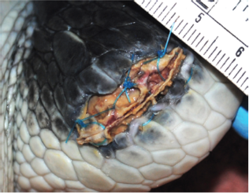
Answer: 1. How dare you criticize me? 2. Great question. From what we know, there is a significant increase in complications with the use of suture as compared to staples for skin closure, but NOT healing duration in sea turtles. You are right, staples may have been a better choice based on the literature but thankfully this will likely heal.
Second Question: You performed a prefemoral coeliotomy on a Kemp’s ridley turtle ~6 weeks prior and the incision looks like this today. Name three factors that may have contributed to its current state of healing based on a 2025 retrospective evaluation of sea turtle incision site healing.
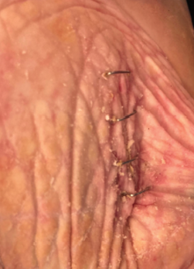
Answer: This is an uncomplicated incision with a relatively short period of healing in this picture. Answers include: Use of staples over suture, soft tissue surgery rather than orthopedic surgery, and if this turtle had a relatively smaller body size as compared to conspecifics.
Journal of Zoo and Wildlife Medicine, 2024, 55(3): 801-809.
AUTOLOGOUS OR ALLOGENIC BLOOD PLEURODESIS AS TREATMENT FOR PNEUMOCOELOM IN FOUR SEA TURTLES (LEPIDOCHELYS KEMPII, CARETTA CARETTA)
Dittmer et al.
Question: What adverse effects and long-term consequences have been observed in sea turtles receiving blood patch pleurodesis for management of pulmonary bullae and persistent pneumocoelom?
Answer: None

