Journal of Zoo and Wildlife Medicine 2023, 54(1): 102-110
Fatal Systemic Fungal Infection In Eastern Bongo Antelope (Tragelaphus Eurycerus Isaaci): Six Cases
Michael M. Garner, Daniel V.E. Fredholm, Scott B. Citino, M. Kelly Keating, Jana M. Ritter, Shawn Lockart, Colleen Lysen, Daniel S. Bradway, Alissa R. Koons, Joseph Newton

Abstract: Over a span of 6 yr, six adult eastern bongo antelope (Tragelaphus eurycerus isaaci) from a single institution died due to systemic mycotic infections. All animals were of the same genetic lineage and in good body condition at the time of death. Gross findings in all cases included multifocal white-to-tan nodules up to 10 cm in diameter that were most numerous in the heart, lung, and kidney. Histologic examination identified these nodules as foci of granulomatous inflammation containing branching, septate, broad, undulating fungal elements. Identification of the fungal species was pursued using PCR with sequencing, immunohistochemistry, and culture. Multiple fungal species were identified using the various modalities, and commonality of species identification was limited to Cladosporium sp. in four of the cases. The clinical and postmortem findings in these cases were identical and were considered to be the same infectious disease. The Cladosporium sp. was considered a candidate as an emerging fatal infectious agent in this population of bongo antelopes. In all of these cases, death was attributed to conduction abnormalities associated with the cardiac lesions or euthanasia.

Background
- Eastern subspecies of bongo listed as critically endangered; nocturnal
Methods
- Retrospective from NW ZooPath for mycotic dz
Results
- 9 cases mycotic dz: 1 cases pulmonary aspergillosis; 7 systemic mycotic infection
- 4 found dead (¾ no antemortem clinical signs); 1 anterior uveitis and weight loss; 1 euthanized for chest wound; 1 euthanized for chronic tendon abscess
- Distribution of mycotic lesions
  - Heart (n=6), kidney (n=6); Lung, lymph node in (n=5); Abomasum (n=2); Pleura, body wall (n=1)
- Lesions: histiocytes and multinucleated giant cells mixed with lymphocytes, plasma cells, neutrophils; discreet granuloma formation around necrotic cellular debris sometimes seen
- Fungal pigmentation note detected in H&E stained histologic sections
Discussion
- Death most likely due to conduction abnormalities associated with severe mycotic lesions in the heart (apart from euthanized animals)
- Pathogen difficult to isolate and true agent of these reports may not have been isolated; most isolates considered contaminant; Cladosporium most consistent isolate
  - Cladosporium is a pigmented fungus, but only 1 case stained for this pigment
  - Mycotic pigmentation is also dependent on age, growth rate, and viability of the fungus
  - DNA by PCR from fresh or fresh frozen tissue
- Incidental findings- thyroid follicular ectasia, moderate ruminoreticulitis (may have been related to zoo diets), lymphoplasmacytic enteritis (from intestinal nematodiasis), rhabdomyolysis, myocardial necrosis (hypoxia associated with conduction abnormalities)
- No age or sex predilection
- Possible seasonal component- five euthanized or died in winter or early spring
- Pulmonary or oral transmission possible

2024 JWD 60.3
Bighorn Sheep (Ovis canadensis) with Higher Whole Blood Selenium Levels Have Improved Survival and Altered Immune Responses
Dana Y. Tsuchida, Morgan F. Gentzkow, Robert S. Spaan Julia Burco,Claire E. Couch, Johannie M. Spaan, Clinton W. Epps, Brianna R. Beechler

Abstract: Bighorn sheep (Ovis canadensis) are herbivorous ungulates that live in forage-poor areas of the American west. The trace minerals that herbivores derive from forage are important for immune function. Therefore, identifying trace minerals that affect immune function in bighorn sheep could provide important insights into disease susceptibility and population health in threatened populations. We sought to determine whether trace mineral composition in blood or plasma correlates to survival and determine whether immunologic parameters correlate with any trace minerals that affect survival. We used data collected from 2016 to 2018 as part of a large study on bighorn sheep in southeastern Oregon and northern Nevada, US. We measured the survival of 135 bighorn sheep during the 8-mo monitoring period, including general metrics of immune function and trace mineral levels. We found that animals with higher selenium had improved survival over the monitoring period, with higher peripheral blood mononuclear cell activity (lymphocytes and monocytes) and lower bacterial killing ability in an in vitro assay. This suggests that bighorn sheep may have altered immune function when selenium levels are low, making them more likely to die during the 8-mo monitoring period. Future work should consider whether habitat management strategies that increase selenium intake might improve disease resistance and survival in bighorn sheep in selenium-poor areas.

Background
- Selenium influences innate and acquired immunity, mechanisms not known
- Bighorn sheep face threats from Mycoplasma ovipneumoniae + other pathogens
- Selenium amount in plants driven by amount in soil, based on location (lowest in NW USA)
- Goal: do blood selenium and other trace minerals predict survival of bighorn sheep? Are selenium levels correlated to immune function? (In NW USA) → historically selenium is poor in that area and big horn mortality has been described in this area
- Based on previous studies, adults more likely to suffer mortality if male, have low genetic diversity and have been exposed to M. ovipneumoniae; juvenile survival decreased by presence of M. ovipneumoniae in env and survival increased by metabolic condition of ewe raising the lamb
Methods
- Sampled 135 bighorn sheep across 6 populations in 2 years; age estimated by horn growth rings
- Evaluated correlations between whole blood selenium and each immune parameter, including WBC differentials (neutrophils, lymphocytes, monocytes, and eosinophils)
Results
- Selenium and copper levels varied in population
- Whole blood concentration of selenium in bighorn sheep was positively correlated to the survival probability during an 8- mo postsampling monitoring period
- Animals with higher selenium had stronger lymphocyte and monocyte responses to an in vitro stimulation w/ a mitogen + reduced BKA → selenium levels may affect immune function
  - Same as previous study in domestic sheep (higher blood selenium associated w/ improved humoral and innate immune responses and reduced foot rot susceptibility)
Discussion
- Study supports selenium plays role in peripheral blood mononuclear cell (eg lymphocytes, monocytes) function in bighorn sheep
Takeaway: Whole blood concentration of selenium in bighorn sheep in Northwest USA was positively correlated to survival probability over a 8 month sampling period. Bighorn sheep with higher selenium had stronger lymphocyte and monocyte responses to an in vitro stimulation, suggesting selenium levels may affect immune function.

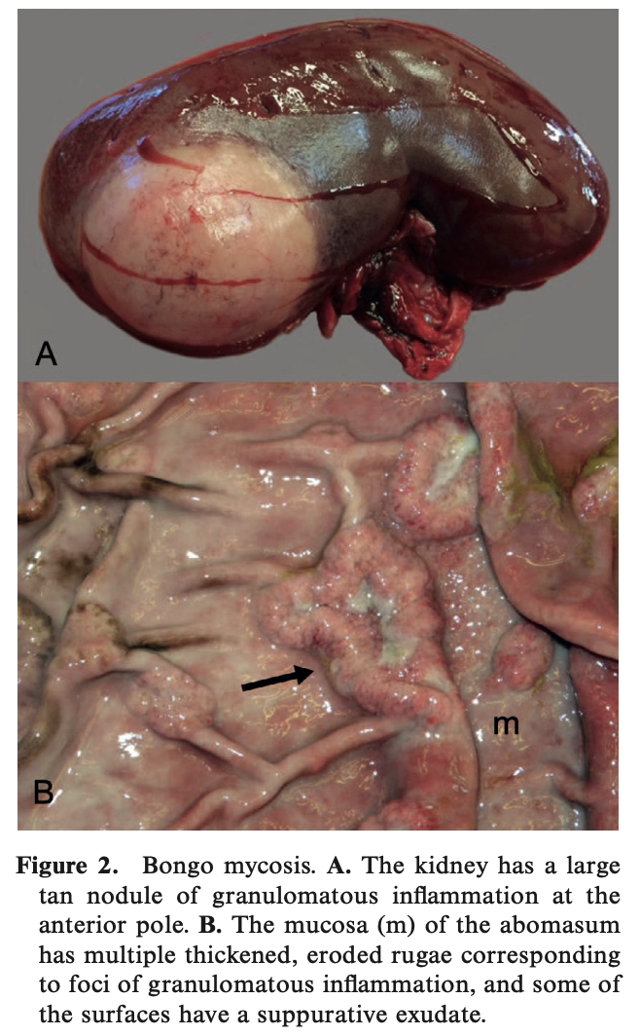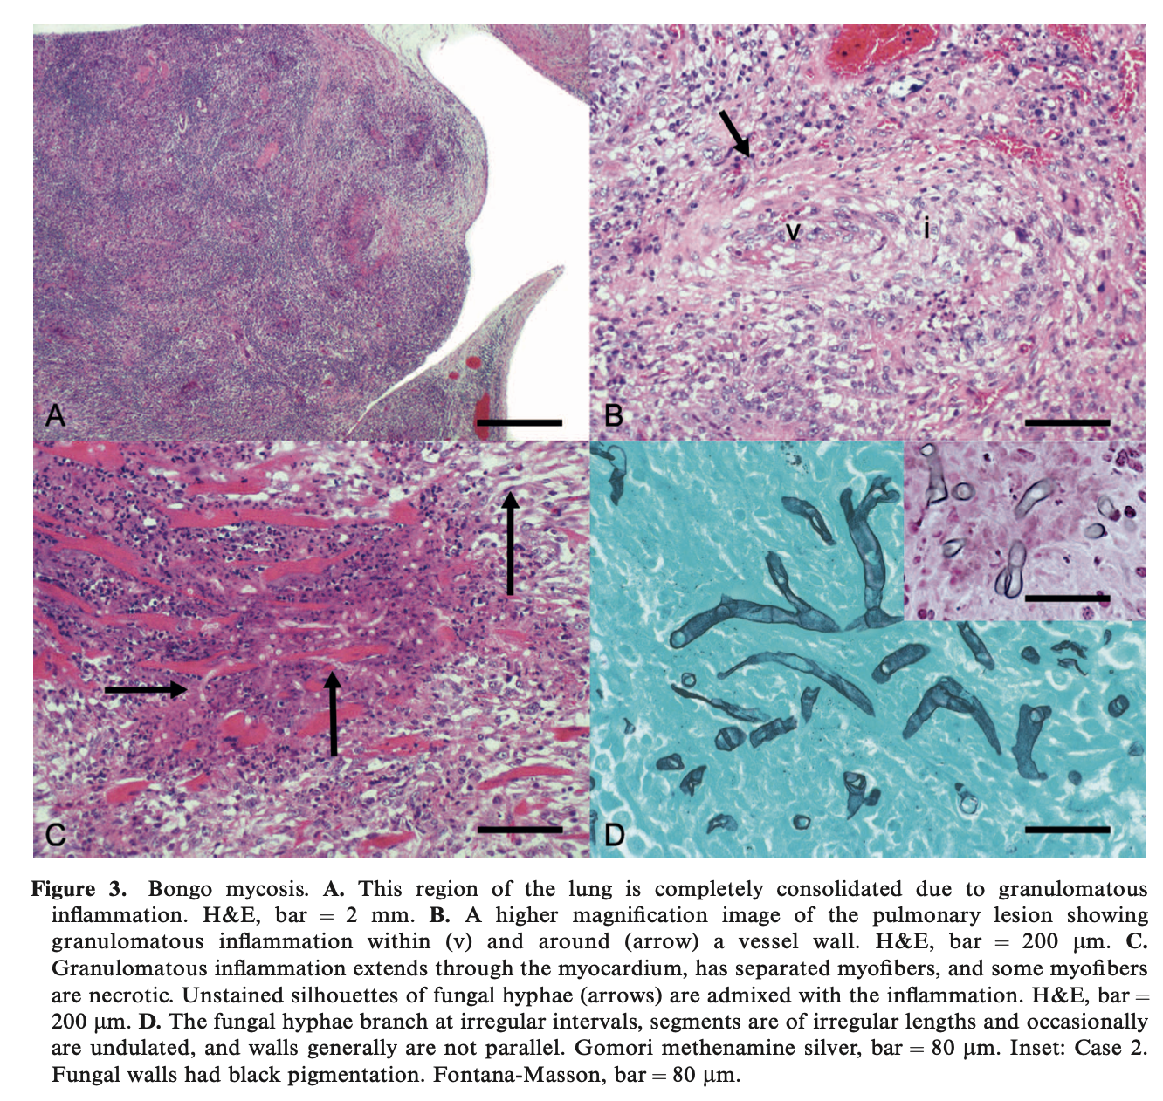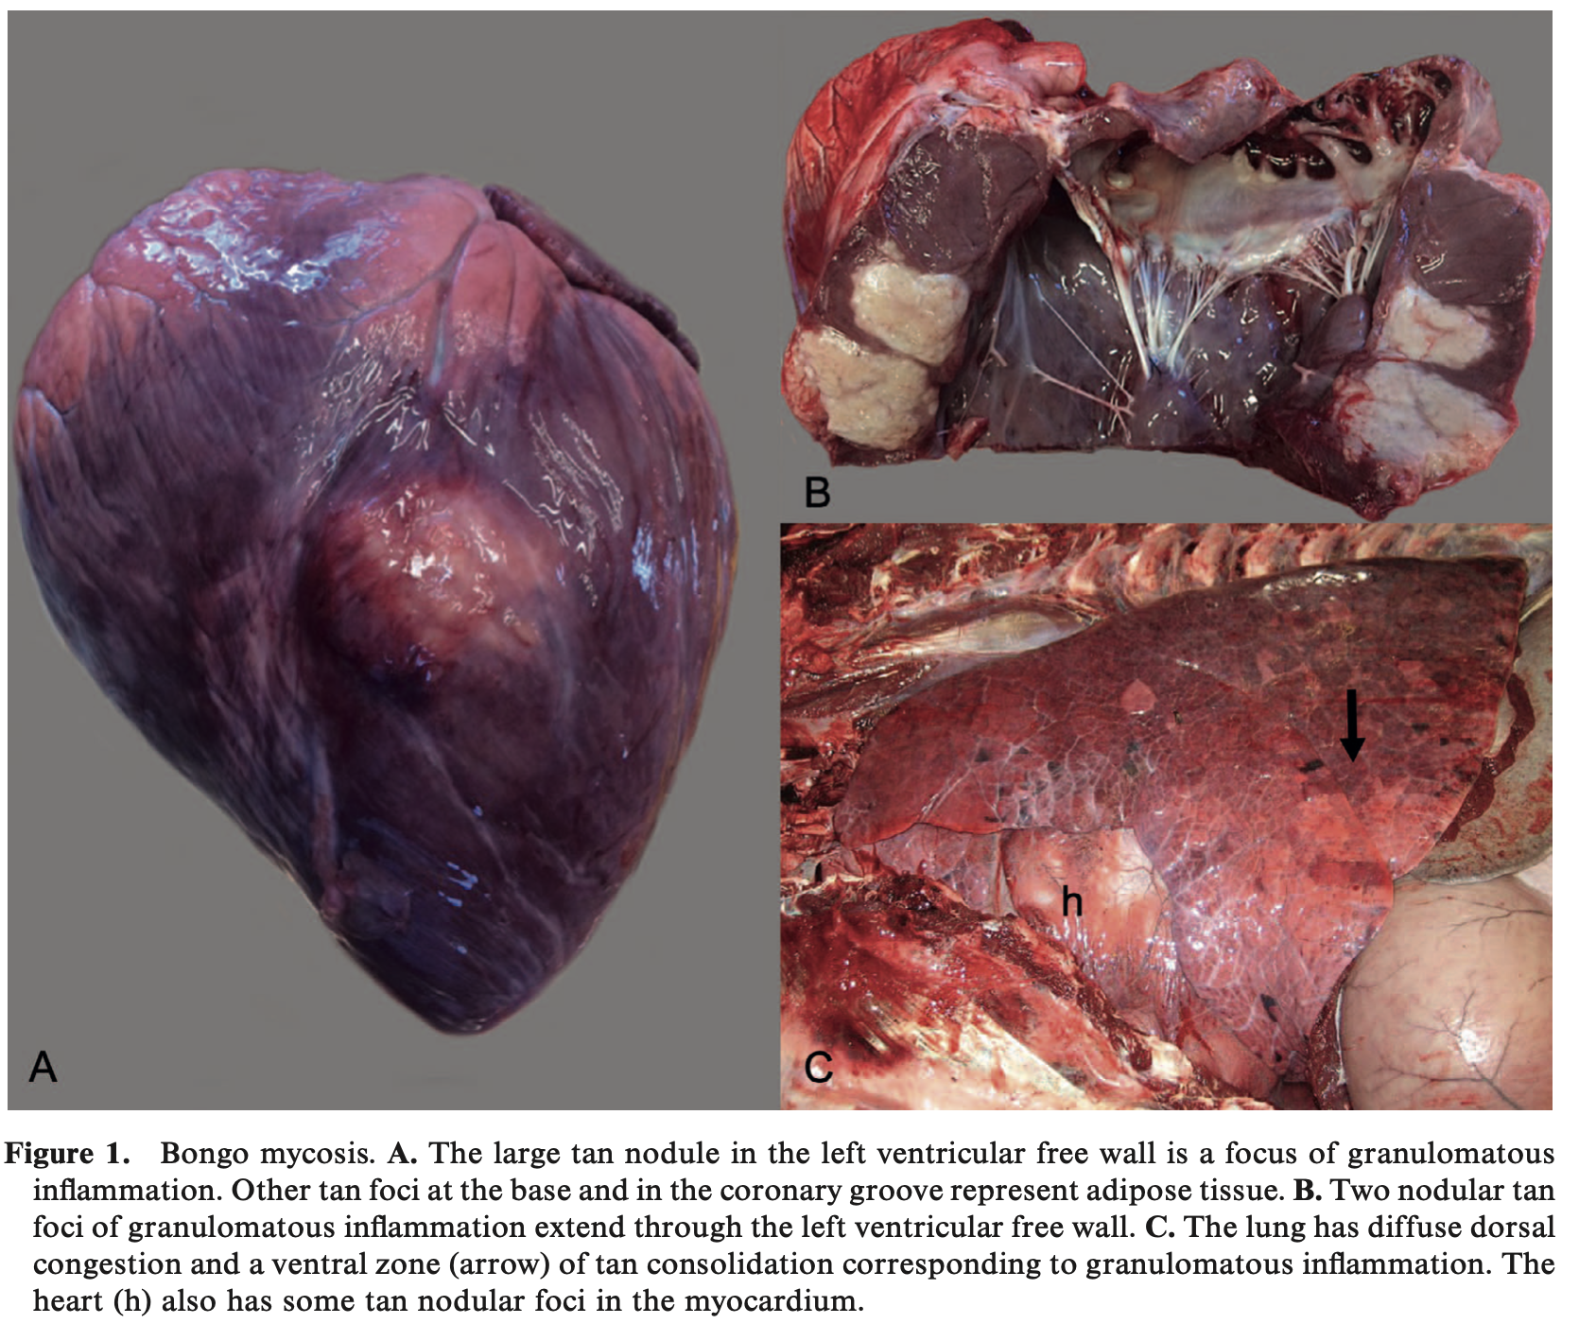

Retrospective analysis of frequent, low-dose copper oxide wire particle treatments, fed as a top dressing, on gastrointestinal trichostrongyloid nematode fecal egg counts in sable (Hippotragus niger) and gemsbok (Oryx gazella)
Tilley A, Schmidt L, Swenson J, Haefele H. J Zoo Wildl Med. 2025;56(1):113-120.—ALD Summary

Abstract: Nematodes of the superfamily Trichostrongyloidea, particularly abomasal species, have severe clinical implications associated with high morbidity and potential mortality of exotic ruminants housed in zoological institutions. The life cycle and ecology of Trichostrongyloid gastrointestinal nematodes (TGN) present challenges in their control including development of anthelmintic resistance and reinfection in high-density managed herds. Copper oxide wire particles (COWP) are used to help control TGN infections in ruminants, administered as a bolus or a feed additive. This study investigated the effects of frequent, low-dose administration of COWP fed as a top dressing on strongyle fecal egg counts (FEC) in gemsbok (Oryx gazella) and sable antelope (Hippotragus niger). Six years of FEC data (n=33), obtained using a modified McMaster fecal flotation, were analyzed from individuals at Fossil Rim Wildlife Center, treated exclusively with commercially available COWP in a top dressing application dosed at 25 mg/kg every 30–60 days. COWP decreased FEC in both species by a mean FEC reduction ratio of 45%, a statistically significant difference (p<0.05) using a one-tailed paired t-test log-stabilized to minimize variance; no clinically negative effects, including copper toxicity, were observed. COWP were more effective at reducing FEC in individuals with pre-treatment FEC greater than 1000 eggs/g of feces, a statistically significant difference (p<0.05). We conclude that frequent, low dose, top dressing application of COWP is effective at reducing FEC in sable and gemsbok, but COWP should not serve as a stand-alone method or to treat clinically affected exotic ruminants.

Background:
- COWP: shown to reduce FEC by 60-90% for 21-28d in small ruminants, remains in abomasum, release Cu up to 32d
  - Unknown MOA: pH in abomasum increases and induces release of high concentrations of Cu
    - Cu absorption by helminth cuticle or ingestion of blood or abomasal fluid w/high Cu

Key Points:
- Objective: analyze impacts of COWP as top dressing at frequent low doses on FEC to assess efficacy as treatment for TGN in gemsbok and sable antelope
- Study: retrospective review 2016-2021n=33 tx (25 animals), COWP at 25mg/kg using total herd weight q 30-60d, FEC 0-21d prior and 6-28d after tx, no other anthelmintic tx during this window
  - Previous coproculture found Trichostrongylus, Haemonchus, and Teladorsagia
- Mean FECR 45% (range 0-100%), no decrease in 10 cases
- Higher FECCR seen in animals with pretx values >1000FECCR more precise and accurate with higher FEC (esp with McMaster’s), or COWP has greater effect on heavily parasitized animals
- Mean FECRR lower than previously reported with COWP in managed exotic antelope (likely due to route and lower dose) and small ruminants (could be due to ingestion factors like dominance, age, human error, weather)
- Cu toxicity: copper liver concentrations (358.97 ppm mean) found to be above adequate per historic ranges in non-domestic bovids (>/=330ppm)
- No cumulative effect of COWP on TGN seen overtime

Take Home:
- COWP effective as top dressing at decreasing FEC when given at a frequent, low dose (25 mg/kg q 30-60d) in sable and gemsbok
  - Good for when TGN risk is high, anthelmintic resistance, and where individual tx is hard
- COWP is more effective at reducing FEC in individual animals with pretx FEC >1000 EPG
Pathology of chronic Mycoplasma ovipneumoniae carriers in a declining bighorn sheep (Ovis canadensis) population
Malmberg JL, Allen SE, Jennings-Gaines JE, Johnson M, Luukkonen KL, Robbins KM, Cornish TE, Smiley RA, Wagler BL, Gregory Z, Lutz D, Hnilicka P Monteith KL, Edwards WH. J Wildl Dis. 2024;60(2):448-460.—ALD Summary

Abstract: Bighorn sheep (Ovis canadensis) across North America commonly experience population-limiting epizootics of respiratory disease. Although many cases of bighorn sheep pneumonia are polymicrobial, Mycoplasma ovipneumoniae is most frequently associated with all-age mortality events followed by years of low recruitment. Chronic carriage of M. ovipneumoniae by adult females serves as a source of exposure of naïve juveniles; relatively few ewes may be responsible for maintenance of infection within a herd. Test-and-remove strategies focused on removal of adult females with evidence of persistent or intermittent shedding (hereafter chronic carriers) may reduce prevalence and mitigate mortality. Postmortem confirmation of pneumonia in chronic carriers has been inadequately reported and the pathology has not been thoroughly characterized, limiting our understanding of important processes shaping the epidemiology of pneumonia in bighorn sheep. Here we document postmortem findings and characterize the lesions of seven ewes removed from a declining bighorn sheep population in Wyoming, USA, following at least two antemortem detections of M. ovipneumoniae within a 14-mo period. We confirmed that 6/7 (85.7%) had variable degrees of chronic pneumonia. Mycoplasma ovipneumoniae was detected in the lung of 4/7 (57.1%) animals postmortem. Four (57.1%) had paranasal sinus masses, all of which were classified as inflammatory, hyperplastic lesions. Pasteurella multocida was detected in all seven (100%) animals, while Trueperella pyogenes was detected in 5/7 (71.4%). Our findings indicate that not all chronic carriers have pneumonia, nor do all have detectable M. ovipneumoniae in the lung. Further, paranasal sinus masses are a common but inconsistent finding, and whether sinus lesions predispose to persistence or result from chronic carriage remains unclear. Our findings indicate that disease is variable in chronic M. ovipneumoniae carriers, underscoring the need for further efforts to characterize pathologic processes and underlying mechanisms in this system to inform management.

Background:
- Bighorn sheep epizootic pneumonia is multifactorial and polymicrobial; subacute to chronic bronchopneumonia within cranioventral consolidation, causes all-age mass mortality events and long-term impacts on juvenile survival (low lamb recruitment)
- M. ovipneumoniae: interferes with mucociliary apparatus, can be found in nasal cavity w/o affecting lung; found in association w/paranasal sinus masses of bighorn sheep; commonly found w/Mannheimia haemolytica, Bibersteinia trehalosi, Pasteurella multocida
- Chronically infected females: limit tissue damage to become chronic spreaders—doesn’t prevent disease but permits host survival, expose juveniles
- Removal of chronic spreaders resulted in dec detection of M. ovipneumoniae in 2 prev studies

Key Points:
- Objectives: characterize pathology in bighorn sheep (BHS) w/chronic carriage of M. pneumoniae, assess correspondence b/t detection of M. ovipneumoniae in nasal cavity and detection in lung quality, determine frequency of co-infecting respiratory pathogens in persistently infected BHS
- Study: investigated a herd of BHS w/known high positive M. ovipenumoniae and pneumonia as leading cause of juvenile mortality, test (2 nasal and 2 tonsil swabs) and remove of chronic females followed by necropsy and testing
- 0.7 euthanized, 6/7 had chronic bronchopneumonia w/cranioventral consolidation, lungworms (Protostrongylus sp.) common, paranasal sinus lesions in 4/7 (inflammatory, hyperplastic; frontal>maxillary>coronal diverticulum)
- M. ovipneumoniae positive by 1 PCR in all ewes—not all lung samples positive, not all proliferative sinus lesions positive
- P. multocida detected in all ewes, seen in all proliferative sinus lesions; T. pyogenes, M. haemolytica, and B. trehalosi also present; no respiratory viral disease present via PCR

Take Home:
- M. ovipneumoniae has been associated with respiratory disease and juvenile death in BHS due to chronic female carriers
- Not all chronic M. ovipneumoniae carriers have bronchopneumonia, and BHS can carry it in the nasal cavity without lung disease
- Paranasal sinus masses are a common finding with M. ovipneumoniae but not found in every case
  - Space occupying lesions in BHS often comprise inflammation and reactive change
- P. multocida and T. pyogenes common commensals, but virulent co-infections not needed for persistence of M. ovipenumoniae in BHS respiratory tracts
- Good histo and gross lesion pictures
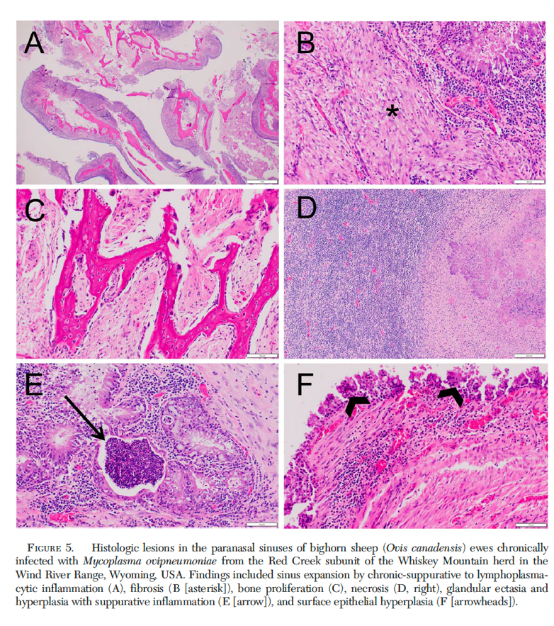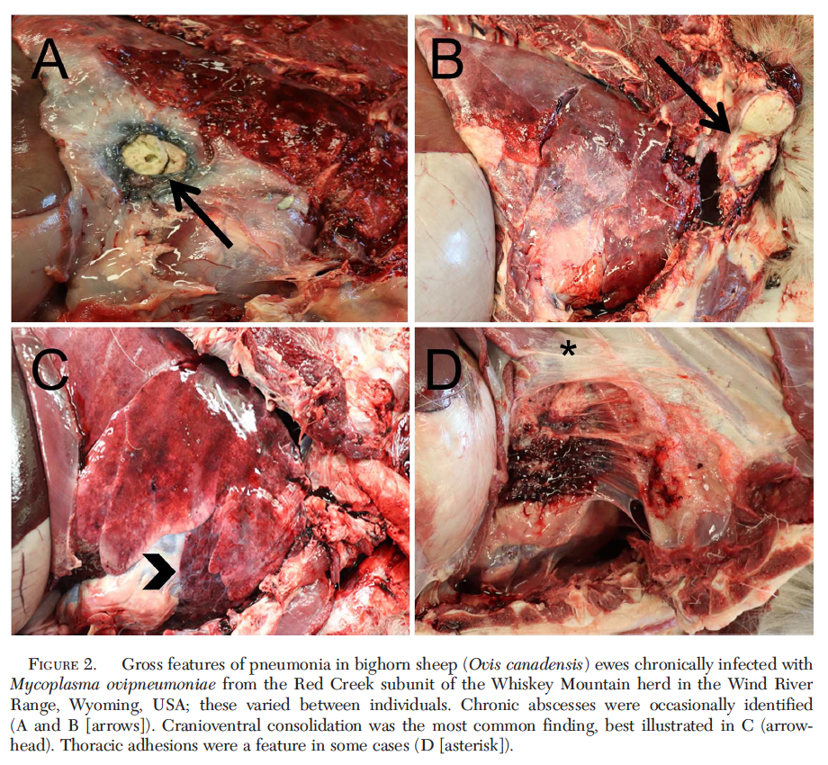
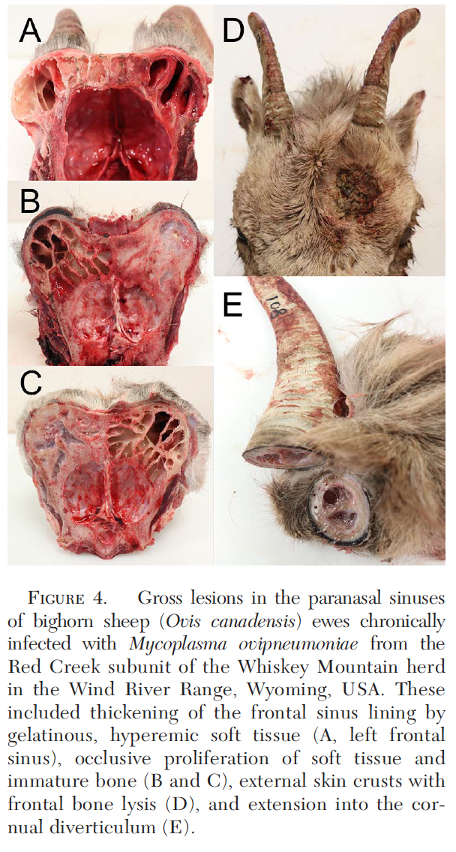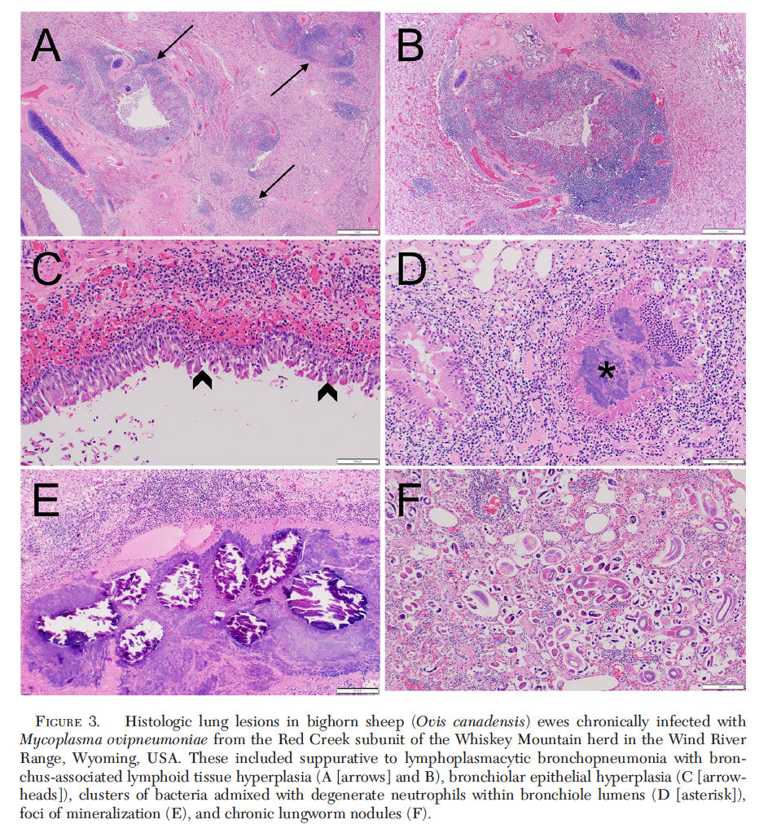

Taylor, Laci C., et al. "PHEOCHROMOCYTOMA IN SIX SCIMITAR-HORNED ORYXES (ORYX DAMMAH)." Journal of Zoo and Wildlife Medicine 56.4 (2025): 782-789. - reviewed by HSS
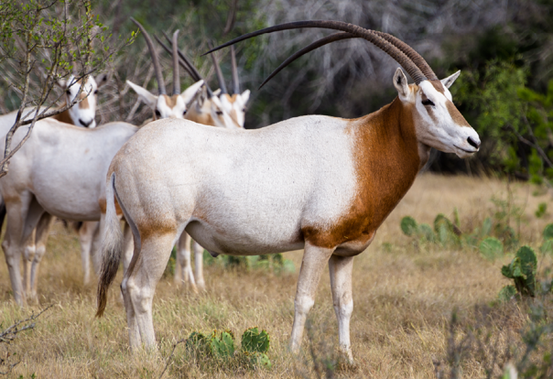
Abstract:
Neoplasia in nondomestic bovids is rarely reported in the literature, leaving prevalence largely unknown. A retrospective review of the pathology records of 101 scimitar-horned oryxes (Oryx dammah; SHO) housed at a single zoological institution over more than 50 years identified six cases of pheochromocytoma. All six cases were geriatric individuals ranging from 15 to 22 years of age. Five cases presented with benign pheochromocytomas, and one case presented with both a malignant and benign pheochromocytoma. Histological features of malignancy for this case included diffuse infiltrative growth, vascular and capsular invasion, tumor necrosis, increased mitotic activity, cellular pleomorphism, and distant metastasis to the liver, diaphragmatic skeletal muscle, and cranial peritoneal cavity. While the malignant tumor exhibited invasive features which may have contributed to morbidity and mortality, none of the six cases exhibited clinical signs or postmortem findings typically associated with catecholamine excess. As such, these pheochromocytomas appear to have been nonsecretory, as is generally observed in domestic bovine cases, wherein pheochromocytomas are typically incidentally identified at slaughter. Nevertheless, the malignant case in which widespread metastasis occurred indicates that pheochromocytoma is an important differential to consider for general decline or a mid-abdominal mass in this species. More broadly, the scarcity of published neoplastic data on SHO highlights the need for collaborative, multi-institutional data sharing to establish broader epidemiological trends in managed populations.

Key Points:
- Genus Oryx 4 extant species of large antelope
  - Arabian oryx (Oryx leucoryx)
  - East African oryx (Oryx beisa)
  - Gemsbok (Oryx gazella); least concern
  - Scimitar-horned oryx (Oryx dammah) – most imperiled
    - Extinct in wild in 2000; captive-bred reintroduced started in 2016 and reclassified as endangered in 2023
- Reported neoplasms in SHO include uterine endometrial carcinoma, uterine metastatic rhabdomyosarcoma, and mammary gland tubule-papillary carcinoma
- Pheochromocytoma – neuroendocrine tumors that arise from chromaffin cells of the adrenal medulla
  - When functional, secrete mixture of epinephrine/norepinephrine
  - Clinical signs related to catecholamine release include tachycardia, hypertension, cardiac hypertrophy that can then lead to fatal complications such as hemorrhage or cardiac failure
- 6/25 instances of neoplasia in at the National Zoo = pheochromocytoma (n = 101 total SHO)
  - Tumors of the adrenal gland were the most frequently observed neoplasms
  - 12/25 neoplasms were endocrine in origin
  - 5/6 benign; 1 malignant with distant metastasis and very aggressive behavior
- All in geriatric individuals; no sex predilection for pheochromocytoma in SHO (3M, 3F)
- None exhibited antemortem clinical signs consistent with catecholamine excess
- Absence of findings consistent with hypertension and other sequela of elevated catecholamines, such as cardiac hypertrophy or retinal vascular changes, suggests that they were likely nonfunctional
- Pheochromocytoma also reported in addax, nilgai, and springbok
- Histologic features of malignancy – diffuse infiltrative growth, vascular and capsular invasion, tumor necrosis, increased mitotic activity, cellular polymorphism, distant metastasis
- Domestic bulls with pheochromocytomas were found to have higher urinary concentrations of norepinephrine in freely-voided samples. Urine was not assessed but represents an avenue of further research
  - However, as majority in SHO nonfunctional, antemortem diagnosis may be limited to presumtive diagnosis based on imaging (i.e. abdominal ultrasound)

Take-Home Message:
- A population of Scimitar-horned oryx (SHO) under human care had a relatively high prevalence of pheochromocytoma. Geriatric individuals with no sex predilection. Tumors mostly benign but one case considered malignant. Considered (presumptively) non-secretory in all SHO, similar to pheochromocytomas in domestic bovines (typically found incidentally at slaughter)

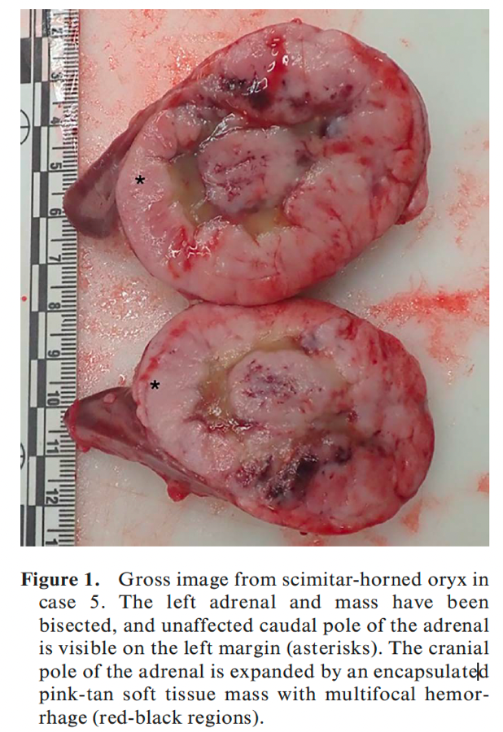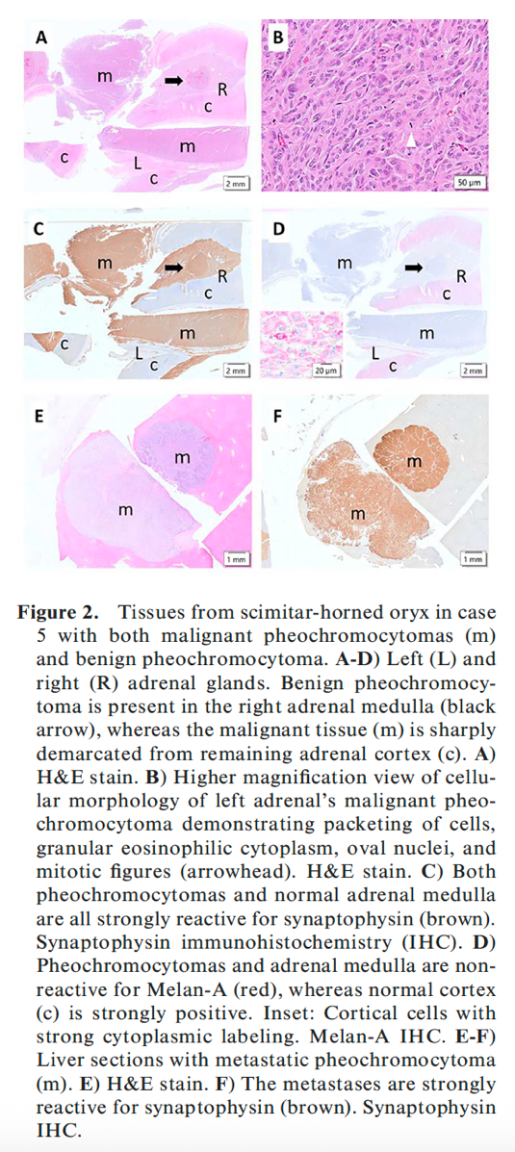

Fisk, Elis A., et al. "Abortion and neonatal mortality due to Toxoplasma gondii in bighorn sheep (Ovis canadensis)." The Journal of Wildlife Diseases 59.1 (2023): 37-48. - reviewed by HSS

Abstract:
Low lamb recruitment can be an obstacle to bighorn sheep (Ovis canadensis) conservation and restoration. Causes of abortion and neonate loss in bighorn sheep, which may affect recruitment, are poorly understood. Toxoplasma gondii is a major cause of abortion and stillbirth in domestic small ruminants worldwide, but no reports exist documenting abortion or neonatal death in bighorn sheep attributable to toxoplasmosis. Between March 2019 and May 2021, eight fetal and neonatal bighorn lamb cadavers from four western US states (Idaho, Montana, Nebraska, and Washington) were submitted to the Washington Animal Disease Diagnostic Laboratory for postmortem examination, histologic examination, and ancillary testing to determine the cause of abortion or neonatal death. Necrotizing encephalitis characteristic of toxoplasmosis was identified histologically in six of eight cases, and T. gondii infection was confirmed by PCR in five cases with characteristic lesions. Other lesions attributable to toxoplasmosis were pneumonia (3/5 cases) and myocarditis (2/5 cases). Protozoal cysts were identified histologically within brain, lung, heart, skeletal muscle, adipose tissue, or a combination of samples in all five sheep with PCR-confirmed T. gondii infections. Seroprevalence of T. gondii ranged from 40–81% of adult females sampled in the Washington population in October and November 2018–2021, confirming high rates of exposure before detection of Toxoplasma abortions in this study. Of 1,149 bighorn sheep postmortem samples submitted to Washington Animal Disease Diagnostic Laboratory between January 2000 and May 2021, 21 of which were from fetuses or neonates, a single case of chronic toxoplasmosis was diagnosed in one adult ewe. Recent identification of Toxoplasma abortions in bighorn sheep suggests that toxoplasmosis is an underappreciated cause of reproductive loss. Abortions and neonatal mortalities should be investigated through postmortem and histologic examination, particularly in herds that are chronically small, demographically stagnant, or exhibit reproductive rates lower than expected.

Key Points:
- Toxoplasma gondii is a major cause of reproductive failure and neonate loss in domestic small ruminants. It is an obligate intracellular parasitic protozoan in the phylum Apicomplexa. Infected animals may remain subclinical or progress to systemic infection, abortion, or death.
- Felidae are the definitive hosts and typically shed oocysts in their feces for 1–2 wk after infection through ingestion of tissues containing T. gondii cysts. Homeothermic vertebrates can become intermediate hosts with T. gondii cysts within host organs persisting for the life of the host. Spread of tachyzoites to the placenta and fetus typically results in necrotizing lesions within the placenta and fetal brain.
- Necrotizing encephalitis, glial nodule formation compatible with T. gondii infection, or both were identified in 6/8 submitted fetuses (75%), with toxoplasmosis confirmed via detection of T. gondii by PCR in 5/6 fetuses (83%)
- Of those confirmed to be PCR-positive for T. gondii, other lesions attributed to toxoplasmosis included histiocytic pneumonia in 3/5 cases (60%), lymphoplasmacytic or granulomatous and necrotizing myocarditis in 2/5 cases (40%), necrotizing to granulomatous hepatitis in 2/5 cases (40%), and lymphoplasmacytic glossitis in 2/5 cases (40%). Intracellular or extracellular protozoal cysts, or both, were appreciated histologically within one or more organs in 5/5 cases (100%).
- Serologic titers for T. gondii were detected in a proportion of ewes from the Asotin population in Washington during every annual serum evaluation from 2018 to 2021. Over this period, 30 ewes were sampled one to four times; 73% (22/30) were seropositive for T. gondii on at least one sampling occasion. Seroprevalence was 50% in 2018 (3/5), 40% in 2019 (2/5), 47% in 2020 (9/19), and 81% in 2021 (17/21).
- One case of chronic toxoplasmosis was confirmed in 2021 in a 2-yr-old nonpregnant bighorn ewe from the Bison Range population in Montana.

Take-Home Message:
- Five cases of toxoplasmosis-associated abortion or neonatal death in bighorn sheep, high seroprevalence in some populations, and one case of chronic toxoplasmosis in an adult. Toxoplasmosis is an underappreciated cause of reproductive loss. Abortions and neonatal mortalities should be investigated through postmortem and histologic examination, particularly in herds that are chronically small, demographically stagnant, or exhibit reproductive rates lower than expected.

J Wildl Dis. 2023;59(2):288-298.
Summarized by MR

Cooling by Dousing with Cold Water Does Not Alter the Pathophysiological Biochemical Changes Induced by Capture in Blesbok (Damaliscus pygargus phillipsi)
Leiberich, Fitte, Burroughs, Steyl, Goddard, Haw, Boesch, Kohn, Meyer

Abstract: Wild animals are commonly captured for conservation, research, and wildlife management purposes. However, capture is associated with a high risk of morbidity or mortality. Capture-induced hyperthermia is a commonly encountered complication believed to contribute significantly to morbidity and mortality. Active cooling of hyperthermic animals by dousing with water is believed to treat capture-induced pathophysiological effects, but remains untested. This study aimed to determine the pathophysiological effects of capture, and whether cooling by dousing with cold water effectively reduces these effects in blesbok (Damaliscus pygargus phillipsi). Thirty-eight blesbok were randomly allocated into three groups: a control group that was not chased (Ct, n=12), chased not cooled (CNC, n=14), and chased plus cooled group (C+C, n=12). The CNC and C+C groups were chased for 15 min prior to chemical immobilization on day 0. Animals in the C+C group were cooled with 10 L of cold water (4 C) for 10 min during immobilization. All animals were immobilized on days 0, 3, 16, and 30. During each immobilization, rectal and muscle temperatures were recorded, and arterial and venous blood samples collected. Blesbok in the CNC and C+C groups presented with capture-induced pathophysiological changes characterized by hyperthermia, hyperlactatemia, increased markers of liver, skeletal, and cardiac muscle damage, hypoxemia, and hypocapnia. Cooling effectively returned body temperatures to normothermic levels, but neither the magnitude nor the duration of the pathophysiological changes differed between the CNC and C+C groups. Therefore, at least in blesbok, capture-induced hyperthermia appears not to be the primary cause of the pathophysiological changes, but is more likely a clinical sign of the hypermetabolism resulting from capture-induced physical and psychological stress. Although cooling is still recommended to prevent the compounding cytotoxic effects of persistent hyperthermia, it is unlikely to prevent stress- and hypoxia-induced damage caused by the capture procedure.

Background:
- Wildlife capture is highly stressful and may result in capture-related deaths
  - Pathophysiological processes responsible for capture-related mortalities often unknown – but hyperthermia is thought to be a main contributor
  - Hyperthermia may result in cellular injury and lead to organ damage, rhabdomyolysis, electrolyte abnormalities, +/- death
  - Use of active cooling often used during capture events in which has been evaluated in effectiveness of reducing body temp but no one has assessed its effectiveness on reducing pathophysiological effects of capture-induced hyperthermia
- Objective: determine the pathophysiological effects induced by a mimicked field-capture procedure that is known to cause hyperthermia, and whether cooling could reduce or prevent these effects.

Summary:
- Prospective, controlled randomized study: 38 (22 M, 16 F) wild Blesbok – mass captured and held in bomas
  - Three randomly allocated groups: control group was not chased, chased and not cooled, chased and cooled.
  - Chased for 15 min prior to chemical immobilization on day 0
  - Serial anesthesias: day 0, 3, 16, 30.
  - Etorphine + azaperone protocol, reversed with naltrexone
- On D0, blesbok from chase groups were vigorously chased for 15 min by people, in an adjoining large boma compartment (50x50 m), then returned to their boma and immediately darted (immobilized).
- Average rectal temps in chased groups of blesbok were ~3.8$°$C than in non-chased group (with no difference between chased groups)
  - With cold water dousing for 10 mins, rectal temp in chased+cooled group decreased to temps similar to not-chased group and lower than the chased+non-cooled
  - Muscle temps followed similar patterns
    - fine thermo-couple probe inserted sterilely 620 mm into the gluteus muscle through an 18-G needle
- CK & AST higher in chased groups compared to non-chased group (no difference in cooled vs non-cooled)
- GGT did not differ between any group
- GLDH higher in chased groups compared to non-chased group (no difference in cooled vs non-cooled)
- CREA higher in chased groups compared to non-chased group, but returned to baseline on day 3 – then on day 16 and 30 chased groups had lower CREA than control group (no difference between chased groups; no differences in BUN)
- Lactate was 8-10x higher in chased groups than control (no difference btwn chased groups)
- cTnI was 10x (chased+not-cooled) and 16x (chased+cooled) higher than control on day 0 sampling; then back to baseline in cooled group by Day 16 (but not in not-cooled group)
- Blood gas analysis (arterial) had no significant/relevant differences

Take Home Points: Active cooling of blesblok with cold water dousing after chase and capture did result in lower body temperatures successfully, but did not result in any significant differences in the bloodwork abnormalities (CK, AST, lactate, GLDH, Creat/BUN, cTnI) found with chased groups compared to non-chased groups despite active cooling.

J Wildl Dis. 2025;61(2):285-296.
Summarized by MR

Diagnostic Strategies and Strain Typing for Johne’s Disease in Wood Bison (Bison bison athabascae)
Leiberich, Fitte, Burroughs, Steyl, Goddard, Haw, Boesch, Kohn, Meyer

Abstract: Cattle diseases are considered a major threat to wood bison (Bison bison athabascae) conservation. Johne’s disease (JD) is a chronic infectious enteritis caused by Mycobacterium avium subspecies paratuberculosis (Map), that affects domestic and wild ruminants globally and could negatively impact wood bison health. Clinical manifestation of JD in free-ranging or captive wood bison has not been documented. We studied animals in a captive wood bison herd in Alberta, Canada 1) to detect Map in bison clinically suspected of Johne’s disease, by histopathology, quantitative PCR (qPCR), and isolation by culture; 2) to identify optimal tissue samples for Map detection; and 3) to identify the strain(s) of Map isolated. Six wood bison were evaluated with clinical signs suggestive of JD. We performed necropsies within 24–48 h after euthanasia and collected 24 tissue samples from each bison. At necropsy, no evidence of thickening or corrugation of the intestinal mucosa was observed in any bison. On histopathologic examination, granulomatous lesions with acid-fast bacilli were more frequent in the paracortex of the midjejunal lymph node (LN) and distal jejunal LN, followed by ileal LN, in comparison to the rest of the tissue samples evaluated. In general, tissue culture had the highest proportion of positive samples, with 62.5% (90/144) of positive samples, followed by F57/IS900 qPCR with 43.1% (56/130), and histopathology with 29.0% (38/131). We concluded that distal jejunum and its associated lymph nodes were the most reliable tissue samples for detecting Map, regardless of tissue autolysis or the absence of visible gross lesions. Finally, using IS1311 PCR-restriction enzyme analysis and single-nucleotide polymorphisms, we identified a type II (cattle) strain, secondary clade, in tissue samples. These findings have practical relevance for field necropsies as they provide evidence to direct selection of preferred sampling sites to detect Map in wood bison and to choose appropriate diagnostic techniques.

Background:
- Subspecies of American bison found in boreal forests across N. Canada and Alaska.
- More than half of free-ranging wood bison reside in populations affected by bovine tuberculosis and/or brucellosis
- Johne’s disease (JD) is a chronic infectious enteritis caused by Mycobacterium avium subspecies paratuberculosis (Map), that affects domestic and wild ruminants globally
- Probable cross-reactive with bTB diagnostic tests
- Clinical signs 2-5yrs post-infection, detected in elk, caribou, bighorn sheep in Canada
- Map DNA identified by nested PCR in fecal samples in past 10 yrs, strain typing of Map isolates typically described as: type I/III (sheep) strain, type II (cattle) strain, and “type B” bison strain (sublineage of cattle strain).

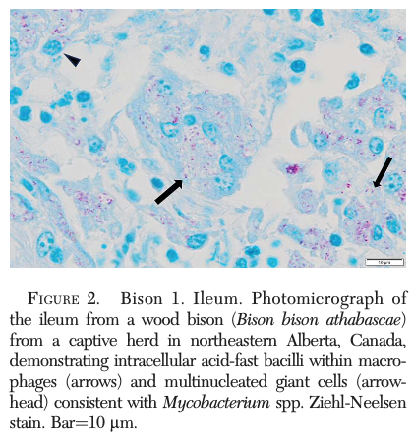
Summary:
- Objective: describe the clinical manifestations, identify optimal tissue samples for detection, and strains of Map in a population of wood bison.
- N = 6 wood bison (females, 2-10YO, 13-42% BW loss) in a herd of 234, a clinical JD case confirmed by direct fecal PCR in 2019
  - Conditions in this specific scenario with high herd density reflect similarities to domestic cattle, which may increase probability of Map transmission
- Necropsies performed within 48hrs of euthanasia – included all gastrointestinal tissues and lymph nodes samples at regions corresponding to intestinal segments
- Tissue samples processed for mycobacterial culture and (fecal and tissue) qPCR + strain typing
- At necropsy, no evidence of thickening or corrugation of the intestinal mucosa was observed in any bison.
- Histopath: granulomatous lymphadenitis characterized by multifocal, noncaseating granulomas in the paracortex of mesenteric lymph nodes, acid-fast bacilli
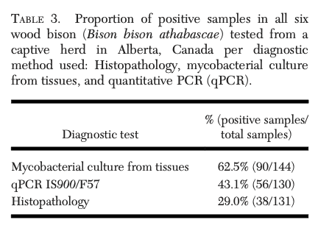
  - In severely autolyzed tissues, lesions not visible on H&E could still be visualized on ZN.
- In culture, 62.5% of tissue samples were positive
- Strain typing: All samples produced a banding pattern consistent with a type II (cattle) strain
  - The type II (cattle) strain identified in a selected set of tissues using IS1311 REA and SNP-PCR is well known for being a common and relatively quick and easy strain to culture (between 4 and 6 wk) compared to other strains

Take Home Points:
- Thickening and corrugation of the intestinal mucosa was not observed on necropsy in this population of wood bison with JD.
- Histopathologic lesions: granulomatous inflammation of mesenteric lymph nodes and distal small intestine (often better seen with Ziehl-Nieelsen stain than H&E)
  - Lesion prevalence: midjejunal and distal jejunal LN > ileal LN
- Mycobacterial culture from tissues yielded the most positive samples, coupling with qPCR is recommended

Journal of Wildlife Diseases, 60(2): 461-473, 2024
DETECTION AND PHYLOGENETIC ANALYSIS OF ORF VIRUS AND MUSKOX RHADINOVIRUS 1 FROM MUSKOXEN (OVIBOS MOSCHATUS) IN THE CANADIAN ARCTIC
Dalton et al

Abstract: Orf virus (genus Parapoxvirus) has been associated with gross skin lesions on muskoxen (Ovibos moschatus) from Victoria Island, Nunavut, Canada, where muskox populations are experiencing population declines. Orf virus causes painful proliferative and necrotizing dermatitis upon viral replication and shedding, which may lead to animal morbidity or mortality through secondary infections and starvation. Herpesvirus, known to cause gross lesions on skin and mucosa during active viral replication, has also been documented in muskoxen but to date has not been associated with clinical disease. Our objective was to characterize the variation of orf virus and herpesvirus in wild muskoxen of the Canadian Arctic. Tissue samples including gross skin lesions from the nose, lips, and/or legs were opportunistically collected from muskoxen on Victoria Island, Nunavut and Northwest Territories, and mainland Nunavut, Canada, from 2015 to 2017. Sampled muskoxen varied in age, sex, location, hunt type, and body condition. Tissues from 60 muskoxen were tested for genetic evidence of orf virus and herpesvirus infection using PCR targeting key viral genes. Tissues from 38 muskoxen, including 15 with gross lesions, were also examined for histological evidence of orf virus and herpesvirus infection. Eleven muskoxen (10 from Victoria Island and one from mainland Nunavut) with gross lesions had microscopic lesions consistent with orf virus infection. Muskox rhadinovirus 1, a gammaherpesvirus endemic to muskoxen, was detected in 33 (55%) muskoxen including 17 with gross lesions. In all tissues examined, there was no histological evidence of herpesvirus-specific disease. Sequencing and characterization of amplified PCR products using phylogenetic analysis indicated that a strain of orf virus, which appears to be unique, is likely to be endemic in muskoxen from Victoria Island and mainland Nunavut. Many of the muskoxen are also subclinically infected with a known muskox-endemic strain of herpesvirus.

Key Points:
- Modern muskoxen populations have low genetic variability and low diversity in the major histocompatibility complex. Populations are declining in Canada.
- Orf virus
  - Genus Parapoxvirus
  - Large, double-stranded DNA virus w/ envelope, ovoid shape
  - “Contagious Ecthyma” in sheep, goats worldwide
  - Transmission = via infected animals or contaminated fomites
    - Virus enters via damaged skin or mucosal surfaces
  - Clinical Signs = proliferative and necrotizing dermatitis on nose, lips, udder, interdigital spaces of the feet and stomatitis; secondary bacterial infections; severe sublethal effects of disease (poor body condition, abandonment of neonates due to painful udder/teats, lameness, weakness, vulnerable to predators)
    - Endemic or virus in sheep goats, gross lesions are typically seen in young animals or naïve adults exposed to carriers
  - Histopath = orthokeratotic or parakeratotic hyperkeratosis creating thick surface keratin crusts, ballooning degeneration of keratinocytes, ulceration, necrotic debris
  - ZOONOTIC (usually mild, self-limiting localized lesions)
  - Orf virus in muskoxen thought to be underlying risk factor for secondary infection with Erysipelothrix rhusiopathiae, leading to widespread mortality of muskoxen on Victoria Island and Banks Island Canada
- Herpesviruses
  - Family Orthoherpesviridae divided into subfamilies Alphaheresvirinae, Betaherpesvirinae, and Gammaherpesvirinae
  - Transmission via direct contact with infected animals actively shedding virus usually via nasal secretions; indirect transmission also documented via contaminated water
  - Muskox rhadinovirus 1 is a gammaherpesvirus reported in muskoxen from Norway, Greenland, and Canada; Believed to be endemic in wild muskox populations and no disease directly associated with infection
- Orf virus detected in muskoxen from Canadian mainland and island populations
  - Half of the muskox adults and calves had gross lesions present, and almost 75% of these had evidence of orf virus on histology
    - Note: A portion of muskoxen were PCR positive for orf virus but did not have gross lesions present, likely subclinical carriers
  - No age or sex predilection for the presence of microscopic lesions consistent with orf virus infection
  - Muskoxen rub their faces on prominent objects in their surroundings such as rocks that could lead to indirect transmission of orf via fomites
  - Strain of orf virus detected in this study likely represents a historical host-pathogen association, wherein the virus remains endemic in the muskoxen, continuously challenging the population, rather than a recent introduction
- Muskox rhadinovirus 1, a gammaherpesvirus endemic to muskoxen was detected in 55% of muskoxen in this study, including 17 with gross lesions but no microscopic lesions suggestive of herpesvirus infection (i.e. necrosis, vasculitis, intranuclear inclusions). Essentially, no disease associated with this virus in muskoxen.
  - Study data supports the idea that Muskox rhadinovirus 1 is endemic in muskoxen and that muskoxen are likely the natural host species for this virus.
Take Home Point: Both Orf virus and Muskox rhadinovirus 1 are endemic in Muskox populations. Orf virus may lead to both gross and histopathologic lesions whereas Muskox rhadinovirus 1 has not been associated with disease in muskoxen.

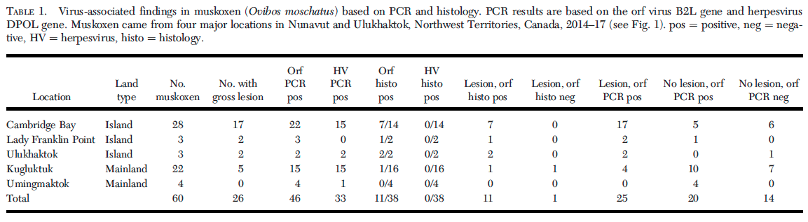
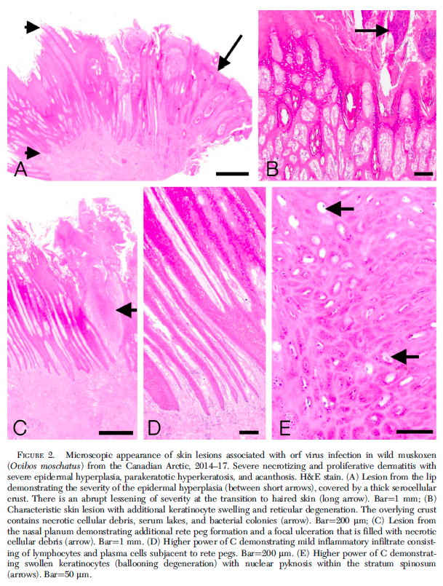

------------------------------------------------------------------------------------------------------------------------------------------

Journal of Wildlife Diseases, 61(3): 563-573, 2025
MYCOPLASMA BOVIS OUTBREAK AND MAINTENANCE OF SUBCLINICAL INFECTIONS IN AN EXPOSED COHORT OF JUVENILE AMERICAN BISON (BISON BISON)
Buttke et al

Abstract: The American bison (Bison bison) is an ecologically, economically, and culturally significant species that is exceptionally vulnerable to disease caused by Mycoplasma bovis. In contrast to livestock in which M. bovis is one of many infectious agents comprising the bovine respiratory disease complex, infection in bison is characterized by severe pneumonia and potential for systemic disease in the absence of coinfecting pathogens. In bison, morbidity and mortality are highest in adult cows, whereas calves and yearlings infrequently present with clinical disease. The infection dynamics of M. bovis in young bison exposed during an outbreak have not been fully characterized. Herein, we describe a severe outbreak of M. bovis in a closed, extensively managed herd from which we established a cohort of young bison for longitudinal observation, sampling, and testing. Our findings indicate that M. bovis can colonize the nasopharynx of calves and yearlings during an outbreak, often without causing apparent clinical signs. Although some animals cleared the infection during a 12-mo follow-up study, others remained PCR and culture positive, highlighting the potential for asymptomatic carriage in bison calves as a source of subsequent outbreaks. Using a paired swabbing approach, we show that sampling the superficial nasal cavity is adequate for detection of M. bovis during an outbreak. Over time, however, deep sampling of the nasopharynx is necessary to maximize detection of subclinical infections. Uncertainty in detection using PCR on nasal swab samples can complicate herd assessments and limit the ability to fully assess risk. This study emphasizes the difficulty of identifying chronic carriers following an outbreak and underscores the need for further research to inform M. bovis management and minimize risk in the sensitive and iconic American bison.

Key Points:
- Disease caused by M. bovis differs significantly between domestic cattle and bison in terms of severity and affected age classes.
  - Domestic Cattle =
    - Part of the bovine respiratory disease complex, causing morbidity and less commonly mortality in young feedlot cattle and young calves
    - Common cause of mastitis in dairy cattle
    - Note: Similarly, in bighorn sheep M. ovipneumoniae establishes chronic infections in adults that can be transmitted to young animals that experience high morbidity and mortality
  - Bison =
    - Severe disease in bison herds, losses of >25% of adult animals, with significant impacts to reproduction on remaining animals
    - Particularly impacts adult cows while calves are rarely affected
    - Clinical signs = pneumonia, pharyngitis, arthritis, mastitis, reproductive los, and death
    - Most herds that experience M. bovis-associated illness with experience repeated M. bovis mortality events in subsequent years (suggesting latent infections)
- Paper describes a severe outbreak of M. bovis and subsequent longitudinal sampling
- Results
  - Bronchopneumonia was the most common finding in bison that died or were euthanized for M. bovis (marked to severe fibrinous pleuropneumonia, multifocal suppurative to caseous abscesses, cranioventral lung consolidation, pleural adhesions to rib cage)
  - Abscesses occasionally seen in liver and occasionally suppurative exudate in joints, one cow had necrosuppurative mastitis
  - In individuals that had recovered from M. bovis but were euthanized for other reasons, lung adhesions to the rib cage and cranioventral consolidation still observed
  - Histopath Necrosuppurative bronchopneumonia, bronchiole inflammation with degenerate neutrophils
  - IHC Strongest positivity within necrotic foci but also prominent in inflamed regions, such as within and around bronchioles
  - PCR, Culture Positive for M. bovis in mammary tissue and milk from lactating animals with clinical signs, amniotic fluid from pregnant animal, and lung tissue from all nine euthanized animals with clinical signs
  - Shallow nasal swabs effective during active outbreak but less so in chronic infection; some bison negative on shallow swab but consistently positive on deep nasopharyngeal swab following the active outbreak period
- Discussion
  - Clinical disease uncommon in the bison calves and yearlings, despite colonization of the nasopharynx by M. bovis following exposure at a young age
    - Few if any deaths in yearlings and none in calves during outbreak
    - Variable duration of infection in calves and yearlings and some did not clear it for at least 12 months
    - Suggests that previously exposed, young bison may be asymptomatic or subclinical reservoirs
  - Outbreaks of M. bovis have been seen in closed bison herds with no new introductions. This is likely from recrudescence and intermittent nasal shedding.

Take Home Point: Mycoplasma bovis is a primary pathogen of adult bison causing necrosuppurative bronchopneumonia, particularly in adult cows. In this longitudinal study, calves and juveniles were positive on deep nasopharyngeal swab up to 12 months post-herd outbreak without clinical signs and likely represent asymptomatic or subclinical reservoirs for this disease. Additionally, superficial nasal swabs were effective during outbreak for detecting M. bovis but deep nasopharyngeal swabs were required and more sensitive post-outbreak during longitudinal testing.

