Question: Which of the following is not an incidental finding noted on necropsies of eastern bongo (Tragelaphus eurycerus isaaci)?
- Lymphoplasmacytic enteritis
- Mild rhabdomyolysis
- Ruminoreticulitis
- Myocardial granulomatous inflammation
- Thyroid follicular ectasia
Answer: D

Question: Based on the study of bighorn sheep in southeastern Oregon and northern Nevada, how did whole blood selenium levels specifically influence the survival and immune responses of the monitored populations?
A) Higher selenium levels were associated with decreased survival probability and a significant reduction in the activity of lymphocytes and monocytes.
B) Selenium levels had no measurable impact on survival, though they were the primary driver of increased neutrophil and eosinophil counts in the blood.
C) Higher selenium levels correlated with improved survival, and were associated with higher peripheral blood mononuclear cell activity but lower bacterial killing ability
D) Selenium was found to be a weaker predictor of survival than copper, which was the only mineral to reach statistical significance in the best-fitting models
E) Higher selenium levels were associated with improved survival primarily by significantly increasing the blood's bacterial killing ability

Correct Answer: C

Retrospective analysis of frequent, low-dose copper oxide wire particle treatments, fed as a top dressing, on gastrointestinal trichostrongyloid nematode fecal egg counts in sable (Hippotragus niger) and gemsbok (Oryx gazella)
Tilley A, Schmidt L, Swenson J, Haefele H. J Zoo Wildl Med. 2025;56(1):113-120.—ALD Summary

Which of the following is true regarding copper oxide wire particles when administered at a frequent, low dose as a top dressing over feed to sable antelope and gemsbok?
- The mean fecal egg count reduction rate was higher than previously reported in domestic small ruminants
- A greater fecal egg count reduction rate was appreciated in animals with higher pretreatment values
- Low mean copper concentrations in the liver were noted from liver biopsies of animals posttreatment
- Reduction in fecal egg counts were seen in all animals that underwent treatment
- Higher fecal egg count reduction rates were appreciated than previously seen with high, less frequent administration

Answer: B. A greater FECRR was seen in animals that had pretreatment values >1000 eggs/g. The mean FECRR was lower (45% versus 60-90%) than that seen in domestic small ruminants, suspected to be due to factors affecting COWP ingestion like individual animal dominance, age, animal behavior, human error, and weather. Mean copper concentrations in the liver were 358.97ppm which is considered to be high compared to the greater than or equal to 330ppm level that is considered “above adequate” per historic ranges in non-domestic bovids. Lower FECRR was appreciated than previously seen in exotic antelope following COWP treatment when administered at a dosage of 100-300 mg/kg (recommended manufacturer’s dosage of 110-220 mg/kg q 6mo).

Pathology of chronic Mycoplasma ovipneumoniae carriers in a declining bighorn sheep (Ovis canadensis) population
Malmberg JL, Allen SE, Jennings-Gaines JE, Johnson M, Luukkonen KL, Robbins KM, Cornish TE, Smiley RA, Wagler BL, Gregory Z, Lutz D, Hnilicka P Monteith KL, Edwards WH. J Wildl Dis. 2024;60(2):448-460.—ALD Summary

The following was seen on gross necropsy of an adult female free ranging bighorn sheep in the western United States. What are two of the most likely bacterial etiologic agents? What do you expect to see in the herd as a result of one of these bacterial infections?
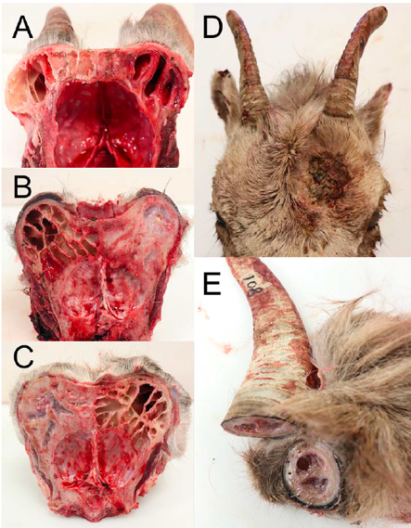
Answer: Mycoplasma ovipenumoniae (seen in 50% of sinus lesions) and Trueperella pyogenes (seen in sinus tissue of all ewes with sinus lesions in 2024 JWD study). M. ovipneumoniae has been associated with epizootic pneumonia in big horn sheep, and this results in all-age mass mortality events followed by periods of low lamb recruitment and impacted juvenile survival.

Taylor, Laci C., et al. "PHEOCHROMOCYTOMA IN SIX SCIMITAR-HORNED ORYXES (ORYX DAMMAH)." Journal of Zoo and Wildlife Medicine 56.4 (2025): 782-789. - reviewed by HSS
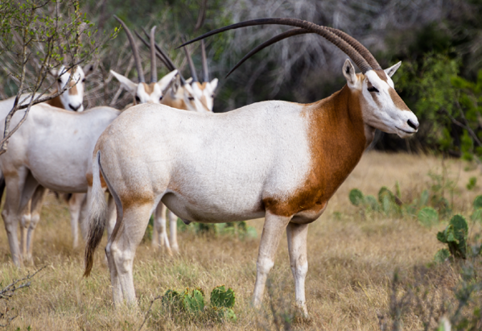
Question: Which of the following statements is most correct regarding pheochromocytoma in scimitar-horned oryx?

- The majority of tumors were malignant
- The majority of animals had concurrent evidence of cardiac hypertrophy
- The majority of animals were <10 years of age
- The majority of tumors were presumptively non-functional
- The majority of animals were found deceased with no premonitory signs

Answer: D

Explanation: Majority of tumors were benign, and all were presumed to be non-secretory. There were no antemortem clinical signs or post-mortem evidence of hypertension or other sequelae of catecholamine release, such as cardiac hypertrophy or retinal vascular changes. All were geriatric (15-22 yo). All animals were euthanized for declining quality of life.

Fisk, Elis A., et al. "Abortion and neonatal mortality due to Toxoplasma gondii in bighorn sheep (Ovis canadensis)." The Journal of Wildlife Diseases 59.1 (2023): 37-48. - reviewed by HSS
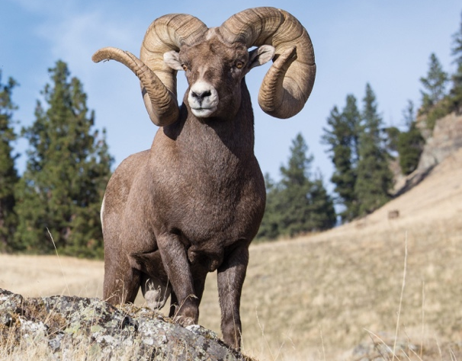

Question:

Histopathology of an aborted bighorn sheep fetus reveals necrotizing encephalitis and glial nodule formation along with extracellular protozoal cysts in the brain, heart, and skeletal muscle. What are the definitive hosts for your top differential?

Answer: Felidae, toxoplasmosis caused by T. gondii

J Wildl Dis. 2023;59(2):288-298.
Summarized by MR

Cooling by Dousing with Cold Water Does Not Alter the Pathophysiological Biochemical Changes Induced by Capture in Blesbok (Damaliscus pygargus phillipsi)
Leiberich, Fitte, Burroughs, Steyl, Goddard, Haw, Boesch, Kohn, Meyer

In a study evaluating the effects of active cooling with cold water after capture in Blesbok (Damaliscus pygargus phillipsi), which of the following bloodwork parameters had no significant difference between groups that were chased and those that were not?

- Creatine kinase
- Glutamate dehydrogenase
- Aspartate aminotransferase
- Creatinine
- Gamma-glutamyl transferase

Answer: E. GGT. CK, AST, GLDH, creatinine, lactate, and cTnI were higher in chased groups than non-chased groups.

J Wildl Dis. 2025;61(2):285-296.
Summarized by MR

Diagnostic Strategies and Strain Typing for Johne’s Disease in Wood Bison (Bison bison athabascae)
Leiberich, Fitte, Burroughs, Steyl, Goddard, Haw, Boesch, Kohn, Meyer

In a study evaluating diagnostic strategies for Johne’s Disease in Wood Bison (Bison bison athabascae), which mycobacterial tissue culture samples were positive in all six individuals necropsied?

- Distal jejunal and duodenal lymph nodes
- Midjejunal and distal jejunal lymph nodes
- Distal ileum and transverse colon
- Inguinal and ileocecal lymph nodes
- Distal jejunal and retropharyngeal lymph nodes

Answer: B. Midjejunal and distal jejunal lymph nodes. Others had variable positivity.

Journal of Wildlife Diseases, 60(2): 461-473, 2024
DETECTION AND PHYLOGENETIC ANALYSIS OF ORF VIRUS AND MUSKOX RHADINOVIRUS 1 FROM MUSKOXEN (OVIBOS MOSCHATUS) IN THE CANADIAN ARCTIC
Dalton et al

Question: List three reasons that Muskoxen are particularly at risk of contracting Contagious ecthyma and other infections.

Answer:
- Low genetic variability
- Low diversity of the major histocompatibility complexes
- Behavior – Muskoxen rub their faces on prominent objects in their surroundings such as rocks that can lead to indirect transmission via fomites

Journal of Wildlife Diseases, 61(3): 563-573, 2025
MYCOPLASMA BOVIS OUTBREAK AND MAINTENANCE OF SUBCLINICAL INFECTIONS IN AN EXPOSED COHORT OF JUVENILE AMERICAN BISON (BISON BISON)
Buttke et al

Question: What age class and sex of American bison (Bison bison) experiences the most severe Mycoplasma bovis necrosuppurative bronchopneumonia?

- Calves, Male
- Juvenile, Female
- Juvenile, Male
- Adult, Female
- Adult, Male
Answer: D

