2025 JWD 61.4
Outbreaks of Highly Pathogenic H5N1 Influenza A Virus infection in Black Vultures (Coragyps atratus), USA, 2022
Cunningham, Mark W., et al. - reviewed by MGF

Mortalities in Black Vultures (Coragyps atratus) caused by A/goose/Guangdong/1/1996 2.3.4.4b lineage highly pathogenic (HP) influenza A virus (IAV) H5N1 (HP H5N1) were detected in Florida, USA, on 14 February 2022. By the end of 2022, at least 2,674 and 5,707 deaths where HP H5N1 infection was confirmed or suspected had been documented in Florida and the USA as a whole, respectively. Reported vulture mortalities at die-off locations nationwide ranged from 1 to 700. In Florida and Pennsylvania, USA, antibodies to both H5 and N1 subtypes of IAV were detected in apparently healthy Black Vultures sampled ≤12 mo after mortality events. Antibodies to these subtypes were not detected in Black Vultures at sites in Kentucky and Tennessee, USA, where HP H5N1 was not detected, nor in Pennsylvania vultures sampled before HP H5N1 introduction into North America. Infections in vultures probably originated through scavenging of infected bird carcasses, but once in the vulture population, HP H5N1 infections may have been maintained by conspecific scavenging. Black Vultures can serve as an indicator species for HP H5N1 in North America, and they may sustain an outbreak after infection rates have declined in other species.

Background
- Influenza A viruses (IAVs) divided into 19 hemagglutinin (HA) and 11 neuraminidase (NA) subtypes; categorized as low pathogenic (LP) or highly pathogenic (HP)
- Anseriformes & Charadriiformes: reservoir, all LP IAV subtypes subclinically maintained
- Transmission primarily via fecal-oral route in birds; however scavenging of infected animal can results in infection
  - HP H5N1 remain infectious in poultry carcass up to 20d in muscle; 3d liver at 20C
- Gs/GD H5 clade 2.3.4.4 South Korea 2014 → Europe/Africa w/ unprecedented mortality events in wild birds → 2021 Gs/GD H5N1 subclade 2.3.4.4b Canada → North America spread to many birds/mammalian species, linked transmission by scavenging and predation
- Goal: characterize epidemiology of HP H5N1 subclade 2.3.4.4b in Black Vultures in NA 2022
Methods
- Cloacal-tracheal or oropharyngeal swabs from some vultures; positive test = confirmed case vs suspect = those mortalities not tested but observed at confirmed HPAI die-off locations
- Collected serum from healthy (no outward sign of dz) vultures from FL, KY, PA, TN; die-offs associated w/ HP H5N1 in FL & PA nearby prior to serum sampling → screened for antibodies
- Collected water, soil, wet feces, dry feces at a state park in Florida post mortality event to identify potential env reservoirs for HP H5N1
Results
- Distribution of confirmed cases followed Atlantic Flyway (Approx from NE and AL down to FL)
- All black vultures confirmed/suspected were adults; infection in nestlings NOT observed
- > 5.7K deaths confirmed or suspected by HP H5N1 in 12 states in 2022 (likely underestimate)
- In FL, 2022 2.6K mortalities, 8.3% confirmed, 91.7% suspect; vs 17 dead in 2021; at least 133 separate die-off locations identified; average duration of die-off 3 months
  - Clinically affected vultures often in/near water; weak, depressed, lethargic but aware of surroundings and attempted to escape when approached; suspected polydipsia
  - Weakness progressed until vulture moribund; death often due to drowning
  - Some ataxia, torticollis, corneal opacities +/- serosanguinous fluid in nares/oral cavity
  - Observed conspecific scavenging at most die-off locations
- Low prevalence antibodies to HP H5N1 in KY, TN (where no mortalities previously reported)
- High prevalence of IAV antibodies in FL and PA at or near where HP H5N1 infections confirmed
- All environmental samples negative for IAV → supports scavenging as spread of infection
Discussion
- HP H5N1 AIV likely arrived in FL via migratory waterfowl Jan 2022; spilled into black vultures through scavenging of infected carcasses → remained in pop due to high pop numbers, communal roosting/feeding, conspecific scavenging
- Serology reviewed from before 2022 showed minimal antibodies; vultures may have been immunologically naive before the H5N1 introduction
- In FL, large number of vultures had antibodies supporting exposure to HP H5N1 w/o apparent residual clinical effects
- Folks attempted to remove carcasses in FL to prevent predation but logistically difficult

2025 JZWM 55.1
The impact of supplementary feeding of pig carcasses on plasma vitamin e concentrations in captive cape vultures (Gyps coprotheres)
Naidoo, Vinny, Lauren N. Havenga, and Kerri Wolter - summary by MGF

With vulture population numbers on the decline globally, many countries resort to supplementary feeding to maintain colony health. Despite what is perceived as adequate feeding in South Africa, colonies are still characterized by poor breeding success. One reason could be that supplementary sites fail to meet micronutrient needs of birds. With results from zoological gardens indicating that some carcasses are low in their vitamin E concentrations, vitamin deficiencies may be an underlying problem. For this study it was determined if the feeding of whole pig carcasses, a common food item, could have a negative effect on plasma vitamin E concentrations in a captive colony. Plasma vitamin E concentrations were 7.38 ± 2.92 and 4.51 ± 1.24 after feeding whole pig carcasses (n = 14). Behaviorally, the birds also avoided the viscera and fat when feeding. Reasons for their low vitamin E concentrations could have resulted from the birds consuming only the pork meat, which is known to be low in vitamin E, or from natural peroxidation because of the high fat content of the carcasses. The study thus highlights the need for further research to ascertain the impact of feeding pig carcasses on wild vultures feeding routinely at supplementary feeding sites and also for considerations towards vitamin E supplementation.

Background
- Vultures globally endangered (lack free ranging pray); many rehab or wild colonies supplement carcasses to meet nutritional needs
- Unexpected deaths: ataxia, paralysis, seizures, progressive weakness; negative for viral dz (eg West Nile, encephalitis viruses); necropsies NSF except rapid autolysis of brain/spinal cord
- Cause unknown but consistent with Vitamin E deficiencies causing encephalomalacias
  - CS: brain hemorrhage w/ edema/necrosis, seizures, ataxia, dysmetria, paresis…
  - E is not made by the body and has to be absorbed through GI tract as fat-soluble vitamine
  - Plants are good source, muscle is bad source → vulture food = mostly muscle tissue
  - Pig meat has lowest levels Vit E due to high levels polyunsaturated fats; after death peroxidation of these fats depletes vitamin E stores
  - Pig meat highest concentration = liver, back fat; lower than a whole adult mice or rat
Methods
- 2 groups: 1 group of birds fed pig carcass diet; other group fed goat carcass
- Vitamin E measured at day 0 and 10 (food offered at days 1 & 8)
Results
- Pig group birds avoided fat and digestive tract, only fed on muscle and visceral tissue
- Vit E significantly lower in both groups after diet trial (dropped by ~40%)
Discussion
- 50% of zoo vultures supplemented with vitamin E
- Compared to other studies, Vit E levels barely sufficient → likely why a good number of the animals in this study population have previously seen unexpected neuro clinical signs and death

Takeaway: Vultures fed pig carcasses without additional nutritional supplementation are not getting adequate vitamin E. Vultures eat more muscle than fat (muscle has lower Vit E) and study showed even those fed goat carcass had lower Vit E. Recommend feed quickly after death to minimize reduction in stored Vit E and supplementing Vitamin E to avoid neurologic clinical signs associated with low levels.

Journal of Avian Medicine and Surgery, 39(1): 12-19, 2025.
SQUAMOUS METAPLASIA ASSOCIATED WITH HYPOVITAMINOSIS A OF THE CROP AND SALIVARY GLANDS IN CAPTIVE FALCONS IN THE UNITED ARAB EMIRATES
Peter McKinney et al. – Reviewed by LMM

Abstract: Twenty falcons exhibiting tongue swelling, oropharyngeal pustules, and crop mucin gland impactions were presented for veterinary care to the Al Aseefa Falcon Clinic in Dubai, United Arab Emirates, from October to January 2018–2021. Squamous metaplasia was confirmed in 2 euthanized falcons from this group. A study was undertaken to assess circulating concentrations of serum retinol in this group of diseased falcons (n = 20) compared with the values of a clinically healthy group (n = 20). Blood samples were collected and analyzed for concentrations of serum retinol. Comparison of serum retinol concentrations between the 2 groups showed a significant difference (P < 0.001), with clinically normal falcons having a median (25–75%) range of 1.43 (1.34–1.66) mg/mL and clinically abnormal falcons 0.17 (0.11–0.36) mg/mL. The significant difference in the serum retinol concentrations between groups provided strong evidence that the squamous metaplasia was associated with hypovitaminosis A. These results demonstrate that circulating serum retinol concentrations may be useful for assessing and diagnosing hypovitaminosis A in cases exhibiting distinctive lesions in the tongue, salivary glands, crop, and oropharynx.

Key Points:
- Vit A = Fat-soluble, essential vitamin
- Dietary Vit A available as preformed Vit A (retinol, retinyl esters) and provitamin A carotenoids (beta-carotene, alpha-carotene)
- Vit A deficiency known to cause squamous metaplasia
  - In birds, Vit A deficiency causes not only changes to epithelium of digestive, resp, urinary, and repro tracts, but also reported to lead to issues with embryogenesis and growth, carbohydrate metabolism, vision, immunity, and reproduction
- Vit A requirements vary between avian species
  - Granivorous species get Vit A from beta-carotene in grain-based diet that is converted to retinol after ingestion
  - Birds of prey ingest Vit A as retinol and retinol esters from their prey
- In this case, numerous falcons presented to a vet hospital in the UAE with tongue swellings, impactions of the crop mucin glands, salivary gland swellings, and oropharyngeal raised pustules suggestive of hypovitaminosis A. Additionally, these birds had nonspecific signs of lethargy, reduced appetite, and weight loss.
- Two groups were compared – 20 healthy individuals fed unsupplemented whole carcass diet (rats, quail, chicks, chicken) vs. 20 diseased individuals that had been switched from whole carcass diet to unsupplemented pigeon muscle at least 2 months prior to presentation
- Microscopic exam of smears from diseased bird lesions identified squamous epithelial cells with few bacteria and minimal inflammatory cells
- Two individuals with most severe lesions were euthanized
  - Identified swollen maxillary salivary glands, tongues covered in yellow film, pustules in orophanryngeal mucosa
  - Histopath identified extensive hyperplastic squamous metaplasia of the epithelium of crop mucin glands and focal replacement of cuboidal or columnar epithelium by stratified squamous epithelium
- Significantly lower serum retinol levels in diseased birds as compared to healthy birds. No significant differences in retinol concentrations by age, sex, or species.
- Squamous metaplasia secondary to hypovitaminosis A has been reported in many bird species (chickens, turkeys, ducks, parrots, canaries, penguins) but this is the FIRST REPORT of it in Falconiformes.
- Vit A essential for maintenance of secretory tissues. In this case series, euthanized birds showed classic signs of squamous metaplasia where metaplastic changes at the salivary glands resulted in duct blockage and symmetrical swellings developed in the rostral choana, oropharynx, tongue, and salivary glands.
- Squamous metaplasia of gland in upper resp and digestive tracts PATHOGNOMONIC for hypovitaminosis A, w/ secondary bacterial infections a feature of the condition.
- Vit A ONLY acquired through dietary intake in birds, so suspect that was cause in these cases
  - In Falconiformes, and other raptors, feeding whole prey not just meat is critical. Liver and skin is essential to ensure they receive fat-soluble vitamins.
- Poultry fed a Vit A deficient diet will start to show signs after 1-5 months of that diet. This was similar to the falcons in these cases.
- The earliest lesions were identified in the esophagus and crop mucin glands (this is similar to disease progression in poultry).
- Differential Diagnoses for the lesions in this case series Pseudomoniasis, Trichomoniasis, and Candidiasis

Take Home Point: Squamous metaplasia presumptively secondary to hypovitaminosis A was documented in 20 cases of Falconiformes in the UAE. The serum retinol levels were significantly lower in affected birds when compared to 20 clinically normal birds. Authors posit that this is likely secondary to diet, as affected birds were fed exclusively a pigeon meat diet while unaffected birds received whole prey. Affected birds likely needed liver and skin from prey to get appropriate Vit A.

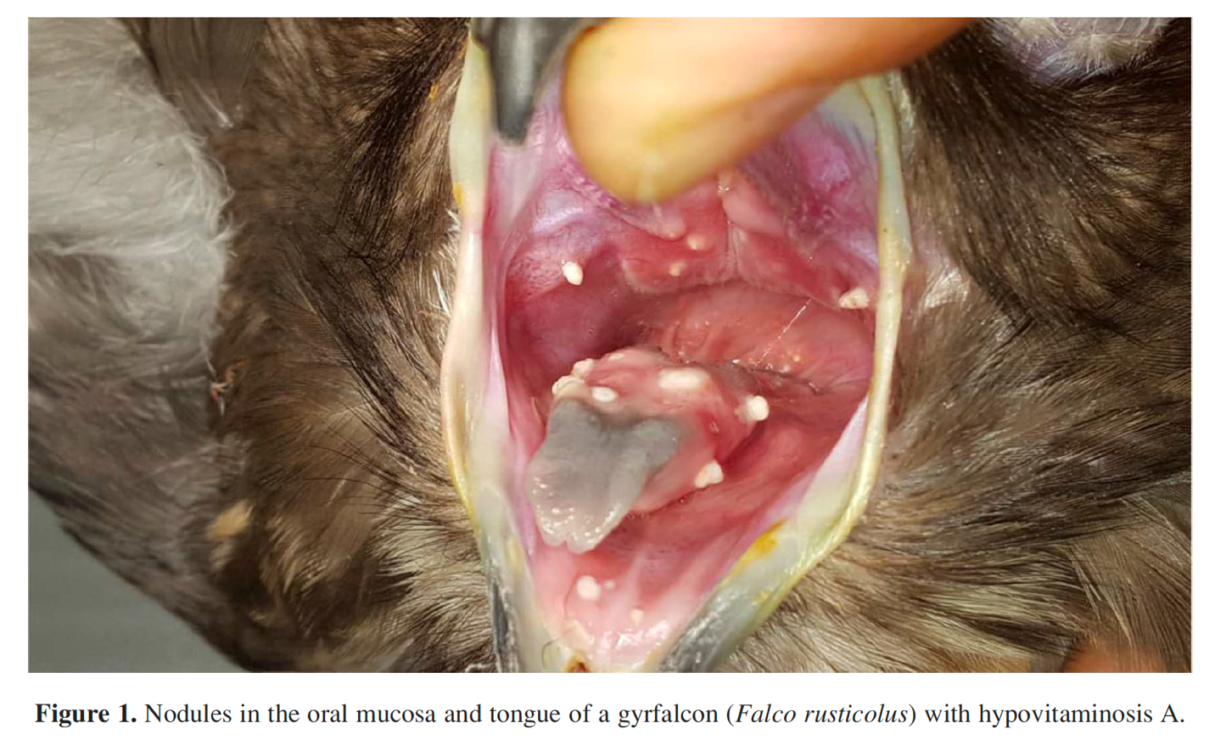

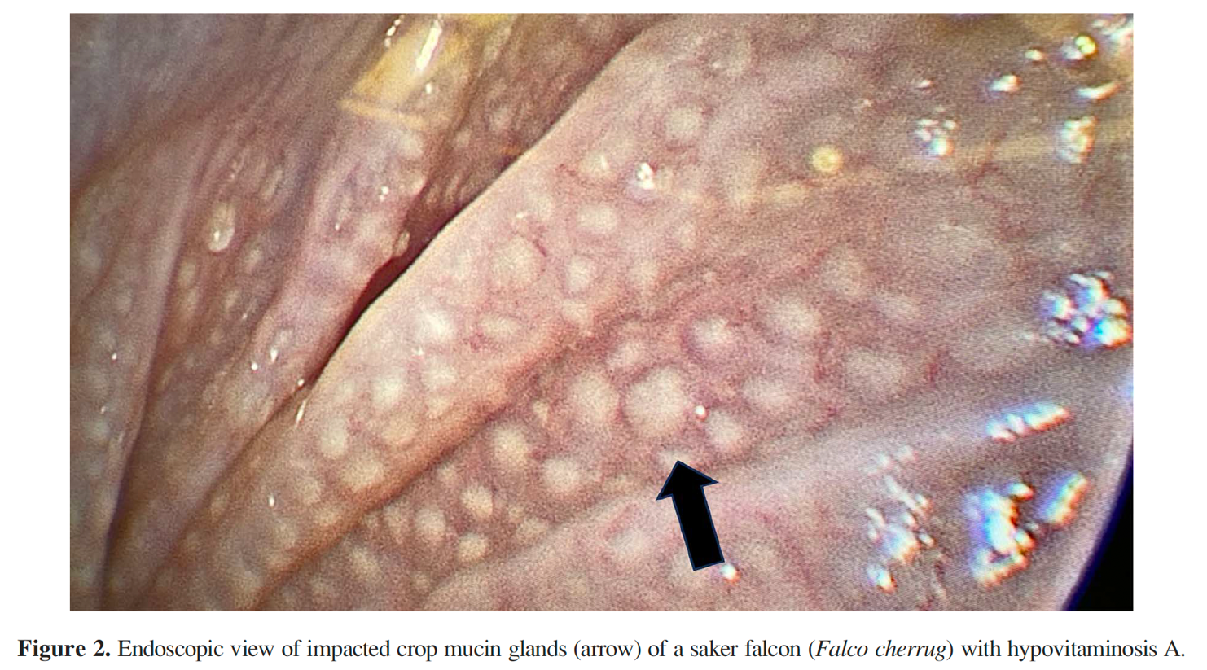

------------------------------------------------------------------------------------------------------------------------------------------

Journal of Avian Medicine and Surgery, 39(1): 39-45, 2025.
TAKOTSUBO CARDIOMYOPATHY-LIKE TRANSIENT SYSTOLIC DYSFUNCTION IN TWO BALD EAGLES (HALIAEETUS LEUCOCEPHALUS)
Samantha Scott, Michael Aherne, Catherine Georges, Darcy B Adin, James FX Wellehan – Reviewed by LMM

Abstract: Two wild adult bald eagles (Haliaeetus leucocephalus) were presented to the University of Florida zoological medicine department on separate dates, both being unable to fly. One eagle had a fracture of the left humerus, and the second had no external injuries. Thoracic radiographs of both animals revealed cardiomegaly, and echocardiography revealed reduced systolic function. Both eagles were treated with oral pimobendan until recheck echocardiography documented normal systolic function. Several weeks after pimobendan was discontinued, the echocardiograms of both eagles showed normal systolic function and were considered normal. The transient nature of systolic dysfunction in these 2 eagles could be consistent with a stress-induced, Takotsubo cardiomyopathy-like phenotype although traumatic myocarditis or adverse anesthetic reactions must also be considered.

Key Points:
- Case 1
  - Case 1 underwent anesthesia for a humeral fracture repair. On radiographs, identified cardiomegaly and an ECG revealed frequent atrial premature complexes with variable P-wave morphology and underlying sinus bradycardia (Fig 2)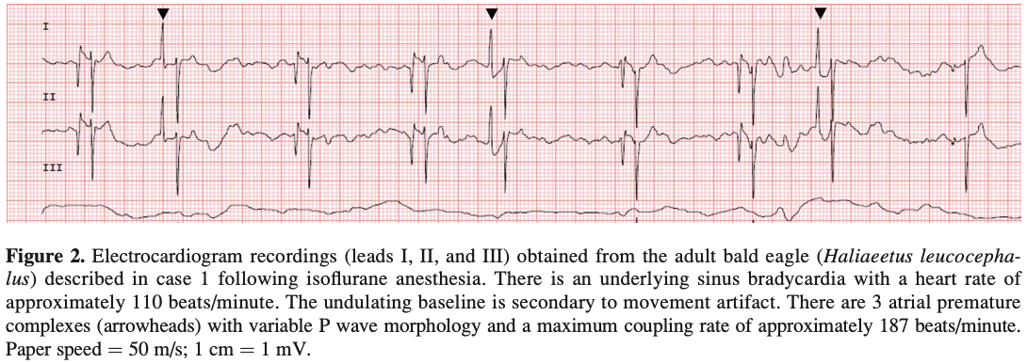
  - Case 1 echo identified subjective left-sided cardiomegaly and decreased left ventricular ejection fraction. Right-side normal in size but right ventricular systolic function decreased. Hepatic veins were prominent. All findings consistent with reduced systolic function compared to normal and pimobendan therapy started.
  - Recheck echo 3 days later and systolic function was markedly improved, so pimobendan was discontinued
  - Third echo 3 days after the second recheck confirmed normal systolic function and normal sinus rhythm
- Case 2
  - Case 2 survey rad’s identified cardiomegaly
  - ECG showed 2nd degree AV block with sinus rate of 170 bpm and ventricular rate of 80 bpm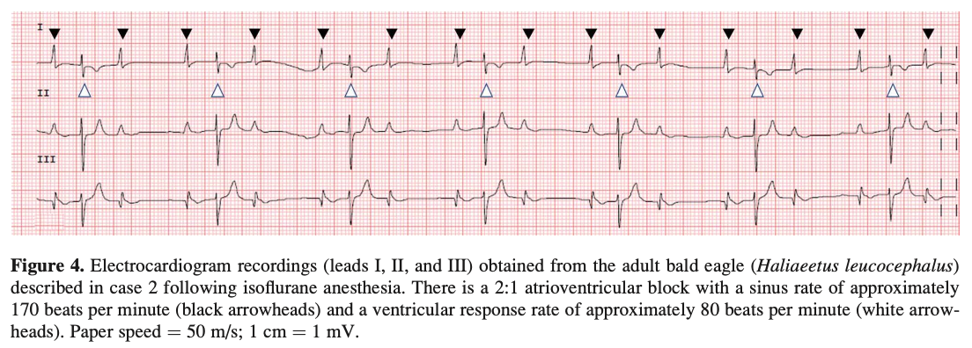
  - Echo identified poor left ventricular systolic function with decreased ventricular ejection fraction and therapy with pimobendane was initiated
  - ECG and echo were improved on recheck 2 weeks later and pimobendane was discontinued
  - Third recheck echo a week after the second was performed and the previously noted improvement was static
- In this case series, based on rapid resolution and apparent lack of clinical signs related to cardiac dysfunction, secondary cardiomyopathy was prioritized over primary cardiomyopathy – most suspicious of stress-induced cardiomyopathy (akin to Takotsubo cardiomyopathy or “broken-heart syndrome” in people), traumatic myocarditis, myocardial stunning, or secondary to recent anesthetic events using isoflurane
- Takotsubo cardiomyopathy = well-described in people, there is a reversible reduced systolic function and ballooning of the left ventricle secondary to extreme physical or emotional duress; proposed mechanism is catecholamine-induced cardiotoxicity
- Reminder Note: Bald eagles are sensitive to isoflurane anesthesia and arrhythmias secondary to isoflurane have been described including second degree AV block, atrial premature complexes, sinus tachycardia, T-wave depression, and sinus arrest. It is now unclear if isoflurane is the cause of this or stress prior to start of anesthesia could be causing systolic dysfunction and these arrhythmias.

Take Home Point: This study identified cardiomyopathy in two Bald eagles that is most consistent with Takotsubo cardiomyopathy (or “broken heart syndrome” in people), a cardiomyopathy caused by stress that is reversible. In these cases, cardiomyopathy resolved rapidly after brief treatment with pimobendan.

Journal of the American Veterinary Medical Association, 261 (2023)
Summarized by MR

An avian Modified Glasgow Coma Scale as a prognostic indicator in raptors with head trauma
Kari Foss, DVM, MS, et. al

Abstract:
OBJECTIVE: To develop a Modified Glasgow Coma Scale (MGCS) for use in raptors presenting with head trauma and assess the agreement of the MGCS scores between examiners with varying backgrounds, and to assess the prognostic value of the avian MGCS in raptors with head trauma.
ANIMALS: 156 native raptorial species.
METHODS: All raptors received an MGCS assessment within 8 hours of their presentation, between January 1, 2018, and December 31, 2019. For the first objective, the assessment was performed by a veterinary student, a wildlife veterinarian, and a board-certified or resident veterinary neurologist. Each animal received a score in 3 categories (motor activity, level of consciousness, and brain stem reflexes) and an overall score. For the second objective, the MGCS scoring was performed by the intaking clinical team member and survival after 48 hours was documented.
RESULTS: Agreement between the 3 individual scores was assessed via Cronbach α and intraclass correlation. There was excellent-good agreement in all 3 assessment categories as well as the overall score. Univariate associations between survival and demographic factors were determined using the χ2 test. Overall, raptors with a total MGCS of < 10 were less likely to survive than those with a score > 12.
CLINICAL RELEVANCE: An avian-specific MGCS demonstrated good-excellent agreement among raters of various backgrounds in assessing raptors with head trauma. Additionally, this study showed that an avian-specific MGCS may be correlated with the probability of survival within the first 48 hours after presentation to rehabilitation facilities in raptors with head trauma.

Background:
- Glasgow Coma Scale (GCS) = objective evaluation of the level of consciousness in human patients by assessing motor, verbal, and eye responses: positive linear relationship between sum scores and mortality in head trauma
- Modified GCS (MGCS) = evaluates motor activity, brain stem reflexes, and level of consciousness
- Blunt force trauma is a significant cause of M&M in raptor species, with collisions into anthropogenic structures and vehicles being most common
  - Oculofacial/head trauma, bleeding of eyes, nares, mouth
- Objectives:
  - To develop an avian specific MGCS for use in raptors presenting with head trauma and assess agreement of scores between examiners with varying backgrounds
  - To assess the prognostic value of the avian MGCS in raptors with head trauma
- Hypothesis: As based on the literature in human and veterinary medicine, we predicted that scores ≤ 8 would have a higher mortality rate than those with a score > 8.

Summary:
- Utilizing canine MGCS, verbiage was adjusted to account for raptor bipedalism and presence of wings
  - 3 assessment components: motor activity, level of consciousness, brain stem reflexes
  - Each scaled 1 – 5, total score of 3 - 15
- Inclusion: raptor species presenting to one of three rehabilitation centers (two university VTHs, one WRC) with known history of head trauma or PE findings (explicitly defined) consistent with head trauma, Jan 2018 – Dec 2019
- Exclusion: Euthanized in first 48 hours unrelated to head trauma: open fractures or coagulopathy
- Each individual received 3 separate, blinded scores: vet student, wildlife veterinarian, boarded neurologist or resident in vet neurology. – this was only performed at one institution, limitation
  - Intra-rater agreement by Cronbach alpha and intraclass correlation
- Demographic info (age class, sex if possible, species) collected – univariate associations between factors and MGCS by fisher exact
- N = 156 raptors of 16 species
- Higher survival associated with higher motor activity scores, higher level of consciousness scores, higher brain stem reflex scores.
- NSD in survival by species of sex
- Diurnal birds were more likely to survive than nocturnal birds
- Good – excellent agreement regardless of experience
- More specifically, animals with a total score of > 12 were more likely to survive and those with a total score of < 10 were unlikely to survive.
- Assessment of brain stem reflexes presents a challenge in assessing the avian MGCS due to the frequent presence of concurrent ocular trauma – pupillary size, constriction, etc.
  - Concurrent ocular trauma may give a lower score by default
  - PLR also confounded by striated skeletal muscle of iris sphincter
- Score level of consciousness was higher in adult raptors than juveniles.
  - In humans, studies have shown elderly patients with TBI have higher GCS scores (can have blunted or delayed clinical response) than juvenile patients with similar severity.
- Single score assessment for prognosis in this study – but multiple concurrent GCS scores are informative in human and canine medicine
- Assessment within first 8 hours is a wide time frame and could have changed since intake

Take Home Points:
- Higher score = higher likelihood of survival
  - Animals with scores >12 were more likely to survive than those with scores <10
- There was excellent agreement between examiners for motor activity, brain stem reflex, and overall score
- There was good agreement for assessing the level of consciousness
- Higher survival was linked to treating institution and higher scores in motor activity, consciousness, brainstem reflexes, and total MGCS score
- Survival did not differ by species, but diurnal birds had higher survival than nocturnal ones

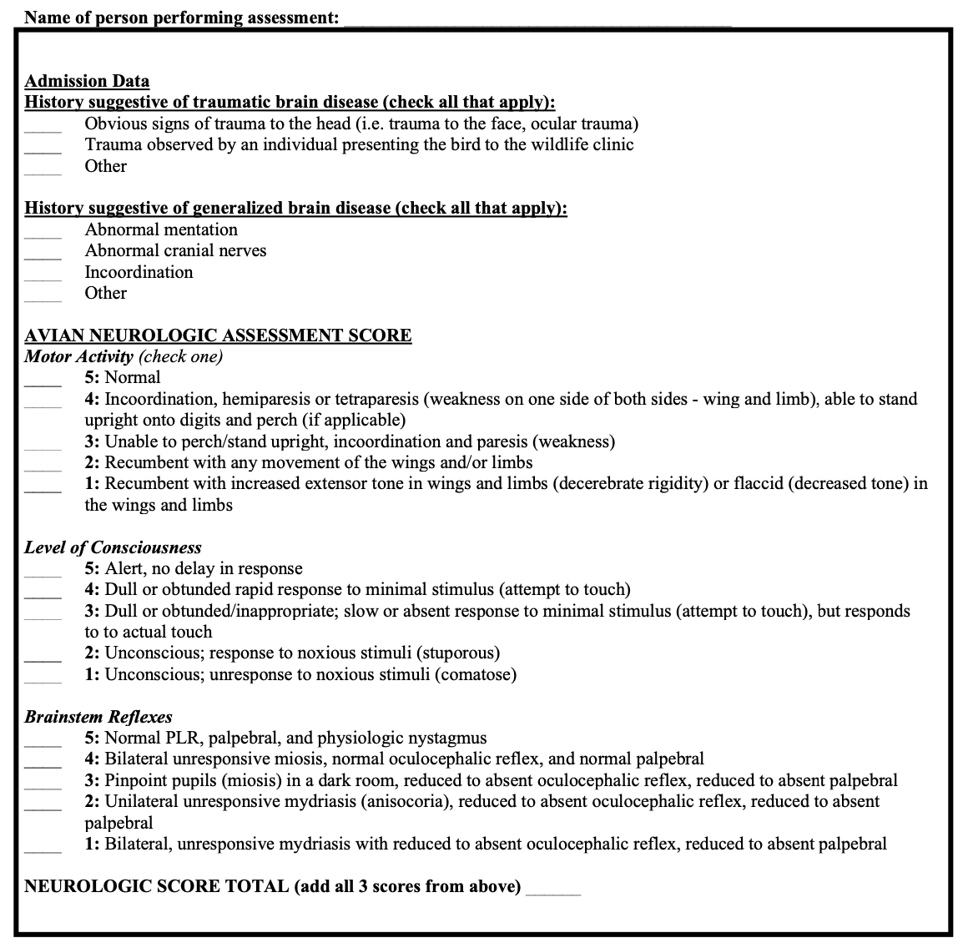
Am J Vet Res. 2025;86(3)
Summarized by MR

Chlamydial infections in free-ranging raptors presenting to a university veterinary medical teaching hospital (1993-2022).
Hawkins MG, Blair E, Keel MK, et al.

Abstract
OBJECTIVE: To describe the prevalence, clinical findings, lesions, and risk factors associated with chlamydial infections in free-ranging raptors presented to a university veterinary medical teaching hospital.
METHODS: Medical records retrospectively searched for raptors admitted from January 1993 through April 2022 were tested for Chlamydia spp infections using quantitative PCR (qPCR), immunohistochemistry, culture, and sequencing. Findings were collected and analyzed. Multivariable logistic regression analyzed the association between Chlamydia spp infection status and risk factors, including age class, species, sex, and season of admission.
RESULTS: The prevalence for cases that tested positive for Chlamydia spp on 1 or more diagnostic tests, including mucosal qPCR samples for Chlamydia spp, tissue PCR for C. buteonis, and mucosal qPCR genotyped as C. buteonis, was 1.9% (74 of 3,983). All positive cases were from the genus Buteo (n = 74). Juvenile birds and winter season had higher odds of infection. All birds were in poor body condition (n = 74), often with moderate-to-severe CBC and biochemistry abnormalities consistent with multiorgan chronic inflammatory disease, emaciation, and dehydration. On postmortem examination of Chlamydia-positive birds (58 of 74), hepatitis (44 of 56), nephritis (24 of 39), splenitis (22 of 53), airsacculitis (21 of 43), myocarditis (21 of 39), and pneumonia (21 of 38) were common lesions, with intracellular bacteria in multiple tissues.
CONCLUSIONS: Signalment, season of admission, clinical signs, clinicopathologic findings, and Chlamydia-specific testing identified chlamydial infections in free-ranging raptors. Appropriate protections to prevent potential zoonotic transmission in clinical wildlife rehabilitation settings are recommended.
CLINICAL RELEVANCE: Many clinical parameters used to identify C psittaci infection in parrots can also be used to identify chlamydial infections in raptors.

Background:
- obligate intracellular, gram-negative bacteria
- C. psittaci widely distributed, frequently discussed zoonotic pathogen
  - biphasic life cycle
    - infectious form—the elementary body, shed across oropharyngeal fluids, ocular, nasal discharge, or urine/feces.
    - noninfectious, metabolically active form—the reticulate body.
  - C sx: conjunctivitis, ocular and nasal discharge, dyspnea, lethargy, diarrhea, anorexia, emaciation, and sudden death
- environmentally stable and can remain infectious in dried feces for months
- Objectives: prevalence, clinical findings, lesions, spatiotemporal distribution, and risk factors associated with chlamydial infections in free-ranging raptors presented to a university veterinary medical teaching hospital from 1993 through 2022.
- PCR target: ompA gene (C felis and psittaci)

Summary:
- Medical records reviewed for search term ‘chlamy’
- Inclusion:
  - confirmed positive case - isolation via culture, Chlamydia spp DNA detection using in situ hybridization, or quantitative PCR (qPCR) of postmortem tissues in combination with characteristic pathology, clinical pathology, serology, or special staining (Gimenez or Machiavello)
  - suspected case - one in which clinical signs were consistent with Chlamydia spp in combination with a positive qPCR result from mucosal swabs or tissue samples, serology, or epidemiologic evidence of a link to a confirmed case.
  - noncase - not tested for Chlamydia spp or tested negative for Chlamydia spp on all diagnostic tests.
- Medical records and pathology review
  - Age: unknown, juvenile (hatch, second year), adult (third year, above)
- Mucosal swab for PCR and genotyping in n = 20 samples (unclear if this was retrospective opportunistic or modified prospective)
- N = 3,983 raptors, of those 270 were tested for chlamydial status
  - 1.9% (74/3983) met suspected or confirmed criteria, all were Buteo sp. (majority RTHA)
- Odds of testing positive were 2.5x higher in juveniles compared to adults
- Odds of testing positive were 15.8x higher in the winter, 8.9x higher in the spring than summer
- Odds did not differ by sex
- 100% in poor BCS
- Most (68/74) obtunded on presentation
- Lice reported in 16% of cases
- Aspergillosis (systemic or localized to the lungs or air sacs) was present in 16 of 74 positive or suspected cases (22%).
- 75% had anemia and leukocytosis, with 68% heterophilia and 66% bands
- CK/AST elevated, hypoalbuminemia, hypoglycemia
- The spleen and liver were the organs most commonly and severely affected by lesions consistent with chlamydiosis followed by the air-sacs, lungs, kidneys, and heart.
- Intracellular bacteria consistent with Chlamydia spp were identified on chlamydial IHC in 40 of 45 cases evaluated (88.8%).
- All 20 mPCR products submitted for genotyping were determined to be C. buteonis.
  - Because many cases were tested before C. buteonis–specific primers or sequencing were available, we cannot say with confidence that all cases are truly C. buteonis.
- Spatiotemporal analysis performed showed a cluster centered over a wildlife area thru the Pacific flyway

Take Home Points:
- Age was significant associated with infection status – higher odds of juvenile hawks testing positive compared to adult counterparts
- Winter and spring months significantly associated with infection
- Emaciation was a prevalent finding, with clinical signs of lower respiratory disease notably absent
- Elevated total WBC count, anemia, heterophilia with left shift, and monocytosis were common findings
- Hepatosplenomegaly was the most common necropsy finding
- Immunosuppression may lead to aspergillosis
- Juvenile hawks (especially in CA) that are emaciated with ectoparasite burden on exam and no evidence of trauma should have bloodwork or CBC/slide review performed to evaluate for leukocytosis.

Vuong, Kristina S., Michael Jones, and Linden E. Craig. "Postmortem Evaluation of Cardiac Valvular Disease in Bald Eagles (Haliaeetus leucocephalus) and a Golden Eagle (Aquila chrysaetos)." Journal of Avian Medicine and Surgery 37.1 (2023): 22-31. - reviewed by HSS
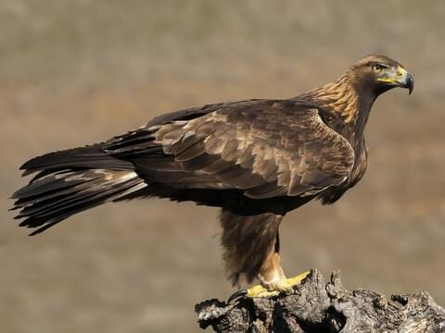
Abstract:
Limited data are available regarding cardiac diseases in birds of prey despite their prevalence in these avian species. Literature regarding valvular lesions in birds of prey is scarce and includes single reports of left atrioventricular valvular endocarditis in an adult, free-ranging, male bald eagle (Haliaeetus leucocephalus) and aortic valvular endocarditis in an adult, free-ranging, female red-tailed hawk (Buteo jamaicensis). The purpose of this study was to evaluate the prevalence, signalment, gross necropsy findings, and histologic lesions of valvular lesions in eagles. In this retrospective study, necropsy reports for 24 free-ranging and captive eagles were evaluated over a 15-year period (July 3, 2006–February 28, 2021). Six (25%; 95% confidence interval: 8.9–58.9) birds, 5 bald eagles and 1 golden eagle (Aquila chrysaetos), met the inclusion criteria. Five (83.3%) of the 6 birds had valvular degeneration, 2 (33.3%) had endocarditis, and Staphylococcus aureus was cultured from 1 (16.7%) of the endocarditis cases. The 6 eagles with valvular lesions were all captive adults. Four of the birds were female (66.7%), and the aortic and left atrioventricular valves were equally affected. Acute or chronic cerebral infarcts were present in all 6 birds. Valvular cardiac disease should be considered as a differential diagnosis in eagles exhibiting respiratory distress, neurologic signs, syncope, or in cases of sudden death.

Key Points:
- Cardiomyopathies, endocarditis, atherosclerosis, and pathogenic arrhythmias (eg, supraventricular premature complexes, second-degree atrioventricular blocks) have been described in raptors
- A retrospective study of postmortem examinations on 75 captive birds of prey found that 24% had cardiac lesions, including myofiber degeneration, myocarditis, endocarditis, pericarditis, atherosclerosis, and thrombi
- The most common valvular diseases described in companion birds include vegetative endocarditis and myxomatous degeneration of the left atrioventricular valve.
- Right-sided CHF is more common in avian species and often progresses to biventricular heart failure
- Birds are more prone to pulmonary hypertension due to the limited ability of the pulmonary capillaries to dilate within nonexpansile lungs.
- Cx of cardiac valvular disease are typically subclinical but can progress to dyspnea, syncope, and arrhythmias.
- The prognosis becomes guarded if secondary congestive heart failure develops
- The main clinical signs noted in the study birds prior to death were respiratory (dyspnea, inspiratory and expiratory wheezes), neurologic (seizures, torticollis, nystagmus, head tremors), or cardiovascular (syncope) in origin.
- 3 birds found dead, 2 euthanized due to poor prognosis, and 1 died despite aggressive supportive care
- The most common heart valves to have pathologic changes were the left atrioventricular valve (cases 1, 2, 4, 5) and aortic valve (cases 1, 2, 3, 6)
- The valvular lesions were characterized as either myxomatous valvular degeneration (cases 1, 3, 4, 6) or endocarditis (cases 2, 5)
- Heterophilic endocarditis affecting the left atrioventricular and aortic valves was present in case 2. Left atrioventricular vegetative endocarditis secondary to a Staphylococcus aureus infection was present in case 5.
- Acute or chronic cerebral infarcts were present in all cases
  - The acute cerebral infarctions were attributed to a turbulence-induced thromboembolism produced from the degenerate left atrioventricular and/or aortic valves
- Myxomatous valvular degeneration (MVD) was the most prevalent cardiac valvular lesion identified in this retrospective study of eagles.
  - Rarely reported in other avian species
- Staphylococcus species, Streptococcus species, Pasteurella multocida, E coli, and Pseudomonas species, are commonly cultured in avian vegetative endocarditis with the most common isolate being S aureus
- Endocarditis most common in chickens. Left AV and aortic valves most commonly affected in birds. Cx include lethargy, decreased appetite, death. Prognosis poor even with long-term abx therapy.
- Avian thrombocytes have longer clotting times and have less tight aggregates (less able to form shear-resistant thrombi ) that may result from differences in the GPIbα receptor
- Thromboemboli are rarely reported in birds. Thrombi move through the middle cerebral artery in both dogs and humans and result in weakness, syncope, altered mentation, and seizures, as observed in the eagles

Take-Home Message:
- Myxomatous valvular degeneration was the most prevalent cardiac valvular lesion identified in this study of eagles. Endocarditis was also appreciated in 2 animals. Left AV valve and aortic valve affected. All cases also had acute or chronic cerebral infarcts.

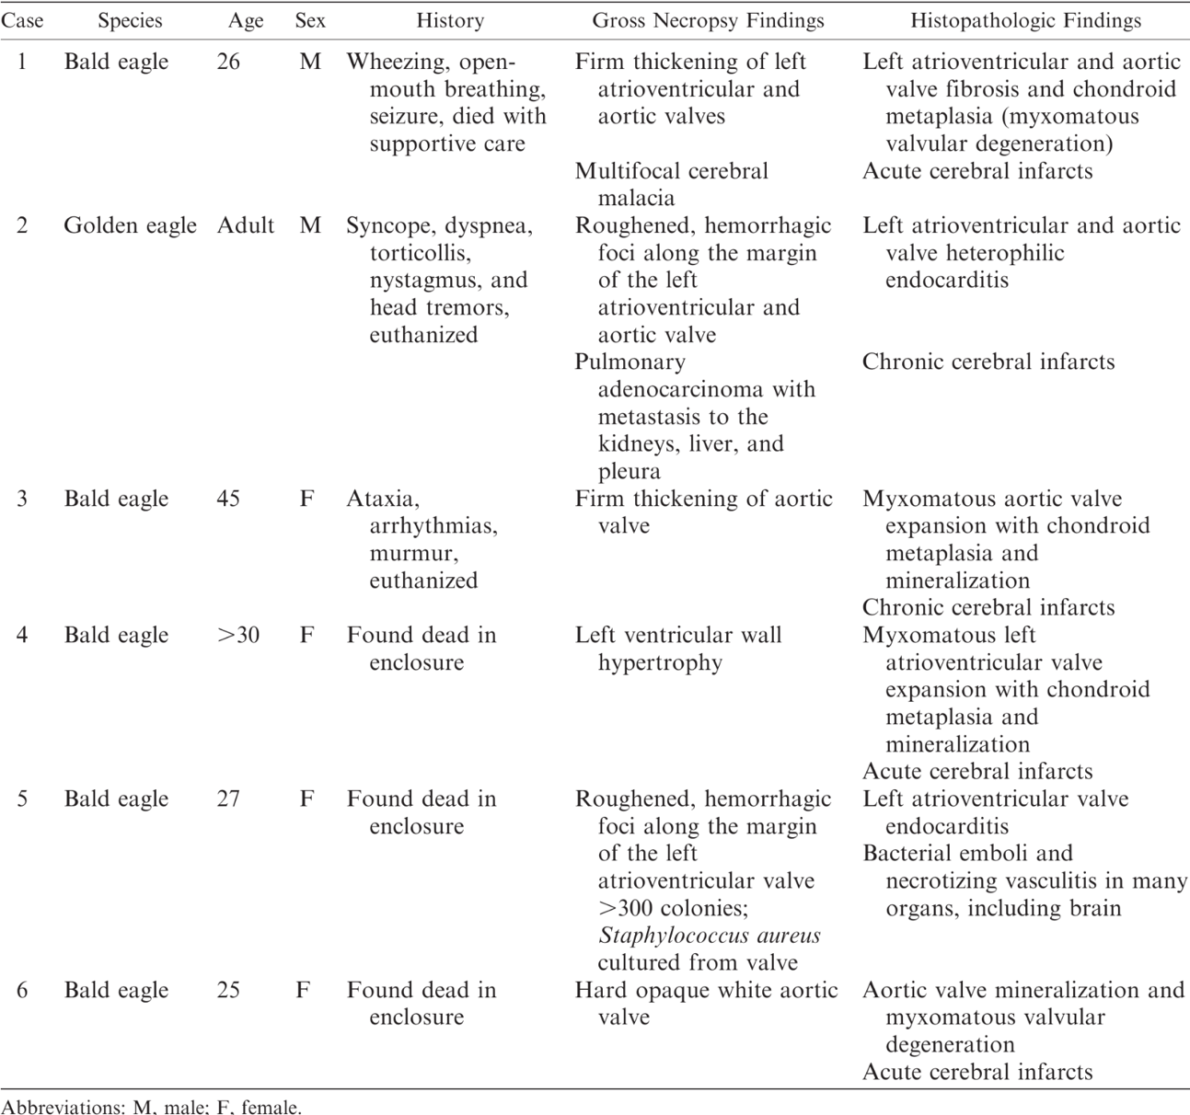

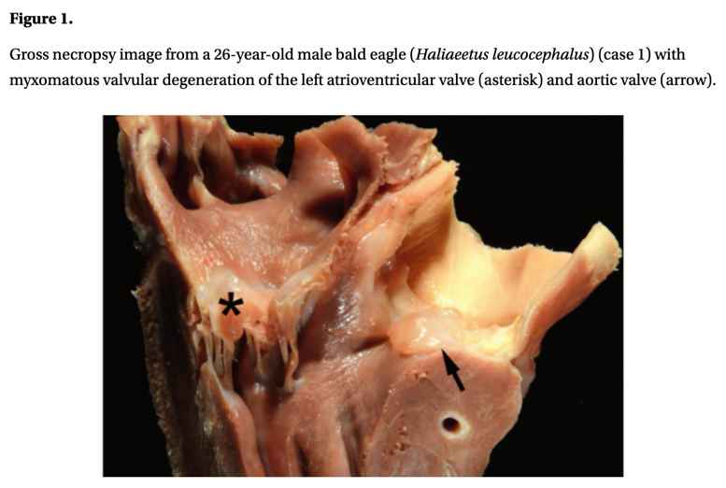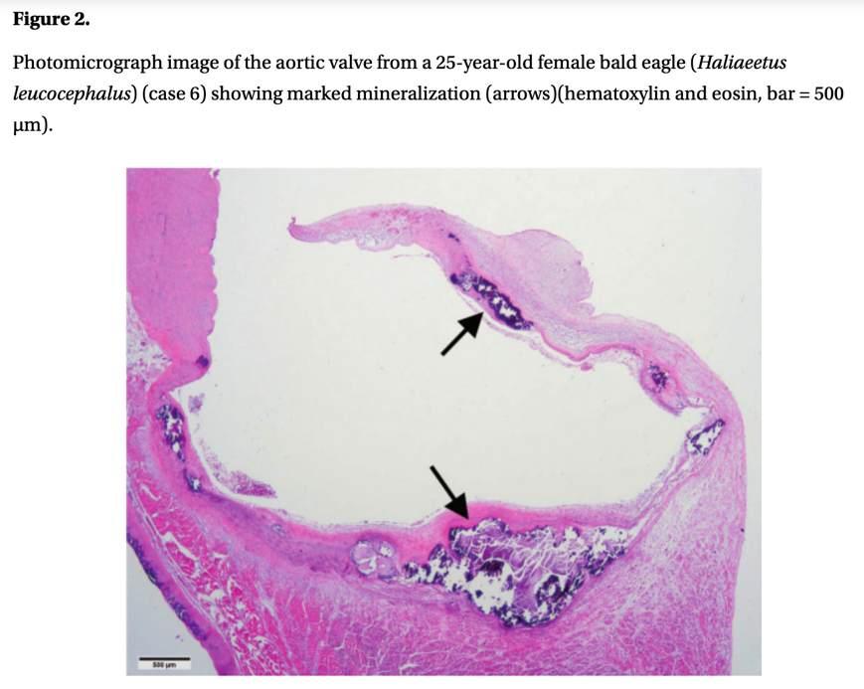
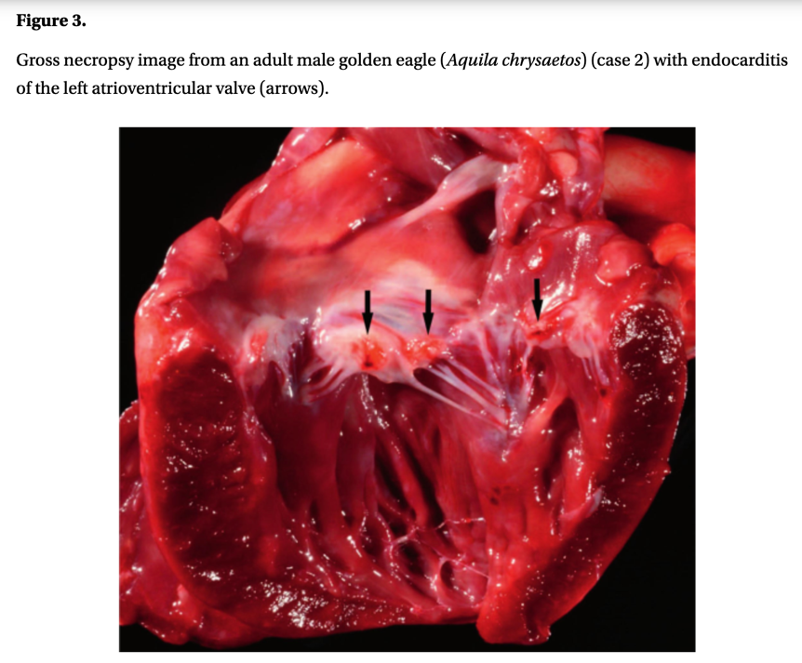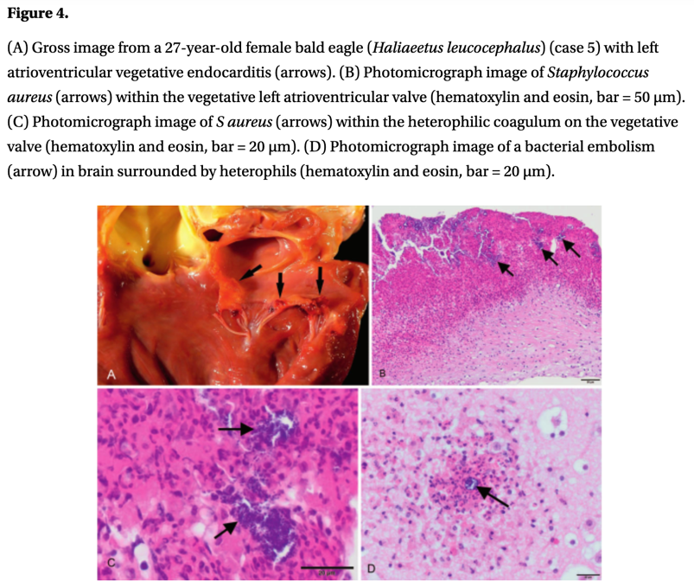
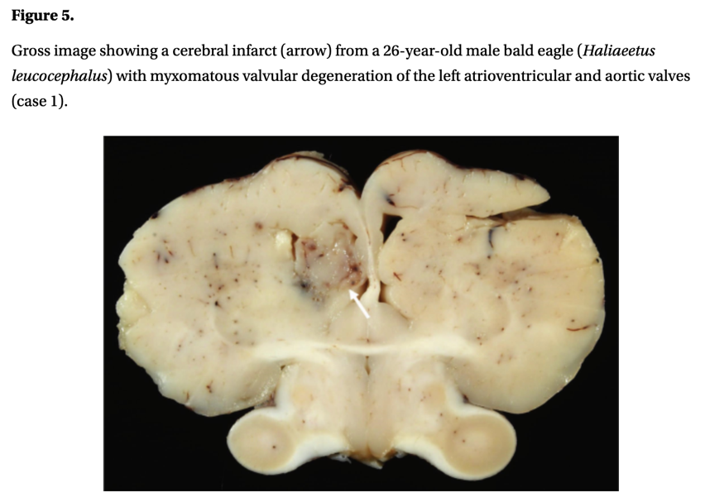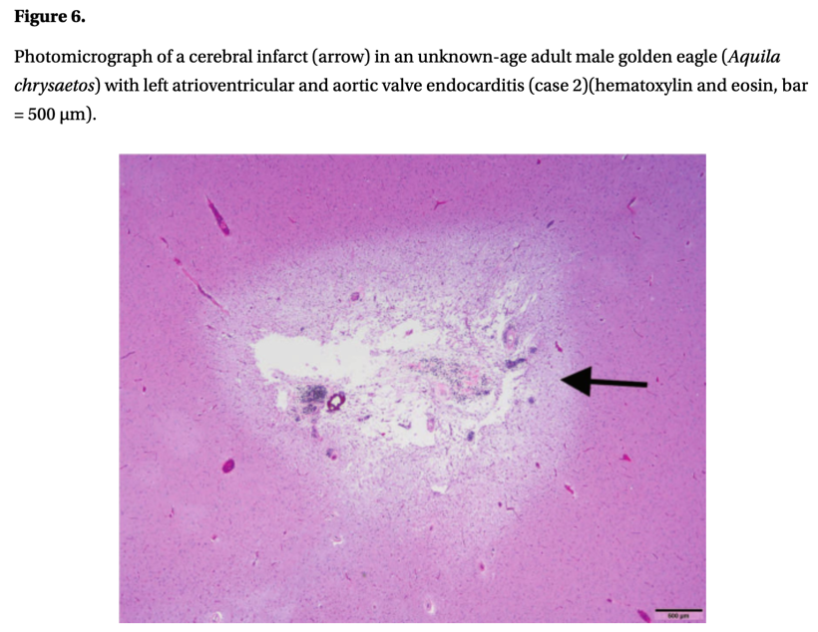

Trumpp, Kelsey M., et al. "Hearing Assessment of Free-Ranging Owls and Implications for Wildlife Rehabilitation: 31 Cases (2014–2023)." Journal of Avian Medicine and Surgery 38.2 (2024): 75-82. - reviewed by HSS
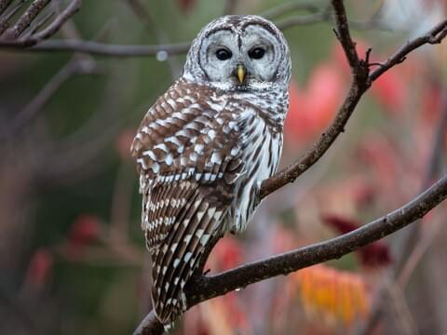
Abstract:
Owls, members of the avian order Strigiformes, are nocturnal birds of prey that are found worldwide except for Antarctica. Traumatized, free-ranging owls are commonly presented to veterinary hospitals and wildlife rehabilitation facilities with the goal of providing medical care and rehabilitation to enable release back into their natural habitat. Minimal guidelines exist for the release of wildlife, and whereas a need for functional vision is described in raptors, assessing and evaluating hearing is usually not mentioned. This can be problematic for nocturnal predators because hearing is the primary sense utilized by owls when hunting and navigating in their dark environment. The brainstem auditory evoked response (BAER) test is a minimally invasive, objective assessment of hearing commonly used in companion animals. To the authors' knowledge, routine or standardized BAER evaluation has not been reported in traumatized, free-ranging owls. In the following retrospective study, 31 free-ranging owls presented to the University of Georgia Veterinary Teaching Hospital for known or suspected trauma or being found in a debilitated state underwent BAER testing to assess for the presence of complete sensorineural hearing loss. Similar to assessment of hearing in companion animals, the BAER test was elicited using a broad click stimulus delivered at 85 dB nHL. In all owls, qualitative assessment and peak latency measurements of the BAER test reflected hearing ability. This study highlights the importance of hearing in nocturnal raptors, how BAER testing can aid in decision making regarding rehabilitation, and provides a foundation for further investigation of hearing loss in traumatized owls. We suggest that veterinarians working with free-ranging owls in a rehabilitation setting should consider BAER testing as part of routine diagnostic testing.

Key Points:
- Head trauma seen in 28% of free-ranging raptors presenting for care
- Guidelines mandate that wildlife must be able to successfully find and obtain food prior to release
- Barn owls (Tyto alba) rely on their well-developed hearing to hunt prey in the dark, suggesting that this sense is critical to hunting success in owls
- Brainstem auditory evoked response (BAER) testing is currently an accepted method for objective testing of hearing in companion animals. Has been used in many birds species but not clinically.
- All owls heavily sedated or under light anesthesia for testing
- In all but 1 owl, the results of the BAER test were considered acceptable quality based on the observation of identifiable waves I through III.
- The typical avian BAER test consists of 2 to 3 distinctive positive waves that are designated as waves I, II, and III (when present) and occur within the first 8 ms following an auditory stimulus. In some birds, wave I comprises 2 peaks referred to as a notched or dual wave I. The initial peak is designated wave I, and the second peak designated as wave Ib. The neuroanatomical regions in avian species that are thought to give rise to waves I through III are the cochlear nerve (wave I); the 2 divisions of the cochlear nucleus, the nucleus magnocellularis and nucleus angularis (wave II); and the nucleus laminaris (wave III).
- In diurnal raptors, the range of best hearing is considered between 2 and 4 kHz with high and low frequencies being between 8–10 kHz and 0.2 kHz, respectively. The range of best hearing may be higher in nocturnal raptors with optimal frequencies between 4 and 8 kHz
- The equipment used to measure the BAER produced a click noise that spanned 1–4 kHz, which is the range most prominent in human speech. Given that owls hear frequencies outside this range, loss of hearing at frequencies not tested may have been present but were not identified.
- The facial feathers, in particular the feathers that make up the ruff, increase both hearing sensitivity and directionality (ie, ability to localize sound)
- Studies have shown that owls with monocular vision do not perform significantly differently than those with binocular vision in controlled flight testing. Additionally, owls with monocular vision can be successfully released and survive in their natural habitat.
- Experimentally, owls with restricted hearing are less effective at capturing prey in the dark.
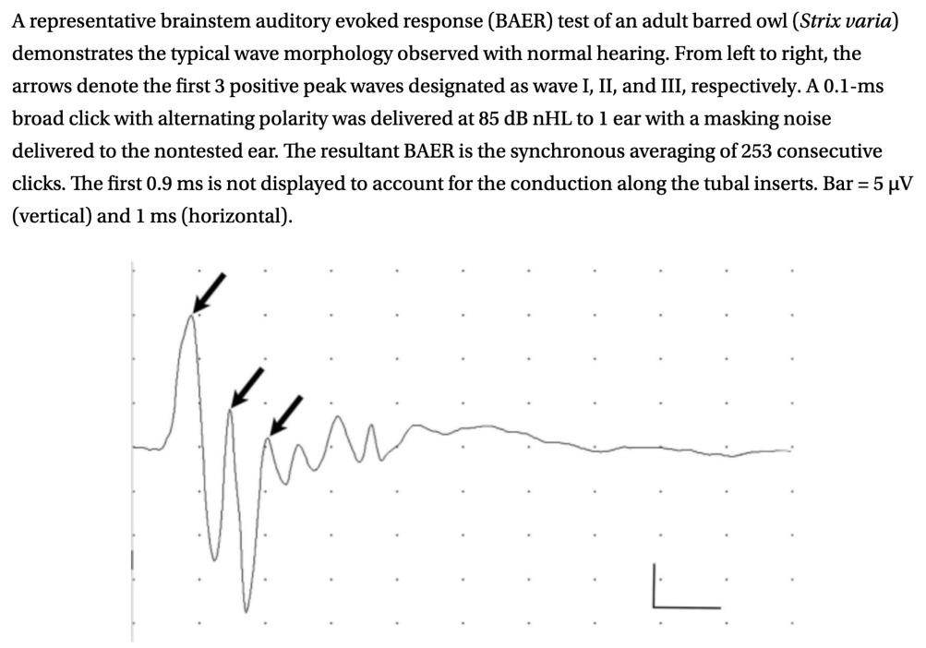

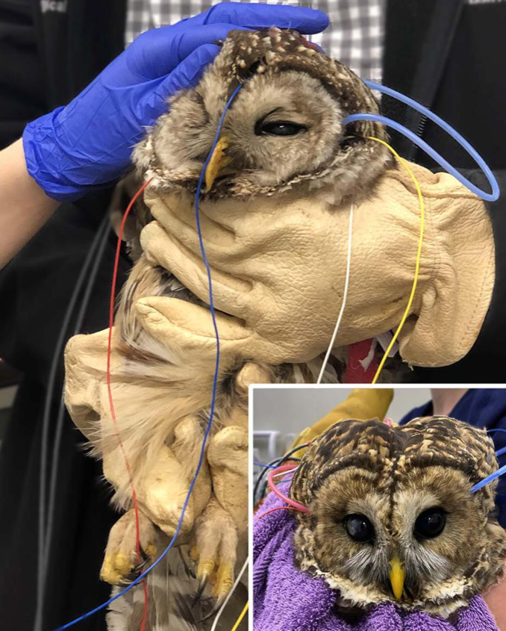

Take-Home Message:
- BAER testing provided a noninvasive method of assessing for complete sensorineural hearing loss in traumatized or debilitated free-ranging owls. The results of the present study suggest free-ranging owls presented to UGA VTH for trauma or debilitation do not have complete sensorineural hearing loss, as evidenced by the presence of the 3 identifiable waves on the BAER test for all of the owls in this study.

Determination of coagulation parameters by whole blood dynamic viscoelastic coagulometry in Strigiformes
Leclerc LA, Vergneau-Grosset C, Fitzgerald G, Brandão J, Gara-Boivin C. J Avian Med Surg. 2023;37(2):99-107.—Summarized by ALD

Abstract: No reference values are available in Strigiformes to evaluate blood coagulation using dynamic viscoelastic coagulometry (DVC) with the Sonoclot (Sienco, Boulder, CO, USA) analyzer. The objectives of this study were 1) to assess the feasibility of DVC in Strigiformes, 2) to calculate the index of individuality of each coagulation parameter, and 3) to assess interspecies variability and establish reference intervals, if relevant, based on the index of individuality. Fresh whole blood samples were obtained from healthy Strigiformes, including 13 barred owls (Strix varia), 10 great horned owls (Bubo virginianus), 6 snowy owls (Bubo scandiacus), and 7 eastern screech owls (Megascops asio), and analyzed with DVC with glass bead (gb) and kaolin clay (k) coagulation activators. Activated clotting time (ACT), clot rate (CR), and platelet function were determined immediately after collection using fresh native whole blood. Intraindividual variability was assessed with a second fresh native whole blood sample from 5 barred owls. Interindividual variability was assessed using a Kruskall-Wallis test. For the parameters gbACT (n=35), gbCR (n=34), and kACT (n=27), no significant differences were detected between species (all P≥0.05). Based on low index of individuality, global Strigiformes reference intervals were determined for gbACT (32.3–852.5 seconds; n=35), gbCR (0–20.1 units/min; n=29), and kACT (0–1570.3 seconds; n=27). In conclusion, DVC can be used in Strigiformes and the gb coagulation activator would be more appropriate when basal individual values are not available in a tested individual.

Key Points:
- Factors XI and XII may be absent in birds in coagulation cascade; rely on extrinsic pathway mostly
  - PTT not suitable, PT can be used (extrinsic and common pathways); using mammalian thromboplastin lengthens PT
- Values obtained by DVC: activated clotting time (ACT, time b/t start of test and first fibrin), clot rate (CR, max speed of conversion from fibrinogen to fibrin (max slope)), platelet function (PF, calc value in relation to time and quality of clot retraction)
- DVC uses human body temp, may cause birds to be hypocoagulable on results due to higher temps
- kCR generally lower (significant) than gbCR: speed of conversion from fibrinogen to fibrin faster w/gb activator
- No stat diff b/t spp & index of individuality low b/t gbACT, gbCR, kACT so global RI calculated
- gCR: 0-20.1u/min, kACT: 0-1570.3 sec
- Index of variability is high with kCR and gbPF, so should base interpretation on basal rate and not RI
- Median gbACT similar to healthy horses and chickens; median gbCR lower than horses and chickens; median kACT higher than chickens

Take Home Message:
- Can use DVC as way to analyze coagulation in Strigiformes, could be useful in clinical context with anticoagulant rodenticide toxicity
- Can initiate coagulation via contact pathway in Strigiformes when proper activator is used, though k may not be as potent as gb in owls as clot activator (using avian thromboplastin activator may reduce interindividual variability for RIs)
- kCR needs basal value so gb may be better for use in wild birds with no original values

Spontaneous wing tip edema in captive birds of prey: review of 41 cases in the United Kingdom (2004-2022)
Byron-Chance D, Gomez L, Saraiva S, Hollwarth AJ, Esquivel E, Dutton TAG. J Avian Med Surg. 2024;38(3):141-152.

Abstract: There is limited literature regarding wing tip edema (WTE) in raptors, and much of our current understanding of the condition is based on anecdotal reports. The aims of this retrospective study were to describe the clinical features of WTE in birds of prey, to identify prognostic factors for return to flight and patient survival following diagnosis, and to develop and assess the clinical significance of a novel WTE grading system. Between 2004 and 2022, 41 cases of WTE were identified in 39 captive birds. No cases were found in wild birds. Harris’s hawks (Parabuteo unicinctus), lanner falcons (Falco biarmicus), and peregrine falcons (Falco peregrinus) had the highest frequencies of WTE, and all cases presented between October and May. Increasing days of air frost per month and colder median monthly temperatures were significant risk factors for the development of WTE. Of the cases where patient outcomes were known, 23/31 (74.2%) cases returned to normal flight and 29/34 (85.3%) cases survived. End-stage disease, represented by primary flight feather loss and metacarpal ischemic (dry) gangrene, and enalapril use were associated with poor patient outcomes. Presentation within 24 hours of disease onset, isoxsuprine use, and physiotherapy were associated with improved patient outcomes. This study showed that WTE is an infrequently encountered but clinically significant condition in captive raptors and is associated with an overall high morbidity and moderate mortality risk.

Key Points:
- WTE: characterized by spontaneous cold pitting edema of distal antebrachium; histo more consistent w/local nonfreezing tissue injury (granulocytic vasculitis and ischemic necrosis) though pathophysiology is similar to frostbite
- Harris’s hawk>lanner falcon>peregrine falcon most common
- No cases in free-living birds reported; most frequently reported in January (36.6%)
- Most frequent CS: cold, pitting edema of distal wing>dropped wing>dry gangrene=fluid-filled bullae in carpal region>impaired flight>spontaneous primary feather loss>malaise>autoamputation
  - 48.7% of cases were bilateral, grade 1 in 43.9%, grade 2 in 43.9%, grade 3 in 12.2%
  - Bulla culture negative in 3 cases, monoculture from skin in 1 case
- Tx progression: 12.2% developed bullae, 19.5% dry gangrene, 22% lost primary feather
- 74.2% returned to normal flight, 85.3% survival (rest euth due to loss of flight at median 3wk)
- More likely to lose feathers if on enalapril, if <1kg, and less likely if on isoxsuprine
- Inc risk of gangrene with increased air frost, dec risk w/inc temp
- Dec likelihood of returning to normal flight w/gangrene development or primary feather loss; inc likelihood w/presentation w/I 24h of CS onset, warming and physiotherapy tx
- Dec survival w/WTE grade 3 or gangrene development
- WTE infrequent in Strigiformes, but reported here
- No significant benefit to topical tx, no significant impact w/COX-2 NSAIDs, rec abx for secondary infections but no bacterial enteritis noted in birds w/o abx anyway

Take Home Message:
- WTE is disease of captive birds, think age may be less significant risk factor than previously reported but was previously reported as a large risk factor in another stuy
  - Increased vigilance should be used w/younger birds, birds <1kg, and cases in colder months
- Birds of prey are at an inc risk of WTE with increasing air frost; decreased risk with increasing temp
- Grade 3 WTE had worse prognosis for flight and survival, and early recognition is important for better prognosis
- Physiotherapy, active warming, and isoxsuprine recommended for tx
- 