2025 JZWM 55.1
The impact of supplementary feeding of pig carcasses on plasma vitamin e concentrations in captive cape vultures (Gyps coprotheres)
Naidoo, Vinny, Lauren N. Havenga, and Kerri Wolter - summary by MGF

What was the primary finding regarding the effect of feeding whole pig carcasses to captive Cape vultures (Gyps coprotheres)?
A. Feeding pig carcasses resulted in stable plasma vitamin E concentrations when viscera were available
B. Plasma vitamin E concentrations increased due to the high fat content of pig carcasses
C. Vitamin E concentrations declined only in vultures that behaviorally avoided viscera and fat
D. Feeding whole pig carcasses was associated with a reduction in plasma vitamin E concentrations
E. Vitamin E deficiency was prevented when carcasses were fed within 24 hours of death
Answer: D; A: Plasma vitamin E concentrations declined. B: The birds avoided the fat. C: Vitamin E declined across feeding groups, not exclusively due to selective feeding behavior. E: Timing of feeding was discussed but not shown to prevent vitamin E decline in this study.

2025 JWD 61.4
Outbreaks of Highly Pathogenic H5N1 Influenza A Virus infection in Black Vultures (Coragyps atratus), USA, 2022
Cunningham, Mark W., et al. - reviewed by MGF

What was the primary mechanism by which highly pathogenic H5N1 influenza A virus was transmitted and maintained within Black Vulture (Coragyps atratus) populations during the 2022 outbreak?
A. Contact with contaminated aquatic environments at die-off sites
B. Scavenging of infected bird carcasses
C. Direct contact with infected migratory waterfowl at roosting sites
D. Consumption of infected feces found in the environment
E. Aerosol transmission within communal roosts
Answer: B; Environmental water and substrate samples were negative for influenza A virus. C: Waterfowl were implicated in regional introduction, not direct vulture-to-vulture exposure. D: Was consumption of the entire animal not just the feces. E: Aerosol transmission was not considered a problem
Journal of Avian Medicine and Surgery, 39(1): 12-19, 2025.
SQUAMOUS METAPLASIA ASSOCIATED WITH HYPOVITAMINOSIS A OF THE CROP AND SALIVARY GLANDS IN CAPTIVE FALCONS IN THE UNITED ARAB EMIRATES
Peter McKinney et al. – Reviewed by LMM

Question: List four differentials for this presentation in a Gyrfalcon.
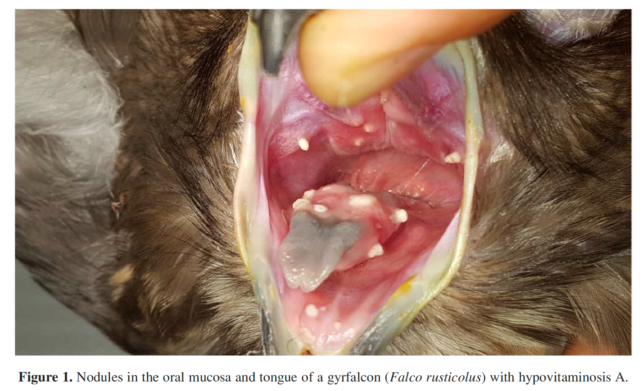
Answer: Hypovitaminosis A, Pseudomoniasis, Trichomoniasis, Candidiasis
------------------------------------------------------------------------------------------------------------------------------------------
Journal of Avian Medicine and Surgery, 39(1): 39-45, 2025.
TAKOTSUBO CARDIOMYOPATHY-LIKE TRANSIENT SYSTOLIC DYSFUNCTION IN TWO BALD EAGLES (HALIAEETUS LEUCOCEPHALUS)
Question: List two differentials for the ECG changes below in a Bald Eagle (Haliaeetus leucocephalus). (Paper speed = 50 m/s; 1 cm = 1 mV).
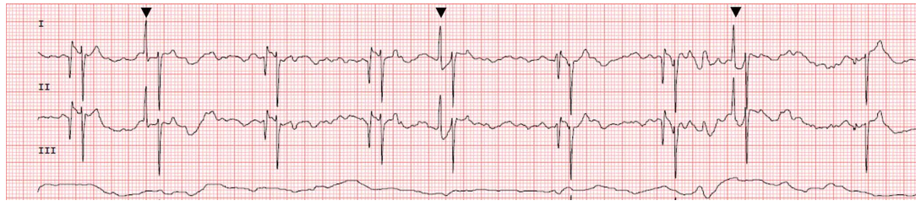
Answer:
- Top differentials include stress-induced cardiomyopathy (akin to Takotsubo cardiomyopathy or “broken heart syndrome” in people) and isoflurane anesthesia. Other potential differentials include traumatic myocarditis or myocardial stunning.
- ECG findings are atrial premature complexes, variable P-wave morphology, and underlying sinus bradycardia.

Journal of the American Veterinary Medical Association, 261 (2023)
Summarized by MR

An avian Modified Glasgow Coma Scale as a prognostic indicator in raptors with head trauma
Kari Foss, DVM, MS, et. al

In a study evaluating a modified Glasgow Coma Scale for use in raptors, which of the following was associated with lower survival?
- Higher motor activity scores
- Nocturnal raptor species
- Higher level of consciousness scores
- Higher brain stem reflex scores
- Juvenile age of raptors
Answer: B. Nocturnal raptor species: diurnal birds were more likely to survive than nocturnal birds. A, C, and D are incorrect because higher scores in each of those categories were associated with higher likelihood of survival. E is incorrect because solely the score level of consciousness was higher (not the overall score) in adult birds in comparison to juveniles.
Am J Vet Res. 2025;86(3)
Summarized by MR

Chlamydial infections in free-ranging raptors presenting to a university veterinary medical teaching hospital (1993-2022).
Hawkins MG, Blair E, Keel MK, et al.

In a retrospective evaluation of chlamydial infections in free-ranging raptors presenting for rehabilitation at a university veterinary medical teaching hospital, the odds of testing PCR positive were higher for which of the following factors?
- Winter admission
- Adult age class
- Phenotypic male
- Summer admission
- Fall admission
Answer: A. Winter (15.8x), then spring (8.8x), had higher odds than summer admission. B is incorrect because juveniles were 2.5x higher odds of testing positive. C is incorrect because there was no difference in odds between a phenotypic male, female, or unknown sex (on the basis of size and weight for common Buteo sp.)

Vuong, Kristina S., Michael Jones, and Linden E. Craig. "Postmortem Evaluation of Cardiac Valvular Disease in Bald Eagles (Haliaeetus leucocephalus) and a Golden Eagle (Aquila chrysaetos)." Journal of Avian Medicine and Surgery 37.1 (2023): 22-31. - reviewed by HSS
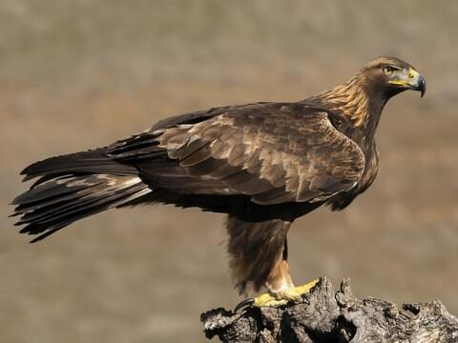

Question:
The following image depicts myxomatous valvular degeneration (MVD) of the left atrioventricular valve (asterisk) and the aortic valve (arrow) of a bald eagle (Haliaeetus leucocephalus). Which of the following pathologic lesions was also found in all eagles identified with MVD in a recent retrospective study?

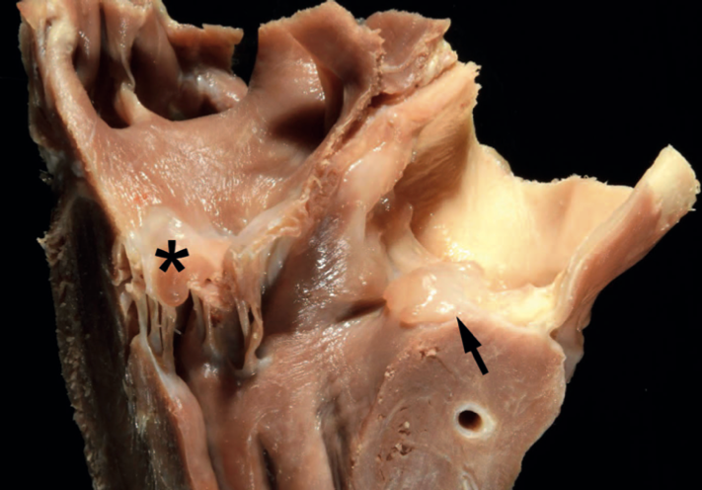

- Splenic hypertrophy
- Coelomic effusion
- Hepatomegaly
- Dilation of pulmonary capillaries
- Cerebral infarction

Answer: E

Trumpp, Kelsey M., et al. "Hearing Assessment of Free-Ranging Owls and Implications for Wildlife Rehabilitation: 31 Cases (2014–2023)." Journal of Avian Medicine and Surgery 38.2 (2024): 75-82. - reviewed by HSS

Question:
The following graph depicts a brainstem auditory evoked response (BAER) test in an adult barred owl (Strix varia). The response of which nerve is shown in the first (left-most) peak?
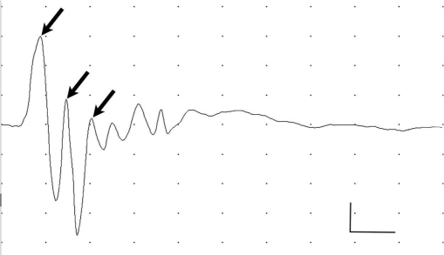

Answer: The cochlear nerve. The 2nd wave is from the nucleus magnocellularis and nucleus angularis. The 3rd wave is from the nucleus laminaris.
Determination of coagulation parameters by whole blood dynamic viscoelastic coagulometry in Strigiformes
Leclerc LA, Vergneau-Grosset C, Fitzgerald G, Brandão J, Gara-Boivin C. J Avian Med Surg. 2023;37(2):99-107.—Summarized by ALD

Which of the following should be interpreted in light of a basal rate and not a reference interval when evaluating dynamic viscoelastic coagulometry in Strigiformes when using a glass bead (gb) or kaolin clay (k) as an activator?
- gb activated clotting time (gbACT)
- k activated clotting time (kACT)
- gb clot rate (gbCR)
- k clot rate (kCR)
- k platelet function (kPF)

Answer: kCR and gbPF have a high index of variability, so a basal rate should be used for interpretation and not a reference interval

Spontaneous wing tip edema in captive birds of prey: review of 41 cases in the United Kingdom (2004-2022)
Byron-Chance D, Gomez L, Saraiva S, Hollwarth AJ, Esquivel E, Dutton TAG. J Avian Med Surg. 2024;38(3):141-152.

Which of the following variables has been associated with an increased likelihood of returning to normal flight after a diagnosis of wing tip edema in a bird of prey?
- Active warming
- Non-steroidal anti-inflammatory administration
- Antibiotic administration
- Topical hemorrhoidal preparations
- Propentofylline administration

Answer: A. Active warming, physiotherapy, and presenting within 24 hours are associated with an increased likelihood of returning to normal flight. Isoxsuprine is also associated with improved outcomes and protective against feather loss. NSAIDs and topical hemorrhoidal preparations didn’t significantly impact patient outcomes, and it was difficult to make any recommendations for antibiotic use due to the number of antibiotics used but use is recommended to prevent secondary infections. However, no birds were found with bacterial enteritis even when antibiotics weren’t prescribed. Propentofylline had favorable responses anecdotally but no statistically significant impact. Enalapril increased the risk of feather loss and gangrene. Air frost was associated with increased risk of WTE, so increased clinical vigilance should be had in colder months as well as with younger birds and birds <1kg.

