Journal of the American Veterinary Medical Association, 261(2): 223-228, 2023
INTRAMUSCULAR ALFAXALONE WITH OR WITHOUT BUPRENORPHINE OR HYDROMORPHONE PROVIDES SEDATION WITH MINIMAL ADVERSE EFFECTS IN HEALTHY RABBITS (ORYCTOLAGUS CUNICULUS) IN A RANDOMIZED BLINDED CONTROLLED TRIAL
Renata S Costa, Miranda Ciotti-McClallen, Rachel Tilley, Stefanie Perry, Lynn Maki, Darius Starks, Amy B Stein – Reviewed by LMM

Question: What minor adverse effect might be observed in rabbits receiving intramuscular alfaxalone or alfaxalone-buprenorphine for sedation?

Answer: Hypersalivation
_____________________________________________________________________________________

Journal of the American Veterinary Medical Association, 261(9): 1368-1373, 2023
SUBCONJUNCTIVAL ENUCLEATION WITH OR WITHOUT THIRD EYELID REMOVAL MAY PRESENT A VIABLE ENUCLEATION TECHNIQUE IN RABBITS: 18 CASES (2014-2022)
Kara Hiebert, Christoph Mans, Seth Eaton – Reviewed by LMM

Question: What complications should you warn owners about when performing a subconjunctival enucleation in a rabbit with plans to leave the nictitating membrane in place?
Answer: Fatal hemorrhage peri-operatively, transient swelling (4 days to 3 months), transient serous to mucoid discharge (up to 10 months), +/- caudal orbital abscess formation (unlikely but possible)

American Journal of Veterinary Research, 84(8): 1-6, 2023
COMPUTED TOMOGRAPHIC LARYNGOTRACHEAL DIMENSIONS IN ADULT DOMESTIC RABBITS (ORYCTOLAGUS CUNICULUS) ARE POSITIVELY ASSOCIATED WITH BODY WEIGHT AND THE LARYNGOTRACHEAL LUMEN IS NARROWEST AT THE LEVEL OF THE THYROID CARTILAGE
Tessa B. Arendt, BA; Samantha J. Loeber, DVM, DACVR; Carrie A. Schroeder, DVM, DACVAA; Michael R. Lasarev, MS; Tatiana H. Ferreira, DVM, MSc, PhD, DACVAA – Reviewed by LMM

Question: The narrowest average tracheal width in the greatest percentage of rabbits occurs at which location?
- Level of the glottis
- Rostral thyroid cartilage
- Caudal thyroid cartilage/rostral cricoid cartilage
- Caudal cricoid cartilage
- Level of C5 vertebral body

Answer: C

American Journal of Veterinary Research, 83(7): 2022.
Pharmacokinetics and ex vivo pharmacodynamics of oral firocoxib administration in New Zealand White rabbits (Oryctolagus cuniculus)
Sara Gardhouse, Michael Kleinhenz, Samuel E. Hocker, Mikaela Weeder, Shawnee R. Montgomery, Yuntao Zhang, Anna Porting, and Tess Rooney
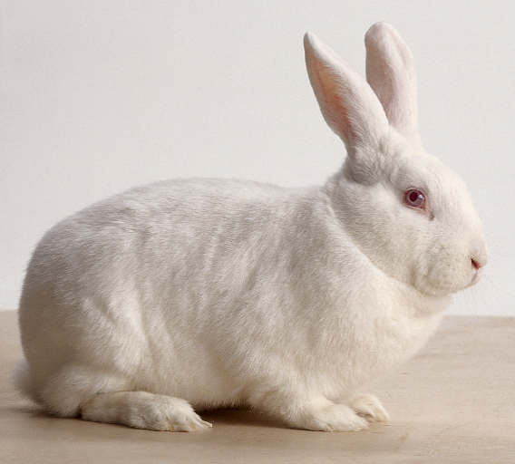

Question:
Which of the following statements is most correct regarding the pharmacokinetics and pharmacodynamics of oral firocoxib administration in New Zealand White rabbits (Oryctolagus cuniculus)?

- Plasma levels reached values considered therapeutic in other species; however, there was no significant difference in levels of cyclooxygenase-2 inhibition
- Plasma levels did not reach values considered therapeutic in other species, and there was no significant difference in levels of cyclooxygenase-2 inhibition
- Plasma levels reached values considered therapeutic in other species, and there was a significant decrease in prostaglandin E2, consistent with cyclooxygenase-2 inhibition
- Plasma levels did not reach values considered therapeutic in other species, but there was a significant decrease in prostaglandin E2, consistent with cyclooxygenase-2 inhibition
- Plasma levels reached values considered therapeutic in other species, and there was a significant decrease in thromboxane B2 at almost all time points within the study

Answer: A
Explanation: Pharmacokinetic data from this study supported that therapeutic levels for analgesia are achieved in rabbits when compared to values considered therapeutic in dogs; however, firocoxib administration did not demonstrate a significant difference in COX-2 inhibition (decreased prostaglandin E2) between any time point. A significant difference for thromboxane B2 was only detected between 24 and 48 hours.

Journal of the American Veterinary Medical Association, 261(12): 1-10, 2023
Prognostic indicators for survival in surgically managed small intestinal obstruction in pet rabbits: 141 presentations (2011–2021)
Joanne C. Sheen, Izidora Sladakovic, and Sue Finch
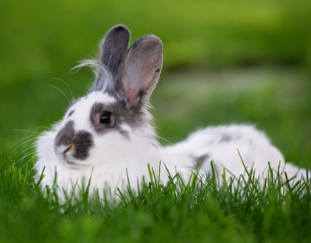

Question: What is the most common cause and site of a small intestinal obstruction in the domestic rabbit?

Answer: A compressed hair pellet within the proximal duodenum

Journal of the American Veterinary Medical Association, 261(10): 1488-1494, 2023
Long-term systemic antibiotics and surgical treatment can be an effective treatment option for retrobulbar abscesses in rabbits (Oryctolagus cuniculus): 21 cases (2011–2022)
Ivana Levy, and Christoph Mans
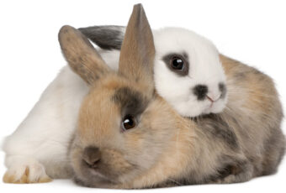

Question:
Which of the following statements is most correct regarding the diagnosis and treatment of retrobulbar abscesses in domestic rabbits (Oryctolagus cuniculus)?

- Even with a combination of surgical and medical management, the 6-month success rate was very low (<20%)
- Medical management alone was only successful in cases that were not associated with odontogenic abscesses
- The most commonly isolated bacteria from the retrobulbar abscesses was Pasteurella multocida
- Enucleation is indicated in most cases to improve exposure of the abscess site for proper debridement
- Leaving an intraoral draining tract is recommended to encourage continuous drainage after surgery

Answer: B
Explanation: Resolution of the clinical signs with no recurrence for at least 6 months occurred in 7 of 9 (78%) surgically treated cases. The most common aerobic and anaerobic isolates were Streptococcus intermedius and Fusobacterium nucleatum, respectively. Enucleation does not provide access to the retrobulbar space due to presence of the retrobulbar venous plexus. Enucleation of the globe is not recommended as part of the therapeutic protocol for retrobulbar abscesses, unless the eye is painful or irreversibly blind. Sealing the extraction site is recommended to prevent infection and impaction of the extraction site and retrobulbar space with material from the oral cavity.

A&P Slide Question:

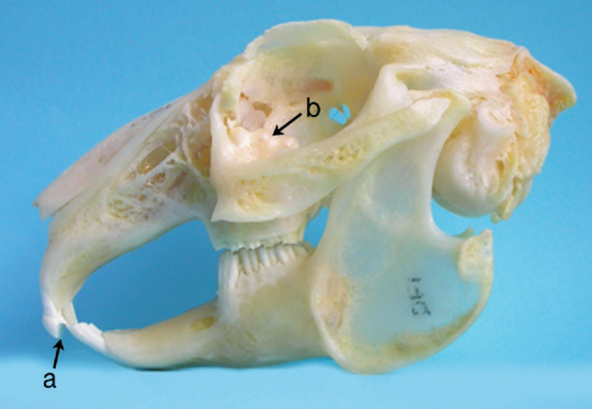

Question: Name the anatomic structure indicated by arrow b and describe a common underlying cause of the abnormality of the structure pictured.

Answer: Arrow b points to the alveolar bulla, which is a unique bony structure of the rabbit skull that contains the apices of the maxillary cheek teeth. The pictured bulges on the alveolar bone are secondary to apical elongation, which is an early feature of acquired dental disease in rabbits.
Computed tomographic findings of nasal and paranasal disease in domestic rabbits highlight maxillary sinusitis and close association with dental disease: 100 studies (2004-20240
Mikoni N, Sanchez-Migallon Guzman D, Beaufrère H, Phillips K. J Am Vet Med Assoc. 2025;263(1):90-99—Reviewed by ALD

Which paranasal sinus is least commonly affected by sinusitis in rabbits with nasal and paranasal disease, and why is this the case?
- Sphenoidal sinus, there is no direct communication of the sphenoidal sinus with any of the other paranasal sinuses and it opens into the nasal cavity via its own sphenoidal sinus ostium

Based on the CT scan below of a rabbit (Oryctolagus cuniculus), what is the structure labelled λ? Why does disease commonly occur in this structure when dental disease is present?
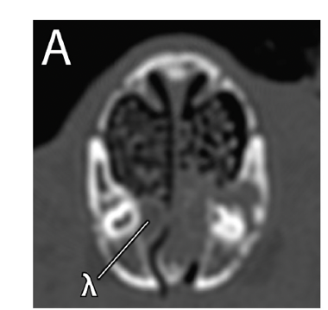
- Nasolacrimal duct, the duct is located between the dorsal and ventral recesses of the maxillary sinus rostrally. Disease of the second premolar in the maxilla can lead to sinusitis of the ventral recess of the maxillary sinus, thus leading to spread of disease to the nasolacrimal duct.

Effects of diet on the bacterial and eukaryotic microbiota across the gastrointestinal tract of healthy rabbits (Oryctolagus cuniculus)
Rahic-Seggerman FM, Rosenthal K, Miller C, Iske C, Graham J, Schmitz-Esser S, Kohles MR. Am J Vet Res. 2024;85(4):1-11—Reviewed by ALD

Which diet was overall found to cause a significantly lower number of bacterial species diversity in the hindgut in rabbits (Oryctolagus cuniculus) when fed for thirty days?
- High fiber uniform extruded diet only (correct)
- Low fiber muesli mix diet only
- High fiber uniform pelleted diet only
- High fiber uniform extruded diet and timothy hay
- High fiber uniform pelleted diet and timothy diet

Explanation: No hay/extruded pellet had a lower diversity to all groups except muesli pellet in foregut, a significantly lower number of microbial spp in the hindgut when compared to all diets, and less richness and lower diversity to all diets except muesli pellets

Assessment of the fecal microbiome of healthy rabbits (Oryctolagus cuniculus domesticus) compared with rabbits with gastrointestinal disease using next generation DNA sequencing
Vecere G, Malka S, Sands N, Lee M, Krumbeck JA. Am J Vet Res. 2024;86(1):1-8—Reviewed by ALD

Which species of bacteria was found in significantly increased amounts in healthy rabbit feces?
- Akkermansia sp. (correct)
- Bacteroides unformis
- Lawsonia intracellularis
- Lactobacillus sp.
- Clostridiales sp.

Explanation: Bacteroidales sp, Odoribacter sp, Paraprevotella xylaniphila, Lachnospiraceae sp, Papillibacter sp, Akkermansia sp, and Ruminococcus sp were seen more commonly in healthy rabbit feces while Lachnoclostridium sp, Anaerotruncus sp, Subdoligranulum sp, and B uniformis were found in greater abundance in rabbits with GI disease

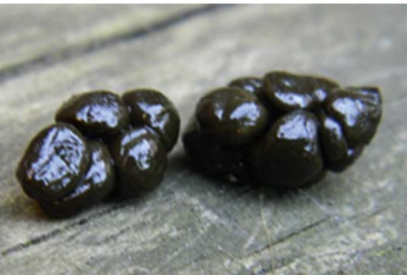

Question: Identify this object and the species it comes from. Describe in 3 sentences how it is formed and what its function is within the physiology of the species.

Answer: cecotroph from lagomorph. Digestible fiber particles and solutes not immediately digested and absorbed enter colon and are selectively retained as substrates for microbial fermentation within cecum. Rabbit directly consumes from anus and cecotropes enter stomach wehre peptidoglycans in microbial cell walls break down and release proteins and micronutrients (vitamins, minerals, amino acids) to be absorbed in jejunum and ileum

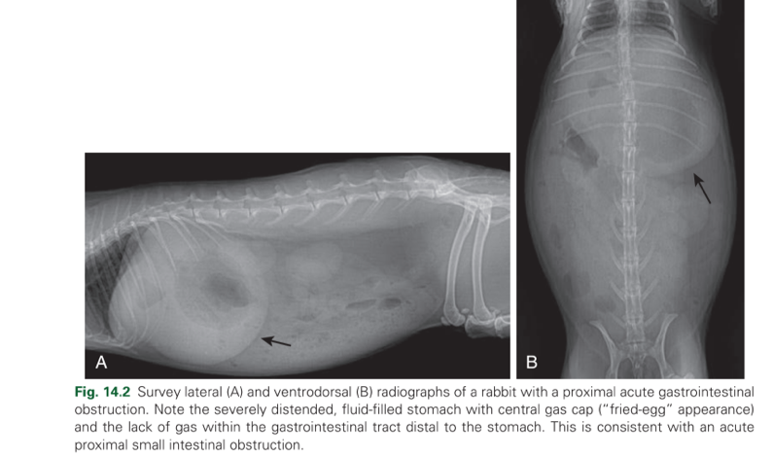
Question: What is the main disease process present? In recent literature, what treatment protocol has been shown to have significantly high survival rate?
Answer: Gastrointestinal obstruction. Lidocaine CRI has shown increased survival
Huckins, Gail L., et al. "Lidocaine constant rate infusion improves the probability of survival in rabbits with gastrointestinal obstructions: 64 cases (2012–2021)." Journal of the American Veterinary Medical Association 262.1 (2024): 61-67.

In a study evaluating oral administration of gabapentin in rabbits, which of the following occurred after gabapentin administration?
- Mobility increased
- Frolicking increased
- Observing increased
- Grooming increased
- Rearing increased

Answer: B (frolicking increased, observing decreased, all other factors in the study did not change in response to gabapentin administration)
Conway, Rachel E., et al. "Single oral dose of gabapentin reduces vigilance and increases play behavior without changing mobility in New Zealand white rabbits (Oryctolagus cuniculus)." Journal of the American Veterinary Medical Association 1.aop (2024): 1-8.

Question: In a study evaluating the prevalence of Mycoplasma spp in pet rabbits, what did the authors conclude?

Answer: Mycoplasma sp detection via next generation sequencing from nasal swabs is common in both healthy and unhealthy rabbits and is significantly more common in healthy rabbits, suggesting that Mycoplasma may be normal nasal flora in rabbits.

Question: In a study evaluating the prevalence of Mycoplasma spp in pet rabbits, which of the following is correct?
A. Mycoplasma was rarely detected in either healthy or unhealthy rabbits
B. Culture was the best methodology to test for Mycoplasma presence
C. Mycoplasma was more common in healthy rabbits than in unhealthy rabbits
D. Mycoplasma was more commonly detected in rabbits with respiratory signs
E. Mycoplasma detection was more prevalent in male compared to female rabbits

Answer: C: more common in healthy rabbits than unhealthy rabbits, no difference in breed or sex, next generation sequencing is recommended over culture

McCready, Julianne E., et al. "Detection of Mycoplasma sp using next-generation DNA sequencing is common on nasal swabs from both healthy and unhealthy pet rabbits (Oryctolagus cuniculus)." American Journal of Veterinary Research 1.aop (2024): 1-7.

