Journal of Herpetological Medicine and Surgery, 33(2): 116-120, 2023
USE OF CAUDOVENTRAL-CRANIODORSAL AND CRANIOVENTRAL-CAUDODORSAL OBLIQUE RADIOGRAPHIC VIEWS MADE AT A 45 DEGREE TO THE FRONTAL PLANE FOR THE EVALUATION OF PELVIC GIRDLES IN PAINTED TURTLES (CHRYSEMYS PICTA)
Miranda Torkelson, Ashley Koetz – Reviewed by LMM

Abstract: Turtles often present to wildlife rehabilitation centers for trauma secondary to motor vehicle collisions. Injuries to the pelvic girdles in turtles are challenging to assess on standard radiographic views due to the superimposition of bones. Pelvic trauma may have long-term consequences for ambulation and reproduction. The novel use of caudoventral-craniodorsal and cranioventral-caudodorsal 45° oblique radiographic views in western painted turtles (Chrysemys picta bellii) at the Wildlife Rehabilitation Center of Minnesota has improved differentiation of bones in the pelvic girdle. Using dorsoventral radiographs, 45% of western painted turtles with caudal carapace fractures had suspected injuries to the pelvis. After using oblique views, 98% of western painted turtles with caudal carapace fractures were found to have pelvic involvement. These radiographic views improve diagnostic ability, facilitate medical and surgical interventions, and aid in monitoring the healing process.

Key Points:
- Due to fusion of spine and shell, all motion both walking and swimming occurs via movements of limbs and mobility within the pelvis, mating occurs in water and females dig nests completely with hindlimbs
- Displaced pelvic fracture may also reduce pelvic inlet size, potentially leading to dystocia
- This paper investigated an adaptation of the “H-view” (caudoventral-craniodorsal 45 degree oblique view) used in birds to assess the coracoid/clavicle for assessment of the pelvic bones in sliders and another oblique view termed the “A-view” (cranioventral-caudodorsal 45 degree oblique view)
- These views clearly separated out the ilium, ischium, and pubis and allowed for increased detection of injuries, advancing medical care and prognostication
- The vast majority of turtles with pelvic injuries had ilium involvement – likely because this bone is vertically oriented and suspends the pelvic girdle from the carapace at the sacroiliac joint and when crushing force occurs on the caudal shell, the next structure absorbing force aside from the shell is the ilium…soft tissue then provides the last remaining support to the pelvic girdle

Take Home Point: The “H-view” and the “A-view” in sliders separated out the ilium, ischium, and pubis and allows for increased detection of injuries to that region in these animals.

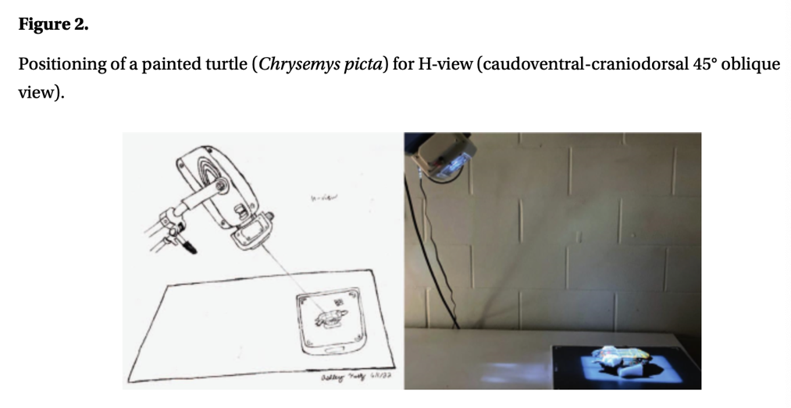
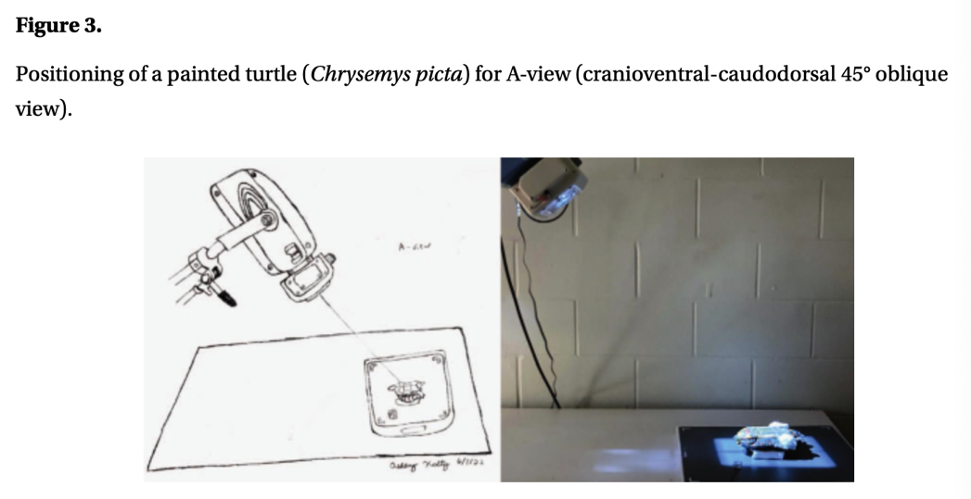
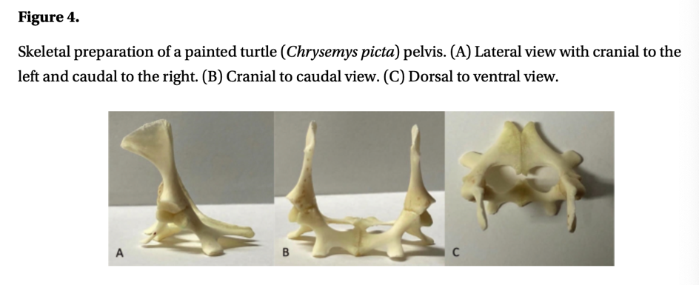
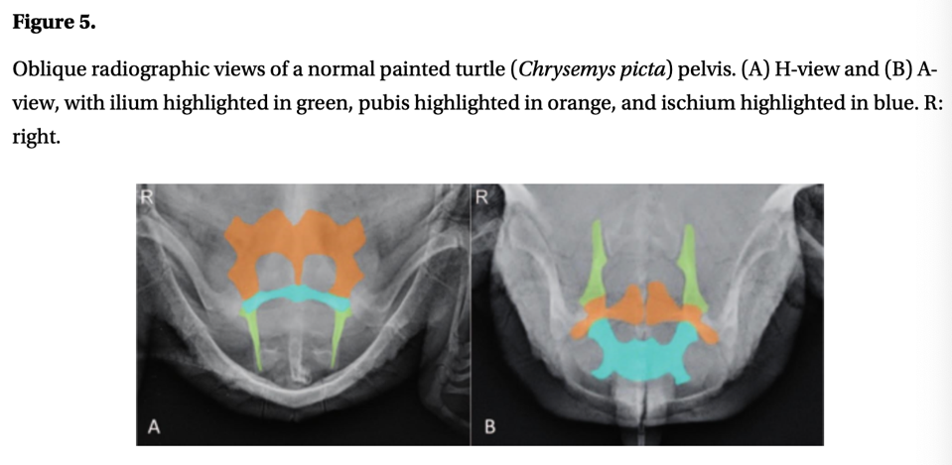
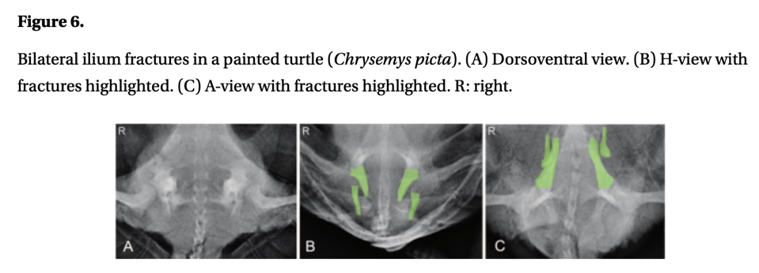
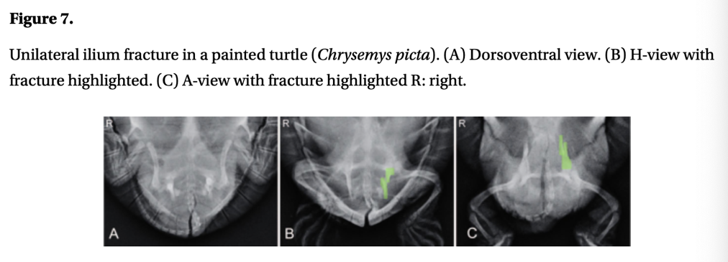
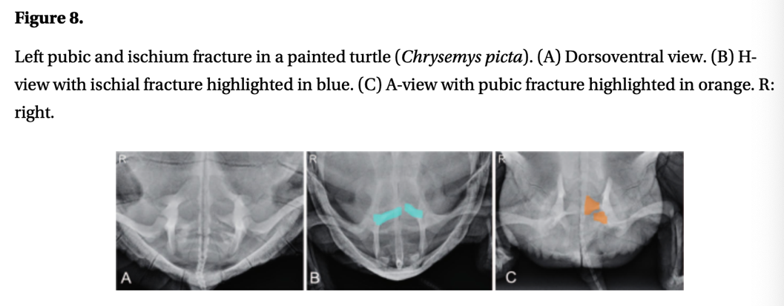
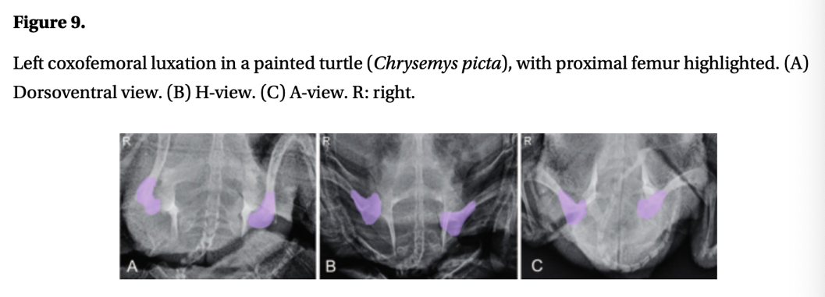

______________________________________________________________________________

Journal of Herpetological Medicine and Surgery, 34(3): 175-183, 2024
DIAGNOSIS OF ORTHOPEDIC FRACTURES USING CRANIDORSAL-CAUDOVENTRAL OBLIQUE AND CAUDODORSAL-CRANIOVENTRAL OBLIQUE RADIOGRAPHIC VIEWS MADE AT 45° TO THE FRONTAL PLANE IN FOUR WILD TURTLES
Chung et al – Reviewed by LMM
Abstract: Four wild chelonians (two three-toed box turtles [Terrapene triunguis] and two red-eared sliders [Trachemys scripta elegans]) were presented to an academic wildlife rehabilitation center after presumably being hit by a car. Physical examinations revealed various carapace, bridge, and plastron fractures, as well as a lack of motor function of different limbs. A craniodorsal-caudoventral oblique view or caudodorsal-cranioventral oblique radiographic view made at 45 to the frontal plane (Cr45D-CdV and Cd45DCrV oblique views, respectively), along with standard views (i.e., dorsoventral, right lateral, craniocaudal views), were performed. The oblique views allowed for visualization of different pectoral girdle or pelvic girdle fractures that were not visualized or clearly identified on the standard views. Based on the four clinical cases described here, the addition of Cr45D-CdV or Cd45D-CrV oblique views to the standard views may be beneficial, especially when advance imaging such as computed tomography is not available. These oblique views can be used to better assess chelonian pectoral and pelvic girdles because these structures are superimposed in standard radiographs. Future studies investigating the diagnostic accuracy of detecting pelvic and pectoral girdle fractures using these views are warranted.

Key Points:
- On the Cr45D-CdV, which should be used to assess the pectoral girdle, the order of the bones cranially to caudally is the acromion, coracoid, then scapula.
  - Anatomical Note: Arrangement of pectoral girdle is called “triradiate morphology”
- On the Cd45D-CrV, which should be used to assess the pelvic girdle, the order of the bones of the pectoral girdle cranially to caudally is the scapula, acromion, then coracoid.

Take Home Point: In presumptive hit-by-car chelonian cases, Cr45D-CdV and Cd45DCrV oblique radiographic views were clinically useful for evaluation of pectoral and pelvic girdles (normally superimposed on traditional 3-view radiographs).

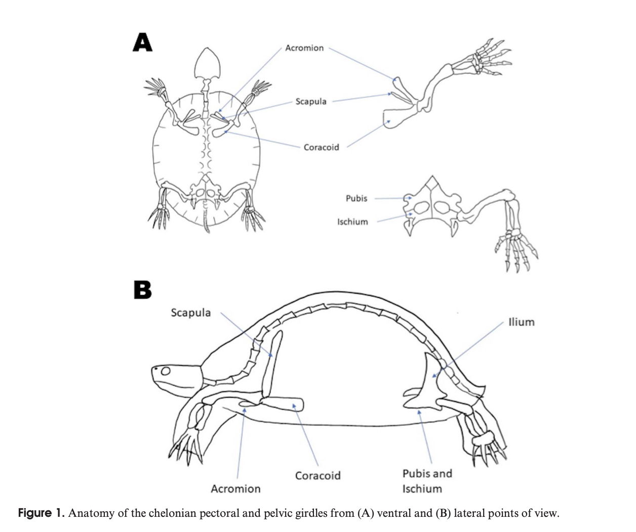
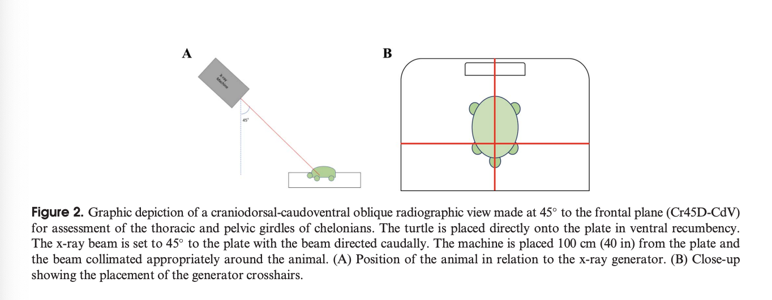
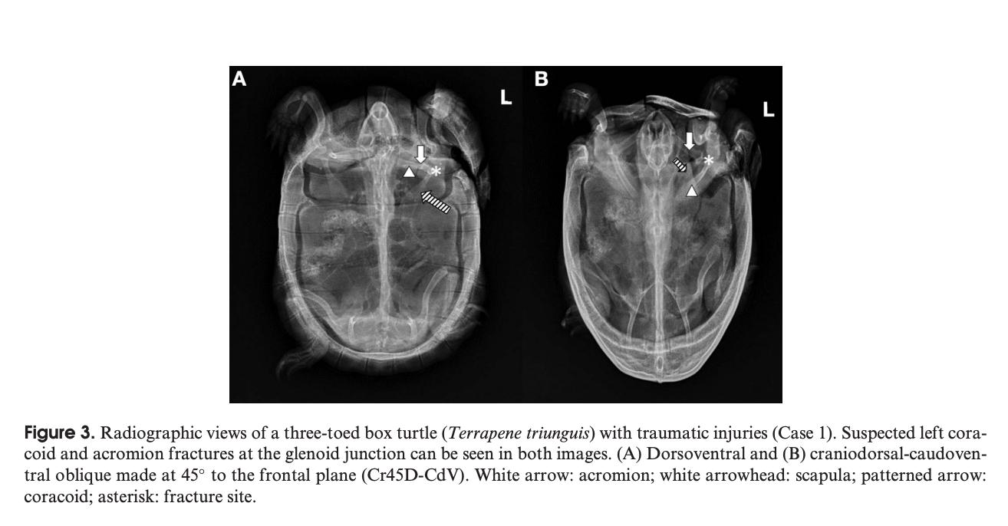
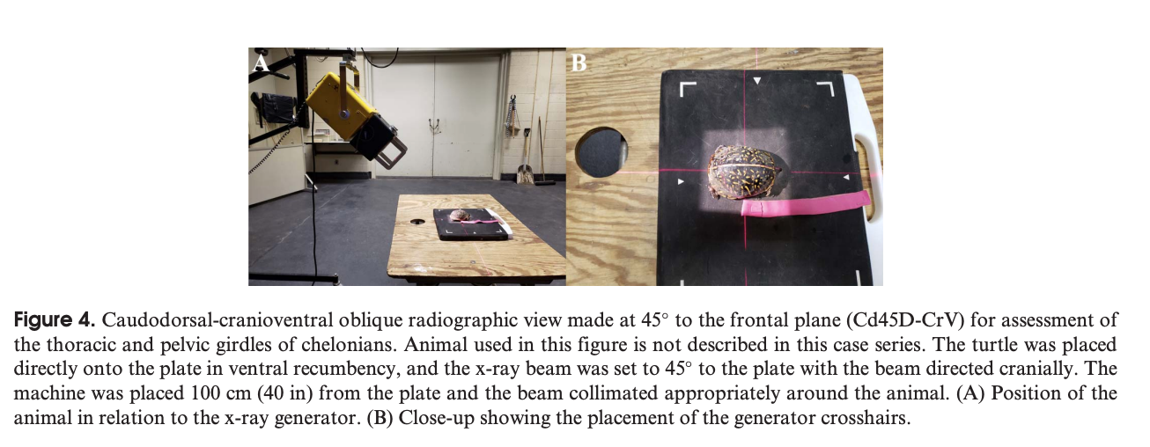

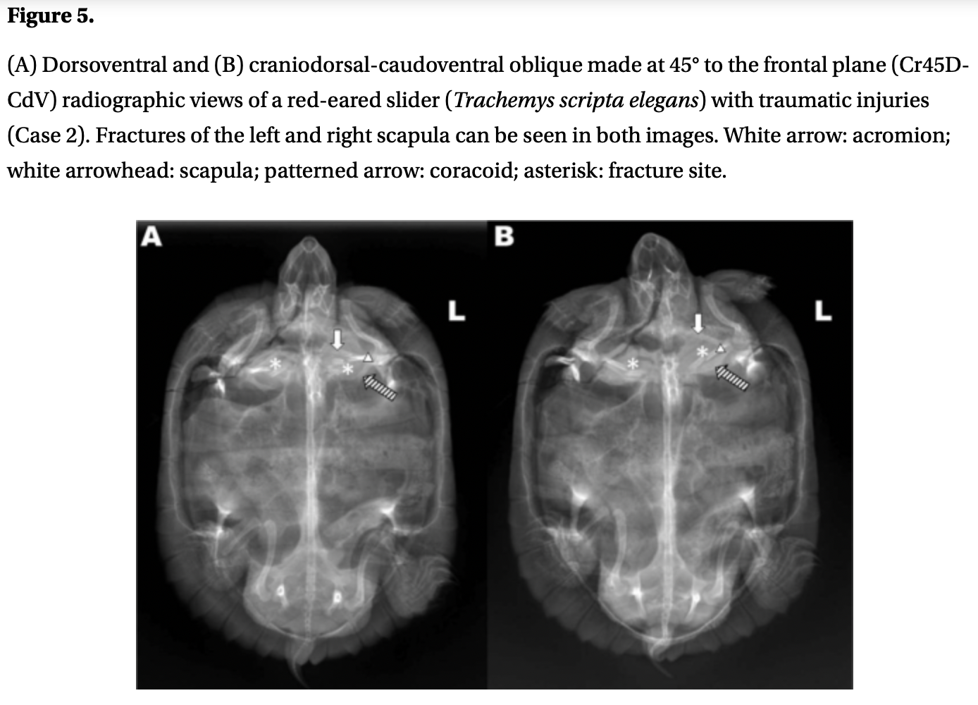
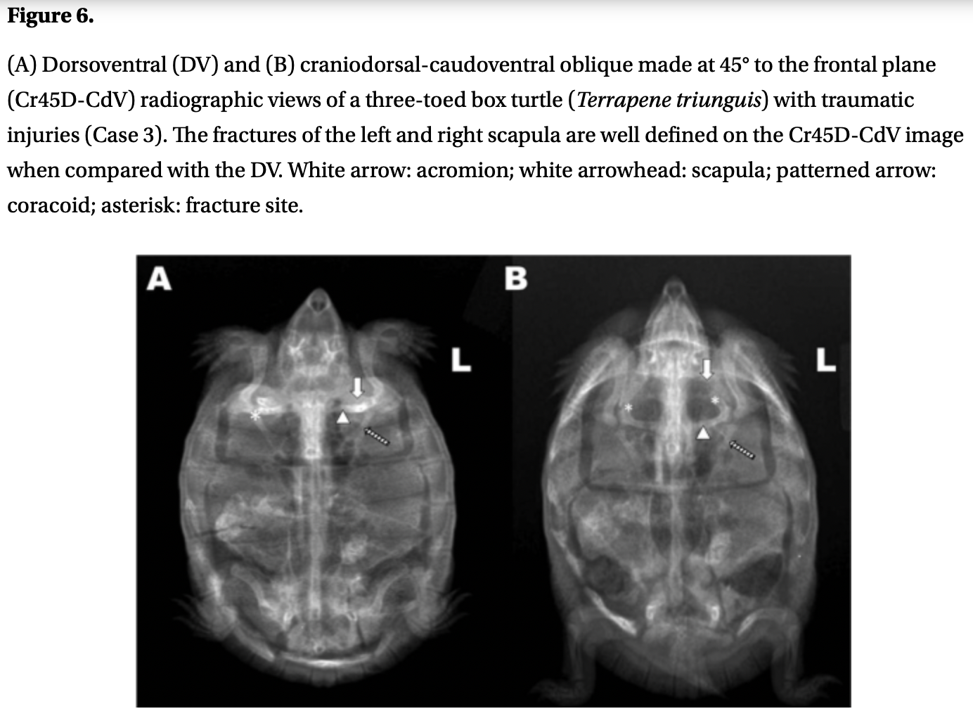
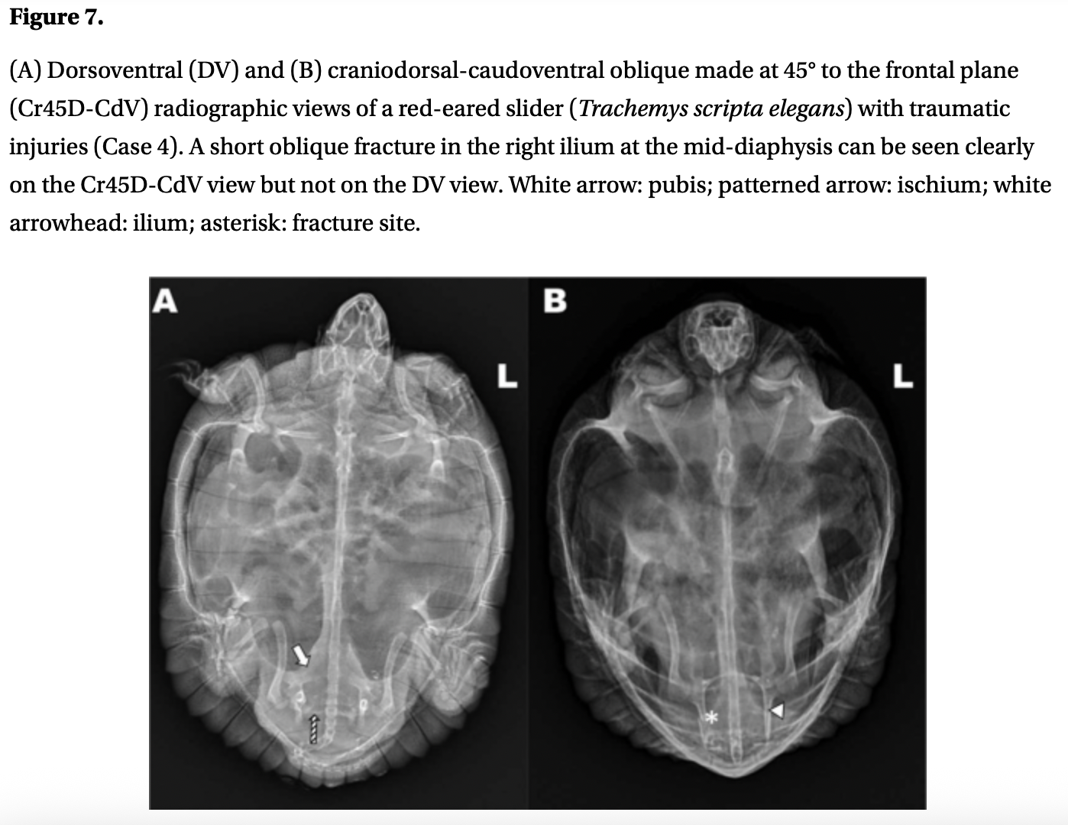

2024 AJVR 85.9
Subcutaneous amikacin administration in red-eared sliders (Trachemys scripta elegans) produces prolonged detectable plasma concentrations without biochemistry evidence of impaired renal function
Kara Hiebert, Heather Knych, Shawna Hawkins – summarized by MGF

OBJECTIVE To establish pilot data on the plasma concentrations of SC amikacin at 2 doses in red-eared sliders and evaluate concurrent plasma biochemistry parameters.
ANIMALS 8 adult red-eared sliders (Trachemys scripta elegans).
METHODS Amikacin was administered SC at target doses of 5 and 10 mg/kg with a 3-week washout period. Blood samples were collected at 0, 24, 48, 72, and 96 hours postadministration. Plasma amikacin concentrations were quantified using liquid chromatography tandem mass spectrometry. Plasma biochemistry analyses were performed before amikacin administration, 1 week post 5-mg/kg administration, and 1 week post 10-mg/kg administration.
RESULTS Mean maximum amikacin plasma concentrations were recorded 24 hours after 5-mg/kg and 10-mg/kg dosing and were 17.5 ± 2.32 µg/mL and 23.6 ± 2.92 µg/mL, respectively. Mean plasma concentrations after 5-mg/kg dosing steadily decreased to 9.1 ± 0.92 µg/mL by 96 hours postadministration. Amikacin remained detectable in all plasma samples 3 weeks post 5-mg/kg dosing with a mean plasma concentration of 1.04 ± 0.22 µg/mL. Mean plasma concentrations after 10-mg/kg dosing did not decrease over the 96-hour study period. There were no clinically relevant changes in biochemistry parameters.
CLINICAL RELEVANCE Amikacin persists at detectable plasma levels for at least 3 weeks after SC administration of a 5-mg/kg dose in redeared sliders, which has not previously been reported in any species. No biochemistry changes consistent with renal toxicity occurred after either dose. Use caution with repeated amikacin dosing in this species until further studies can better characterize cumulative amikacin pharmacokinetics and toxic threshold.

Summary
- Amikacin: aminoglycoside; bactericidal, broad-spectrum particularly against gram-neg becili
  - Commonly used against Pseudomonas spp, Enterobactericeae, Aeromonas spp, Morganella spp, Proteus spp (all gram neg commonly in pet turtles)
  - Common mammalian adverse effect: nephrotoxicity → not documented in reptiles; vs gentamicin (aminoglycoside) nephrotoxicity in ball python + Haitian boa and renal tubule necrosis and visceral gout in gopher snakes (at 50mg/kg/day; no PK data)
- Previous amikacin PK reptiles: gopher snake 5mg/kg followed by 2.5mg/kg q72hr when high end of optimal temp; ball python IM remained elevated 6 d after so single admin recommended (no difference in temp changes); juvenile american alligators 1.75 and 2.25mg/kg found t_{1/2} of ~50hr
  - Chelonians: gopher tortoise 5mg/kg: clearance higher in those housed at 30º C than 20ºC
  - Suggest temperature effect on amikacin PK species dependent (this study all same temp)
- Used 8 red eared sliders; temp 75-81F, each received fenbendazole 50mg/kg 2 week prior, chemistry (subcarapacial plexus); each received amikacin at 5mg/kg SC and then 10mg/kg SC after 3 week washout period → first study evaluating SC in reptile
- Measurable amikacin plasma concentrations more than 9ug/mL > 96 hrs after SC admin at 5mg/kg or 10mg/kg; persistent detectable levels of amikacin 3 weeks past initial 5mg/kg dose
- Plasma concentrations didn’t decrease during study after 10mg/kg dose reached peak (23ug/mL)
- No detectable cutaneous redness, swelling, discoloration or other reaction
- No biochemistry changes after amikacin administration; didn’t evaluate histopathologic change
  - Uric acid = marker of renal fxn in reptiles; this study significant decrease and remained within normal limits for species after amikacin (opposite of what expect); Ca and Na also decreased but remained WNL for species
- Other studies: Ceftiofur sodium in iguana peak plasma 40 min; buprenorphine 1 hr; excede CS bearded dragon 33 hrs; compared this study did not evaluate samples < 24 hrs

Takehome: Amikacin persists at detectable plasma levels for at least 3 weeks after SC administration of a 5-mg/kg dose in redeared sliders (Trachemys scripta elegans) and no cutaneous adverse effects or biochemistry changes consistent with renal toxicity occurred after either (5mg/kg, 10mg/kg) dose.

2024 AJVR 85.5
Subcutaneous administration of ceftazidime at 20 and 40 mg/kg produces theoretically therapeutic plasma concentrations for at least 120 hours in red-eared sliders (Trachemys scripta elegans)
Kara Hiebert, Sherry Cox, Shawna Hawkins – summarized by MGF

OBJECTIVE To evaluate and compare the pharmacokinetic parameters of SC ceftazidime administered at 20 and 40 mg/kg to red-eared sliders.
ANIMALS 8 adult red-eared sliders (Trachemys scripta elegans).
METHODS In a sequential, 2-period study with a 3-week washout period between treatments, ceftazidime was administered SC to turtles at 20 and 40 mg/kg. Blood samples were collected from the subcarapacial sinus at 0, 24, 48, 72, 96, and 120 hours after ceftazidime administration. Plasma ceftazidime concentrations were quantified using reversedphase HPLC.
RESULTS Mean plasma half-life after 20- and 40-mg/kg dosing was 39.75 ± 8.0 hours and 33.03 ± 6.56 hours, respectively. Mean maximum plasma concentration after 20- and 40-mg/kg dosing was 71.0 ± 15.93 µg/mL and 120.0 ± 30.62 µg/mL, respectively. Mean plasma ceftazidime concentrations remained ≥ 8 µg/mL, the theoretical MIC for various reptile pathogens for all time points.
CLINICAL RELEVANCE Results indicate that ceftazidime dosed at either 20 or 40 mg/kg produces plasma concentrations exceeding the theoretical MIC of various reptile pathogens for at least 120 hours. An ideal dosing interval could not be determined, as all plasma concentrations remained above the threshold of interest for all time points. Follow-up studies should focus on establishing a dosing interval and more rigorous monitoring for potential adverse effects.

Summary
- Ceftazidime: third generation cephalosporin; high efficacy against gram neg
  - Mammals excreted through kidneys; not described in turtles
- Previous studies: Ceftaz 20mg/kg IM or IV loggerhead ST plasma exceeded MIC for pseudomonas (defined as > 8ug/mL) for 60 hrs; Ceftaz 20mg/kg IM eastern box turtle + yellow bellied slider + river cooter plasma level > 8ug/mL up to 120 hrs
  - This study uses MIC > 8ug/mL as threshold for common reptile pathogens
  - Ceftaz SC eastern hellbender clinically relevant plasma concentration 5 d; 24hrs in Northern leopard frogs
- 8 red eared sliders, received 50mg/kg fenbendazole prior to study; PE with baseline BW
- Turtles administered Ceftazidime 20mg/kg SC; 3 week washout then 40mg/kg SC antebrachial
- Plasma concentrations detectable above MIC for Pseudomonas (8 ug/mL) at all timepoints for both doses → similar to study in wild North American freshwater turtles (20mg/kg) high concentration for 120 hr; different from loggerhead ST (20mg/kg), only high 60 hr after IV/IM
- Half-lives between 20mg/kg and 40mg/kg not different but 40mg/kg dose produced higher ceftazidime concentrations at every time point (but all above threshold 8 ug/mL)
- No cutaneous reactions noted → did not evaluate biochemical or histo differences after admin
- Did not evaluate temperature differences (shown temp affects PK amikacin in gopher tortoise)
- Unknown if excreted in urine/feces; turtles housed together and could have been reexposed
- Can’t definitively say but from study generally recommend 20mg/kg ceftazidime in red-eared sliders with an expected duration of action of at least 5 days

Take home: Ceftazidime 20mg/kg or 40mg/kg produce plasma concentrations above reptile presumed MIC (used for Pseudomonas 8 ug/mL) at all time points but 40mg/kg consistently had higher concentrations; no adverse cutaneous effects.
**very easy to compare this study against 2024 AJVR 85.9 Subcutaneous amikacin administration in red-eared sliders (Trachemys scripta elegans) produces prolonged detectable plasma concentrations without biochemistry evidence of impaired renal function
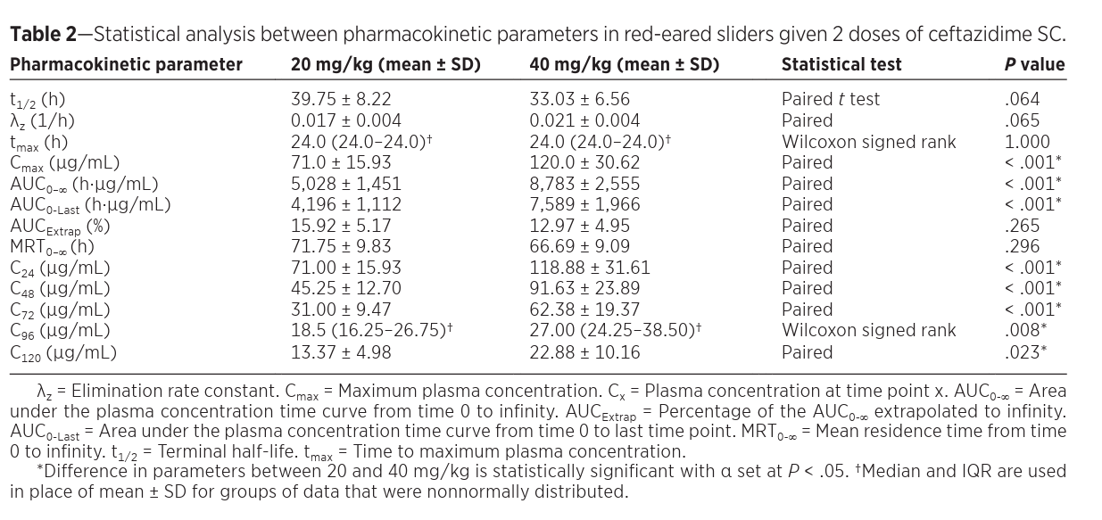
The Journal of Herpetological Medicine and Surgery, Volume 35, No. 1, 2025 pp. 40–44
Summarized by MR

Effectiveness of Nasal Flush Treatments in Mycoplasma PCR- or DNA Sequencing–Positive Tortoises
Marianne Caron, Ian Kanda, Mark Mitchell, Thomas Boyer

Abstract: Mycoplasmas can cause severe chronic nasal sinusitis in tortoises and box turtles, both in captive and wild populations. The aim of this study was to compare positive and negative Mycoplasma sp. test results before and after a nasal flush protocol combined with systemic enrofloxacin and to compare positive and negative results between DNA sequencing and PCR in tortoises with nasal discharge. Fifteen mycoplasma-positive tortoises were included in the study. All were treated with the nasal flush protocol. At the end of the nasal flush protocol, 26.7% of the treated tortoises remained mycoplasma positive. One month after the end of the nasal flush protocol, 20% remained positive. The PCR and DNA sequencing tests had good agreement based on a weighted kappa of 0.64. Based on these results, we conclude that the outlined nasal flush protocol is overall successful at acutely resolving nasal discharge and leading to a PCR- or DNA sequencing–negative tortoise 1 month after treatment.

Background:
- Mycoplasma (Mycoplasmopsis) agassizii causes upper respiratory tract disease (URTD): serous, mucoid, or purulent nasal discharge
  - High infectious rate, wide distribution worldwide, low host specificity
  - Attaches to nasal sinus and choanal epithelium causing an overexuberant, chronic immune response that fails to clear infection
  - Ocular discharge, conjunctivitis, and palpebral edema
- Reported that this decreases olfaction, which may suppress appetite since that sense is used to select food, as well as predator detection and reproduction
- Poor success to date in clearance of infection

Summary:
- N = 15 Testudinidae with Mycoplasma spp. detected on either PCR or DNA sequencing (MiDOG) were included
  - 8 were desert tortoises (Gopherus agassizii), five were leopard tortoises (Stigmochelys pardalis), and two were African spurred tortoises (Centrochelys sulcata).
- Treatment consisted of five nasal flushes under sedation, administered every 48–72 h, with additional flushes per- formed if nasal discharge was persistent at the fifth flush.
- After sedation with telazol (20-30mg/kg), a cotton ball was used to occlude the glottis from aspiration, held down in dorsal recumbency, each naris flushed with 15mL 0.9% NaCl (samples taken from this flush and one choanal swab)
- Protocol: total 3mL: 0.4mL enrofloxacin, 0.2mL dexamethasone, and 2.4mL of 0.9% NaCl – 0.5mL of solution instilled into each nostril and 1mL into each choanal slit and allowed to drip down and out the nares to floor the nasal sinuses
  - + 10mg/kg enrofloxacin IM after each flush
- PCR and DNA sequencing samples collected at first nasal flush, last nasal flush, 1 mo after last nasal flush
- Overall, 12 of 15 tortoises that were mycoplasma positive at the beginning of the study tested negative 1 month after the last nasal flush
  - None of the tortoises had residual nasal discharge
  - 3/15 were positive 4-10 months after tx (only 6/15 rechecked)
  - 2/15 had recurrence of nasal discharge by one month later
- Based on statistical analysis, the PCR and DNA sequencing were concluded to have good agreement
  - PCR seemed to have fewer negative results that disagreed with DNA sequencing rather than the other way around and therefore has been adopted by the authors as the preferred testing modality for future cases.

Take Home Points:
- MiDOG (DNA sequencing) is a useful tool to diagnose Mycoplasma via nasal flush with good agreement via PCR
- The outlined nasal flush protocol successfully decreases detectability of M. agassizii in tortoises and was efficacious at acutely resolving nasal discharge. If the patient is still positive at the fifth treatment, additional nasal flushing should be considered until PCR testing is negative.

Journal of the American Veterinary Medical Association, 260(S2): S101-S110, 2022
Relationship, difference, and diagnostic discordance between blood ionized and total calcium concentrations in client-owned chelonians
Nicola Di Girolamo

Abstract:
OBJECTIVE
To determine (1) the relationship, (2) the difference, and (3) the diagnostic discordance between blood total calcium concentration (tCa) and ionized calcium concentration (iCa) in a population of client-owned chelonian patients.
ANIMALS
161 consecutively admitted client-owned chelonians.
PROCEDURES
Results for tCa, iCa, and other variables were extracted from records. Bound calcium concentration (tCa – iCa) was calculated. General linear models were developed to evaluate factors affecting tCa, iCa and bound calcium concentrations. Diagnostic discordance between tCa and iCa was assessed.
RESULTS
iCa decreased with increasing albumin concentration, it was not influenced by sex, and it was lower in chelonians with disorders of the reproductive tract than in those with disorders of the endocrine/hemopoietic and urinary systems. Total calcium and bound calcium concentrations increased with increasing albumin concentration; they were higher in females and in chelonians with disorders of the reproductive tract. Of the 161 chelonians, 93 (57.7%; 95% CI, 49.7% to 65.5%) would have had a different diagnosis of calcium status based on tCa and iCa results (ie, diagnostic discordance). A 2.2 mmol/L cutoff value for bound calcium could differentiate chelonians with and without disorders of the reproductive tract with a sensitivity (95% CI) of 81.8% (64.5% to 93.0%) and specificity of 76.4% (68.0% to 83.5%).
CLINICAL RELEVANCE
tCa and iCa were related and were associated with albumin concentrations in chelonians. Evaluation of tCa or iCa alone is likely to result in underdiagnosis of alterations of the calcium status. Calculation of bound calcium concentration could help identify chelonians with reproductive disorders.

Key Points:
- Blood calcium concentrations may be affected by several parameters including diet, exposure to UVB radiation, sex, season, physiological status, and medications, among others.
- Plasmatic calcium is present in three different states: ionized or free (approx 56% in dogs and 45% in humans), protein bound (approx 34% in dogs and 41% in humans), and bound to other anions, such as phosphate, lactate, and bicarbonate (approximately 10% in dogs and 14% in humans)
- Blood iCa concentration increased by 0.25 mmol/L for each unit of increase in blood tCa concentration, decreased of 0.20 mmol/L for each unit of increase in blood albumin concentration, and was similar between females or males and animals of unknown sex. iCa was higher in red-eared sliders, African spurred tortoises, and leopard tortoises compared to other species. iCa was higher in chelonians with endocrine/hemopoietic and urinary organ systems affected than in chelonians with reproductive organ system affected
- Blood tCa concentration increased by 5.49 mg/dL for each unit of increase in blood iCa concentration, increased of 2.3 mg/dL for each unit of increase of albumin, and was 2.25 mg/dL higher in females than in animals of unknown sex, while it was similar between males and animals of unknown sex. Blood tCa was lower in African spurred tortoises and leopard tortoises and higher in chelonians with reproductive organ system affected than in chelonians with any other organ systems affected
- The difference between blood tCa and iCa concentrations (bound calcium) increased by 0.54 mmol/L for each unit increase in blood albumin concentration and was 0.59 mmol/L higher in females than in animals of unknown sex. Bound calcium was higher in chelonians with reproductive disorders than in chelonians with any other organ system affected
- When chelonians were categorized on the basis of a priori determined tCa cutoffs of 10 to 14 mg/dL, 67 (41.6%) were normocalcemic, 31 (19.3%) were hypocalcemic, and 63 (39.1%) were hypercalcemic. When chelonians were categorized on the basis of a priori determined iCa cutoffs of 1.2 to 1.6 mmol/L, 70 (43.5%) were normocalcemic, 22 (13.7%) were hypocalcemic, and 69 (42.9%) were hypercalcemic
- Diagnostic discordance between tCa and iCa in chelonians was common (between 57.7% and 36.6%, depending on the cutoffs used)
- The cutoff value for blood-bound calcium concentration at 2.2 mmol/L could differentiate chelonians with and without reproductive disorders with a sensitivity of 81.8% (64.5% to 93.0%), specificity of 76.4% (68.0% to 83.5%) (higher in animals with reproductive disease)

Take-Home Message:
- iCa decreased with increasing albumin concentration, it was not influenced by sex, and it was lower in chelonians with disorders of the reproductive tract than in those with disorders of the endocrine/hemopoietic and urinary systems. Total calcium and bound calcium concentrations increased with increasing albumin concentration; they were higher in females and in chelonians with disorders of the reproductive tract. 57.7% had diagnostic discordance between tCa and iCa results. A 2.2 mmol/L cutoff value for bound calcium could differentiate chelonians with and without disorders of the reproductive tract.

Journal of Herpetological Medicine and Surgery, 34(2): 145-149, 2024
PREVALENCE OF UROLITHIASIS IN CLIENT-OWNED CHELONIANS AND ITS ASSOCIATION WITH SELECTED HOUSING AND DIETARY PARAMETERS IN AFRICAN SPURRED TORTOISES (CENTROCHELYS SULCATA)
Violaine Colon, Nicola DiGirolamo
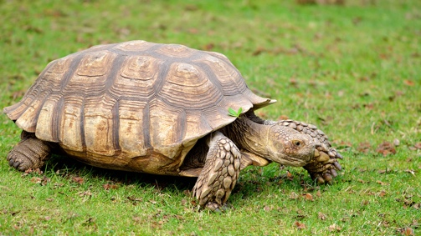

Abstract:
There is limited information on the prevalence and etiology of urolithiasis, although it is considered a common condition in chelonians. Several hypotheses regarding urolith formation in chelonians have been proposed, but none has been tested by epidemiological research. The objective of this study was to evaluate the prevalence of urolithiasis in a large number of chelonians and to evaluate the association between housing and dietary conditions and urolithiasis in African spurred tortoises (Centrochelys sulcata). Records of all client-owned chelonians that underwent radiographs at two institutions were extracted. Univariable and multivariable logistic regression models were built to explore associations between the presence of urolithiasis and husbandry variables. Prevalence of urolithiasis was 4.4% (95% confidence interval [CI]: 3.3–5.9%; 46/1,033) among all chelonians. Terrestrial chelonians had 64 times the odds (odds ratio [OR]: 64.2; 95% CI: 15.4–266.6; P < 0.001) of presenting urolithiasis compared with aquatic chelonians. African spurred tortoises had 22 times the odds (OR: 22.3; 95% CI: 7.7–64.5; P < 0.001) of presenting urolithiasis compared with other terrestrial chelonians. African spurred tortoises living in a confined indoor area had 3 times the odds of presenting urolithiasis compared with the tortoises living outdoors (OR: 3.01; 95% CI: 1.06–8.55; P = 0.038), and African spurred tortoises that were not fed any fruit had 0.31 times the odds of presenting urolithiasis compared with the tortoises fed fruit (OR: 0.31; 95% CI: 0.10–0.99; P = 0.049). Certain chelonians in captivity are at higher risk than others of suffering urolithiasis. African spurred tortoises in a confined indoor area had the highest risk of developing urolithiasis. As a precaution, avoiding fruit should be considered in the diet of African spurred tortoises.

Key Points:
- Terrestrial chelonians had increased odds of urolithiasis compared to aquatic chelonians
- African spurred tortoises had increased odds of urolithiasis compared to other terrestrial chelonians
- African spurred tortoises living indoors had increased odds of urolithiasis compared to animals living outdoors
- African spurred tortoises NOT fed fruit had decreased odds of urolithiasis compared to African spurred tortoises fed fruit
  - In mammals, fructose metabolism produces urate as a byproduct.
- No significant association between urolithiasis and dietary hay, pellets, vegetables, calcium supplementation, sun exposure, UVB exposure, soaking
- “Treadmill walking could be instituted in tortoises at risk of developing urolithiasis to increase the turnover of urine in the urinary bladder.”
- Uric acid in urine supersaturates at pH < 5.5, whereas at a pH > 6.5 most uric acid is in the form of urates; both a pH lower than normal and a pH higher than normal could be responsible for urolithiasis in chelonians.

Take-Home Message:
Terrestrial chelonians had increased odds of urolithiasis compared to aquatic chelonians. African spurred tortoises had increased odds of urolithiasis compared to other terrestrial chelonians. African spurred tortoises housed inside and fed fruit at greater risk of urolithiasis.

The Journal of Herpetological Medicine and Surgery, Volume 35, No. 2, 2025 pp. 108–112
Summarized by MR

Comparison of Different Physiological Parameters for the Assessment of Hydration Status in Turtles of the Genus Trachemys
Oliver Baca-Montero, Daniel Alejandro Gomez Pizano, Maria Guadalupe Sanchez Gonzalez

Abstract: Because of their anatomical and physiological characteristics, and the limited published research on the subject, it is difficult to objectively determine the hydration status of reptiles and consequently provide appropriate fluid therapy. Various clinical and laboratory parameters have been used as indicators of chelonian hydration status, such as the presence of saliva strands or hematocrit, but their correlation with actual hydration status has not been verified. The objective of this work was to determine whether there is a significant change in various physiological parameters in Trachemys turtles exposed to a dehydration period. Fifteen Trachemys spp. turtles were studied. A physical examination was performed on day 1, including skin turgor test (SK), eyeball position (EY), tear production (Schirmer tear test [STT]), mucosal moisture (MM), cornea moisture (MC), and body weight (BW). Also, blood samples were collected to measure total solids (TS), uric acid (UA), total protein (TP), serum osmolarity (OS), and hematocrit (Hct). Water intake was completely withheld for 10 days, and sampling and physical examination were repeated. The OS, TS, TP, SK, EY, and BW differed significantly between days 1 and 10 (P < 0.05). Using these analytes in sick and dehydrated Trachemys spp. turtles will allow development of a more precise scale for hydration status in these reptiles. By contrast, UA, Hct, STT, MM, and MC did not differ significantly between the start and end of the study, indicating that these analytes may be less reliable indicators of hydration status for these species.

Summary:
- N = 22 Trachemys spp. turtles
- PE parameters evaluated: skin turgor test (SK), eyeball position (EY), tear production (Schirmer tear test [STT]), mucosal moisture (MM), cornea moisture (MC), and body weight (BW).
  - Significant difference: SK, EY, BW
- Bloodwork parameters evaluated: total solids (TS), uric acid (UA), total protein (TP), serum osmolarity (OS), and hematocrit (Hct).
  - Significant difference: OS, TS, TP
- Water withheld for 10 days, testing repeated to evaluate for SD in the aforementioned parameters.
- Increase in OS was used as gold standard test of dehydration, describes the ratio between dissolved substances and solvents in serum.
  - Unlike the above-mentioned analytes, it is less affected by concomitant diseases and malnutrition, making it more accurate for evaluating hydration
- MM is not an indicator of hydration status in turtles, nor is the presence or absence of saliva strands.

Take Home Point:
- Skin turgor, eyeball recession, body weight, serum osmolarity, total solids, and total protein were significantly different in Trachemys with water withheld for 10 days.
- The following were not significantly different, and thought to be unreliable indicators of hydration: STT, MM (mucosal strands), MC, UA, HCT

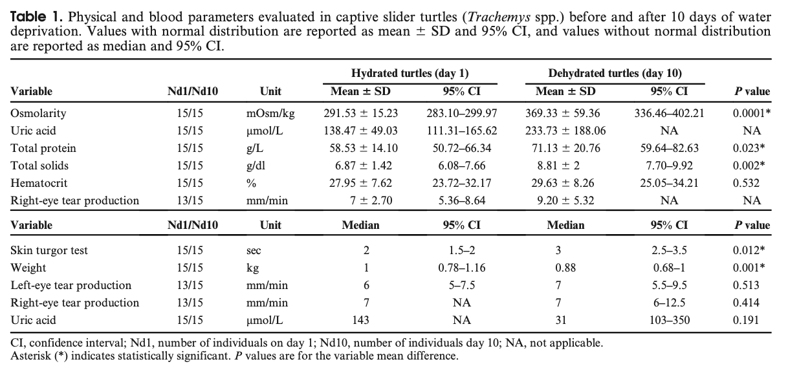

Shell lesion prevalence and bacteriome associations in threatened western pond turtles (Actinemys marmorata and Actinemys pallida) in California, USA
Green N, Norwood A, Sidhe C, Mutlow A, Aymen J, Stiles R, Bushell J, Lim T, Culver E, Reeder N, Timmer M, Connelly F, Charbonneau J, McCall W, Koenig L, Stein M, Geist N, Lambert MR, Hernández-Gómez O. J Wildl Dis. 2025;61(3):574-586.—Reviewed by ALD

Abstract: Bacteriome characterization studies can provide insights into the microbial ecology associated with disease. We collected western pond turtles (Actinemys marmorata and Actinemys pallida) from six San Francisco Bay Area, California, USA, ponds; assessed their shells for lesions; and collected shell swabs and keratin scrape samples to evaluate bacteriome differences between the whole shell (swabs) and the affected tissues (scrapes). We quantified shell lesion type and prevalence by using visual inspections of photographs collected of the plastron and carapace and then applied 16S rRNA amplicon sequencing to characterize the associated bacteriomes of shells that observed pits, ulcerations, or no lesions. We observed shell lesions at high frequencies throughout our sites, with larger individuals (>100-mm plastron length) more likely to possess injuries. We saw no differences in alpha diversities between shells presenting with lesions and those on which we did not observe lesions; however, swab samples showed higher bacterial richness than keratin scrapes. The bacterial composition within the scrapes was influenced by pond location and then lesion presence. We observed a higher relative abundance of Actinobacteriota, Bacteroidota, Cyanobacteria, and Deinococcota in the shell keratin microflora of turtles with shell lesions. Because western pond turtles are under consideration for listing under the Endangered Species Act of 1973 in the USA, understanding patterns of shell disease pathologies and the bacteria associated with disease is imperative for the management of current populations.

Background:
- Microbiome helps to understand how host has evolved w/assoc collection of microorganisms, competence of immune system, etiologies & contributing microbiologic agents of dz
- Ulcerative shell lesions (USLs): caused by trauma, malnutrition, microbial etiologies (G- and fungi)
- No turtles tested were positive for E. testavorans

Key Points:
- M&M: scraped pits or ulcerations, swabbed entire shellsto tell the difference b/t shell surface and deeper layers w/I shell
  - DNA extraction, and amplified 16S rRNA, filtered out mitochondria and chloroplast 16S rRNA
  - Alpha diversity metrics: community richness (number of amplicon sequence variants (ASV) detected per sample) and Shannon diversity indices
  - 125 turtles (36.48.45), 66 shell swab, 50 keratin scrapes
- Prevalence of shell ulceration below 50% except in 2 places; pits >60% in all but 2 sites
- Shell lesion sig assoc w/plastron length (1.036x inc probability w/inc plastron length)
- Bacterial richness sig assoc w/sample type and shell lesion presence, but not w/interaction b/t sample type and lesion presenceshell swab had higher bacterial richness than scrapes
  - Shannon indices didn’t differ based on sample type, lesion presence, or interaction term
- Most ASV associated w/shell lesions, ASV identified w/Acidobacteriota, Actinobacteriota, Bacteroidota, Cyanobacteria, Deinococcota, Firmicutes, Alphaproteobacteria, Gammaproteobacteria
- similar prevalence of ulceration previously seen in free ranging P. concinna and T. scripta; spp experiencing higher prev of ulceration basked at higher freq than other turtles
- Inadequate husbandry assoc w/development and exacerbation of shell dz in captivity
- Strong geographic effect noted previously w/cloacal, skin, and keratin scrapes in aquatic turtles
- Environmental quality is potential contributor to lesion formation
  - Previous bacteriome research into gut of western pond turtles: lower Bacteroidetes & more Firmicutes w/lower land covertypically see w/diet shifts to more herbivorous

Main Takeaways:
- Increased incidence of shell lesions in larger animals than young, ulcerations found at lower frequency than pits
- Community richness (number of ASVs in a sample) but not diversity (evenness in frequency of ASVs observed per sample) differed b/t swabs and scrapes and differed in composition, but composition was mostly influenced by pond location
- Mechanism b/t land use change, diet shifts, and bacteriome shifts important to understand link b/t environment and health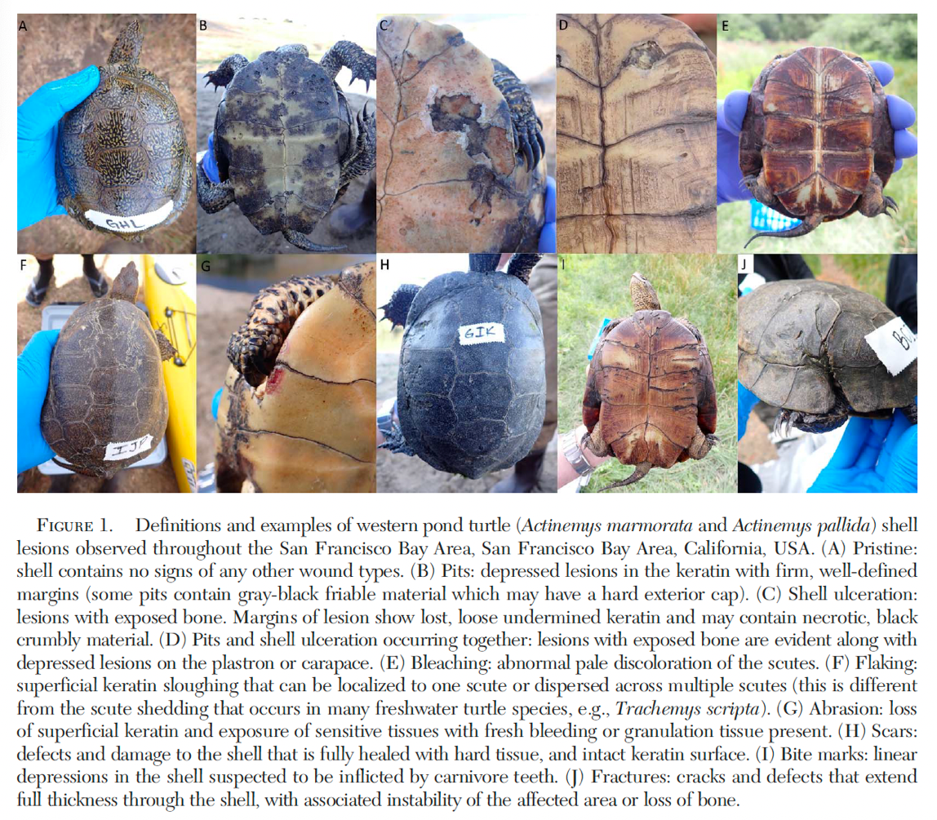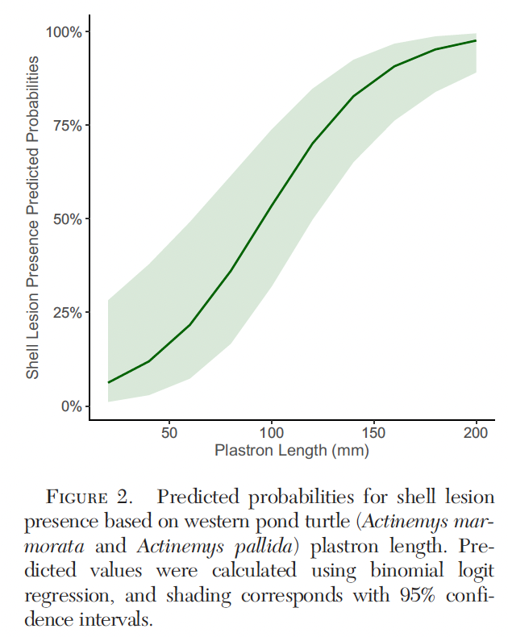

Evaluating the efficacy of disinfectant methods against Emydomyces testavorans, a fungus associated with shell disease in freshwater aquatic turtles
Liszka NC, Adamovicz L, Moorhead KA, Daleo MJ, Grochowski K, Allender MC. J Wildl Dis. 2024;61(1):234-240.—Reviewed by ALD

Abstract: Emydomyces testavorans is an onygenalean fungus associated with shell and skin lesions in chelonians and is increasingly linked to morbidity and mortality. Effective disinfection methods are a critical component of biosecurity protocols to prevent and manage emydomycosis; however, disinfectant efficacy against E. testavorans is unknown. This study determined the in vitro efficacy of 13 disinfectants across a range of concentrations and exposure times used in veterinary, wildlife, and environmental settings against E. testavorans. Pure E. testavorans culture material was exposed to each disinfectant at manufacturer recommended concentration and exposure times in triplicate. Disinfectant was removed via centrifugation and cultures were inoculated onto inhibitory media plates, maintained at room temperature (20–22 C), and examined weekly for fungal growth. After 6 wk of incubation, ethanol, Virkon S (active ingredient potassium peroxymonosulfate 21.41%), benzalkonium chloride, and desiccation proved ineffective at completely inhibiting fungal growth. All other agents, including bleach, chlorhexidine, and accelerated hydrogen peroxides, effectively inhibited fungal growth. These data suggest that several effective disinfection options are available for use against E. testavorans. These findings can be used in managed care and field settings to reduce transmission of E. testavorans between turtles through contaminated surfaces and equipment.

- Turtles in managed care have highest prevalence of emydomycosis

Key Points:
- Colonies of E. testavorans exposed to disinfectant method per manufacturer recommendations, and then re-plated and monitored for 6wk
- Bleach (6% Na hypochlorite) at 3% and 10% dilutions inhibited growth after 1min
- Rescue: accelerated H2O2, effective against M. canis and Trichophyton spp. E. testavorans inactivated after 2min
- Povidone-iodine: iodine not shown to inhibit growth of other reptile fungi, betadine inhibited E. testavorans at full strength
- Chlorhexidine diacetate 2%: little efficacy against other onygenalean fungi but completely inhibited E. testavorans after 1min
- Quaternary ammonium compounds: F10 ineffective against environmental contamination of N. guarroi at 1:250 conc after 10 min; F10 at 1:250 conc inhibited E. testavorans after 2 min
  - Roccal-D Plus inhibited at 2 and 10 min, but known to be toxic to aquatic organisms
  - Lysol: inhibited E. testavorans in 2 min
  - Benzalkonium chloride: only QAC that failed to inhibit, fungal growth inhibited until 28dthink fungistatic
- Virkon S 1%: no complete inhibition of fungal growth, 10 min exposure inhibited colony growth until 28d (fungistatic), may need higher conc
- Desiccation: for at least 3h kills B. dendrobatidis, E. testavorans seen growing after dessication for 24h, not recommended; 60C for 5min inhibited fungus

Main take aways:
- Bleach diluted to 3% or 10%, as well as full-strength Betadine and undiluted Lysol All-Purpose Cleaner, manufacturer-recommended concentrations and exposure times for F10 SC, F10 SCXD, Roccal-D Plus, Rescue, and chlorhexidine, and heating to 60 C eliminated E. testavorans
- Benzalkonium chloride, ethanol, Virkon S and desiccation did not eliminate all fungal growth

- 