Journal of the American Veterinary Medical Association, 261(2): 223-228, 2023
INTRAMUSCULAR ALFAXALONE WITH OR WITHOUT BUPRENORPHINE OR HYDROMORPHONE PROVIDES SEDATION WITH MINIMAL ADVERSE EFFECTS IN HEALTHY RABBITS (ORYCTOLAGUS CUNICULUS) IN A RANDOMIZED BLINDED CONTROLLED TRIAL
Renata S Costa, Miranda Ciotti-McClallen, Rachel Tilley, Stefanie Perry, Lynn Maki, Darius Starks, Amy B Stein – Reviewed by LMM

Abstract: OBJECTIVE - To evaluate the effects of alfaxalone administered IM with or without buprenorphine or hydromorphone in healthy rabbits (Oryctolagus cuniculus). ANIMALS - 24 male rabbits undergoing elective orchiectomy between August 21, 2021, and November 6, 2021. PROCEDURES - In this controlled clinical trial, rabbits were randomly assigned to receive alfaxalone (4 mg/kg, IM) alone (group A; n = 8) or with buprenorphine (0.03 mg/kg, IM; group BA; 8) or hydromorphone (0.1 mg/kg, IM; group HA; 8). Vital signs and sedation scores were recorded immediately prior to (T0) and 10 minutes after (T1) treatment. Ease of IV catheter placement and pain scores were also evaluated. All rabbits received ketamine (2.5 mg/kg, IV), midazolam (0.13 mg/kg, IV), and meloxicam (0.5 mg/kg, SC) before orchiectomy but after IM treatments. Results were compared across groups with ANOVA or Fisher exact tests and across time with paired t tests. RESULTS - Sedation score, median time to recumbency, and ease of catheter placement did not differ among groups. Supraglottic airway device placement was possible for 1 rabbit in group A, 1 in group BA, and 2 in group HA. Mean respiratory rate at T1 versus T0 was significantly decreased for groups BA (63.8 vs 128.6 breaths/min) and HA (66.7 vs 123.2 breaths/min). Mean postoperative pain scores were significantly lower for rabbits in group HA (0.58), compared with those in groups A (2.25) and BA (2.06). CLINICAL RELEVANCE - All 3 treatments provided reliable sedation; however, alfaxalone (4 mg/kg, IM) combined with hydromorphone (0.1 mg/kg, IM) may be a better choice for painful procedures.

Key Points:
- Rabbits are at higher risk of anesthetic-related death (overall risk of 1.39%) when compared to domestic species like dogs (0.17%) and cats (0.24%)
- Potential reasons for higher mortality rate include undiagnosed cardiovascular or respiratory diseases such as P. multocida, challenges with IV catheter and ET intubation due to size, anatomic differences (e.g. small oropharyngeal cavity and glottis), and physiologic response to stress
- Alfaxalone a popular alternative to ketamine (painful when administered IM) and medetomidine-based protocols (higher risk of developing laryngospasm and bradycardia)
- Alfaxalone = neurosteroid anesthetic agent commonly administered IV but can be given IM (extralabel)
  - Rapid onset, short duration, minimal to mild cardiovascular effects, but does not provide analgesia
  - Typically add an analgesic drug such as buprenorphine (partial μ-agonist) or hydromorphone (full μ-agonist). Note that hydromorphone can cause dose-dependent sedation in rabbits.
- When comparing rabbits undergoing routine orchiectomy, the following groups were compared: alfaxalone alone (A), alfaxalone + buprenorphine (BA), and alfaxalone + hydromorphone (HA)
  - BA and HA had significantly lower mean respiratory rates when compared to baseline but this was not the case for group A. All RR’s were within acceptable physiologic range and no apnea occurred for rabbits in any treatment group.
    - The lack of change in RR for group A contrasts with a previous study in which a significant decrease in RR was noted after the same IM dose of alfaxalone. Unclear why this occurred but authors listed a large number of possibilities (current study had smaller cohort, differences in breed-drug sensitivity, environmental factors, etc).
  - Mean post-operative pain scores were significantly lower in group HA in comparison to groups A and BA. 3 rabbits in A and 2 in BA received rescue analgesia postoperatively.
- IM administration of alfaxalone alone or in combination with buprenorphine or hydromorphone provided reliable sedation in healthy rabbits
- Alfaxalone with hydromorphone did not provide superior sedation when compared to other treatment groups but did provide superior analgesia
- No severe adverse events were observed in this study, and no death or morbidity reported 1 week following study completion. (Minor adverse effect: Hypersalivation in 1/8 rabbits in group A and 1/8 rabbits in group BA)
- Majority of rabbits in all groups did not tolerate supraglottic airway device placement, this is in accord with current literature and if placement is desired then likely need higher doses of alfaxalone

Take Home Point: Alfaxalone alone or with either buprenorphine or hydromorphone provided reliable and uneventful sedation in rabbits and permitted IV catheter placement. Alfaxalone with hydromorphone provided superior analgesia compared to alfaxalone alone and alfaxalone with buprenorphine. For that reason, an alfaxalone-hydromorphone protocol would be recommended for more invasive procedures.
_____________________________________________________________________________________

Journal of the American Veterinary Medical Association, 261(9): 1368-1373, 2023
SUBCONJUNCTIVAL ENUCLEATION WITH OR WITHOUT THIRD EYELID REMOVAL MAY PRESENT A VIABLE ENUCLEATION TECHNIQUE IN RABBITS: 18 CASES (2014-2022)
Kara Hiebert, Christoph Mans, Seth Eaton – Reviewed by LMM

Abstract: Objective - To evaluate intraoperative and postoperative complications and outcomes following subconjunctival enucleations with and without third eyelid removal in domestic rabbits. Animals - 18 client-owned rabbits with ocular disease confined to the globe that underwent 20 subconjunctival enucleation procedures at a veterinary teaching hospital. Methods - Records were retrospectively reviewed for all enucleations performed at a veterinary teaching hospital from 2014 to 2022. A standard subconjunctival enucleation procedure was performed in all cases, with third eyelid removal in 2 surgeries and without third eyelid removal in the remaining 18 surgeries. Outcomes were assessed on the basis of observations in medical records and owner follow-up. Results - 20 total enucleations were included. Reported reasons for enucleation included suspected or confirmed ocular Encephalitozoon cuniculi infection in 9 rabbits, refractory glaucoma in 4 rabbits, and various intraocular diseases in 5 rabbits. The only intraoperative complication reported was hemorrhage during the third eyelid removal in 1 surgery. Postoperative complications included serous to mucoid discharge from the surgical site in 8 of 20 surgeries and swelling at the surgery site in 2 of the 8 cases that had discharge. Postoperative swelling spontaneously resolved within 3 months of surgery; postoperative discharge spontaneously resolved within 10 months of surgery. Clinical Relevance - Subconjunctival enucleation with or without third eyelid removal in rabbits may be a viable enucleation technique to reduce the risk for intraoperative hemorrhage, but it can result in postoperative complications, including transient discharge and swelling at the surgical site.

Key Points:
- En bloc (i.e. transpalpebral and lateral) enucleation techniques offer advantage of resecting the globe and adnexa in one piece but risk is higher for intraoperative hemorrhage
- Subconjunctival enucleation technique offers better visualization of the ocular and adnexal tissues and lower risk of intraoperative hemorrhage
- Most significant source of hemorrhage encountered during a rabbit enucleation is the orbital venous sinus within the ventral and medial orbit – if transected can cause life-threatening hemorrhage, and many hemostatic techniques may not be successful
  - The venous sinus is intimately associated with the Harderian gland at the deep base of the third eyelid
  - Note: A single case report documents successful use of the LigaSure electrocautery device to reduce hemorrhage associated with third eyelid removal during en bloc enucleation in a rabbit. Promising methodology but many practitioners do not have access to a LigaSure.
- The third eyelid was only removed in 2 of 20 surgeries
- Post-op complications
  - Mucoid to serous discharge form the surgery site in 8/20 cases, noted as early as 2 days after surgery and as late as 2.5 months after surgery and persisted for up to 10 months; this discharge was not responsive to antibiotics
  - Swelling of surgery site in 2/20 cases, noted as early as 2 days after surgery and as late as 19 days after surgery (both of these cases also had discharge) and persisted for up to 3 months in one case (only 4 days in the other)
  - One individual developed a caudal orbital abscess at the site of the previously enucleated eye 23 months after enucleation; unclear if complication of the surgery or incidental finding – owners did not elect necropsy
- Based on complication of serous to mucoid discharge non-responsive to antibiotics, this is likely secondary to residual secretory tissue within the nictating membrane that was left in place
  - The two surgeries with nictating membrane removal did not exhibit any postoperative swelling or discharge.
- Note that the nictitating membrane does not hold all of the secretory tissue, so even if you remove that, you will still have tear-producing tissue remaining in the orbit; Careful preservation of the nasolacrimal duct can help reduce postoperative swelling
- Median age of rabbits undergoing enucleation for E cuniculi ocular pathology was 1.3 years which is lower than rabbits undergoing enucleation for glaucoma, 4.3 years, and other causes, 8 years
  - Note: None of the rabbits that underwent unilateral enucleation for E cuniculi pathology developed the same pathology in the other eye, suggesting that it is a viable option for management if phacoemulsification is not feasible
  - After E cuniculi, glaucoma was the second most common reason for enucleation

Take Home Point: Subconjunctival enucleation in rabbits with or without nictitating membrane removal is a viable surgical approach with a low rate of postoperative complications and favorable long-term outcomes up to 56 months postoperatively. Postoperative complications were transient and self-limiting.
_____________________________________________________________________________________

American Journal of Veterinary Research, 84(8): 1-6, 2023
COMPUTED TOMOGRAPHIC LARYNGOTRACHEAL DIMENSIONS IN ADULT DOMESTIC RABBITS (ORYCTOLAGUS CUNICULUS) ARE POSITIVELY ASSOCIATED WITH BODY WEIGHT AND THE LARYNGOTRACHEAL LUMEN IS NARROWEST AT THE LEVEL OF THE THYROID CARTILAGE
Tessa B. Arendt, BA; Samantha J. Loeber, DVM, DACVR; Carrie A. Schroeder, DVM, DACVAA; Michael R. Lasarev, MS; Tatiana H. Ferreira, DVM, MSc, PhD, DACVAA – Reviewed by LMM

Abstract:
OBJECTIVE: This retrospective study aimed to measure rabbit laryngotracheal dimensions at different locations on computed tomography (CT), assess the relationship of these measurements with rabbit body weight, determine the most common narrowest measurement and assess its relationship with endotracheal tube (ETT) size and body weight.
ANIMALS: 66 adult domestic rabbits (Oryctolagus cuniculus) of different breeds and body weights.
PROCEDURES: CT laryngotracheal luminal height, width, and cross-sectional area measurements were made at the rostral thyroid cartilage at the level of the arytenoids, caudal thyroid cartilage/rostral cricoid cartilage, caudal cricoid cartilage/ cranial trachea, and trachea at the level of the fifth cervical vertebra.
RESULTS: The data for every measurement of luminal airway dimensions revealed robust positive associations with body weight (P < .001). The narrowest laryngotracheal measurement was the width at the level of the caudal thyroid cartilage/rostral cricoid cartilage, and the smallest cross-sectional area was at the rostral thyroid cartilage at the level of the arytenoids. There was a strong association between body weight and the likelihood of appropriate ETT fit. To have at least an 80% chance of appropriate ETT fit with a 2.0, 2.5, and 3.0 mm ETT, the rabbits’ weight predicted by the model (lower 95% confidence limit) were at least 2.99 (2.72) kg, 5.24 (4.65) kg, and 5.80 (5.21) kg, respectively.
CLINICAL RELEVANCE: The laryngotracheal lumen was narrowest at the level of the caudal thyroid cartilage in rabbits, which indicates this location may be the limiting factor in determining ETT size in rabbits.

Key Points:
- Challenges of rabbit intubation – relatively large tongue, long and narrow oropharyngeal cavity, and small glottis
- Sublaryngeal tracheal injury and ulceration described in rabbits for both uncuffed and cuffed ET tubes – suggesting they are predisposed to injury from routine intubation leading to things like tracheal stenosis, etc.
  - Rabbit airway studied as a model for subglottic stenosis in pediatric human airway
- Statistically significant moderate to strong positive correlation occurred between rabbit body weight and all 3 measurements (laryngotracheal height, width, and cross-sectional area) taken at all four locations (see Figure included in summary)
  - Greatest average laryngotracheal height (in most) = caudal thyroid cartilage/rostral cricoid cartilage
  - Narrowest average width = On average, the narrowest width was the caudal thyroid cartilage/rostral cricoid cartilage BUT some rabbits’ narrowest width was the rostral thyroid cartilage. Overall, the thyroid cartilage was the narrowest.
  - Smallest average cross-sectional area = rostral thyroid cartilage (at the level of the arytenoids) (for all except rabbits < or = 1.5 kg whose was at the thyroid cartilage/rostral cricoid cartilage)
- BCS was not informative regarding correlation with ET tube fit
- No evidence that breed has an association with likelihood of ET tube fit

Take-Home Message: The thyroid cartilage is the limiting factor in determining ET tube size. Increasing body weight had a significant, positive correlation with laryngotracheal height, width, and cross sectional area in rabbits.

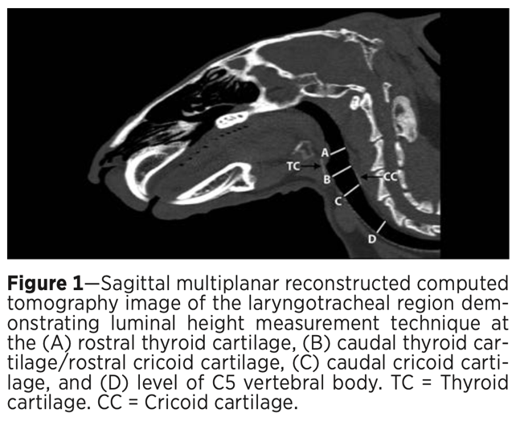
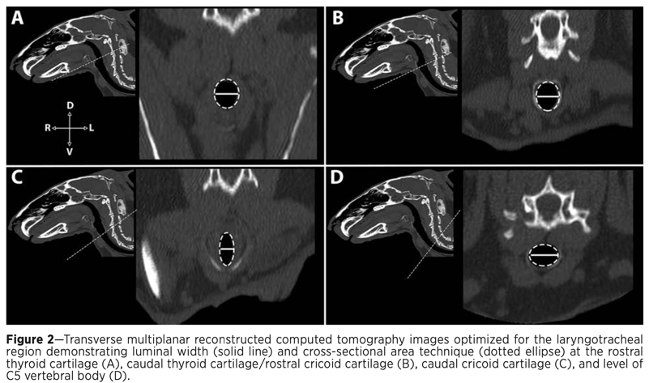

American Journal of Veterinary Research, 83(7): 2022.
Pharmacokinetics and ex vivo pharmacodynamics of oral firocoxib administration in New Zealand White rabbits (Oryctolagus cuniculus)
Sara Gardhouse, Michael Kleinhenz, Samuel E. Hocker, Mikaela Weeder, Shawnee R. Montgomery, Yuntao Zhang, Anna Porting, and Tess Rooney
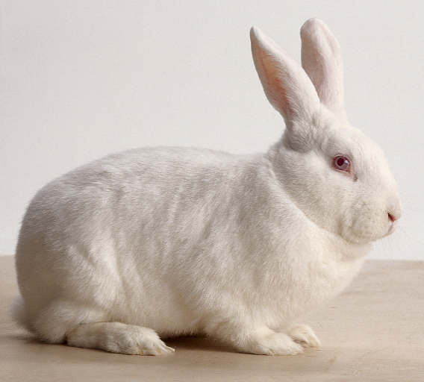
Abstract:
OBJECTIVE
To examine the pharmacokinetics and ex vivo pharmacodynamics of oral firocoxib administration in New Zealand White rabbits (Oryctolagus cuniculus).
ANIMALS
6 healthy New Zealand White rabbits.
PROCEDURES
Pharmacokinetics were determined from plasma concentrations measured via ultra performance liquid chromatography-tandem mass spectrometry after oral administration of firocoxib at a dose of 3.74 to 4.20 mg/kg. Pharmacokinetic analysis was performed using non compartmental methods. Pharmacodynamics of firocoxib were evaluated by measuring plasma concentrations of thromboxane and prostaglandin via ELISAs as surrogate markers of cyclooxygenase enzyme isoform inhibition.
RESULTS
The terminal rate constant was 0.07 hours (range, 0.05 to 0.11 h). The mean maximum concentration (Cmax) and time to Cmax were 0.16 µg/mL and 3.81 hours (range, 2.0 to 8.0 h), respectively. Mean residence time was 15.02 hours. Mean elimination half-life was 9.12 hours. For the pharmacodynamic analysis, firocoxib administration did not demonstrate a significant difference between any time point for prostaglandin E2 and only a significant difference between 24 and 48 hours for thromboxane B2.
CLINICAL RELEVANCE
Although the pharmacokinetic research supports that plasma firocoxib concentrations that would be therapeutic in dogs are achieved in rabbits, the pharmacodynamic results do not demonstrate a significant difference in levels of cyclooxygenase-2 inhibition, which indirectly reflects the anti-inflammatory effects of the drug. Further pharmacodynamic studies and multidose studies are warranted to determine the efficacy and safety of this drug in rabbits.

Key Points:
- Good review of COX enzymes/COX-2 preferential or selective NSAIDs:
  - The principle action of NSAIDs is inhibition of the cyclooxygenase (COX) enzymes. The COX enzymes are important in catalyzing a key step in converting arachidonate to prostaglandin (PG) H2, which acts as an immediate substrate in the biosynthesis of prostaglandins and thromboxane
  - There are three isoforms of COX enzymes: COX-1, COX-2, and COX-3.
  - COX-1 is constitutively expressed in a large number of tissues, and its activity is responsible for the production of cytoprotective prostaglandins that are critical to the maintenance of the gastric mucosa, maintenance of renal blood flow and glomerular filtration rate, and production of the precursors for synthesis of thromboxane, a potent inducer of platelet aggregation.
  - COX-2 is an inducible enzyme that plays a major role in inflammation and neoplasia and becomes upregulated during times of tissue damage, which results in the generation of proinflammatory PGs, including PGE2 and PGI2.
  - Many of the well-known and undesirable adverse effects of NSAIDs may be attributed to inhibition of the constitutive COX-1 isoform enzyme and include renal toxicity, platelet inhibition, and GI ulceration and perforation; however, inhibition of the COX-2 isoform has also been reported to produce undesirable effects.
  - NSAIDs have been demonstrated to be either nonselective, COX-2 preferential, or COX-2 selective. The COX-2 selective inhibitors have been demonstrated to have fewer side effects reported compared to those seen with nonselective COX-inhibitors, making them more desirable and clinically useful to inhibit inflammation at the site of tissue damage.
- Firoxcoxib is an NSAID that selectively inhibits the COX-2 isoform, with sparing of COX-1 isoform inhibition.
  - Horse dose 0.1 mg/kg, dog dose 5 mg/kg
- Thromboxane B2 (TXB2) and PGE2 can be used as surrogate markers of COX-1 and COX-2 inhibition, respectively
- In dogs, effective in vivo and therapeutic plasma range from 30 to 67 ng/mL. This level was achieved between 0.5 and 2.0 hours after oral administration in the rabbits in this study and was maintained until 24 hours in all but 1 rabbit.
- Although some inhibition of PGE2 is seen for approximately 12 hours, the difference between any time points is not significant, suggesting the current dosing regimen may not be sufficient for therapeutic efficacy for analgesia.
- A significant (P = 0.04) difference between 24- and 48-hour time points for TXB2 concentration was detected.
- Given the presence of plasma concentrations that are present at 48 hours, there is consideration for bioaccumulation of this drug in the rabbit.

Take-Home Message:
- Although the pharmacokinetic data from this study supported that therapeutic levels for analgesia are achieved in rabbits when compared to dogs, the pharmacodynamic results did not demonstrate a significant difference in levels of COX-2 inhibition (no significant difference in PGE2), which indirectly reflects the anti-inflammatory effects of the drug

Journal of the American Veterinary Medical Association, 261(12): 1-10, 2023
Prognostic indicators for survival in surgically managed small intestinal obstruction in pet rabbits: 141 presentations (2011–2021)
Joanne C. Sheen, Izidora Sladakovic, and Sue Finch
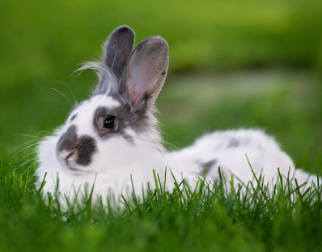
Abstract:
OBJECTIVE
To determine prognostic relevance of various patient factors and intraoperative variables associated with surgical management of small intestinal obstruction in pet rabbits.
ANIMALS
114 pet rabbits with 141 presentations of small intestinal obstruction treated surgically between June 2011 and December 2021.
METHODS
In a retrospective observational study design, medical records were reviewed for rabbits with small intestinal obstruction that had undergone surgical intervention. Data were collected on variables of interest and outcome (survival to hospital discharge). Univariable and multivariable logistic regression analyses were performed to identify variables associated with survival.
RESULTS
Overall survival was 75.2% (106/141). Specifically, 95.7% (22/23) of presentations involving rabbits < 25 months survived. The odds of survival on univariable modeling were significantly lower in presentations of rabbits > 72 months compared with those < 25 months (OR, 0.05; 95% CI, 0.01 to 0.40; P = .005). Rectal temperature, clinicopathologic findings, etiology of obstruction, presence of full-thickness gastrointestinal wall injury, and previous small intestinal obstruction surgery did not show significant effects on survival. In a multivariable model that controlled for plasma potassium and calculated plasma osmolarity and tonicity, the odds of survival in presentations of rabbits > 72 months were 95% lower than those < 25 months (OR, 0.05; 95% CI, 0.01 to 0.50; P = .012).
CLINICAL RELEVANCE
Surgical intervention should be considered a suitable treatment option for small intestinal obstruction in rabbits < 72 months and carried a good prognosis. The most common etiology was consistent with a compressed hair pellet, and extraluminal digital manipulation into the cecum was a successful surgical technique in most presentations.

Key Points:
- Small intestinal obstruction in rabbits is a common, potentially life-threatening condition. Associated with hypovolemic and obstructive shock, acid-base and electrolyte derangements, hyperglycemia, and pain
- While medical management offers a favorable outcome in many rabbits, surgical intervention is the treatment of choice in those that continue to decline or show minimal response to medical management.
- A compressed hair pellet (CHP) located in the proximal duodenum is considered the most common cause and site of small intestinal obstruction in rabbits. Foreign bodies and extraluminal conditions such as neoplasia and abdominal adhesions have also been reported
- The well-developed cardiac sphincter in rabbits limits emesis or eructation. Therefore, marked and rapid dilation of the gastrointestinal tract occurs orad to the obstruction, with the stomach usually most significantly affected.
- While there is consensus that surgical intervention is not generally indicated in rabbits with presence of cecal gas on diagnostic imaging, opinions vary regarding selection criteria and time points for surgical intervention
- Two main surgical techniques have been described for small intestinal obstruction in rabbits. A CHP or foreign body may be manipulated extraluminally along the small intestine aborally into the cecocolic complex. Alternatively, enterotomy or enterectomy can be performed.
- Rabbits showing radiographic findings consistent with small intestinal obstruction received immediate medical intervention.
  - Radiographic parameters included a summed gastric silhouette length and width greater or equal to the length between the first lumbar vertebra and the coxofemoral joint, extension of the gastric silhouette beyond the caudal edge of the second lumbar vertebra (both assessed on lateral abdominal radiographic views), homogenous gastric contents of soft tissue radiopacity together with a gas “cap,” and absence of significant gas accumulation within the cecocolic complex.
- Medical intervention included IV fluid resuscitation, opioid analgesia, and active warming. Gastrointestinal promotility agents, assist feeding, and oral products were never administered at this stage.
- Orogastric decompression was performed prior to surgery
- The thin small intestinal wall in most rabbits allowed characterization of intraluminal material. A discrete pellet that was round, smooth, brown in color, and moderately pliable was considered most consistent with a CHP.
- For presentations in which a CHP-like or foreign body was identified, this was gently manipulated extraluminally to determine whether it could be moved along the intestinal tract. Where manipulation was possible and the gastrointestinal tract appeared viable, the CHP-like or foreign body was gently manipulated extraluminally past the ileocecocolic junction into the cecum. Enterotomy or enterectomy was performed when a nonmobile CHP-like or foreign body was identified or where there was gross evidence of intestinal wall devitalization.
- There were a total of 141 presentations from 114 different rabbits. In 93 (81.6%) presentations, this was the first recorded small intestinal obstruction surgery. It was the second surgery for 16 (14.0%), the third for 4 (3.5%), and the fourth for 1 (0.9%) presentation.
- Most presentations were neutered males, and most were in the 25- to 72-month age group.
- Most presentations were hypothermic (108/133 [81.2%]), hyperglycemic (112/126 [88.9%]), had elevated BUN (72/100 [72.0%]), were eunatremic (80/96 [83.3%]) and eukalemic (66/92 [71.7%]). Specifically, 66/126 (52.4%) presentations had severe hyperglycemia > 20 mmol/L (360 mg/dL)
- The cause of small intestinal obstruction in most presentations was consistent with a CHP (130/141 [92.2%]). Less commonly, obstruction occurred from other causes (9/141 [6.4%]), including abdominal adhesions and foreign bodies. In 2 of 141 (1.4%) presentations, a CHP-like body was found in conjunction with other causes.
- The proximal duodenum was the most common site of obstruction (78/141 [55.3%])
- Extraluminal manipulation of a CHP-like body into the cecum was successful in 124 of 141 (87.9%) presentations.
- Overall, 106 (75.2%) presentations survived and 35 (24.8%) presentations died. Presentations involving rabbits < 25 months showed 95.7% survival, while those between 25 and 72 months showed 80.2% survival. Just over half (51.4%) of the presentations > 72 months survived.
- The odds of survival on univariable modeling were significantly lower in presentations of rabbits > 72 months compared with those < 25 months. After multivariable adjustment, the association with survival between the oldest and youngest age groups persisted, with the odds of survival in presentations of rabbits > 72 months 95% lower than for those < 25 months (OR, 0.05; 95% CI, 0.01 to 0.46; P = .009).
- Nonsurvival in this study primarily occurred in the postoperative period, with persistent ileus and single- or multiorgan failure reported to be common antemortem findings.
- Rectal temperature, clinicopathologic findings, etiology of obstruction, presence of full-thickness gastrointestinal wall injury, and previous small intestinal obstruction surgery did not show significant effects on survival.
- In previous studies, hypothermia, severe hyperglycemia (> 20 mmol/L), true hyponatremia, and elevated BUN concentration on presentation have been associated with increased mortality in rabbits. A different study assessing orogastric decompression in rabbit intestinal obstruction suggested that increased calculated serum osmolarity was associated with rabbits in a critical condition. These relationships were not observed in this study.

Take-Home Message:
- Rabbits < 72 months presented with small intestinal obstruction showed good outcomes with surgical intervention. The most common etiology was consistent with a CHP, and extraluminal digital manipulation into the cecum was an appropriate and successful surgical technique in most presentations.

Journal of the American Veterinary Medical Association, 261(10): 1488-1494, 2023
Long-term systemic antibiotics and surgical treatment can be an effective treatment option for retrobulbar abscesses in rabbits (Oryctolagus cuniculus): 21 cases (2011–2022)
Ivana Levy, and Christoph Mans
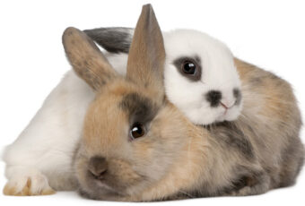
Abstract:
OBJECTIVE
To characterize the epidemiologic features of rabbits with retrobulbar abscesses, including the clinical signs, diagnosis, treatment, and outcome.
ANIMALS
21 client-owned rabbits.
METHODS
The medical record database of a veterinary teaching hospital was searched from 2011 to 2022 for records of rabbits diagnosed with retrobulbar abscesses by CT. Data reviewed included age, breed, presenting complaint, association with an odontogenic infection, aerobic and anaerobic culture results, treatment, and outcome.
RESULTS
The primary presenting complaint was exophthalmos (19/21 [90%]). Most cases (15/21 [71%]) were associated with an odontogenic infection. Dental disease, not associated with a retrobulbar abscess (14/21 [67%]), was a common comorbidity on CT. The most common aerobic and anaerobic isolates were Streptococcus intermedius (5/12 [42%]) and Fusobacterium nucleatum (2/12 [17%]), respectively. Surgical treatment combined with long-term systemic antibiotic therapy was performed in 9 of 21 (43%) cases. It included intraoral tooth extraction (4/9 [44%]) versus extraoral peribulbar abscess lancing with either abscess packing with antibiotic-soaked gauze (3/9 [33%]) or surgical abscess debridement (2/9 [22%]). Resolution of the clinical signs with no recurrence for at least 6 months occurred in 7 of 9 (78%) surgically treated cases. Medical treatment with long-term systemic antibiotic therapy was performed in 4 of 21 (19%) cases, and 3 of 4 (75%) resolved. Due to poor prognosis or financial concerns, euthanasia was performed or recommended in 8 of 21 (38%) cases.
CLINICAL RELEVANCE
On the basis of the data from this study, retrobulbar abscesses in rabbits carry a guarded prognosis. When intraoral and extraoral surgical treatment options combined with systemic antibiotic therapy were used, it resolved clinical disease in most cases.

Key Points:
- Rabbit dentition: elodont, hypsodont, aradicular
- Dental disease in rabbits is characterized by clinical or reserve crown elongation, malocclusion, and the formation of dental spurs. Periapical odontogenic infections are a common sequela
- Infection can spread from maxillary teeth to retrobulbar space retrobulbar abscess, unilateral exophthalmos
  - Other Cx can include lethargy, hyporexia, facial masses, weight loss, gastrointestinal disease, ocular or nasal discharge, or problems chewing or swallowing
  - CT recommended for diagnosis
  - Ddx include neoplasia, hematoma, parasitic cyst
    - FNA for cytology, culture recommended
  - Retrobulbar abscesses are more challenging in rabbits due to their thick caseous abscess material and alveolar bulla anatomy
    - [The alveolar bulla of the rabbit is a unique pre-formed bony structure of the skull containing the apices of the caudal most maxillary cheek teeth]
    - Reported treatment includes long-term systemic antibiotic treatment in conjunction with an intraoral or extraoral surgical approach or both.
      - Intraoral techniques include a blind or stomatoscopy-guided approach to remove the affected teeth and create a draining tract.
      - Extraoral approaches described are either a peribulbar facial mass incision with flushing and closure, marsupialization of the abscess capsule, or partial ostectomy of the zygomatic arch with lavage of the alveolar bulla.
- Presenting complaints and clinical signs associated with retrobulbar abscesses included unilateral exophthalmos ipsilateral to the abscess in 19 of 21 (90%) cases, elevated third (14/21 [67%]), facial mass (11/21 [52%]), unilateral or bilateral ocular discharge and conjunctivitis (4/21 [19%]), and anorexia/hyporexia (4/21 [19%]).
- 15 of 21 (71%) cases with a retrobulbar abscess were associated with an odontogenic infection
  - 13/15 assocaited with maxillary teeth, 2/15 associated with mandibular teeth
- Bacterial isolates (12 total, 9 aerobic and 3 anaerobic) included Streptococcus intermedius (5/12 [42%]), α-hemolytic Streptococcus spp (2/12 [17%]), Fusobacterium nucleatum (2/12 [17%]), Actinobacillus capsulatus (1/12 [8%]), Escherichia coli (1/12 [8%]), and Clostridium aidenense (1/12 [8%]).
  - Strep = aerobic, Gram positive cocci
  - Decreased anaerobic growth may have been due to patients already receiving antibiotics with anaerobic coverage
    - The authors concur with previous studies that demonstrate anaerobic bacteria predominating in odontogenic abscesses and recommend choosing an appropriate antimicrobial with a broad spectrum of activity to cover against anaerobic bacteria such as metronidazole
- Euthanasia performed in 1/3 of cases within 7 days of presentation.
  - Development of neuro signs or severe comorbidities
- Treatment recommendations other than euthanasia included medical management with long-term antibiotics or a combination of long-term systemic antibiotics and surgical intervention
  - 4 received abx alone. Abx were prescribed for at least 4-week courses and most frequently included procaine-penicillin G injections, azithromycin, metronidazole, enrofloxacin, or a combination.
  - Of these cases, 3 of 4 (75%) had complete resolution (none of these had an odontogenic cause)
    - It is hypothesized that the cases that received long-term broad-spectrum antibiotics may have resolved due to their lack of radiographically-evident association with an odontogenic infection.
- Surgical treatments were performed in 9 of 21 (43%) cases and always combined with long-term systemic antibiotic therapy, including procaine penicillin G, ceftiofur crystalline-free acid, metronidazole, enrofloxacin, azithromycin, or a combination.
  - Intraoral surgical treatments by means of maxillary cheek tooth extraction and abscess drainage were performed in 4 of 9 (44%) cases. In all these cases, the extraction site was sealed with doxycycline hyclate–containing polymer gel (Doxirobe Gel). Three of 4 (75%) were resolved based on clinical signs.
  - Extraoral surgical treatment via a peribulbar approach to allow for access to the retrobulbar abscess was performed in 5 of 9 (56%) cases (all of which had palpable facial masses). Of these cases, 3 of 5 (60%) received repeated antibiotic-soaked gauze packings, while 2 of 5 (40%) were lanced and debrided with no packing.
    - 3 packing cases resolved, 1 lance/debride case resolved

Take-Home Messages:
- Although retrobulbar abscesses carry a guarded prognosis, surgical treatment (intraoral tooth extraction, extraoral abscess packing) in conjunction with long-term systemic antibiotics is an effective treatment method. It also demonstrated that organisms isolated from retrobulbar abscesses in rabbits consist of a mixture of aerobic and anaerobic gram-positive and gram-negative organisms. Culture and susceptibility of any abscess are recommended

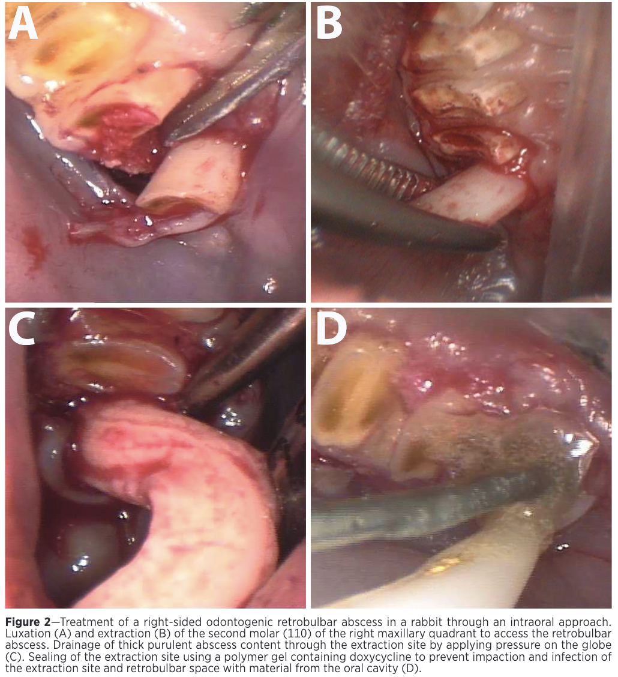

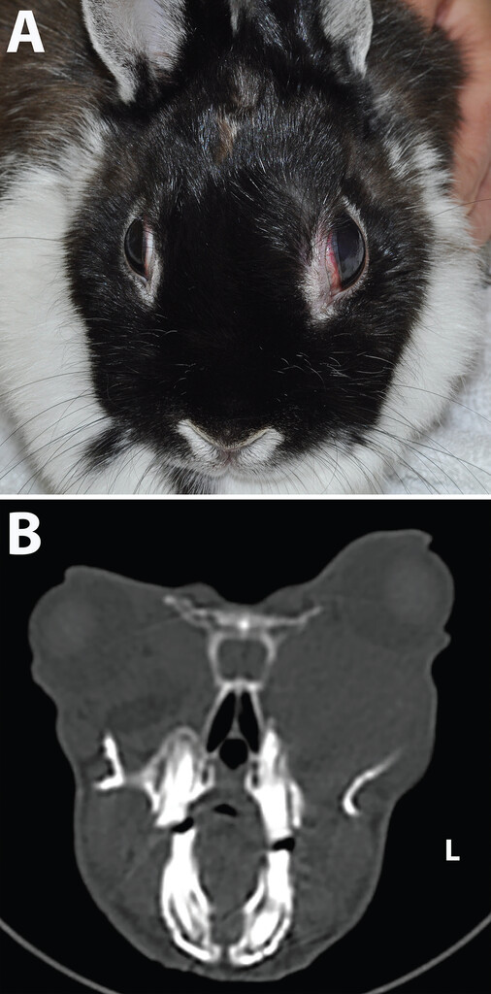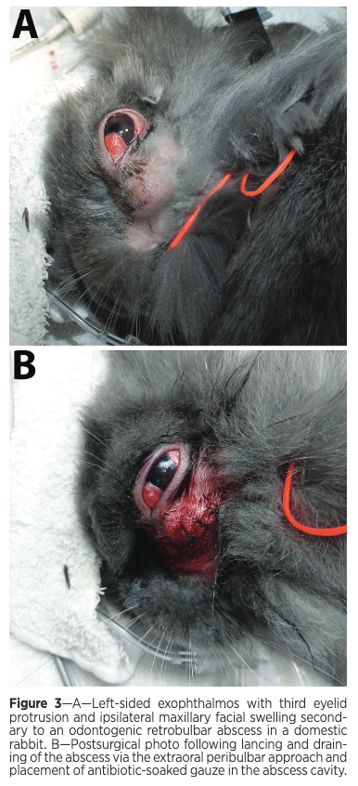
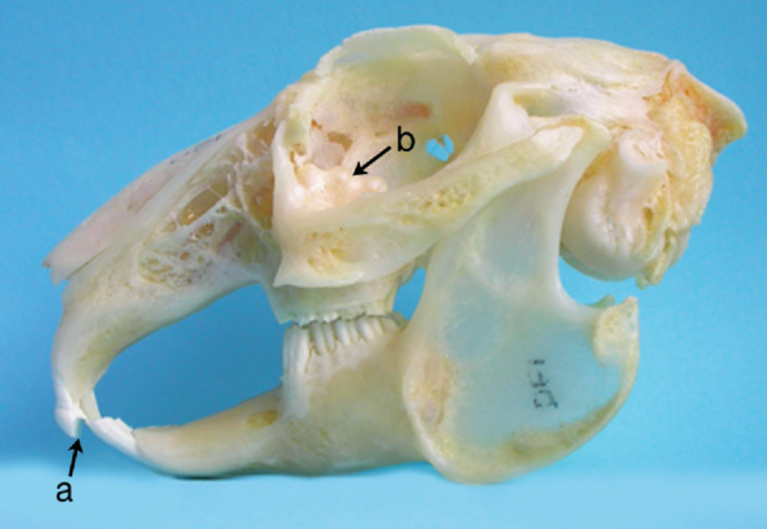
B shows bulges on alveolar bulla from PSADD (image for anatomy reference, NOT from this paper)

Computed tomographic findings of nasal and paranasal disease in domestic rabbits highlight maxillary sinusitis and close association with dental disease: 100 studies (2004-20240
Mikoni N, Sanchez-Migallon Guzman D, Beaufrère H, Phillips K. J Am Vet Med Assoc. 2025;263(1):90-99—Reviewed by ALD

OBJECTIVE
To describe CT findings and epidemiologic features of nasal and paranasal disease of rabbits (Oryctolagus cuniculus).
METHODS
An electronic search was performed for rabbits that underwent skull CT from 2004 to 2024 and had findings consistent with nasal/paranasal or maxillary dental disease. History, signalment, and physical examination findings were recorded and reevaluated retrospectively for evidence of changes to the nasal passages, paranasal sinuses, and nearby associated anatomy. Data were analyzed with descriptive statistics, ordinal mixed logistic regression, and correlation analysis.
RESULTS
100 studies from 69 rabbits were reviewed. Lop-eared rabbits represented 30 of 69 cases. Upper respiratory signs (48 of 69 [69.6%]) and dental-related disorders (21 of 69 [31.9%]) were primary complaints. Rhinitis (49 of 69 [71.0%]), sinusitis (50 of 69 [72.5%]), and both (40 of 69 [60.0%]) were most diagnosed, with turbinate destruction (48 of 69 [69.6%]) and alveolar bone loss of adjacent teeth (51 of 69 [73.9%]) being common findings. Sinusitis was most common in the ventral (48 of 50 [96.0%]) and dorsal (33 of 50 [66.0%]) recesses of the maxillary sinus. Multiple CT variables were significantly correlated (P < .05); of those, maxillary alveolar bone loss of the incisor teeth and the second premolar tooth were, respectively, correlated with rhinitis grade and with sinusitis and sinusitis grade within the ventral recess of the maxillary sinus (P < .001).
CONCLUSIONS
Computed tomographic evaluation allowed characterization of nasal and paranasal disease in rabbits and the association of rhinitis, sinusitis, and dental disease.
CLINICAL RELEVANCE
The correlation between the maxillary dentition, rhinitis, and sinusitis highlights the need for thorough evaluation in CT of the teeth in rabbits with upper respiratory signs.

Background:
- Rabbits obligate nasal breathers d/t elongated soft palate and epiglottis dorsal to soft palate
- Paranasal sinuses: dorsal conchal sinus, dorsal recess of maxillary sinus, ventral recess of maxillary sinus, sphenoidal sinus
  - Dorsal conchal: large opening into dorsal recess of maxillary sinus
  - Dorsal & ventral recesses: indented along lateral margin by nasolacrimal duct, drain into nasal cavity w/dorsal conchal via maxillary sinus ostium, caudal to eye medial canthus, communicate
  - Sphenoidal: no direct connection w/other paranasal sinuses, opens to nasal cavity via own sphenoidal sinus ostium, rostral portion near caudal dorsal & ventral recesses but don’t connect

Key points: (see above for M&M)
- Age, sex, repro status, and breed had no sig effect on odds of more severe rhinitis, nonlop had sig higher odds of more severe sinusitis (lop most common, avg age 6y)
  - Prev study: lops more prone to develop aural dz
- Masses: nasal adenocarcinoma, lymphoma, osteosarcoma—epistaxis common CS (also in dogs)
- Most had concurrent dz and alterations in nasal passage anatomy: turbinate destruction (69.6%)
- Maxillary alveolar bone loss in 73.9%, 2nd PM most common (82.4%), then I1 (43.1%)
- Rhinitis in 71%, sinusitis in 72.5% (ventral maxillary (96%)>dorsal maxillary (66%)>dorsal conchal (62%) >sphenoidal (38%)), concurrent rhinitis and sinusitis 57.8%
- Concurrent otitis in 49.3%, rhinolith in 40.6%
- Uncommon for only 1 sinus affected, sphenoidal least commonly affected
- Nasolacrimal duct b/t dorsal and ventral recesses of max sinus rostrally, saw dz in 21.7%
- Correlation b/t dz in PM2 and sinusitis of ventral recess & b/t maxillary alveolar bone loss of incisors and rhinitis—think d/t anatomy
- Nasal septum deviation cause sinusitis in humans and cats, not really seen here

Take aways:
- Significant association b/t dz of PM2 and sinusitis of ventral recess of maxillary sinus and b/t incisor dz and rhinitis. Lop rabbits were most commonly seen, but severe disease was more common in nonlops. Over half of animals had concurrent rhinitis and sinusitis as well as turbinate destruction. Epistaxis was a common CS in animals with neoplasia. It was uncommon for only 1 sinus to be affected, and the sphenoidal sinus was the least affected d/t it having no communication with the other sinuses

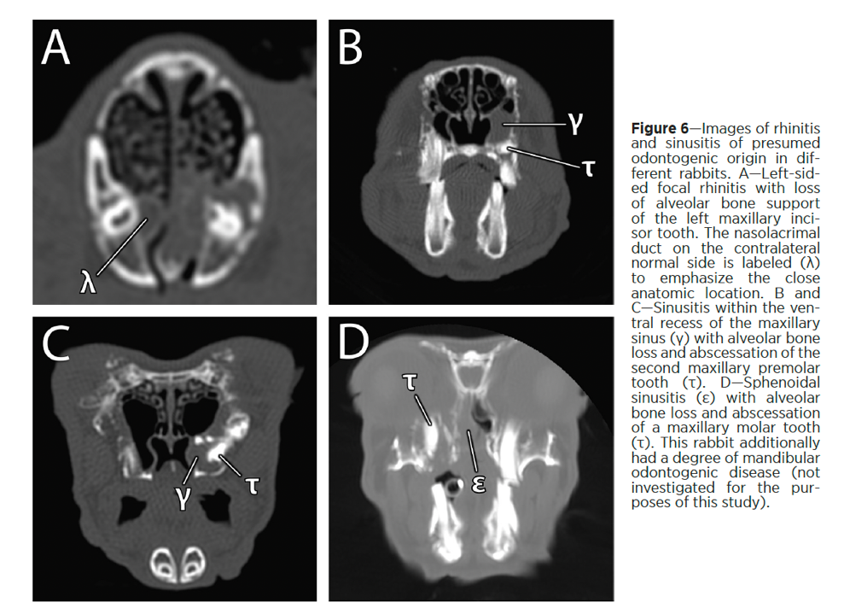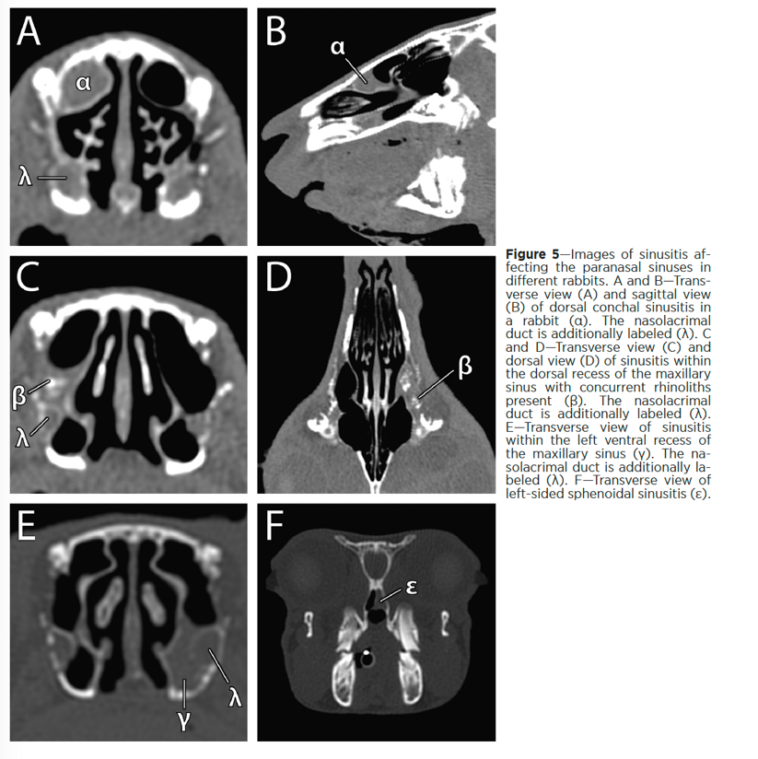

Effects of diet on the bacterial and eukaryotic microbiota across the gastrointestinal tract of healthy rabbits (Oryctolagus cuniculus)
Rahic-Seggerman FM, Rosenthal K, Miller C, Iske C, Graham J, Schmitz-Esser S, Kohles MR. Am J Vet Res. 2024;85(4):1-11—Reviewed by ALD

OBJECTIVE
This study aimed to characterize the bacterial and eukaryotic microbiota of the gastrointestinal (GI) tract in domestic rabbits and to evaluate the effect of different diet characteristics, such as pelleting, extrusion, and hay supplementation.
ANIMALS
30 New Zealand White rabbits (15 male and 15 female; 6 to 7 months old) were fed 1 of 6 diets (5 rabbits per diet) for 30 days after an initial acclimation period. At the end of the trial, samples were collected from the stomach, small intestine, cecum, large intestine, and hard feces.
METHODS
The samples were analyzed using 16S rRNA and internal transcribed spacer 1 region-targeted amplicon sequencing.
RESULTS
The bacterial microbiota was distinct between the foregut and hindgut. The most abundant bacterial genera included an unclassified genus in the Bacteroidales order and Alistipes. Candida was the most abundant genus in the eukaryotic dataset. In the bacterial dataset, diet No Hay/Pellet E was shown to have lower diversity (Shannon diversity, P < .05) compared to all diet groups except for No Hay/Pellet M. Few significant differences in alpha-diversity indexes between diet groups were detected in the eukaryotic dataset.
CLINICAL RELEVANCE
Our findings demonstrated that feeding hay had a significant effect on the beta diversity of the bacterial microbiota. Given the prevalence of gastrointestinal disease in the domestic rabbit population, furthering our understanding of what constitutes a healthy rabbit microbiota and the effects of different diets on the microbial community can help veterinarians implement better intervention strategies and allow pet owners to provide the best level of care.

Background:
- Rabbit, g pigs, chinchillas are hindgut cecal fermenters; symbiotic relationship with microbiota to breakdown cellulose in plants
- Dysbiosis d/t low fiber, excess dietary protein or simple carbs, stress, inapp abx usage, dehydration lead to shift in GI pHfurther microbiota imbalanceeffects fermentation (important for VFAs)
- Disorders related to dysbiosis: epizootic rabbit enteropathy (ERE), mucoid enteritis
  - ERE: Clostridium—Vet Rec 2018 paper; overgrowth of Bacteroides fragilis, Clostridium perfringen, Enterobacter sakazakii and Akkermansia muciniphila and inhibition of Bifidobacterium spp. and Butyrivibrio fibrisolvens (Sci Reports 2018 paper)
  - Mucoid enteritis: 7-14wk, unknown cause, feed high fiber diet w/low simple carbs (Quesenberry)

Key points:
- M&M: 30 rabbits; 6 diets: hay, hay & pellet, hay & extruded pellet, no hay & pellet, no hay & extruded pellet, no hay & muesli mix pellet; GI samples postmortem from stomach, SI, cecum, LI, and colon, then DNA via 16S rRNA gene PCR and sequencing
- Clear division b/t upper & lower GIT microbial communities (stat sig division)
- Bacteria:
  - Firmicutes and Bacteroidota in hindgut>foregut, Actinobacteriota foregut>hindgut; see table
  - Number of observed spp, predicted spp richness, and estimated diversity sig higher in foregut but this may be d/t dead organisms from cecotropes also being detected in foregut
    - Cecotropes mean hindgut bacteria ends up in stomach, but likely killed by pH—lower percentage of bacteria in foregut is likely alive vs hindgut
  - Diet has significant impact on beta diversity of GIT; hay vs no hay had sig effect on beta diversity at all sites in GIT, pellets vs. no pellets also caused significant change as well as pellet type (hindgut only)
  - No hay/extruded pellet: lower diversity to all groups except muesli pellet in foregut, sig lower number of spp in hindgut when compared to all diets, less richness and lower diversity to all except muesli pellet
  - Lactobacillales minimally present, so probiotics should be questioned
  - Alistripes: produces acetic acid, more abundant in healthy rabbits, see reduced and lower acetic acid production in rabbits w/diarrhea, also seen dec in rabbits w/EREhighest amt seen w/hay & pellets here
- Eukaryotes:
  - Most Ascomycota then Basidiomycota phylum; stomach significantly different from rest of GIT
  - Stomach: Candida>Malassezia>Humicola; Candida much higher than in other locations in GIT
  - Other locations: Candida>unclassified Ascomycota>Malassezia
  - Same sig effect of location on diversity, but no specific clustering like bacteria
  - Lower diversity than bacteria, stomach lowest number of spp but higher estimated diversity (?)
  - Diet only had minor impact, few significant diff in alpha diversity b/t diet groups
  - No hay/muesli pellet had lower number of spp and richness compared to hay only, hay & pellet had higher number of spp than no hay & extruded pellet and muesli pellet
Take aways:
- Significantly different microbiota between the foregut and hindgut in rabbits, and diet (especially hay) did have an effect on the diversity of microbial communities, especially in the hindgut.
- Clinically: feed hay, regular pellets, and don’t really think probiotics will help

Terms (defined in Assessment of the fecal microbiome of healthy rabbits (Oryctolagus cuniculus domesticus) compared with rabbits with gastrointestinal disease using next generation DNA sequencing):
- Alpha diversity: used to assess microbial diversity w/I a sample
- Beta diversity: measurement of differentiation diversity b/t samples, used to understand how variation in community composition is correlated w/environmental or clinical variables

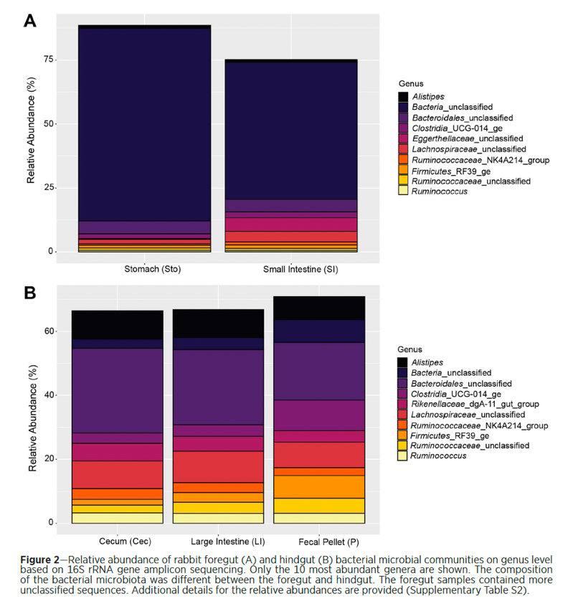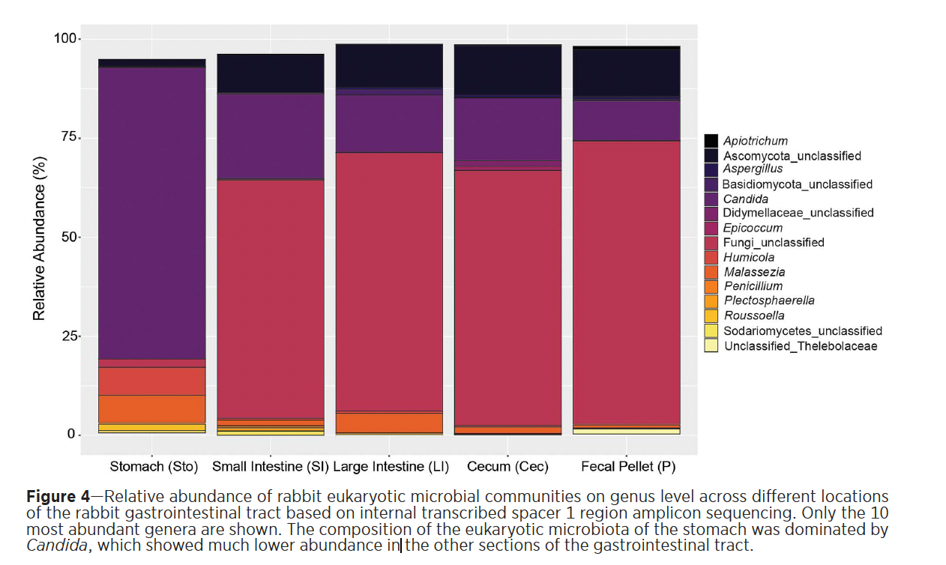

Assessment of the fecal microbiome of healthy rabbits (Oryctolagus cuniculus domesticus) compared with rabbits with gastrointestinal disease using next generation DNA sequencing
Vecere G, Malka S, Sands N, Lee M, Krumbeck JA. Am J Vet Res. 2024;86(1):1-8—Reviewed by ALD

OBJECTIVE
To determine the normal fecal microbiome of healthy rabbits in comparison to rabbits with gastrointestinal (GI) disease. Next-generation DNA sequencing was used to identify the primary bacteria and fungi in the microbiome.
METHODS
Fecal pellets from 25 clinically healthy rabbits and 25 rabbits experiencing GI disease were collected. Next-generation DNA sequencing was performed targeting the ITS-2 region for mycobiome, and the V1–V3 region of the 16S rRNA for bacteriome analysis. ITS-2 stands for internal transcribed spacer 2, a region of DNA in fungi that is used to identify and classify species.
RESULTS
In healthy rabbit feces, Bacteroidales sp, Odoribacter sp, Paraprevotella xylaniphila, Lachnospiraceae sp, Papillibacter sp, Akkermansia sp, and Ruminococcus sp were noted to be more prevalent. Comparatively, Lachnoclostridium sp, Anaerotruncus sp, Subdoligranulum sp, and B uniformis were found in greater abundance in rabbits with GI disease. Only 1 fungal species, Malassezia restricta, was significantly enriched in the GI disease group.
CONCLUSIONS
Next-generation DNA sequencing technology can be used to evaluate the microbiome of the rabbit GI tract through fecal material and can provide a clinically accessible testing method for veterinarians.
CLINICAL RELEVANCE
Numerous bacteria and fungi in the fecal samples of healthy rabbits were identified that could be considered markers of gastrointestinal health; similarly, specific bacteria and fungi were noted in greater abundance in rabbits with GI disease, which should be further investigated for their importance in causing, contributing to, or as the result of clinical disease. These findings support the use of next-generation DNA sequencing in order to diversify our understanding of the microbiome of rabbit feces, aid in clinical diagnosis, and provide support for the need for more specific probiotic supplements for rabbits.

Background:
- Differences in GI microbiome b/t rabbits and other hindgut fermenters, and b/t rabbit breeds
- Diarrhea in rabbits: Clostridium spp, Spiroforme spp, E. coli, Lawsonia intracellularis, Campylobacter spp, Mycobacterium spp

Key points:
- 50 fecal samples (25 RGIS, 25 healthy), privately owned rabbits
- No stat sig difference in # of spp (bacteria and fungi) detected b/t groups
- Bacteria:
  - Clinically healthy: phyla Bacteroidetes, Proteobacteria, Verrumicrobioa, Synergistetes, Firmicutes, and Tenericutes most common; considerable diff among rabbits though
    - Saw especially 3 families: Prevotellaceae (w/I Melainabacteria) and one w/I Saccharibacteria Melainabacteria in healthy GIT in humans, Saccharibacteria reported prev but least abundant
  - RGIS: Clostridiales species, the same species in Ruminococcaceae, and species in Lachnospiraceae most common
  - Bacteroidetes used to be characterized in just cecum, but seen here in feces so not a clear indicator of GI health, B. uniformis seen in RGIS here too
  - Only 1 Lactobacillales seen in both groups, Clostridiales seen w/I both groups
  - Lachnoclostridium seen w/RGIS and in previous study w/lower weaning weights
  - Ruminococcaceae seen in both groups here but seen w/higher weaning weights in previous study
    - Bacteroidetes at young age and shift to more Firmicutes, Lachnospiraceae, and Ruminococcaceae in another study—only Prevotellaceae sig more abundant in healthy here (could be d/t ages studied)
  - Akkermansia sp. sig more common in healthy, seen with ERE so may be an opportunistic pathogen
  - E. coli and L. intracellularis: not seen in sig # in both groups
- Fungal:
  - Cyniclomyces guttulatus: most common fungi in both groups, may be opportunistic
  - Malassezia restricta: seen w/RGIS, causes cutaneous dz in mammals, seen in human fecals w/IBD & hepatocellular carcinoma

Take aways:
- Akkermansia sp., Melainabacteria sp., and Saccharibacteria sp. could be considered marker of healthy GIT in rabbits. B. uniformis and M. restricta could be markers of diseased GIT. No large amount of Lactobacillus seen—probiotic options should be used with caution in rabbits. There is no statistically significant difference in the number of species of bacteria and fungi detected between both groups.
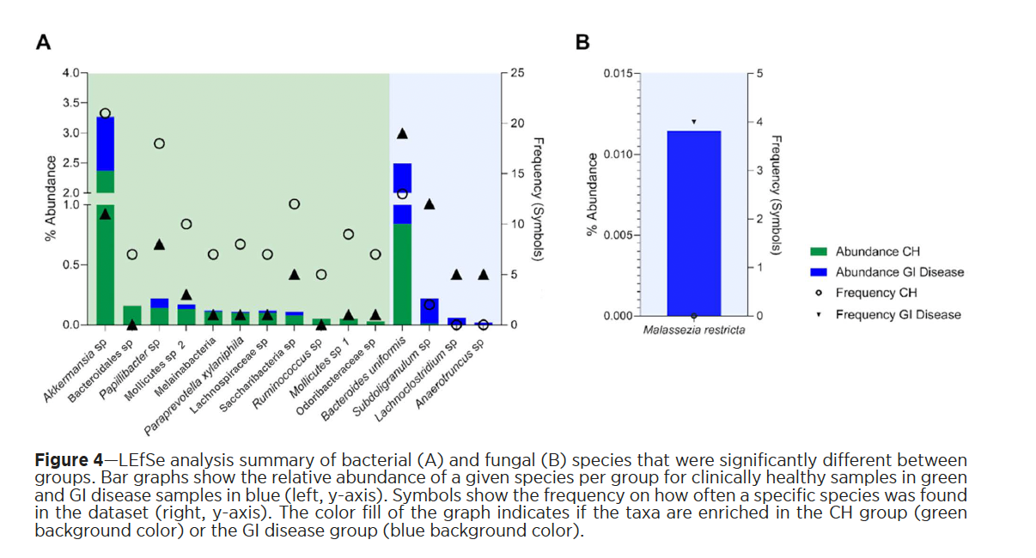

J Am Vet Med Assoc. 2023;261(S2):S52-S61.
Summarized by MR

Radical debridement guided by advanced imaging and frequent monitoring is an effective approach for the treatment of odontogenic abscesses and jaw osteomyelitis in rabbits: a review of 200 cases (2018–2023)
Vladimir Jekl, DVM, PhD, DECZM1,2*; Edita Jeklova, DVM, PhD3; Karel Hauptman, DVM, PhD1

Abstract:
OBJECTIVE: To report the prevalence and document the treatment and outcome of odontogenic abscesses and associated jaw osteomyelitis in pet rabbits.
ANIMALS: 200 client-owned rabbits.
METHODS: Pet rabbits surgically treated using extraoral teeth extraction with marsupialization for abscesses of dental origin and jaw osteomyelitis were included in the study (February 2018 to February 2023). A case must have had pre-and postoperative computed tomographic study and a follow-up period of at least 4 months.
RESULTS: In total, 113 male and 87 female rabbits were treated surgically. The mean age at the time of the diagnosis at the authors’ clinic was 3 years and 11 months. Male rabbits suffered from odontogenic abscesses significantly more often than females. The mean surgical time varied from 25 to 95 minutes, based on the severity of the pathology and location. The wound healed completely in an average of 39.7 days (range, 14 to 145 days; 95% CI, 36.9 to 42.5 days). Major complications detected in 18.5% (37/200) cases were associated with prolonged healing time mostly due to the formation of a bone sequestrum and gingival suture failure. The disease-free time following abscess resolution was on average 29 months (range, 4 to 60 months). The recurrence of the odontogenic infection was 8% (16/200 cases).
CLINICAL RELEVANCE: The radical surgical technique with the extraction of all the infected teeth with the removal of all affected tissue and osteomyelitic bone and regular follow-up wound management is an effective method for the treatment of odontogenic abscesses with jaw osteomyelitis.

Background:
- In rabbits – prevalence of dental disease has been determined to be 6.7% - 38%
  - True prevalence of dental dz higher than what is evident clinically
- Etiology of dental disease: hereditary, infectious, metabolic (calcium metabolic disorders), lack of chewing, diet that is insufficiently abrasive, traumatic (including foreign bodies), iatrogenic, neoplastic
- Etiology for odontogenic abscesses most commonly periapical bacterial infection of a diseased of damaged tooth
  - Parts of feed become impacted in periodontal space → periodontitis → tooth and alveolar bone damage
- Presentation: facial masses, respiratory disorders (rhinitis, paranasal cavity, infection/empyema), exophthalmia (retrobulbar or parabulbar pus)

Summary:
- Methods: skin incision over affected area → infected bone and tissues debrided → affected tooth/teeth removed → soft tissues marsupialized to the skin → potassium permanganate antiseptic solution applied
  - Maxillary procedures may require removal of part of the zygomatic arch (zygomatic arch resection, ZAR) +/- osteotomy of the lateral wall of the maxillary alveolar bulla
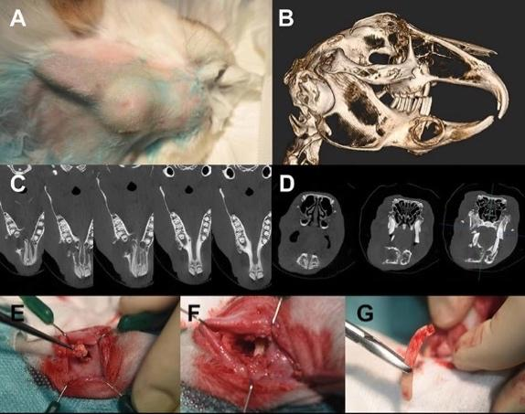
- Prevalence of odontogenic abscesses was found to be 8.5%
- Average age at time of diagnosis: 3-4y, Males diagnosed more often than females
- No significant changes between sex, presence of abscess on maxilla v mandible, or healing time
  - More than 1 tooth was affected in 99%, 63% had infection of more than 3 teeth
- 37 animals (18.5%) surgically treated for persistent or recurrent infection – recurrence recurred on average at 5.5m after wound was healed

Take Home Points: Radical surgical technique with extraction of all the infected teeth with removal of all affected tissue and osteomyelitic bone and regular follow-up wound management is an effective method for the tx of odontogenic abscesses with jaw osteomyelitis

J Am Vet Med Assoc. 2024;262(9):1-11.
Summarized by MR

Epidemiologic, clinicopathologic, and diagnostic findings in pet rabbits with myxomatosis caused by the California MSW strain of myxoma virus: 11 cases (2022–2023)
Hilary S. Stern, DVM, DABVP1* ; Ethan Biswell, DVM, MS, DACVP2 ; Matti Kiupel, Dr med vet, PhD, DACVP3; Robert J. Ossiboff, DVM, PhD, DACVP4 ; Kelsey Brust, DVM, DACVR

Abstract:
OBJECTIVE: To determine epidemiologic features of naturally occurring myxomatosis in domestic rabbits in California and to
characterize clinicopathologic and diagnostic findings.
ANIMALS: 11 client-owned rabbits, Oryctolagus cuniculus subsp domesticus.
CLINICAL PRESENTATION: A prospective study of pet rabbits with myxomatosis seen at an exotic animal specialty clinic in Santa Cruz county, California, was conducted between January 1, 2022, and December 31, 2023. Rabbits were included in the study if
they had bilateral blepharedema and were PCR positive for myxoma virus.
RESULTS: All infected rabbits had spent time outdoors. Common clinical signs included bilateral blepharedema (11/11), anogenital edema (10/11), rectal temperature ≥ 39.7 °C (5/9), and sudden death (4/11). Eyelid biopsies from all rabbits (11/11) were positive for myxoma virus by qualitative PCR followed by Sanger sequencing (100% nucleotide identity to strain MSW, also known as California/San Francisco 1950 [Genbank accession KF148065]). Most rabbits had keratinocytes containing eosinophilic intracytoplasmic viral inclusions in biopsies of edematous skin (8/11) and lymphocyte necrosis in the spleen (10/11). Immunohistochemistry identified myxoma virus in samples of skin, heart, lung, ileum, spleen, and lymph node.
CLINICAL RELEVANCE: Clinical signs of myxomatosis caused by the MSW strain of myxoma virus are distinctive but subtle. Cases occur regularly in the Santa Cruz and San Jose regions of California. As infection with this virus is almost 100% fatal and
no vaccine is available in the US, owners of domestic rabbits in endemic areas should keep their pets indoors or behind mosquito screens. Myxomatosis is a reportable disease in the US, and the appropriate state or federal agencies should be contacted when outbreaks occur.

Background:
- Myxoma virus – Leporipoxvirus naturally carried by New World cottontail rabbits
  - 2 lineages: SA and NA, cause cutaneous fibromas in native hosts
  - Systemic virulent myxomatosis in European rabbits (pet variation)
- California/San Fran strain: MST 6.5-8.5 days, mortality almost 100% [San Jose, Santa Cruz]
- N. American myxomatosis limited to brush rabbit’s native habitat, Oregon – Baja California peninsula
- Myxoma virus can spread from brush rabbits to domestic rabbits via biting insects, direct contact, and contaminated fomites.
  - Mosquitos likely the primary mode of viral transmission

Summary:
- Prospective study between Jan 2022 – Dec 2023 at a single private practice
- Rabbits received exam, sedation for workup: CBC/Chem, radiographs anesthesia & euthanasia
- PM eyelid biopsies submitted, conjunctival swabs from subset for PCR
- Full necropsies
- Young rabbits (median 2 yo): presented on ER basis: swollen eyes, hyporexia, lethargy, rapid/labored breathing, sneezing, sudden death
- PE features: bilateral blepheredema, erythematous conjuctiva, edematous anogenital region, swollen lips, dyspnea, hyporexia, febrile
- Bloodwork features: decreased hematocrit, leukocytosis or leukopenia (wide variation a discussion point), low PLT. Mild biochemistry panel findings
- Imaging features: Mild-severe anogenital swelling, GI stasis features, mild cardiomegaly, mild interstitial lung patterns
- Necropsy features: edema is a prominent feature of almost any part of the body, postmortem hemorrhage a feature in 3, 2 of which from the nose,
- 100% PCR confirmation by biopsy. Antemortem conjunctival swabs were not an effective means of diagnosis in this study.

Take Home Points:
- Domesticated rabbits that spend time outdoors are at greater risk of transmission
- Regionally exclusive at this time: CA
- Edema is a prominent feature
- PCR diagnosis successful on eyelid biopsy, antemortem conj swabs not successful
- No vaccine approved for use in the US, mortality approaches 100%

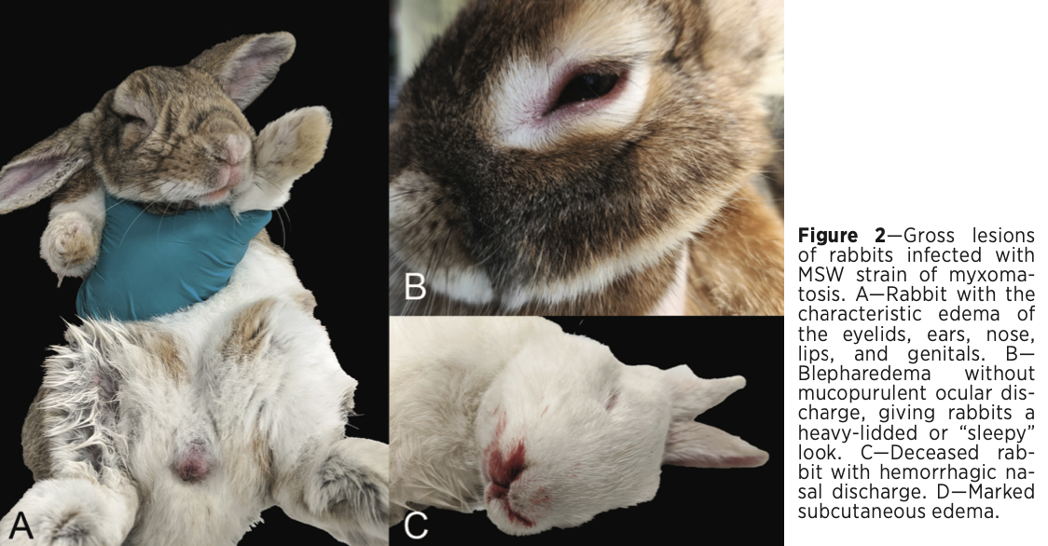
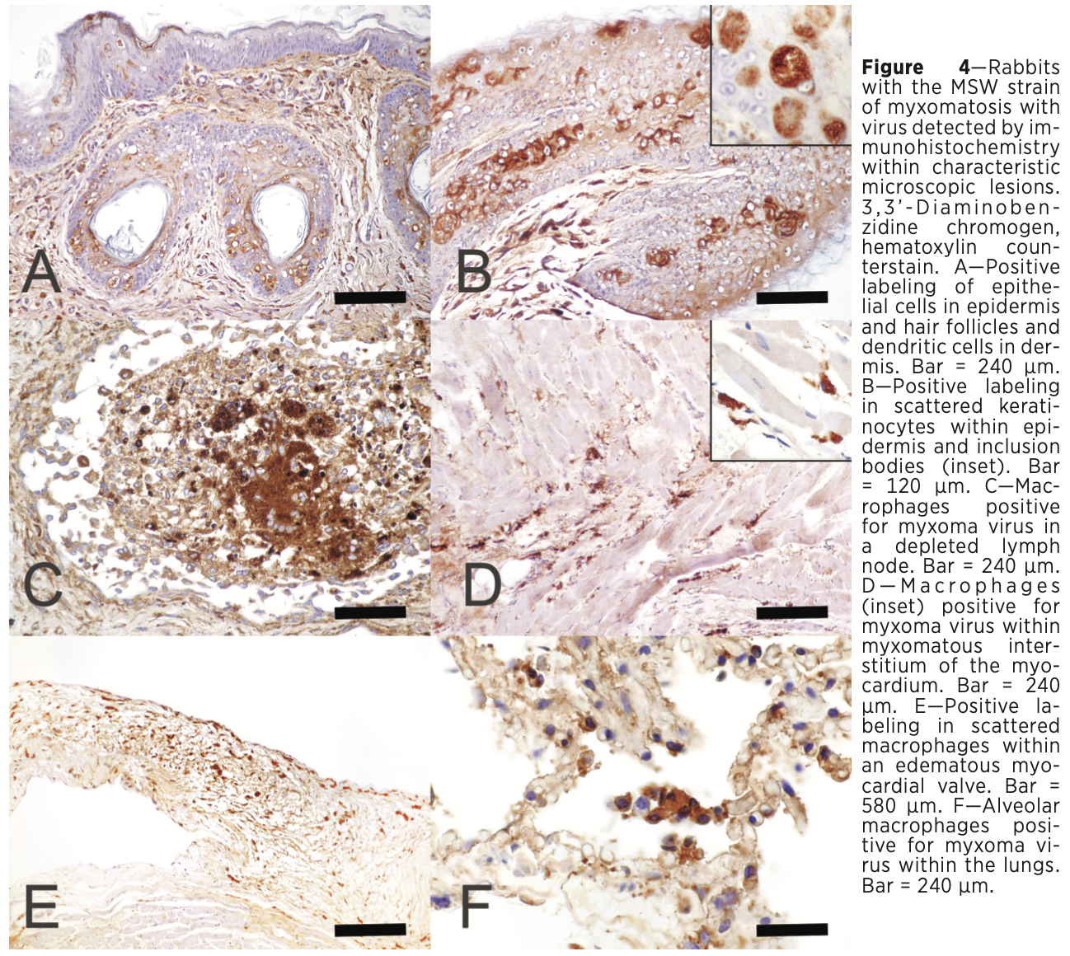
Am J Vet Res. 2025;86(8):ajvr.25.03.0101.
Summarized by MR

Development of septa in the urinary bladder of client-owned rabbits leading to urinary outflow obstruction, urinary retention, and urinary bladder distension
Giulia Bersanetti, DVM, MS1*; Paolo Selleri, DVM, PhD, DECZM1; Alice Reginato, DVM, PhD, DECVP2; Elvio Lepri, DVM, PhD, DECVP3; Marco Masi, DVM, MS1; Nicola Di Girolamo, DVM, PhD, DECZM, DACZM, DACVPM4
Abstract:
OBJECTIVE: To describe a novel condition in rabbits characterized by the development of septa in the urinary bladder leading to partial urinary outflow obstruction.
METHODS: A multicenter retrospective case series was designed, including 7 rabbits presented from 2017 to 2023 that met 2 inclusion criteria: (1) underwent histopathology of the urinary bladder, and (2) had clinical evidence of membranes and septa in the urinary bladder through diagnostic imaging and/or necropsy. Clinical signs of urinary outflow obstruction and bladder distension were observed in all cases.
RESULTS: Abdominal radiographs and ultrasound identified abnormalities consistent with septa in 5 of 7 and 1 of 3 cases, respectively. In all 7 rabbits, the septa were visible via rigid cystoscopy. In 6 cases, the septum developed in a dorsoventral/laterolateral plane, causing variable degrees of narrowing of the lumen of the bladder neck and accumulation of sediment cranial to it. In 1 case, the septum developed in a craniocaudal/laterolateral plane, dividing the bladder neck into dorsal and ventral portions. The most common histopathological findings in the septum included urothelial hyperplasia (7 of 7) and heterophilic, lymphocytic, and plasmocytic inflammation (5 of 7). One rabbit died while recovering from cystoscopy. In the remaining 6 cases, endoscopic removal of the septum resolved the clinical signs consistent with urinary outflow obstruction and urinary retention.
CONCLUSIONS AND CLINICAL RELEVANCE: Rabbits can develop septa inside their urinary bladder. These benign proliferations can result in urinary outflow obstruction and urinary retention. Rigid cystoscopy was effective for the diagnosis and treatment of urinary outflow obstruction and urinary retention.

Background:
- Proliferative and polypoid cystitis described
- A rare form of proliferative cystitis forms membranes of cell debris, inflammatory cells, and clots of blood
  - Most similar to human pseudomembranous cystitis
  - Cats > dogs – UO
- Rabbit UO’s typically associated with urinary sludge, urolithiasis and neoplasia
Summary:
- Multicenter retrospective case series: evaluated all aspects of case management that met inclusion criteria at three institutions
- Inclusion criteria: underwent histopathology of the UB and had clinical evidence of membranes and septa in UB by either diagnostic imaging or necropsy
- This case series characterizes a first report of a distinct proliferative disorder of UB characterized by septum formation and reduced urine outflow/urine retention
- Clinical features were consistent with lower urinary disease: dark malodorous urine, reduced outflow
- A sex predilection was not identified, no evidence of breed predilection, small sample size
- Elevated total calcium and ALP
- Diagnostic imaging revealed urinary bladder overdistention
  - Septum allowed minimal urinary flow with retention of debris
- Ablation of the septum resolved clinical signs in 5 rabbits that have long-term follow up
- Concurrent bacterial infection was not documented, but given urinary retention, is possible
- In one case, a congenital malformation was possible

Take Home Points:
- LUT signs in a rabbit may be due to development of bladder septum (congenital etiology not ruled out)
- Abdominal radiographs can assist in diagnosis and endoscopy was effective in obtaining a definitive diagnosis
- Endoscopic ablation was an effective means of treatment in the cases that had long term follow-up (months to up to 3 yrs in one animal, but serial urinary complications occurred in some)
- 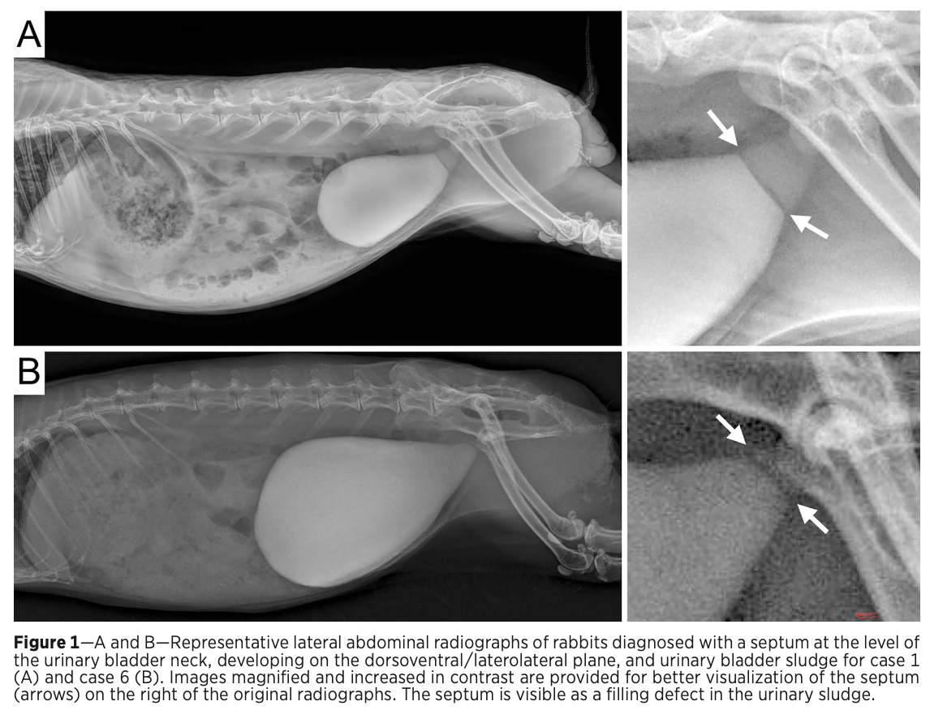
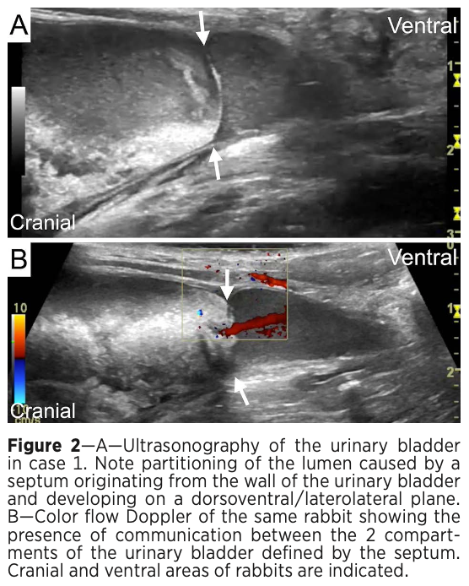
- 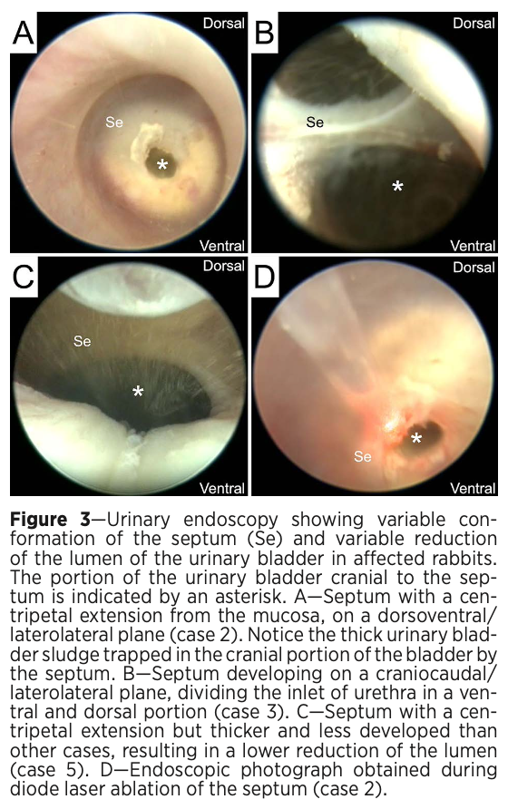
2023 JAVMA 262.1
Lidocaine constant rate infusion improves the probability of survival in rabbits with gastrointestinal obstructions: 64 cases (2012–2021)
Gail L. Huckins, Chelsey Tournade, Courtney Patson, Kurt K. Sladky

OBJECTIVE To determine the survival to discharge rate of rabbits with gastrointestinal obstructions treated with lidocaine constant rate infusion (CRI) and other factors associated with survival.
ANIMALS Cases of gastrointestinal obstruction in rabbits (n = 56, including 64 events) that had presented to a veterinary teaching hospital from 2012 to 2021.
METHODS This was a retrospective study in which data on rabbits with evidence of gastrointestinal obstruction were extracted from veterinary teaching hospital medical records over a 9-year period. Systemic lidocaine treatment, breed, sex, age, temperature at presentation, blood glucose at presentation, and time to discharge or death were evaluated with univariate and multivariate logistic regression to identify factors significantly associated with survival to hospital discharge in rabbits with gastrointestinal obstruction.
RESULTS Comparatively, 89.7% of rabbits treated with lidocaine CRI (n = 39) survived to hospital discharge, while only 56% of rabbits that were not treated with lidocaine CRI (25) survived. In the final multivariate analysis, 2 factors were associated with survival to discharge: rabbits treated with systemic lidocaine and male rabbits had increased odds of survival compared to those not treated with systemic lidocaine and female rabbits, respectively.
CLINICAL RELEVANCE Results demonstrated that rabbits with gastrointestinal obstruction and treated with a lidocaine CRI were more likely to survive compared to rabbits not treated with lidocaine CRI.

Summary
- Lidocaine: Na channel blocker
- Previous study: lidocaine in rabbits have high LD₅₀ at 20mg/kg, suggests low risk of side effects
  - Study: IV lidocaine improved food intake/fecal output in rabbits after ovariohysterectomy
  - Study: rabbits receiving lidocaine CRIs more likely to display normal behaviors postoperatively compared to rabbits receiving buprenorphine
  - Study: lidocaine CRIs shown to reduce isoflurane MAC in rabbits
  - Study: laboratory rabbits treated with Escherichia coli endotoxin demonstrated that lidocaine CRIs have clinically significant anti-endotoxemia effects
- Lidocaine CRI 75-100 ug/kg/min for 1-3 days +/- loading dose 2mg/kg IV, Fluids, buprenorphine
  - Loading dose vs no loading dose no significant difference
  - Without loading dose, can take up to 1 hr to reach therapeutic concentration
- Odds of survival to discharge increased for rabbits treated with lidocaine CRI (89.7% survival rate; 7.7 times more likely to survive compared to non-lidocaine)
  - No rabbits had an orogastric decompression in this study
- Median time to discharge or death 1 day for lidocaine and non-lidocaine rabbits → previous study was 3 days; suggests lidocaine resolves GI obstructions faster
- Prognostic indicators
  - Time to discharge or death not predictive of survival when accounting for other variables
  - Multivariate analysis showed male rabbits had increased survival but barely significant and both age + sex did not have significant different in univariate analysis
  - Body temperature prognostic indicator: study found hypothermia 4.6 times more likely to die/euthanized; another study for every 1ºC drop, 3x risk of death
  - Glucose not a prognostic indicator for survival; however can differentiate between GI obstruction (hyperglycemia, secondary to catecholamine release +/- response to decreased serum osmolality) and gastrointestinal stasis (normo to hypoglycemia)
    - Previous studies suggest cut off between stasis & obstruction ~ > 300-360 mg/dL
- Compared to previous studies
  - 2022 retrospective: 91% survival with buprenorphine, metoclopramide CRI, ranitidine, cerenia, IV fluids, lidocaine CRI 50 ug/kg/min; some required orogastric decompression
  - 2007 retrospective 87% survival with metoclopramide and NSAID, only treated if radiographs showed obstruction passed out of small intestines
  - 2014 retrospective: 89% survival w/ metoclopramide, frequent small feeding, metamizole
  - Prospective evaluating acid-base with GI obstruction, 63% survival with buprenorphine, metamizole, metoclopramide, ranitidine, IV fluids
- Use of prokinetics like metoclopramide and cisapride controversial, minimal evidence efficacious
  - similar survival rates between lidocaine and previous study suggest use of prokinetic may help with resolution of GI obstruction in rabbits
- Opioid use rabbits other studies
  - Inconclusive results whether buprenorphine causes significant ileus
  - Hydromorphone, morphine, butorphanol shown to reduce GI motility in single dose study
  - Single dose methadone minimal GI side effects rabbits

Main takeaway: Rabbits diagnosed with GI obstruction have an increased probability of survival to discharge when treated with a lidocaine CRI compared with medical treatment without a lidocaine CRI

2025 JAVMA 263.3
Single oral dose of gabapentin reduces vigilance and increases play behavior without changing mobility in New Zealand white rabbits (Oryctolagus cuniculus)
Rachel E. Conway, Marion Desmarchelier, Mollie Burton, Khursheed Mama, Sangeeta Rao, Lon V. Kendall, Miranda J. Sadar

Objective: To evaluate rabbit behavioral responses and activity after gabapentin administration.
Methods: In this study, 5 intact female and 3 intact male New Zealand white rabbits aged 8 to 12 months were administered a single oral 25-mg/kg dose of gabapentin. This study was conducted from December 2020 to February 2021. Effects on individual behavior, posture, and motor activity were evaluated with ANY-maze software (video tracking system) and ethograms. Rabbits were assessed 2 hours after gabapentin administration. Rabbits were acclimated to the assessment pen for 3 days prior to testing, and baseline measurements (control) were assessed 1 day prior to the first gabapentin administration. Treatment was performed 3 times daily, with each rabbit given gabapentin once a day for morning, midday, and late afternoon doses. Treatments were repeated with a 1-week interval period in between until all rabbits had received dosing at all 3 time periods. Data were analyzed as continuous with a linear mixed model.
Results: There was a significant increase in frolicking behavior and significant decrease in observing behavior between baseline and after gabapentin administration. There was no significant change in other rabbit behaviors, postures, or motor patterns.
Conclusions: Results indicated that oral gabapentin at 25 mg/kg increased play (frolicking) and decreased vigilance (observing) behaviors without significantly affecting motor patterns, suggesting that this dose reduced stress-associated behaviors without causing excessive sedation.
Clinical Relevance: Oral gabapentin appears to reduce fear and anxiety in rabbits in a controlled environment. This shows promise for its ability to reduce stress with veterinary visits, transport, and other stressful events.

Summary
- Gabapentin: gamma-aminobutyric acid analogue, binding with high affinity to alpha2-delta subunit of voltage-activated Ca²⁺ channels
- Administered Gabapentin once a day either morning, midday, afternoon; assessed 2 hours following administration – ANY-maze testing and ethogram evaluation
- No adverse effects from Gaba administration; did not see sedation or decreased mobility
- No difference after gabapentin administration: distance traveled, mean speed, maximum speed, times rabbits were mobile or immobile, number of mobile or immobile episodes, grooming, being nonvisible, resting, posture, time spent standing, sitting, moving or lying down; number of rears → sprawling and thumping not analyzed
  - Note that grooming and rearing can be both stress and non-stress response; confounding
- Increased after gabapentin: frolicking (binkying – run and leap into air; indication of play)
- Decreased after gabapentin: observing (analog for vigilance, includes freezing and scanning)
- Results indicate gabapentin may have stress-reducing effects on rabbit behavior: increased play, decreased vigilance

2024 AJVR 85.11
Detection of Mycoplasma sp using next-generation DNA sequencing is common on nasal swabs from
both healthy and unhealthy pet rabbits (Oryctolagus cuniculus)

Julianne E. McCready, Janina A. Krumbeck, Linda Siperstein, Joao Brandao

Objective: Upper respiratory infections are a frequent problem in pet rabbits and rodents, and Mycoplasma pulmonis is one of the most common causes of respiratory infections in pet rats. M pulmonis was detected in 1967 in laboratory rabbits via culture of the nares and oropharynx, but overall, Mycoplasma is not commonly identified in the upper airway of rabbits. The objective of this study was to compare the prevalence of Mycoplasma sp detection via next-generation DNA sequencing on nasal swabs obtained from healthy and unhealthy rabbits.
Methods: The results of nasal swabs from both healthy and unhealthy rabbits submitted for next-generation DNA sequencing from January 2022 to February 2023 were reviewed. Data gathered included signalment, whether or not Mycoplasma sp was detected, and the cell count and relative predominance of Mycoplasma sp compared to other organisms.
Results: 91 rabbits met the inclusion criteria, of which 49 were healthy and 42 were unhealthy. Overall, 52 of 91 (57.1%) rabbits were positive and 39 of 91 (42.8%) were negative for Mycoplasma sp. Mycoplasma positivity was significantly (P < .001) more common in healthy rabbits (37/49 [75.5%]) compared to unhealthy rabbits (15/42 [35.7%]).
Clinical Relevance: The fact that Mycoplasma positivity was common in both groups of rabbits, and particularly common in rabbits without upper respiratory signs, suggests that Mycoplasma may be normal nasal flora in rabbits. Further research is needed to determine whether Mycoplasma could function as an opportunistic pathogen in rabbits.

Summary
- Mycoplasma pulmonis is common cause of respiratory disease in rats
  - First detected in rabbits in laboratory setting 1967; study evaluating bacterial cultures from nasolacrimal duct flushes in healthy/sick rabbits did not find it; study did not find mycoplasma in lung culture of rabbits with respiratory signs
- Culture alone insufficient to determine mycoplasma status; next generation sequencing preferred
- Nasal samples submitted for next generation sequencing (NGS) from healthy and sick rabbits; also submitted portion of samples for Mycoplasma sp PCR
  - 14 samples submitted for PCR, 10 were positive on NGS → 5/10 positive PCR positive; 4 negative on NGS → 1/4 positive on culture
- 52/91 rabbits positive for Mycoplasma; 39/91 negative →75% of healthy rabbits positive and 36% of unhealthy rabbits were positive
- Healthy rabbits had higher Mycoplasma cell counts than unhealthy rabbits
- No difference in detection by sex, breed, or age for presence of Mycoplasma
  - Other: lop rabbits prone to aural/dental dz; lionhead & dwarf lop prone to dacryocystitis
- Not determined whether all rabbits had same Mycoplasma species or multiple different species
- Previous studies supporting Mycoplasma as normal nasal flora in rabbits
  - M arthritidis & M pulmonis injections caused synovitis w/ prolonged inflammation, rapid clearance of viable organisms; M pulmonis less inflammatory changes than M arthritidis
  - Bacterial diversity (particularly Helicobacter, Moraxella, Mycoplasma, and Neisseria species) significantly increased during unilateral sinus occlusion in rabbits
  - Proteobacteria and Tenericutes ( phylum including Mycoplasma genus) predominated in control samples prior to sinus blockage and was more prevalent in controls compared to rabbits with sinusitis
- Unknown if rats can spread to rabbits and vice versa

Takeaway: Mycoplasma sp detection via next generation sequencing from nasal swabs is common in both healthy and unhealthy rabbits and is significantly more common in healthy rabbits, suggesting that Mycoplasma may be normal nasal flora in rabbits.

