For Steller sea lions (*Eumetopias jubatus*), what disease process is commonly associated with being born in a managed care facility?

1. Gastrointestinal disease
2. Neoplasia
3. Ocular disease
4. Endocrine disease
5. Reproductive disease

*Answer: C: ocular disease; though neoplasia was the most common cause of death for animals in this study*

In a study evaluating Alaskan Ice Seals, which of the following is correct?

1. Sex and species had a significant impact on thyroid levels
2. Thyroid levels were significantly higher during molting
3. Vitamin A decreased while thyroid increased during winter
4. Cortisol showed significant seasonal variance and was higher in summer
5. Hair generation decreased during molt with elevated thyroid levels

*Answer: B - thyroid and Vit A levels higher during molting; cortisol did not show variation*

American Journal of Veterinary Research, 86(2):1-8. 2025.   
**SUCCESSFUL TREATMENT OF MEGAESOPHAGUS WITH SILDENAFIL IN JUVENILE PACIFIC HARBOR SEALS (PHOCA VITULINA RICHARDII) UNDERGOING REHABILITATION**  
Laura Martinelli

**Question:** You obtain the following radiograph on a juvenile Harbor seal exhibiting regurgitation. What treatment would you recommend? What potential explanation would you give to caretakers about why/how this disorder may occur?

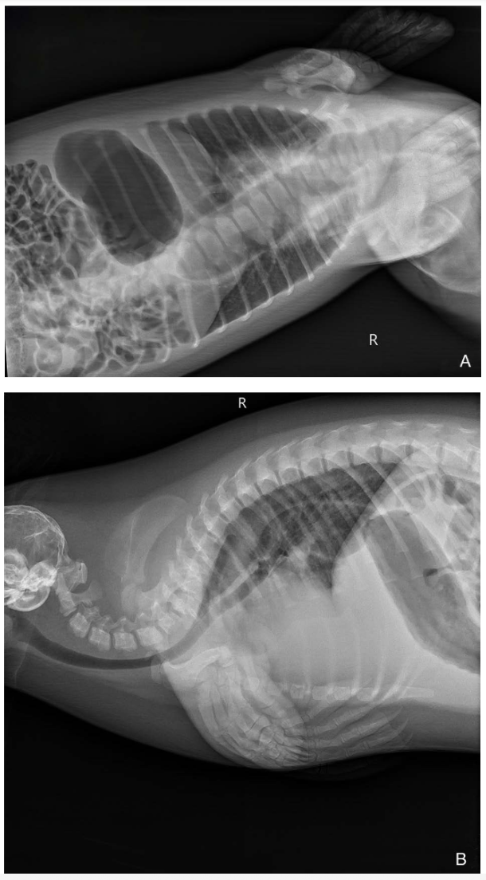

**Answer:** Sildenafil 1 mg/kg PO q12h x 14 days. It is unclear what may cause megaesophagus in Harbor seals but the previous dogma that it is solely a congenital is likely not true based on case review – as Harbor seals undergoing rehabilitation at one facility developed megaesophagus a few weeks into rehabilitation and some were able to recover with sildenafil treatment. Neither of those factors are consistent with a congenital disorder.

------------------------------------------------------------------------------------------------------------------ Journal of Wildlife Diseases, 61(3):628-641. 2025.   
**GRAY SEAL (HALICHOERUS GRYPUS) PUPS FAIL TO MOUNT AN INFLAMMATORY CYTOKINE RESPONSE TO INFLUENZA A VIRUS**  
Laura Martinelli

**Question:** Name three viruses that Gray seals (*Halichoerus grypus*) are less susceptible to when compared to sympatric Harbor seals (*Phoca vitulina*).

**Answer:** Influenza A Virus, Phocine Distemper Virus, Phocine Herpesvirus

*Journal of Wildlife Diseases, 59(3), 2023, pp. 487–494*

*Summarized by MR*

Dirofilaria immitis Identified in Galapagos Sea Lions (*Zalophus wollebaeki*): A Wildlife Health and Conservation Concern

Taylor M. Gregory, Isabella Livingston, Eleanor C. Hawkins, Andrea Loyola, Ashley Cave, Shelly L. Vaden, Diane Deresienski, Matthew Breen, Marjorie Riofr ́ıo-Lazo, Gregory A. Lewbart, and Diego Pa ́ez-Rosas

1. In Galapagos sea lions (*Zalophus wollebaeki*) which parasite has been identified by PCR and also found within the right ventricle on necropsy?
2. *Acanthocheilonema odendhali*
3. *Acanthocheilonema spirocauda*
4. *Dirofilaria immitis*
5. *Dirofilaria repens*
6. *Echinophthirius horridus*

Answer*: C. Dirofiliaria immitis*

*Journal of Wildlife Diseases, 60(4), 2024, pp. 860–873*

*Summarized by MR*

Surveillance for *Toxoplasma gondii, Brucella* spp., and *Chlamydia* spp. in Australian Fur Seal (*Arctocephalus pusillus doriferus*) Abortions

Brett R. Gardner, Andrew Stent, Rhys Bushell, John P.Y. Arnould, Rebecca McIntosh, K.L.D. Tharaka D. Liyanage, Aymeric Fromant, Jonathan Botha, Yonina H. Eizenberg, O. Martins Olaogun, Marc Marenda, Michael Lynch, and

Jasmin Hufschmid

1. In a surveillance study of *Toxoplasma gondii, Brucella* spp., and *Chlamydia* spp. in Australian Fur Seals (*Arctocephalus pusillus doriferus*), what histological lesions were associated with *Toxoplasma gondii* in aborted fetuses?

A. Myocarditis and histiocytic pneumonia  
B. Severe placentitis and hepatic necrosis  
C. Chronic nephritis and adrenal cortical atrophy  
D. Encephalitis and CNS hemorrhage  
E. Pulmonary granulomas and CNS hemorrhage

**Answer: A.** Myocarditis and histiocytic pneumonia

Journal of Wildlife Diseases, 59(4): 629-639, 2023

**Causes and trends of harbor seal (*Phoca vitulina*) mortality along the British Columbia Coast, Canada, 2012–2020** - reviewed by HSS

Courtney N. Pace, Martin Haulena, Hannah E. Drumm, Lindsaye Akhurst, Stephen A. Raverty

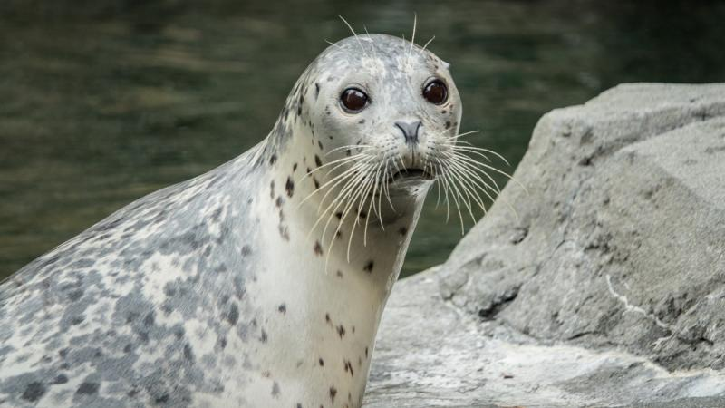

Question:

Which of the following is the most common cause of mortality in harbor seals along the British Columbia Coast, Canada form 2012-2020?

1. Congenital
2. Infectious/inflammatory
3. Human interaction
4. Malnutrition
5. Trauma (nonanthropogenic)

Answer: B

Explanation:

Infectious disease most frequently observed cause of mortality across all age groups (60.5%). This was followed by nonanthropogenic trauma (7.1%), undetermined causes (7.1%), metabolic disorders (5.4%), nutritional deficiencies (5.0%), parasitic injury (5.0%), congenital conditions (2.5%), and human-associated trauma (0.4%).

American Journal of Veterinary Research, 84(7): 1-6, 2023.

**Normal pre-and post-prandial bile acids and protein C values vary by age in harbor seal pups (*Phoca vitulina richardsi*) undergoing rehabilitation** - reviewed by HSS

Barbara K. Linnehan, Jenelle E. Leedam, David A. S. Rosen, and Martin Haulena

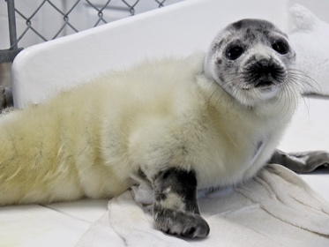

Question:

Which of the following statements is most correct regarding bile acids and protein C values in harbor seal pups?

1. There was no significant effect of age on either bile acids or protein C in harbor seal pups
2. Both bile acids and protein C were lower in harbor seals < 14 days old
3. Both bile acids and protein C were higher in harbor seals < 14 days old
4. Bile acids were lower and protein C was higher in harbor seals < 14 days old
5. Bile acids were higher and protein C was lower in harbor seals < 14 days old

Answer: E

Explanation: This study presented reference intervals for serum bile acids (pre- and post-prandial) in harbor seal pups undergoing rehabilitation. Seals < 14 days of age had the highest bile acid values. These bile acid values were well above established normal ranges for domestic species. Additionally, this study presented a preliminary investigation into the use of protein C activity. Protein C activity increased with pup age. The elevated bile acids and low protein C in these pups are thought to be transient and physiologic due to an immature liver.

**Retrospective review of neurologic disease in stranded Atlantic harbor seals (*Phoca vitulina concolor*) along the New England coast**

Wright SE, Díaz-Delgado J, Rivard MR, Flower JE, Sirpenski G, Tuttle AD. J Zoo Wildl Med. 2022;53(4):705-713—reviewed by ALD

Which of the following is the most histological diagnosis associated with neurological disease in Atlantic harbor seals (*Phoca vitulina concolor*)?

1. Meningoencephalitis (correct)
2. Neuroaxonal dystrophy
3. Cerebral edema
4. Meningeal hemorrhage
5. Hydrocephalus

**Development and validation of a novel duplex probe-hybridization quantitative PCR for lymphoma-associated miroungine gammaherpesvirus 3 in northern elephant seals (*Mirounga angustirostris*)**

Horgan M, Martinez ME, Archer LL, Duignan PJ, Wellehan Jr. JFX. J Wildl Dis. 2023;59(1):121-127—reviewed by ALD

Which viruses have been associated with oncogenesis in seals? Which species and cancers are these viruses associated with?

* Otariid gammaherpesvirus 1 w/development of urogenital carcinoma in SA fur seals
* Miroungine gammaherpesvirus 3 and lymphoma in northern elephant seals (*Mirounga angustirostris*)

Which virus was found to be significantly associated with lymphoma in northern elephant seals (*Mirounga angustirostris*)?

* Miroungine gammaherpesvirus 3