Butorphanol-Azaperone-Medetomidine Is as Safe and Effective as Nalbuphine-Azaperone-Medetomidine for Immobilization of Juvenile American Black Bears (Ursus americanus)
Sheldon JD, Zhu X, Williamson R, Blair C. J Wildl Dis. 2024;60(1):188-192—reviewed by ALD

Abstract: Immobilization kits including butorphanol- azaperone-medetomidine (BAM) and nalbuphine-azaperone-medetomidine can provide effective, safe, and easy-to-use protocols in bears. Nalbuphine-azaperone-medetomidine is not commercially available but may be useful for wildlife agencies because it does not contain controlled substances. This study directly compared BAM to nalbuphine-azaperone-medetomidine immobilization in 10 juvenile healthy black bears (10 mo old; four females, six males) undergoing prerelease examinations after rehabilitation. Bears were immobilized via remote delivery of 1 mL of BAM (n=5) or nalbuphine-azaperone-medetomidine (n=5) intramuscularly in the shoulder during December (randomized, blinded trial). Bears were intubated, monitored with an electrocardiogram, pulse oximeter, capnograph, noninvasive blood pressure cuff, and rectal thermometer, and underwent physical examination, sample collection, morphometrics, and ear-tag placement. Induction, physiologic, and recovery parameters were recorded, including arterial blood gas analysis. The anesthetic agents were antagonized with atipamezole and naltrexone. There were no differences between protocols in induction or recovery times. There were no differences between protocols in heart rate, respiratory rate, temperature, oxygen saturation, end-tidal CO2, mean arterial pressure, or blood gas analysis or any differences between male and female bears in any parameters. Bears were hypertensive and normoxemic with low oxygen saturation via pulse oximeter, but all recovered smoothly and were released within 2 h of recovery. This study supports that nalbuphineazaperone- medetomidine is clinically as safe and effective as BAM in American black bears.

Background:
- BAM: low volume, rapid recovery; NAM: no controlled substances
- Butorphanol and nalbuphine: same MOA (mu antagonist, kappa agonist), naltrexone antagonist
- Medetomidine: alpha 2 agonist, atipamezole antagonist
- Azaperone: butyrophenone tranquilizer

Methods/Results:
- Pre-release bears, immobilization via 1mL BAM or NAM IM; no supplemental O2
- Recorded induction parameters, intubated, measured ETCO2, blood gas analysis (femoral art), ECG, SpO2, HR, RR, NIBP, temp, depth
- 1 NAM bear needed supplemental ketamine during induction
- Both protocols maintained palpebral and blink but unresponsive to stimuli

Take aways:
- Bears hypertensive and normoxemic via ABG, but SpO2 <95% via pulse ox (only 6 samples actually arterial)
- Art O2 conc high—think d/t intubation
- NAM as safe and effective as BAM in juvenile black bears in field setting
- High medetomidine dosage but no SEs seen—think d/t ceiling effect (dose inc while magnitude of physiological effects don’t)

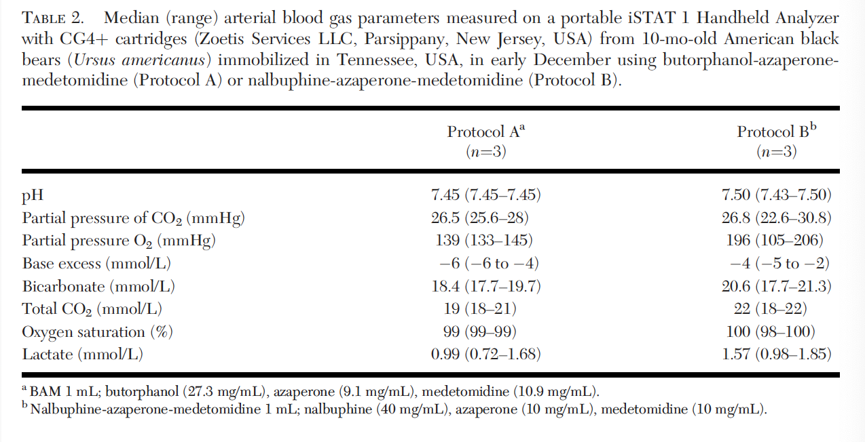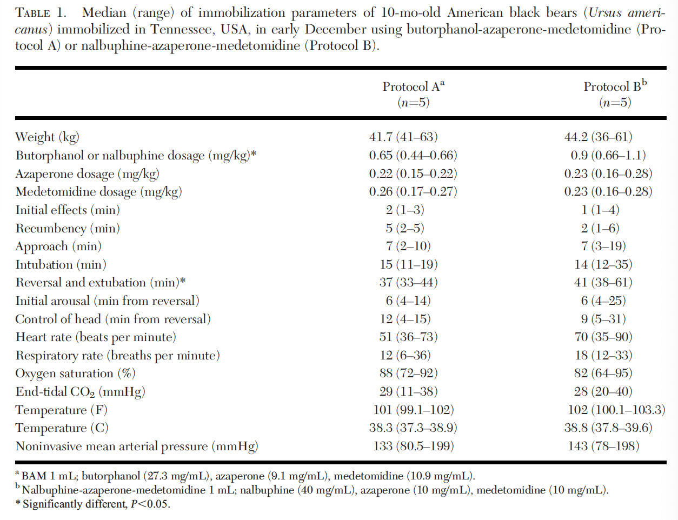

Occurrence of mange in American black bears (Ursus americanus) in New York State, USA
Rojas-Sereno Z, Abbott RC, Hynes K, Bunting E, Hurst J, Heerkens S, Hanley B, Hollingshead N, Martin P, Schuler K. J Wildl Dis. 2022;58(4):847-858—reviewed by ALD

Abstract: Mange, a parasitic skin disease caused by various species of mites, is found in free-ranging wildlife populations and has been increasingly reported in American black bears (Ursus americanus) over the last decade in New York State (NYS), USA. Our goal was to describe the geographic, seasonal, and demographic factors associated with mange in this species in NYS. Our retrospective study used historic, opportunistic data from diagnostic necropsy records and visual sighting reports collected by the NYS Wildlife Health Program from 2009 to 2018. We used chisquare tests for independence and odds ratios to examine whether geographic location, year, season, sex, age, and reason for laboratory submission were associated with mange in bears. We used maps and seasonal analysis to investigate emerging patterns. We confirmed increased black bear mange reports in recent years. Necropsy data revealed more bears submitted to the laboratory because of mange, mainly caused by Sarcoptes scabiei; females were more likely than males to present with sarcoptic mange. We found that cases of mange in the Northern Zone were widely disseminated throughout the region, whereas cases in the Southern Zone were concentrated in two areas along the Pennsylvania border. Seasonally, mange cases showed peaks occurring in late spring to early summer and in fall. Our results were on the basis of available data; a comprehensive statewide surveillance program would be useful to better understand the apparent increase in mange and its potential impact on both the welfare of individual animals and the population of black bears in NYS. Additional research on the timing of transmission dynamics associated with females in winter dens may be helpful to wildlife managers to identify strategies to mitigate deleterious spread of the disease in black bears.

Background:
- S. scabiei most common cause of mange in black bears, think related to immunocompromised after hibernation; zoonotic
  - See S. scabiei in social carnivores (coyotes, red foxes), but black bears solitary
- CS of mange: alopecia, poor BCS, epidermal exfoliation, Lichenification

Methods/Results:
- Retrospective cross-sectional study—necropsy, histology, and diagnostic testing of bears submitted to diagnostic labs as well as sighting data (time, date, body condition)
  - Also collected age, sex, location, date, reason for lab submission, final diagnosis
- Discarded duplicate sighting reports, only included one record (necropsy or sighting) for each
- Submitted for nuisance complaint, accident, disease, then other (research, hunted, orphan)
- Parasitic dz most common dx, then trauma, (males>females)
  - 54/150 cases of mange (both primary and secondary cause of mortality)
- Odds of mange 4x higher in northern zone than south, no sig diff by year, no sig diff by season
- Bears w/mange: highest odds submitted for suspected disease (less likely accidental death), more likely w/mange if submitted b/c of nuisance complaints but not significant
- Females 4.1x more likely to have mange, males more likely trauma w/mange secondary
- No sig diff by age for either sex
- Sightings inc steadily after 2016, first in 2012
- Higher #of sightings during early summer compared w/# of necropsies, necropsy mange peaked late spring w/slight inc in fall and late winter

Take aways:
- Mange=emerging dz in black bears, rare as a source of mortality historically but more common now
- Unclear transmission: direct or indirect contact w/other wildlife; infested dens; inc bear densities
- Seasonal variations, but unsure if epizootic or enzootic
- Mange peaks in late spring/early summer & small inc early fall & late winter
  - Could be due to inc sightings by people (more bears out)
  - Mange bears may leave hibernation dens early d/t depleted fat reserves (mange makes inc use of energy during hibernation)late winter peak
- Females more likely to have mange: think d/t dec cellular immunity d/t female hormones, red immune fn in lactating females, hibernation challenges d/t implantation, gestation, or lactation d/t high metabolic demand
- Secondary infections noted w/mange: Malassezia, Pelodera, B. transfuga
- Juveniles: think infection from mother, but no diff by age class seen
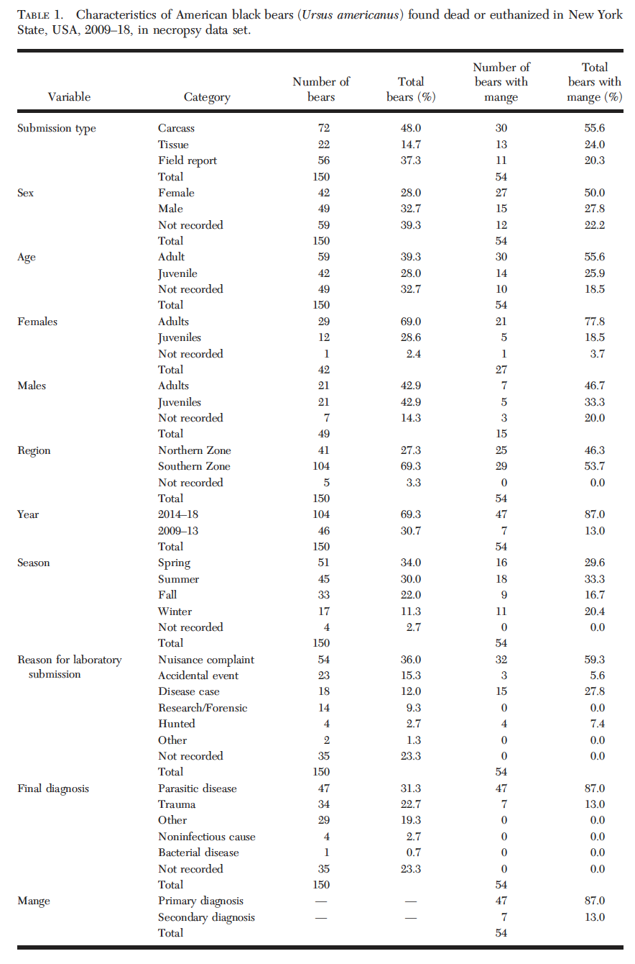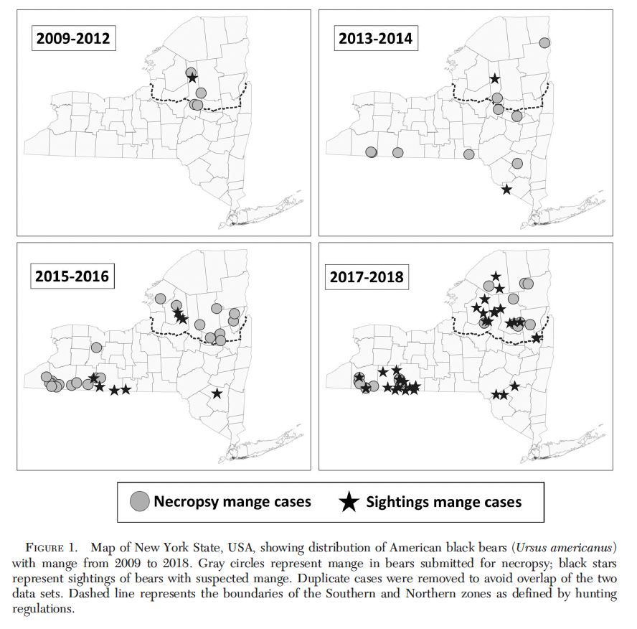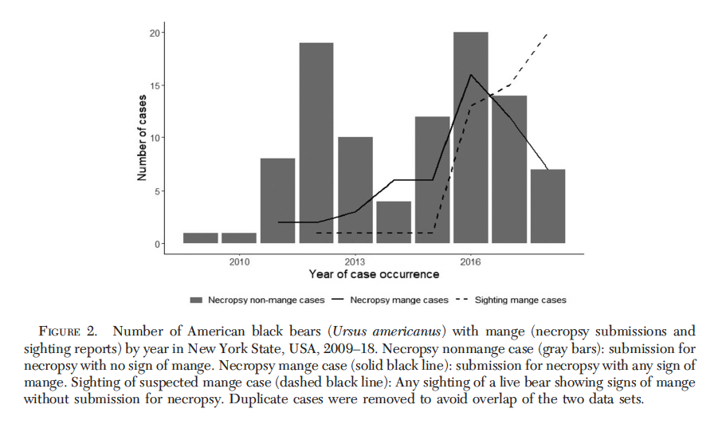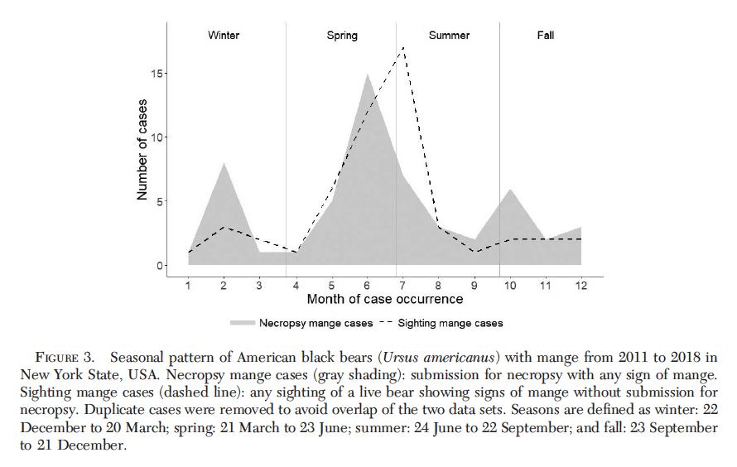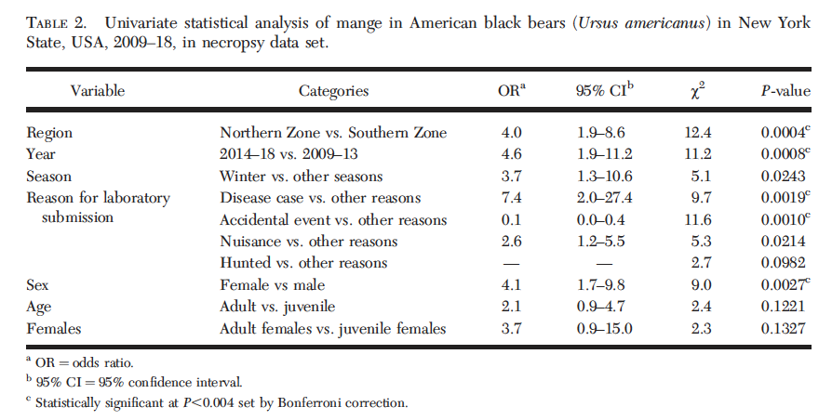

Hematology and plasma chemistry comparisons among juvenile American black bears (Ursus americanus) undergoing rehabilitation. Journal of Zoo and Wildlife Medicine 2024: 776-784.

Abstract: The American black bear (Ursus americanus) is an opportunistic and adaptable species with high rehabilitation success rates. Injured, ill, and orphaned bears across the southeastern United States are examined and treated at the University of Tennessee College of Veterinary Medicine followed by rehabilitation at Appalachian Bear Rescue (ABR). Hematology and biochemistry reference ranges exist for healthy adult black bears; however, most bears presenting to ABR are young and of variable health status. Thus, further investigation into the difference of blood values at varying ages and presentations is warranted. ABR records from 1996 to 2022 included 106 bears with completed hematology and plasma biochemistry panels (22 paired samples at intake and release, 84 at intake only). Intake-only samples consisted of 12 neonates (<3 mon old), 64 cubs (3–12 mon), and 30 yearlings (1–2 yr). Bears presented as orphaned neonates (22%), orphaned cubs (45%), malnourished yearlings (24%), and injured/ill (9%) during fall (16%), winter (13%), spring (32%), and summer (39%). Changes in hematology and plasma biochemistry results between intake and release included an increase in hematocrit and glucose. Injured/ill bears presented with higher total leukocyte count (WBC), absolute neutrophils (ABS segs), alanine aminotransferase (ALT), aspartate aminotransferase (AST), and creatine kinase (P<0.05). Positive correlation between ALT, AST, proteins, and blood urea nitrogen and negative correlation between absolute lymphocytes and alkaline phosphatase were noted with age. Both WBC and ABS segs were lower during winter (P < 0.05). Understanding what factors affect juvenile black bear blood values improves clinical expectations and evaluation upon intake, clinical evaluation, and treatment.

Key Points:
- Reference range exist for black bears; however rehab setting often ill/injured bears, different age groups; changes between free-ranging and under human care
- Intake to release: increase in HCT, RBC, hemoglobin, absolute eosinophil, TP, albumin, creatinine increased blood volume, O₂ carrying capacity, muscle mass, overall health and nutritional status, resolution inflammation
  - Unpublished data: higher fecal nematodes at release (don’t expect eos to increase)
- Age decreases: lymphocytes, ALP, A:G, Ca, Phos, Chol, Mg, RBC, HCT
  - Yearlings solitary, malnutrition and high parasites, cause decreased HCT
  - Young animals have higher ALP, Ca, Phos for bone growth
  - Low GGT in orphaned cubs (post colostrum normal change)
- Age increases: ALT, AST, Glob, Creat, TP, CK
  - Low glob initially since not encountered immune stimulants for glob production
  - ALT, AST, BUN increase with age due to tissue growth
- Injured/ill bears: higher leukocyte, neutrophils, monocytes (inflammation); higher ALT, AST, CK (tissue damage)
- Malnourished yearling lower WBC (chronic nutritional deficits), ALP (slower growth rate), calcium and phosphorus (malnutrition); RBC and HCT compared to orphaned neonate/cub (general poor health); in contrast TP and globulins highest (hemoconcentration, dehydration – unexpected finding)
- Lower in winter: RBC, HCT, HGB, WBC, Absolute segs, Absolute monos, platelets (decreased metabolism, decreased exposure to inflammatory stimuli during hibernation)
  - Some brown bear studies found opposite: higher RBC, HCT, HGB
- TP higher in summer, AG higher in spring and summer, TP lower winter (change in nutritional status and inflammatory stimuli in hibernation)

Take Home Point: Age group, intake code, season impact hematology and biochemistry of juvenile American black bears; interpret current reference ranges with caution

Pneumonia as a cause of mortality in juvenile and adult red pandas (ailurus fulgens styani) in Chengdu, China Journal of Zoo and Wildlife Medicine 56.2:311-315

Abstract: The red panda (Ailurus fulgens) is an endangered herbivorous mammal, with wild populations distributed in the Himalaya–Hengduan Mountains. Published scientific work indicates that pneumonia is still an important cause of death in ex situ populations of red pandas, particularly in neonates. This retrospective study used historical necropsy records, systematic necropsies, and pathogen detection methods to identify histopathologic patterns and pathogens in red pandas that had died with fatal respiratory disease at the Chengdu Research Base of Giant Panda Breeding, China, from 2014 to 2020. Of a total of 62 deceased red pandas, 25 were diagnosed with pneumonia, with an incidence rate of 40.3%. Pneumonia was the cause of death for the six juveniles and eight adults in the study of the 25 that had the diagnosis of pneumonia on record. Microbiologic cultures with sequencing identified Acinetobacter johnsonii, Bacillus ciccensis, Streptococcus gallinaceus, and Staphylococcus saprophyticus from individuals with pneumonia. Two other cases involved nematode parasite infections; PCR sequencing identified one nematode as Strongyloides sp.; the other nematode could not be identified. Additional systematic in-depth studies on the epidemiology of disease patterns in managed red pandas are needed to clarify the susceptibility to pathogens, trends in disease occurrence, and identification of other risk factors, such as novel infectious agents, which may affect the stability and welfare of both ex situ and in situ populations.

Key Points
- High mortality common for neonate red pandas (pneumonia and sepsis)
- Comprehensive mortality review indicated pneumonia major cause of death across all age classes initiated this study to understand underlying causes
- Evaluated all deceased pandas over 6 years, 40% diagnosed with pneumonia
  - Fibrinous bronchopneumonia (fibrin and serous fluid on histopath); interstitial pneumonia (widened and hyperplastic interstitium with fusion of tissue planes and replacement of alveolar spaces); suppurative pneumonia (neutrophilic inflammatory exudate); parasitic bronchopneumonia (thickening alveolar septa, congested capillaries); various nematode parasites
- No viral component; No anaerobic growth
- 5 isolates under aerobic growth:
  - Bacillus ciccensis and Streptococcus gallinaceus (fibrinous bronchopneumonia)
  - Staphyloccocus saprophyticus (suppurative pneumonia)
  - Acinetobacter johnsonii (fibrinosuppurative bronchopneumonia)
- Study differs from North American study in which pneumonia was leading cause of neonates and juveniles but cardiovascular disease was predominant in adults; here pneumonia predominant for all age categories
- Stronglyloides sp. Associated with severe bronchopneumonia

Key Take Home Point: Pneumonia is a major cause of death in both juvenile and adult red pandas under managed care in Chengdu, with various bacterial and parasitic agents identified.

Journal of Wildlife Diseases, 61(1), 2025, pp. 76–87
Summarized by MR

Seroprevalence of Erysipelothrix rhusiopathiae in Beaufort Sea Polar Bears (Ursus maritimus) is Linked to Ringed Seal (Pusa hispida) Demographics
Brooke A. Biddlecombe, Nicholas W. Pilfold, Evan S. Richardson, Susan Kutz, Fabien Mavrot, Angela Schneider, and Andrew E. Derocher

Abstract: Polar bear (Ursus maritimus) life history is intimately associated with the distribution of sea ice and their prey in Arctic ecosystems. These ecosystems are changing in response to climate warming, resulting in the increased prevalence of pathogens in polar bears. Erysipelothrix rhusiopathiae has a long history of infection in domestic species and more recently in wildlife in the Canadian Arctic. As a result of increasing reports of E. rhusiopathiae causing morbidity and mortality in Arctic terrestrial mammals, we tested the seroprevalence of E. rhusiopathiae in Beaufort Sea polar bears sampled in 1985–87, 1992, 1994, and 2003–11. Our sample of 180 polar bears (117 females, 61 males, two unknown) with a median age of 9 yr (range 1–26 yr) had a seropositivity of 27.2% (49/ 180 individuals). We used binomial logistic regressions to investigate biotic and abiotic factors that may be linked to seropositivity. The resulting top model found that increased predation on adult ringed seals (Pusa [Phoca] hispida) and negative winter Arctic Oscillation Index (AOI) years were associated with a higher probability of seropositivity. Ringed seals may be a reservoir for E. rhusiopathiae via their consumption of infected prey, as the pathogen can persist in marine fish, mollusks, and crustaceans. Negative winter AOIs in our data set reflected high ice volume years, which reduced ringed seal natality, resulting in fewer seal pups available as prey. Our results suggest that exposure to E. rhusiopathiae in Beaufort Sea polar bears is modulated by a predator–prey mechanism.

Background:
- Gram positive bacteria infecting a wide range of marine and terrestrial vertebrates
- Canadian Arctic Archipelago: widespread mortality in muskoxen, detected in feces/carcasses of Arctic foxes, wolves, seals, caribou – mortality rate is highly variable
- Transmission thru damaged skin or mucous membranes
- Polar bears scavenge muskox remains and predate upon seals (~90% prey of polar bears).
- 2012: Concern regarding exposure to an agent (DDx Erysipelothrix) given alopecia and reduced BCS observed in bears
  - Elevated dead and sick ringed seals reported near Alaska in the same period
  - Heavy ice years also reduce breeding success of ringed seals
- Marine fish, mollusks, and crustaceans are hosts for E. rhusiopathiae, and it can persist in tissues for long periods, surviving in decaying tissues for up to 10 months
- Increased seroprevalence of various pathogens are documented to be correlated to climate-mediated changes in the environment

Summary:
- 180 polar bears from the Southern Beaufort Sea and Northern Beaufort Sea subpopulations (1985-87, 1992, 1994, 2003-2011)
- Polar bears ID’ed from helicopter and remotely administered telazol, age obtained from extracting vestigial premolar and counting cementum annuli, BCS taken
- Blood samples collected under anesthesia and serum was obtained by indirect ELISA (anti-Erysipelothrix antibodies)
- Covariates to model likelihood of Erysipelothrix: age, sex, BCS, prey age, BCS of ringed seal prey, if females had a cub the previous year, latitude/longitude, low levels of sea ice, sea pressure anomalies and Arctic wind-drive circulation regimes.
- AIC stands for Akaike Information Criterion corrected for small sample sizes – essentially, a method for selecting the best statistical model from a set of candidates
  - the ringed seal consumption model had the lowest AICc value
  - Prey age had a significant positive effect
  - Winter AOI (seal-level pressure anomalies) was marginally significant, which is linked to ringed seal population dynamics – high volume ice years reduce seal natality
- Data from this study shows that Beaufort sea polar bears have been exposed for several decades
- Results suggest that the food web is a driver of E. rhusiopathiae exposure in polar bears

Take Home Points:
- E. rhusiopathiae in Beaufort Sea polar bears is modulated by a predator–prey mechanism (which is impacted by climate-mediated changes in the environment)
- 27.2% of polar bears were seropositive

Journal of Wildlife Diseases, 59(1), 2023, pp. 186–191
Summarized by MR

Survey for Selected Parasites in Alaska Brown Bears (Ursus arctos)
Ellen Haynes, Sarah Coker, Michael J. Yabsley, Kevin D. Niedrighaus, Andrew M. Ramey, Guilherme G. Verocai, Grant V. Hilderbrand, Kyle Joly, David D. Gustine, Buck Mangipane, William B. Leacock, Anthony P. Crupi, and Christopher A. Cleveland

Abstract: To assess infection with or exposure to endo- and ectoparasites in Alaska brown bears (Ursus arctos), blood and fecal samples were collected during 2013–17 from five locations: Gates of the Arctic National Park and Preserve; Katmai National Park; Lake Clark National Park and Preserve; Yakutat Forelands; and Kodiak Island. Standard fecal centrifugal flotation was used to screen for gastrointestinal parasites, molecular techniques were used to test blood for the presence of Bartonella and Babesia spp., and an ELISA was used to detect antibodies reactive to Sarcoptes scabiei, a species of mite recently associated with mange in American black bears (Ursus americanus). From fecal flotations (n =160), we identified the following helminth eggs: Uncinaria sp. (n=16, 10.0%), Baylisascaris sp. (n=5, 3.1%), Dibothriocephalus sp. (n=2, 1.2%), and taeniid-type eggs (n=1, 0.6%). Molecular screening for intraerythrocytic parasites (Babesia spp.) and intracellular bacteria (Bartonella spp.) was negative for all bears tested. We detected antibodies to S. scabiei in six of 59 (10.2%) individuals. The relatively low level of parasite detection in this study meets expectations for brown bear populations living in large, relatively undisturbed habitats near the northern edge of the range. These results provide a contemporary understanding of parasites in Alaska brown bears and establish baseline levels of parasite presence to monitor for changes over time and relative to ecologic alterations.
Summary:
- Brown bear parasite surveys have been limited to Canada prior to this study
- Opportunistic fecal collection in anesthetized bears (n = 156 total, 2013 – 2017)
  - Fecal floatation performed on 114 fecal samples, 1-5 samples per study period
  - GLMM were created, predicting detection of each parasite by year, month, location of sampling
- Blood collected tested for Bartonella and Babesia PCR
- Serum samples tested for antibodies for Sarcoptes scabiei using indirect ELISA kit designed for dogs – also validated in black bears
- Most common GI parasites included: Uncinaria, Baylisascaris spp. [nematodes] and Dibothriocephalus, taenia-like [cestodes]
  - Floatation techniques in live bears may underdiagnose infections compared with necropsy based studies (this has been proven for Baylisascaris repeatedly)
  - Intermittent shedding is a consideration
- Parasite prevalence varied drastically by year, suggesting periodic shedding
- All animals were PCR negative
- Antibodies to S. scabiei were detected in six (10%) of 59 blood samples: all from two sites in May 2016
  - There have not been any reported cases of sarcoptic mange in any wildlife species in Alaska, and it is possible that this assay may cross-react with other mites

Take Home Points:
- Low level of intestinal parasites relative to previous studies on brown bears in N America
- Subject to accelerated ecologic change due to climate shifts – monitoring changes to this low level prevalence over time is pertinent

Journal of Zoo and Wildlife Medicine, 54(4): 796-800, 2024.
ANESTHESIA IN CAPTIVE GIANT PANDAS (AILUROPODA MELANOLEUCA) WITH MEDETOMIDINE-KETAMINE
Laura Martinelli
Abstract: One male and one female giant panda (Ailuropoda melanoleuca) from a Belgian zoo were anesthetized on eight different occasions over a course of 4 yr for electro-ejaculation (n = 3) or artificial insemination (n = 5). Medetomidine (0.03–0.04 mg/kg) and ketamine (2.5–3 mg/kg) were administered by intramuscular remote injection. Animals gained sternal recumbency with the loss of response to external stimuli after 4.9 ± 1.6 min (mean ± SD). The trachea was intubated with a 14-mm–internal diameter endotracheal tube; anesthesia was maintained with isoflurane in oxygen adjusted according to the required depth of anesthesia with a small-animal circle system. Physiological variables (heart rate, respiratory rate, oxygenation, end tidal carbon dioxide partial pressure and non-invasive blood pressure) were measured and remained within an acceptable range throughout anesthesia. Atipamezole (0.17–0.25 mg/kg) was administered intramuscularly after anesthesia. Recoveries were rapid and uneventful. Medetomidine 0.03 mg/kg and ketamine 2.5 mg/kg IM appeared to be the preferred doses for giant pandas.
Key Points:
- Giant Panda population is currently increasing
- There are more than 600 captive individuals in China and more individuals are held in 20 countries outside of China. All Giant Pandas outside China are held under a conservation agreement run by the Chinese government.
- This paper describes successful use of medetomidine-ketamine anesthesia on 8 different occasions in Giant Panda at a zoo in Belgium
- Pandas fasted for ~8 hours
- Darted in hindlimb (interesting they went for hindlimbs) with Daninject the above listed doses in abstract of medetomidine-ketamine
- NIBP hypertensive (as expected) and a gradual decrease was noted over time (makes senses since they were put on isoflurane and based on drug combination)
- The dose of medetomidine and ketamine was tinkered with throughout these procedures but ultimately authors concluded that the optimal dose for giant pandas is 0.03 mg/kg medetomidine and 2.5 mg/kg ketamine IM
- These doses provided superior/faster time to sternal recumbency than any other protocol for giant pandas in the literature
Take Home Point: Medetomidine 0.03 mg/kg and ketamine 2.5 mg/kg IM in giant panda provides repeatable and satisfactory anesthesia for electro-ejaculation and artificial insemination.
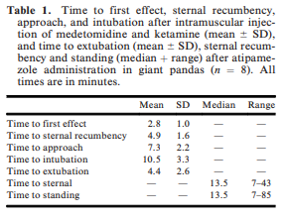
-------------------------------------------------------------------------------------------------------------------------------
Journal of Zoo and Wildlife Medicine, 55(4): 1104-1113, 2024.
EVIDENCE FOR ADRENAL DYSFUNCTION CONTRIBUTING TO PERACUTE MORTALITY SYNDROME IN RED PANDA (AILURUS FULGENS)
Laura Martinelli
Abstract: Red pandas (Ailurus fulgens) are endangered with extinction due to deforestation and habitat fragmentation. Reported causes of unexpected death in managed red pandas include kidney, liver, gastrointestinal, and cardiac disease. A previously undetailed syndrome, red panda peracute mortality syndrome, may be emerging, as red pandas have died unexpectedly, with no clear cause of death identified at necropsy. This case series describes the clinical and postmortem findings of five red pandas at Brookfield Zoo with abnormal adrenal size and associated histologic lesions as possible contributing factors to acute death. Antemortem clinical signs consisted of thin body condition, vomiting, intermittent diarrhea, neck ventroflexion, ataxia, and electrolyte abnormalities. Mortality may have been due to abnormal adrenal function, resulting in fatal electrolyte disturbances. Antemortem adrenocorticotropic hormone (ACTH) stimulation tests indicated an inappropriate response to ACTH with persistently low cortisol and aldosterone levels after cosyntropin administration. Clinical improvement was seen when red pandas were provided steroids, but all cases were eventually fatal. Further study is needed to understand red panda peracute mortality syndrome and associated adrenal dysfunction.
Key Points:
- At BFZ, five red pandas died acutely with gross adrenal cortical atrophy and thinning of all zone cortices, suggestive of abnormal and insufficient adrenal function
- Table 1 summarizes the cases
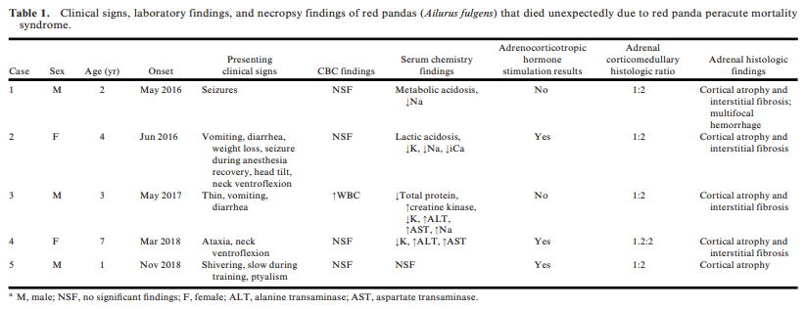
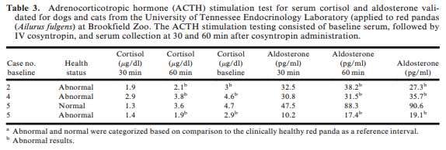
- Common clinical signs across cases = often vague or non-specific signs!!!, ataxia, seizures, neck ventroflexion, vomiting, lethargy, diarrhea, weight loss
  - Note: All had neurologic or GI signs
  - Note: Two animals had neck ventroflexion presumptively from hypokalemia, similar to domestic cats.
- Common postmortem findings = bilaterally small adrenal glands with markedly thin cortices, cortical cell atrophy, degeneration, and associated interstitial fibrosis
  - None of the examined adrenals had inflammation, making immune-mediate destruction of cortical cells (like you would see in Addison’s disease in animals and humans) unlikely
  - Note: Pituitary glands were normal in these cases both grossly and histologically
- All individuals in this series were adults and there was no sex predilection
- Red pandas in this series were most similar to primary adrenal dysfunction (disease impacting the adrenal gland itself), and although electrolyte changes varied between cases, none exhibited the classic hyponatremia and hyperkalemia seen in hypoadrenocorticisim in dogs
- MAJOR POINT: The ACTH stim test validated in cats and dogs is NOT recommended to be used in red pandas based on this paper. After reviewing the cases, authors did follow-up testing on 20 random individuals and got incongruent test results. Authors state that this makes the assay methodology of questionable diagnostic utility for red pandas (despite having some evidence of adrenal dysfunction during theses cases on ACTH stims).
- The five red pandas were genetically related, from direct offspring to a multigenerational relationship. See included Figure 3.
Take Home Point: Adrenal dysfunction likely contributes to peracute mortality in red pandas. Any red panda with vague clinical signs and hypokalemia may be experiencing adrenal dysfunction and administration of steroids should be considered.

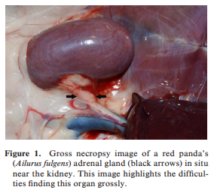=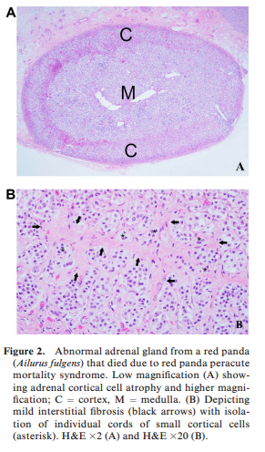 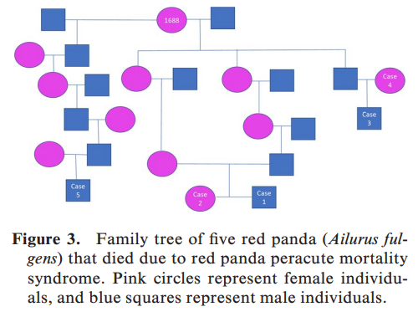
Journal of Wildlife Diseases, 60(2), 2024, pp. 434–447
Resolution of Clinical Signs of Sarcoptic Mange in American Black Bears (Ursus americanus), in Ivermectin-Treated and Nontreated Individuals
Hannah S. Tiffin, Justin D. Brown, Mark Ternent, Brandon Snavely, Emily Carrollo, Ethan Kibe, Frances E. Buderman, Jennifer M. Mullinax, and Erika T. Machtinger – reviewed by HSS
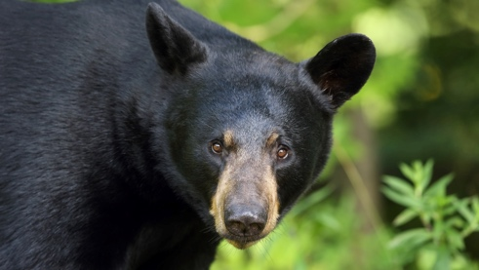
Abstract:
The parasitic mite Sarcoptes scabiei causes mange in nearly 150 species of mammals by burrowing under the skin, triggering hypersensitivity responses that can alter animals' behavior and result in extreme weight loss, secondary infections, and even death. Since the 1990s, sarcoptic mange has increased in incidence and geographic distribution in Pennsylvania black bear (Ursus americanus) populations, including expansion into other states. Recovery from mange in free-ranging wildlife has rarely been evaluated. Following the Pennsylvania Game Commission's standard operating procedures at the time of the study, treatment consisted of one subcutaneous injection of ivermectin. To evaluate black bear survival and recovery from mange, from 2018 to 2020 we fitted 61 bears, including 43 with mange, with GPS collars to track their movements and recovery. Bears were collared in triplicates according to sex and habitat, consisting of one bear without mange (healthy control), one scabietic bear treated with ivermectin when collared, and one untreated scabietic bear. Bears were reevaluated for signs of mange during annual den visits, if recaptured during the study period, and after mortality events. Disease status and recovery from mange was determined based on outward gross appearance and presence of S. scabiei mites from skin scrapes. Of the 36 scabietic bears with known recovery status, 81% fully recovered regardless of treatment, with 88% recovered with treatment and 74% recovered without treatment. All bears with no, low, or moderate mite burdens (<16 mites on skin scrapes) fully recovered from mange (n=20), and nearly half of bears with severe mite burden (≥16 mites) fully recovered (n=5, 42%). However, nonrecovered status did not indicate mortality, and mange-related mortality was infrequent. Most bears were able to recover from mange irrespective of treatment, potentially indicating a need for reevaluation of the mange wildlife management paradigm.

Key Points:
- In North America, wild canids have historically been affected by sarcoptic mange with several documented epizootics, particularly within coyote (Canis latrans), gray wolf (Canis lupus), and red fox (Vulpes vulpes) populations. Black bears were rarely affected by sarcoptic mange until the early 1990s, when cases were increasingly reported in Pennsylvania
  - Regional expansion to states in the northeast, mid-Atlantic, and southeast in recent years
- Sarcoptic mange lesions may appear similar to or be indistinguishable from other types of mange that can affect black bears, namely chorioptic (caused by Chorioptes sp.), demodectic (Demodex ursi), and audycoptic (Ursicoptes americanus) mange
- Treatment with a single acaricidal dose is frequently administered to opportunistically captured wildlife, but there are little data on the efficacy of this treatment for clearance of mite infestation or resolution of overt disease
  - Ivermectin does not have efficacy against ova stage, so 2-4 doses should ideally be administered
- Treatment consisted of one subcutaneous injection of 0.4 mg/kg ivermectin
- Overall, 81% of black bears with sarcoptic mange fully recovered over the course of the study regardless of treatment, and 86% of bears showed improvement in mange severity
- Although treatment with ivermectin was not a significant predictor of bear recovery (P=0.73), five of the seven bears that did not fully recover were in the untreated.
- 14/19, 74% of untreated bears fully recovered. 16/19, 84% of untreated bears improved or fully recovered
- All bears that did not show improvement had initial mange matrix scores ≥8.0 (range=8.0–9.5), indicating moderate to severe disease, and bears that showed improvement had much greater variation in initial mange matrix scores (range=1.5–11.0). However, initial mange matrix score was also not a significant predictor of bear recovery (P=0.15).
- Of the bears with severe mite burdens, 5/12 (42%) fully recovered from mange and two bears had improved mange condition when last evaluated, even if they did not show full recovery (7/12, 58% improved or fully recovered).
- Black bear survival was high regardless of mange infestation, severity, or ivermectin treatment, with average monthly survival estimates above 0.90 across treatment groups and mange severity
  - Healthy bears and bears with mild mange had the highest survival rates, and bears with moderate to severe mange had the lowest survival rates
- Primary routes of transmission in black bears are still unknown; solitary animals, so direct transmission unlikely. May become affected through areas bears congregate, such as baiting and feeding sites
- Black bears with alopecia but signs of hair regrowth and minimal skin crusting often had low or no mites present, indicative of recovery, compared to bears with alopecia and diffuse crusted skin lesions, which frequently had high mite burdens indicative of active disease
- The ability of black bears to recover from this disease could prolong the period for which scabietic bears might infect other animals on the landscape.
- Most mange treatments are general antiparasitics and acaricides rather than active specifically against S. scabiei, thus possible negative environmental effects of widespread use must be considered in decision making regarding treatment

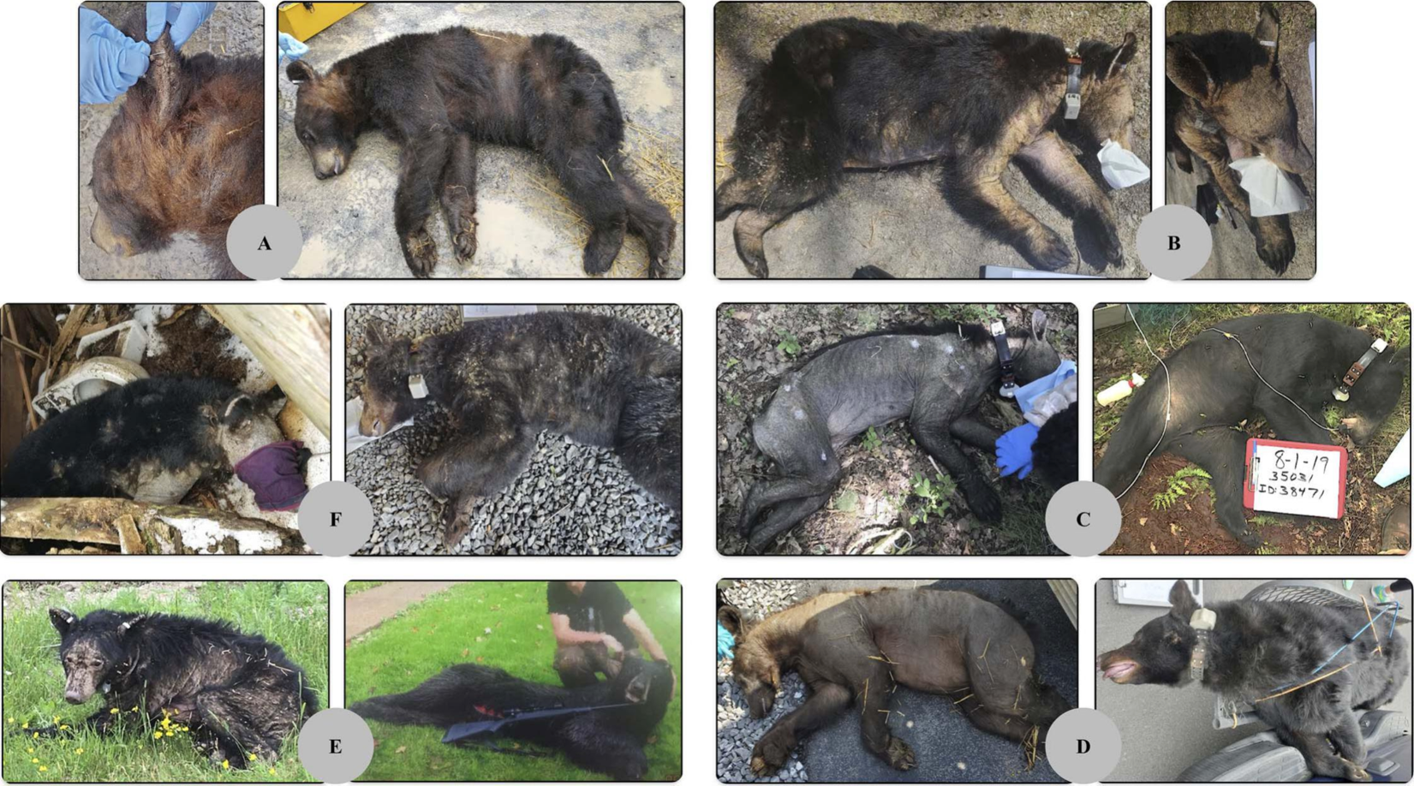

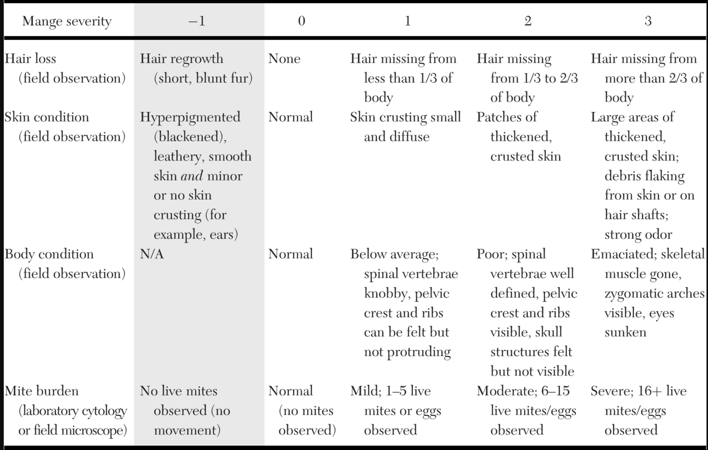

Take-Home Message:
- Most scabietic black bears were able to recover from the disease, and treatment was not correlated with recovery: Most bears recovered regardless of treatment status.
- Black bear survival was high regardless of mange infestation, severity, or ivermectin treatment

Journal of Zoo and Wildlife Medicine, 56(1): 104-112, 2025.
OCULAR FINDINGS IN SLOTH BEARS (MELURSUS URSINUS) RESCUED FROM THE DANCING BEAR TRADE IN INDIA
Claudia Hartley, Claudia Busse, Marian Matas Riera, Heather J. Bacon, Attur Shanmugam Arun, Ilayaraja Selvaraj, Kartick Satyanarayan, Geetha Seshamani, Alan Knight - reviewed by HSS
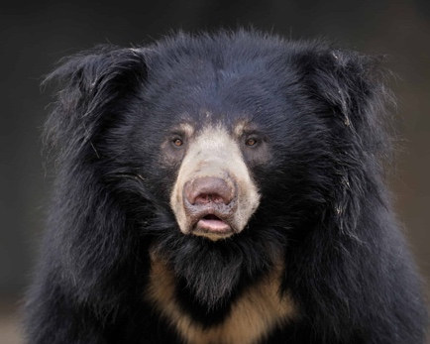
Abstract:
The aim of this study was to descriptively characterize the ophthalmic findings identified in 43 adult sloth bears (Melursus ursinus) rescued from the dancing bear trade in India and examined at two sloth bear rehabilitation centers in Agra and Bannerghatta nr. Bangalore. Animals were selected where ocular disease was suspected except for two bears which were examined while anesthetized for other reasons (fight wound, health check). Full ophthalmic examinations were undertaken under general anesthesia. Ocular ultrasonography, electroretinography, and photography were also performed. Forty-three bears (86 eyes) were examined. Mean Schirmer tear test (STT) = 12+/–6.2 (median 12, 95% CI –0.4–24.4) mm/min. Mean intraocular pressure (IOP) = 11.4+/–3.7 (median 12, 95% CI 4–18.8) mmHg excluding phthisical or grossly hydrophthalmic eyes. Ocular disease perceived to result in uni- or bilateral blindness was common (35 bears) with one or more of the following: phthisis bulbi (19 eyes; 13 bears), cataract (28 eyes; 17 bears), retinal detachment (29 eyes; 21 bears), and retinal degeneration (19 eyes; 16 bears) recorded frequently. Ocular ultrasound recorded mean axial globe diameter in non-phthisical/non-hydrophthalmic eyes as 16.5 +/–1.4 (median 16.4, 95% CI 13.7–19.3) mm and mean axial lens diameter of 4.9 +/–0.1 (median 4.7, 95% CI 4.7–5.1) mm. Blinding ocular disease was common, in particular, phthisis bulbi, retinal degeneration, and retinal detachment. Retinal detachment and phthisis bulbi may relate to blunt force ocular trauma prior to rescue, but ocular tuberculosis (TB) cannot be excluded, and retinal degeneration could result from a poor diet prior to rescue.

Key Points:
- The sloth bear (Melursus ursinus) is an insectivorous species (myrmecophagous) that also consumes fruit (season-dependent). The sloth bear has evolved a long lower lip and palate advantageous for sucking up insects (ants and termites) as well as well-developed nasal alar cartilages capable of closing the nostrils during feeding.
  - Vulnerable; populations are believed to be in decline due to habitat destruction, poaching (conflict animals and for body parts), and capture for exploitation
  - Sloth bears (Melursus ursinus) kept for ‘dancing’ as a popular entertainment was traditional in India dating back to the 13th century. The practice was banned in 1972, but bears remained on the streets, often within the Kalandar community.
- 41 bears identified as having ophthalmic disease in their combined population of 389 sloth bears (11%)
- STT – no differences between eyes or M/F animals
- IOP – F had significantly lower IOP than M
- Bilateral blindness with no potential for vision was documented in 18 bears (36 eyes), and unilateral blindness in 17 bears. Four bears (six eyes) were considered to have poor vision due to retinal degeneration and demonstrated reduced electroretinography (ERG) results. Two bears were identified as having potential for vision due to cataract (no retinal detachment on ultrasound and positive ERG results)
- Nuclear sclerosis was also common even in apparently normal eyes within this population of bears (41/43 bears were >8 years).
- Funduscopy of ophthalmoscopically normal bear eyes revealed a large central tapetum with a peripheral tapering ring of non-tapetal fundus. The fundus was holangiotic
- Phthisis bulbi was evident in 19 eyes (13 bears) with a typical shrunken, often mis-shapen appearance to the globe with total corneal fibrosis giving a blue-white opacified appearance
  - Could reflect blunt trauma from disciplinary beatings. Other causes such as end-stage uveitis or glaucoma secondary to infectious or inflammatory systemic disease could not be excluded.
    - One bear with bilateral phthisis bulbi had no observable lens in either eye on B mode ultrasonography, suggestive of globe rupture and loss of the lens at each trauma.
- Unilateral hydrophthalmos was identified in two bears
- Corneal opacities were identified in 24 eyes (18 bears)
- Anterior (three bears, three eyes) and posterior (three bears, four eyes) synechiae were identified suggestive of previous corneal perforation or uveitis, respectively
- Cataract was one of the most commonly identified abnormalities, occurring in 28 eyes (17 bears)
- Lens luxation or subluxation was identified in 16 eyes (14 bears)
  - Lens luxation in combination with retinal detachment was documented in seven bears (nine eyes).
- Retinal detachment in combination with cataract was identified by ocular ultrasound in 14 eyes (12 bears).
- Retinal detachment was identified in 29 eyes (21 bears)
- Retinal degeneration (from mild to total) was present in 19 eyes (16 bears)
  - Causes of retinal degeneration could include secondary to uveitis (and in particular secondary to systemic tuberculosis), glaucoma, age-related and nutritional.
  - Retinal lipofuscinosis has been described on histopathology of the globe of an Asiatic black bear, which is perhaps suggestive of vitamin E deficiency
  - Malnutrition is likely in this population
- Postmortem and antemortem tests revealed 24 of the 43 bears are or were positive for tuberculous Mycobacteria
  - MycoPac dual kit, 94% sensitivity in sloth bears
  - TB commin in humans in India
  - Likely to represent a reverse zoonosis with bears contracting Mycobacterium tuberculosis from their unnatural habitat in human environments
  - Clinical signs of TB in sloth bears were reported as ill-thrift, weight loss, cachexia, anorexia, dullness, pale mucous membranes, respiratory distress, and cough; cular signs were not reported
  - Ocular tuberculosis in humans has been described as manifesting with anterior uveitis and/or choroiditis, and/or choroidal tubercle formation, retinal detachment, and retinal vasculitis. The development of chronic hypotony and secondary phthisis bulbi has also been reported with ocular TB.
    - Unknown if TB contributed to ocular pathology in this population
- Aqueous flare is rarely encountered in other bear species, despite other indications of intraocular inflammation (synechia, cataract)

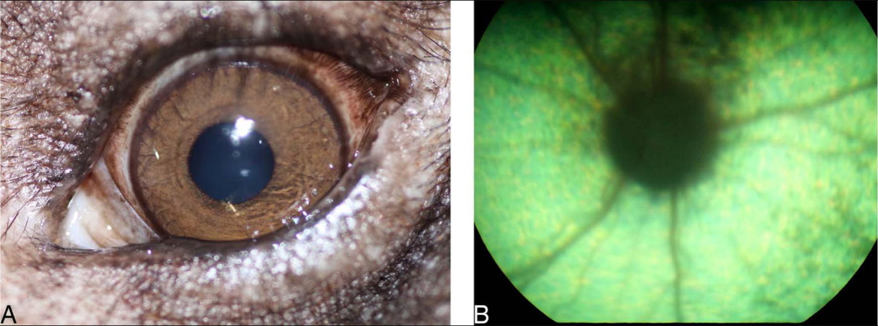
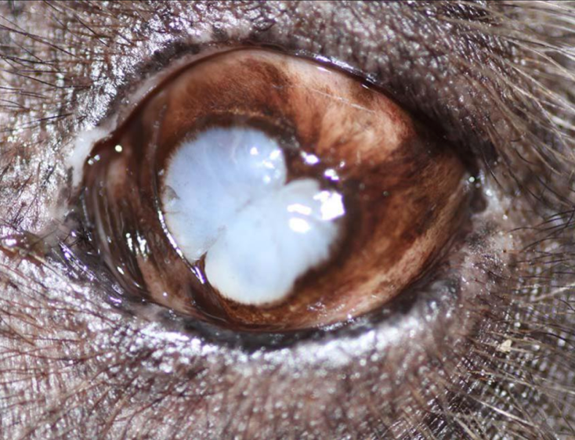
Take-Home Message:
- Blinding ocular disease was common in this population, in particular phthisis bulbi, retinal degeneration and retinal detachment. Retinal detachment and phthisis bulbi may relate to blunt force ocular trauma prior to rescue but ocular TB cannot be excluded and retinal degeneration could result from a poor diet prior to rescue.

