**Butorphanol-Azaperone-Medetomidine Is as Safe and Effective as Nalbuphine-Azaperone-Medetomidine for Immobilization of Juvenile American Black Bears (*Ursus americanus*)**

Sheldon JD, Zhu X, Williamson R, Blair C. J Wildl Dis. 2024;60(1):188-192—reviewed by ALD

Question:

Which of the following physiologic effects are noted in juvenile American black bears (*Ursus americanus*) after administration of 1 mL of nalbuphine-azaperone-medetomidine for anesthesia in a field setting?

1. Hypertension (correct)
2. Hypoxemia
3. Apnea
4. Hypercapnia
5. Hypothermia

Explanation:

Hypertension was noted, though animals were noted to have resp rates, ETCO2, and body temps within normal limits. SpO2 was noted to be <95% on the pulse oximeter, though the oxygen saturation was normoxemic on ABGs.

**Occurrence of mange in American black bears (*Ursus americanus*) in New York State, USA**

Rojas-Sereno Z, Abbott RC, Hynes K, Bunting E, Hurst J, Heerkens S, Hanley B, Hollingshead N, Martin P, Schuler K. J Wildl Dis. 2022;58(4):847-858—reviewed by ALD

Question:

Which of the following is true in regards to mange infestations in American black bear (*Ursus* americanus) populations in the American northeast?

1. Mange infestations peak in late winter with smaller peaks in early fall and late spring
2. Females are more likely to be infested with mange than males (correct)
3. Females are more likely to have mange as a secondary disease process
4. Juveniles were significantly more likely to have mange than any other age class
5. Transmission is most often due to direct contact with other wildlife species with mange

Explanation:

Mange infestations peak in late spring/early summer with small increases also seen in early fall and late winter. Females are more likely to be infested with mange than males, but males were more likely to have mange as a secondary disease process (most likely disease was trauma). There was no statistically significant difference seen by age class, and transmission is unknown.

Hematology and plasma chemistry comparisons among juvenile American black bears (*Ursus americanus*) undergoing rehabilitation. *Journal of Zoo and Wildlife Medicine* 2024: 776-784.

In the study on juvenile American black bears undergoing rehabilitation, which of the following hematologic or biochemical changes was **observed from intake to release** and is most indicative of improved health and growth?

A. Decrease in total protein concentration  
B. Decrease in creatinine concentration  
**C. Increase in hematocrit (Hct)**  
D. Decrease in red blood cell (RBC) count  
E. Increase in mean cell volume (MCV)

Pneumonia as a cause of mortality in juvenile and adult red pandas (*ailurus fulgens styani*) in Chengdu, China *Journal of Zoo and Wildlife Medicine* 56.2:311-315

In a study evaluating mortality in red pandas in Chengdu, what **bacterial species was isolated from a red panda case with fibrinosuppurative bronchopneumonia?**  
A. Klebsiella pneumoniae  
**B. Acinetobacter johnsonii**C. Streptococcus gallinaceus  
D. Staphylococcus aureus  
E. Escherichia coli

*Journal of Wildlife Diseases, 61(1), 2025, pp. 76–87*

*Summarized by MR*

Seroprevalence of Erysipelothrix rhusiopathiae in Beaufort Sea Polar Bears (*Ursus maritimus*) is Linked to Ringed Seal (*Pusa hispida*) Demographics

Brooke A. Biddlecombe, Nicholas W. Pilfold, Evan S. Richardson, Susan Kutz, Fabien Mavrot, Angela Schneider, and Andrew E. Derocher

In a recent study evaluating the seroprevalence of *Erysipelothrix rhusiopathiae* in Beaufort Sea Polar Bears (*Ursus maritimus*), what factor was found to have a significant positive relationship with seropositivity?

1. Increased consumption of adult ringed seals by polar bears
2. Poor body condition scores of sampled polar bears
3. Reduced sea ice during the spring sampling season
4. Increased muskoxen mortality rates during sampling
5. A specific longitude was associated with seropositivity

Answer: A. Increased consumption of adult ringed seals by polar bears

*Journal of Wildlife Diseases, 59(1), 2023, pp. 186–191*

*Summarized by MR*

Survey for Selected Parasites in Alaska Brown Bears (*Ursus arctos*)

Ellen Haynes, Sarah Coker, Michael J. Yabsley, Kevin D. Niedrighaus, Andrew M. Ramey, Guilherme G. Verocai, Grant V. Hilderbrand, Kyle Joly, David D. Gustine, Buck Mangipane, William B. Leacock, Anthony P. Crupi, and Christopher A. Cleveland

What parasite was most common amongst Alaskan Brown Bears (*Ursus arctos*) sampled in North America?

1. *Baylisascaris sp.*
2. *Sarcoptes scabiei*
3. *Dibothriocephalus sp.*
4. *Taeniid-type cestodes*
5. *Uncinaria sp.*

Answer: E. *Uncinaria sp.*

Journal of Zoo and Wildlife Medicine, 54(4): 796-800, 2024.   
**ANESTHESIA IN CAPTIVE GIANT PANDAS (AILUROPODA MELANOLEUCA) WITH MEDETOMIDINE-KETAMINE**   
Laura Martinelli

**Question:** What is the scientific name of the Giant Panda?

**Answer:** *Ailuropoda melanoleuca*

-------------------------------------------------------------------------------------------------------------------------------

Journal of Zoo and Wildlife Medicine, 55(4): 1104-1113, 2024.   
**EVIDENCE FOR ADRENAL DYSFUNCTION CONTRIBUTING TO PERACUTE MORTALITY SYNDROME IN RED PANDA (AILURUS FULGENS)**   
Laura Martinelli

**Question:** A colleague is consulting you on a potential adrenal dysfunction case in a Red panda at their facility. They are curious if they should do the ACTH stimulation test. First, would you advise them to do the test? Second, explain your reasoning in two sentences or less.

**Answer:** The ACTH stimulation test validated in canine and feline patients is not validated for red pandas. While one case series initially showed some support that this test may be helpful in Red pandas, further testing in healthy Red pandas provided incongruent test results. For that reason, this test is currently not of appropriate diagnostic utility in this species.

Journal of Wildlife Diseases, 60(2), 2024, pp. 434–447

**Resolution of Clinical Signs of Sarcoptic Mange in American Black Bears (*Ursus americanus*), in Ivermectin-Treated and Nontreated Individuals**

Hannah S. Tiffin, Justin D. Brown, Mark Ternent, Brandon Snavely, Emily Carrollo, Ethan Kibe, Frances E. Buderman, Jennifer M. Mullinax, and Erika T. Machtinger – reviewed by HSS

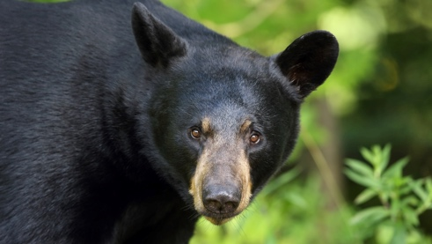

**Question:**

What is the expected outcome when treating American black bear (Ursus americanus) populations with a single dose of ivermectin during a *Sarcoptes scabiei* epizootic?

1. Treatment with ivermectin is a significant positive predictor of bear recovery.
2. Bears with moderate to severe clinical disease have a poor chance of survival regardless of treatment.
3. Multidose ivermectin is the only regimen effective at clearing clinical signs in American black bears.
4. Most American black bears are expected to recover regardless of treatment or initial mange severity score.
5. Due to high levels of ivermectin resistance, clinical resolution is not expected in treated American black bears.

**Answer: D**

Journal of Zoo and Wildlife Medicine, 56(1): 104-112, 2025. **OCULAR FINDINGS IN SLOTH BEARS (MELURSUS URSINUS) RESCUED FROM THE DANCING BEAR TRADE IN INDIA**

Claudia Hartley, Claudia Busse, Marian Matas Riera, Heather J. Bacon, Attur Shanmugam Arun, Ilayaraja Selvaraj, Kartick Satyanarayan, Geetha Seshamani, Alan Knight–reviewed by HSS

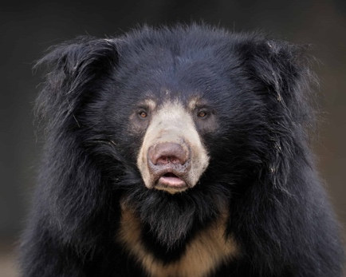

**Question:**

Which of the following ocular abnormalities was most commonly identified in sloth bears (Melursus ursinus) rescued from the dancing bear trade in India?

1. Cataract
2. Lens luxation
3. Phthisis bulbi
4. Retinal degeneration
5. Retinal detachment

**Answer: E**

Explanation:

* Cataract was identified in 28 eyes (17 bears)
* Lens luxation or subluxation was identified in 16 eyes (14 bears)
* Phthisis bulbi was evident in 19 eyes (13 bears)
* Retinal detachment was identified in 29 eyes (21 bears)
* Retinal degeneration was present in 19 eyes (16 bears)