Journal of Avian Medicine and Surgery 37(4):297–313, 2023
Summarized by MR

Parrot Dietary Habits and Consumption of Alternate Foodstuffs
Elise V. Voltura, Donald J. Brightsmith, Juan Cornejo, Ian Tizard, Christopher A. Bailey, and J. Jill Heatley
- According to a study evaluating alternate foodstuffs in Psittacines, which alternate foodstuff category was reported as the most commonly consumed by parrots across genera?
A. Sap from tree exudates such as resin and latex
B. Foliage including leaves, shoots, and buds
C. Charcoal and minerals obtained from burned vegetation
D. Vertebrates and their byproducts such as carrion
E. Aquatic invertebrates including snails and crustaceans
Correct Answer: B. Foliage including leaves, shoots, and buds
Journal of Avian Medicine and Surgery 38(2):108–115, 2024
Summarized by MR

Prevalence, Anatomical Distribution, and Risk Factors of Adipocytic Tumors and Xanthomas in Psittaciformes: 1096 Cases (1998–2018)
Lucyanne Megan, David Sanchez-Migallon Guzman, Kevin Keel, and Hugues Beaufrere

- In a retrospective study evaluating adipocytic tumors and xanthomas in psittacines, which genus was found to have a significantly lower risk of developing adipocytic tumors compared with other genera?

- Amazona spp.
- Myiopsitta spp.
- Ara spp.
- Melopsittacus sp.
- Agapornis spp.

Correct Answer: C. Ara spp.

Journal of Avian Medicine and Surgery 39(1):2–11, 2025
Summarized by MR

Determining the Fecal Microbiome of Healthy Cockatiels (Nymphicus hollandicus) Fed Seeds Versus Formulated Pelleted Diets by Next-Generation DNA Sequencing
Lucyanne Megan, David Sanchez-Migallon Guzman, Kevin Keel, and Hugues Beaufrere

- In a study evaluating the fecal microbiome of healthy cockatiels (Nymphicus hollandicus) fed either a seed-based or pellet-based diet, what fungal genus was shared between both diet groups?

- Aspergillus spp.
- Meyerozyma sp.
- Fusarium sp.
- Cladosporium sp.
- Bulleribasidium sp.
Correct Answer: D. Cladosporium sp.

2024 American Journal of Veterinary Research 85.7
The pharmacokinetics of single-dose oral atorvastatin and its metabolites support therapeutic use in cockatiels (Nymphicus hollandicus)

2024 American Journal of Veterinary Research 85.1
Pharmacokinetics of single-dose oral atorvastatin and its metabolites support therapeutic use in orange-winged Amazon parrots (Amazona amazonica)

In studies evaluating the pharmacokinetic effects of atorvastatin in pscittacines, which of the following is correct
- Cockatiels (Nymphicus hollandicus) have a higher C_{max} than orange-winged Amazon parrots (Amazona amazonica) contributing to higher bioavailability
- Parahydroxyatorvastatin has shorter half-lives compared to atorvastatin
- Atorvastatin causes liver toxicity and should be used with caution in avian species
- T_{1/2} was longer for atorvastatin in orange-winged Amazon parrots (Amazona amazonica) than Cockatiels (Nymphicus hollandicus)
- AUC was lower for Cockatiels (Nymphicus hollandicus) compared to orange-winged Amazon parrots (Amazona amazonica)

Answer A

2023 Journal of Avian Medicine and Surgery 37.2
Effects of Atorvastatin and Rosuvastatin on Blood Lipids in Quaker Parrots (Myiopsitta monachus)

In a study evaluating the effects of Atorvastatin and Rosuvastatin on Blood Lipids in Quaker Parrots (Myiopsitta monachus), which of the following conclusions is correct?
- Atorvastatin was more effective than Rosuvastatin in reducing triglycerides but had no significant effect on HDL cholesterol levels
- Rosuvastatin increased HDL cholesterol levels in the parrots, while Atorvastatin showed no significant change in any lipid fraction
- Neither drug caused significant changes to plasma lipoproteins
- Both Atorvastatin and Rosuvastatin increased total cholesterol levels in the parrots
- Birds fed an elevated cholesterol diet showed a greater decrease in lipoprotein concentration

Answer: C

Outcomes and complications associated with caudal thoracic and abdominal air sac cannulation in 68 birds
Byron-Chance D, Gomez L, Hollwarth AJ, Dutton TAG. J Avian Med Surg. 2023;37(2):144-154—reviewed by ALD

When placing an air sac cannula (ASC) in a psittacine bird, which of the following is recommended?
- Peri-interventional antibiotic therapy (correct)
- Placing a neck collar at time of placement
- Placement in the abdominal air sac
- Placement on the left side of the coelom
- Length of ASC wider than coelomic width
Explanation: Peri-interventional antibiotic therapy and placement in the intercostal space (not caudo-costal which would be into the abdominal air sac) was associated with an increased likelihood of survival. There was no association with side of coelom and survival, and patient interference was only seen in 2 cases suggesting that a neck collar is not always necessary. Length of ASC was not studied in this paper, but it has been recommended previously to use an ASC length of 2/3 coelomic width (mentioned in the discussion).

Resolution of egg binding is possible in most client-owned parrots when multiple treatment strategies are considered
Vavlas A, Galusha H, Mayer J, Speer B, Di Girolamo N. J Am Vet Med Assoc. 2025;263(5):628-634—reviewed by ALD

You are presented with a female sun conure (Aratinga solstitialis) weighing 120g that has been noted to be egg bound. Which of the following treatment methods for this condition has been associated with the least successful outcome in managing this condition when used alone?
- Surgery
- Ovocentesis
- Mechanical assistance
- Medical management (correct)
- Oxytocin administration

Explanation: Surgery had an associated 60.6% success rate, whereas ovocentesis was 85.7%, mechanical assistance was 86.1%, and medical management alone was 33.1% though the use of medical management was associated with a 7x increased odds of success. None of the cases had oxytocin used.

Retrospective analysis of pelvic limb fracture management in companion psittacine birds (60 cases)
Hollwarth AJ, Dutton TAG. J Avian Med Surg. 2023;37(2):165-174—reviewed by ALD

Which fracture type is seen most commonly in the pelvic limb of companion psittacine birds?
- Closed, simple, diaphyseal (correct)
- Closed, compound, epiphyseal
- Open, simple, diaphyseal
- Open, compound, diaphyseal
- Open, simple, epiphyseal

Explanation: Fracture types seen most commonly in companion psittacine birds were closed, simple, and diaphyseal in the pelvic limb and were significantly more likely than other types of fractures.

You are presented with a privately owned, approximately 350g grey parrot (Psittacus erithacus) with a closed, simple right femoral fracture of the diaphysis. Which method of fracture fixation is associated with the highest complication rate? State two reported long-term potential complications.
- External coaptation is associated with highest complication rates in companion psittacine birds. Long term complications can include angular limb deformities, pododermatitis on the contralateral limb, and arthrosis.
Journal of Avian Medicine and Surgery, 39(2): 68-74, 2025
Effects of Capromorelin, Mirtazapine, and Cyproheptadine on Food Intake in Budgerigars (Melopsittacus undulatus) - reviewed by HSS
Caroline Titel, Grayson Doss, Christoph Mans
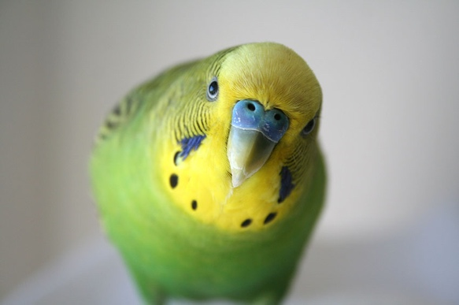

Question:
Which of the following statements is most correct regarding the administration of capromorelin, mirtazapine, and cyproheptadine in budgerigars?

- Capromorelin significantly increased food intake, but mirtazapine and cyproheptadine did not
- Capromorelin and mirtazapine significantly increased food intake, but cyproheptadine did not
- Capromorelin and cyproheptadine significantly increased food intake, but mirtazapine did not
- Mirtazapine significantly increased food intake, but capromorelin and cyproheptadine did not
- Mirtazapine and cyproheptadine significantly increased food intake, but capromorelin did not
Answer: A

Journal of Avian Medicine and Surgery, 38(4): 202-207, 2025
Use of Haloperidol in Companion Psittacine Birds: 19 Cases (2012–2022) - reviewed by HSS
Katharine E. Hausmann Farris, Grayson A. Doss

Question:

A client presents with a 20 year-old female grey parrot with a history of chronic feather destructive behavior (FDB). You perform a work-up including a thorough examination, CBC, chemistry, and anesthetized radiographs, and a medical cause for the feather destructive behavior cannot be identified. Provide three medical, three socioenvironmental, and three genetic/psychological/neurobiological (internal) factors that may contribute to the onset and maintenance of feather destructive behavior in this patient.

Answer: See table below. Source: van Zeeland YR, Friedman SG, Bergman L. Behavior. In: Speer BL, ed. Current Therapy in Avian Medicine and Surgery. 1st ed. St. Louis, MO: Elsevier; 2016:177–251.

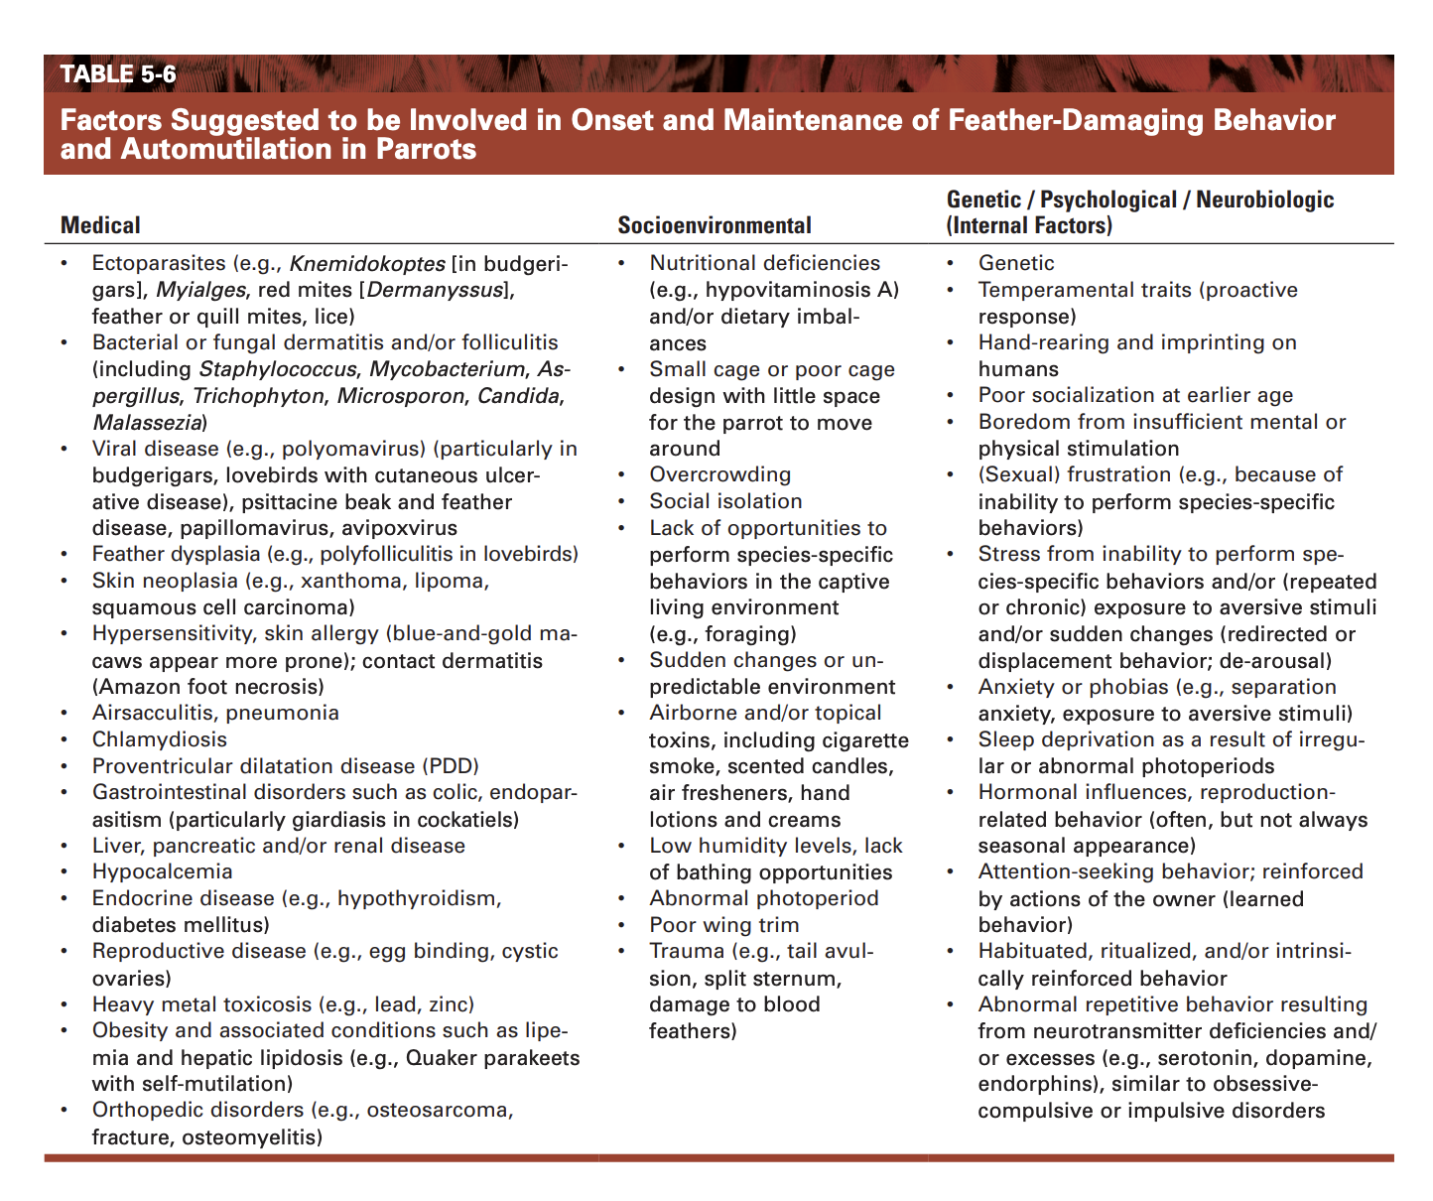

American Journal of Veterinary Research, 1.aop:1-6, 2025.
Maropitant citrate exhibits rapid absorption, short half-life, and fast clearance in orange-winged Amazon parrots (Amazona amazonica) following subcutaneous and intravenous administration
Ariella Darvish, David Sanchez-Migallon Guzman, Hugues Beaufrère, Heather K. Knych, and Olivia A. Petritz- reviewed by HSS
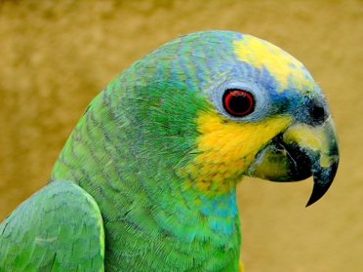

Question:

Which of the following statements is true regarding administration of subcutaneous maropitant in orange-winged Amazon parrots?

- Injection-site reactions occurred
- Bioavailability was low
- Absorption was slow
- Elimination half-life was short
- Clearance was slow

Answer: D

Journal of Avian Medicine and Surgery, 36(3): 250-261, 2022.
HEMATOLOGIC REFERENCE INTERVALS AND COMPARISON OF NATT-HERRICK TECHNIQUE AND SMEAR-BASED LEUKOCYTE ESTIMATION IN COCKATIELS (NYMPHICUS HOLLANDICUS)
Laura Martinelli
Question: Which cell types are preferentially stained with phloxine B?
Answer: Heterophils and eosinophils
Journal of Avian Medicine and Surgery, 36(4): 345-355, 2023.
COMPARISON OF LIPOPROTEIN ANALYSIS USING GEL-PERMEATION HIGH-PERFORMANCE LIQUID CHROMATOGRAPHY AND A BIOCHEMISTRY ANALYZER IN NORMOLIPIDEMIC AND DYSLIPIDEMIC QUAKER PARROTS (MYIOPSITTA MONACHUS)
Laura Martinelli
Question: What is the main plasma lipoprotein in parrots?
Answer: HDL
Journal of Avian Medicine and Surgery, 37(4): 314-320, 2024.
MEASURING THE LEVEL OF AGREEMENT FOR LACTATE MEASUREMENTS IN HISPANIOLAN AMAZON PARROTS (AMAZONA VENTRALIS) AMONG 2 POINT-OF-CARE ANALYZERS AND A BENCHTOP ANALYZER
Laura Martinelli
Question: What avian species has a documented increase in lactate concentration with increased length of capture?
Answer: American Flamingo

