The Journal of Herpetological Medicine and Surgery. 34(1): 70-83. 2024. PLASMA AND SHED-SKIN CORTICOSTERONE LEVELS IN A POPULATION OF LOUISIANA PINE SNAKES (PITUOPHIS RUTHVENI).

Laura Martinelli

Abstract: Measurement of corticosterone in various tissues has been used to investigate the stress response in reptile and amphibian species for decades. The tissue source from which corticosterone is measured reflects different periods of time and chronicity of stress levels in the subject, and different tissue-collection methods differ in degree of invasiveness. Studies of corticosterone in keratinized tissues of reptiles, such as shed skin, are limited in number compared to hair and feather glucocorticoid studies in avian and mammalian species, but warrant continued research, as they may reflect more different periods of time and chronicity of corticosterone levels than plasma or other tissues, and can be obtained in a minimally invasive manner. In this study, we measured corticosterone concentrations in both plasma and shed skin of Louisiana pine snakes (Pituophis ruthveni) that were all previously diagnosed with subclinical Cryptosporidium serpentis infection. We also tracked stressors experienced by different individuals to identify potential relationships between periods of increased stress and corticosterone levels in plasma and shed skin. There were no significant correlations between individual plasma and shed-skin corticosterone levels, or between corticosterone levels in either tissue type and stressors experienced. This is the first study where corticosterone levels were measured in plasma and shed skin of Louisiana pine snakes, and is the first known evaluation of plasma and shed-skin corticosterone levels in a snake population previously testing positive for Cryptosporidium serpentis.

Key Points:
- In reptiles and amphibians, corticosterone is the predominant glucocorticoid secreted
- Generally accepted that plasma samples obtained within 3 min of capture and handling will accurately reflect baseline circulating corticosterone levels in most reptile species
  - Females typically exhibit higher glucocorticoid levels than males
  - Most animals exhibit higher glucocorticoid levels during repro season
- Glucocorticoid levels in keratinized tissue represent levels over longer periods of time compared to that in plasma.
  - Hormones stored in keratin endure years without degradation, not influenced by short-term factors (handling stress, hydration status, or time of day)
- Study included adult Louisiana Pine snakes. All tested positive more than once for Cryptosporidium serpentis via PCR of gastric swabs but no snakes were exhibiting clinical signs of the disease during the study.
- Direct stressors (handling, exhibiting abnormal behavior, inappetence, mortality, signs of clinical illness, hospitalization, reproductive activity) and Indirect stressors (if staff entered snake room for reasons other than routine husbandry) were tracked and quantified
- Results
  - Plasma Corticosterone
    - Snakes showed high individual variation in plasma corticosterone levels from month to month
    - Heterophilia was inversely correlated with plasma corticosterone (but note only one individual exhibited heterophilia). This finding statistically significant but likely not biologically significant.
  - Shed skin Corticosterone
    - Snakes showed high individual variation in shed skin corticosterone levels
    - H:L ratio positively correlated with shed skin corticosterone levels (clinical significance unclear, thought to represent physiologic stress in a number of other species)
  - Plasma and shed skin corticosterone levels were not correlated

Take Home Point: Results of this study as well as previous work, indicate that corticosterone measured in shed skin may not be a reliable means of monitoring stress in snakes. Corticosterone in plasma and shed skin samples were not correlated.

Fowler 10, Chapter 42: Welfare in Aquatic Invertebrates - reviewed by HSS
Catherine Hadfield, Sarah Wahltinez

- Animal Welfare
  - Animal welfare defined as how an animal is coping with the conditions in which it lives. Good welfare = healthy, comfortable, well-nourished, safe, able to express innate behavior, and not suffering from pain/fear/distress.
  - Pain = “an aversive sensory and emotional experience typically caused by, or resembling that caused by, actual or potential tissue injury”
    - Only one part of welfare
    - Nervous system complexity is markedly variable among invertebrates
  - Example frameworks
    - 5 freedoms (freedom from hunger/thirst, freedom from discomfort, freedom from pain/injury/disease, freedom to express normal and natural behavior, freedom from fear and distress)
    - 5 domains (nutrition, environment, health, behavior, mental state)
      - Consider substituting mental state for choice in invertebrates
    - A life worth living
- Welfare Assessments
  - Usually group rather than individual for invertebrates
  - Build indicators within welfare domains (e.g. environment, appearance and behavior, nutrition, health)
  - Indicators should focus on outputs rather than inputs
    - Can be positive or negative, generic or specific, continuous or categorical, free-text comments encouraged
  - Environment
    - Provide enriched physical and social environment based on natural history
    - Ex. indicators: water flow and water quality, life-support systems, habitat (design, light spectrum, intensity, and photoperiod), stocking density, social situation, environmental enrichment, nuisance species, and noise or vibration stressors
  - Appearance and behavior
    - Ex. external surfaces (coloration, condition or texture of skin/shell), ventilation rates, position, posture, movements, space use, environmental manipulation, social interactions, avoidance behaviors, protective behaviors, spawning behaviors, autophagy, or stereotypies
  - Nutrition
    - Ex. variety of feed items, similarity to wild-type diets, food storage and handling, food intake, morphometrics/growth rate, nutritional composition of foods
      - Evaluating food intake can be difficult with cryptic species, scavengers, and photosynthetic species, but related indicators can be used (polyp extension, time spent foraging, density of zooxanthellae)
  - Health
    - Physiologic parameters
    - Focus on morbidity, mortality, and longevity
      - Individual ID if possible for tracking
    - Animal handling procedures
      - Sedation protocols
      - Pain management
    - 2-step euthanasia method recommended
      - Removing from water, freezing, or immersion in tissue fixative are unacceptable single-steps
  - Choice and Control
    - Focuses on providing choice without assuming specific emotional response
    - Ex. variety of substrates and shelters, suitable temperature and lighting gradients, environmental enrichment
- Welfare Assessment Reviews
  - Review when score is low, concern is reported, and with live-changing events
  - Consider severity, duration, number of animals effected
  - Regular review with all stakeholders
- Special Topics
  - Touch Pools
    - Promote empathy and engagement
    - Mot commons species are intertidal aquatic invertebrates
    - Must provide motile animals ability to move out of reach
    - If animal shows shorter longevity or higher morbidity/mortality than nontouch conspecifics, that animal may not be suitable for touch pool
  - Live Invertebrates as Food

Chapter 43: Animal Welfare and Birds
Major factors critical to avian welfare: enclosures, social groupings, environmental enrichment, human-animal interactions, species selection, nutrition, flight restriction, and health status
OIE: animal has good welfare if it is healthy, comfortable, well nourished, safe, able to express innate behavior, and if it is not suffering from unpleasant states such as pain, fear, and distress. (expression of innate behaviors may be more challenging in birds)
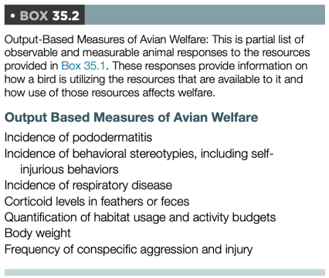
Enclosure Design
- Vast species diversity: well-planned exhibits will vary tremendously
- Must accommodate opportunities for nesting and species-appropriate rearing of offspring
- Birds should be able to fly, swim, ambulate comparably to their free-ranging counterparts
  - Maintain normal muscle mass, cardiovascular heath, psychological wellbeing
- Species-specific temp. ranges: ex. Penguins have increased adrenocortical activity with increased temp.
- Light cycles and humidity are important for plumage, hydration, breeding, and molt, as well as for mitigation of health conditions (Aspergillosis, also air quality)
- Acoustic influences should avoid non-natural, loud noises and instead can mimic natural background sounds (low volume music, white noise, species-specific noises) can prevent startle reflexes and acclimate birds
- Substrate and perching choices affect development of pododermatitis
- Assessments of multispecies exhibits have demonstrated the importance of the careful selection of species and individual animals for each habitat
Social Groupings
- Flocks should be encouraged for birds that naturally live in them: consequences of housing individuals may include FDB, stereotypies
- Appropriate flock size (minimum 20, ideal 40 for breeding groups) can promote breeding behaviors
Environmental Enrichment
- Foraging, nest-building, carcass-feeding (raptors)
Human-Animal Interaction
- Operant conditioning for voluntary behaviors
- Responses to humans should be evaluated on an individual basis, as even species from the same taxonomic family (i.e., penguins) can show significant differences in behavior in response to visitors
Nutrition: natural food items are preferred and positively influence avian behavior and welfare
Flight Restriction (enclosures that prevent flying, tethering, or physical alteration of the feathers or wing)
If flight restriction is being considered, completing a thorough welfare assessment of the possible benefits, risks, and negative effects prior to moving forward is recommended.
- The most commonly deflighted zoo birds include flamingos, pelicans, storks, cranes, some grebes, and ground hornbills.
  - These animals spend most of their time on the ground or in water, and are managed this way to provide larger habitats
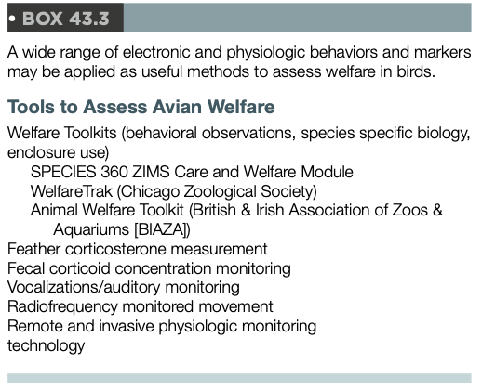
- No significant differences in feather corticosterone were noted in three populations of flamingos that were held under varying deflighting conditions (feather trim, pinioned, enclosure too small to fly)
- Taxa in which flight time constitutes a large portion of their natural daily activity budget have a greater propensity to developing health alterations (obesity, pododermatitis, feather destruction) associated with flight restriction.
Conscious sedation to decrease physiologic stress response associated with handling for veterinary care with intranasal and intramuscular sedative combinations have proved safe and useful for minor procedures.
Fecal and feather corticosteroid testing have been increasingly used to evaluate welfare questions in birds.

Attitudes of Brazilian Veterinarians Towards Anesthesia and Pain Management in Reptiles.
Gris VN, Ferraro MA, Lima AF, Cortopassi SR, Carregaro AB

Veterinarians' perceptions regarding anesthetics and pain management in reptiles are understudied. We conducted an internet-based survey of Brazilian practitioners to assess their knowledge and attitudes towards the use of anesthetics, as well as recognition and treatment of pain, in reptiles. The most commonly cited anesthesia-related complications were prolonged recovery periods and respiratory depression. Difficulty in recognizing pain was the main impeding factor for providing analgesics. Tramadol (88.2%) and meloxicam (97%) were the most commonly used analgesics, and ketamine (88.2%), midazolam (88.2%), and isoflurane (94.5%) were the most common anesthetic agents. In conscious patients, the assessment of pain was performed mainly by observation of behavioral changes. Only 32.7% of the respondents considered their knowledge of anesthesia and analgesia in reptiles to be adequate. More women than men considered their knowledge to be insufficient (P < 0.0068), whereas age of the practitioner had no effect. Nevertheless, all respondents believe that reptiles can feel pain, and 82% provide analgesia to most of their patients. Understanding the criteria, choice, and timing of drug administration, as well as opinions on pain and anesthesia, provides information on the current practices and might assist in targeting areas where more research and development is needed to ensure reptile welfare.

Key Points
- Main anesthesia-related complications were prolonged recovery and respiratory depression
  - Most used propofol for induction and gas for maintenance, many used ket/midaz
- All vets believed reptiles can feel pain
- Over half categorized their knowledge of reptile anesthesia and analgesia as insufficient
- Confidence in ability to recognize pain in reptiles was low
  - Older people were more confident
- Most used analgesia routinely, regardless of age and gender - increased use compared to previous study
- Urogenital surgery was considered least painful and extensive burn treatment most painful
- Reasons for limited analgesia use in reptiles: difficulty recognizing pain, lack of knowledge of appropriate therapy, drugs being unavailable, fear of adverse effects
- Most commonly used: meloxicam, tramadol, dipyrone (nonspecific NSAID), morphine
- Main source of info: peer-reviewed papers, wildlife med textbooks, case discussions with colleagues, CE, personal experience, social networks and online forums
- Behavioral changes continue to be the main indicators of pain appreciated
  - Unusual posture and gait, anorexia, increased aggression, hiding, keeping eyes closed, mouth gaping, increased resp rate and HR
Conclusions
- A large proportion of Brazilian veterinarians do not feel confident or have difficulty assessing and treating pain in reptile patients
- All believed reptiles feel pain and majority administer analgesics routinely

THE EFFECT OF VARIED ENRICHMENT TYPES ON SNAKE BEHAVIOR. JZWM 53(2): 266-274, 2022. Krishnan S, Klaphake E, Rao S, Sadar MJ. – Reviewed by LEM

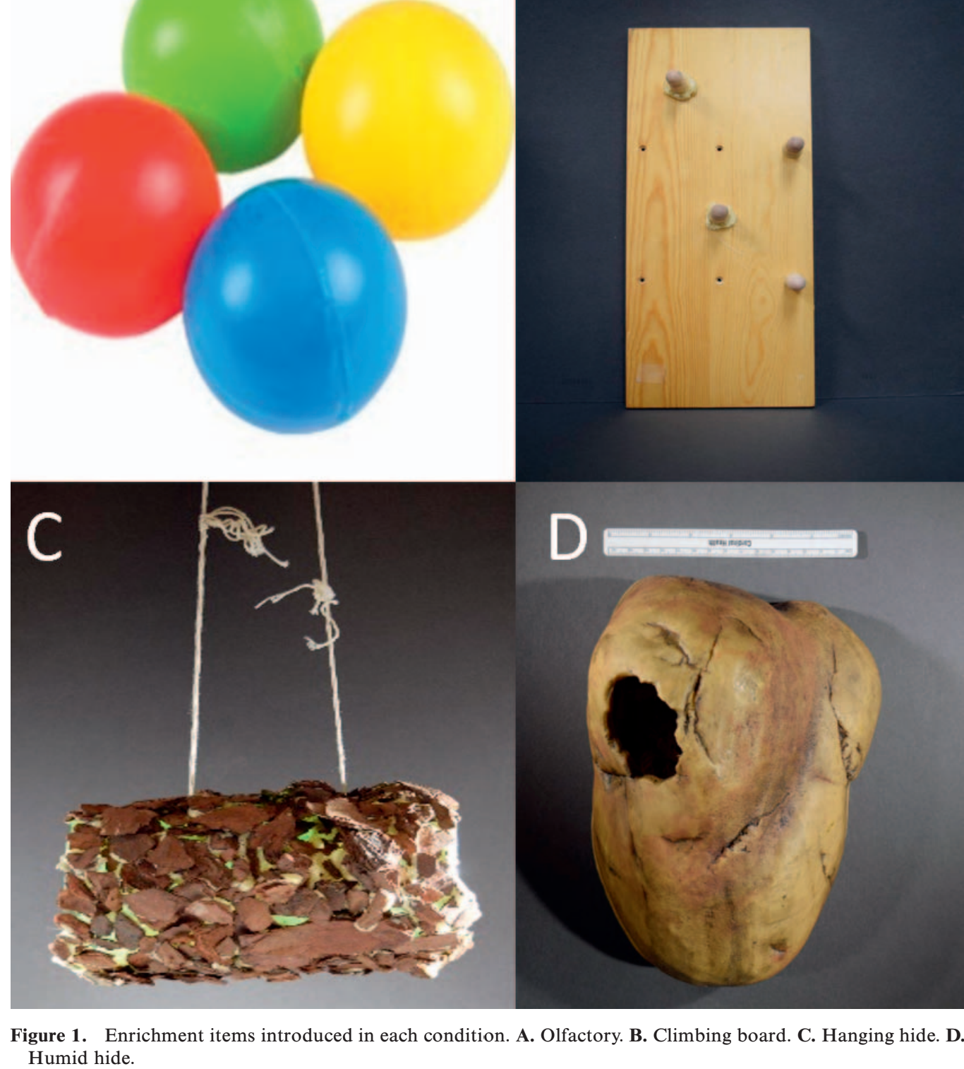
Environmental enrichment is a strategy used to improve the welfare of animals under human care. While enrichment techniques for mammals and birds have been studied extensively, reptilian enrichment has received less attention. There has been an increase in enrichment programs for reptiles in zoological institutions, however many are not accompanied by behavioral studies. Detailed recording of behavioral responses to enrichment is necessary to assess the efficacy of the enrichment type and to determine its utility in various settings. In this study, 18 snakes of multiple species, from two Families (Colubridae, Pythonidae), were exposed to four enrichment types (Humid Hide, Olfactory [wallaby balls], Climbing, Suspended Hide). Baseline recordings were conducted prior to the introduction of enrichment. Snakes were recorded for two hours after introduction of each item. Five behavior types were identified based on baseline videos: tongue flicking, climbing, hiding, interacting with transparent boundaries, and utilizing non-enrichment items. Interacting with transparent boundaries was classified as an undesirable behavior, while the other four behaviors were classified as desirable. Changes in climbing and tongue flicking behaviors were noted with introduction of each item- these changes were not statistically significant. The increase in these behaviors may indicate clinical importance, and shows that snakes under human care respond to environmental enrichment. As some snakes showed a reduction in undesirable behaviors when compared to baseline conditions, this may suggest increased welfare during times when enrichment is offered. The extent to which these results can be applied to other species merits further study

Background:
- Goal of snake enrichment = stimulate species-specific behaviors with physical items
- Prev study: complex envmts in rat snakes improved performance of cognitive tasks
- Snakes rely on chemical and visual cues to navigate environment
  - Members of superfamily Boidea and family Viperidae have highly sensitive infrared receptors for perceiving infrared sources independent of visual cues
- Captive-related chronic stress behaviors can include abnormal behavior, behavioral inhibiting, excessive hiding, fearfulness, aggression, repro behavior, dietary indiscretion
- Stressors often consistent with maladaptation to environment

Key Points:
- No difference in frequencies of behaviors from baseline conditions to enriched conditions
- 8/18 (44%) demonstrated new behaviors from enrichment (chemical sampling, interacting with items, environmental exploration, hiding)
- 4/18 (22%) showed increased frequency of chemical sampling with wallaby balls
- Items that received more attention than others = climbing board and humid hide
- Four snakes that did not hide during baseline displayed a 100% frequency of hiding in all enrichment conditions (potential negative effect)
- Some items reduced frequency of undesirable behavior (interacting with transparent boundaries)
- Snakes may have been distracted from behaviors by item or stressed / fearful

TLDR: Offering enrichment may encourage snakes to spend more time engaging in desirable behaviors and less time engaging in undesirable behaviors (at least temporarily), however possibility that could have negative effects (i.e. more hiding).

