The Journal of Herpetological Medicine and Surgery. 34(1): 70-83. 2024. PLASMA AND SHED-SKIN CORTICOSTERONE LEVELS IN A POPULATION OF LOUISIANA PINE SNAKES (PITUOPHIS RUTHVENI).

Laura Martinelli

Question: Which of the following was positively correlated with corticosterone levels in shed skin of Louisiana Pine Snakes (Pituophis ruthveni)?

- Lymphocytes
- Total WBC
- Azurophils
- H:L Ratio
- MCHC

Answer: D

Fowler 10, Chapter 42: Welfare in Aquatic Invertebrates - reviewed by HSS
Catherine Hadfield, Sarah Wahltinez

Question:
Give an example of a parameter that you might assess on a welfare assessment within each of the following domains for a group of chocolate chip sea stars (Protoreaster nodosus) in a touch tank: nutrition, environment, health, appearance/behavior, and choice.

Example answer:
Nutrition: Animals observed eating during target feeds
Environment: Appropriate water quality measured on a weekly basis
Health: Similar longevity compared to conspecifics not in a touch tank environment
Appearance/Behavior: Normal coloration and condition of skin with no external lesions observed
Choice: Ability to move out of reach of people

- Which of the following species would be least appropriate to consider for deflighting in a zoo setting? (enclosures that prevent flying, tethering, or physical alteration of the feathers or wing)
- American flamingo (Phoenicopterus ruber)
- Saddle-bill stork (Ephippiorhynchus senegalensis)
- Red crowned crane (Grus japonensis)
- American kestrel (Falco sparverius)
- Abyssinian ground hornbill (Bucorvus abyssinicus)

Answer: D) American kestrel. The other species are amongst those commonly deflighted in zoos, and other species mentioned spend most of their time on ground or in water. Managing them in this way would ideally afford them a larger habitat.

- Which of the following species would be most appropriate to house in a breeding pair, rather than a flock, under managed care?
- Bald eagle (Haliaeetus leucocephalus)
- Lesser flamingo (Phoeniconaias minor)
- Rainbow lorikeet (Trichoglossus moluccanus)
- Magellanic penguin (Spheniscus magellanicus)
- Wood duck (Aix sponsa)

Answer: A) Bald eagles are typically solitary and also monogamous in breeding pairs. The other species are all flocking birds that their welfare will benefit from that aspect of their natural history.

- What is the most common analgesic used by brazilian veterinarians?
  - Tramadol
  - Gabapentin
  - Ketamine
  - Meloxicam
  - Morphine

Answer: D meloxicam followed closely by tramadol

- Name the Five Freedoms specified in animal welfare.

Answer:
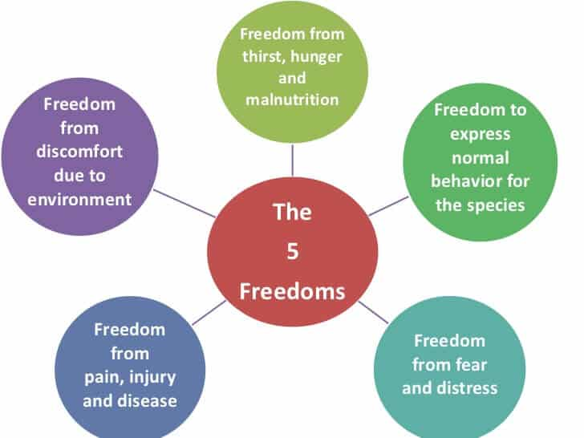
QUESTION: Snakes from which taxonomic family have specialized receptors that perceive infrared sources independent of visual cues?
- Colubridae
- Elapidae
- Viperidae
- Boidae
- Typhlopidae

ANSWER: D – Boidae and Pythonidae
Source: Krishnan et al. JZWM 2022. THE EFFECT OF VARIED ENRICHMENT TYPES ON SNAKE BEHAVIOR.

