EFFECT OF BOMA CONFINEMENT ON HEMATOLOGIC AND BIOCHEMICAL VALUES IN FREE-RANGING WHITE RHINOCEROS (CERATOTHERIUM SIMUM) IN KRUGER NATIONAL PARK, SOUTH AFRICA. JWD 2022. Miller et al. - Review by LEM

Boma adaptation is an important component of rhinoceros translocations to allow transition to new diets, restricted space, and quarantine for disease screening. However, up to 20% of recently captured white rhinoceros (Ceratotherium simum) do not adjust to captivity, resulting in early release or even death. The causes and physiologic consequences of maladaptation to boma confinement are poorly understood. The aim of this investigation was to evaluate hematologic and serum biochemical changes in maladapted rhinoceros compared to animals that adapted under the same boma conditions. Ninety-six white rhinoceros were captured between 2009 and 2011 in Kruger National Park, South Africa and placed in bomas prior to translocation. Weight, complete blood count, and serum biochemical panel results were recorded when rhinoceros were placed in the boma and repeated on the day of release. In this study, the mean duration of boma confinement for maladapted white rhinoceros was 13 d (range 8–16 d) compared to 89.9 d (range 39–187 d) for adapted animals. Mean weight loss between capture and release was significantly greater in maladapted rhinoceros (224.0 versus 65.9 kgs; P=0.001). Although adapted rhinoceros had statistically significant changes in some hematologic and biochemical values, most were not considered clinically relevant. In contrast, the maladapted rhinoceros had significant changes at the time of early release from the boma, including evidence of leukocytosis with left shift, lymphopenia, eosinopenia, decreased red blood cell count and hematocrit, increased serum creatine kinase, and decreased serum calcium, phosphorus, and magnesium values. Along with loss of body condition, these findings were consistent with a stress-associated catabolic response. These changes occurred in the first 2 wk of confinement, and the results provide a foundation for evaluating adaptation in white rhinoceros. Future studies should focus on factors that improve adaptation and welfare of recently confined free-ranging white rhinoceros.

Background:
- Capture, movement, and translocation crucial to increasing genetic diversity to save white rhino
- Approximately 10-20% of free-ranging white rhinoceros are unable to adapt to boma confinement
  - Bomas = holding enclosure; as an adaptation step, however can induce stress (exposure to humans, new food, water sources)
- Boma scoring system: daily evaluation of appetite, fecal consistency and volume, and behavior
- Early release of maladaptive individuals recommended to prevent further morbidity and mortality

Methods: Immobilized (zuclopenthixol acetate), ectoparasite treatment, moved to boma, and boma scored
- Boma adapted rhinos (n=79) mean stay length 90 days
- Boma maladapted (n=19), mean stay 13 days, one death (salmonella gastroenteritis)

Key Points:
- Boma adaptation scores significantly greater starting at day 8
- Adapted rhinos: increases in TP, albumin, AST, CK and BUN, mild weight loss but had static boma scores by 3 weeks (not clinically concerning)
- Maladapted rhinos: changes in BW and weight loss consistent with decline in condition or catabolic state secondary to stress response despite shorter duration of confinement
  - CBC: leukocytosis with left shift, eosinopenia, decreased Hct
    - Decreased RBC suspect due to gastric ulceration or suppression of production
  - Chem: higher CK and BUN, lower serum albumin, AST, Ca, P, Mg
  - Weight loss significantly greater
- Conclude that may be individual differences in response of white rhino to boma confinement and can be quantified with boma scoring system, CBC/chem, weight monitoring
PHARMACOKINETIC PROFILES OF ORAL PHENYLBUTAZONE, MELOXICAM, AND FIROCOXIB IN SOUTHERN BLACK RHINOCEROS (DICEROS BICORNIS MINOR). JZWM 2024. Bryant B, Campbell-Ward M, Kimble B, Govendir M.

The pharmacokinetic profile of selected NSAIDs in southern black rhinoceros (Diceros bicornis minor) were studied. Phenylbutazone (PBZ), meloxicam (MEL), and firocoxib (FIR) were administered orally to five captive, black rhinoceros, and blood was collected at predetermined time points for NSAID quantification and noncompartmental pharmacokinetic (PK) analysis. Phenylbutazone 4.0 mg/kg PO q12h for three doses, MEL 0.3 mg/kg PO q24h administered twice, and a single oral dose of FIR 0.1 mg/kg, were tested with a minimum washout time of 2 wk. PBZ reached a median (range) peak concentration (Cmax) of 9.42 (2.74-11.5) g/ml at a mean (range) time (Tmax) of 6.00 (4.00 to >12.00) h, and the median (range) elimination half-life (T1/2) was 6.07 (3.95-6.49) h. Phenylbutazone pharmacokinetic parameters for black rhinoceros in this study were similar to domestic horses. Meloxicam reached a median (range) Cmax of 0.576 (0.357-0.655) µg/ml at a median (range) time (Tmax) of 6.00 (4.00-12.00) h; the median (range) T1/2 of MEL was 14.0 (12.4-17.9) h. These results demonstrate that once-daily administration of MEL at 0.3 mg/kg resulted in a serum concentration of greater than 0.200 µg/ml from 2 to 24 h in four animals, which is within the analgesic range (0.200-0.400 µg/ml) for this drug in other species postulated by other studies. A single dose of firocoxib (0.1 mg/kg) reached a median (range) peak concentration (Cmax) of 15.7 (9.65-17.3) ng/ml at a median (range) Tmax of 4.00 (4.00-6.00) h. The median (range) elimination T1/2 of FIR was 4.96 (4.47-6.51) h, which is faster than in the horse. The data suggest that extrapolation from equine FIR dosage recommendations is inappropriate for black rhinoceros.

Background
- Black rhino (Diceros bicornis) = Family rhinocerotidae, five extant species, critically endangered
- NSAIDs suppress inflammation via inhibition of COX enzymes (prevent AA → PG conversion and reduction in inflammation, pain, fever)
  - Highly bound to plasma proteins and can attach to tissues and persist longer than in transudates or plasma; can have short plasma half-life but longer duration of effect
  - Common adverse signs: gastric ulcers, platelet dysfunction, renal impairment
- Previous NSAID studies in rhinos:
  - Phenylbutazone PO in white rhino PK (JVetPharm 2021 Houck/Papich)
  - Carprofen single dose in white rhino PK (JVetPharm 2018)
  - Flunixin, meloxicam, gabapentin PO in black rhino PK (JZWM 2023 Flanders)
- Drug doses for rhinos often extrapolated from domestic horse PK/PD

Key Points
- Readily consumed all drugs in banana, no adverse reactions, compliant for venipuncture
- Phenylbutazone (4 mg/kg PO q12 x 3 doses): T1/2 = 6 hrs, Tmax = 6 hrs (4-12 hrs)
  - PK parameters similar to domestic horse; both have 2nd peak at 6hrs
    - Suspect some drug absorbed in feed and released via fermentative digestion in HG/cecum/colon
    - PO absorption of PBZ is greatly influenced by food in GIT and absorption may be improved if food withheld for a few hours prior to admin
  - Half life shorter in black rhinos (6 hrs) than in white rhinos (9 hrs)
    - Only able to calculate T1/2 in n=2 (second dose admin before blood sample)
  - Majority of elimination by 24 hrs (below assay detection at 24 hrs after single dose)
- Meloxicam (0.3 mg/kg PO q24 x 2 doses): T1/2 = 14 hrs, Tmax = 6 hrs
  - Horses 0.6 mg/kg SID, elephants 0.2 mg/kg SID according to previous studies
  - Slower mean half-life compared to horse; for any drug with half life longer than 12 h there is risk of accumulation when administered q12 (less risk with q24)
    - Caution with chronic/long-term dosing
  - Absorption much faster than elimination for all animals
- Firocoxib (0.1 mg/kg PO single dose): T1/2 = 5 hrs, Tmax = 4 hrs
  - Selective COX 2; first report of firocoxib PO in rhinos
  - Significantly higher Cmax than horses receiving same dose
  - Elimination T/12 much faster (shorter) in black rhino (5h) than other herbivores (horses 30h, calves 19 h, goats 21 h) but similar to dogs (6.5h)
    - Equine SID dosing freq inadequate for maintenance analgesia in black rhino

TLDR: Phenylbutazone appears to be more safe/effective than meloxicam (half life >12 hours increases risk of accumulation) or firocoxib (short half life) as an oral NSAID in black rhinos (Diceros bicornis) at studied dosages.

Journal of Zoo and Wildlife Medicine, 54(2): 336-344, 2023.
PHARMACOKINETICS OF ORAL FLUNIXIN MEGLUMINE, MELOXICAM, OR GABAPENTIN IN THREE BLACK RHINOCEROS (DICEROS BICORNIS) - reviewed by HSS
John A. Flanders Jr., Ronette Gehring, Kristina Delaski, Larry Wulf, Johann Coetzee, Kathryn C. Gamble
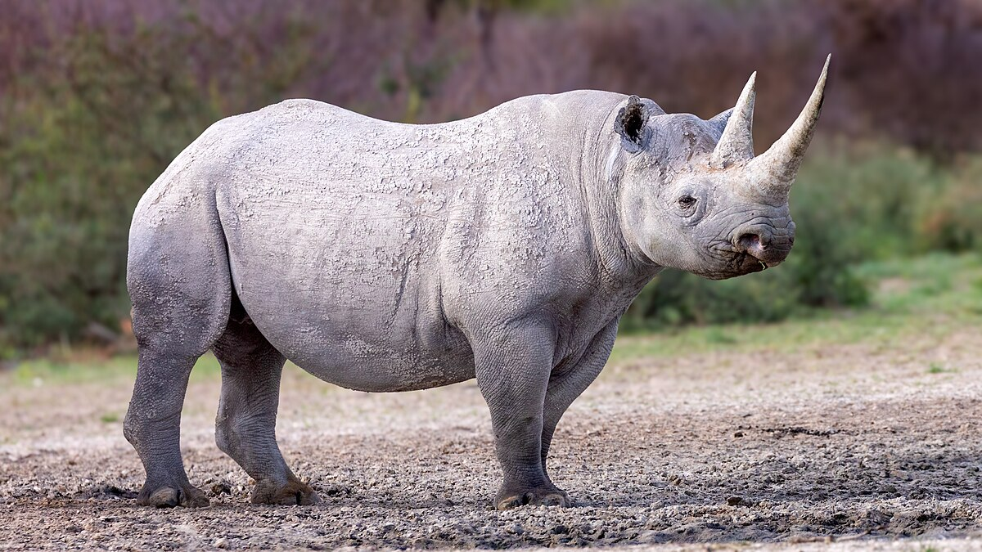
Abstract:
Pharmacokinetics of single, separate doses of IV flunixin meglumine (1 mg/kg), IV meloxicam (0.5 mg/kg), oral flunixin meglumine (1 mg/kg), oral meloxicam (1 mg/kg), and oral gabapentin (15 mg/kg) in three adult black rhinoceroses (Diceros bicornis) were determined from serial blood collection made over 72 h. The concentration versus time profiles were analyzed for each drug and route in each individual rhinoceros, and individual pharmacokinetic parameters were calculated for each medication administered. Meloxicam had near complete bioavailability in each trial, while flunixin meglumine was generally lower. Oral meloxicam was noted with similar half-life values between all animals (range 9.22–14.52 h) tested, while oral gabapentin had a larger range (range 10.25–24.85 h). Oral flunixin meglumine achieved a lower Cmax (range 170.67–664.38 ng/ml) in this study compared with the mean Cmax (1,207 ng/ml) reported in a similar study in white rhinoceroses (Ceratotherium simum), but some overlap in range of values was noted. Oral flunixin meglumine Tmax (range 1.05–10.78 h) and half-life (range 3.88–14.85 h) values in black rhinoceroses was similar to mean values reported in white rhinoceroses (3 and 8.3 h, respectively).

Key Points:
- IV administration was not complete. The estimated percentage of successful IV FM (BR2 61% and BR3 80%) and meloxicam (BR2 75% and BR3 92%) doses were noted. SQ extravasation occurred in BR2
- The oral FM half-life ranged from 3.9–14.9 h, while the IV FM half-life was 27.6 h in BR2 and 4.8 h in BR3. This disparity was likely due to partial dose extravasation in BR2, resulting in slower systemic drug absorption.
  - Oral FM bioavailability ranged from 52.1–94.2%
- The oral meloxicam half-life ranged from 9.2–14.5 h, while the IV meloxicam half-life was 14.4 h in BR2 and 9.4 h in BR3
  - Oral meloxicam bioavailability ranged from 91.9–119%
- Oral gabapentin half-life ranged from 10.3–24.9 h
  - Oral gaba and FM had greater inter-individual variability in half-life than meloxicam
- Oral FM (1 mg/kg) pharmacokinetics in WR have been reported, and the mean Cmax (1,207 ng/ mL) was greater than values measured in BR, but lower than horses, at the same dose. However, Tmax (3 h) and half-life (8.3 h) were both similar to values in BR
  - Lower Cmax but similar Tmax and T1/2 compared to WR. Species-specific physiology or feeding during study could have impacted absorption
- The PK-PD modeling of experimentally induced equine carpal arthritis treated with FM reported drug concentrations that correlated to pharmacodynamic efficacy for two variables, stride length and rest angle, at 930 ± 350 ng/ml and 240 ± 130 ng/ml, respectively
  - Only BR2 reached the effective rest angle serum value in both trials, while no BR reached the value for stride length
- The IV meloxicam PK-PD equine modeling reported mean drug concentrations that correlated to pharmacodynamic efficacy for stride length and clinical lameness score as 130 ng/ml and 195 ng/ml, respectively
  - All BR trials had serum concentrations above these values for more than 24 h after dosing oral meloxicam at 1.0 mg/kg
- Good perceived efficacy in BR for gabapentin (2.5–5.0 mg/kg oral), FM (0.2–1.6 mg/kg oral), and meloxicam (0.2 mg/ kg oral) in greater one-horned rhinoceroses (Rhinoceros unicornis) was described

Take-Home Message:
- Oral meloxicam had near complete bioavailability and maintained serum concentrations greater than concentrations that correlate to pharmacodynamic efficacy and horses. Oral gabapentin and flunixin meglumine had greater inter-individual variability than meloxicam.

Journal of Zoo and Wildlife Medicine, 54(2): 301-312, 2024.
GUT MICROBIOME DIVERSITY OF THREE RHINOCEROS SPECIES IN EUROPEAN ZOOS- reviewed by HSS
Roy M. van der Meijs, Willem van Leeuwen, Casper Prins, Floyd Wittink, Walter Pirovano, Daniël Duijsings, Bartholomeus van den Bogert, Linda G.R. Bruins-van Sonsbeek
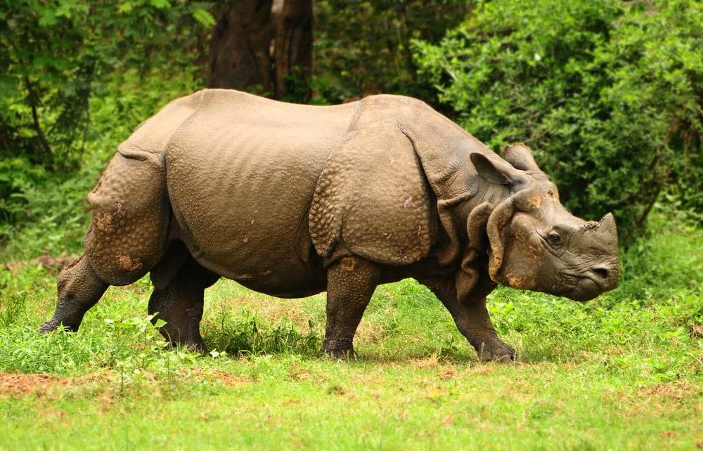
Abstract:
The wild rhinoceros populations have declined drastically in the past decades because the rhinoceros are heavily hunted for their horns. Zoological institutions aim to conserve rhinoceros populations in captivity, but one of the challenges of ex situ conservation is to provide food sources that resemble those available in the wild. Considering that the mammalian gut microbiota is a pivotal player in their host's health, the gut microbiota of rhinoceros may also play a role in the bioavailability of nutrients. Therefore, this study aims to characterize the fecal microbiome composition of grazing white rhinoceros (WR; Ceratotherium simum) and greater one-horned rhinoceros (GOHR; Rhinoceros unicornis) as well as the browsing black rhinoceros (BR; Diceros bicornis) kept in European zoos. Over the course of 1 yr, 166 fecal samples in total were collected from 9 BR (n = 39), 10 GOHR (n = 56), and 14 WR (n = 71) from 23 zoological institutions. The bacterial composition in the samples was determined using 16S rRNA gene Illumina sequencing. The fecal microbiomes of rhinoceros clustered by species, with BR clustering more distantly from GOHR and WR. Furthermore, the data report clustering of rhinoceros microbiota according to individual rhinoceros and institutional origin, showing that zoological institutions play a significant role in shaping the gut microbiome of rhinoceros species. In addition, BR exhibit a relatively higher microbial diversity than GOHR and WR. BR seem more susceptible to microbial gut changes and appear to have a more diverse microbiome composition among individuals than GOHR and WR. These data expand on the role of gut microbes and can provide baseline data for continued efforts in rhinoceros conservation and health status.

Key Points:
- The family Rhinocerotidae consists of five extant species: the black rhinoceros (BR; Diceros bicornis) and the white rhinoceros (WR; Ceratotherium simum) from Africa and the greater one-horned or Indian (GOHR; Rhinoceros unicornis), the Javan (JR; Rhinoceros sondaicus), and the Sumatran (SR; Dicerorhinus sumatrensis) rhinoceros from Asia.
  - BR, JR, and SR are critically endangered, the GOHR is vulnerable, and the WR is near threatened
  - BR, WR, and GOHR are kept and bred in zoological institutions worldwide, whereas the remaining populations of JR and SR reside only in protected areas in Indonesia.
- Captive BR are known to suffer from iron accumulation (iron overload disorder), reduced insulin sensitivity, and increased inflammatory and oxidative stress
  - It has recently been suggested that a reduced gut microbiome diversity and metabolome differences are associated with an increased risk for iron overload disorder in BR and SR versus GOHR and WR
- BR are browsers and primarily feed on shrubs, leaves, twigs, branches, and bark. WR are grazers, with a diet consisting solely of grasses. GOHR are also mostly grazers, but have a slightly mixed diet with some aquatic plants and browse.
- The mean relative profiles of all rhinoceros species were dominated by Firmicutes (46.8 ± 7.37%) and Bacteroidetes (26.9 ± 5.14%), with lower abundances of Spirochaetes (4.2 ± 2.15%), Fibrobacteres (3.5 ± 3.03%), Planctomycetes (2.3 ± 1.17%), Proteobacteria (1.3 ± 1.42%), and Euryarchaeota (1.1 ± 0.63%).
  - Firmicutes and Proteobacteria were significantly more abundant in BR microbiomes than in microbiomes of GOHR and WR, whereas in the GOHR and WR microbial communities significantly higher abundances of Spirochaetes, Fibrobacteres, and Planctomycetes were found. Spirochaetes and Fibrobacteres were furthermore elevated in the profiles of WR compared with the profiles of GOHR. Euryarchaeota were found to be relatively more abundant in the microbiomes of BR and GOHR
  - Elevated ratios of Firmicutes to Bacteroidetes have been associated with obesity in humans and some animals
- BR had a more distinct bacterial profile than the microbiota of GOHR and WR, which grouped more closely together.
- RDA analysis also revealed that the compositional profiles of individual BR grouped independently from that of other BR, indicating that the BR appear to have individual specific microbial compositions
- BR from the same zoological institution shared a similar bacterial microbiome, because their fecal profiles grouped together.
- The alpha diversity for the different rhinoceros species were very similar, albeit that the alpha diversity of BR microbiomes was significantly higher, followed by WR and GOHR, respectively
- WR are grazers, GOHR are intermediate grazers-browsers, and SR and BR are browsing species. These findings suggest that feeding habit may be one driver of the microbiome of captive rhinoceros in relation to host phylogeny

Take-Home Message:
- Significant differences in BR, GOHR, and WR gut microbiome composition. Clustering of rhino microbiomes according to species, individual, and institution. BR appear to have a more diverse microbiome composition among individuals than GOHR and WR. Our data also show that the microbiome does not vary over time-season substantially. Microbiome might be mainly based on feeding habit instead of the food that they are offered.

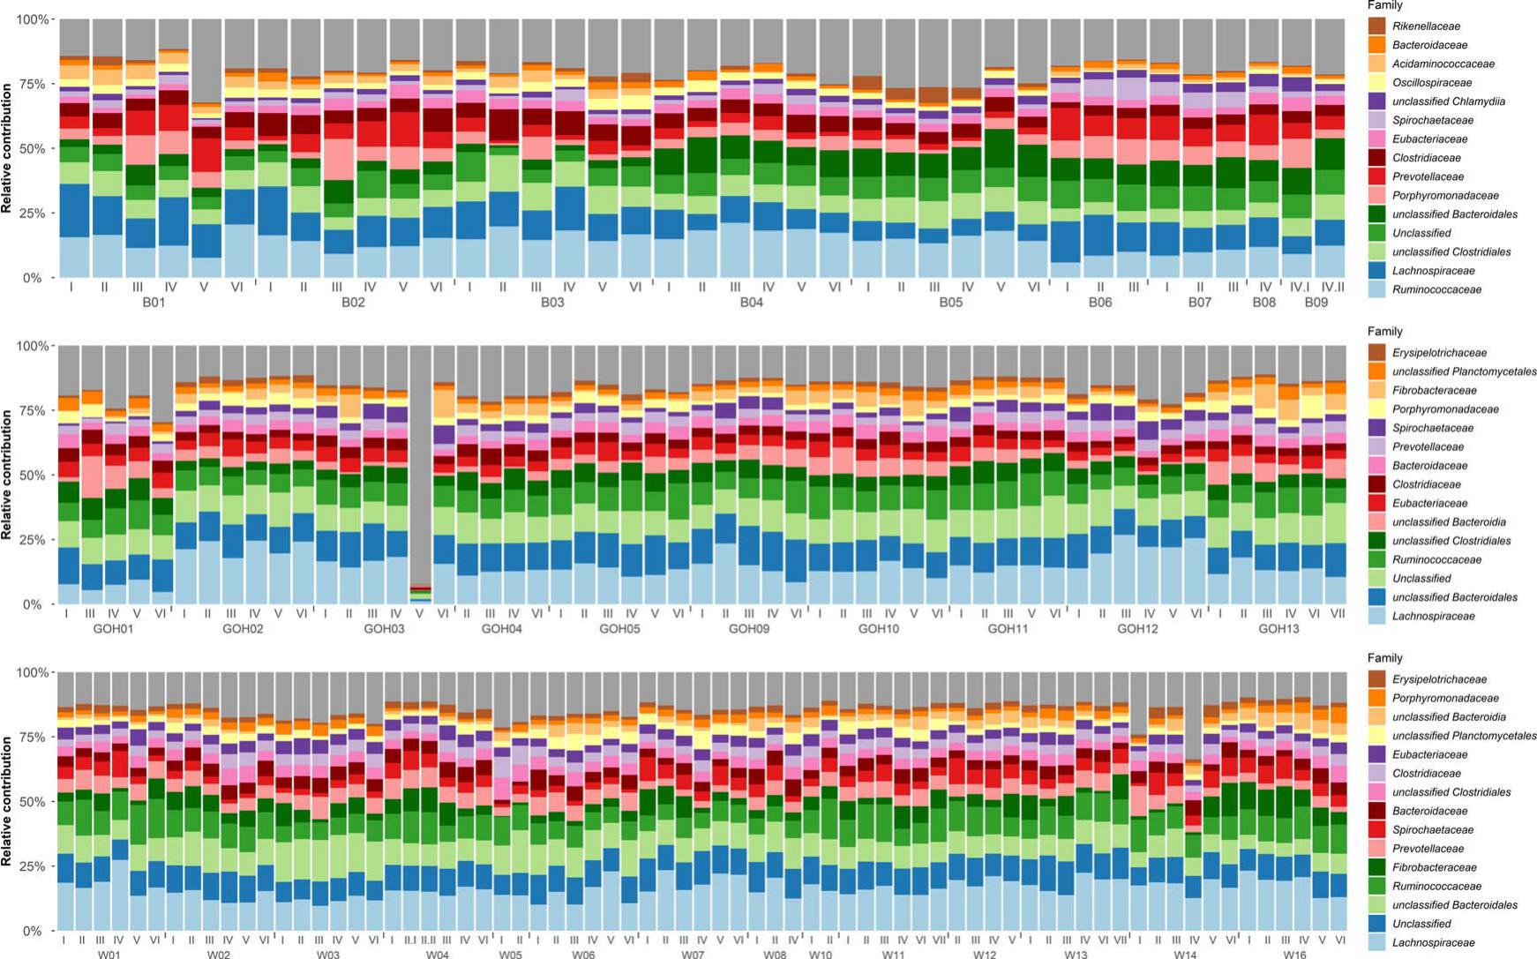

Vesicular stomatitis virus in two species of rhinoceros at a California zoological park
Abstract: OBJECTIVE To describe an outbreak of vesicular stomatitis virus (VSV) in southern white rhinoceros (SWR; Ceratotherium simum simum) and greater one-horned rhinoceros (GOHR; Rhinoceros unicornis) at a safari park in San Diego, CA, from May to September 2023.
ANIMALS 21 SWR and 5 GOHR in professionally managed care.
METHODS Rhinoceros of both species presented with a range of clinical signs and severities. Lesion locations were categorized as cutaneous (coronary bands, heels and soles, limbs, ventrum, neck folds, and ears) and mucocutaneous (lips, nostrils, mucous membranes of the oral cavity, and vulva). Clinical signs included lethargy, lameness, difficulty with prehension, hyporexia to anorexia, and hypersalivation. Severely affected rhinoceros had clinical pathology findings consistent with systemic inflammation.
RESULTS Vesicular stomatitis New Jersey virus was confirmed via PCR from swabs of lesions in 10/26 (38%) rhinoceros. Of these 10 confirmed cases, 9 (90%) were SWR and 1 (10%) was a GOHR. A further 6/26 (24%) were considered probable cases, and 10/26 (38%) were considered suspect cases based on clinical signs, but the inability to appropriately sample due to the housing environment precluded confirmation. Histopathology samples from 3 rhinoceros were consistent with VSV, and viral RNA was localized in histologic lesions via RNA in situ hybridization for 1 case. All rhinoceros survived infection despite severe systemic illness in 2 animals.
CLINICAL RELEVANCE This case series describes the clinical appearance and progression of VSV in 2 rhinoceros species. To the authors’ knowledge, this is the first report of VSV in a rhinoceros.
Background:
- VSV is causative agent of vesicular stomatitis. Most reported in equids but also reported in livestock and camelid spp. Negative ss RNA virus in family Rhabdoviridae.
- Notifiable because of clinical similarity to FMDV (foot & mouth dz virus)
- Transmission may be vector-driven (mosquitoes, sandflies, black flies, Culicoides midges often implicated; also direct contact w/ vesicles, nasal secretions, saliva + fomites/environment – can survive 1-3 days
- Domestic livestock C/S = vesicles, papules, erosions, ulcers on mouth, feet, prepuce, mammaries – uncomplicated infections can resolve in 2-3 weeks w/o intervention. Outbreaks occur in warmer months when vector activity is high and there is increased movement of livestock.
- No previous reports of VSV in nonequid Perissodactyla (rhinos/tapirs); No reports of VSV in California since 1985 – but a new outbreak occurred in 2023 in California, Nevada, Texas.
Cases:
- 21 SWR and 5 GOHR; any w/ cutaneous lesions or abnormal behaviour swabbed for qRT-PCR for VSV and FMD, and virus isolation and sent to NVSL; ELISA on blood samples. 3 cases had lesions biopsied for histo. Also did in-house conventional PCR in-house on nasal swabs.
- Case definition = gross lesions that were PCR positive for VSV were ‘confirmed cases’; were ‘probable cases’ if had gross lesions but unable to be swabbed or had lesions but were negative on PCR. ‘Suspect’ if had mild clinical signs that correlated with the outbreak +/- mild lesions that could also be consistent with trauma or concurrent dz (e.g. chronic allergic dermatitis in one case). All 26 animals were considered at least suspect cases. Of these, 10 were PCR confirmed. High morbidity and no mortality.
- C/S = lethargy, lameness, anorexia, ptyalism, difficulty in food prehension, head shaking (w/ ear lesion), separation from the herd, increased frequency of defecation, bilateral inguinal swellings, slow/stiff gait; ulcerative lesions of the nares/lips. Had 10 confirmed cases, 7 probable, 9 suspect.
- Lesions primarily in 2 locations – cutaneous (coronary bands, heels, soles, limbs, ventrum, neck folds, and ears) and mucocutaneous (lips, nostrils, mucous membranes of the oral cavity, vulva). Several cutaneous lesions started as vesicles and progressed to ulcerations. Lesions at coronary band led to separation of the nail from the skin.
- Most severe lesions on the plantar aspect of the foot and progressed to sloughing of the soft tissues of the heel, sole, and interdigital space.
- 8 rhino had lesions in only one anatomic location, 11 rhino had lesions in at least 2 locations. No consistent patterns in primary and secondary lesion locations. Healing was fastest for cutaneous axillary lesions and longest for sole/heel lesions.
- Two serotypes of VSV are endemic in southern Mexico, central America, and northern South America: the New Jersey virus (VSNJV) and the Indiana virus (VSIV) – 20 animals were sampled for VSV PCR here, 10 were positive for VSNJV and all were negative for VSIV and FMDV. Animals that had blood submitted for serology/ ELISA were seropositive for VSNJV.
- Major Clinpath findings = hyperfibrinogenemia and severe neutrophilic left shift.
- Histo = diffuse necrotizing dermatitis; extensive acute epidermal necrosis and suppurative inflammation w/ numerous and sometimes coalescing vesicles separating cords of necrotic cells In the suprabasilar regions.
- Tx used = included firocoxib, meloxicam, flunixin meglumine, and/or gabapentin. Topical wound care w/ betadine scrub, SSD, honey products, +/- mouthwash solution (containing diphenhydramine, aluminum hydroxide, Mg hydroxide, simethicone liquid, and lidocaine). Topical insecticide also used. TMS, cefazolin, or ceftiofur used for abx (in only 2 cases w/ bad left shift). Multiple immobilization procedures needed for wound care in some cases + custom-made boots.
- The combo of betadine scrub + silver honey spray was most effective topical treatment (subjectively)
- Oral and foot lesions, esp coronary band and interdigital areas are common across spp for VSV, BUT for the rhinos the foot lesions also affected the heel and the sole.
- Rhino have an extensive thick vascular dermis with an overlying thin epidermis – may predispose them to linear cracks and ulcerations seen following limb/ventrum swelling.
- There was no mammary gland involvement in the rhinos UNLIKE in cattle
- Shedding detected 8-46 days after initial positive PCR.
- Prevention recommendations = vector control, housing vulnerable animals in vector-proof shelters. Access to pasture or water ↑ odds of developing lesions during an outbreak. Frequent manure removal, keeping vegetation low to the ground, topical insecticides, removing standing water, having indoor barns w/ fans, lower lighting, keeping doors closed.
- Culicoides and Simulium spp. counts were higher in San Diego during the 2023 outbreak.
- Facility put under state mandated quarantine – no outgoing mammal movement until all lesions resolved.
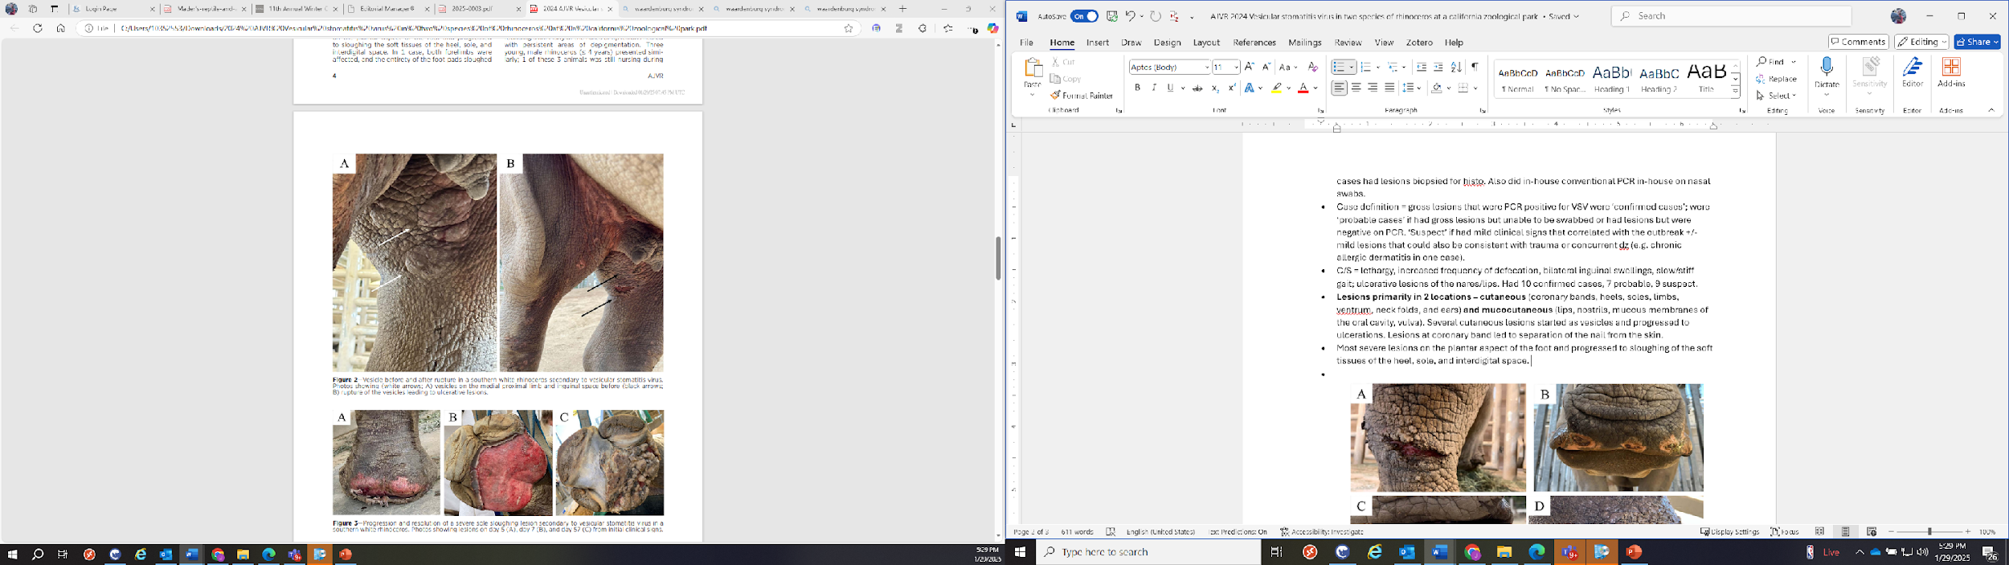
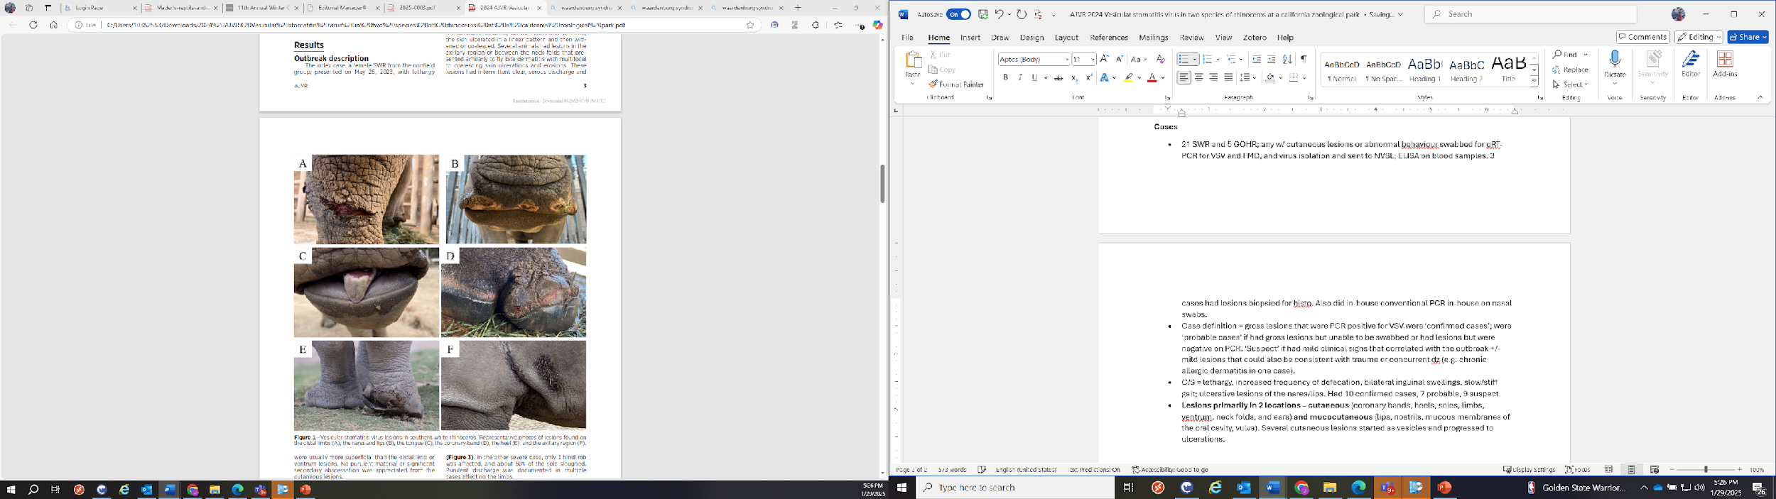
Take Home: VSV should be included in ddx for skin or oral lesions in rhinoceros in areas of VSV risk. High morbidity, no mortality. This outbreak emphasizes the importance of knowing the disease status of the local animal population surrounding a zoological institution and maintaining good communication with local, state, and federal veterinarians.

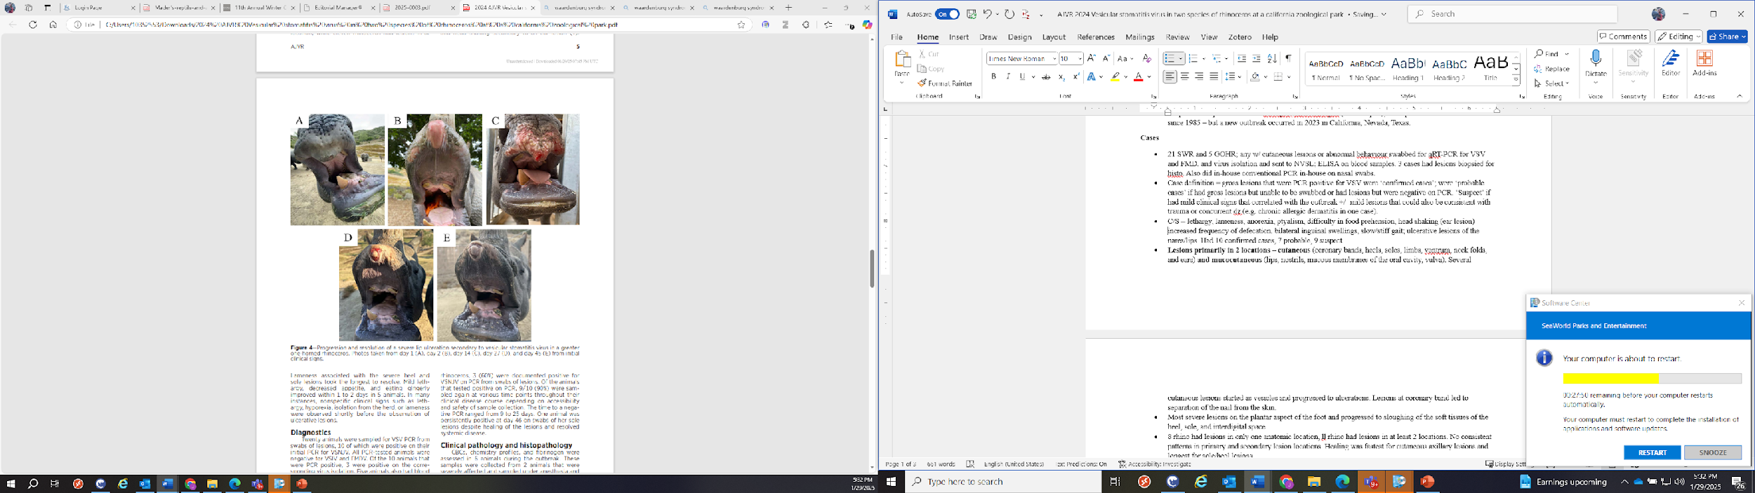

Assessment Of Capillary Zone Electrophoresis And Serum Amyloid A Quantitation In Clinically Normal And Abnormal Southern White Rhinoceros (Ceratotherium Simum Simum) And Southern Black Rhinoceros (Diceros Bicornis Minor)

ABSTRACT: Capillary zone electrophoresis (CZE) and an immunoassay for serum amyloid A (SAA) were used to examine serum samples from clinically normal and abnormal southern white rhinoceros (Ceratotherium simum simum) and southern black rhinoceros (Diceros bicornis minor) under managed care. CZE resolved seven fractions as well as subfractions for α1 globulins. Reference intervals were calculated for white rhinoceros (n = 33) and found to have some differences over previously reported intervals generated using agarose gel electrophoresis (AGE) methods in sera from free-ranging animals. In addition, the coefficient of variation related to fraction quantitation was found to be overlapping or superior to that reported for AGE. No significant differences were observed in CZE measurands and total protein between clinically normal and abnormal rhinoceros. In contrast to CZE, significant differences in SAA levels (P < 0.001) were observed in samples from the white rhinoceros between clinically normal and abnormal animals. In addition, in limited sample sets with repeated measures, SAA provided prognostic value. Future studies should generate more robust reference intervals and delineate the application of both SAA quantitation and CZE in routine health assessments and in prognostication.

Key Points:
- Serum Amyloid A (SAA) is a highly conserved major Acute Phase Protein (APP) in many species
  - A multispecies sandwich ELISA for SAA has been validated for white & black rhinos
  - In the black rhinos, SAA levels were higher in animals under managed care in conjunction with elevated cytokines and insulin-to-glucose ratio
  - SAA in white rhinos was significantly higher from a group with tissue injury
  - In the present study, SAA levels were found to increase in varied clinical presentations in white and black rhinos
- In the present study, SAA > 20 mg/L were consistent with systemic inflammation
  - Results < 7 mg/L should be interpreted as normal or possible mild inflammation
  - SAA values tended to correlate with clinical signs
  - SAA returned to normal when clinical signs resolved
- Capillary zone electrophoresis (CZE) provides increased fraction resolution vs. Agarose gel electrophoresis (AGE)
  - AGE is a semiautomated method; proteins separated by size/charge on a gel substrate
    - Fractions are then resolved using protein-binding dyes
  - CZE is an automated method; protein fractionation is done via high voltage in a capillary
    - The fractions are quantitated by a UV detector
- No significant differences were observed in the electrophoresis measurands between clinically normal and abnormal white and black rhinoceros
  - This contrasts with injured white rhinos using AGE where changes including decreased albumin, α₂, and β₁ globulins were observed in acute and chronic inflammation
  - These changes were associated with wounds and tissue trauma, which were often extensive and untreated

Take Home: SAA is a clinically useful major positive APP in white and black rhinos

Journal of Wildlife Diseases. 2022, 58(4): 735-745.
EFFECT OF BOMA CONFINEMENT ON HEMATOLOGIC AND BIOCHEMICAL VALUES IN FREE-RANGING WHITE RHINOCEROS (CERATOTHERIUM SIMUM) IN KRUGER NATIONAL PARK, SOUTH AFRICA
Laura Martinelli

Abstract: Boma adaptation is an important component of rhinoceros translocations to allow transition to new diets, restricted space, and quarantine for disease screening. However, up to 20% of recently captured white rhinoceros (Ceratotherium simum) do not adjust to captivity, resulting in early release or even death. The causes and physiologic consequences of maladaptation to boma confinement are poorly understood. The aim of this investigation was to evaluate hematologic and serum biochemical changes in maladapted rhinoceros compared to animals that adapted under the same boma conditions. Ninety-six white rhinoceros were captured between 2009 and 2011 in Kruger National Park, South Africa and placed in bomas prior to translocation. Weight, complete blood count, and serum biochemical panel results were recorded when rhinoceros were placed in the boma and repeated on the day of release. In this study, the mean duration of boma confinement for maladapted white rhinoceros was 13 d (range 8–16 d) compared to 89.9 d (range 39–187 d) for adapted animals. Mean weight loss between capture and release was significantly greater in maladapted rhinoceros (224.0 versus 65.9 kgs; P<0.001). Although adapted rhinoceros had statistically significant changes in some hematologic and biochemical values, most were not considered clinically relevant. In contrast, the maladapted rhinoceros had significant changes at the time of early release from the boma, including evidence of leukocytosis with left shift, lymphopenia, eosinopenia, decreased red blood cell count and hematocrit, increased serum creatine kinase, and decreased serum calcium, phosphorus, and magnesium values. Along with loss of body condition, these findings were consistent with a stress-associated catabolic response. These changes occurred in the first 2 wk of confinement, and the results provide a foundation for evaluating adaptation in white rhinoceros. Future studies should focus on factors that improve adaptation and welfare of recently confined free-ranging white rhinoceros.

Key Points:
- African rhino depend on capture and translocation to maintain genetic diversity and restore populations
- Rhino often placed in holding enclosures, bomas, as an adaptation step for weeks to months during translocation
- Early release of maladapted rhino from bomas is recommended to prevent morbidity and mortality
- 96 White rhino were managed in bomas over study period and scored daily for adaptability based on appetite, fecal consistency/volume, and behavior; if scoring low, considered maladapted and were then visually examined by veterinarian and decision on whether to release was made
- Results
  - Adapted rhinos had significantly longer length of stay, higher boma adaptation scores, lower mean weight loss, than maladapted rhinos
  - Maladapted rhinos had significantly higher WBC count, higher proportion of neutrophils, decreased proportion of eosinophils, higher CK, lower albumin, AST, BUN, calcium, phosphorous, and Mg, as well as in 2011 specifically decreased RBC count and hematocrit as compared to adapted rhinos
- Overall, bloodwork indicated adjustment in the adapted rhinos and movement to catabolic state in maladapted rhinos
- Adaptation appears to take a minimum of 3 wk, based on scores reaching a plateau; it is recommended that white rhino put into bomas be given more time (8-12 wk) to regain condition prior to being transported
- Enterocolitis caused by Clostridium and Salmonella spp reported in rhino in stressful situations and can lead to death, as was seen in one rhino in this study
Take Home Point: Significant weight loss as well as hematologic and biochemical abnormal values within the first 10-14 days in a boma indicate potential maladaptation to the boma and release or treatment should be considered.
------------------------------------------------------------------------------------------------------------------------------------------
Journal of Wildlife Diseases. 2024, 60(2): 388-400.
EFFECTS OF BUTORPHANOL ON RESPIRATION IN WHITE RHINOCEROS (CERATOTHERIUM SIMUM) IMMOBILIZED WITH ETORPHINE-AZAPERONE
Laura Martinelli

Abstract: This article reports on respiratory function in white rhinoceros (Ceratotherium simum) immobilized with etorphine-azaperone and the changes induced by butorphanol administration as part of a multifaceted crossover study that also investigated the effects of etorphine or etorphine-butorphanol treatments. Six male white rhinoceros underwent two immobilizations by using 1) etorphine-azaperone and 2) etorphine-azaperone-butorphanol. Starting 10 min after recumbency, arterial blood gases, limb muscle tremors, expired minute ventilation, and respiratory rate were evaluated at 5-min intervals for 25 min. Alveolar to arterial oxygen gradient, expected respiratory minute volume, oxygen consumption, and carbon dioxide production were calculated. Etorphine-azaperone administration resulted in hypoxemia and hypercapnia, with increases in alveolar to arterial oxygen gradient, oxygen consumption, and carbon dioxide production, and a decrease in expired minute ventilation. Muscle tremors were also observed. Intravenous butorphanol administration in etorphine-azaperone–immobilized white rhinoceros resulted in less hypoxemia and hypercapnia; a decrease in oxygen consumption, carbon dioxide production, and expired minute ventilation; and no change in the alveolar to arterial oxygen gradient and rate of breathing. We show that the immobilization of white rhinoceros with etorphine-azaperone results in hypoxemia and hypercapnia and that the subsequent intravenous administration of butorphanol improves both arterial blood oxygen and carbon dioxide partial pressures.

Key Points:
- Major adverse effects of etorphine (and ultra-potent opioids in general) = depression of ventilation, resulting in hypoxemia, hypercapnia and acidemia
- Etorphine usually combined with azaperone to shorten induction time
- Etorphine-azaperone typically used in field immobilizations of rhino but it poses significant mortality risk by altering ventilation
- Butorphanol more recently has been administered in theory to antagonize the depression of ventilation
- Six rhino in this study were captured and allowed time to adjust to boma prior to this complete crossover study
- “Expired minute ventilation....measured by redirecting expired air through a PowerLab exercise physiology system by using modified equine endotracheal tubes inserted into each nostril with the cuffs inflated to create an airtight seal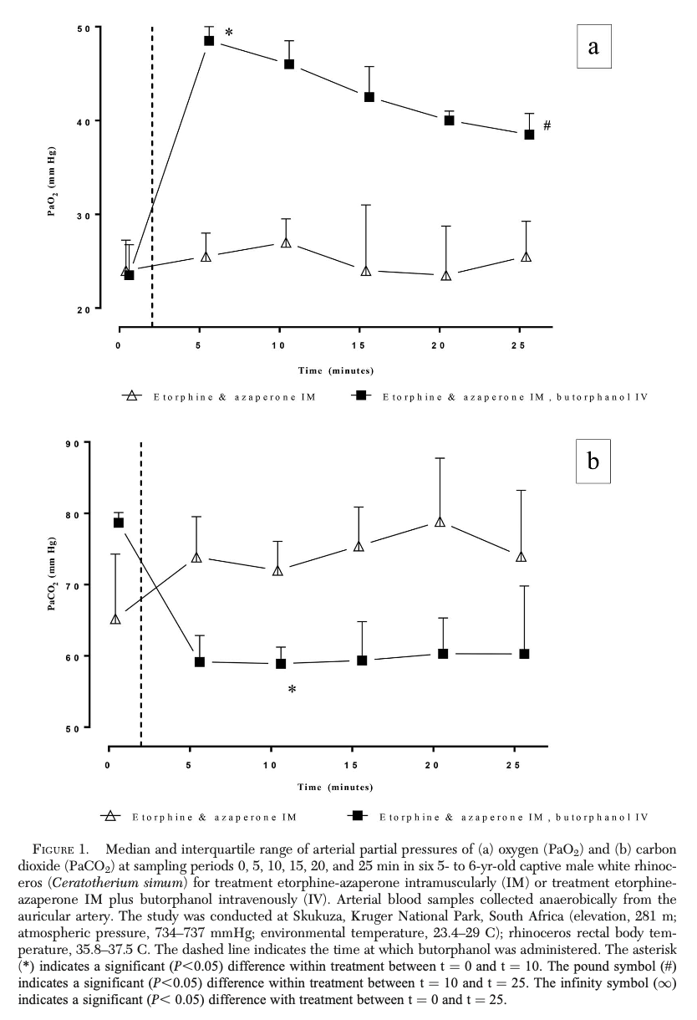
- Butorphanol administration was associated with a significant increase in PaO2 and decrease in PaCO2 for the 10 min following administration
- The median PaO2 was higher and the median PaCO2 was lower in etorphine-azaperone-butorphanol immobilized animals than those without the butorphanol in the protocol
- Positive association noted between tremor scores and VO2 and VCO2, both of which decreased after IV butorphanol suggesting decreased in metabolic activity after giving butorphanol
- When given butorphanol, rhino had PaO2 values inversely associated with VO2 and muscle tremor scores, supporting the theory that butorphanol-induced reduction in metabolic activity led to improvements in blood gas values
- Addition of azaperone reduced muscle tremors (as compared to etorphine alone, this was part of a separate concurrent study but a good note)
Take Home: In White rhino immobilized with etorphine-azaperone, adding butorphanol IV 2 min after immobilization lead to clinically beneficial improvements in hypoxemia and hypercapnia.

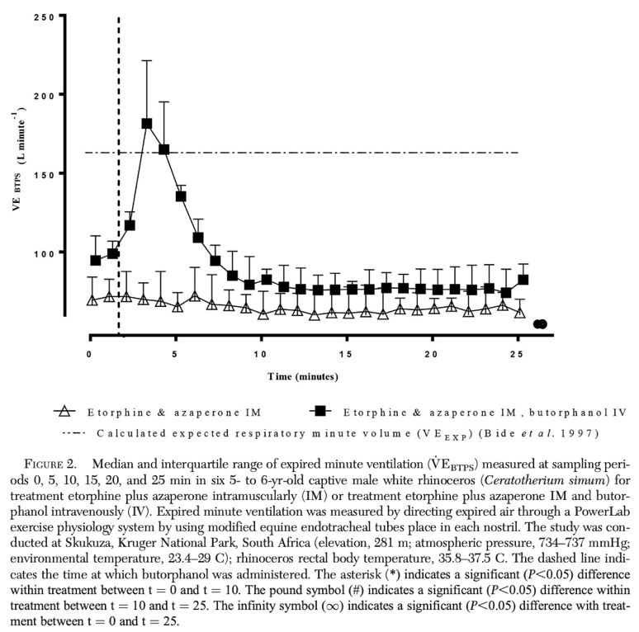

Journal of Zoo and Wildlife Medicine 53(1): 141–152, 2022
Summarized by MR

DEVELOPMENT OF A QUANTITATIVE IMMUNOASSAY FOR SERUM HAPTOGLOBIN AS A PUTATIVE DISEASE MARKER IN THE SOUTHERN WHITE RHINOCEROS (CERATOTHERIUM SIMUM SIMUM)
Henrik H. Petersen, DVM, PhD, Rikke Stenbak, DVM, Camilla Blaabjerg, DVM, Anne K.H. Krogh, DVM, PhD, Mads F. Bertelsen, DVM, DVSc, Dipl ACZM, Dipl ECZM (ZHM), Peter Buss, BVSc, MMedVet (Fer), PhD, and Peter M.H. Heegaard, MSc, PhD

Abstract: Objective disease markers in the southern white rhinoceros (Ceratotherium simum simum) are in high demand. In the field, such markers are typically needed to decide whether a captured white rhinoceros is fit to cope with quarantine, transport, or both. Captive white rhinoceros have a need for unbiased biomarkers for early detection of disease. Acute phase proteins, including haptoglobin, are proteins that significantly change their plasma concentration in response to tissue perturbation or inflammation, such as that occurring during infection or neoplastic disease. Acute phase proteins are well known diagnostic tools in both human and veterinary medicine. In this study, an ELISA with commercially available anti-human haptoglobin antibodies for quantification of haptoglobin in white rhinoceroses’ serum was developed. The validity of the haptoglobin assay and haptoglobin as a biomarker of disease was investigated with the use of serum samples from both captive and free-ranging animals with a well-described health status. The assay was precise (intra-assay and interassay reproducibility were 5.0% and 13.1%, respectively) and reliably quantified white rhinoceros haptoglobin serum concentrations consuming low volumes of sample. The assay was sensitive to the presence of free hemoglobin in the sample at levels corresponding to a visibly hemolyzed sample. Haptoglobin was readily measurable, baseline levels (in white rhinoceros with no clinical signs of disease) did not differ between genders, and a significant increase was seen in captive as well as in free-ranging white rhinoceros with inflammatory disease. Thus, haptoglobin is a positive acute phase protein in southern white rhinoceros with potential for use as an objective marker of disease.

Background:
- APPs: serum proteins produced in liver – induced by cytokines, released to circulation in response to trauma, infection, or inflammation
  - correlation between severity of inflammation and magnitude of the AP response
- Serum amyloid A investigated in black rhinos, haptoglobin in white rhinos (positive APPs)
Summary:
- Objective: validate a “sandwich” ELISA for quantification of serum haptoglobin
  - Utilized commerically available antibodies for human haptoglobin
- Four groups: healthy, zoo-housed (Z-H; n = 17), diseased, zoo-housed (Z-D; n = 5), healthy, free ranging (F-H; saved serum), diseased, free ranging (F-D; saved serum: n = 14)
  - Age estimated in free ranging individuals
  - F-D: snare entrapment, poaching injuries, fighting injuries, fractures, bullet wounds, sepsis
  - Z-D: pododermatitis, SCC, rectal laceration, integumentary and ophthalmic morbidities
- Free hemoglobin as present in (visibly; 0.04AU) hemolyzed samples interfered significantly with the assay
- Haptoglobin in Z-D was significantly higher than Z-H; P < 0.0001
  - Biochem analyses: NSF; no difference in TP, albumin, iron
- Haptoglobin in F-D was significantly higher than F-H; P < 0.001
- High sensitivity of the assay allowed samples with low concentration to be run at 100 dilution, using very little sample volume
- LLOD 0.03 a.u., all rhinos >0.3 a.u.

Take-Home Points:
- Haptoglobin is a positive acute phase protein that has a validated, sensitive assay for measurement in white rhinos
- Studies suggest haptoglobin in an effective marker of disease in white rhinos
- Samples must be non-hemolyzed
- Also look for patterns of decreasing iron (negative acute phase protein) and increasing EPH protein populations: $α$1, $β$1, and $β$2

Journal of Zoo and Wildlife Medicine 53 (2), 485-491 (2022)
Summarized by MR

THE USE OF INTRADERMAL SKIN TESTING AND HYPOSENSITIZATION INJECTIONS TO CONTROL SEASONAL DERMATITIS IN GREATER ONE-HORNED RHINOCEROSES (RHINOCEROS UNICORNIS)
Sarah B. Chaney, DVM, PhD, DACVP, Melissa Loewinger, DVM, Donna Doherty, Colleen M. McCann, PhD, Kenneth J. Conley, DVM, DACVP, Denise McAloose, VMD, DACVP, Andrew Rosenberg, DVM, DACVD, and John M. Sykes IV, DVM, DACZM

Abstract: Allergic dermatitis was diagnosed in a 25-yr-old female greater one-horned rhinoceros (Rhinoceros unicornis) and her 6-yr-old female offspring by skin biopsy, intradermal skin testing (IDST), and allergen-specific serum IgE testing. Dam and offspring presented with seasonal, erosive, and ulcerative dermatitis affecting the face, legs, and trunk starting at 6 and 2 yr of age, respectively. IDST was performed at the caudal pinnal base using 61 regionally specific allergens. Specific serum allergen responses were detected using Heska’s Equine ALLERCEPT Allergen Panel. Histopathology of the lesions was consistent with an allergic etiology. Injectable allergen-specific immunotherapy was initiated in both animals and within 6 to 18 mon after commencing hyposensitization clinical improvement was noted. This report documents a repeatable methodology for IDST and serological allergen testing for use in rhinoceroses. The hyposensitization protocol detailed here can help guide future treatment protocols.

Background:
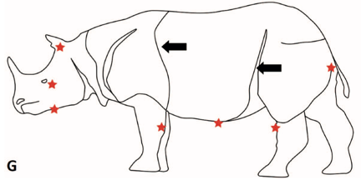
- Knowledge of dermatopathies in rhinos is limited
- Methodologies for diagnosis, treatment, and results of hyposensitization therapy for 2 greater one-horned rhinos presented

Results/Summary:
- Case 1: Seasonal erosive and ulcerative dermatitis – Lesions localized over lateral aspect of limbs, skin folds of limbs, base of ear, and pinnae margins
  - Blood collected for IgE-specific serum allergen testing - positive titers for Dermatophgoides farinae (dust mite), Lepidogyphus destructor (storage mite), and horsefly
  - Biopsy of skin confirmed eosinophilic dermatitis (HST rxn)
  - Ear base used for intradermal skin testing – strongest reactions to Kentucky bluegrass, mosquitoes, and horsefly
- Case 2 (offspring of Case 1): similar lesion localization as Case 1
  - IgE-specific serum allergen testing – Tryophagus (storage mite)
  - Intradermal skin testing – moth, mouse, red cedar, privet, Drechslera spicifera (mold)
- Both cases underwent hyposensitization (based on IDST) via SQ injections with clinical improvement of seasonal dermatitis – signs of dermatitis still occur, but are much less severe and respond faster to topical treatment
  - IDST reactions support antibody formation to allergens – but don’t confirm/correlate to significance of these allergens
  - IgE serum titer testing not currently validated in rhinoceroses

Take Home Points: Intradermal skin testing considered gold standard method to determine which allergens should be selected for desensitization and was successfully used in two greater one-horned rhinoceroses resulting in improved severity of clinical signs.

