QUESTION: Which of the following changes might you expect to see in a white rhino maladapted to boma confinement during a translocation scenario?
- Increased Hct and increased body weight
- Decreased body weight and increased tWBC
- Decreased tWBC and increased Ca
- Decreased Ca and increased AST
- Decreased AST and increased Hct
Answer: B
Source: EFFECT OF BOMA CONFINEMENT ON HEMATOLOGIC AND BIOCHEMICAL VALUES IN FREE-RANGING WHITE RHINOCEROS (CERATOTHERIUM SIMUM) IN KRUGER NATIONAL PARK, SOUTH AFRICA. JWD 2022. Miller et al.

QUESTION: A single dose of oral firocoxib (0.1 mg/kg equine dosage) in black rhinos (Diceros bicornis) is likely to have:
- Prolonged Tmax compared to oral meloxicam
- Significantly lower Cmax than domestic horses
- Adverse reactions of hyporexia and gastric ulcers
- Short half life compared to other domestic herbivores
- Poor consumption compliance in banana vehicle
Answer: D - T/12 in black rhino (5h) similar to dogs (6.5h) vs. other herbivores (horses 30h, calves 19h, goats 21h)
Source: PHARMACOKINETIC PROFILES OF ORAL PHENYLBUTAZONE, MELOXICAM, AND FIROCOXIB IN SOUTHERN BLACK RHINOCEROS (DICEROS BICORNIS MINOR). JZWM 2024. Bryant et al.

Journal of Zoo and Wildlife Medicine, 54(2): 336-344, 2023.
PHARMACOKINETICS OF ORAL FLUNIXIN MEGLUMINE, MELOXICAM, OR GABAPENTIN IN THREE BLACK RHINOCEROS (DICEROS BICORNIS) - reviewed by HSS
John A. Flanders Jr., Ronette Gehring, Kristina Delaski, Larry Wulf, Johann Coetzee, Kathryn C. Gamble
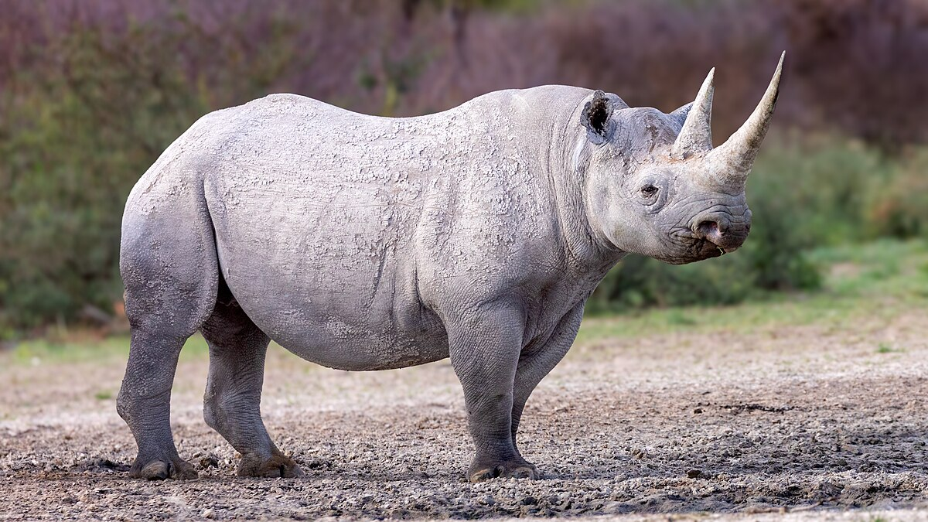
Question:

Which of the following is most correct regarding the pharmacokinetics of flunixin meglumine, meloxicam, and gabapentin in black rhinoceros (Diceros bicornis; BR)?

A. The concentration versus time graphs for oral meloxicam had secondary peaks in some animals, consistent with enterohepatic recycling
B. All BR trials had serum concentrations above values believed to be efficacious in horses for >24 h after dosing oral meloxicam at 1.0 mg/kg
C. Flunixin meglumine had near complete oral bioavailability in each trial, while the oral bioavailability of meloxicam was generally lower
D. Oral gabapentin had similar half-life values between all animals, whereas the half-lives of meloxicam and flunixin meglumine were more variable
E. Oral flunixin meglumine (1 mg/kg) pharmacokinetics in white rhinoceros have been reported, and the mean Cmax was lower than values measured in BR

Answer: B

Explanation:
- Secondary peaks seen with FM in one animal. FM enterohepatic recycling has been reported in many species, including cattle (Bos taurus), goats (Capra hircus), cats (Felis catus), dromedary camels (Camelus dromedarius), WR, and Asian elephants (Elephas maximus)
- Meloxicam had near complete bioavailability in each trial, while flunixin meglumine was generally lower.
-Oral meloxicam was noted with similar half-life values between all animals (range 9.22–14.52 h) tested, while oral gabapentin (range 10.25–24.85 h) and oral flunixin meglumine (range 3.9–14.9 h) had a larger range
-Oral FM (1 mg/kg) pharmacokinetics in WR have been reported, and the mean Cmax (1,207 ng/ mL) was greater than values measured in BR (171 to 655 ng/ mL)

Journal of Zoo and Wildlife Medicine, 54(2): 301-312, 2024.
GUT MICROBIOME DIVERSITY OF THREE RHINOCEROS SPECIES IN EUROPEAN ZOOS- reviewed by HSS
Roy M. van der Meijs, Willem van Leeuwen, Casper Prins, Floyd Wittink, Walter Pirovano, Daniël Duijsings, Bartholomeus van den Bogert, Linda G.R. Bruins-van Sonsbeek
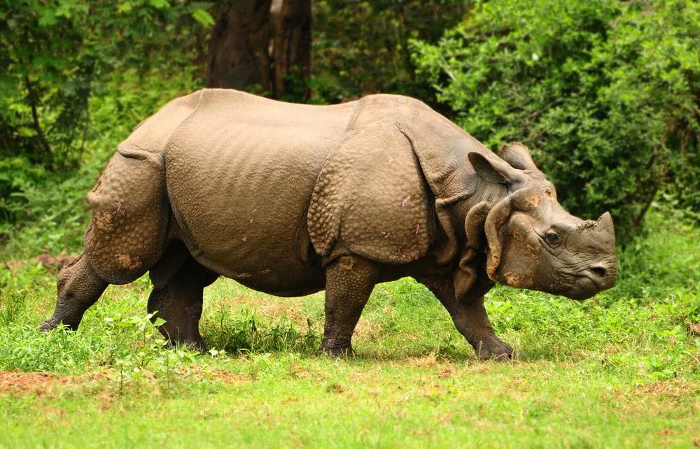

Question:

Which of the following microbial phyla was most common in the gut microbiome of black rhinoceros, white rhinoceros, and greater one-horned rhinoceros?

A. Bacteroidetes
B. Euryarchaeota
C. Firmicutes
D. Fibrobacteres
E. Proteobacteria

Answer: C

Explanation: Taxonomic classification revealed that the mean relative profiles of all rhinoceros species were dominated by Firmicutes (46.8 ± 7.37%) and Bacteroidetes (26.9 ± 5.14%), with lower abundances of Spirochaetes (4.2 ± 2.15%), Fibrobacteres (3.5 ± 3.03%), Planctomycetes (2.3 ± 1.17%), Proteobacteria (1.3 ± 1.42%), and Euryarchaeota (1.1 ± 0.63%).

- Which of the following is true about vesicular stomatitis?
  - Reportable RNA virus, that is primary cutaneous and mucocutaneous
  - Reportable DNA virus, that is primary cutaneous and mucocutaneous
  - Nonreportable RNA virus, that is primary cutaneous
  - Nonreportable DNA virus, that is primary cutaneous
  - Nonreportable RNA virus, that is primary mucocutaneous

Answer: A. RNA virus family Rhabdoviridae, reportable due to similarity to FMD

What are the differences between capillary zone electrophoresis and agarose gel electrophoresis?

Answer:

Capillary Zone Electrophoresis | Agarose Gel Electrophoresis
Automated method | Semi-automated method
Protein separated by high voltage in capillary | Protein separated by size/charge on gel
Fractions quantified by UV detector | Use protein binding dye

Journal of Wildlife Diseases. 2022, 58(4): 735-745.
EFFECT OF BOMA CONFINEMENT ON HEMATOLOGIC AND BIOCHEMICAL VALUES IN FREE-RANGING WHITE RHINOCEROS (CERATOTHERIUM SIMUM) IN KRUGER NATIONAL PARK, SOUTH AFRICA
Laura Martinelli

Question: What is a significant indicator of maladaptation to boma confinement for the White Rhinoceros?
- Non-regenerative anemia
- Marked weight loss
- Longer length of stay
- Increased eosinophils
- Elevated AST

Answer: B
------------------------------------------------------------------------------------------------------------------------------------------
Journal of Wildlife Diseases. 2024, 60(2): 388-400.
EFFECTS OF BUTORPHANOL ON RESPIRATION IN WHITE RHINOCEROS (CERATOTHERIUM SIMUM) IMMOBILIZED WITH ETORPHINE-AZAPERONE
Laura Martinelli

Question: In a study of White Rhinoceros immobilized with etorphine-azaperone, the addition of butorphanol IV 2 minutes after induction produced what clinically relevant, beneficial change?
- Increased arterial partial pressure of oxygen
- Increased arterial partial pressure of carbon dioxide
- Increased tidal volume
- Increased oxygen consumption
- Increased alveolar to arterial oxygen gradient

Answer: A

Journal of Zoo and Wildlife Medicine 53(1): 141–152, 2022
Summarized by MR

DEVELOPMENT OF A QUANTITATIVE IMMUNOASSAY FOR SERUM HAPTOGLOBIN AS A PUTATIVE DISEASE MARKER IN THE SOUTHERN WHITE RHINOCEROS (CERATOTHERIUM SIMUM SIMUM)
Henrik H. Petersen, DVM, PhD, Rikke Stenbak, DVM, Camilla Blaabjerg, DVM, Anne K.H. Krogh, DVM, PhD, Mads F. Bertelsen, DVM, DVSc, Dipl ACZM, Dipl ECZM (ZHM), Peter Buss, BVSc, MMedVet (Fer), PhD, and Peter M.H. Heegaard, MSc, PhD

Question: Which of the following has demonstrated to be a negative acute phase protein in the white rhinoceros (Ceratotherium simum)?
- Serum haptoglobin
- Serum iron
- Serum amyloid A
- Serum Alpha1
- Serum Beta2

Answer: B. Serum iron – haptoglobin and EPH fractions increase with inflammation, whereas serum iron decreases with inflammation. Serum amyloid A is a positive APP for both black and white rhinos. (See CZE pub from JZWM 2022 - Souza).

Journal of Zoo and Wildlife Medicine 53 (2), 485-491 (2022)
Summarized by MR

THE USE OF INTRADERMAL SKIN TESTING AND HYPOSENSITIZATION INJECTIONS TO CONTROL SEASONAL DERMATITIS IN GREATER ONE-HORNED RHINOCEROSES (RHINOCEROS UNICORNIS)
Sarah B. Chaney, DVM, PhD, DACVP, Melissa Loewinger, DVM, Donna Doherty, Colleen M. McCann, PhD, Kenneth J. Conley, DVM, DACVP, Denise McAloose, VMD, DACVP, Andrew Rosenberg, DVM, DACVD, and John M. Sykes IV, DVM, DACZM

Question: Which of the following is true regarding seasonal allergies in greater one-horned rhinoceroses (Rhinoceros unicornis)?
- The use of hyposensitization treatments can be performed successfully in greater one-horned rhinoceroses experiencing seasonal allergic dermatitis following intradermal skin testing.
- The use of IgE serum titers is the gold standard for allergen testing in greater one-horned rhinoceroses.
- Lesions associated with allergic dermatitis in greater one-horned rhinoceroses involves erythema and ulceration of the skin localized over the dorsum and rump.
- Intradermal skin testing cannot be performed in greater one-horned rhinoceroses due to their thick skin.
- The use of hyposensitization treatments can be performed successfully in greater one-horned rhinoceroses experiencing seasonal allergic dermatitis following IgE serum testing.

Answer: A. The use of hyposensitization treatments can be performed successfully in greater one-horned rhinoceroses experiencing seasonal allergic dermatitis following intradermal skin testing.

