Journal of Zoo and Wildlife Medicine, 54(4): 704-712, 2024.
INTRAOCULAR PRESSURES OF AQUARIUM-HOUSED COWNOSE RAYS (RHINOPTERA BONASUS) WITH NORMAL AND ABNORMAL OPHTHALMIC EXAMS - reviewed by HSS
Laura Martinelli, Braidee C. Foote, Xiaojuan Zhu, James G. Johnson III, Jared Durrett, Chris Buckner, Julie D. Sheldon
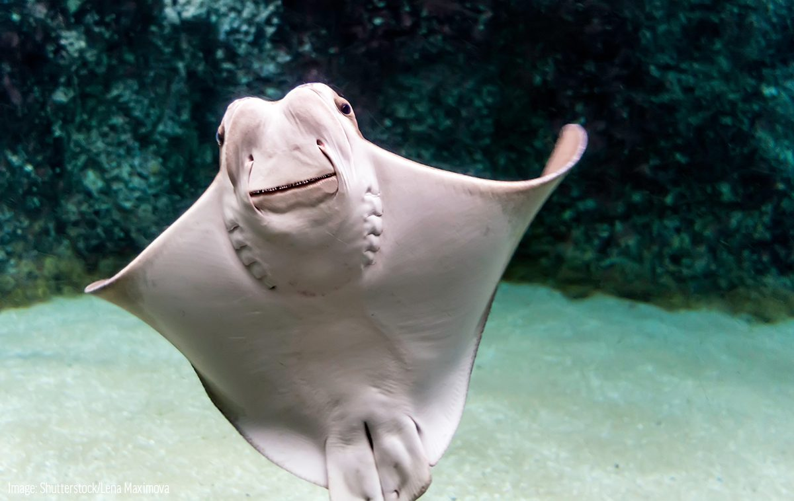
Abstract:
Cownose rays (Rhinoptera bonasus) are common elasmobranchs in zoos and aquaria; however, there is a lack of published information regarding ocular findings in this species. Intraocular pressure (IOP) was measured in a total of 52 cownose rays (Rhinoptera bonasus) from two unrelated aquaria (n = 22 from A1, n = 30 from A2) using a TonoVet rebound tonometer on two settings (dog = D, and unidentified species = P) as part of a full ophthalmologic examination. Adult (n = 38) and juvenile (n = 14) rays were sampled out of water briefly in sternal recumbency. Intraocular pressure (mean ± SD [range]) in the D setting (9.10 ± 2.57 [4–18] mmHg) was higher than the P setting (5.21 ± 2.32 [0–12] mmHg) (P<0.001). Statistical analysis revealed no difference in IOP between right and left eyes, and no correlation between body weight and IOP. No differences in IOP between sex, age group, and location were identified in either setting. However, a significant difference was observed between levels of severity of corneal disease in IOP D setting (P=0.006) and P setting (P=0.024), and levels of severity of intraocular disease in IOP D setting (P=0.034) only. This study provides baseline IOP values using rebound tonometry in aquarium-housed cownose rays with apparent corneal and intraocular lesions and reveals that the D setting may be more sensitive in identifying IOP changes in eyes with intraocular disease.

Key Points:
- Compared to mammals, the piscine lens is completely spherical and located more anteriorly, decreasing the relative depth in the anterior chamber greatest refractive index of all vertebrates, reducing chromatic and spherical changes to an image received at the level of the retina
- No significant difference in IOP between right/left eyes. No correlation between weight and IOP. No differences in IOP between sex, age, or aquarium.
- IOP significantly higher on D setting than P (undetermined species) setting but moderate agreement between settings
- IOP 1.5 mmHg higher for eyes with moderate/severe corneal disease (26% prevalence) compared to eyes with none/mild corneal disease (74% prevalence) on both D and P settings
- IOP 1.5 mmHg higher for eyes with moderate/severe intraocular disease (21% prevalence) compared to eyes with none/mild intraocular disease (79% prevalence) on D setting only, suggesting D setting more sensitive to intraocular changes
- The P setting had valid readings of 0 mmHg in several individuals, suggesting that the P setting is not as sensitive as the D setting for lower IOP measurements in cownose rays.

Take-Home Message:
- The dog setting on a rebound tonometer may be more sensitive in identifying IOP changes in cownose rays with corneal and intraocular disease
- Globes with moderate/severe corneal disease and intraocular disease had significantly higher IOPs on the D setting

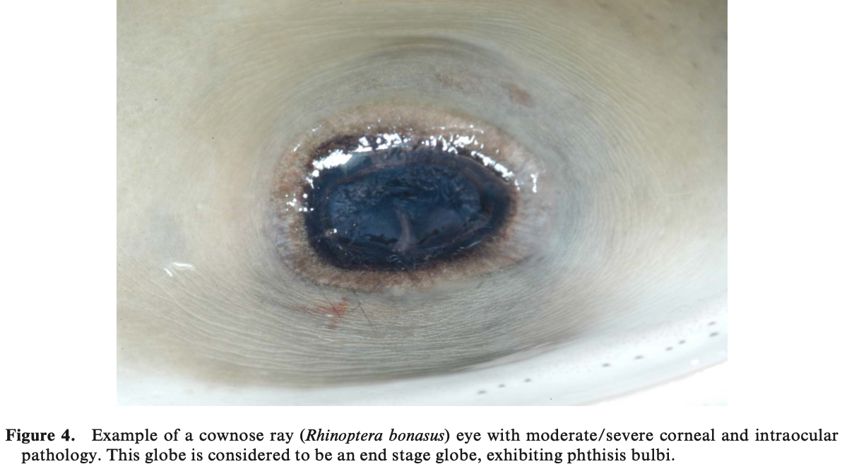
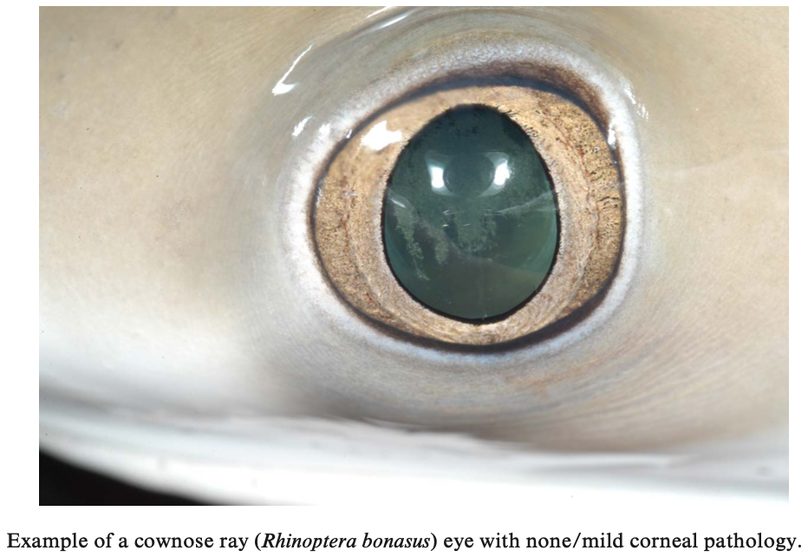

Journal of Zoo and Wildlife Medicine, 54(4): 692-703, 2024.
CLINICAL AND HISTOPATHOLOGIC OCULAR FINDINGS IN AQUARIUM-HOUSED COWNOSE RAYS (RHINOPTERA BONASUS)- reviewed by HSS
Braidee C. Foote, Lindsay D. Seyer, Laura Martinelli, Caroline Betbeze, Kim Newkirk, Karen Terio, Xiaojuan Zhu, James G. Johnson III, Jared Durrett, Chris Buckner, Christa E. Barrett, Julie D. Sheldon

Abstract:
Cownose rays (Rhinoptera bonasus) are susceptible to ocular disease with their prominent globes, but despite being popular animals housed in aquaria, there is little published information about their normal ocular anatomy and common pathologic ocular findings. A total of 63 live cownose rays (CNR) from three unrelated, separately housed groups had ocular examinations, and 5 adult rays were selected for ocular ultrasound. All examinations were performed out of the water, and most without anesthesia. Clinical findings were described, categorized, and scored by severity. Sixty-two of 63 rays (123 eyes) had clinical abnormalities, including 110 eyes with corneal pathology (mild = 76, moderate/severe = 34) and 74 eyes with intraocular pathology (mild = 44, moderate/severe = 30). Grey-to-white corneal opacities were the most common pathology (n = 58 rays/100 eyes) followed by cataracts (n = 41 rays/58 eyes), then persistent (or dysplastic) pupillary membranes (n = 14 rays/15 eyes). Most pathologic findings appeared inactive, but one aquarium had several CNR with active ocular pathology. There was a significant association between the diagnosis of moderate/severe corneal and intraocular pathology with age (P = 0.008 and P = 0.014, respectively) and weight (P = 0.001 and P = 0.039, respectively), as well as moderate/severe corneal pathology and group sampled (P = 0.03). There were no other significant variables identified. Additionally, histopathology of 14 eyes (11 rays) from two different facilities were examined, with keratitis (n = 8) and uveitis (n = 2) as the most common lesions. This study shows a high prevalence of pathologic ocular findings in cownose ray eyes with heavier adults more likely to be affected than lighter juveniles. Comprehensive ocular evaluation is important in this species and serial ocular exams and future studies should be pursued to monitor ocular disease progression and better understand possible etiologies.

Key Points:
- Prominent eye position and reproductive behaviors of CNR may make them more susceptible to trauma and ocular disease. CNR are also commonly affected by parasites that may contribute to ocular pathology
- Clinical exam results
  - Able to retract globe slightly
    - In contrast, sharks can dramatically retract globe to prevent trauma
  - The cornea had slight curvature and appeared subjectively flatter dorsally
  - The anterior chamber was most shallow axially
  - The pupil was vertically ellipsoid and non-responsive to light
  - The lens was nearly spherical and there was a gap between the lens and ventral iris
  - The fundus was anangiotic, had a highly reflective yellow/green granular tapetum dorsally and a darkly pigmented non-tapetum
  - The optic nerve head was mostly round and white, but varied widely in appearance
- Clinical lesions
  - Ocular disease common but must often incidental and inactive
    - Corneal opacities and cataracts most common
  - Intraocular pathology was less prevalent (59% of eyes) than corneal pathology (88% of eyes)
  - All but two eyes with intraocular abnormalities were found concurrent with corneal pathology
    - Possible that severe keratitis led to secondary uveitis
  - Only one individual, a juvenile, had two completely clear eyes devoid of corneal or intraocular pathology
  - Weight and age were significantly associated with corneal and intraocular pathology; heavier adults more likely to be affected
- Ocular ultrasound
  - Slightly ellipsoid (nearly spherical) globe with no appreciable dorsal retinal ramp
  - Relatively flattened cornea which measured thinner axial than peripheral, and an anteriorly placed lens with a shallower anterior chamber axial than peripheral
- Histologic findings
  - Cornea: 1-3 layers of epithelial cells overlying Bowman’s layer and a dense collagenous stroma. Descemet's membrane and corneal endothelium are absent
  - No iris or ciliary musculature
  - 14 eyes, keratitis (n = 8) and uveitis (n = 2) were the most common lesions
- CNR eyes share many characteristics with other elasmobranchs, including the lack of eyelids, an increase in corneal thickness from axial to peripheral, and a spherical lens.
- Appear to have an occlusible tapetum with choroidal melanocyte processes that wrap around tapetal cells containing crystals. In an occlusible tapetum, melanin is maintained posterior to the crystals so that the tapetum is exposed and reflects light during dim lighting. Melanin migrates anteriorly, occluding the crystals, and decreasing tapetal reflection during bright lighting. An occlusible tapetum takes hours to light-adapt
- As there was no dorsal retinal ramp or muscle within the ciliary body, the CNR may not have accommodative abilities, which has also been previously reported in elasmobranchs
- Possible causes for the common corneal and intraocular lesions include trauma, environmental factors (UV light exposure, water quality variation, substrate irritation), parasites (monogeneans ex. Benedeniella posterocolpa, copepods), bacterial infections, nutritional factors, senility, or genetics.
- Risk factors for pinniped and cetacean keratopathies include ultraviolet (UV) light exposure, light pool paint colors, age (> 10 yr), and low water salinity (< 29 g/l)

Take-Home Message:
- Increasing age and weight were statistically significant risk factors for developing corneal and intraocular pathology.
- Grey-to-white corneal opacities were the most common pathology followed by cataracts, then persistent or dysplastic pupillary membranes

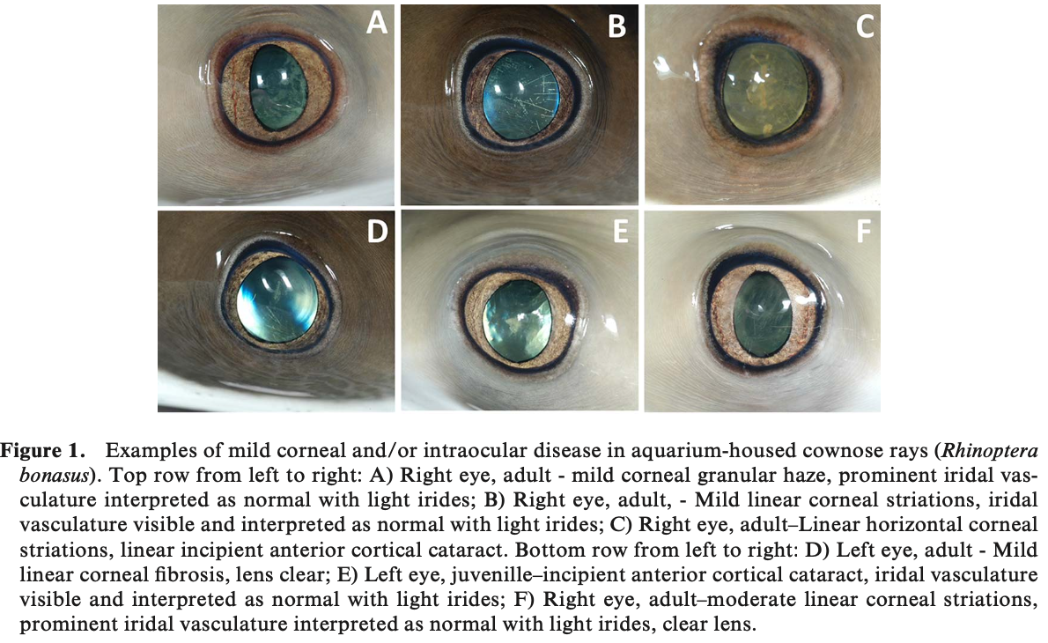
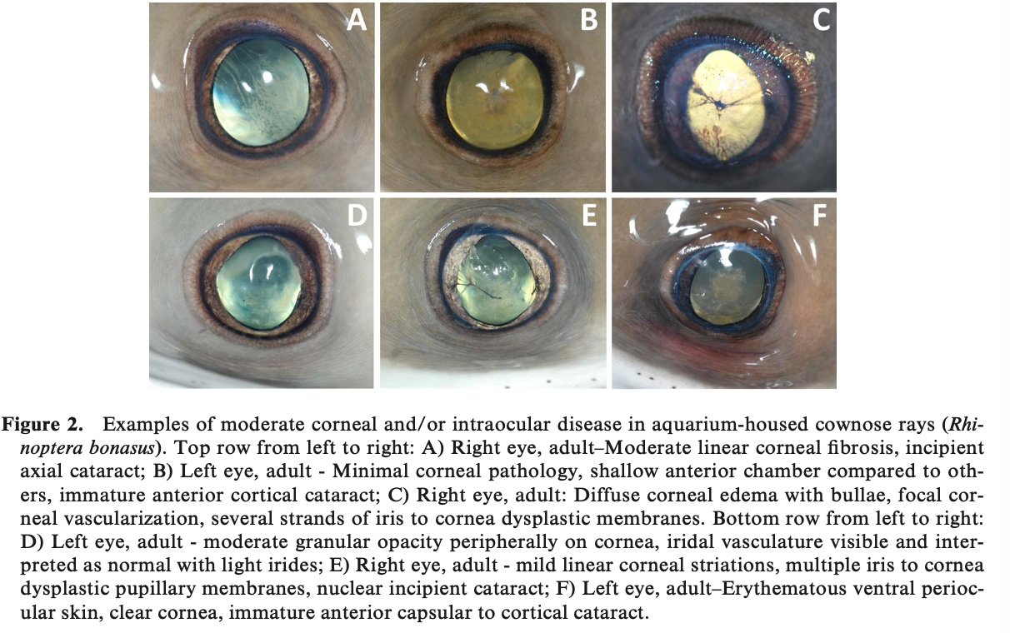
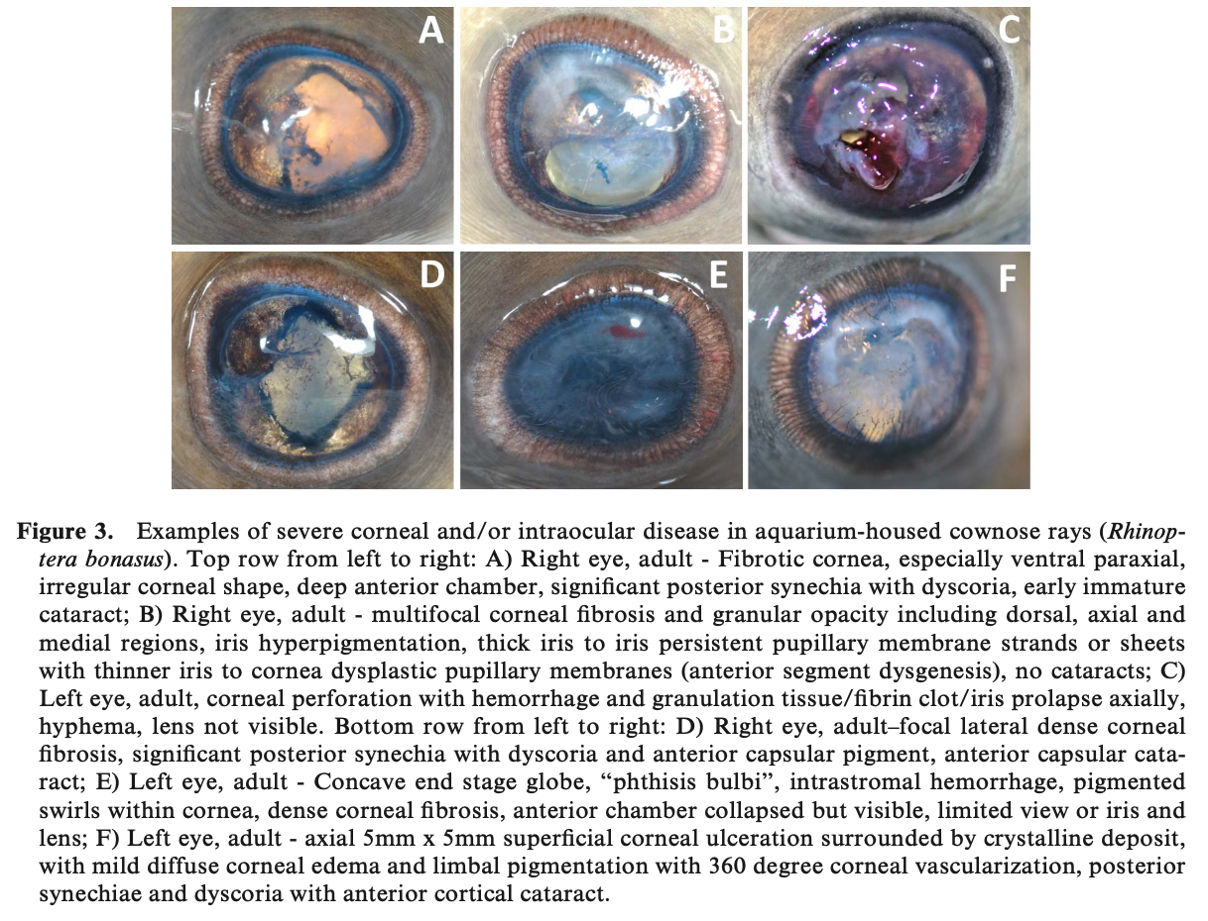
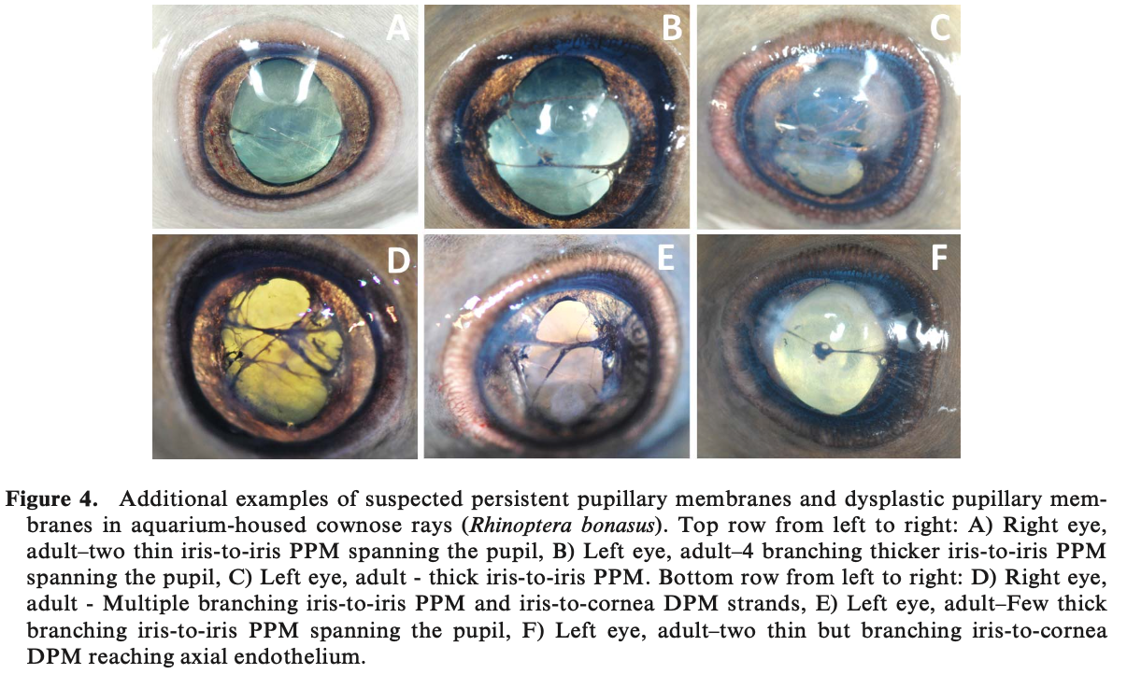

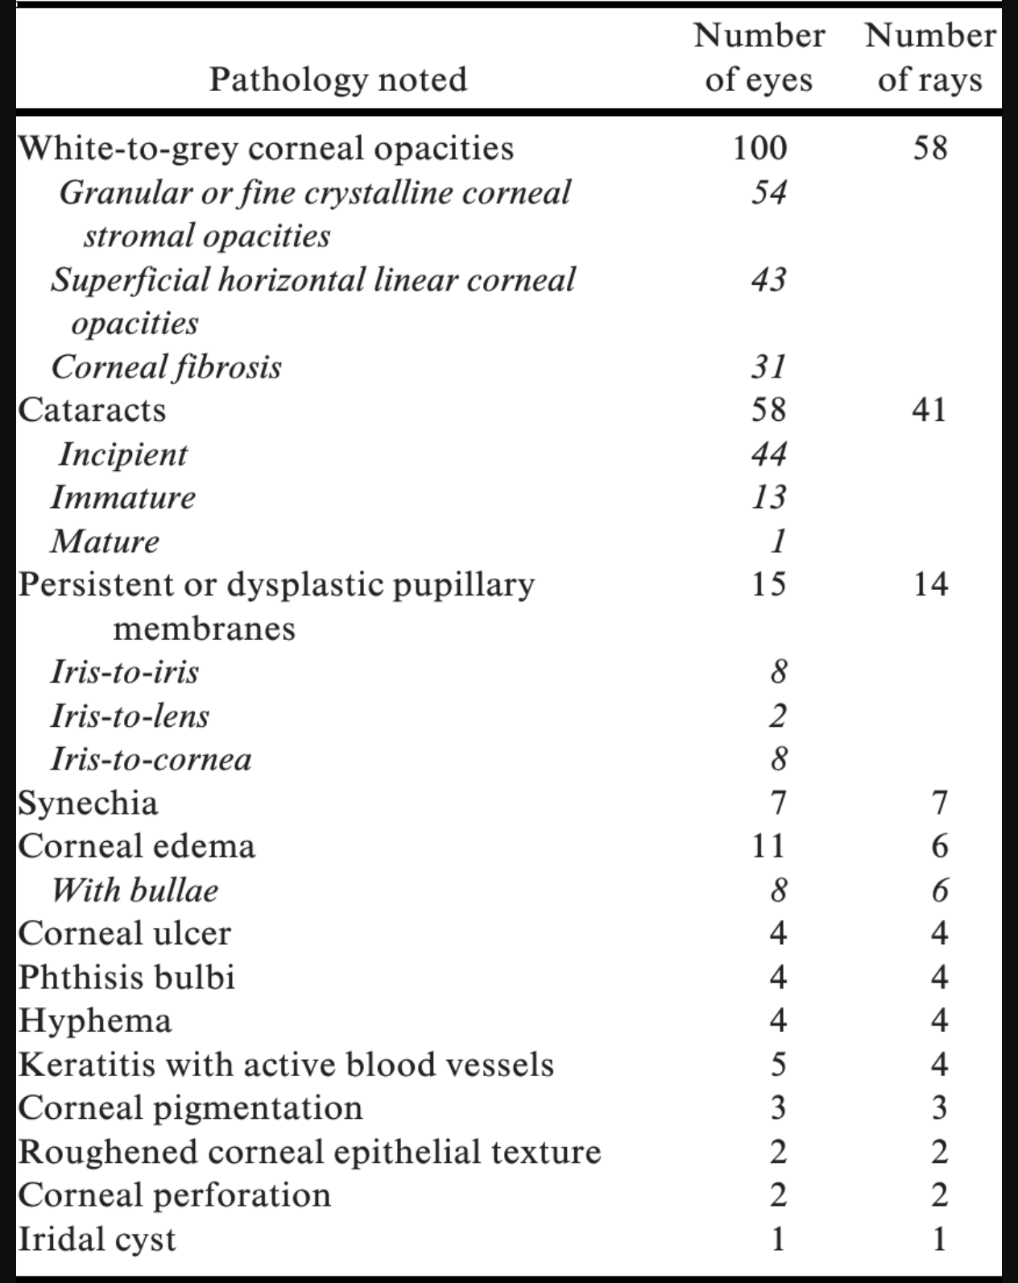

DEXMEDETOMIDINE AND MIDAZOLAM INTRAMUSCULAR SEDATION IN BROWNBANDED BAMBOO SHARKS (CHILOSCYLLIUM PUNCTATUM). JZWM 54.3 (2023). Chang RK, Stevens B, Quijano Cardé EM, Adams LM. - review by LMumm

Abstract: Bamboo sharks are some of the most common elasmobranch species in zoos and aquaria and are frequently sedated for medical exams, treatments, and research. This study investigated the use of an IM sedation protocol of a single dose of dexmedetomidine (0.05 mg/kg) and midazolam (2.0 mg/kg) in n=8 brownbanded bamboo sharks (Chiloscyllium punctatum) . Sharks were serially monitored every 5 min for heart rate, branchial beats, righting reflex, coelomic response, cloacal response, pelvic fin reflex, response to noxious stimulus, voluntary movement, and ability to swim. This sedation dose was effective at rapidly and significantly decreasing responses to tactile and noxious stimuli with minimal respiratory depression and was quickly reversible with atipamezole (0.5 mg/kg) and flumazenil (0.05 mg/kg). Sedated sharks developed a mild metabolic acidosis evidenced by a significant increase in lactic acid (mean < 0.37 mmol/L presedation, 4.2 mmol/L after reversal) and decrease in blood pH (mean 7.464 presedation, 7.277 after reversal); however, clinical intervention was not required. This protocol should be further investigated in different elasmobranch species but is promising for providing sedation for noninvasive procedures in brownbanded bamboo sharks.

Background:
- Benefits of IM sedation in sharks = can be admin underwater with pole in community tanks
  - Other common routes: tonic immobility, immersion, IV medications
- Alpha-2s have benefit of some analgesia in small animals and reptiles; suspect similar in fish
- Shark species with buccal pumping (i.e. bamboo shark) less susceptible to O2 deprivation/resp acidosis than ram ventilators when sedated

Key Points:
- Produced rapid sedation with minimal respiratory depression
  - Higher dexmed doses in pilot (>0.065 mg/kg) did cause more resp depression
  - Lower dexmed doses used alone, and dexmed with lower midaz doses were both inaccurate at producing adequate sedation
- Developed MILD metabolic acidosis (increased lactic acid, decreased blood pH) that did not require medical intervention and did significantly decreased pCO2
- Did not induce significant changes in HR or pelvic fin reflex
- Did decrease response to noxious stimuli, response to response to tactile stimuli (coelomic response, cloacal response), branchial beats, voluntary movement, righting reflex, ability to swim
- Deepest sedation occurred at 30-50 minutes
- Quickly reversible (atipamezole and flumazenil) and uneventful recoveries in all animals
  - All sharks returned to community tank within 30 minutes of reversal agents

TLDR: Dexmedetomidine (0.05 mg/kg) + midazolam (2.0 mg/kg) IM is effective for rapid sedation (decreased tactile and noxious stimuli) with minimal resp depression and is rapidly reversible (atipam/flumaz) in brownbanded bamboo sharks

RETROSPECTIVE REVIEW OF PROPOFOL ANESTHESIA IN MULTIPLE ELASMOBRANCH SPECIES AT GEORGIA AQUARIUM, 2010–2022. JZWM 54.2 (2023). Laura A.B. Aguilar, Cara L. Field, Alexa J. Delaune, Roxane A. Aflalo, Adrienne Atkins, Tonya M. Clauss. – review by LMumm

Abstract: General anesthesia is often required in elasmobranch species for medical procedures. A variety of anesthetic drugs have been administered to elasmobranchs with wide variability in efficacy and safety. A retrospective review of 47 anesthetic procedures using IV propofol in eight different elasmobranch species at the Georgia Aquarium from 2010 to 2022 was performed. Cases involving seven sand tiger sharks (Carcharias taurus), four largetooth sawfish (Pristis perotteti), one longcomb sawfish (Pristis zijsron), four blacktip reef sharks (Carcharhinus melanopterus), three silvertip sharks (Carcharhinus albimarginatus), one sandbar shark (Carcharhinus plumbeus), five cownose rays (Rhinoptera bonasus), and one blotched fantail stingray (Taeniura meyeni) were evaluated. Induction dose of IV propofol (median: 2.5; 25–75%: 2.3–3.0; range: 1.7–4.0 mg/kg), time to desired effect (median: 4.0; 25–75%: 2.0–5.0; range: 0.5–15.0 min) and anesthetic duration (median: 76.0; 25–75%: 61.5–119.0; range: 27–216 min) were reported in all species. In six procedures (12.7%), maintenance of desired anesthetic plane required a supplemental dose of propofol IV (1 mg/kg) or addition of tricaine methanesulfonate (70 mg/L) as an immersion bath. The most common side effects were apnea and prolonged recovery. The IV propofol was efficacious and provided a procedural plane of anesthesia for a clinically relevant period of time in the majority of elasmobranch species, but observation for and management of complications is warranted.

Background:
- Propofol IV and via immersion has been reported in elasmos and teleosts
  - IV: caudal tail vein or dorsal fin sinus in sharks, radial pectoral vessels in rays
  - Following IV injection by shark ringer solution (has urea in it)

Key Points:
- Variable responses and effects of IV propofol across many elasmo species
- Highest propofol dose needed in cownose rays (4 mg/kg) vs. lowest in largetooth sawfish
  - Cownose rays may require higher doses of propofol compared to other elasmos
  - Median IV propofol induction dose for all procedures = 2.5 mg/kg
- Longest time to desired effect in sand tiger sharks and cownose rays vs. shortest in sandbar sharks, silvertip sharks, blacktip reef sharks
- Longest duration in sand tiger and silvertip sharks vs. shortest in cownose and fantail rays
- Sand tiger sharks appear more sensitive to propofol vs. other elasmos and may require lower doses for induction
  - Had longest mean time to desired effect, longest mean duration of anesthesia, and prolonged recoveries
- Blood lactate increased and blood pH slightly decreased over time in most species
- Supplemental immersion MS222 or additional propofol IV needed for 6/47 procedures
- Most common side effects: apnea in sharks (but not rays), prolonged recovery in sand tigers
  - Did not experience hyperexcitability as often seen with MS222 alone

TLDR: IV propofol can be safely used for induction of anesthesia in elasmobranchs however sand tiger sharks may be more sensitive/require lower doses (long time to desired effect, long duration of GA, prolonged recoveries), and apnea is a common side effect in sharks (but not rays).

American Journal of Veterinary Research. 84(7): 1-10. 2023.
ESTABLISHMENT OF A 2-DIMENSIONAL ECHOCARDIOGRAPHIC PROTOCOL AND REFERENCE PARAMETERS FOR CLINICALLY HEALTHY SOUTHERN STINGRAYS (HYPANUS AMERICANUS).
Laura Martinelli

Abstract:
OBJECTIVE: To establish an echocardiographic technique and 2-dimensional reference parameters for southern stingrays (Hypanus americanus). A second objective was to compare echocardiographic measurements obtained from animals of different sex, size, environment, handling technique, and position.

ANIMALS: 84 presumed healthy, wild, semiwild, and aquarium-housed southern stingrays.

PROCEDURES: Animals, anesthetized and manually restrained, were positioned in dorsal recumbency, and echocardiography was performed. A subset of this population was also imaged in ventral recumbency for comparison.

RESULTS: Echocardiography was feasible, and reference parameters were established for this species. While some standard measurements could not be assessed due to body habitus, all valves, chambers, and the conus were clearly visualized in the majority of animals. Statistical significance was reached for some variables when comparing animals from different environments and handling methods, but these differences were not considered clinically relevant. The data were therefore separated into 2 subsets of echocardiographic reference parameters based on disc width since some of the measurements were dependent on body size. This approach mostly separated the sexes due to strong sexual dimorphism.

CLINICAL RELEVANCE: Limited information is available regarding cardiac disease in elasmobranchs; most of the available information on cardiac physiology focuses on a few shark species. Two-dimensional echocardiography is a noninvasive tool utilized to evaluate cardiac structure and functionality. Southern stingrays are one of the most commonly displayed elasmobranchs in public aquaria. This article expands on the growing body of information regarding veterinary care in elasmobranchs and provides clinicians and researchers with another diagnostic modality to utilize in screening for health/disease.
Key Points:
- Elasmobranchs have 2-chambered heart
  - Sinus venosus – receives systemic blood
  - Chamber 1 = Atria
  - Chamber 2 = Ventricle
  - Conus arteriosus – distributes blood to gills
- Able to visualize heart by placing transducer in longitudinal plane just cranial to coracoid bar
- Divided results into disc width <80 cm and disc width >80cm (based on data plotted and identification of distinct populations, also females sexually mature around 80 cm)
  - No males in dataset >80 cm; a few females in the dataset <80 cm
- Flow velocities could not be obtained due to anatomical constraints, but all chambers and valves were consistently visualized and standard 2-dimensional measurements (eg wall thickness and ventricular chamber sizes) were obtained.
- Conal and AV valves consistently observed but sinoatrial valve more difficult to identify
- Elasmobranch Cardiac Physiology Review
  - Rely much more heavily on stroke volume than on alteration of heart rate to alter cardiac output; so HR remains relatively constant between periods of exercise and rest in elasmos
  - Rely heavily on changes in pericardial pressure to regulate stroke volume (unlike a mammal that changes stroke volume mostly via vascular and autonomic tone) this can be done because they have a relatively more rigid, noncompliant pericardium (unlike a mammal that is looser)
    - The rigid pericardium creates more negative pericardial pressure
    - Greater negative pericardial pressure leads to increase in transmural (distending) pressure of both atrial and ventricular walls
    - Greater transmural pressure leads to increased venous return
    - Increased venous return enhances the Frank-Starling mechanism leading to increased stroke volumes
  - Studies demonstrate elasmo’s can alter volume of pericardial fluid via pericardioperitoneal canal. During high output states (like exercise) pericardial fluid is evacuated from the pericardial space through this canal allowing for decrease in pericardial pressure. Since pericardial pressure and cardiac output are inversely related, this results in an increase in the stroke volume and therefore increased cardiac output.
  - Based on relationship between stress, pericardial fluid volume, and cardiac filling, animals experiencing higher level of stress during handling would be expected to have larger ventricular chamber sizes, smaller ventricular wall measurements, larger valve diameters, and higher fractional shortening and ejection fractions compared to nonstressed animals. However, all animals in study (regardless of wild, semiwild, captive or anesthetized vs. Non-anesthetized) had low corticosterone (measured as part of a concurrent study) and markers of ventricular chamber size and function were not statistically different.
  - Some statistically sig differences between environments (wild, semiwild, captive), restraint, sex, size, and approach, only size and sex were deemed clinically relevant. However, due to pronounced sexual dimorphism (females bigger than males), suspect that is the main reason for sig differences rather than true sexual dimorphism.
  - Some sig differences between dorsal and ventral approaches but not considered clinically relevant. Either approach considered acceptable by authors.
Take Home Point: Echocardiography was feasible in southern stingrays and parameters were established. Significant differences between sex and size were considered clinically relevant and led to echo reference parameters based on disc width.
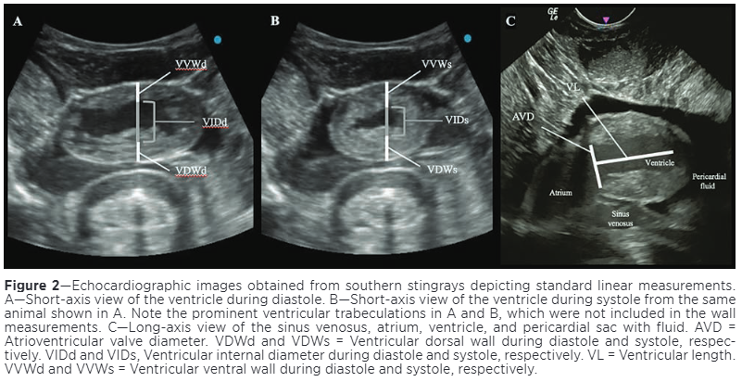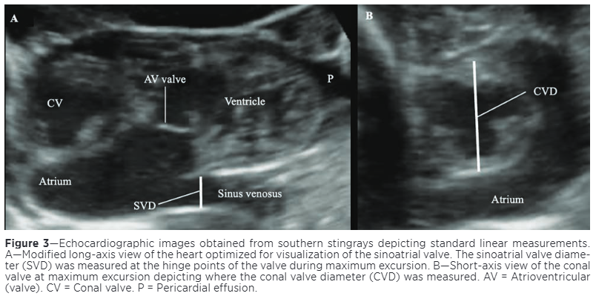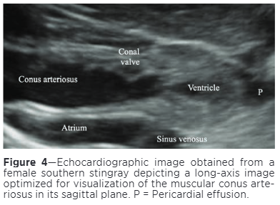
------------------------------------------------------------------------------------------------------------------
Journal of Zoo and Wildlife Medicine. 53(2): 363-372. 2022. DIAGNOSIS AND MANAGEMENT OF SUSPECTED CONGESTIVE HEART FAILURE SECONDARY TO DILATED CARDIOMYOPATHY IN A SAND TIGER SHARK (CARCHARIAS TAURUS) WITH ESTABLISHMENT OF PRELIMINARY NORMAL ECHOCARDIOGRAPHIC INDICES.
Laura Martinelli
Abstract: Elasmobranch cardiac anatomy and physiology has been well described; however, there is a dearth of information regarding cardiac disease. In support of a clinical case of suspected congestive heart failure in a 22-yr-old male sand tiger shark (Carcharias taurus), a study was undertaken to identify feasible echocardiographic imaging planes and preliminary indices for this species. Eleven echocardiograms were performed on six apparently healthy sand tiger sharks. Echocardiographic parameters are presented using descriptive statistics, including mean, median, standard deviation (SD), minimum and maximum values. These data were utilized for the diagnosis and clinical management of the affected shark. The shark initially presented with increased respiratory effort, dependent, peripheral edema, and anemia. Echocardiography revealed atrial, ventricular, and sinus venosus dilation. As congestive heart failure secondary to dilated cardiomyopathy was strongly suspected, therapy was initiated with oral benazepril and torsemide, and later pimobendan. After a year of therapy, clinical signs resolved. Cardiac size and function improved on echocardiography with a reduction in sinus venosus dilation, maximum and minimum atrial and ventricular inner diameters, and an increase in atrial and ventricular fractional shortening. Cardiac disease in elasmobranchs may be underdiagnosed, so it may be necessary to develop standardized ultrasound techniques and cardiac measurements for each species of elasmobranch managed within zoos and aquaria.
Key Points
- Elasmobranch heart
  - Atrium, Ventricle = Cardiac muscle
  - Sinus venosus, Conus arteriosus = Smooth muscle interspersed with cardiomyocytes
- Elasmobranch cardiac physiology
  - HR remains steady (even with exercise, etc) as cardiac output more heavily influenced by stroke volume. Change stroke volume by regulating pericardial pressure via alteration of pericardial fluid volume by use of the pericardioperitoneal canal
  - Lack sympathetic innervation to heart, rely on parasympathetic via vagus nerve and circulating catecholamines.
  - Catecholamines exert positive inotropic and chronotropic effects to atrium and ventricle via β-adrenoreceptors to counteract parasympathetic innervation
  - Cardiorespiratory coupling often occurs, gill ventilation in sync with heart rate
- Index Case
  - 22 yo wild caught male sand tiger shark managed in public aquaria
  - Initial Presentation: increased resp effort (increased mouth gape and buccal pumping) as well as focal, dependent, peripheral edema involving both claspers and base of pelvic fins
  - Initial Echocardiogram: atrial, ventricular, sinus venosus dilation; reduced atrial and ventricular contractility; hepatic veins emptying into sinus venosus subjectively dilated – presumptive dilated cardiomyopathy with secondary congestive heart failure
  - Initial bloodwork identified moderate anemia (11%) but otherwise unremarkable (included CBC, chemistry, protein electrophoresis, and blood gas analysis)
  - Treatment with oral benazepril, torsemide started. Iron dextran course also administered IM for anemia.
    - Benazepril chosen for reduced dosing frequency (over other ACE-inhibitors)
    - Torsemide chosen over furosemide because torsemide has higher and more predictable bioavailability, longer duration of action, decreased susceptibility to diuretic resistance, and adjunctive aldosterone antagonistic properties
  - After two months, edema worsened – increased benazepril and torsemide dosage
  - After six months, edema continues to progress and resp effort still apparent – elected to add pimobendan at this point. (It was increased in dose a month after starting because it was well-tolerated but no echo changes apparent.)
  - From initiation of pimobendan, recheck exams at 3, 6, 9, and 12 months showed progressive clinical and echo improvements
    - Anemia resolved by 6 mon
    - Peripheral dependent edema, dyspnea resolved by 9 mon
  - One year of pimobendan therapy alongside benazepril and torsemide -> all echo indices normalized within the ranges of the healthy sharks
  - Discussion Points
    - The systolic dysfunction presumably led to decrease in cardiac output, which likely caused chronic hypoxia/hypoxemia resulting in increased mouth gape to improve oxygenation
    - Cause of the DCM unknown in this case. DDX include toxic insult, nutritional deficiency, metabolic derangements, genetics, myocarditis, and idiopathic. Top differentials for this case are idiopathic or an infectious/inflammatory myocarditis.
- Reference Echocardiograms
  - To better assist index case, 10 echocardiograms performed on five clinically normal aquarium-housed individuals and one wild sand tiger shark during field research (date combined because findings similar between aquarium-housed and wild shark)
  - Positioned in dorsal recumbency, tonic immobility, with ram ventilation via PCV pipe
  - Ultrasound placed just cranial to coracoid bar of pectoral girdle
    - To get sinus venosus in view had to go caudal to the coracoid bar and was sitting in the cranial liver
Take Home Point: First report of presumptive DCM and secondary CHF in Sand Tiger Shark. Case successfully managed with pimobendan. Also, authors established reference parameters for echocardiograms in healthy Sand Tiger Sharks.
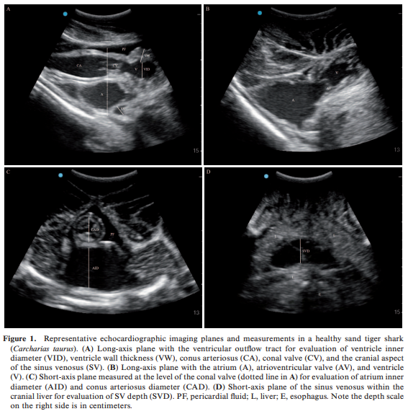
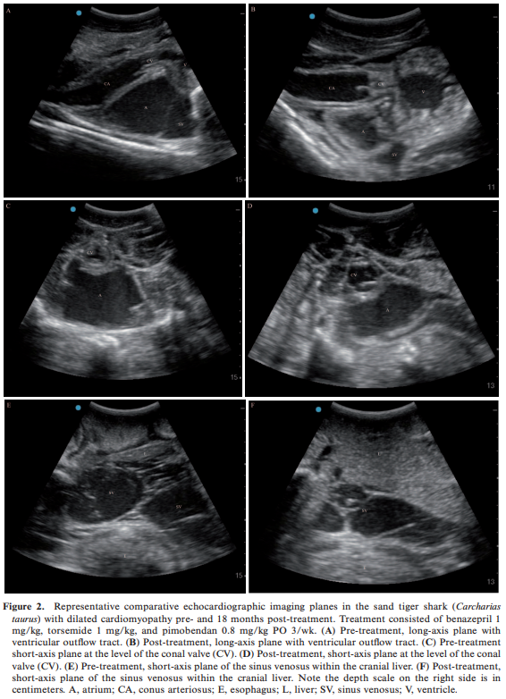
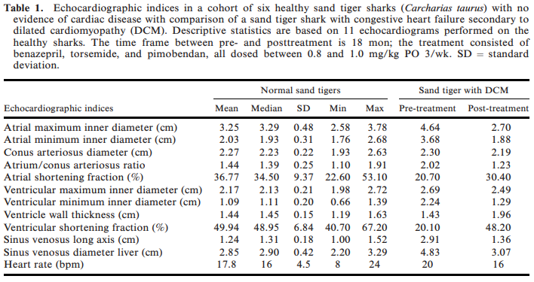------------------------------------------------------------------------------------------------------------------
Journal of Zoo and Wildlife Medicine. 54(2): 401-405. 2023. MANAGEMENT OF SUSPECTED DILATED CARDIOMYOPATHY WITH PIMOBENDAN IN TWO LEOPARD SHARKS (TRIAKIS SEMIFASCIATA).
Laura Martinelli
Abstract: Two adult male leopard sharks (Triakis semifasciata) under managed care were diagnosed with suspected dilated cardiomyopathy. Clinical signs included lethargy, inappetence, and regurgitation. On cardiac ultrasound, fractional shortening was 14% and 10%, respectively (versus 21%–31% in four healthy conspecifics). Ventricular end-diastolic diameter to body weight ratio was 1.72 cm/kg in Case 1 (versus 0.52–1.24 cm/kg in four conspecifics). These results collectively suggested a dilated cardiomyopathy. Treatment was implemented with oral pimobendan at 0.3 mg/kg q48h for 1 mon. The pimobendan dose was increased to 0.5 mg/kg 3/wk, following plasmatic dosage of pimobendan and its metabolite. After 3 mon, fractional shortening increased to 38% and 20%, respectively, sharks regained a normal appetite, and body weight increased by 50% in one individual. After 2 yr, both individuals remained clinically normal, and no adverse effect was noted with pimobendan administration. Pimobendan plasma concentration suggested that this medication was well absorbed in this species.
Key Points:
- Dilated cardiomyopathy characterized by ventricular dilation and decreased contractility, which may lead to congestive heart failure
- Pimobendan = calcium sensitizer and phosphodiesterase inhibitor, positive inotrope and vasodilator commonly used to treat DCM in domestic animals
- Case 1
  - 3 yo male Leopard Shark, always in managed care
  - Presentation = Hyporexia, lethargy, weight loss, regurgitation
  - Work-up = Coelomic effusion, bloodwork normal, blood culture negative
  - Echocardiogram (a few months later) = lower factional shortening and higher ventricular end-diastolic diameter to body weight ratio (compared to clinically normal conspecifics) suggestive of DCM
- Case 2
  - >14 you male Leopard Shark, wild caught
  - Presentation = Slow swimming, hyporexia
  - Work-up = Bloodwork normal
  - Echocardiogram = low fractional shortening suggestive of DCM
- Both cases treated with pimobendan at 0.3 mg/kg but had to increase to 0.5 mg/kg after testing plasma concentrations. Improved concentrations with higher doses BUT stopped checking case 1 because it “displayed cardiac arrest during anesthesia and was successfully resuscitated by ventilation with a water-filled syringe and cardiac compression”
- Both cases regained normal appetite and activity level a few weeks after starting pimobendan
- Ventricular fractional shortening increased at 3 mon recheck and was within normal limits by 2 yr recheck echo
- Both cases remained on pimobendan for rest of lives
- Case 2 was euthanized 2 yr 4 mon after starting pimobendan for vertebral lesions and ecreased mobility, on necropsy no cardiac histologic lesions were noted
- The etiology of DCM in these sharks remains undetermined
Take Home Point: Elasmobranchs with cardiac disease can present with variable clinical signs and in cases of presumptive dilated cardiomyopathy, Leopard Sharks respond well to oral pimobendan.
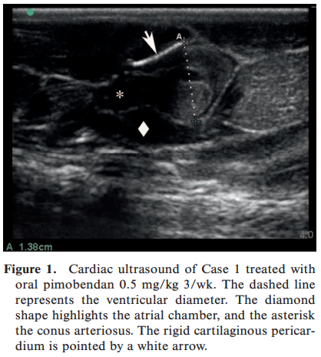
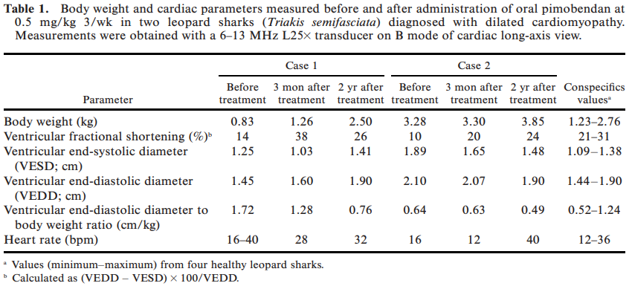

PHARMACOKINETICS OF ROBENACOXIB AFTER A SINGLE INTRAMUSCULAR DOSE IN SMOOTH DOGFISH (MUSTELUS CANIS).
David J. Minich, MAS, DVM; Melissa A. Fayette, DVM, DAZCM; Sherry Cox, MS, PhD

Abstract:
OBJECTIVE: To determine the pharmacokinetics of robenacoxib after a single intramuscular dose (4.0 mg/kg) in smooth dogfish (Mustelus canis).
ANIMALS: 8 healthy adult male smooth dogfish in human care within the same habitat.
METHODS: All sharks received a single intramuscular dose of robenacoxib (4.0 mg/kg) in the right caudolateral epaxial musculature. Blood samples were collected under manual restraint from the ventral tail vessel at 30 minutes, 1 hour, 2 hours, 4 hours, 8 hours, and 24 hours after drug administration. Plasma drug concentrations were determined by HPLC followed by noncompartmental pharmacokinetic analysis of the data.
RESULTS: A maximum plasma concentration of 1.24 μg/mL was reached at a mean time of 30 minutes following robenacoxib administration with a plasma elimination half-life of 3.79 hours. Plasma concentrations did not fall below the lower limit of quantification (0.1 μg/mL) at the time points sampled in this study.
CLINICAL RELEVANCE: Intramuscular administration of a single dose (4.0 mg/kg) of robenacoxib in smooth dogfish resulted in rapid absorption to a maximum concentration at approximately 30 minutes after administration and persisted above levels considered to be therapeutic in domestic species for at least 8 hours.

- Elasmobranchs are commonly housed in aquaria- with trauma being the third most prevalent condition

Key Points:
- Robenacoxib (Onsior)
  - Highly selective COX-2 inhibition with weak inhibition of COX-1
  - Highly protein bound 🡪 easily transported to sites of inflammation in body and remains at sites longer than within blood
- Three animals showed mild bruising under the injection site shortly after administration
- Compared to rainbow trout, smooth dogfish had shorter mean time to plasma concentration, shorter mean terminal half-life, and higher C max but higher dose used in smooth dogfish

Take Home Point: IM Robenacoxib (4 mg/kg) in smooth dogfish results in rapid absorption (30 min) and plasma concentrations above levels considered therapeutic in domestic species for at least 8 hours.

Pharmacokinetics of meloxicam after a single 1.5 mg/kg intramuscular administration to nursehound sharks (scyliorhinus stellaris) and its effects on hematology and plasma biochemistry.
Morón-Elorza P, Rojo-Solís C, Álvaro-Álvarez T, Valls-Torres M, García-Párraga D, Encinas T.

A single-dose meloxicam pharmacokinetic (PK) study was performed with eight clinically healthy nursehound sharks (Scyliorhinus stellaris) maintained under human care. Meloxicam was administered IM at a dosage of 1.5 mg/kg to six animals; two animals were administered elasmobranch physiological saline solution (EPSS) IM as a negative control group. Blood samples were obtained prior to and at 12 predetermined times during the first 36 h after administration. Effects on hematology and plasma biochemistry were compared prior to and 24 h after administration. No animal died or showed clinical signs during the study. A significant increase in creatinine kinase and aspartate aminotransferase was found in both EPSS and meloxicam groups and could be considered a direct consequence of sampling and handling required for the PK study. Observed mean time to maximum plasma concentration ± SEM was 2.58 ± 0.47 h and observed mean maximum plasma concentration ± SEM was 806 ± 66 ng/ml; mean terminal half-life ± SEM was 15.97 ± 1.20 h; mean residency time ± SEM was 23.40 ± 2.25 h. Area under the plasma concentration–versus-time curve extrapolated to infinity ± SEM was 15.52 ± 1.70 h·µg/ml. This study suggests that meloxicam 1.5 mg/kg IM in nursehound sharks is likely to result in clinically relevant plasma levels for periods of 24 h without producing significant alterations in blood analytics, although further PK studies with meloxicam IV in sharks are needed. Future PK and pharmacodynamic studies with different drugs and doses are needed in elasmobranchs to establish safe and effective treatment protocols.

Background
- Shark WBC
  - Fine eosinophilic granulocytes - granulocyte type I; heterophil-like cells
  - Neutrophil - granulocyte type II; neutrophil-like cells
  - Coarse eosinophilic granulocyte - granulocyte type III; eosinophil-like cells
  - Granulated thrombocytes
  - Lymphocytes
  - Monocytes
- In vitro equine studies - plasma meloxicam 150-250 ng/ml can effectively inhibit COX-2.3
Key Points
- 1.5 mg/kg meloxicam (5 mg/ml) IM in epaxial mm. and blood drawn while manually restrained
  - Preliminary study with 0.2 and 0.5 mg/kg IM and IV had low plasma concentrations
- Rapid absorption, prolonged elimination, potentially therapeutic levels for at least 24hr
  - Tmax and T1/2 were longer in sharks than previous study in fish (tilapia 1 mg/kg)
- No change in CBC results 24hr after meloxicam
- Elevated CK and AST, lower elevation in LDH after PK study in meloxicam and control/saline sharks - presumed from repeated handling +/- IM injection
- No evidence of adverse effects or toxicity
Conclusions
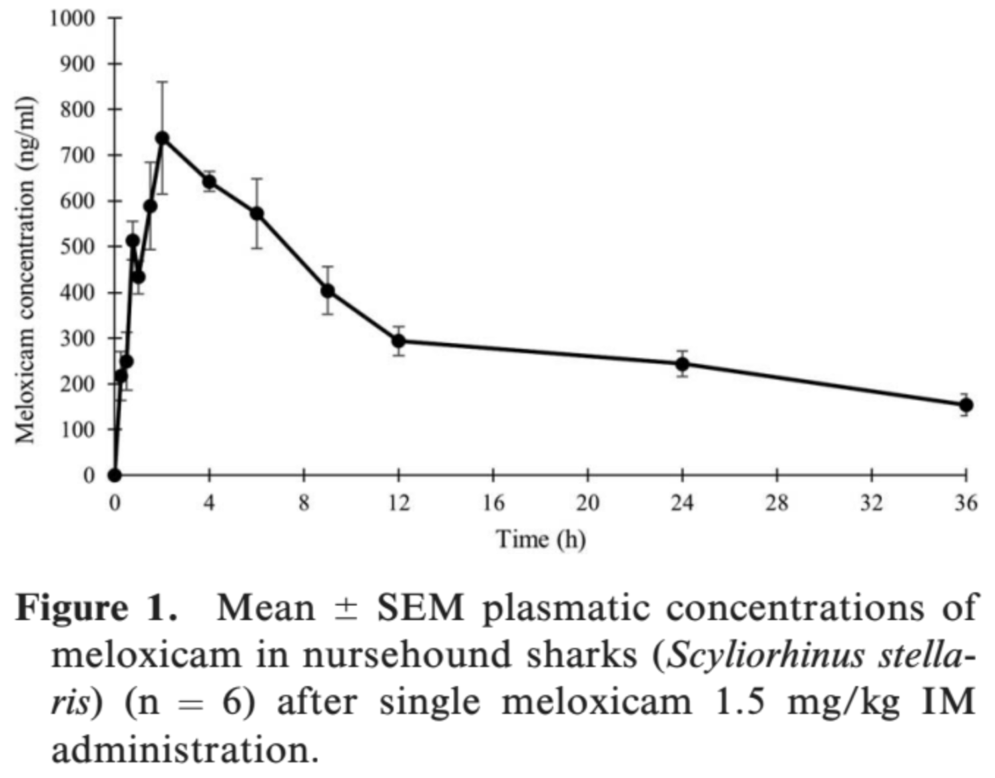
- Single dose meloxicam 1.5 mg/kg in nursehound sharks had theoretically therapeutic plasma concentrations with no adverse effects or changes in BW, possible interdose period of 16-24hr
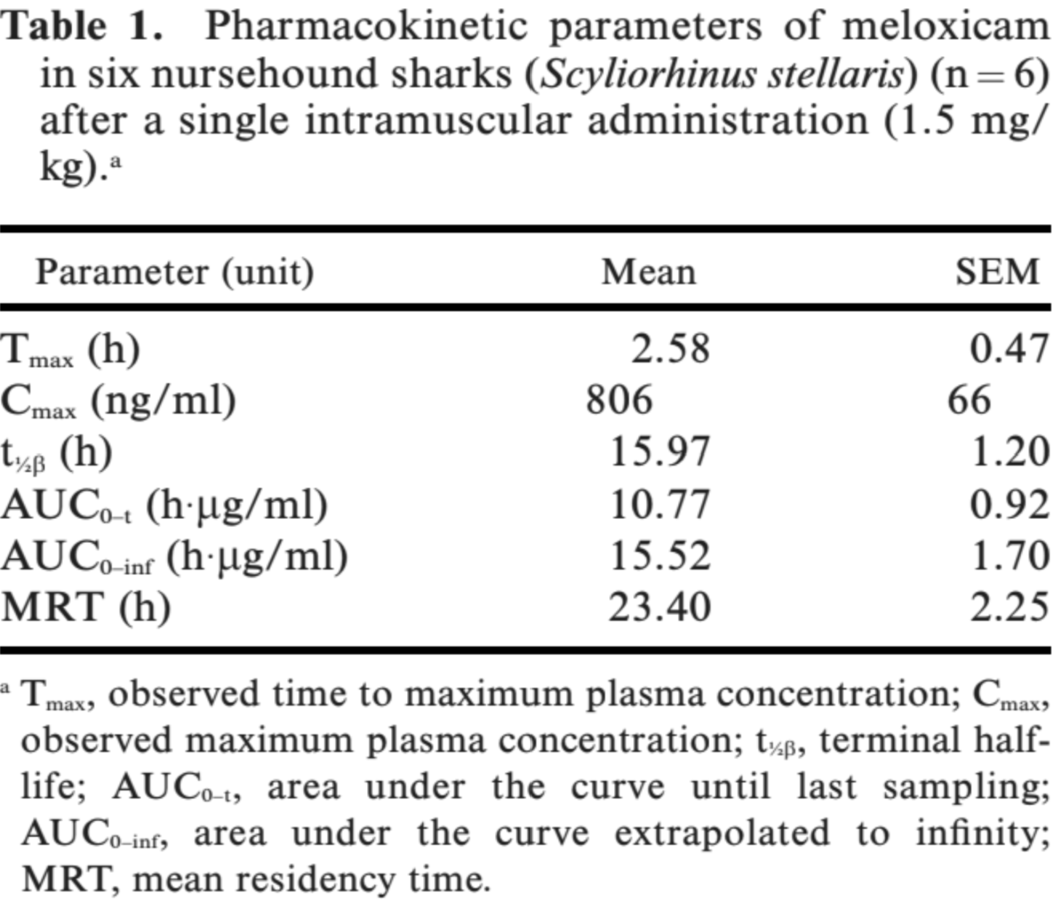
  - Repeated handling (suspected) caused elevations of muscle damage enzymes (CK, AST, LDH)

PHARMACOKINETICS OF A SINGLE DOSE OF INTRAMUSCULAR AND ORAL MELOXICAM IN YELLOW STINGRAYS (UROBATIS JAMAICENSIS)
Kane, Lauren P., Matthew R. O'Connor, and Mark G. Papich

Abstract: Elasmobranchs are popular display animals in public aquaria and zoos, but medical management gaps remain in the understanding of the pharmacokinetics of analgesics and pain management in these species. Meloxicam is a nonsteroidal anti-inflammatory drug that has been evaluated intravenously and intramuscularly in teleosts, but has yet to be studied in any elasmobranch species. The pharmacokinetics of meloxicam were determined in 17 yellow stingrays (Urobatis jamaicensis). All stingrays were determined to be healthy from complete physical examinations and baseline bloodwork performed prior to study inclusion. A single dose of 1 mg/kg meloxicam intramuscularly was administered to all rays, followed by a 2 mg/kg oral dose after an 8 wk washout period. Blood samples were collected from the mesopterygial vein at baseline and nine time points up to 96 h after administration of meloxicam. Plasma concentrations were determined using reversed-phase highperformance liquid chromatography. Pharmacokinetic analysis was performed using a noncompartmental technique. The mean peak plasma concentrations for intramuscular and oral meloxicam were 1.29 and 0.42 lg/ ml, respectively. The mean terminal half-lives of meloxicam after intramuscular and oral administration were 5.75 and 15.46 h, respectively. Based on these findings, the recommended meloxicam dosage and frequency for yellow stingrays is 2 mg/kg orally once daily. Due to rapid elimination with the intramuscular administration, maintaining clinically relevant plasma concentrations may be difficult using this route. Further studies are needed to determine multidose pharmacokinetics of meloxicam in yellow stingrays, as well as single-dose and multidose pharmacokinetics in other elasmobranch species.

Intro
· The objective of this study was to determine the pharmacokinetic data of a single dose of intramuscular and oral meloxicam in yellow stingrays
M&M
· 17 healthy yellow stingrays (Urobatis jamaicensis)
· Single dose of meloxicam 1 mg/kg IM followed by 2 mg/kg PO after 8-week washout
Results
· Easy to administer, no adverse effects noted 4 months post study
· The mean peak plasma concentrations for intramuscular and oral meloxicam were 1.29 and 0.42 lg/ ml, respectively. The mean terminal half-lives of meloxicam after intramuscular and oral administration were 5.75 and 15.46 h, respectively
Discussion
· Oral meloxicam administration in yellow stingrays produced variation in the pharmacokinetic analysis. The reason for this variation is undetermined without further study, but may be due to differences in plasma protein binding and biotransformation pathways
· Both administration routes produced plasma concentrations
· however, significant variability was appreciated with oral administration. Oral meloxicam maintained above therapeutic plasma concentrations for 16 h and intramuscular for only 6 h.
· Due to this, it is recommended that meloxicam be administered to yellow stingrays at 2 mg/kg orally once daily.
· Intramuscular administration is not recommended at this time due to rapid elimination and unsustainable clinically relevant plasma concentrations.

J Am Vet Med Assoc. 2023;261(8):1-4.
Summarized by MR

Production of live offspring following unilateral (left) ovariectomized Potamotrygon rays (Potamotrygon castexi, Potamotrygon leopoldi, and Potamotrygon motoro)
Chelsea E. Anderson, DVM, Cert AqV1*; James D. Gillis, PhD2; Sarah N. Miller, DVM; Michelle R. Davis, DVM, DACZM1
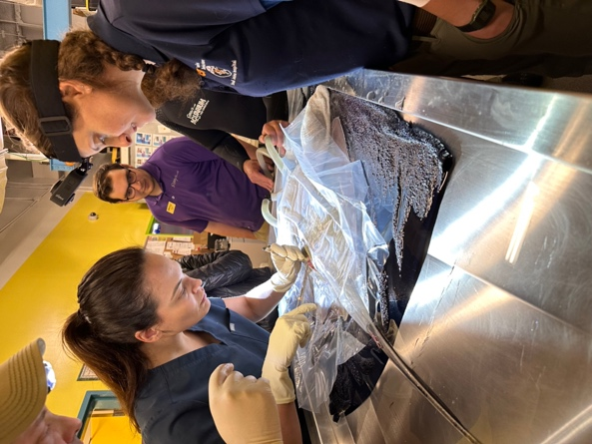
OBJECTIVE: To evaluate the surgical technique and subsequent clinical observations (reproductive and ultrasound findings) of left unilateral ovariectomy in 3 species of Potamotrygon rays—Potamotrygon castexi, Potamotrygon leopoldi, and Potamotrygon motoro—for reproductive management.
ANIMALS: Between 2018 and 2019, multiple Potamotrygon rays (P castexi, n = 1; P leopoldi, 1; P motoro, 6) underwent left
ovariectomies to evaluate this technique for reproductive management.
PROCEDURES: At time of surgery, patient age ranged from juvenile to adult. Rays were anesthetized with MS222 buffered with sodium bicarbonate, and a left craniodorsal surgical approach was made to isolate and excise the left ovary. All rays
had uneventful recoveries. Eight unilateral ovariectomized females and 6 males were combined in a mixed species
freshwater touch pool of Potamotrygon rays and teleost species.
RESULTS: In December 2020, 3 live and 1 premature autolyzed pup were noted in the habitat. The following day, the adult females were examined via ultrasound and separated from the males. Four dams were identified that produced 8
Left unilateral ovariectomy on a cownose ray... about a month before this paper came out
viable offspring and 4 premature abortions. A large right ovary was observed in all females, with no evidence of left
ovarian tissue present via ultrasound.
CLINICAL RELEVANCE: Previous histologic evaluation of freshwater ray ovarian tissue suggests both ovaries may be functionally active yet maintain left dominance like some other elasmobranch species. This manuscript provides proof the right ovary alone can produce live offspring. Furthermore, the enlarged right ovary observed in these females suggests that removal of the left ovary may result in compensatory enlargement of the right ovary.

Background:
- Potamotrygon sp. believed to be left ovary dominant with vestigial right ovaries
- Acquired n = 14 individuals for mixed-species touch pool: contraception required due to inability to deaccession any potential offspring.
- Administration of GnRH agonists to contracept elasmobranchs has had poor to limited success
  - 7 different types of GnRH found in elasmobranch species
- Due to space constraints, separation of sexes was not an option
- Left ovariectomies have been used successfully in other batoids including southern stingrays

Overlapping Features:
- U/S: normal-sized left ovaries and small or nonvisible right ovaries prior to surgery
- Left craniodorsal approach surgical approach
- N = 8 ovariectomized females + 6 males combined in mixed spp. exhibit in Jul 2020 Dec 2020: 3 live mature and 1 pre-mature autolyzed pup
- All females received transcoelomic ultrasound: 4/8 currently or recently gravid and produced 8 viable offspring.
- The consistent notable finding of all left ovariectomized females on ultrasound examination was a large right ovary with no evidence of left ovarian tissue
- Histopathology
  - right ovary: germinal epithelium and atretic follicles
  - left ovary: corpus lutea and atretic follicles, ovulation occurred only on the left size
- Given the timeline of surgery and delayed reintroduction to males, it is unclear whether the access to males specifically drove the enlargement of the remaining right ovary.

Take Home Points:
- Successful reproduction can occur in this species in the absence of the left ovary
  - Although smaller in size, the right ovary may be functional in potamotrygonids
- Unilateral ovariectomy is not a recommended method of contraception in Potamotrygon sp.
- Bilateral ovariectomy may remove the entire epigonal organ, partial epigonadectomies have been successful in other spp.
- Maintain separate sex habitats as the most reliable method of reproductive management…

Journal of Zoo and Wildlife Medicine 54(1): 40–48, 2023
Summarized by MR

EFFECTS OF A GNRH VACCINE AND DESLORELIN ACETATE IMPLANTS IN MALE FRESHWATER STINGRAYS (POTAMOTRYGON SP.)
Anaı ̈s Sailler, DVM, Sylvie Laidebeure, DVM, and Alexis Le ́cu, DVM, DECZM (ZHM)

Abstract: Very little information is available in veterinary literature concerning chemical contraception in elasmobranchs. To decrease breeding and adverse reproductive behaviors, male Potamotrygon sp., housed in two zoologic institutions, were treated using methods used in other elasmobranchs. Four animals received deslorelin acetate implants (Suprelorin 4.7 mg and 9.4 mg), four animals received a gonadotropin-releasing hormone vaccine (Improvac 50–100 lg) twice separated by 1 mon, and two animals were not treated to serve as controls. Health checks, including blood sampling, coelomic ultrasound, and sperm analysis, were performed bimonthly and then monthly over almost 2 yr. Microscopic examination of sperm never revealed any significant change in concentration or motility. Size of testes and seminal vesicles glands did not change significantly after treatment. Plasma testosterone concentrations were stable (~1 ng/ml) in intact and vaccinated animals throughout the study period. Plasma testosterone level increased significantly after deslorelin implantation and remained very high for at least 13 mon, never returning to initial values. Peak concentration varied according to the deslorelin acetate concentration used. Aggression toward females continued despite the use of contraception. Histopathologic examination on dead stingrays revealed active testicular tissue. These results suggest that deslorelin acetate implants and GnRH vaccine are ineffective at dosages used in our cases. Implants caused a continuous stimulation of the hypothalamic-pituitary-gonadal axis that could be harmful for the animals.

Background:
- Potamotrygonidae family are seasonal breeders in the wild, but breed year round under human care
  - Linked to variations in water levels and pulse flooding in natural habitat
- Challenges with reproductive management include male aggression, lack of successful contraceptive options, surgical castration risks (radial architecture, epigonal organ)
- One study evaluating GnRH antagonists (Antide) modified plasma androgens in sand tiger sharks
- Cartilaginous fishes lack a direct vascular connection from the hypothalamus to the ventral lobe of the pituitary gland; thus, GnRH is likely released into the general circulation

Summary:
- N = 6 male P. motoro, P. castexi, P. jabuti from two institutions
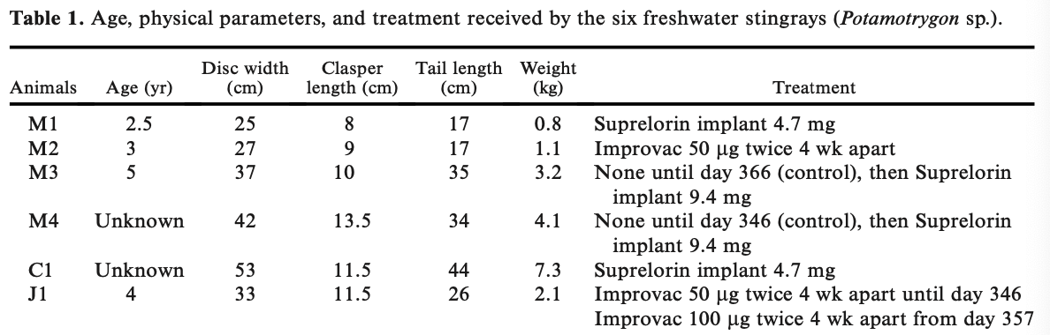
- No adverse reaction at the site of implant or injection
- Testosterone levels were not significantly different between Improvac treated animals at either dose when compared to controls
- Rays implanted with either 4.7 or 9.4mg deslorelin acetate had significantly higher testosterone levels than control
  - Testosterone levels remained high for at least 13 mon., never decreasing
- Sperm was highly concentrated, motile, without morphologic abnormalities in all groups
- N = 4 necropsies in this group over 2 yr: testes microscopically active for all four individuals

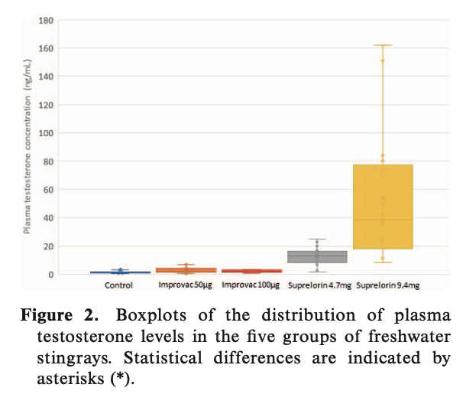
Take Home Points:
- In (this species of) elasmobranchs, GnRH agonists appear to stimulate the HPA axis, but negative feedback does not occur
- There is no evidence that exists that a higher dose could stimulate negative feedback – this study suggested that higher doses subsequently lead to higher testosterone
- Suprelorelin and Improvac were ineffective for chemical castration in male freshwater stingrays

