Journal of Zoo and Wildlife Medicine, 54(4): 704-712, 2024.
INTRAOCULAR PRESSURES OF AQUARIUM-HOUSED COWNOSE RAYS (RHINOPTERA BONASUS) WITH NORMAL AND ABNORMAL OPHTHALMIC EXAMS - reviewed by HSS
Laura Martinelli, Braidee C. Foote, Xiaojuan Zhu, James G. Johnson III, Jared Durrett, Chris Buckner, Julie D. Sheldon

Question: Which of the following rebound tonometer settings is recommended for cownose rays?
- Dog
- Cat
- Rabbit
- Horse
- Unidentified species

Answer: A

Journal of Zoo and Wildlife Medicine, 54(4): 692-703, 2024.
CLINICAL AND HISTOPATHOLOGIC OCULAR FINDINGS IN AQUARIUM-HOUSED COWNOSE RAYS (RHINOPTERA BONASUS)- reviewed by HSS
Braidee C. Foote, Lindsay D. Seyer, Laura Martinelli, Caroline Betbeze, Kim Newkirk, Karen Terio, Xiaojuan Zhu, James G. Johnson III, Jared Durrett, Chris Buckner, Christa E. Barrett, Julie D. Sheldon

Question: What type of fundus do cownose rays have?

- Holangiotic
- Merangiotic
- Paurangiotic
- Anangiotic
- Euangiotic

Answer: D

BONUS question (combining both papers)

Which of the following statements is most correct regarding cownose ray (Rhinoptera bonasus) ophthalmology?

- Use of the “unidentified species” setting on a rebound tonometer is recommended.
- Cataracts were identified as the most common ocular pathology in this species in aquaria.
- Corneal pathology was less prevalent than intraocular pathology in aquaria-housed rays.
- Moderately to severely diseased globes had higher IOP compared to non-diseased globes.
- Increased age and sex (female) were risk factors for developing corneal and intraocular pathology.

Answer: D
Explanation:
- Use of the dog (D) setting is recommended for measuring IOP in cownose rays
- White-to-grey corneal opacities were the most common pathology, followed by cataracts and persistent or dysplastic pupillary membranes
- Corneal pathology was more common than intraocular pathology; almost all rays with intraocular pathology also had corneal pathology
- Increased age and weight were risk factors for developing corneal and intraocular pathology. No association with sex and corneal or intraocular pathology.

QUESTION: Which parameter do you expect to significantly increase with dexmedetomidine + midazolam IM sedation in brownbanded bamboo sharks (Chiloscyllium punctatum)?
- Heart rate
- Blood pH
- pCO2
- Respiration
- Lactic acid
Answer: E - heart rate and respiratory rate minimally affected; blood pH and pCO2 both significantly decreased over time with sedation

Source: DEXMEDETOMIDINE AND MIDAZOLAM INTRAMUSCULAR SEDATION IN BROWNBANDED BAMBOO SHARKS (CHILOSCYLLIUM PUNCTATUM). JZWM 54.3 (2023). Chang et al.

QUESTION: Which is the most common side effect of IV propofol in sharks, but not rays?
- Hyperexcitability
- Hypoventilation
- Rapid recovery
- Prolonged induction
- Acute mortality
Answer: B - apnea commonly seen in sharks but not rays

Source: RETROSPECTIVE REVIEW OF PROPOFOL ANESTHESIA IN MULTIPLE ELASMOBRANCH SPECIES AT GEORGIA AQUARIUM, 2010–2022. JZWM 54.2 (2023). Aguilar et al.

American Journal of Veterinary Research. 84(7): 1-10. 2023.
ESTABLISHMENT OF A 2-DIMENSIONAL ECHOCARDIOGRAPHIC PROTOCOL AND REFERENCE PARAMETERS FOR CLINICALLY HEALTHY SOUTHERN STINGRAYS (HYPANUS AMERICANUS).
Laura Martinelli
Question: In elasmobranch cardiac physiology, what primarily regulates cardiac output?
- Heart rate
- Vascular tone
- Autonomic tone
- Pericardial pressure
- Venous return
Answer: D
------------------------------------------------------------------------------------------------------------------------------------------
Journal of Zoo and Wildlife Medicine. 53(2): 363-372. 2022. DIAGNOSIS AND MANAGEMENT OF SUSPECTED CONGESTIVE HEART FAILURE SECONDARY TO DILATED CARDIOMYOPATHY IN A SAND TIGER SHARK (CARCHARIAS TAURUS) WITH ESTABLISHMENT OF PRELIMINARY NORMAL ECHOCARDIOGRAPHIC INDICES.
Laura Martinelli
Question: Which of the following clinical signs was observed in a presumptive case of dilated cardiomyopathy and secondary congestive heart failure in a Sand tiger shark (Carcharias taurus)?
- Elevated HR
- Anorexia
- Weight loss
- Coelomic effusion
- Anemia
Answer: E
------------------------------------------------------------------------------------------------------------------------------------------- Journal of Zoo and Wildlife Medicine. 54(2): 401-405. 2023. MANAGEMENT OF SUSPECTED DILATED CARDIOMYOPATHY WITH PIMOBENDAN IN TWO LEOPARD SHARKS (TRIAKIS SEMIFASCIATA).
Laura Martinelli
Question: What finding on echocardiogram in both a Sand Tiger shark and two Leopard sharks is suggestive of dilated cardiomyopathy?
- Decreased ventricular fractional shortening
- Decreased heart rate
- Decreased sinus venosus diameter
- Decreased atrial maximum inner diameter
- Decreased atrium/conus arteriosus ratio
Answer: A

- Which of the following is true in using robenacoxib in smooth dogfish?
- All of the animals experienced significant bruising at the administration site
- Compared to the rainbow trout, the smooth dogfish had a lower Cmax
- Maximum plasma concentration was rapidly achieved post administration
- One animal within the study died due to likely robenacoxib adverse effects
- Smooth dogfish had a longer mean terminal half life compared to rainbow trout

Answer: C. Only three animals showed mild bruising at the administration site. Compared to rainbow trout, smooth dogfish had a shorter mean terminal half life, shorter mean time to plasma concentration (30 min) and a higher Cmax. One animal within the study was euthanized; however, pathology reports indicated diffuse sepsis not related to the robenacoxib

2. Which of the following is true regarding intramuscular meloxicam in nursehound sharks?
- Changes were seen in uric acid post administration
- Adverse effects included lethargy and anorexia post administration
- It reached therapeutic effect slowly but had prolonged elimination
- The half life is shorter in sharks compared to that of tilapia
- The drug reaches therapeutic levels for approximately a day

Answer E. There were not blood work changes or adverse side effects. The drug was quickly absorbed, had prolonged elimination with the half life longer compared to that of previous studies in tilapia

3. Which of the following time points is the designated Cmax?


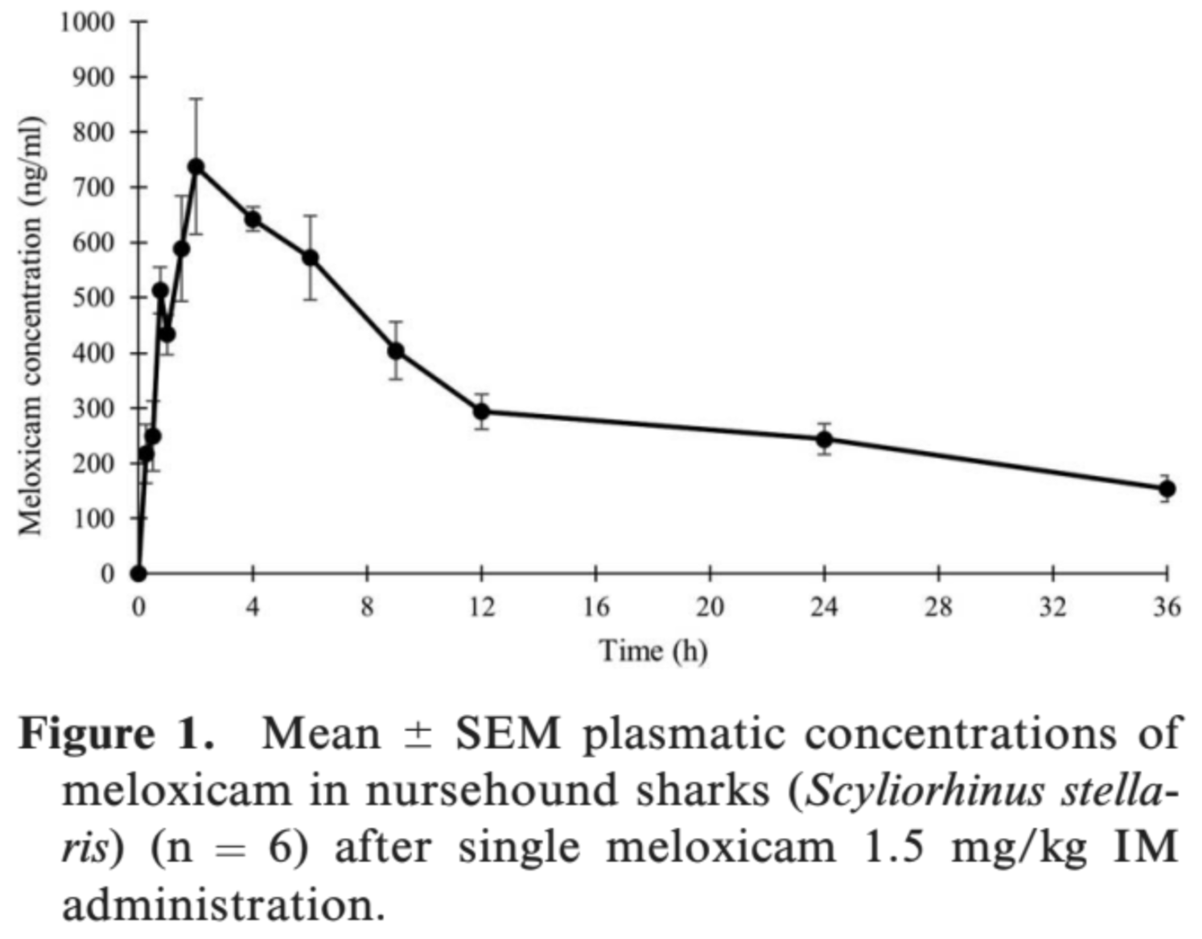
Answer: B

4. Which of the following non-steroidal anti-inflammatory medications showed potential for dosing once daily oral dosing in yellow stingrays?
- Robenacoxib
- Ketoprofen
- Meloxicam
- Ketorolac
- Diclofenac

Answer: C

J Am Vet Med Assoc. 2023;261(8):1-4.
Summarized by MR

Production of live offspring following unilateral (left) ovariectomized Potamotrygon rays (Potamotrygon castexi, Potamotrygon leopoldi, and Potamotrygon motoro)
Chelsea E. Anderson, DVM, Cert AqV1*; James D. Gillis, PhD2; Sarah N. Miller, DVM; Michelle R. Davis, DVM, DACZM1

Slide Question: The ultrasound image below was acquired from a freshwater stingray (Potamotrygon motoro) who underwent unilateral ovariectomy the year prior. The animal was manually restrained and the probe is positioned on the right ventrum. What organ is circled in red?
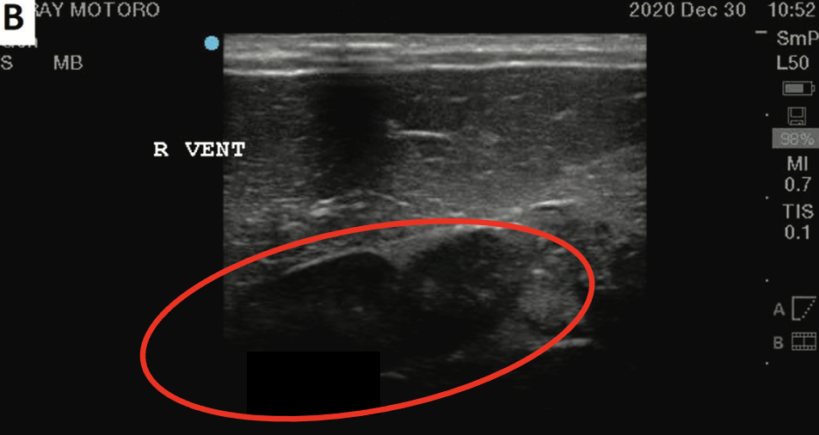
Answer: Right ovary
Journal of Zoo and Wildlife Medicine 54(1): 40–48, 2023
Summarized by MR

EFFECTS OF A GNRH VACCINE AND DESLORELIN ACETATE IMPLANTS IN MALE FRESHWATER STINGRAYS (POTAMOTRYGON SP.)
Anaı ̈s Sailler, DVM, Sylvie Laidebeure, DVM, and Alexis Le ́cu, DVM, DECZM (ZHM)

What method of reproductive management is most appropriate in freshwater stingrays (Potamotrygon sp.)?

- Suprelorelin implant
- Separate sex habitats
- Left unilateral ovariectomy
- Bilateral ovariectomy
- Improvac injection

Answer: B) Separate sex habitats

