Journal of Avian Medicine and Surgery 38(2):98–107, 2024
Summarized by MR

Pharmacokinetics of Trazodone in Hispaniolan Parrots (Amazona ventralis)
Haley M. Straub, Thomas N. Tully, Jr., Levent Dirikolu, Andreas F. Lehner, Justin Zyskowski, and John Buchweitz

Abstract: The objective of this study was to establish the pharmacokinetics of a single oral dose of trazodone in the Hispaniolan Amazon parrot (Amazona ventralis). Trazodone is a selective serotonin antagonist and reuptake inhibitor used commonly in both human and veterinary medicine as an antidepressant behavioral modification medicine. A single oral dose of compounded trazodone hydrochloride solution (20 mg/mL) at 50 mg/kg was administered to a total of 7 healthy adult Hispaniolan Amazon parrots. The 7 healthy adult parrots ranged in age from 10 to 15 years and weighed 228 to 323g. Blood was collected at baseline (2 weeks before study) and at 1, 2, 4, 6, 10, and 14 hours post–drug administration. Plasma concentrations of both trazodone and its active metabolite m-chlorophenylpiperazine (mCPP) were measured via liquid chromatography tandem mass spectrometry. Noncompartmental pharmacokinetic analysis was completed. The half-life (t1/2) $±$ SD of trazodone for the Hispaniolan parrots was 1.89 $±$ 0.49 hours, and the t1/2 $±$ SD of mCPP metabolite was 1.9 $±$ 0.55 hours. Maximum serum drug concentrations, or Cmax (ng/mL), were 738.3 $±$ 285.3 for trazodone. Times to achieve Cmax (hours) for trazadone and the mCPP metabolite were 1 hour and 2 hours postdosing, respectively. While this study did not establish the behavioral effects of trazodone, no adverse side effects were observed throughout the 48-hour period following drug administration and blood collection. Our results indicate that the oral administration of a 50-mg/kg single dose of trazodone to Hispaniolan parrots may be considered a safe dose. Plasma concentrations are comparable to previously published values in humans, dogs, horses, and pigeons (Columba livia domestica) for up to 14 hours following dosing. This study indicates that further studies are needed to establish the pharmacodynamics and the efficacy of trazodone in the medical management of behavioral problems in psittacine species.

Background:
- Amitriptyline, fluoxetine, and clomipramine have been previously investigated in psittacines for behavioral issues
- Trazodone blocks serotonin reuptake at presynaptic neurons while exhibiting minimal effects on norepinephrine and dopamine (reducing risk of adverse effects).
- Previously evaluated in pigeons: Desmarchelier M, Beaudry F, Ferrell S, et al. Determination of the pharmacokinetics of a single oral dose of trazodone and its effect on the activity level of domestic pigeons (Columba livia). Am J Vet Res. 2019; 80:102-109.
  - Cmax could not be calculated due to rapid absorption of the drug (30mg/kg in n = 3 pigeons)
- A previous study in chickens showed trazodone had no appreciable behavioral effects at 0.1-3mg/kg
- Human studies have showed variation in metabolism of trazodone between pediatric (faster) and geriatric (slower) patients
Summary:
- Objective: establish PK profile of trazodone in n = 7 amazon parrots (sparse sampling)
- T = 0 sample 2 wks prior to study
- Dose: Trazodone (20mg/mL oral suspension): 50mg/kg PO once (admin by gavage), no regurg
- Sampling times: 1, 2, 4, 6, 10, 14 hours
- No adverse effects during the study, but also no visible effects on activity level or mentation
- Peak plasma concentration 1hr post-administration: then declined rapidly after the 2hr mark
- Further studies are needed to establish the true therapeutic range of trazodone in avian species.
- Cannot rule out the possibility of individual hypersensitivities to the drug skewing the data, given sparse sampling (small sample size)

Take Home Points:
- 50mg/kg PO is a safe trazodone dose: but changes in mentation or behavior were not observed
- Further studies are needed to establish the true therapeutic range of trazodone in avian species.
- Trazodone is rapidly absorbed (1h or less) in avian species studied thus far: Psittaciformes, Columbiformes
- Plasma concentrations are comparable to previously published values in humans, dogs, horses, and pigeons (Columba livia domestica) for up to 14 hours following dosing.

Am J Vet Res. 2024;85(10) 1-7.
Summarized by MR

Medetomidine-vatinoxan-midazolam provides similar sedation depth with reduced bradycardia compared to dexmedetomidine-midazolam in pigeons (Columba livia domestica)
Alison Jeffrey, DVM1; Laura Burns, DVM1; Stephen Santangelo, DVM1; Nicole Sallaberry-Pincheira, DVM, MSc1,2; Sarah Camlic, DVM1; Brianna Paredes3; Michele Barletta, DVM, PhD, DACVAA4;
Stephen Divers, DZooMed, DECZM, DACZM1

Abstract: OBJECTIVE: To determine if sedation with medetomidine-vatinoxan (Zenalpha; Dechra Veterinary Products) and midazolam (Alvogen) (ZM) would cause less cardiovascular depression and maintain similar depth and duration of sedation in pigeons (Columba livia domestica) compared to dexmedetomidine and midazolam (DM).
METHODS In a blinded crossover study, 15 healthy adult domestic pigeons were sedated IM with either dexmedetomidine (0.08 mg/kg) and midazolam (2 mg/kg) or medetomidine (0.16 mg/kg), vatinoxan (3.2 mg/kg), and midazolam (2 mg/kg) from November through December 2023. Each subject was monitored for 60 minutes, then the sedation was reversed with atipamezole (0.8 mg/kg) and flumazenil (0.1 mg/kg) as needed. Sedation scores, heart rates, and respiratory rates were compared.
RESULTS There was no significant difference in the peak sedation score between DM and ZM groups, with both exhibiting median scores of 4 (heavy sedation). Mean heart rate was significantly higher for ZM than DM at 5, 10, 20, 30, 45, 60, and 65 minutes postinjection. Bradycardia occurred in both groups at 5 and 10 minutes postinjection and persisted for DM until reversal with atipamezole. Arrhythmias were auscultated in both groups. Bradypnea was not observed in either group, and all birds resumed normal behavior following recovery and the following day.
CONCLUSIONS Medetomidine-vatinoxan-midazolam provides a similar depth of sedation to DM but with less incidence of bradycardia. Further study is needed to determine the clinical applicability of this sedative in birds.
CLINICAL RELEVANCE Medetomidine-vatinoxan may be considered for short-term sedation and restraint in cardiovascularly stable pigeons.

Background:
- Reversibility is a desired component of avian sedation protocols
- In pigeons, medetomidine and dexmedetomidine alone have provided minimal or unreliable sedation in pigeons except at very high doses
- Dexmed-midazolam has produced effective sedation
  - Dexmed in pigeons: significant bradycardia, bradypnea, and hypothermia
- Vatinoxan is an a-2 adrenoreceptor antagonist that poorly crosses BBB – reduce CV side effects in dogs, cats, sheep
- Zenalpha: medetomidine (0.5 mg/mL) and vatinoxan (10 mg/mL) without reversal of sedative effects

Summary:
- Objective: eval Zenalpha as a sedative in pigeons (n=15 included; 5 with heart murmurs excluded) and eval CV effects
- Crossover study
  - 0.08mg/kg dexmedetomidine + 2mg/kg midazolam (n = 7; dexmedetomidine dose decided based upon equipotency of medetomidine)
  - 5 days later: 0.16 mg/kg of medetomidine and 3.2 mg/kg of vatinoxan (Zenalpha) combined with 2 mg/kg of midazolam
  - The other 8 received this protocol in the opposite order
  - The person recording vitals was blinded to treatment: monitoring over 60 mins prior to reversal
- sedation was scored as follows: 0 was defined by normal behavior; 1, minimal sedation with fluffed feathers, stooped broad-based stance, ataxia, and resisting manual restraint; 2, mild sedation with sternal recumbency, closed eyes, and resisting manual restraint; 3, moderate sedation with allowing placement in dorsal recumbency but retaining righting reflex; and 4, heavy sedation with absence of righting reflex and no resistance to wing extension.
- There was no significant difference in the peak sedation score between ZM or DM groups (P = .708), and both had a median peak score of 4
- The median duration of peak sedation was longer for DM than ZM, not a significant finding
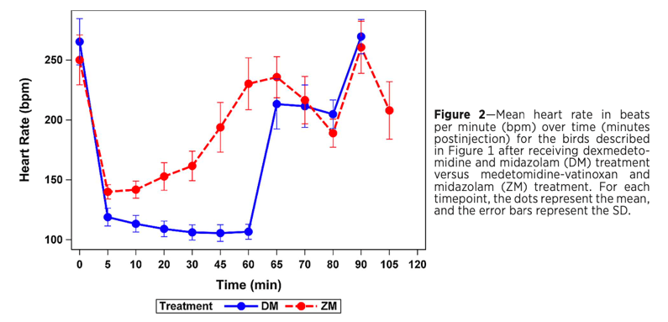
- NSD in time to sternal position
- Three birds that received ZM did not require reversal with flumazenil due to the rapidity of return to sedation score 0 after receiving atipamezole.
- The mean heart rate was significantly higher for ZM than DM at most time points, although bradycardia still occurred
- There were more birds in the DM group (n = 9) that had an auscultated pathologic arrhythmia (ie, “dropped beats”) event than in the ZM group (n = 4)
- In both groups, there were episodes of abnormal respiratory pattern noted (ZM n = 7; DM n = 8), characterized as “panting,” and there was no difference in occurrence between the groups (P = .655).
- Three birds that received DM regurgitated during the sedation or recovery period. All birds recovered appropriately.

Take Home Points:
- Zenalpha-midazolam provides comparable sedation scores to Dexmedetomidine-midazolam in domestic pigeons.
- Zenalpha-midazolam provides improved heart rate (although still bradycardic at the earliest phases of sedation, first 10 mins) when compared to dexmedetomidine-midazolam.

American Journal of Veterinary Research 84(4): 1-11, 2023
TWICE-DAILY ORAL ADMINISTRATION OF A CANNABIDIOL AND CANNABIDIOLIC ACID-RICH HEMP EXTRACT WAS WELL TOLERATED IN ORANGE-WINGED AMAZON PARROTS (AMAZONA AMAZONICA) AND HAS A FAVORABLE PHARMACOKINETIC PROFILE
Mariana Sosa-Higareda, David Sanchez-Migallon Guzman, Heather Knych, Alex Lyubimov, Alexander Zakharov, Beatriz Gomez, Hugues Beaufrere

Abstract:

OBJECTIVE: To determine the pharmacokinetics of 8 cannabinoids and 5 metabolites after oral administration of single and multiple doses of a cannabidiol (CBD)-cannabidiolic acid (CBDA)–rich hemp extract to orange-winged Amazon parrots (Amazona amazonica) as well as to evaluate the extract’s adverse effects.

ANIMALS: 12 birds.

PROCEDURES: Based on pilot studies, a single-dose study based on 30/32.5 mg/kg of cannabidiol/cannabidiolic acid of a hemp extract was administered orally to 8 fasted parrots, and 10 blood samples were collected over 24 hours after administration. After a 4-week washout period, the hemp extract was administered orally to 7 birds at the previous dose every 12 hours for 7 days, and blood samples were collected at the previous time points. Cannabidiol, Δ9-tetrahydrocannabinol, cannabinol, cannabichromene, cannabigerol, cannabidiolic acid, cannabigerolic acid, Δ9-tetrahydrocannabinolic acid, and 5 specific metabolites were measured by liquid chromatography-tandem/mass-spectrometry, and pharmacokinetic parameters were calculated. Adverse effects and changes in the plasma biochemistry and lipid panels were evaluated.

RESULTS: Pharmacokinetic parameters for cannabidiol, cannabidiolic acid, Δ9-tetrahydrocannabinol, Δ9-tetrahydrocannabinolic acid, and the metabolite 11-hydroxy-9-tetrahydrocannabinol were established. For the multiple-dose study, cannabidiol/cannabidiolic acid mean Cmax was 337.4/602.1 ng/mL with a tmax of 30 minutes and a terminal half-life of 8.6/6.29 hours, respectively. No adverse effects were detected during the multidose study. The predominant metabolite was 11-hydroxy-9-tetrahydrocannabinol.

CLINICAL RELEVANCE: Twice daily oral administration of the hemp extract based on 30 mg/kg/32.5 mg/kg of cannabidiol/cannabidiolic acid was well tolerated and maintained plasma concentrations considered to be therapeutic in dogs with osteoarthritis. Findings suggest different cannabinoid metabolism from mammals.

Key Points:
- Endocannabinoid system (ECS) identified in multiple species – receptors CB1 and CB2 are involved in neuronal plasticity, pain, inflammation, and immune regulation among others
  - CB1 identified in chickens and budgerigars, suggesting presence of ECS in birds
  - CB2 not present in parrots
- Pilot:
  - One bird in lowest dose treatment group experienced a 2 minute seizure but recovered, middle dose group had no issues, the higher dose group experienced marked sedation for ~4 hours and then were quiet for 12 hours (could not hold heads up, wide-based stance, wing droop, only responsive to loud stimuli, one even in ventral recumbency) took them up to 24 hours to fully recover
  - Based on this, middle dose of hemp extract 30/32.5 mg/kg CBD/CBDA was selected for next parts of the study
- Single-Dose Study
  - Of the 8 CB’s measured, CBG, CBC, and CBN were below quantification level and were not assessed further. CBGA was also only present at very low levels early on.
  - For the metabolites, only 11-OH-THC had quantifiable plasma concentrations.
  - See Figure 1 (Note that Figure 1 legend says 11-OH-THC the metabolite is graphed on there but there is no corresponding line in the Figure.)
- Multiple-Dose Study
  - All birds maintained body weight, no changes in appetite, sedation/agitation, or behavior. One bird in treatment group developed intermittent diarrhea.
  - Data shows weak accumulation after multiple dose administration, suggesting minimal drug accumulation of all cannabinoids measured
  - No significant effect of time or treatment on lipid panel or some chemistry values. Plasma glucose, potassium and TP were significantly higher after treatment. AST was significantly higher in the control group after treatment. Overall, none of these changes were clinically significant. However, not statistically significant but 2/6 birds had slight to moderate elevation of ALP in treatment group. ALP and AST elevation has been seen in mammals as an adverse effect hemp administration in dogs.
- Discussion
  - PK parameters were established for CBD, CBDA, THC, and THCA as well as the metabolite 11-OH-THC in both the single and multiple dose studies in Orange-winged Amazon Parrots (OWAP)
  - Twice daily administration of hemp extract was well tolerated in healthy OWAP and resulted in plasma concentrations above 50 ng/mL (considered therapeutic level based on extrapolation from dogs) when using dose of 30/32.5 mg/kg of CBD/CBDA for at least 6 hours following administration without significant adverse effects.
  - No major differences in plasma level and PK parameters between CB’s and their acid precursors
  - Higher concentrations of CBDA observed in single-dose study suggest that it is better absorbed than CBD (had 6x greater Cmax), but CBDA also had shorter T1/2. So CBDA is likely absorbed and metabolized faster. For multi-dose study, the difference in Cmax was not as marked but both T1/2 were three times longer than those in the single-dose study. Similar trends found with THC and THCA, with THCA reaching higher plasma concentrations but metabolized or cleared faster.
  - THC and THCA had longer half-life than CBD and CBDA
  - Differences between CB’s in OWAP and species of mammals studied
    - Only 11-OH-THC metabolite was measurable in OWAP (this is considered the psychoactive metabolite of THC)
    - Birds have much higher 11-OH-THC level than dogs given comparable or even higher doses of cannabinoids, suggesting birds have different THC metabolism. Also, some metabolites that are higher in dogs and horses were not quantifiable in birds.
  - Compared to study in Hispaniolan Amazon parrots given single doses of CBD, the CBD Cmax was much higher for Hispaniolan Amazon parrots than OWAP. However, there were significant differences in study design so difficult to compare results.

Take Home Point: Twice-daily for 7-day administration of hemp extract with known CB concentrations was well tolerated in healthy Orange-winged Amazon Parrots and resulted in plasma concentrations considered therapeutic (based on extrapolation from dogs) without adverse effects. Study suggests that birds may have a different cannabinoid metabolic pathway than mammals.
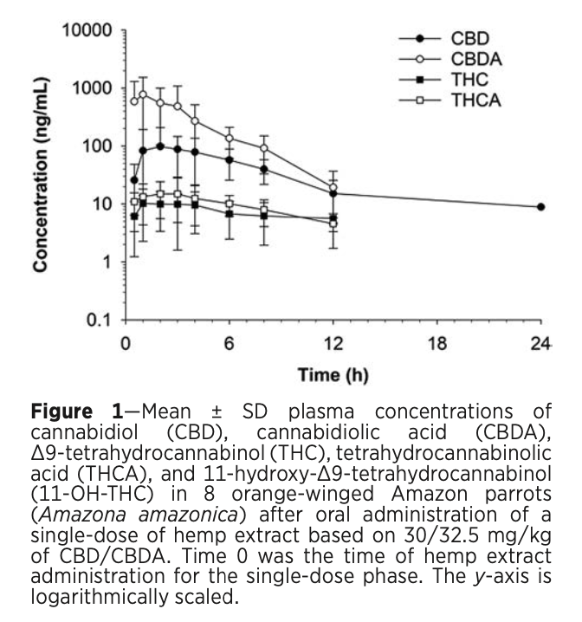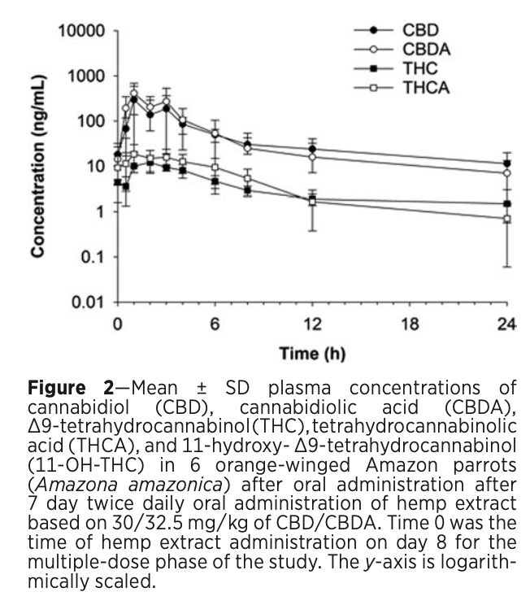

------------------------------------------------------------------------------------------------------------------------------------------

American Journal of Veterinary Research 83(12): 1-8, 2022
INTRANASAL BUTORPHANOL AND MIDAZOLAM ADMINISTERED PRIOR TO INTRAMUSCULAR ALFAXALONE PROVIDES SAFE AND EFFECTIVE SEDATION IN QUAKER PARROTS (MYIOPSITTA MONACHUS)
Chelsea M. Conner, DVM; Sharman M. Hoppes, DVM, DABVP (Avian); Brian J. Stevens, MSBA; Bradley T. Simon, DVM, MSc, DACVAA – Reviewed by LMM
Abstract:
OBJECTIVE: To evaluate 2 doses of alfaxalone on cardiopulmonary parameters, temperature, sedation, endotracheal intubation, the incidence of muscle tremors, and radiographic positioning in Quaker parrots previously administered intranasal midazolam and butorphanol.
ANIMALS: 10 healthy adult Quaker parrots (male = 5; female = 5).
PROCEDURES: A randomized, masked, crossover study was conducted where birds received midazolam (2 mg/kg) and butorphanol (2 mg/kg) intranasally 15 minutes prior to a low- or high-dose of intramuscular alfaxalone: 2 mg/kg (LDA) or 5 mg/kg (HDA), respectively. Heart (HR) and respiratory rate (RR), cloacal temperature, sedation quality, and ability to position for radiographs were recorded over time. The incidence of muscle tremors and the ability to intubate were recorded. Data were compared to baseline values and between treatments where appropriate. Significance was set at P < .05.
RESULTS: There were no significant differences in HR, RR, cloacal temperature, and sedation scores between treatments at any time point. Duration of time from midazolam-butorphanol administration to complete recovery from treatment administration was significantly shorter for LDA when compared to HDA (90 [60 to 195] vs 127.5 [90 to 210] minutes, respectively). Compared to baseline, sedation scores were significantly higher from T = 15 to 60 for LDA and from T = 15 to 75 for HDA. The incidence of muscle tremors was greater in HDA (9/10) than in LDA (7/10). All birds were successfully intubated and positioned for radiographs.
CLINICAL RELEVANCE: The combination of intranasal midazolam-butorphanol and intramuscular alfaxalone at the doses examined was a safe and effective method for sedating Quaker parrots. LDA produced adequate sedation with a shorter time to recovery and with fewer muscle fasciculations when compared to HDA.

Key Points:
- Alfaxalone – neuroactive steroid, GABA_{A} receptor agonist
- One study in Quaker parrots used solely alfaxalone and compared to alfaxalone with midazolam premedication. The group with solely alfaxalone noted hyperexcitation and muscle tremors, this was decreased but not eliminated in the alfaxalone plus midazolam group (rationale for the paper electing to use midazolam and butorphanol premedication).
- This study measured cloacal temperature for a set number of timepoints or until blood detected on the thermometer – notably one individual died after the completion of the study due to a ruptured cloaca
- No significant difference in sedation scores existed at any time point for LDA vs. HAD
- Sedation adequate to intubate and radiograph all birds
- For both treatment groups, heart rate and respiratory rate were significantly increased compared to baseline
  - One individual had an episode of resp. distress at 45 min after drug administration (resolved with oxygen therapy)
- For both treatment groups, temp significantly decreased (despite active thermal support)
- Administration of LDA (2.5 mg/kg alfaxalone) was associated with lower incidence of muscle fasciculations and tremors
- This protocol, when tested in other species, provides minimal analgesia, would need adjunct for painful procedures.
Take-Home Message: IN midazolam-butorphanol and IM alfaxalone provided effective sedation for Quaker parrots. The low-dose alfaxalone in this study is recommended because it produced fewer muscle fasciculations while still having appropriate sedation.

Absorption of grapiprant in red-tailed hawks (Buteo jamaicensis) is decreased when administered with food. AJVR 2022 83(6). Rodriguez P, Paul-Murphy JR, Knych HK, Drazenovich TL, Hawkins MG.

Objective: Describe the pharmacokinetics of grapiprant administered orally with food to red-tailed hawks (RTHAs; Buteo jamaicensis) and compare the results with previously described grapiprant pharmacokinetics administered without food in this species.
Animals: 6 healthy adult RTHA (3 males, 3 females) under human care.
Procedures: A single dose of grapiprant (30 mg/kg) was given orally to RTHAs, followed by force-feeding. Blood samples were obtained at 14 time points for 120 hours postgrapiprant administration. Plasma concentrations of grapiprant were measured via tandem liquid chromatography-mass spectrometry. Nonparametric superimposition using pharmacokinetic modeling software used plasma concentrations to calculate simulations of grapiprant plasma concentrations for 30 mg/kg administered orally with food every 12 hours.
Results: The arithmetic mean maximum plasma concentration was 405.8 ng/mL, time to maximum plasma concentration was 16 hours, and harmonic mean terminal half-life was 15.6 hours. Simulations determined 30 mg/kg every 12 hours could attain minimum effective concentrations (> 164 ng/mL) reported in dogs for a sustained period of approximately 20 hours.
Clinical relevance: Grapiprant plasma concentrations were achieved above the canine therapeutic concentrations within 16 hours postmedication. Mean concentrations were maintained for approximately 20 hours. Simulations support a dosing frequency of 12-hour intervals with food reaching minimum effective concentrations established for canines, although it is unknown whether these plasma concentrations are therapeutic for birds. Bioaccumulation was not noted on simulations secondary to increased grapiprant administration. Further research including multidose assessments at this current dose with food, in vitro pharmacological characterization, and pharmacodynamic studies in this species are warranted.

Key Points:
- Grapiprant = specific antagonist for prostaglandin EP4 receptor
- Previous study: 30 mg/kg grapiprant PO q 24h in fasted RTHAs achieved plasma concentrations > canine minimum effective concentration (MEC) of 164 ng/mL
- This study with food: RTHAs achieved mean plasma grapiprant concentrations > 164 ng/mL at 16 hours post-administration and maintained up to 24 hours
  - RTHA plasma grapiprant concentrations were DECREASED (by 88%) when administered with food
- Increasing to q12h with food may achieve plasma concentrations similar to the canine MEC
- Unclear if dose can be considered therapeutic in RTHAs without pharmacodynamic data

TLDR: RTHA plasma grapiprant concentrations were decreased when administered with food (compared to fasting) thus may require increased frequency in dosing (q12hr opposed to 24hr)

Evaluation of dexmedetomidine-midazolam sedation in budgerigars (Melopsittacus undulatus). Journal of the American Veterinary Medical Association, 260(10), 1194-1199. Mumm & Mans. (2022).

Objective: To evaluate the sedative effects of IM administration of a high or low dose of dexmedetomidine in combination with midazolam in budgerigars (Melopsittacus undulatus).
Animals: 20 healthy adult budgerigars.
Procedures: In a prospective, randomized, blinded study, birds were sedated with a high dose (HD; 0.04 mg/kg, IM; n = 10) or low dose (LD; 0.01 mg/kg, IM; 10) of dexmedetomidine in combination with midazolam (3 mg/kg, IM). Twenty minutes later, atipamezole (0.4 mg/kg [HD group] or 0.1 mg/kg [LD group], IM) and flumazenil (0.1 mg/kg, IM) were administered for reversal of sedation.
Results: Times to first effect and to sternal recumbency after administration of the sedatives and times to standing and eating after administration of the antagonists did not differ between groups. Most birds (9/10 in the HD group and 7/10 in the LD group) lost the righting response by 10 minutes after sedative administration, and the peak effect for radiographic positioning was by 15 minutes. Although it was not clinically relevant, most birds showed mild resedation by 60 minutes after administration of the reversal agents. There was no significant cardiorespiratory compromise detected with either protocol.
Clinical relevance: Dexmedetomidine-midazolam can safely and effectively provide a dose-dependent level of sedation in healthy budgerigars. The HD protocol is recommended for radiographic positioning, as it allows for a more reliable, deeper plane of sedation.

Methods: evaluate sedative effects of IM dexmed (HD or LD) + midaz in healthy adult budgies
- n=20, randomly split into 2 groups
- Put bird in box, let it acclimate, inject bird (HD or LD blinded), watch for first effects (eye droopy or ataxia) and sternal recumbency monitor RR, visual response, auditory response, tactile response, HR, righting response, ability to radiograph, and withdrawal at 5, 10, 15, 20 minutes post-injection (each response only assessed if the former was lost)
- Scored sedation at each time point (none, mild, moderate, deep)
- Birds reversed at 20 minutes with atipamezole and flumaz
  - Birds returned to enclosure 60 minutes after reversal

Key Points:
- No difference in time to first effects and recumbency for either group
- HD: all lost tactile, 9/10 lost righting, 7/10 rad positioning went well
- LD: almost all (9/10) lost tactile, 6/10 lost righting, 4/10 rad positioning went well
- HR decreased for both groups, was <20% difference between both groups at all times, but HD was consistently lower
  - Same with RR, but a little less so
- All birds standing <5 minutes after reversal and time to standing not different between groups
- 8/10 birds in HD and all birds in LD eating before return to enclosure
  - Median time to eating not statistically different:19 min (HD) vs. 12 min (LD)
- 60 minutes after reversal 9/10 in HD and 7/10 in LD showed mild re-sedation
- No deaths, no significant adverse effects

TLDR: Dexmed+midaz produces safe, effective, dose dependent sedation in budgies
- HD protocol recommended for diagnostic manipulation with peak effect 10-15 minutes post administration
- LD likely not sufficient in healthy birds for radiograph positioning/manipulation, but may be sufficient in compromised birds

American Journal of Veterinary Research, 84(5), 2023
High bioavailability, short half-life, and metabolism into hydromorphone-3-glucuronide following single intramuscular and intravenous administration of hydromorphone hydrochloride to great horned owls (Bubo virginianus) - reviewed by HSS
Mariana Sosa-Higareda MVZ, David Sanchez-Migallon Guzman LV, MS, DECZM, DACZM, Heather K. Knych DVM, PhD, DACVCP, and Michelle G. Hawkins VMD, DABVP

Abstract:
OBJECTIVE
To determine the pharmacokinetic parameters of hydromorphone hydrochloride and its metabolite, hydromorphone-3-glucuronide (H3G), after a single IV and IM dose in great horned owls (Bubo virginianus).
ANIMALS
6 healthy adult great horned owls (3 females and 3 males).
PROCEDURES
A single dose of hydromorphone (0.6 mg/kg) was administered once IM (pectoral muscles) and IV (left jugular) with a 6-week washout period between experiments. Blood samples were collected at 5 minutes and 0.5, 1.5, 2, 3, 6, 9, and 12 hours after drug administration. Plasma hydromorphone and H3G concentrations were determined with liquid chromatography–tandem mass spectrometry, and a noncompartmental analysis was used for the determination of pharmacokinetic parameters.
RESULTS
Hydromorphone had a high bioavailability of 170.8 ± 37.6% and rapid elimination after IM administration and rapid plasma clearance and a large volume of distribution after IV administration. Mean Cmax was 225.46 ± 0.2 ng/mL at 13 minutes after IM injection. Mean volume of distribution and plasma drug clearance was 4.29 ± 0.5 L/kg and 62.11 ± 14.6 mL/min/kg, respectively, after IV administration. Mean t1/2 was 1.62 ± 0.36 and 1.35 ± 0.59 hours after IM and IV administration, respectively. The metabolite H3G was readily measured shortly after administration by both routes.
CLINICAL RELEVANCE
A single dose of 0.6 mg/kg was well tolerated in all birds. Hydromorphone rapidly attained plasma concentrations following IM administration and had high bioavailability and short t1/2. This study is the first to document the presence of the metabolite H3G in avian species, which suggests similar hydromorphone metabolism as in mammals.

Key Points:
- Hydromorphone is a semisynthetic full μ-opioid agonist; recommended first choice for treating moderate to severe pain
- In mammals, hydromorphone is metabolized to form the metabolite hydromorphone-3-glucuronide (H3G)
- A recent pharmacodynamic study evaluating the thermal antinociceptive effects of hydromorphone in GHOWs at 0.3- and 0.6-mg/kg doses resulted in significantly higher mean thermal foot withdrawal thresholds at 0.5, 1.5, and 3 hours and at 0.5 and 1.5 hours, respectively
- No adverse effects noted
- Hydromorphone IM was rapidly absorbed, had high bioavailability, and had a short half-life (t1/2) (1.62 ± 0.36 hours)
- Hydromorphone IV had rapid plasma clearance and a large volume of distribution after IV administration.
- A dose of 0.6 mg/kg of hydromorphone in GHOWs yielded plasma concentrations > 1 ng/mL for 9 hours after IM and 6 hours after IV administration.
  - Thermal antinociceptive effects were detected at 1.5 hours after administration of same dose of hydromorphone in the pharmacodynamic counterpart, which corresponded with a mean hydromorphone plasma concentration of 57.7 ± 8.43 ng/mL at that time point. These concentrations would not represent the minimum effective concentrations in GHOWs considering that in the pharmacodynamic counterpart of the current study, a dose of 0.3 mg/kg IM resulted in thermal antinociceptive effects at 3 hours, which was associated with much lower plasma concentrations.
- H3G was detectable in all birds at 30 minutes following drug administration by both the IV and IM routes and had measurable plasma concentrations up to 12 hours postadministration, which was the last time point measured
  - The mean t1/2 of H3G is longer than that of hydromorphone in this species; this should be taken into account when considering multiple and frequent dosing, as dose-dependent neuroexcitatory effects have been described in rats
    - A study investigating the neuroexcitant effects of H3G in rats revealed that it can induce dose-dependent-excitatory behaviors such as myoclonus, changes in body postures, and tonic-clonic seizures
  - Unknown if H3G has analgesic effects

Take-Home Message:
- Hydromorphone IM in GHOW was rapidly attained plasma concentrations, had high bioavailability and a short half-life (t1/2), and was metabolized to H3G.

American Journal of Veterinary Research, 84(10), 2023
Carrageenan-induced inflammation elicits behavioral changes in cockatiels (Nymphicus hollandicus) for potential pain scale development - reviewed by HSS
Nicole A. Mikoni DVM, David Sanchez-Migallon Guzman LV, MS, Hugues Beaufrere DVM, PhD, and Joanne R. Paul-Murphy DVM
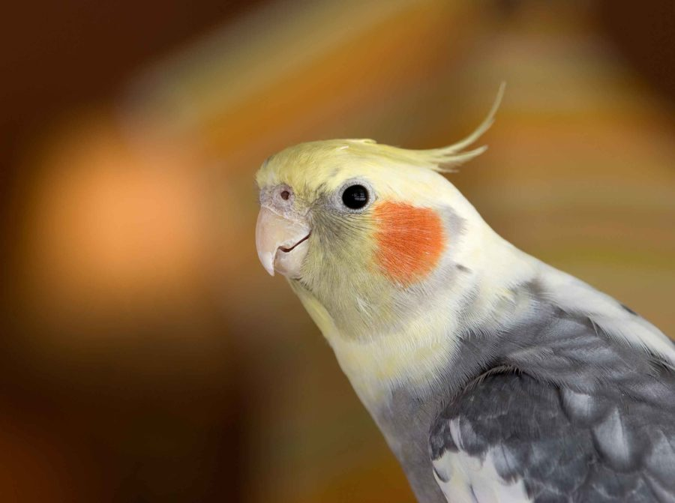
Abstract:
OBJECTIVE
To evaluate behaviors associated with inflammatory pain induced by carrageenan injection in the cockatiel and determine interobserver agreement.
ANIMALS
16 adult cockatiels.
METHODS
Cockatiels were randomly assigned as either treatment (carrageenan injection) or control (sham injection) group. The treatment group received a subcutaneous injection of 0.05 mL of a 1% lambda carrageenan solution into the left footpad. Following treatment or control procedures, all cockatiels were video recorded individually for 9.5 hours. Ten minutes of video at each of 11 time points postinjection and/or handling were evaluated by 3 different observers. Twenty-five behaviors within 6 categories (resting, locomotion, maintenance, intake, interaction with environment, and limb and body posture) were assessed, in addition to crest position and mentation. Differences in individual behaviors tallies were assessed using serial Wilcoxon sum rank tests. Interobserver agreement was assessed using an intraclass correlation coefficient for a 2-way design for consistency among multiple observers.
RESULTS
Treatment cockatiels exhibited significantly increased focal preening (q = .023) and increased burst preening (q = .036), while control cockatiels spent significantly more time in an upright stance (q = .036). Although the remainder of behaviors observed were not statistically significant between groups, additional variables of interest seen more frequently in treatment cockatiels included non–weight-bearing stance, holding of the body low, and being nonvigilant. The level of agreement between observers was variable based on the specific behaviors; nevertheless, the dynamic behaviors were substantial to strong.
CLINICAL RELEVANCE
Carrageenan-induced inflammation-associated behaviors may be valuable in developing a pain scale and evaluating mild inflammatory pain in small psittacine species.

Key Points:
- The introduction of pain to an animal will concurrently introduce stress. Stress, even in the absence of pain, will significantly alter behavior, as documented in European starlings (Sturnus vulgaris) and trumpeter swans (Cygnus buccinator).
- The induction of acute inflammation and hyperalgesia with carrageenan is one of the most widely used and well-established rodent models for studying acute inflammation that persists for a limited period of time.
  - When injected, stimulates local inflammatory responses primarily through the aggregation of macrophages
- Twenty-five behaviors were assessed following treatment or control procedures, in addition to monitoring the crest position (erect, lowered, or flat) and mentation (alert, quiet, depressed, or nonvigilant) of each cockatiel.
- Treatment cockatiels exhibited significantly increased focal preening (q = .023) and increased burst preening (q = .036), while control cockatiels spent significantly more time in an upright stance (q = .036).
  - Additional variables of interest seen more frequently in treatment cockatiels included non–weight-bearing stance, holding of the body low, and being nonvigilant.
- This contrasts with behaviors more likely to be expressed in control cockatiels such as time spent upright, drinking, and cage biting (environmental interaction)
- Behaviors found to have slight to low interobserver agreement included burst preening, focal preening, leaning, holding body low, lowered crest position, and flat crest position.
- More dynamic behaviors such as active climbing, thorough preening, rousing, stretching, eating, and drinking had strong levels of interobserver agreement.
- When introduced to stress associated with handling and venipuncture in the study of Turpen et al, cockatiels had a significant decrease in “luxury” behaviors (locomotion, feeding, and environmental interactions) and a significant increase in resting and “reactionary” behaviors such as avoidance of objects/others and guarded crouching. In the current study, control cockatiels collectively demonstrated similar environmentally engaged activities such as cage biting and drinking from their water line, while treatment cockatiels were more likely to display behaviors such as being nonvigilant (sleeping).
  - The cockatiel stress study reported that “maintenance” behaviors such as preening, stretching, and scratching did not significantly differ following the introduction of stress. This is in contrast to the current study, in which treatment cockatiels had a greater number of displays of focal and burst preening compared to control birds.

Take-Home Message:
- This study evaluated pain-related behaviors via use of a novel carrageenan-induced inflammatory model in cockatiels and found that focal preening, burst preening, and having an upright body stance each significantly differed between treatment versus control cockatiels. Additional variables of interest seen more frequently in treatment cockatiels included non–weight-bearing stance, holding of the body low, and being nonvigilant. Additionally, this study had a strong level of interobserver agreement for the dynamic behaviors evaluated.

