Journal of Avian Medicine and Surgery 38(2):98–107, 2024
Summarized by MR

Pharmacokinetics of Trazodone in Hispaniolan Parrots (Amazona ventralis)
Haley M. Straub, Thomas N. Tully, Jr., Levent Dirikolu, Andreas F. Lehner, Justin Zyskowski, and John Buchweitz

Question
- Which of the following is true of trazodone pharmacokinetics in Hispanolian amazon parrots (Amazona ventralis)?
A) Signs of sedation were observed in one hour
B) Trazodone is rapidly absorbed in one hour
C) A majority of birds regurgitated after administration
D) Trazodone’s active metabolite was not detected
E) Plasma concentrations were much higher than pigeons

Answer: B) Trazodone is rapidly absorbed in one hour
- Sedation was not reported in any birds at this dose. No adverse effects. The active metabolite, mCPP, was detected. Plasma concentrations were comparable to a previous PK in pigeons.

Am J Vet Res. 2024;85(10) 1-7.
Summarized by MR

Medetomidine-vatinoxan-midazolam provides similar sedation depth with reduced bradycardia compared to dexmedetomidine-midazolam in pigeons (Columba livia domestica)
Alison Jeffrey, DVM1; Laura Burns, DVM1; Stephen Santangelo, DVM1; Nicole Sallaberry-Pincheira, DVM, MSc1,2; Sarah Camlic, DVM1; Brianna Paredes3; Michele Barletta, DVM, PhD, DACVAA4;
Stephen Divers, DZooMed, DECZM, DACZM1

Question: Which of the following drug combinations provided efficacious sedation over 60 minutes in domestic pigeons (Columba livia domestica), while also sparing bradycardia for the majority of the sedation event?
A) Dexmedetomidine-midazolam
B) Medetomidine-midazolam
C) Medetomidine-vatinoxan-midazolam
D) Butorphanol-midazolam
E) Butorphanol-dexmedetomidine

American Journal of Veterinary Research 84(4): 1-11, 2023
TWICE-DAILY ORAL ADMINISTRATION OF A CANNABIDIOL AND CANNABIDIOLIC ACID-RICH HEMP EXTRACT WAS WELL TOLERATED IN ORANGE-WINGED AMAZON PARROTS (AMAZONA AMAZONICA) AND HAS A FAVORABLE PHARMACOKINETIC PROFILE
Question: What cannabinoid metabolite had higher plasma concentrations post-administration of hemp extract in Orange-winged parrots as compared to studies in dogs and horses?
- 7-OH-CBD
- 7-COOH-CBD
- 11-OH-THC
- COOH-THC
- COOH-THC-Glu

Answer: C

------------------------------------------------------------------------------------------------------------------------------

American Journal of Veterinary Research 83(12): 1-8, 2022
INTRANASAL BUTORPHANOL AND MIDAZOLAM ADMINISTERED PRIOR TO INTRAMUSCULAR ALFAXALONE PROVIDES SAFE AND EFFECTIVE SEDATION IN QUAKER PARROTS (MYIOPSITTA MONACHUS)
Question: In Quaker parrots (Myiopsitta monachus), what adverse effect can occur with the administration of alfaxalone.
^{A. Hypertension}
^{B. Hyperthermia}
^{C. Muscle fasciculations}
^{D. Regurgitation}
^{E. Fulminant liver necrosis}
^{Answer: C}

QUESTION: What might you expect to occur with grapiprant absorption in red-tailed hawks when administered orally with a force-feeding compared to administration when fasted?
- Decreased maximum plasma concentration
- Increased bioavailability
- Longer mean terminal half-life
- Decreased dosing frequency requirement
- Significant bioaccumulation
Answer: A

Source: Absorption of grapiprant in red-tailed hawks (Buteo jamaicensis) is decreased when administered with food. AJVR 2022. Rodriguez et al.

QUESTION: What adverse effect would you most likely expect from dexmedetomidine-midazolam intramuscular anesthesia in budgerigars (Melopsittacus undulatus)?
- Regurgitation
- Apnea
- Re-sedation
- Torticollis
- Hyperexcitability

Source: Evaluation of dexmedetomidine-midazolam sedation in budgerigars (Melopsittacus undulatus). JAVMA 2022. Mumm & Mans.

American Journal of Veterinary Research, 84(5), 2023
High bioavailability, short half-life, and metabolism into hydromorphone-3-glucuronide following single intramuscular and intravenous administration of hydromorphone hydrochloride to great horned owls (Bubo virginianus) - reviewed by HSS
Mariana Sosa-Higareda MVZ, David Sanchez-Migallon Guzman LV, MS, DECZM, DACZM, Heather K. Knych DVM, PhD, DACVCP, and Michelle G. Hawkins VMD, DABVP
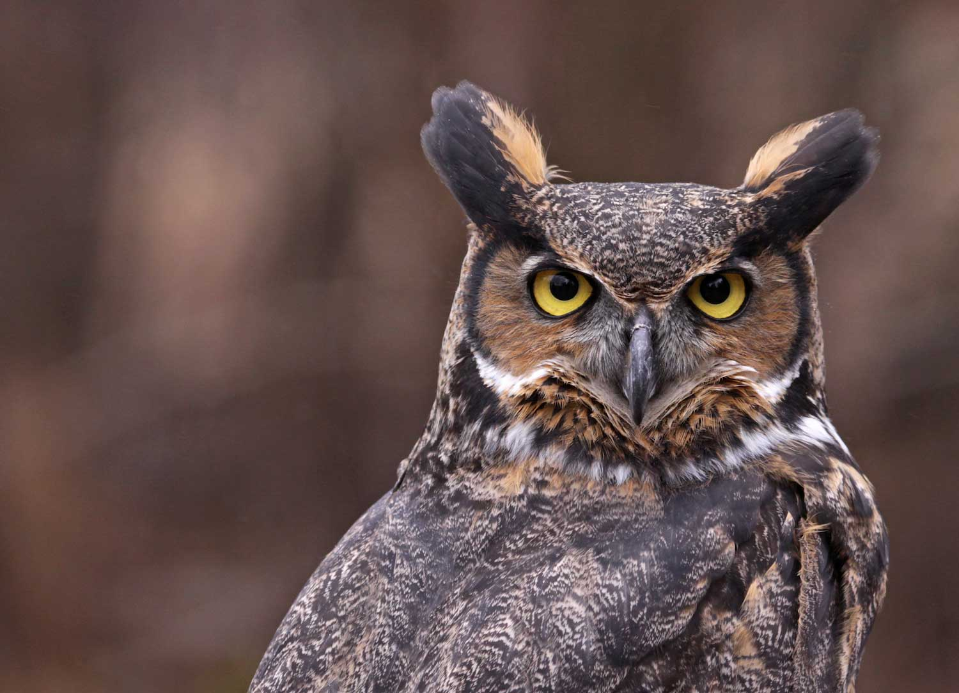
Question:

Which of the following statements is most correct regarding hydromorphone in great horned owls (Bubo virginianus)?

A. Intramuscular administration results in slow absorption and a longer half-life compared to intravenous administration
B. Hydromorphone is metabolized to hydromorphone–3-glucuronide following intravenous administration only
C. Hydromorphone administration yields antinociceptive effects when administered at 0.6 mg/kg but not 0.3 mg/kg
D. Hydromorphone has low bioavailability when administered intramuscularly
E. The metabolite, hydromorphone-3-glucuronide has not been demonstrated to have analgesic effects

Answer: E

Explanation:
- Hydromorphone IM was rapidly absorbed, had high bioavailability, and had a short half-life (t1/2) (1.62 ± 0.36 hours), which was similar to the t1/2 for IV administration (1.35 ± 0.59 hours)
- H3G was detectable in all birds at 30 minutes following drug administration by both the IV and IM routes and had measurable plasma concentrations up to 12 hours postadministration, which was the last time point measured
- A recent pharmacodynamic study evaluating the thermal antinociceptive effects of hydromorphone in GHOWs at 0.3- and 0.6-mg/kg doses resulted in significantly higher mean thermal foot withdrawal thresholds at 0.5, 1.5, and 3 hours and at 0.5 and 1.5 hours, respectively

American Journal of Veterinary Research, 84(10), 2023
Carrageenan-induced inflammation elicits behavioral changes in cockatiels (Nymphicus hollandicus) for potential pain scale development - reviewed by HSS
Nicole A. Mikoni DVM, David Sanchez-Migallon Guzman LV, MS, Hugues Beaufrere DVM, PhD, and Joanne R. Paul-Murphy DVM
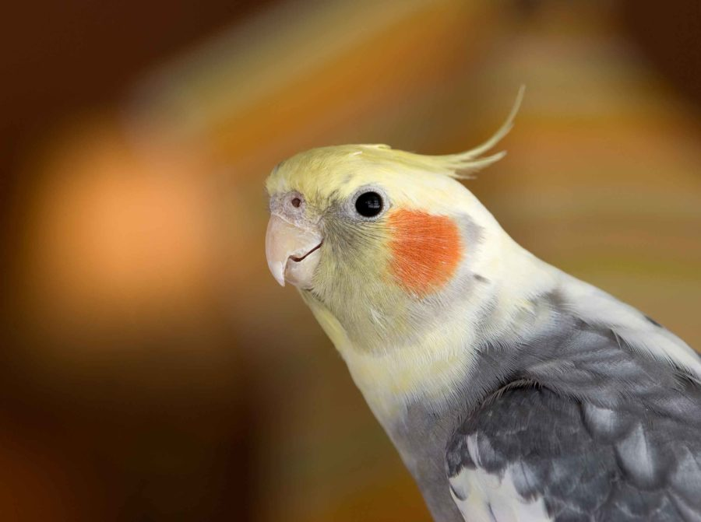

Question:

Which of the following behaviors was significantly increased in the control group compared to cockatiels that received carrageenan injections to induce inflammatory pain?

A. Burst preening
B. Focal preening
C. Cage biting
D. Non-vigilant behavior
E. Holding of the body low

Answer: C

Explanation:
- Treatment cockatiels exhibited significantly increased focal preening (q = .023) and increased burst preening (q = .036), while control cockatiels spent significantly more time in an upright stance (q = .036).
- Additional variables of interest seen more frequently in treatment cockatiels included non–weight-bearing stance, holding of the body low, and being nonvigilant.
- This contrasts with behaviors more likely to be expressed in control cockatiels such as time spent upright, drinking, and cage biting (environmental interaction)

