*Journal of Zoo and Wildlife Medicine 55(3): 750–756, 2024*

*Summarized by MR*

DETECTION OF *BABESIA CF. ODOCOILEI, BABESIA CAPREOLI*, AND *ANAPLASMA PHAGOCYTOPHILUM* IN CERVIDS OF THE SCOTTISH HIGHLANDS, UNITED KINGDOM

Sonika B. Lakshminarayana, BVSc, MSc, Amanda Guthrie, DVM, DACZM, DECZM, Damer P. Blake, BSc, MSc, PhD, Jane Harley, BVMS, Arran MacKintosh, BVetMed, Philippa J.P. Lait, BSc, PhD, Alice Bacon, DVM, MVetSci, and Ellie L. Milnes, VetMB, MVetSci, DVSc, DACZM, DECZM

Abstract: Outbreaks of suspected tick-borne disease (Redwater fever) have been reported in captive deer of the Scottish Highlands. In this pilot study, **polymerase chain reaction and amplicon sequencing were used to detect tick-borne pathogens in opportunistically collected blood and spleen samples from 63** (healthy, n = 44; diseased, n = 19) cervids, and **45 questing and feeding ticks *(Ixodes ricinus*)** from the outbreak sites in 2021–2022. Potentially pathogenic *Babesia* species were detected in deer but not identified in ticks, Anaplasma phagocytophilum was detected in both deer and ticks, and *Borrelia afzelii* was **detected in ticks but not in deer**. Sequencing confirmed *Babesia capreoli* and *Babesia cf. odocoilei* parasitemia in clinically healthy red deer (*Cervus elaphus*), B. capreoli parasitemia in clinically healthy domestic reindeer (*Rangifer tarandus tarandus*), and two cases of B. cf. odocoilei–associated hemolytic anemia in white-lipped deer (*Cervus albirostris*), of which one **was fatal despite imidocarb treatment**. **White-lipped deer appear to be highly susceptible to babesiosis caused by B. cf. odocoilei**. This investigation highlights the importance of disease surveillance, including molecular diagnostics, for the detection of emerging tick-borne pathogens in managed populations of cervids.

**Background:**

* Climate warming supports tick population expansion → surveillance updates and impacts on free-ranging and managed deer populations
* *Babesia odocoilei* (MC in NA!) and *capreoli* (MC in Europe) caused high mortality outbreaks in managed deer, hemolytic crises often precipitated by stress/immunosuppression
  + Recent surveys suggest *B. odocoilei* may be pathogenic to humans
* *Borrelia burgdorferi* and *Anaplasma phagocytophilum* are not known to be causative of disease in deer

**Summary:**

* Objective: Investigate occurrence of these four pathogens in managed cervids of the Scottish Highlands, where tick-borne disease outbreaks have previously been high impact
* Opportunistic use of samples collected unrelated to this study between Jun 2021 – Jan 2022, along with associated clinical history, animal health assessment at time of sampling, or necropsy report available for 100% of individuals
  + Used banked whole blood and splenic tissue samples for the study
  + Species included European elk (FYI – this is *Alces alces*, effectively a moose but is supposedly a distinct subsp.), white-lipped deer, burkhara deer, red deer, forest and domestic reindeer.
* Ticks were collected opportunistically by zookeepers at HWP from March to July 2021, either directly from animals during training or health checks, at necropsy, or from zookeepers’ clothing after working in animal enclosures
* PCR performed on blood, splenic tissue, and tick samples (tick species and life stage first identified prior to extraction of DNA)
  + PCR targets: *Babesia*: 18S rRNA gene, *Anaplasma*: 16S rRNA gene, *Borrelia*: ospA gene
* 44 healthy deer and 19 diseased deer included
  + All samples negative for *Borrelia*
  + Of asymptomatic deer, 25% PCR positive for Babesia sp, one individual co-infected with *Anaplasma*
  + Two white-lipped deer with hemolytic anemia
    - *Babesia odocoilei*
    - With imidocarb treatment, one survived and one died
  + *Anaplasma phagocytophilum* was also detected in a debilitated elk (*Alces alces*) with neoplasia
  + *Babesia capreoli* was found only in clinically healthy animals (26%)
* N=45 *Ixodes ricinus* ticks
  + Ticks found on the same animal on the same day were combined together into a pool for DNA extraction and all other ticks were extracted separately, giving 7 pools containing between 2 and 13 ticks, and 5 individual ticks.
  + *Anaplasma* positive tick pool: collected from asymptomatic red deer culled for population mgmt., spleen was PCR neg.
  + The *B. afzelii*–positive tick pools were collected from two asymptomatic and PCR-negative animals

**Take Home Points:**

* two confirmed (one fatal) and one suspected case of *B. cf. odocoilei*–associated hemolytic anemia in white-lipped deer during this study – histopathology confirmed in both fatal cases
  + This is first molecularly confirmed report of fatal babesiosis *from B. odocoilei* infection in the UK
* As found in previous studies, asymptomatic *Babesia* parasitemia is not uncommon in *Cervus spp*.
  + reindeer at CRH have been treated with imidocarb at 6-wk intervals during tick season (May–September) which has prevented further disease outbreaks
  + interval determined based upon likely reinfection in previous surveys between imidocarb treatment and blood sampling
* *Anaplasma* only identified in animals that were likely immunosuppressed: either from co-infection with clinical Babesiosis or an individual with neoplasia, not thought to be causative or contributory to disease
* *Borrelia* was not ID’ed in any deer tissue or blood samples
* The relatively high prevalence of *B. capreoli* parasitemia in clinically healthy domestic reindeer (26.3%) and *B. cf. odocoilei* in healthy red deer (22.6%) suggests that they may be involved in the maintenance of *Babesia spp.* in this ecosystem.

*Journal of Wildlife Diseases, 60(1), 2024, pp. 105–115*

*Summarized by MR*

Seasonal Variation in Detection of Haemosporidia in a Bird Community: A Comparison of Nested PCR and Microscopy

María Teresa Reinoso-Pérez, Keila V. Dhondt, Holland Dulcet, Nina Katzenstein, Agnes V. Sydenstricker, and André A. Dhondt

Abstract: In a 2-yr study on prevalence of Haemosporidia in an avian community in Ithaca, New York, USA, we **tested the hypothesis that apparent seasonal variation in prevalence is influenced by the detection protocol.** We confirmed a **higher detection of Haemosporidia using a molecular diagnosis technique (PCR) than by microscopy**; this further increased when the PCR test was triplicated. Microscopic examination and PCR techniques have different specificity and sensitivity and therefore different probabilities of detecting hemoparasites. **Birds with chronic infections or sampled during winter often have very low parasitemia, and such infections may be missed by microscopy but detected by PCR.** Haemosporidian prevalence was **higher during the breeding season than during the nonbreeding season regardless of the method used**. Detection of *Leucocytozoon spp*. infection from blood smears using microscopy was challenging.

**Background:**

* Seasonal variation in parasite prevalence due to host, vector, and environmental factors
  + Late summer/fall: increased local transmission when host numbers increase following reproduction
  + Spring: relapse of infection due to immunosuppression due to hormonal changes associated with breeding
* In different avian populations this seasonal bimodal pattern has been found for various *Plasmodium spp.* and for some *Haemoproteus* and *Leucocytozoon spp*.
* prevalence and diversity of these parasites decreases with increasing latitude
* Microscopy and PCR have different SP/SN = different probabilities of parasite detection (daily variation, need for PCR replication to increase SN)
* Previous studies: insufficient sensitivity of different PCR-based protocols to ID these parasites → underestimation of prevalence especially in coinfections with different lineages

**Summary:**

* Objective: Report prevalence of Hemosporidia in a wild bird community in Ithaca, NY – hypothesized that seasonal prevalence influenced by detection protocol (PCR vs. microscopy)
* Birds attracted with feeders and mist netted Mar 2018 – Feb 2020: blood sample used for two blood smears/bird + blood drop saved on filter paper in sterile microtube for PCR.
* Microscopy: 100x objective, number of infected cells in 100 random fields
* PCR: For each sample, nested PCR (two sequential PCR with different primers) was performed to detect separately *Plasmodium* spp.–*Haemoproteus spp.* or *Leucocytozoon spp.*
* N = 425, 25 avian spp.
  + 42 different Haemosporidian lineages with PCR
* *Haemosporidian* prevalence in general was significantly higher during the breeding than in the nonbreeding season, 58% and 41%, respectively (x2 =12.85, df=2, P<0.001).
* 9% of birds were co-infected with *Plasmodium and Leucocytozoon sp.*
* Twenty of the 25 avian species tested were infected by more than one lineage either from the same or from different genera of Haemosporidia.
* Detection probability of *Plasmodium-Haemoproteus spp*. increased significantly when replicating the PCR tests two (P= 0.04) and three times (P<0.01) compared to when performing it only once
* Infection probability for Plasmodium-Haemoproteus was thus significantly higher using nested PCR than microscopy and this in both seasons.

**Take Home Points:**

* These Haemosporidian pathogens have many host, environment, and vector factors that influence detection in various studies
  + Various species are nest mitted in each study, with likely different susceptibilities
  + Different vectors involved
  + overlap of various lineages is limited: differences in host specificity?
  + Differences in exposure based on environmental ecology for each species
  + **Given these challenges: prevalence should be investigated with microscopy and PCR**
* While for Plasmodium-Haemoproteus detection increased with use of two PCR tests, with Leucocytozoan an increase was observed only with three tests. (low parasitemia with Leucocytozoan spp. and different life cycle?)
  + Leucocytozoan peak parasitemia during evening or night and study samples taken during day
* Nested PCR enabled detection of more cases of haemosporidian than did microscopy, regardless of the season.
* Higher prevalence during breeding season corresponded with patterns described in previous studies (breeding stress)

Journal of Wildlife Diseases, 60(4): 886-902, 2024.  
**TRYPANOSOMIASIS IN INTRODUCED SOUTHERN WHITE RHINOCEROS (CERATOTHERIUM SIMUM SIMUM) GIFTS TO EX SITU HABITAT IN AITONG, KENYA**  
 Francis Gakuya, Richard Kock, Isaac Lekolool, Steve Mihok – Reviewed by LMM

**Abstract:** **During the opening of diplomatic relations in the 1990s, South Africa gifted 20 southern white rhinoceros (*Ceratotherium simum simum*) to Kenya.** The **species is not indigenous to Kenya**, and management of the introduction was not clearly addressed in the legislation. Responsibility was left to the private sector and local authorities. **Ten of the animals were introduced to land contiguous with the Maasai Mara National Reserve, an area with tsetse–trypanosomiasis challenges, and with rare cases of human sleeping sickness.** Mortalities had been previously documented when indigenous naïve black rhinoceros were introduced to areas with tsetse; hence there was no consensus on the management of this introduction. Feasibility was only explored once before with the introduction of two animals in a monitored and managed translocation from Lewa Downs, Laikipia in 1992–1994. **Ultimately, Kenyan experts were co-opted to address risk after trypanosomiasis occurred in many animals. Unfortunately, this finding was followed by gradual mortalities of most rhinoceros with only a few being saved by removal to highland private sanctuaries.** This event was complicated by many factors. Samples were only sporadically collected, and mainly from sick animals. With no clear responsibility by government agencies, a collaboration between veterinarians and researchers resulted in characterization of the disease challenge, and when invited, assessment of health status. **Laboratory diagnostics revealed common and sometimes severe infections with *Trypanosoma brucei*, a normally infrequent trypanosome. Infection was associated with disturbances in erythropoiesis, especially anemia. Symptoms varied from sudden death associated with intestinal atony, to a semiparalyzed animal that was partially responsive to treatment for trypanosomes.** This event should be used as a caution to future movements of this species that are planned or ongoing in Africa, for conservation or other purposes.

**Key Points:**

* Two extant species of African rhinoceros
  + Black Rhinoceros (*Diceros bicornis*) = browser living in bush and scrub habitat
  + White Rhinoceros (*Ceratotherium simum*) = grazer living in grassland habitat
    1. Northern Subspecies (extinct) = *C. s. cottoni*
    2. Southern Subspecies (living) = *C s. simum*
* White rhinos live outside of the tsetse belt and therefore assumed to have evolved in the absence of trypanosomiasis whereas Black rhinos often harbor trypanosomes and naturally exist in harmony with tsetse
  + In Black rhino, trypanosome tolerance probably reflects innate immunity (rather than acquired) therefore in translocations, naïve black rhino can likely cope with trypanosomes – typically subclinically or they not affected at all
* In white rhinos, trypanosomiasis disturbs erythropoiesis but appears to be reversible, but with possible long-term effects such as hemosiderosis (hemosiderosis more so an issue in managed care than in the wild)
* White Rhinos were infected with *Trypanosoma brucei* exhibited variable signs some of the signs included low PCV’s, presence of metarubricytes, low hemoglobin, low MCHC, depression, inappetence, and in one case neurologic signs. (Not all rhinos had all these signs.)
  + Piroplasms (*Theileria* spp.) were present on smears but are a normal feature of rhino hematology
  + *Nannomonas*, an unknown trypanosome, was identified in a few individuals but trypanosome could not be further characterized (unclear clinical significance)
  + The neurologic signs in a single individual included unilateral sensory loss (sight, hearing, touch) and died soon after signs. On histopath, hemosiderosis was present but no evidence of meningoencephalitis. Meningoencephalitis is normally noted in black rhinos infected with *T brucei* in Zambia.
  + Small sample size but comparing Aitong animals to normal white rhino data qualitatively, infected white rhinos had low neutrophils and eosinophils as well as low total leukocytes. Additionally, erythrocyte indices were low (Hgb, PCV, MCH, MCHC, and MCV) with exception of RBC count.
* The serum antigen-ELISA trypanosome test kit for bovines proved to be unreliable in white rhinos
* Authors recommend PCR combined with proof of parasite ID via inoculation of blood into a variety of animals (not just rodents) as well as xenodiagnoses (e.g. with cryopreserved blood) for future characterization of parasites infecting rhinos.

**Take Home Points:**

* White rhino are particularly susceptible to a normally rare trypanosome in wildlife (*Trypanosoma brucei*). Subpatent infections are common and include the new finding of an unknown species or DNA type of *Nannomonas*. The pathogenic effect of *T. brucei* is acute to chronic, moderate to severe, and can lead to death.
* REMINDER: *Trypanosoma brucei* is the human pathogen causing sleeping sickness and there is a potential for zoonotic transmission.
* Disturbed erythropoiesis is the best indicator of infection, with low Hgb, PCV, MCH, MCHC, and MCV, accompanied by low neutrophils and platelets. Typically inadequate response to anemia noted with metarubricytes present on blood smears.

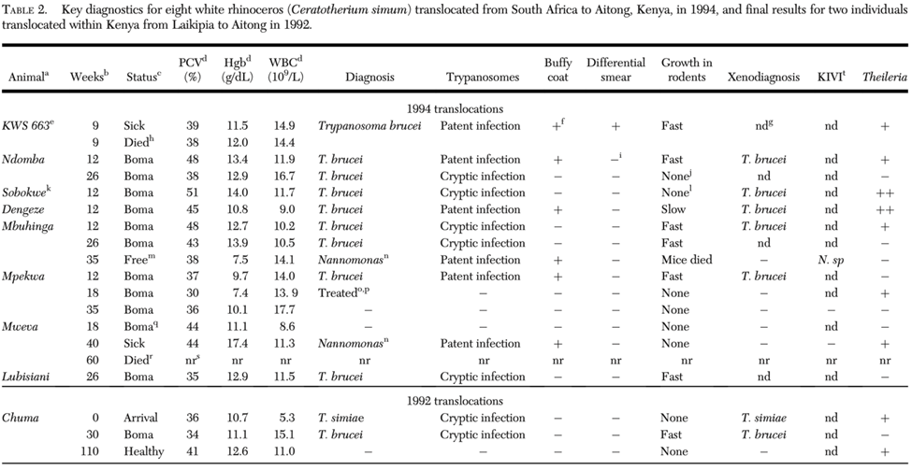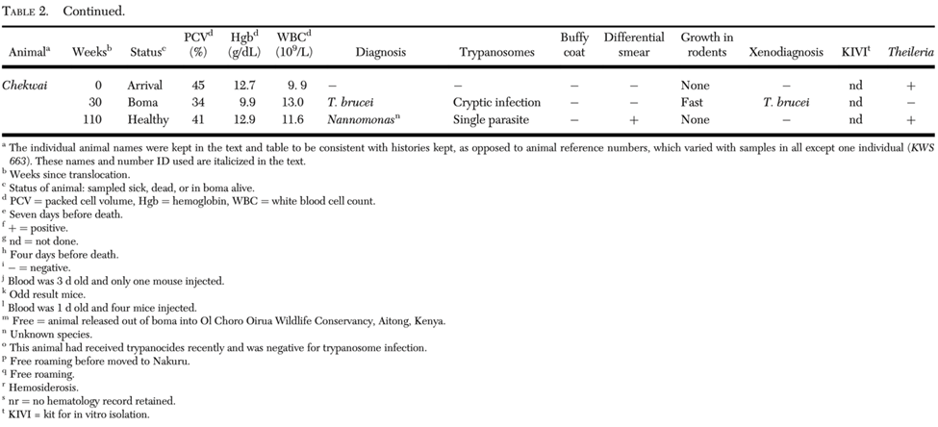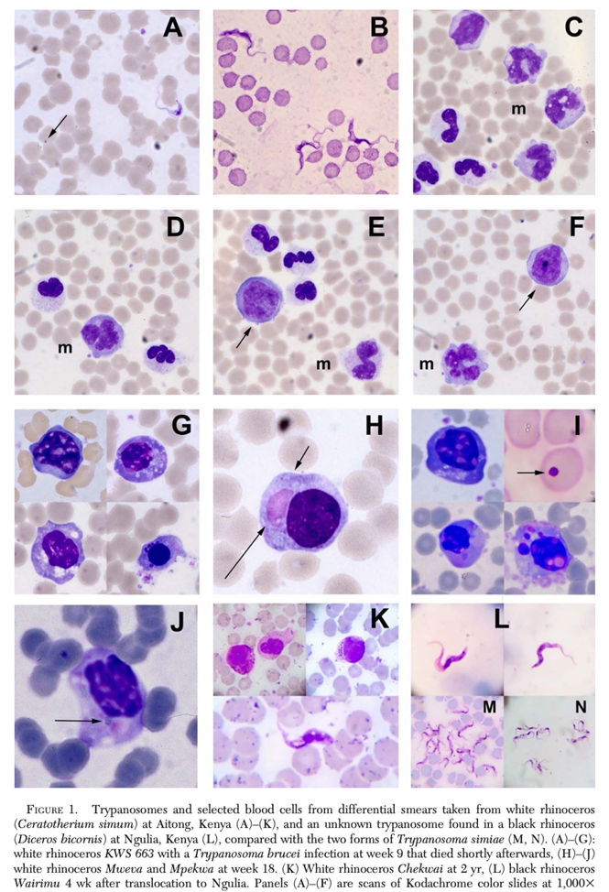

------------------------------------------------------------------------------------------------------------------

Journal of Wildlife Diseases, 59(4): 722-733, 2023.  
**POTENTIAL SHARED DISEASE RISK AMONG DOGS AND COYOTES (CANIS LATRANS) EXEMPLEFIED BY THE ECOLOGY OF RICKETTSIOSIS IN A ROCKY MOUNTAIN SPOTTED FEVER-EPIDEMIC REGION IN NORTHERN MEXICO**  
Jacob Marcek, Janet Foley, Laura Backus, Gerardo Suzan, Andres M Lopez-Perez – Reviewed by LMM

**Abstract:** Rocky Mountain spotted fever (RMSF), caused by the bacterium *Rickettsia rickettsii*, is a re-emerging tick-borne zoonosis in North America, with hundreds of human fatalities in multiple outbreaks in northern Mexico and the southwestern US in the past few decades. **Free-roaming dogs are key because they are reservoirs for the pathogen and the main hosts of the brown dog tick (*Rhipicephalus sanguineus*), which vectors RMSF in this region.** Because coyotes (*Canis latrans*) can be infected with *R. rickettsii* and infested with *Rh. sanguineus*, we hypothesized that space sharing among dogs and coyotes could enhance disease risks. In summer 2021, **we captured and sampled 11 coyotes at two sites in Baja California, Mexico, near population centers with human cases of RMSF, and fitted seven individuals with GPS logging collars.** We also **tested tissue samples, sera, and ectoparasites for DNA of *R. rickettsii* with PCR and used serology to detect antibodies to *R. rickettsii*.** Finally, we **deployed an array of cameras to document dog-coyote interactions.** Mean home range size was 40.37 km2. Both GPS and camera data showed considerable home range overlap both between individual coyotes and between coyotes and dogs. Coyotes were active in areas where dogs occur including the domestic interface surrounding human settlements. **Although none of our samples were positive for *R. rickettsii* on PCR, 72.7% (8/11) of the samples were seropositive with titers *≥*64.** **Our data confirm shared space use and risk of shared parasites and disease between coyotes and dogs.**

**Key Points:**

* In the last two decades, more than 2,000 human cases of RMSF have been reported in the western US-Mexico border region, mortality rates up to 40%
* The etiologic agent, *Rickettsia rickettsii,* is transmitted exclusively by ticks, specifically the brown dog tick (*Rhipicephalus sanguineus*) in the southwest US and northern Mexico
  + Outbreaks are associated with overpupulation of tick-infested free roaming dogs
* Only one hard tick (*Dermacentor similis*) was recovered from a coyote, otherwise it was various species of fleas
  + The brown dog tick (*Rhipicephalus sanguineus*) was not observed. Samples were taken earlier in the summer and the brown dog tick has increased activity and decreased host specificity with increasing temperature. May have missed their normal window during sampling.
* No samples (blood, ear tissue, fleas, or single tick) were PCR-positive for *Rickettsia* on qPCR, indicating that no individuals had active infection
  + This result was not surprising as *R. rickettsia* tends to circulate in blood for only a short time before entering the vascular endothelium
* On IFA, 8/11 blood samples had antibodies to spotted fever group rickettsia and 7/11 had positive antibodies for typhus group rickettsiae
  + Seropositivity on IFA was significantly greater in females as compared to males
* Collar and camera trap data suggested overlap between domestic dogs and coyotes and a risk of shared parasitism and transmission of *R. rickettsii*
  + Interesting Tidbit: One of their camera traps was stolen during the study.

**Take Home Point:** In northern Mexico, dogs and coyotes share space and there is risk for shared parasites and disease transmission. Coyotes in this study were seropositive for spotted fever group rickettsia and for that reason they may serve as reservoirs for *Rickettsia rickettsii* (etiologic agent of Rocky Mountain Spotted Fever).

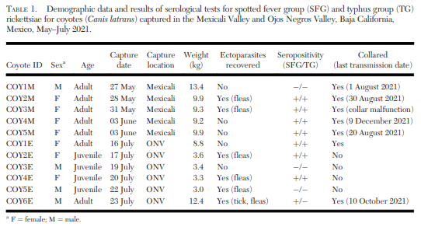

Journal of Wildlife Diseases, 59(3): 432-441, 2023.    
**HIGH PREVALENCE OF *CYTAUXZOON FELIS* IN BOBCATS (*LYNX RUFUS*) ACROSS OKLAHOMA AND OCCURRENCE IN WEST TEXAS, USA** - reviewed by HSS

Pabasara Weerarathne, Tiana L. Sanders, Yun-Fan Kao, Stacy R. Cotey, Joshua D. Place, W. Sue Fairbanks, Craig A. Miller, Mason V. Reichard

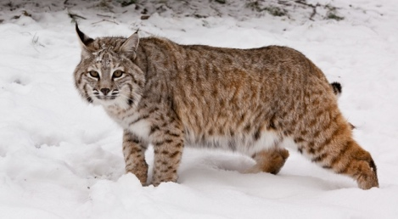

**Abstract:**

Cytauxzoonosis is a fatal tick-borne disease in domestic cats caused by infection with the **apicomplexan *Cytauxzoon felis*.** **Bobcats are the natural wild-vertebrate reservoirs** for *C. felis*, and infections are **typically subclinical and chronic** in this species. The present study was done to determine the **prevalence and geographic distribution** of *C. felis* infection in **wild bobcats from Oklahoma** and the **occurrence in northwestern Texas**. Tongue samples from 360 bobcats were collected from 53 counties in Oklahoma and 13 samples from three counties in Texas. For DNA extracted from each tongue sample, a probe-based droplet digital PCR assay was performed targeting the *C. felis* mitochondrial gene *cytochrome c oxidase* subunit III (*cox3*). Prevalence of *C. felis* infection was calculated for each county sampled, and data from individual counties were combined according to geographic regions and compared using chi-square tests. **Overall prevalence of *C. felis* in bobcats from Oklahoma was 80.0%** (95% confidence interval [CI], 75.6–83.8). The **prevalence of infection was >90% for bobcats from central, northeastern, south-central, and southeastern regions of Oklahoma, but <68% for bobcats from northwestern and southwestern regions**. **Bobcats from central counties in Oklahoma were 25.693 times more likely to be infected with *C. felis* compared to all other bobcats sampled** from the state. **Higher prevalence estimates of *C. felis* in bobcats appeared to be in counties where known tick vectors are most common. Occurrence of *C. felis* in bobcats from northwestern Texas was 30.8%** (95% CI, 12.4%–58.0%) based on 13 samples. Results of this study support the utilization of bobcats as sentinel animals to identify geographic areas with risk of *C. felis* infection to domestic cats.

**Key Points:**

* *Cytauxzoon felis* is an emerging tick-borne apicomplexan parasite that causes cytauxzoonosis in domestic and wild felids. Severe disease may occur, characterized by depression, fever, lethargy, inappetence, dehydration, icterus, and possibly death
* Tick vectors include *Amblyomma americanum* (lone star tick) and *Dermacentor variabilis* (American dog tick)
* The complete life cycle of *C. felis* is not known; however, schizogony of *C. felis* occurs in feline macrophages and is the most pathogenic stage for felids. Ticks ingest piroplasms of *C. felis* along with a blood meal, and sexual reproduction of the protozoan occurs in the tick definitive host.
* The overall prevalence of *C. felis* in bobcats from Oklahoma was 80.0%
  + The overall prevalences of *C. felis* in bobcats from counties in southeast, northeast, central, and south-central regions of Oklahoma were >90%. Of the bobcats sampled from central and south-central Oklahoma counties, all the samples were infected with *C. felis*, indicating a 100% prevalence.
* When combined, the occurrence of *C. felis* in bobcats sampled from the three counties in Texas was 30.8%
* *C. felis* infections in bobcats were highest in areas where *A. americanum* and *D. variabilis* populations and activity are well established and considered common. Climatological differences result in a higher tick prevalence in the eastern regions compared to western regions of Oklahoma.
* ddPCR (droplet digital PCR) assay has a high sensitivity and is able to detect low levels of *C. felis* DNA in tissues.

**Take-Home Message:**

* *C. felis* infections in bobcats in Oklahoma were highest in areas where *A. americanum* and *D. variabilis* populations are well established. Bobcats are the wild reservoir for *C. felis*. *C. felis* was documented in bobcats in Texas for the first time.

Journal of Wildlife Diseases, 60(2): 375-387, 2024.    
**SEROLOGIC SURVEY OF SELECTED ARTHROPOD-BORNE PATHOGENS IN FREE-RANGING SNOWSHOE HARES (*LEPUS AMERICANUS*) CAPTURED IN NORTHERN MICHIGAN, USA** - reviewed by HSS

Erik Hofmeister, Eric Clark, Melissa Lund, Daniel Grear

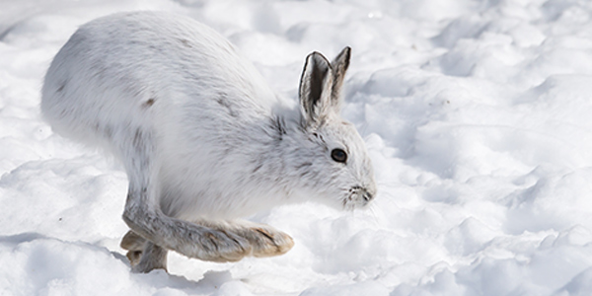

**Abstract:**

Snowshoe hares (*Lepus americanus*) in the Upper Peninsula (UP) of Michigan, USA, occupy the southern periphery of the species' range and are vulnerable to climate change. In the eastern UP, hares are isolated by the Great Lakes, potentially exacerbating exposure to climate-change–induced habitat alterations. Climate change is also measurably affecting distribution and prevalence of vector-borne pathogens in North America, and increases in disease occurrence and prevalence can be one signal of climate-stressed wildlife populations. We conducted a **serosurvey for vector-borne pathogens in snowshoe hares that were captured in the Hiawatha National Forest in the eastern UP of Michigan, USA, 2016–2017.** The **most commonly detected antibody response was to the mosquito-borne California serogroup snowshoe hare virus (SSHV). Overall, 24 (51%) hares screened positive for SSHV antibodies and of these, 23 (96%) were confirmed positive by plaque reduction neutralization test.** We found a **positive association between seroprevalence of SSHV and live weight** of snowshoe hares. Additionally, we detected a significant effect of ecological land type group on seroprevalence of SSHV, with **strong positive support for a group representing areas that tend to support high numbers of hares** (i.e., acidic mineral containing soils with cedar, mixed swamp conifers, tamarack and balsam fir as common overstory vegetation). We also **detected and confirmed antibodies for Jamestown Canyon virus and Silverwater virus in a single hare each. We did not detect antibodies to other zoonotic vector-borne pathogens, including Lacrosse encephalitis virus, West Nile virus, *Borrelia burgdorferi*, Powassan virus, and *Francisella tularensis*.** These results provide a baseline for future serological studies of vector-transmitted diseases that may increase climate vulnerability of snowshoe hares in the UP of Michigan, as well as pose a climate-related zoonotic risk.

**Key Points:**

* Known vector-borne diseases that hares might be exposed to include mosquito-transmitted Jamestown Canyon virus (JCV), La Crosse virus (LACV), snowshoe hare virus (SSHV), West Nile virus (WNV), tick-transmitted Powassan virus (POWV), Silverwater virus (SILV), *Borrelia burgdorferi*, and *Francisella tularensis*, which can be transmitted by a number of arthropods
* We did not detect antibodies to other zoonotic vector-borne pathogens, including Lacrosse encephalitis virus, West Nile virus, *Borrelia burgdorferi*, Powassan virus, and *Francisella tularensis*.
* This study detected exposure to three arboviruses, Serogroup snowshoe hare virus (SSHV), Jamestown canyon virus (JCV), and Silverwater virus (SILV)
  + All three have sylvatic transmission cycles and are potentially zoonotic
  + Exposure to SSHV was detected in 51% of samples
    - Mosquito transmitted
    - Positive relationship with weight; older animals = increased exposure
    - Strong positive relationship with wetlands with coniferous forest species = more snowshoe hares and mosquitoes
  + Detected and confirmed antibodies for Jamestown Canyon virus and Silverwater virus in a single hare each
    - JCV is transmitted by mosquitos, reservoir host = WTD
    - SILV is transmitted by the rabbit tick (*Haemaphysalis leporispalustris*), not reported in humans yet
* Lacrosse encephalitis virus
  + Vectored by *Aedes triseriatus* mosquitoes with hardwood forest small mammals, particularly Eastern chipmunks (*Tamias striatus*), as the reservoir hosts
* Powassan virus
  + Causes Powassan encephalitis in people
  + Two host–vector cycles.
    - Lineage I is found in midsized mammals such as groundhogs (*Marmota monax*) with the ticks *Ixodes marxi*, *Ixodes spinipalpus*, and *Ixodes cookei* as vectors.
    - Lineage II of POWV resides in smaller mammals such as white-footed mice (*Peromyscus leucopus*) and is vectored by *Ixodes scapularis*
* *Borrelia burgdorferi* 🡪 Lyme disease
  + *I. scapularis* ticks are the primary vector

**Take-Home Message:**

* High prevalence of snowshoe hare virus (SSHV) in snowshoe hares in the Upper Peninsula of Michigan. Jamestown Canyon virus and Silverwater virus detected in a single hare each. No antibodies to Lacrosse encephalitis virus, West Nile virus, *Borrelia burgdorferi*, Powassan virus, or *Francisella tularensis* detected.

**RACCOONS (PROCYON LOTOR) SHOW HIGHER TRYPANOSOMA CRUZI DETECTION RATES THAN VIRGINIA OPOSSUMS (DIDELPHIS VIRGINIANA) IN SOUTH CAROLINA, USA**

*David A. Bernasconi, Madison L. Miller, Jacob E. Hill, Pooja Gupta, Richard Chipman, Amy T. Gilbert, Olin E. Rhodes Jr., Guha Dharmarajan*

Chagas disease, a significant public health concern in the Americas, is caused by a protozoan parasite, Trypanosoma cruzi. The life cycle of T. cruzi involves kissing bugs (Triatoma spp.) functioning as vectors and mammalian species serving as hosts. Raccoons (Procyon lotor) and opossums (Didelphis virginiana) have been identified as important reservoir species in the life cycle of T. cruzi, but prevalence in both species in the southeastern US is currently understudied. We quantified T. cruzi prevalence in these two key reservoir species across our study area in South Carolina, US, and identified factors that may influence parasite detection. **We collected whole blood from 183 raccoons and 126 opossums and used PCR to detect the presence of T. cruzi**. We then used generalized linear models with parasite detection status as a binary response variable and predictor variables of land cover, distance to water, sex, season, and species. Our analysis indicated that **raccoons experienced significantly higher parasite detection rates than Virginia opossums,** with T. cruzi prevalence found to be 26.5% (95% confidence interval [CI], 20.0-33.8) in raccoons and 10.5% (95% CI, 5.51-17.5) in opossums. Overall, our results concur with previous studies, in that T. cruzi is established in reservoir host populations in natural areas of the southeastern US.

**Background:**

* Chagas disease caused by *Trypanosoma cruzi*, zoonotic disease
  + Small mammals, including Virginia opossums and raccoons, are important reservoir hosts
  + Kissing bugs (*Triatoma* spp.) are most common vectors - disease is spread when feces from the bug enters host through breaks in skin (often bite wound of bug) or mucous membranes
  + Despite relatively high prevalence in reservoirs in the US, human infection is rarely reported here (much higher in Latin America), likely due to lower vector colonization of housing dwellings - although also possible it is under-recognized

**Main points:**

* Performed PCR on whole blood of free-ranging opossums and raccoon in South Carolina.
* Raccoons had higher + rate (26.5%) than opossums (10.5%) - overall prevalence relatively similar to previous studies in a similar region.
  + Possible raccoons have more contact with vectors, also have a higher population density in this region which could contribute
* No significant differences by land cover, sex, season in this study

**Takehome:** In South Carolina, raccoons are more likely to be positive for *Trypanosoma cruzi* than opossums. Both species are reservoirs for the disease in the US, *Triatoma* sp. insects are vectors (*Triatoma sanguisuga* and *Triatoma lecticularia* being the two species reported in South Carolina.)

TRYPANOSOMA CRUZI INFECTION IN THREE SLENDER-TAILED MEERKATS (SURICATA SURICATTA)

**Abstract**: **Trypanosoma cruzi is a protozoan parasite primarily transmitted by triatomine insects (Hemiptera: subfamily Reduviidae) and is the cause of Chagas disease (CD)**. This report describes three cases of CD in a mob of five slender-tailed meerkats (Suricata suricatta) living in an outdoor exhibit at one zoological institution in Texas. The index case was a 9.5-yr-old female that presented with **ataxia, lethargy, and pleural effusion**. This case was **diagnosed with CD postmortem via cytology, T. cruzi PCR of whole blood and lung fluid, and histology**. Blood was opportunistically collected from the remaining four meerkats 28 d after the death of the index case and tested by PCR and serology. The second case was a clinically normal 7.5-yr-old male that tested PCR and antibody positive and the third case was a clinically normal 9-yr-old female that tested PCR positive. The second animal presented depressed, with pneumonia, and with continuous shivering 53 d after blood collection, and clinically improved after treatment with antibiotics and supportive care. Fifteen days later, the animal was found minimally responsive and died shortly thereafter. Histologic examination revealed Trypanosoma sp. amastigotes in the myocardium and the tissue was positive for T. cruzi DNA. The third meerkat, which received two separate courses of benznidazole over a span of almost 2 yr, was monitored routinely by PCR and serology and **appeared clinically normal until found dead on exhibit 93 d after completion of the second treatment.** Myocardium was positive for T. cruzi DNA. To the authors’ knowledge, this case series is the first to document Chagas disease in meerkats and features associated cytologic and histologic findings.

**Taxonomy: Order** Carnivora, **Family** Herpestidae, **Genus / Species** *Suricata suricatta*

* Trypanosoma cruzi= protozoan parasite transmitted by triatomine insects and cause of Chagas disease
  + Vector defecates while sucking blood from the host and metacyclic trypomastigotes shed in the feces enter the bite wound
* Zoo’s have reported Chagas disease in red panda, maned wolfs, pampas cats, a giant anteater and non human primatesA close-up of a microscope

  Description automatically generated
* This was a case report

**Main points:**

* Case 1: 9.5yo Female
  + Clinical Signs: Stuporous, ataxic, dyspneic, pale MM, pleural effusion
  + Anesthetized with isoflurane for diagnostics (bloodwork and radiographs) → became apneic (administered dopram) and arrested during thoracocentesis
  + Diagnosed with *T. cruzi* postomortem via cytology, PCR (blood / lung fluid), and histology
  + The remaining four meerkats were tested 28d following the death of Case 1
* Case 2: 7.5yo Male
  + Clinically normal → tested PCR and antibody positive
  + 53d later, presented depressed with pneumonia and shivering → clinically improved with supportive care and antibiotics (meloxicam, enrofloxacin)
  + 15d later, animal found minimally responsive and died shortly after evaluation, myocardial tissue PCR positive for *T. cruzi*
* Case 3: 9yo Female
  + Clinically normal → tested PCR Positive → received 1st course of benznidazole 8 months after sampling due to lack of drug availability (6.25 mg PO q12h x 68d)
  + 15 months later, PCR and antibody positive → 2nd course of benznidazole (6.25 mg PO q12h x 75d) → 5d prior to end of treatment, PCR negative and antibody weak positive
  + Found dead on exhibit 93d after 2nd treatment, myocardium PCR positive for *T. cruzi*

**Take home:** Chagas disease / American trypanosomiasis should be considered a differential diagnosis for sudden death in meerkat with myocardial tissue submitted for PCR. Apparently healthy conspecifics should be tested PCR and serology and treated with benznidazole where appropriate.

**DETECTION OF VECTOR-BORNE INFECTIONS IN LIONS AND TIGERS AT TWO ZOOS IN TENNESSEE AND OKLAHOMA, USA.** JZWM 2022. Cerreta, Anthony J. et al. - reivew by LEM

Abstract: Protozoal and bacterial vector-borne infections are frequently diagnosed in domestic felids.

However, with the exception of Mycoplasma haemofelis and Cytauxzoon felis, their occurrence in managed nondomestic felids housed in the United States is largely unknown. Following a case in February 2020 of fulminant cytauxzoonosis in an African lion (Panthera leo), EDTA–whole blood samples were collected opportunistically from February 2020 through June 2020 from 34 adult tigers (Panthera tigris) and eight adult African lions from the same sanctuary in eastern Tennessee as well as 14 adult tigers from a zoo in southern Oklahoma. Samples were analyzed for Cytauxzoon felis, Bartonella spp., hemotropic Mycoplasma, Rickettsia spp., Anaplasma spp., Ehrlichia spp., Babesia spp., and Hepatozoon spp. DNA by PCR amplification. All animals were asymptomatic at the time of collection. None of the Oklahoma animals were positive for vector-borne organisms, but these pathogens were detected in tigers at the Tennessee facility, including Cytauxzoon felis (11.8%), ‘‘Candidatus Mycoplasma haemominutum’’ (5.9%), and Ehrlichia ewingii (2.9%). During the study period, two animals developed clinical signs of cytauxzoonosis and were assessed for vector-borne infections as part of their diagnostic evaluation. This study documents the presence of tick-borne diseases in managed nondomestic felids in the southeastern United States and underscores that ectoparasite control measures should be practiced to minimize exposure of carnivores in managed care.

Background:

* Lions serve as reservoir for babesia in South Africa; bobcats for C. felis in USA
* **C. felis and Mycoplasma haemofelis are the only VB pathogens thoroughly documented in nondomestic felids in US**
* Healthy managed care exotic felids known to harbor pathogens without disease

Methods: screen for 8 vector borne diseases via PCR amplification of DNA in asymptomatic tigers (n=34) and lions (n=14) at TN facility, and tigers (n=14) from Oklahoma facility

* If positive on screening, submitted for sequencing
* Histopath of C. felis (reported in one lion prior to this study which prompted investigation)
  + Intravascular and intrahistiocytic Cytauxzoon felis schizonts within the lungs
  + Fewer organisms within the spleen and lymph nodes
  + Marked erythrophagocytosis in the spleen, indicative of extravascular hemolysis

Key Points:

* C. felis, Ehrlichia ewingii, and hemotropic mycoplasma-like organism (Candidatus mycoplasma haemominutum) were detected in tigers at TN facility
* **C felis associated with fatal disease in felids - acute, nonspecific clinical signs (lethargy, anorexia, depression) quickly causing death in 1-5 days**
  + **American dog tick (dermacentor sp) and lone star (amblyomma sp) are vectors**
* **Tigers and lions can harbor subclinical infection with vector borne pathogens making them a potential source of infection for other captive animals\*\***
* Given potential for clinical disease, captive wild felids should be screened via PCR that are coming from or being moved to a region in which VBO are endemic

**DOCUMENTATION OF TRYPANOSOMA EVANSI IN CAPTIVE TIGERS AND LIONS IN PUNJAB (2016–2018), PAKISTAN.** JZWM 2022. Muhammad Akbar Khan et al. - reivew by LEM

Trypanosoma evansi is an important hemoparasite of a variety of animal species worldwide. This parasite is a threat to the health of domestic animals as well as wild animals, particularly those managed in captivity. The current study investigated the presence of T. evansi in captive tigers (Panthera tigris tigris) and lions (Panthera leo) in Pakistan. In total, 24 blood samples from 11 tigers and 3 lions (n = 14) were collected during the course of roughly 3 yr (2016–2018). Eighteen samples were subjected to both microscopic and molecular evaluation for the presence of T. evansi; the remaining 6 samples were processed for PCR only. Of the 18 samples tested by both methods, 3 (16%) and 8 (44%) were positive by microscopy and PCR, respectively. This highlights the higher sensitivity of PCR over microscopy for detection of trypanosomes. Of the 24 total samples evaluated by PCR, 12 (50%) were positive. The three sequences obtained showed 99% identity with variant surface glycoprotein genes of the different isolates of T. evansi. **The sensitivity, specificity, positive predictive value, and negative predictive value of microscopy in identifying T. evansi was 37.5, 100, 100, and 66.7%, respectively, considering PCR as the gold standard.** We recommend rigorous monitoring of captive tigers and lions for hemoparasites, particularly in winter and early spring in areas with high infection rate of this parasite, preferably via PCR.

Background

* Trypanosoma: protozoan hemoparasite; important species include T. evansi, T. brucei, T. gambiense, T. congolense, T. vivax, and T. cruzi
  + T. evansi has widest geographic distribution
  + Can cause dz (Trypanosomiasis) or host mammals can act as subclinical reservoirs
  + Arthropod vectors: horse flies, “kissing flies”, assassin flies, tsetse flies
* Trypanosomiasis previously reported in tigers, leopards, jaguars
  + Clinical signs: anorexia, anemia, emaciation, pale mm, fever, enlarged LN, V+, lethargy
  + Necropsy findings: splenomegaly, enlarged LN, atrophy of fat
  + Has been reported in zoos –transmission via arthropod vector or infected meat ingestion

Key Points

* Screened for Trypanosoma in tigers and lions at Pakistan zoos via microscope eval of blood smears vs blood PCR; compared sensitivity and specificity of methods
  + All animals experienced loss of BCS, decreased appetite, anemia
  + One tiger showed neuro signs in days leading up to death; excitation and seizures
* Of 18 paired samples: 3 positive via microscopy and 8 positive via PCR (the 8 positive on PCR included the 3 positive via microscopy)
* Total prevalence out of 24 samples: 50% positive via PCR
* Sequenced as T. evansi
* PCR has higher sensitivity than microscopic eval of blood smear
* **Blood smear eval has high specificity and PPV, but lower sensitivity and NPV**

**TLDR: PCR higher sensitivity than blood smear for Trypanosoma detection in tigers and lions**

* **Reported weight loss, decreased appetite, anemia associated with positive Trypanosoma status in tigers and lions**