*Journal of Zoo and Wildlife Medicine 55(3): 750–756, 2024*

*Summarized by MR*

DETECTION OF *BABESIA CF. ODOCOILEI, BABESIA CAPREOLI*, AND *ANAPLASMA PHAGOCYTOPHILUM* IN CERVIDS OF THE SCOTTISH HIGHLANDS, UNITED KINGDOM

Sonika B. Lakshminarayana, BVSc, MSc, Amanda Guthrie, DVM, DACZM, DECZM, Damer P. Blake, BSc, MSc, PhD, Jane Harley, BVMS, Arran MacKintosh, BVetMed, Philippa J.P. Lait, BSc, PhD, Alice Bacon, DVM, MVetSci, and Ellie L. Milnes, VetMB, MVetSci, DVSc, DACZM, DECZM

Fill in the blanks to describe the life cycle of Babesiosis in Cervids (discussed last semester in Dr. Harrison’s cervid CBS, and this year in this paper):

The typical etiologic agent of “Redwater Disease” in cervids in North America is *Babesia* _____(A)_____ **[species name]**. The parasite is most commonly transmitted by ______(B)_____ **ticks**. Parasite trophozoites and merozoites develop in the _____(C)____ **[a cell type]**. This cell lyses to release the infectious stage within the host, resulting in _____(D)_____ **[the clinical condition]**. Subclinical cases may occur and may progress to clinical disease with stress: high population density, concurrent disease, transport, reproduction, poor nutrition. **Treatment** with _______(E)________ is indicated.

1. *Babesia odocoilei*
2. Ixodes/Ixodid
3. Erythrocytes
4. Immune-mediated hemolysis (intracellular and extracellular).
5. Imidocarb

Hildebrandt A, Hunfeld KP. Humane Babesiose - eine seltene, aber potenziell gefährliche Zoonose [Human babesiosis - a rare but potentially dangerous zoonosis]. *Dtsch Med Wochenschr*. 2014;139(18):957-962.

*Journal of Wildlife Diseases, 60(1), 2024, pp. 105–115*

*Summarized by MR*

Seasonal Variation in Detection of Haemosporidia in a Bird Community: A Comparison of Nested PCR and Microscopy

María Teresa Reinoso-Pérez, Keila V. Dhondt, Holland Dulcet, Nina Katzenstein, Agnes V. Sydenstricker, and André A. Dhondt

Abstract: In a 2-yr study on prevalence of Haemosporidia in an avian community in Ithaca, New York, USA, we **tested the hypothesis that apparent seasonal variation in prevalence is influenced by the detection protocol.** We confirmed a **higher detection of Haemosporidia using a molecular diagnosis technique (PCR) than by microscopy**; this further increased when the PCR test was triplicated. Microscopic examination and PCR techniques have different specificity and sensitivity and therefore different probabilities of detecting hemoparasites. **Birds with chronic infections or sampled during winter often have very low parasitemia, and such infections may be missed by microscopy but detected by PCR.** Haemosporidian prevalence was **higher during the breeding season than during the nonbreeding season regardless of the method used**. Detection of *Leucocytozoon spp*. infection from blood smears using microscopy was challenging.

Fill in the blanks to describe the life cycle of Avian malaria (discussed last week in Dr. Harrison’s penguin CBS!):

The etiologic agent of avian malaria is ____(A)______ **sp.** ________(B)_____ **[vector genus]** is typically the most significant vector that spreads the disease. First, ___(C)____ **cells** are invaded. Several cycles of merogony may follow, then they may infect ______(D)____ **[a different cell type]**. Morphologically similar _____(E)____ **sp.** DO NOT form erythrocytic meronts. Erythrocytic stages of (A) stay inside (D) and do not continue development until being ingested by (B), and fertilization occurs in the vector to repeat the cycle. Clinical signs of avian malaria are non-specific: lethargy, inappetence, weight loss, pale mucous membranes, regurgitation, respiratory distress, or neurologic signs.

1. A penguin and mosquito diagram

   Description automatically generated*Plasmodium sp.*
2. *Culex sp.*
3. Reticuloendothelial cells (endothelial cells, macrophages/monocytes)
4. Erythrocytes
5. *Haemoproteus sp.*

Grilo ML, Vanstreels RE, Wallace R, et al. Malaria in penguins - current perceptions. *Avian Pathol*. 2016;45(4):393-407.

Journal of Wildlife Diseases, 60(4): 886-902, 2024.  
**TRYPANOSOMIASIS IN INTRODUCED SOUTHERN WHITE RHINOCEROS (CERATOTHERIUM SIMUM SIMUM) GIFTS TO EX SITU HABITAT IN AITONG, KENYA**  
Laura Martinelli

Question: What is the scientific name of the Black rhinoceros? Is it a browser or grazer?

Answer: Black Rhinoceros (*Diceros bicornis*) = browser living in bush and scrub habitat

------------------------------------------------------------------------------------------------------------------------------------------

Journal of Wildlife Diseases, 59(4): 722-733, 2023.  
**POTENTIAL SHARED DISEASE RISK AMONG DOGS AND COYOTES (CANIS LATRANS) EXEMPLEFIED BY THE ECOLOGY OF RICKETTSIOSIS IN A ROCKY MOUNTAIN SPOTTED FEVER-EPIDEMIC REGION IN NORTHERN MEXICO**  
Laura Martinelli

Question: What is the primary vector for Rocky Mountain Spotted Fever?

1. *Dermacentor similis*
2. *Rhipicephalus sanguineus*
3. *Ixodes scapularis*
4. *Amblyomma americanum*
5. *Haemophysalis longicornis*

Answer: B

Journal of Wildlife Diseases, 59(3): 432-441, 2023.    
**HIGH PREVALENCE OF *CYTAUXZOON FELIS* IN BOBCATS (*LYNX RUFUS*) ACROSS OKLAHOMA AND OCCURRENCE IN WEST TEXAS, USA** - reviewed by HSS

Question: Which of the following is a vector for *Cytauxzoon felis*?

1. *Ixodes scapularis*
2. *Amblyomma americanum*
3. *Rhipicephalus sanguineus*
4. *Haemaphysalis longicornis*
5. *Ornithodoros hermsi*

Answer: B

Explanation: The tick vectors of *C. felis* are *Amblyomma americanum* (lone star tick) and *Dermacentor variabilis* (American dog tick)

Journal of Wildlife Diseases, 60(2): 375-387, 2024.    
**SEROLOGIC SURVEY OF SELECTED ARTHROPOD-BORNE PATHOGENS IN FREE-RANGING SNOWSHOE HARES (*LEPUS AMERICANUS*) CAPTURED IN NORTHERN MICHIGAN, USA** - reviewed by HSS

Erik Hofmeister, Eric Clark, Melissa Lund, Daniel Grear

Question: Which of the following pathogens is paired with its correct vector?

1. Lacrosse encephalitis virus; *Amblyomma americanum*
2. Jamestown Canyon virus; *Ixodes scapularis*
3. Silverwater virus; *Haemaphysalis leporispalustris*
4. Snowshoe hare virus; *Rhipicephalus sanguineus*
5. Powassan virus; *Aedes triseriatus*

Answer: C

Explanation:

* Lacrosse encephalitis virus, Jamestown Canyon virus, and snowshoe hare virus are mosquito-borne
  + Lacrosse encephalitis virus; *Aedes triseriatus* mosquitoes
  + Jamestown Canyon virus; *Culiseta inornata* mosquitoes
  + Snowshoe hare virus; mosquitoes (*Aedes* spp. mosquitos and potentially others)
* Silverwater virus and Powassan virus are tick-borne
  + Silverwater virus; *Haemaphysalis leporispalustris* (rabbit tick)
  + Powassan virus; two host-vector cycles
    - Lineage I is found in midsized mammals such as groundhogs (*Marmota monax*) with the ticks *Ixodes marxi*, *Ixodes spinipalpus*, and *Ixodes cookei* as vectors.
    - Lineage II of POWV resides in smaller mammals such as white-footed mice (*Peromyscus leucopus*) and is vectored by *Ixodes scapularis*

MC:

In South Carolina, USA, which wildlife species is a reservoir for Chagas Disease and likely to be positive if tested?

1. Virginia Opossum
2. Skunk
3. Raccoon
4. Armadillo
5. Woodrat

Answer: C

Visual:

Upon walking through the outdoor exhibit in South Carolina, you see the following insect: What is the scientific name of this insect (be specific) and the disease it can carry?

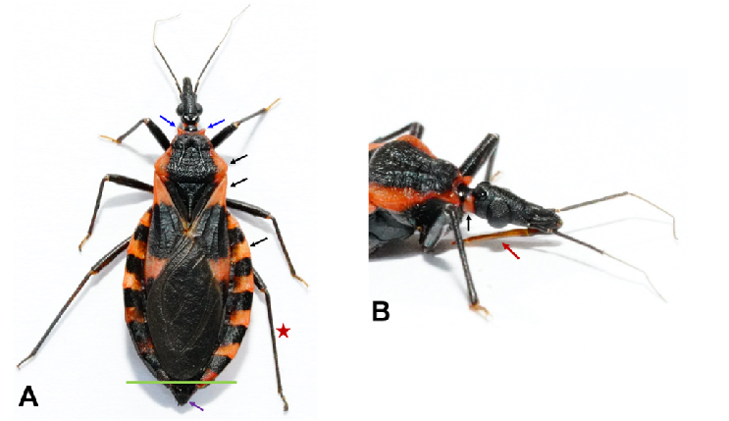

Answer: *Triatoma sanguisuga* or *Triatoma lecticularia* a.k.a The Kissing Bug; Chagas Disease or American Trypanosomiasis

MC:

A meerkat at your facility was found dead on exhibit and Chagas disease is expected, which tissue would be the most sensitive for PCR for detection of the disease?

1. Spleen
2. Lung
3. Liver
4. Heart
5. Brain

Answer: D- heart- myocardial tissue is very helpful in detection of a positive case

Visual:

Upon a chest tap of an older female meerkat, your technician examines the pleural fluid collected under the microscope. What is the black arrow pointing to (be specific) and what disease should you be concerned about?

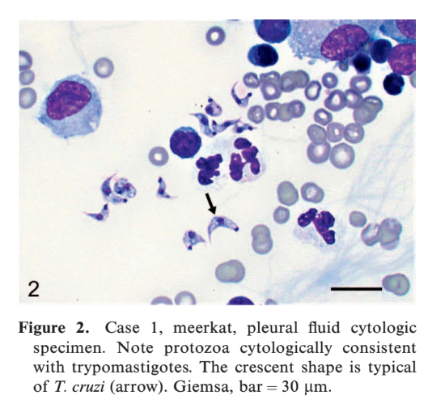

Answer: *Trypansoma cruzi* trypomastigote and Chagas Disease or American Trypanosomiasis

**DETECTION OF VECTOR-BORNE INFECTIONS IN LIONS AND TIGERS AT TWO ZOOS IN TENNESSEE AND OKLAHOMA, USA.** JZWM 2022. Cerreta, Anthony J. et al.

**Q:** Which vector borne pathogen is an asymptomatic tiger in southeastern US most likely to be positive for?

1. Anaplasma
2. Rickettsia
3. Cytauxzoon
4. Mycoplasma
5. Ehrlichia

Answer: C

**DOCUMENTATION OF TRYPANOSOMA EVANSI IN CAPTIVE TIGERS AND LIONS IN PUNJAB (2016–2018), PAKISTAN.** JZWM 2022. Muhammad Akbar Khan et al.

**Q:** Microscopy for the detection of Trypanosoma evansi in tigers and lions has which of the following test characteristics?

1. High sensitivity and low positive predictive value
2. High positive predictive value and high specificity
3. Low specificity and low negative predictive value
4. High negative predictive value and high sensitivity
5. Low sensitivity and low positive predictive value

Answer: B