Journal of Zoo and Wildlife Medicine, 55(1): 125-135, 2024.
CHARACTERIZATION OF THE FUNGAL MICROBIOTA IN THE NOSTRILS AND RECTUM OF AMAZONIAN MANATEES (TRICHECHUS INUNGUIS) FROM A REHABILITATION PROGRAM IN BRAZIL
Salene A Colombo, Daniela MD de Mello, Bruna RM Morais, Lauranne A Salvato, Fernanda A Dorella, Guilherme C Tavares, Vera MF da Silva, Maria I de Azevedo – Reviewed by LMM
Abstract: The present study characterized the filamentous and yeast-like fungal microbiota of the nasal cavity and rectum of Amazonian manatees (Trichechus inunguis) undergoing rehabilitation at the Laboratory of Aquatic Mammals, National Institute of Amazonian Research, Manaus, Amazonas, and determined the antifungal susceptibility of these organisms. Nasal and rectal swabs were collected from 22 calves and three juveniles. The samples were seeded in Sabouraud agar supplemented with chloramphenicol 10%, incubated at 26°C, and observed daily for up to 7 d. The growth of different filamentous and yeast-like fungi was observed among the two anatomical sites. Filamentous fungi were categorized by macro- and microscopic characteristics of the colonies. Representatives of each group were selected for molecular identification based on the internal transcribed spacer region. Yeast identification was performed using MALDI-TOF MS and molecular analyses. Thirteen genera of filamentous fungi and six genera of yeasts were isolated and identified. The dominant filamentous species were Fusarium spp., Aspergillus spp., and Cochliobolus lunatus in the nostril samples and Aspergillus melleus in the rectal samples. Candida was the dominant genus among the identified yeasts at both anatomical sites. In the antifungal susceptibility test, 28 isolates showed resistance to fluconazole (78%), itraconazole (39%), and nystatin (42%). The knowledge of fungal microbiota composition of Amazonian manatees provides information that assists in monitoring the health status of individuals maintained in captivity, as these organisms can behave either as opportunists or as primary pathogens. Moreover, the composition and resistance of these organisms may vary among different rehabilitation institutions or different time frames of search, reinforcing the importance of constant in loco surveillance of these microorganisms. This study provides new perspectives on the fungal diversity in the microbiota of manatees and supports future studies concerning the clinical and epidemiological aspects and the impacts of these agents on the health of Amazonian manatees undergoing rehabilitation.

Key Points:
- Amazonian manatees in rehab typically are screened with nasal and rectal swabs for detection of Salmonella spp, Clostridium spp, and Mycobacterium spp as well as parasitic diseases like giardiasis and cryptosporidiosis prior to release. All these org’s have been found in manatees.
- All individuals sampled were considered healthy at time of collection
- 21 species of filamentous fungi within 13 different genera were isolated
- The dominant species or genera of filamentous fungi were
  - Both Anatomical Sites = Penicillium citrinum and Pestalotiopsis sp
  - Nostril = Fusarium sp, Aspergillus sp, Cochliobolus lunatus
  - Rectal = Aspergillus melleus
- The most common filamentous fungi isolated, Penicillium citrinum, was resistant to all antifungal drugs tested (fluconazole, itraconazole, and nystatin)
  - Common fungi worldwide, inhabits indoor and outdoor environments, found in cereal grains, vegetables, and fruits; produce mycotoxin called citrine that can be toxic to kidneys and liver but it is rarely lethal in humans
- Another common fungi isolated was Aspergillus spp; This is frequently isolated from the respiratory tract of marine mammals
- The dominant species of yeast were
  - Both Anatomical Sites = Candida spp, (Candida orthopsilosis and Candida parapsilosis were the main species identified but most isolates were classified as Candida spp)
  - Candida often colonizes the respiratory tract of marine mammals and can go to the GI tract; Most candidiasis cases are mild and are not always treated but can become an issue with systemic or localized infections
- Generally high level of antifungal resistance among isolates from this group of manatees

Take Home Points: The Amazonian manatee microbiota is dominated by filamentous fungi Penicillium citrinum and yeast Candida spp most commonly when looking at both nasal and rectal swabs. All cultured organisms demonstrated a high level of resistance to antifungal drugs.

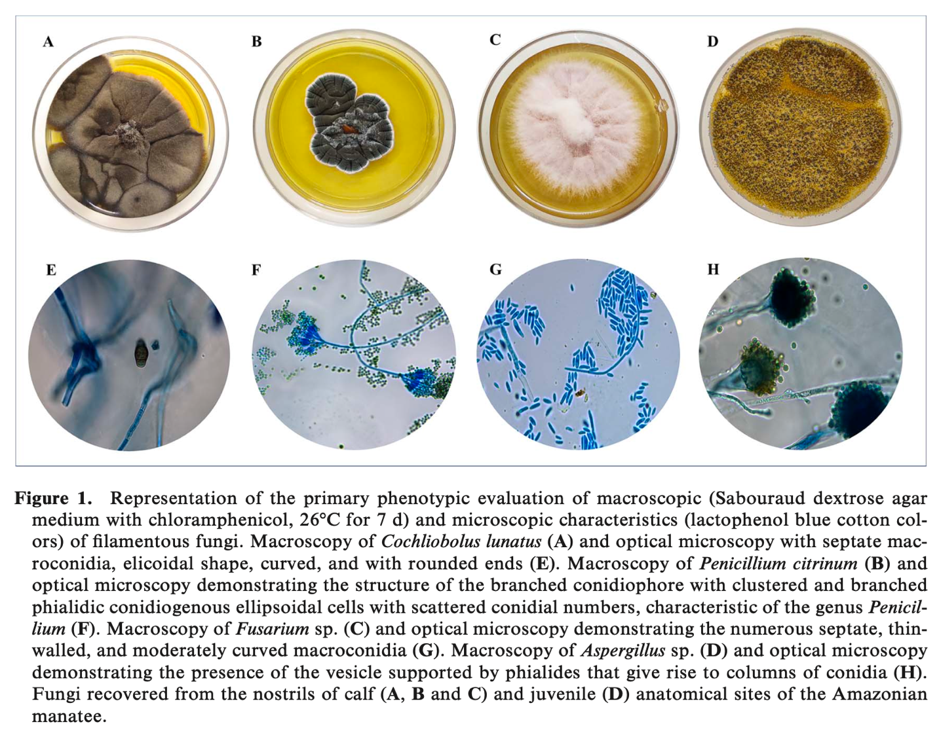
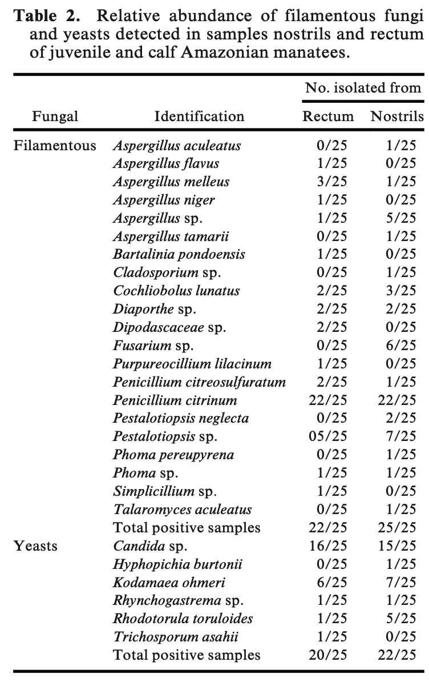
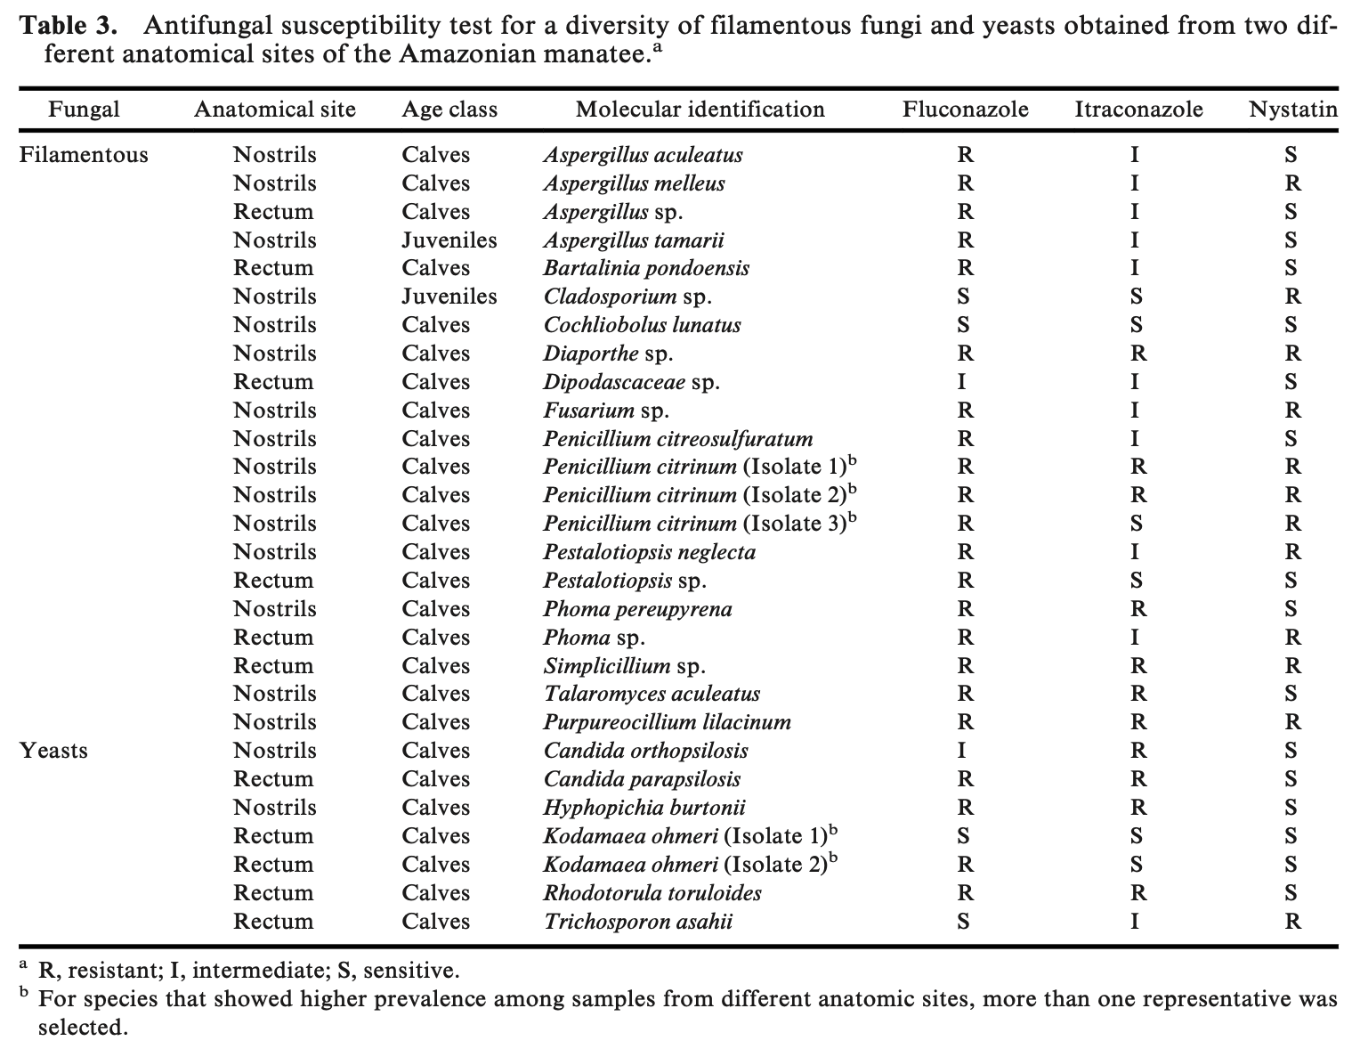

Journal of Zoo and Wildlife Medicine, 55(2): 511-520, 2024.
THE MANAGEMENT OF LYMPHOPROLIFERATIVE NEOPLASIA IN FOUR NORTHERN SEA OTTERS (ENHYDRA LUTRIS KENYONI)
Michael S McEntire, Karisa N Tang, Matthew R O’Connor, Martin Haulena – Reviewed by LMM
Abstract: Lymphoproliferative neoplasia has been reported in both free-ranging sea otters and those in managed care, but little information is available on the management of this neoplastic disease in this species. This case series describes clinical lymphoma in four northern sea otters (Enhydra lutris kenyoni) in managed care. Two otters presented with Stage 5 lymphoma with evidence of hematologic spread resulting in leukemia. Two additional otters presented with Stage 3 disease. Immunophenotypes in these cases included disseminated large B-cell lymphoma and lymphoblastic lymphoma of potential T-cell origin. Cases were managed with multiagent chemotherapy protocols including prednisone, L-asparaginase, cyclophosphamide, vincristine, cytosine arabinoside, lomustine, and doxorubicin. Unique approaches included the use of a vascular access port in one case and development of an autologous vaccine in another. Survival time ranged from 81 to 409 days. Diagnosis, staging, and treatment with multiagent protocols is recommended for the management of lymphoma in sea otters.

Key Points:
- Northern Sea Otter pops on the rise after significant decline in early 1900’s from commercial hunting; However, current rebound in pop struggling due to infectious diseases (streptococcosis, acanthocephaliasis, toxoplasmosis) and predation from great white sharks and orcas
- Most cases had lymph node enlargement as first sign (one had an inguinal mass) and all cases were >10 yo
- In this series, two cases had large B-cell origin, one potential T-cell origin, the fourth unclear
- In ferrets, most commonly lymphoma is multicentric and GI; Majority of other mustelids have multicentric lymphoma
- An autologous vaccine was used in one case but did not increase survival time compared to other cases
- A vascular access port was placed in once case but resulted in multiple additional procedures to address incisional dehiscence from over-grooming
- Survival time ranged from 81 to 403 days with the lower times in the more advanced, leukemic stages of disease
- One major challenge in this species is relatively high metabolic rate and high nutritional requirements; may need to administer gastroprotectants, antiemetics, etc to encourage eating or delay chemotherapy if animal anorexic to encourage eating

Take Home Points: Lymphoma and leukemia appears with some regularity in sea otters with first signs typically being lymphadenomegaly +/- lethargy. Work-up and treatment generally performed as would be done in small animal clinical medicine.

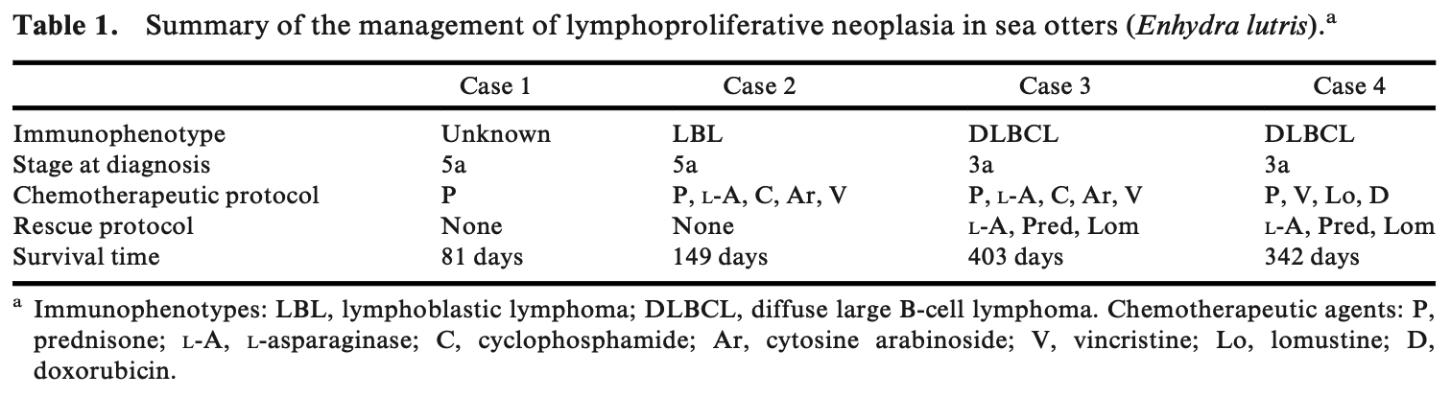
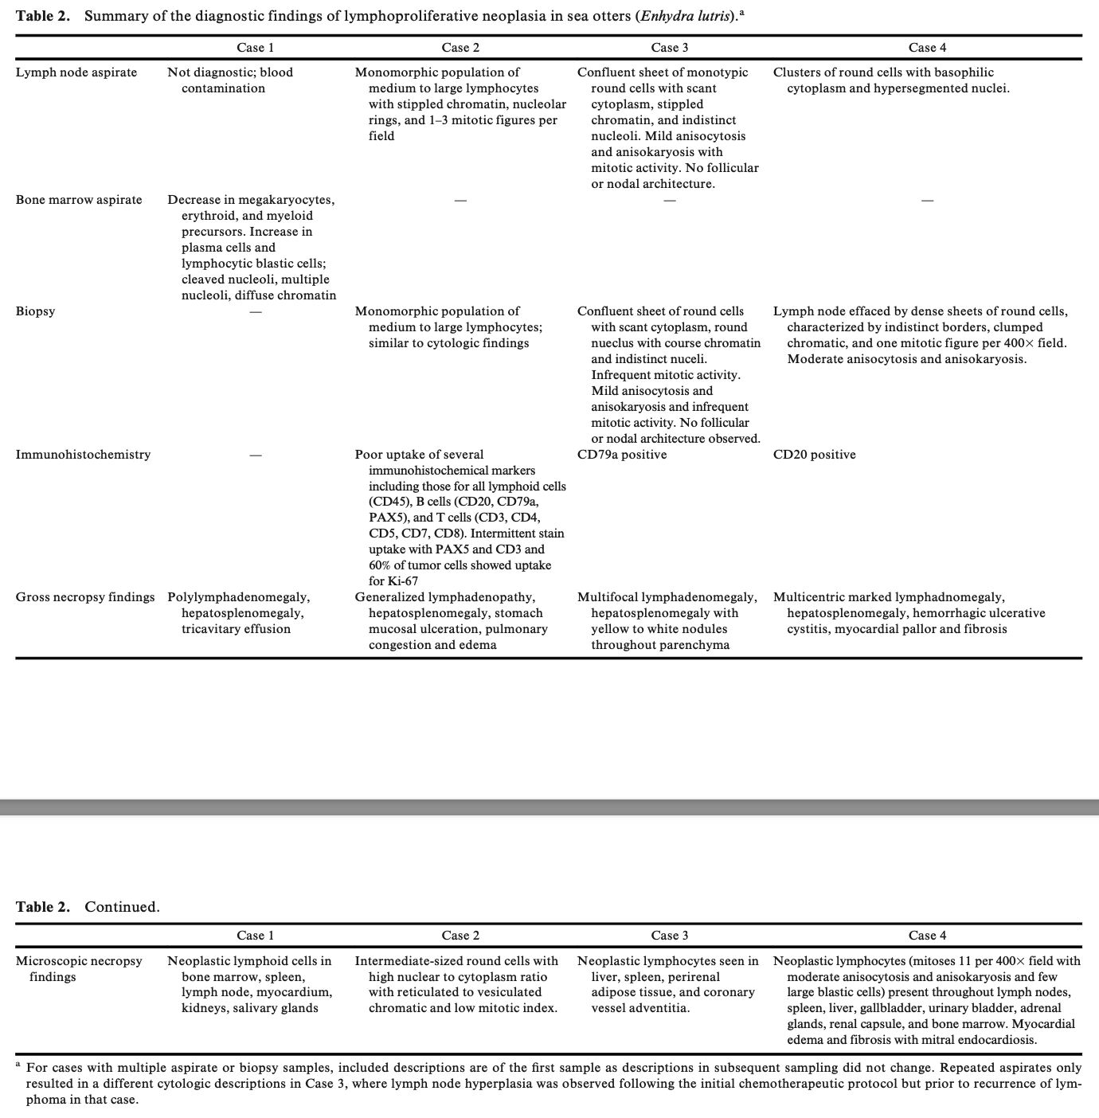
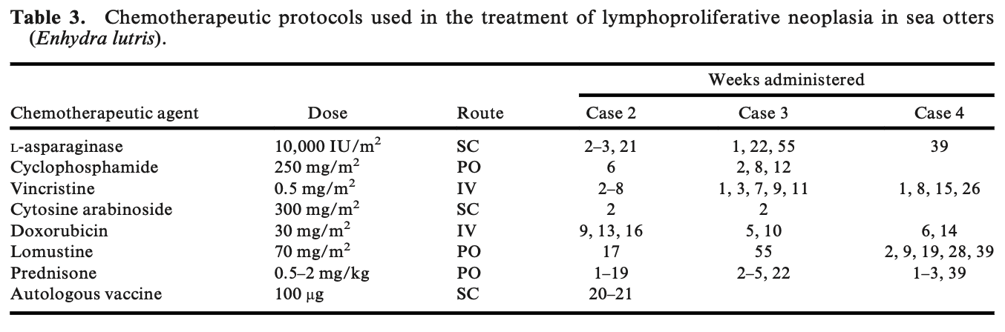

NO PROGRESSION OF UROLITHS IN ASIAN SMALL-CLAWED OTTERS (AONYX CINEREUS) FED A NATURALISTIC CRUSTACEAN-BASED DIET FOR 2 YEARS. JZWM 53.2 (2022). Francis Cabana, Guillaume Douay, Thomas Yeo, Yaoprapa Mathura - review by LMumm

Abstract: Asian small-clawed otters (ASCO; Aonyx cinereus) are a popular species of otter housed in zoological institutions. A common health challenge in this species is the development of uroliths, which may have a dietary origin. Feeding recommendations for ASCO are largely based on the nutrient requirements of domestic carnivore models. Using otter-specific feeding ecology may allow for further refinement of these nutrient recommendations. This study aimed to assess if a naturalistic diet of crustaceans, mollusks, and fish could control the development of uroliths in ASCO. Baseline data were collected on 10 ASCO (five males and five females) of different ages and repeated 2 years after the treatment diet was introduced. Blood and urine parameters, as well as the size of nephroliths based on radiographic images, were recorded. The treatment diet was higher in protein and lower in calcium than the nontreatment diet and did not contain any kibble. During the 2-year treatment trial, blood globulin, glucose, and sodium increased and albumin decreased. Glucosuria and leukocyturia significantly decreased. There were no significant changes in urolith size over the 2 years, and animals without nephroliths at the beginning of the study remained urolith free. The development of nephroliths was significantly reduced during the treatment compared with the year prior. Although interpretation is limited by the methods used, a naturalist diet may have a beneficial impact in the development of uroliths in ASCO.

Background
- Otters prone to urolithiasis both in the wild and captivity
  - Most composed of calcium oxalates > ammonium acid urate
  - Affects larger proportion of captive otters ~24.5% (range 9.4-66.1%) and at younger ages
  - Genetic predisposition possible; nutrition considered most sig. and controllable variable
  - Risk assessment study suggested that ASCO diets in captivity should be high in protein, controlled in calcium, and not limited in sodium
- ASCO natural diet predominately crustaceans vs. captive diet predominantly fish
- Crude protein recommendations for ASCO in captivity range between 20-33% on DMB, whereas natural diet of Lutra lutra estimated to be ~73%

Methods: n=10 (5.5) clinically healthy adult captive ASCO, 6 previously dx with nephrolithiasis transitioned to treatment diet over 4 weeks for 2 years, diagnostics at start and end
- Typical diets primarily fish (i.e. 90-97% capelin) → natural treatment diet of primarily crustaceans (70% crustaceans/crabs/prawns, 15% mussels, 10% freshwater fish, 5% chicken, thiamine supplement)
  - Increased protein, copper and zinc; decreased calcium, fat, phosphorus, vit A

Key points
- Blood and urine parameters:
  - Globulin and sodium sig. higher and albumin sig. lower after 2 years
  - Glucosuria and leukocyturia sig. lower after 2 years
  - One sample with crystalluria at start, none after 2 years
- Nephrolith proportion: measured with rads
  - Start of study: 7/10 with uroliths (6 historical known), 3/10 without uroliths
  - Otters without uroliths did not develop any, and otters with existing kidney stones did not exhibit any significant difference in stone size during the study
    - Even though uroliths had increased in size the year prior to study!

TLDR: Naturalistic diet (high protein/sodium and low fat/calcium i.e. crustaceans, mollusks, freshwater fish) may slow development of uroliths in ASCOs

DEVELOPMENT OF A MOBILITY ASSESSMENT SCORE FOR EVALUATION OF THE EFFECTS OF ORAL HYALURONIC ACID ON CLINICAL LAMENESS IN ASIAN SMALL-CLAWED OTTERS (AONYX CINEREA) AND AFRICAN SPOT-NECKED OTTERS (HYDRICTIS MACULICOLIS) UNDER HUMAN CARE. JZWM 2022. Russell, Jennifer, Francis, Lindsay, Russell, Neil J., Osborn, Steven, and Dennison, Sophie. - review by LMumm

Abstract: Oral hyaluronic acid has been shown to reduce inflammation and pain in humans with osteoarthritis. Eight Asian small-clawed otters (Aonyx cinerea) and two African spot-necked otters (Hydrictis maculicolis) with varying degrees of osteoarthritic changes identified on radiographs were selected for a randomized, doubleblinded, placebo-controlled clinical trial. Animal husbandry staff completed otter mobility assessment (OMA) questionnaires for each animal prior to study commencement and following either oral hyaluronic acid at a loading dose of 4 mg/kg PO SID for 10d followed by a maintenance dose of 2 mg/kg PO SID for 20 d, or placebo for 30 d. Four veterinarians with experience assessing otters watched randomized videos of otter gaits and assigned a clinical lameness score. Two additional evaluators watched the videos: an experienced veterinarian in small animal practice and a final-year veterinary student. All evaluators for OMA and clinical lameness score were blinded to treatment group. Radiographs performed prior to, and following, the study were assessed by a board-certified radiologist (Dennison). The OMA questionnaire had high reliability coefficients and correlated strongly with clinical gait scores and radiographic assessment. Although hyaluronic acid appears to be safe for use in otters at the dose described, there was no observed significant effect of hyaluronic acid on clinical lameness scores, OMA scores, or radiographic assessment of the limbs. The development of the OMA questionnaire is a promising tool for evaluating lameness in managed-care otters and may be further validated in future studies investigating therapeutics or incorporated as a component of animal welfare assessment.

Background:
- Hyaluronic acid (HA) = high-molecular-weight glycosaminoglycan in synovial fluid
  - Produced by chondrocytes and synovial fibroblasts
  - Provides viscoelastic and lubricating properties of synovial fluid; functions shock absorber and protects outer layer of cartilage
  - Intra-articular injection reduces inflammation (PGE2) and pain in humans with OA
  - Oral formulation reduces risk of iatrogenic trauma/infection
- Degenerative joint disease = common in mustelids

Objective: determine if HA liquid supplement improves clinical signs, behavior or radiographically appreciable OA in Asian small clawed otters (n=8) and African spot-necked otters (n=2)
- Assessed with OMA, lameness scores, and radiographs interpreted by radiologist
- Evaluators (aquatic vet, vet student, small animal vet, caretakers) blinded to treatment

Key Points:
- No adverse effects from PO HA throughout study duration
- Lameness scores more reliable from 4 aquatic vets vs. vet student and small animal vet
- No significant radiographic differences found between pre and post-HA treatment in forelimbs and hindlimbs, but there was increased spondylosis deformans and narrowed disc spaces post-tx
- OMA questionnaire is a reliable and quantitative assessment
  - Animals with lower clinical lameness had higher OMA scores (better QOL)
  - OMA scores had a negative (inverse) correlation with radiographic FL and HL evals
    - Higher OMA scores correlated with fewer radiographic changes
  - OMA scores did not correlate with radiographic spinal evaluations
- No observed effect of hyaluronic acid on clinical lameness scores or OMA score

TLDR: HA 2 mg/kg PO SID x 30 days is safe in otters but there is no clinical effect on lameness/mobility scores.

Journal of Zoo and Wildlife Medicine, 52(3): 880-885, 2021
EVALUATION OF THE PHARMACOKINETIC BEHAVIOR OF TULATHROMYCIN (DRAXXIN) IN FLORIDA MANATEES (TRICHECHUS MANATUS LATIROSTRIS) UNDERGOING MEDICAL REHABILITATION
Lauren N. Smith, Claire Bublitz, Emma Nixon, James Yeatts, Ray L. Ball, Ronald E. Baynes
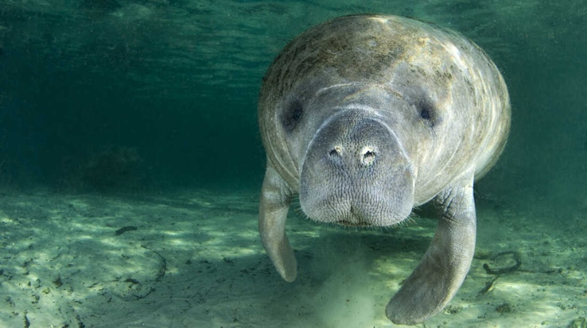
Abstract:
Florida manatees (Trichechus manatus latirostris) frequently present to rehabilitation care facilities for various conditions, including boat strike trauma, cold stress syndrome, and brevetoxicosis. Throughout the course of treatment, antimicrobial use to treat respiratory disease is frequently warranted. To date, clinicians have extrapolated dosages based on established information available in bovine and equine medicine. The routes of administration, efficacy, and treatment intervals are considerations in dealing with critical wild animals. The use of tulathromycin, a triamilide antibiotic, has been studied in multiple domestic species of economic importance, including cattle, small ruminants, and swine, and has revealed efficacy against respiratory diseases. Given this information, this antibiotic has also been used in manatees with positive clinical outcomes. This study employed sparse sampling and evaluated banked plasma samples at various time intervals post–tulathromycin administration obtained during the clinical treatment course of nine animals during their rehabilitation. Preliminary pharmacokinetic analysis following administration of a single dose estimated a half-life of 33.75 h and volume of distribution per fraction absorbed (Vz/F = 4.29 L/kg). The pharmacokinetic behavior of tulathromycin in Florida manatees can be used to optimize dosage regimens in this species.

Key Points:
- Wild Florida manatees routinely require rescue and rehabilitation for water-craft injury, cold stress syndrome, brevetoxicosis, and entanglements. One of the major concurrent diseases associated with all of these presentations is respiratory infection from pulmonary trauma, immune suppression, or aspiration.
- Tulathromycin: Gram-negative spectrum, relatively long half-life, and affinity for pulmonary tissue
  - Triamilide antibiotic (macrolide subclass)
  - Binds to 50s subunit of the ribosome, inhibits cell division and leads to cell death
  - Mixed bacteriostatic and bacteriocidal properties
- The current tulathromycin protocol routinely used at manatee critical care rehabilitation facilities is 2.5 mg/kg subcutaneously once every 7 d.
- Retrospectively analyzed banked plasma from 7 animals that received 1 SQ injection, and 3 animals that received 2 SQ injections 9 days apart
- Single dose PK
  - Tulathromycin concentrations in plasma fell below 0.1 µg/ml by 120 h
  - Rapid elimination and fairly short half-life (T1/2) of 33.75 h
    - Shorter than T1/2 for cattle (44 h to 90 h)
- Double dose PK
  - Tulathromycin concentrations in plasma fell below 0.1 µg/ml after 216 h
  - Prolonged elimination phase with a long half-life (T1/2) of 279.32 h
  - Yielded longer T1/2 and greater volume of distribution compared to single dose
- Cattle study showed higher drug concentrations in lungs than plasma; may be true for manatees (supported by large volume of distribution, volume of distribution comparable to cattle)
- Manatees were clinically ill; pneumonia, pulmonary trauma, renal disease, or concomitant diseases could have effects on the clearance and volume of distribution
- No adverse effects
- First PK in Florida manatees

Take-Home Message:
- Tulathromycin can reach clinically applicable pharmacokinetic values within the manatee. Given that the pharmacokinetic data suggest a more prolonged and persistent concentration in the body, the current multidose regimen is supported (2.5 mg/kg SQ q7d).

Journal of Zoo and Wildlife Medicine, 52(3): 1084-1089, 2021
PRESENTATION AND MANAGEMENT OF DENTAL PAD FRACTURES IN TWO FLORIDA MANATEES (TRICHECHUS MANATUS LATIROSTRIS)
Whitney Greene, Vivian M. Lee, Lynne Byrd, Laura Denum, Katharine Boerner, M. Andrew Stamper

Abstract:
The Florida manatee (Trichechus manatus latirostris) has well-developed keratinized dental pads at the most rostral aspect of their mouth to assist with mastication. This unique development is thought to be an adaptive response to their highly abrasive diets that contain phytoliths and sediments that may accelerate dental wear. In May 2013, two Florida manatees presented with multiple fractures in their inferior dental pads. The fractures were successfully managed with nutritional modifications, dental pad trimming, and vigilant monitoring through behavioral husbandry training. Signs of spontaneous healing were observed as early as 60 days after initial presentation with subsequent full resolution. Although surgical intervention was planned, the spontaneous healing mitigated significant health risks associated with the procedure. To the authors' knowledge, these are the first reported cases of dental pad fractures and their spontaneous healing and resolution in manatees.

Key Points:
- Adult manatees may consume 5-10% of their BW daily and are known to eat >60 species of plants in Florida.
- Manatees have only molariform teeth. They lack canines and incisors that are replaced by gingival plates adjacent to the commissure of the mouth.
- They continuously develop new molars and may have >120 teeth throughout their life. The teeth move anteriorly by constant absorption and deposition of alveolar bone; once they reach the most anterior portion of the oral cavity, the roots are absorbed, the crown falls out, and the alveolus closes. This is a form of polyphyodonty and has been referred to as continuous distomesial tooth replacement and horizontal tooth replacement.
- Manatees have well-developed keratinized dental pads at the front of their mandibles, rostral to the cheek-teeth. These heavily cornified pads provide a hard surface area to mechanically break down sea grasses during mastication and before transit to the cheek-teeth. In addition, the upper lip and lower lip perioral bristle fields, located rostral to the inferior dental pad, collect and position sea grasses between the horny pad surfaces
- Two animals housed together developed fractures of the inferior dental pads. For animal 1, weekly trimming under behavioral husbandry was implemented because of the epithelium not healing appropriately. Dental pad trimmings were performed with either small surgical scissors or a number 11 scalpel with the animal positioned under behavioral control. Both animals had spontaneous healing of the dental pad in ~60d.
- Several husbandry modifications were performed. All food items were tailored to minimize pressure points during mastication. Romaine and kale were offered as leaves only with the bases removed, and monkey biscuits were soaked in water before being fed. All enrichment and training food items (apples, beets, and sweet potato) were cut into very thin, small pieces or boiled so that they could be easily smashed. Enrichment items were examined to ensure the animals could not bite in a way that would increase pressure points on the dental pad.
- The exact physiologic mechanism that resulted in the repair is uncertain, although it was hypothesized that the epithelial layers of the dental pad reattached.

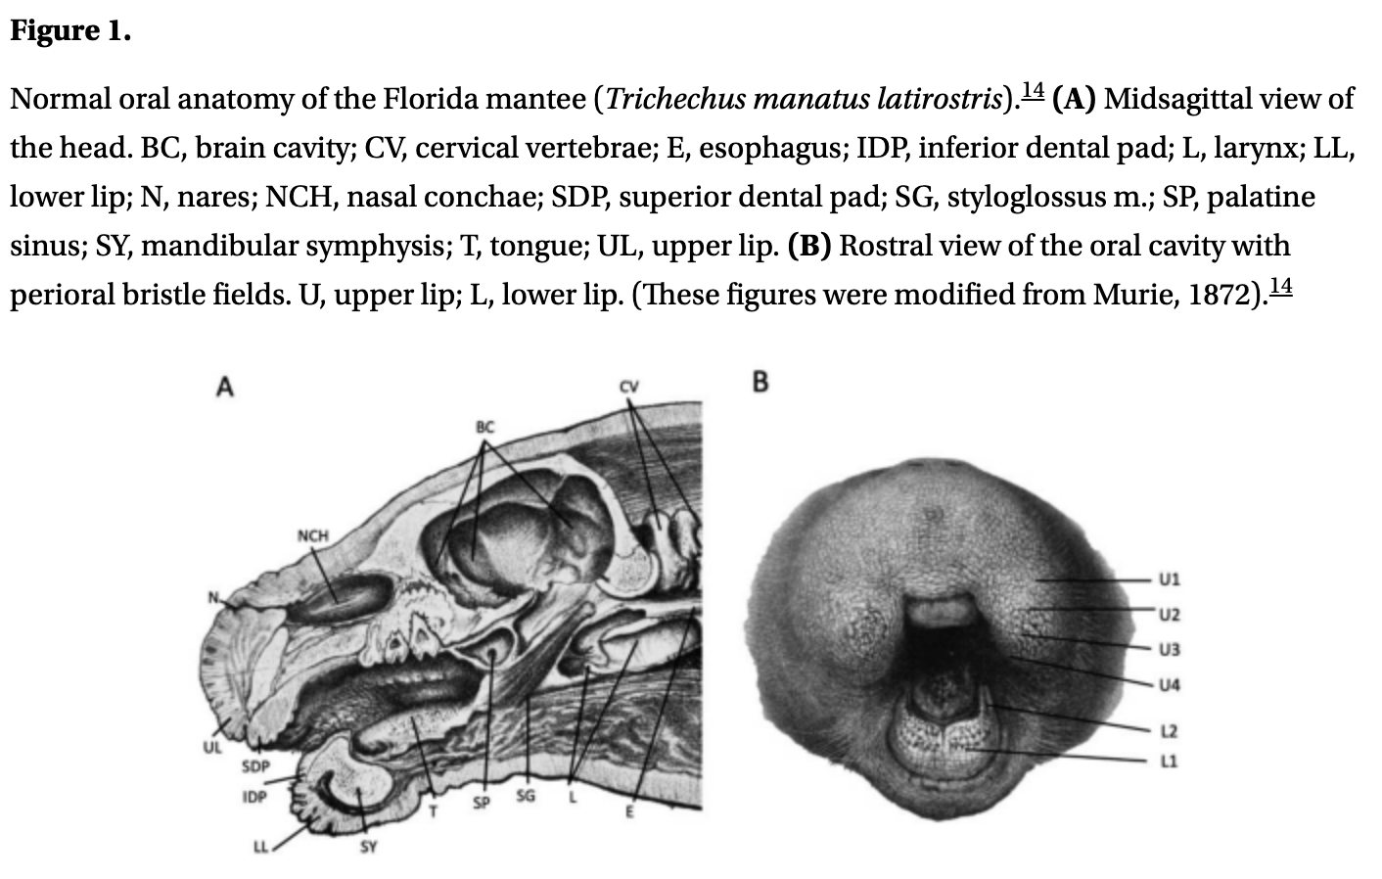
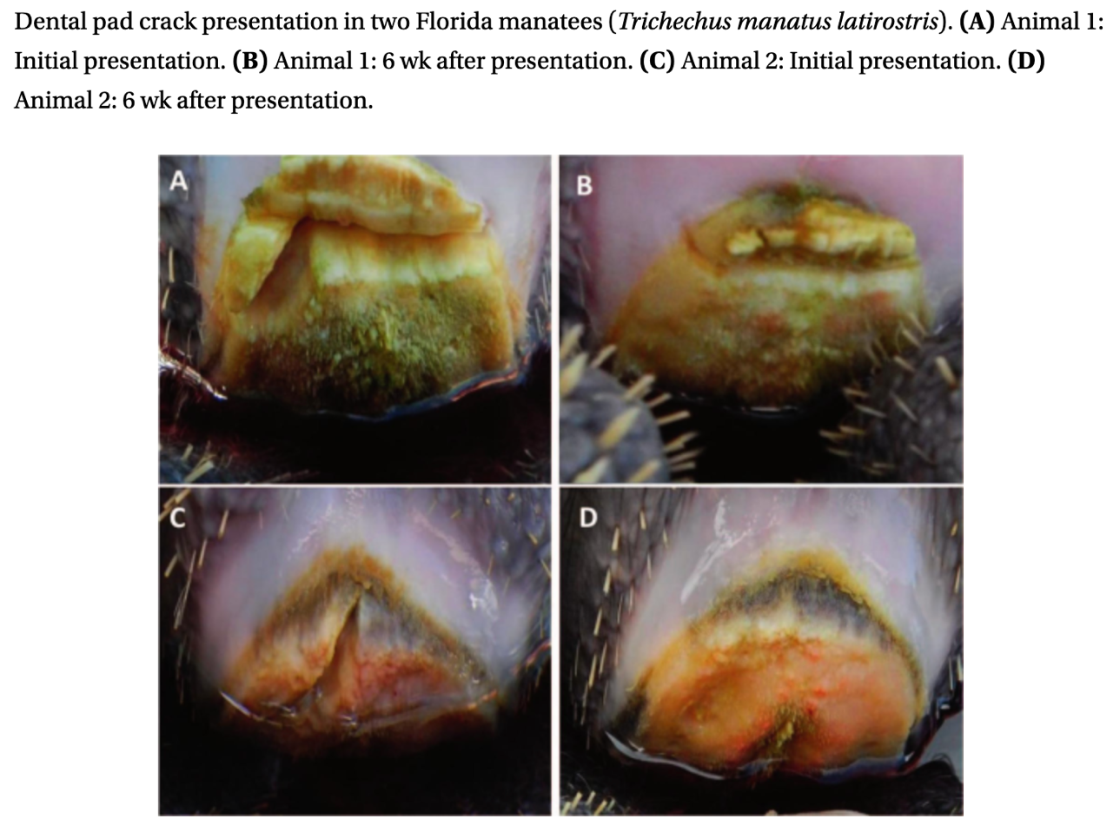

Take-Home Message:
- Florida manatee dental pads fractures can spontaneously heal without the need for surgical intervention. Dental pad fractures in two manatees were managed with nutritional modifications, dental pad trimming, and vigilant monitoring through behavioral and husbandry training.

PRELIMINARY EVALUATION OF SYMMETRIC DIMETHYLARGININE AS A BIOMARKER OF RENAL INSUFFICIENCY IN WILD AND REHABILITATED FLORIDA MANATEES (TRICHECHUS MANATUS LATIROSTRIS)

Abstract: Currently, there are limited antemortem tests available to evaluate renal function in Florida manatees (Trichechus manatus latirostris). Although few reports of renal pathology in manatees exist in the veterinary literature, debilitated animals that present to rehabilitation centers are frequently dehydrated, may have sustained renal trauma secondary to watercraft injury, and may experience ischemic events related to coagulation disorders leading to renal compromise. Clinicians remain limited to the analysis of blood urea nitrogen, creatinine levels, and urinalysis (if urine is obtained) to determine the extent of renal insufficiency, which may not accurately reflect renal function. This poses a diagnostic challenge for clinicians in discerning how critical renal compromise is to the animal’s overall health and prognosis. For the first phase of this study, retrospective symmetric dimethylarginine (SDMA) values were determined from banked serum or plasma samples from 14 wild Florida manatees that had been collected while the animals were under rehabilitation in zoological institutions prior to their deaths. Values of SDMA for nine samples from eight manatees with known renal disease, as determined by
histopathology, were compared to SDMA values for seven samples from six manatees with no reported renal lesions on histopathology. Values of SDMA from wild Florida manatees with known renal disease (mean 33.56 lg/dl 6 13.15, P¼0.017) were statistically significantly elevated when compared to SDMA values from manatees with no reported renal lesions (mean ¼ 18.71 lg/dl 6 6.9) on histopathology. For the second phase of the study, serum or plasma samples were obtained from wild manatee populations from two geographically separate presumed-healthy wild manatee populations (n ¼ 57). Although the upper limit was higher, serum SDMA concentrations from presumed-healthy wild manatees were comparable to those reported in small animal and equine medicine at 5.88–16.97 lg/dl.

Introduction:
- Florida manatees (Trichechus manatus latirostris) - subsp of West Indian manatee, through Caribbean and Gulf of Mexico
- Threatened - victims of watercraft injuries (+/- trauma to kidneys), cold stress syndrome, brevetoxicosis, entanglements, dehydration, +/- ischemic events
- SDMA - validated measure of GFR in cats/dogs
  - In cats detects renal dz on avg of 17 months before BUN/Cre; 9 months earlier for dogs and can detect insufficiency with as little as 20% loss of kidney fxn
Points of Study:
- Phase 1 - n=17 retrospective samples from sick rehab animals, divided into known renal dz or none, sent for SDMA levels
- Phase 2 - n=57 from 2 wild populations in FL, non-calves
- BUN/creat also measured in both phases when available
  - Blood from brachial plexus of pectoral flippers
- 2 cases also compared Cre and SDMA in clinical context for trends (both had high creat at start)
- SDMA statistically higher in renal dz animals vs not (33 vs 18), while no stat sig for BUN/Cre in renal dz vs not renal dz
- In example of 2 cases, SDMA was elevated for both before creatinine was elevated - may indicate that SDMA is more sensitive for renal disease (if truly renal insuff)
- Blood urea nitrogen and creatinine appear to be insensitive and nonspecific indicators of renal function in manatees and do not account for prerenal and/or extrarenal factors.
- One study with manatees showed normal BUN/Creat despite nephrolithiasis and pyelonephritis
- Another study revealed creat can increase significantly with low food intake, change to food, salinity of environment when fasting
- UA baseline recently reported in Antillean manatees (no other species of manatee)
- Calves had higher SDMA values (which is consistent with canine, feline, equine neonates)
- Assay for SDMA in this paper has not been validated
- SDMA is mediator of inflammation & impaired immune fxn, increases TNF, IL6 in monocytes

HISTOLOGIC ANALYSIS OF TESTICULAR DEVELOPMENT AND SEXUAL MATURATION IN REHABILITATED NORTHERN SEA OTTERS (ENHYDRA LUTRIS KENYONI)
Pace, Courtney; Goertz, Caroline E.C.; Woodie, Kathleen; … Garner, Michael M. JZWM 54(2) 2023

Abstract: As part of routine captive management of the species, sea otter (Enhydra lutris) males are often castrated to prevent reproduction, to preserve limited spaces for future nonreleasable stranded individuals, and to minimize potential aggression among cohorts. To determine the relative stage of testicular development, testicles from 14 castrated, rehabilitated northern sea otters (Enhydra lutris kenyoni) were submitted for histologic examination. Eight of the otters (aged 201, 304, 344, 352, 360, 373, 401, and 1,423 d old) had evidence of varying degrees of sexual maturity. Histologic grading of maturity of individual testicles showed inactive testes, spermatocytes with some maturation of spermatogenic precursors, and fully active spermatogenesis. Spermatozoa were seen in the otters that were 401 and 1,423 d old (1.1 and 3.9 yr old). Sexual maturity for wild male sea otters in Alaska has been previously reported to occur from 3 to 5–6 yr. Social maturity, or the ability to breed and reproduce, may occur a few years later than the onset of physiologic maturity; age, weight, territory quality, and the length of time holding a territory may influence a male otter's mating success. Early testicular development in rehabilitated sea otters may be related to abundant resources, lack of competition, and decreased environmental pressures. Additionally, these findings have implications for husbandry and management practices in short- and long-term care facilities.

Introduction:
- Deslorelin may be used to control reproductive activities and reduce aggression
  - Decreases: testicular size, testosterone levels, and aggression in males
  - Repeated implantation needed every 6-12 month with exact duration unknown causing possible gaps in coverage
- Surgical castration is method of choice for population control and has been performed successfully with a modified closed approach with very little complications since 2009

Main Points:
- 14 otters (including one that died prior to placement) were stranded in south central Alaska and deemed non-releasable and were castrated once they were healthy and testicles were descended
- Immature animals had closed tubules with no obvious lumen, a simple epithelium that consisted of a single layer of Sertoli cells or prospermatogonia along the basement membrane, and no spermatozoa present in the testis or the epididymis
- Maturing animals had varied findings, ranging from spermatocytes without spermatids, immature spermatids, or mature spermatids; the seminiferous tubules were not fully open, and spermatozoa were absent within the epididymis
- Mature animals had open tubules with pronounced lumens, complex epithelia, and spermatozoa within the testis and the epididymis, youngest mature was 401 days (1.1 years of age)
- Early testicular development in the rehabilitated sea otters may be related to abundant resources, lack of competition, and decreased environmental pressures (3-5/6 years in the wild)
- Age but not weight was predictive of sexual maturity
- Long-term effects of early castration and optimal age for castration warrants further study

Take Home: Northern male sea otters as young as 1 year old may produce sperm and lead to unplanned pregnancies in managed care where resources are readily available. Authors recommend that individuals less than 222 d should be considered immature with high confidence, those more than 302 should be considered maturing or mature, and those 222–302 d should be considered borderline.

Journal of Wildlife Diseases, 58(1), 2022, pp. 63–75

INVESTIGATING ASSOCIATIONS AMONG RELATEDNESS, GENETIC DIVERSITY, AND CAUSES OF MORTALITY IN SOUTHERN SEA OTTERS (ENHYDRA LUTRIS NEREIS)
Nicole H. Carter, Melissa A. Miller, Megan E. Moriarty, M. Tim Tinker, Roderick B. Gagne, Christine K. Johnson, Michael J. Murray, Michelle M. Staedler, Berit Bangoura, Shawn Larson, and Holly B. Ernest

Abstract: Southern sea otter (Enhydra lutris nereis) population recovery is influenced by a variety of factors, including predation, biotoxin exposure, infectious disease, oil spills, habitat degradation, and resource limitation. This population has also experienced a significant genetic bottleneck, resulting in low genetic diversity. We investigated how two metrics, familial relatedness and genetic diversity, are correlated with common causes of mortality in southern sea otters, including cardiomyopathy, acanthocephalan (Profilicollis spp.) peritonitis, systemic protozoal infection (Toxoplasma gondii and Sarcocystis neurona), domoic acid intoxication, end-lactation syndrome, and shark bite. Microsatellite genetic markers were used to examine this association in 356 southern sea otters necropsied from 1998 to 2012. Significant associations with genetic diversity or familial relatedness (P<0.05) were observed for cardiomyopathy, acanthocephalan peritonitis, and sarcocystosis, and these associations varied by sex. Adult male cardiomyopathy cases (n=86) were more related than the null expectation (P<0.049). Conversely, female acanthocephalan peritonitis controls (n=110) were more related than the null expectation (P<0.004). Including genetic diversity as a predictor for fatal acanthocephalan peritonitis in the multivariate logistic model significantly improved model fit; lower genetic diversity was associated with reduced odds of sea otter death due to acanthocephalan peritonitis. Finally, male sarcocystosis controls (n=158) were more related than the null expectation (P<0.011). Including genetic diversity in the multivariate logistic model for fatal S. neurona infection improved model fit; lower genetic diversity was associated with increased odds of sea otter death due to S. neurona. Our study suggests that genetic diversity and familial relatedness, in conjunction with other factors such as age and sex, may influence outcome (survival or death) in relation to several common southern sea otter diseases. Our findings can inform policy for conservation management, such as potential reintroduction efforts, as part of species recovery.

Background:
- Keystone species of pacific rim that due to fur trade hunt in 1800s → genetic bottleneck
- Defined common causes of morbidity and mortality: cardiomyopathy, acanthocephalan (Profilicollis spp.) peritonitis, systemic protozoal infections with Toxoplasma gondii and Sarcocystis neurona, domoic acid intoxication, end-lactation syndrome, and white shark (Carcharodon carcharias) bite
  - Acanthocephalans are a helminth parasite (not nematode or trematode) that have a proboscis/spines → burrow thru GI wall causing peritonitis
  - Domoic acid = algal toxin
  - End-lactation syndrome = maternal emaciation and death near the weaning period
Summary:
- Objective: low genetic diversity (degree of heterozygosity) may correlate with decreased fitness and increased disease susceptibility. Identify correlations between relatedness and known common causes of mortality using microsatellite DNA markers
  - Are individuals that share the same cause of mortality are more related than expected by chance (null)?
    - Hypothesis: for fatal cardiomyopathy, yes. For fatal parasitic and S. neurona infections yes due to specialization of prey types that may be intermediate hosts. All other described causes no, because they are common in this species and should not have a genetic propensity.
- N = 560 necropsies (1998-2012) assigned a primary and up to 3 contributing causes of death + demographic info where available. Using a previously developed microsatellite panel, 356/560 with necropsy + panel were ultimately included.
  - Estimated age classes: subadult (1–3 yr old) and adult (>4 YO), cardiomyopathy and end-lactation only assessed in adults
  - A necropsied otter was considered a negative control for a given condition if this condition was not noted as one of the primary or contributing causes of death.
  - MV logistic regression with sex as a predictor, pairwise relatedness
- Significant associations with relatedness or individual genetic diversity were observed for cardiomyopathies, acanthocephalan peritonitis, and sarcocystosis
  - Cardiomyopathy: males > females
- Cardiomyopathy: MV logistic regression did not find sex to be a significant predictor for fatal cardiomyopathy, consistent with previous studies. Pairwise relatedness results however suggest that there may be some degree of sex-specific genetic variation associated with cardiomyopathy.
- Acanthocephalans: Female southern sea otter CONTROLS were more genetically related than null expectation, possible protective genetic factor from fatal peritonitis. However, parasite distribution is patchy and sampling bias may have occurred, where related individuals existed in the same areas and were coincidentally, not exposed to high acanthocephalan regions
  - higher individual genetic diversity increased risk of death from acanthocephalan peritonitis, which contradicted our initial hypothesis – likely that the region is third factor
- LR: Males were at higher odds of dying from sarcocystosis compared with females, although this was not significant (P=0.09). This is consistent with previous studies.
Take Home Points: Male southern sea otters may be genetically pre-disposed to fatal cardiomyopathy, where females may carry a genetic factor that is protective (X-linked, as is reported in humans and NHP). Females may also carry a protective genetic factor for Acanthocephalans. The finding was not significant, but males were at a higher odds than females of dying from sarcocystosis.

