Question: What is the most common filamentous fungi isolated specifically from the rectum of Amazonian manatees in rehabilitation?
- Penicillium sp.
- Fusarium sp.
- Cochliobolus sp.
- Aspergillus sp.
- Pestalotiopsis sp.

Answer: D, Aspergillus melleus was the most common

SOURCE: JZWM, 55(1): 125-135, 2024, CHARACTERIZATION OF THE FUNGAL MICROBIOTA IN THE NOSTRILS AND RECTUM OF AMAZONIAN MANATEES (TRICHECHUS INUNGUIS) FROM A REHABILITATION PROGRAM IN BRAZIL

Question: What is one major, species-specific challenge to managing Sea Otters with lymphoproliferative disease?

Answer: Relatively high metabolic rate and high nutritional requirement. These animals cannot tolerate hyporexia or anorexia for as long as other similarly sized species.
SOURCE: JZWM, 55(2): 511-520, 2024, THE MANAGEMENT OF LYMPHOPROLIFERATIVE NEOPLASIA IN FOUR NORTHERN SEA OTTERS (ENHYDRA LUTRIS KENYONI)
Q: What effects might you expect from 30 days of oral hyaluronic acid 2 mg/kg SID in otters with osteoarthritic changes?
- Lameness score would improve but radiographic changes would not
- Radiographic changes would improve but appetite would be decreased
- Neither lameness scores nor radiographic changes would improve
- Appetite would be decreased but lameness scores would improve
- Both lameness scores and radiographic changes would

Answer: C
Source: DEVELOPMENT OF A MOBILITY ASSESSMENT SCORE FOR EVALUATION OF THE EFFECTS OF ORAL HYALURONIC ACID ON CLINICAL LAMENESS IN ASIAN SMALL-CLAWED OTTERS (AONYX CINEREA) AND AFRICAN SPOT-NECKED OTTERS (HYDRICTIS MACULICOLIS) UNDER HUMAN CARE. JZWM 2022. Russell et al.

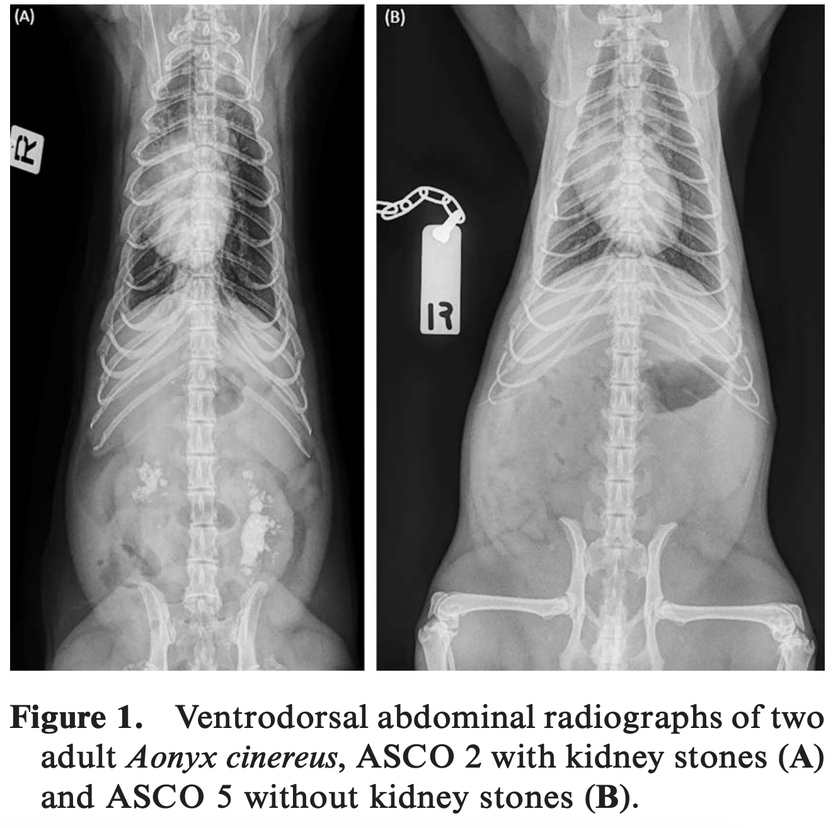
Q: You take this radiograph of your 2-year-old ASCO who has a primarily capelin diet. What is your diagnosis (be specific) and what husbandry recommendations might you have?

Answer: calcium oxalate nephroliths; transition from predominately fish diet to crustacean diet (decrease calcium and increase protein)
Source: NO PROGRESSION OF UROLITHS IN ASIAN SMALL-CLAWED OTTERS (AONYX CINEREUS) FED A NATURALISTIC CRUSTACEAN-BASED DIET FOR 2 YEARS. JZWM 2022. Cabana et al.

Journal of Zoo and Wildlife Medicine, 52(3): 880-885, 2021
EVALUATION OF THE PHARMACOKINETIC BEHAVIOR OF TULATHROMYCIN (DRAXXIN) IN FLORIDA MANATEES (TRICHECHUS MANATUS LATIROSTRIS) UNDERGOING MEDICAL REHABILITATION
Lauren N. Smith, Claire Bublitz, Emma Nixon, James Yeatts, Ray L. Ball, Ronald E. Baynes
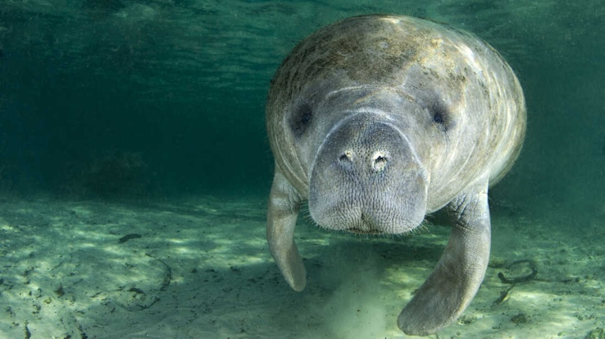

Question: Which of the following statements is most correct regarding the use of tulathromycin in Florida manatees (Trichechus manatus latirostris)?

- Two injections of tulathromycin were associated with a prolonged elimination phase with a long half-life
- Injection site inflammation was observed in a majority of animals included in this study
- Plasma concentrations did not reach levels presumed to be therapeutic based on pharmacokinetic data in cattle
- The half-life of tulathromycin following a single injection was substantially longer than the half-life in cattle
- There was a small volume of distribution for both the single and double dose regimens

Answer: A

Journal of Zoo and Wildlife Medicine, 52(3): 1084-1089, 2021
PRESENTATION AND MANAGEMENT OF DENTAL PAD FRACTURES IN TWO FLORIDA MANATEES (TRICHECHUS MANATUS LATIROSTRIS)
Whitney Greene, Vivian M. Lee, Lynne Byrd, Laura Denum, Katharine Boerner, M. Andrew Stamper

Slide question: Describe how you would manage a dental pad fracture in a Florida manatee.
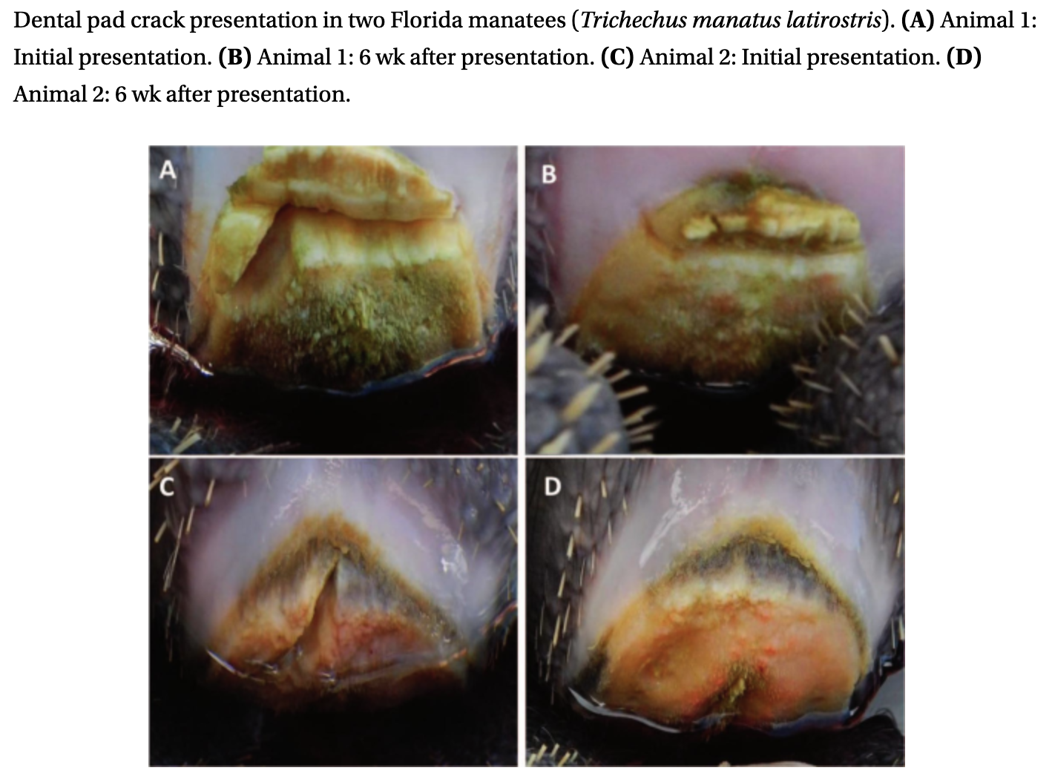

Answer:
- Diet modification: Food items should be tailored to decrease pressure points on the dental pads during mastication. For example, greens should be offered as leaves only without bases, and biscuits should be soaked in water to soften them prior to feeding. Enrichment/food items should be cut into small pieces or boiled so that they can be easily smashed.
- Dental pad trimming: The dental pad can be trimmed with surgical scissors or a scalpel blade as needed, ideally via behavioral husbandry training.
- Vigilant monitoring, ideally through behavioral husbandry training
- If the dental pad fracture fails to resolve, surgical intervention may be considered

- Which of the following is more likely to affect Trichechus manatus latirostris?
  - Domoic Acid
  - Microcystis
  - Okadaic Acid
  - Brevetoxin
  - Saxitoxin

Answer: D:

Toxin | Organ system/Signs | Animal (specific)
Brevetoxin (bind to voltage gated Na channels) | Respiratory and Neurologic | Manatee and Bottlenose dolphin
Domoic Acid (activate glutamate receptors) | Neurologic signs  Spontaneous abortion (pinnipeds) | California sea lions and various dolphins  Pinnipeds, cetaceans, and sea otters (myocarditis)
Saxitoxin (binds to voltage gated Na channels) | Muscle paralysis, respiratory arrest | Alexandrium (dinoflag): humpback whales  Paralytic shellfish toxin: humans and mammals
Okadaic Acid (protein phosphatase inhibitor) | diarrhea | Diarrheic shellfish poisoning (human)
Microcystins | Hepatotoxin; neurologic signs | Sea otters: neurologic  Humans: GI, piloerection, pallor  Mass mortality of fish  Lesser flamingos: Neuro, cyanosis, respiratory failure, death  Cattle, sheep, goats, wildlife: 2 episodes at Kruger National Park: rhino, lion, cheetah, zebra, wildebeest, hippo, giraffe, warthog and kudu died

- Which of the following is true in regards to maturation and reproducibility of Northern sea otters?
  - Weight is a predictor of sexual maturity
  - Maturing animals had open tubules with no spermatozoa present
  - Early castration showed shortened life span and issues with bone growth
  - Deslorelin use in otters has shown increased aggression
  - Rehabilitated sea otters showed earlier testicular development

Answer: E. Age is a predictor of maturity, maturing animals have closed tubules, there is more research needed on early castration in sea otters (if it affects them as dogs), deslorelin has been used in otters and showed decreased testicular size, lowered testosterone levels, and decreased aggression.

Journal of Wildlife Diseases, 58(1), 2022, pp. 63–75

INVESTIGATING ASSOCIATIONS AMONG RELATEDNESS, GENETIC DIVERSITY, AND CAUSES OF MORTALITY IN SOUTHERN SEA OTTERS (ENHYDRA LUTRIS NEREIS)
Nicole H. Carter, Melissa A. Miller, Megan E. Moriarty, M. Tim Tinker, Roderick B. Gagne, Christine K. Johnson, Michael J. Murray, Michelle M. Staedler, Berit Bangoura, Shawn Larson, and Holly B. Ernest

Question: Based on a recent study investigating familial relatedness and common causes of mortality in southern sea otters (Enhydra lutris nereis) of the Central California coast, which of the following causes of mortality was significantly associated with a higher familial relatedness in male individuals?
- Domoic acid intoxication
- Fatal sarcocystosis
- Fatal toxoplasmosis
- Fatal cardiomyopathy
- Acanthocephalan peritonitis

Correct answer: D. Fatal cardiomyopathy
Take Home Points: Male southern sea otters may be genetically pre-disposed to fatal cardiomyopathy, where females may carry a genetic factor that is protective (X-linked, as is reported in humans and NHP). Females may also carry a protective genetic factor for Acanthocephalans. The finding was not significant, but males were at a higher odds than females of dying from sarcocystosis.

