**CLINICAL AND PATHOLOGIC FINDINGS OF AN OUTBREAK OF VITAMIN D3–RESPONSIVE METABOLIC BONE DISEASE IN HERON AND EGRET (FAMILY ARDEIDAE) CHICKS FED CAPELIN (MALLOTUS VILLOSUS).** JZWM 2020. Horgan, Molly, Rebecca Duerr, and Brian Murphy. - review by LMumm

Abstract: An increase in cases of metabolic bone disease (MBD) in chicks of six species of heron and egret (family Ardeidae) was identified at a wildlife rehabilitation center in the spring and summer of 2018. The outbreak affected 34.3% of birds in care for four or more days during the first 3 mo of the study and was the most common reason for euthanasia during that time. Cases were characterized by lameness, increased flexibility of multiple long bones, angular deformities, and bone fractures. Gross postmortem examinations were conducted on 145 nestlings and fledglings that died or were euthanatized either because of MBD or for unrelated conditions. Histology was performed in four cases and three controls. Histologic findings were characterized by multiple lesions in the appendicular long bones, including variable elongation of the physis, retention of cartilage cores in the metaphyseal primary spongiosa, poorly mineralized osteoid seams within the primary spongiosa, thinning or lack of diaphyseal cortical bone compaction, and folding fractures typically propagating through the physis-metaphyseal interface. Folding fractures were often associated with focal metaphyseal fibroplasia. The parathyroid gland diameter of birds diagnosed postmortem with MBD in care was significantly larger than that of unaffected birds. The authors hypothesized that a dietary deficiency of vitamin D3 because of low levels in the bird's captive diet of capelin (*Mallotus villosus*) was the cause of the MBD. Starting in mid-July every chick's diet was supplemented with 714 IU oral vitamin D3/kg body weight per day, after which the number of birds developing MBD declined to a rate of 4.3%. **This study characterizes the clinical, gross, radiographic, and histologic features of vitamin D3-responsive MBD in young herons and egrets and provides evidence to support the recommendation that captive birds on a diet of capelin be supplemented with vitamin D3, especially during growth**.

Background on MBD

* MBD = disorders resulting from disturbance in calcium/phosphorus homeostasis
  + Four subtypes: osteoporosis, rickets, osteomalacia, fibrous osteodystrophy
    - Often presents with multiple concurrent subtypes
* Signs: soft, poorly mineralized bones; angular limb deformities; limb disuse; pain; fractures
* Etiology in birds (and mammals): inadequate dietary Ca, phos, or vitamin D3 (diet or UVB) +/- low Ca:P ratio
  + Renal insufficiency (2ndary hyperparathyroidism) NOT reported to cause MBD in birds (such as in mammals)
  + Piscivorous birds get MBD from fish low in Vit D3
* Refresher on calcium regulation:
  + PTH released in response to low serum iCa → pulls Ca stores from bone and increased renal resorption → increased blood calcium → long-term leads to MBD
  + Vitamin D3 (cholecalciferol)→ ingestion or skin absorption → metabolized by liver → then kidneys → converted to bio active form (calcitriol) → required for absorption of Ca and P from GIT and kidney
* Herons and egret chicks have rapid skeletal growth (3-5mm/day) → increased susceptibility to bone deformities when nutrient deficient

Methods: Retrospective on outbreak/increased cases of MBD (n=83) in egrets/herons at a wildlife center and evaluation of the clinical response to oral supplementation of vitamin D3

Key Points:

* Diet was changed from smelt → capelin (inexpensive and commercially available but known to have low Ca) supplemented with Ca carbonate
* MBD noted in ⅓ of birds (83/242) fed this diet; caused by lot vitamin D3 levels
  + Median time birds spent in care before showing MBD signs = 12 days
  + Treatment by corrective splinting and increased Ca supplementation = minimal success
  + Majority (75%) cases severe (fractures, angular limb) → euthanized
  + Bone most commonly affected (74/83 cases) = **tarsometatarsus**
    - **Folding fractures and angular limb deformities**
    - ALL fractures occurred in proximal or distal ⅓ of long bones
* Radiographs: increased lucency and loss of trabecular bone around physes (figure)
  + Fractures lacked evidence of callus formation - lack of body Ca stores to ossify?
* Gross findings:
  + Tarsometatarsus easily cut with scalpel (majority) revealing gelatinous medullary bone
    - Also easily cut with scalpel in non-MBD birds (but these were nestlings)
  + Rib fractures were common with both MBD (53%) > controls (30%)
  + **Parathyroid glands significantly larger in birds with MBD → supportive of nutritional secondary hyperparathyroidism!**
* **Histopath: evidence of rickets**
  + Defective mineralization; no evidence of fibrous osteodystrophy, thin cortices compared to controls, PT enlargement consistent with hyperplasia (no difference in chief cells between MBD and controls)
* New cases of MBD decreased (from 34% to 4%) after starting oral D3 supplementation
  + THUS → suspect dietary deficiency in D3 cause of MBD in this population
  + Previously reported that capelin = poor source of D3; MBD and low serum D3 reported in penguins fed exclusively capelin

**TLDR: Piscivorous captive birds (herons and egrets) fed predominantly capelin should receive supplemental vitamin D3 due to susceptibility to MBD (rapid growth of long-legged birds) causing rapid development of angular limb deformities and folding fractures most commonly of the tarsometatarsus when deficient.**

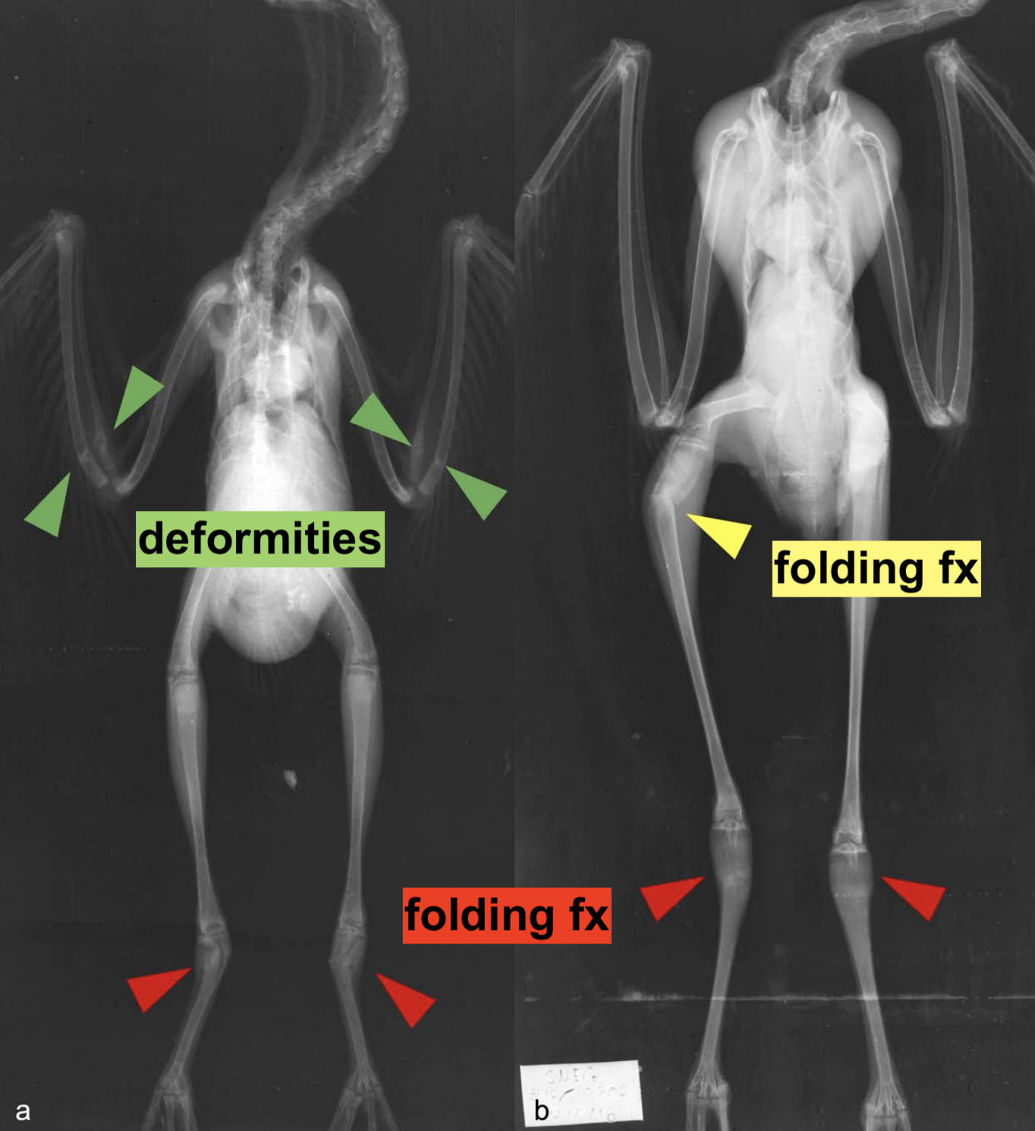

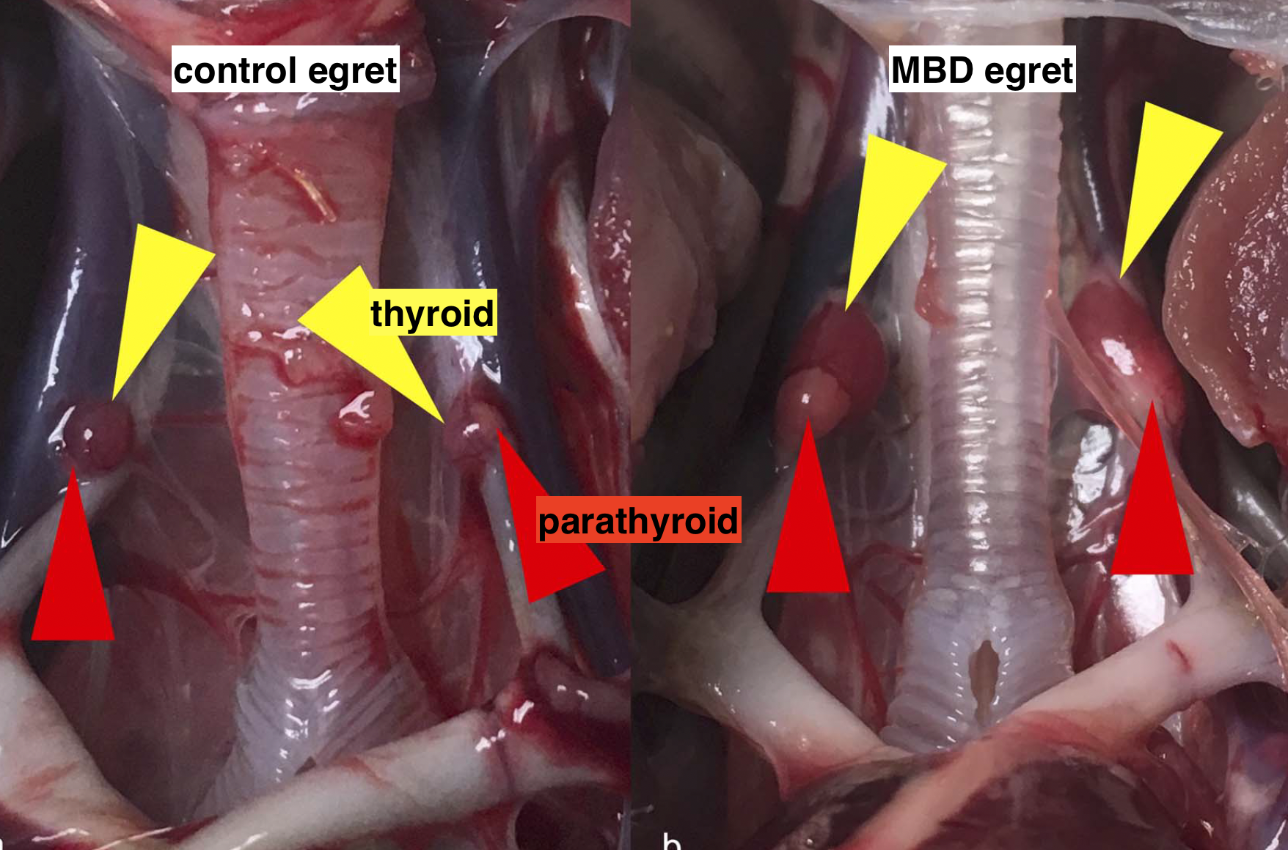

**Retrospective Analysis of Cataract Formation and Nutritional Etiology in a Managed Collection of Parakeet Auklets (*Aethia psittacula*).** JAMS 2021. Brianne E. Phillips, Ellen S. Dierenfeld, Robert English, Brigid Troan, Ken Reininger, Debbie J. Zombeck, Ryan S. DeVoe, Barbara Wolfe, Michael R. Loomis, Larry J. Minter. - review by LMumm

Abstract: The parakeet auklet (Aethia psittacula) is a piscivorous seabird with a natural diet of various invertebrate and teleost species, which is challenging to replicate in a managed collection. A high prevalence of early onset cataracts was observed in a managed collection of parakeet auklets at the North Carolina Zoo (Asheboro, NC, USA), which was hypothesized to be related to inappropriate vitamin A and E levels. From 1994 to 2002, these parakeet auklets were offered dietary supplementation comprising Vita-Zu small bird tablets. In June 2002, the birds were transitioned to only Thiamin-E paste (vitamin E and thiamin only). Plasma samples were collected from birds with and without cataracts from 1998 to 2005 and submitted for vitamin A (retinol) and vitamin E (α-tocopherol) analysis. Food items comprising the birds' diet were also evaluated for vitamin content. This information was combined with clinical and necropsy data from medical records from 1994 to 2015. A total of 78% of birds (39/50) developed cataracts, with a median age of onset of 7 years (range, 2–12 years). Cataracts ranged from incipient to hypermature during both routine ophthalmic examinations and postmortem evaluations. The median (range) of plasma retinol and α-tocopherol values were 1.99 µg/mL (0.20–6.68 µg/mL) and 15.39 µg/mL (3.40–96.27 µg/mL), respectively. **There were no significant differences in plasma concentrations of vitamins based on the animals' sex, origin, presence of cataracts, or administered vitamin supplementation product**. No other etiologies for cataract development were identified in the population. Further research in free-ranging parakeet auklet nutrition and cataract occurrence is warranted for continued species collection management.

Background:

* Parakeet auklets = small, diving seabirds native to Alaska; spend majority of time foraging
* Vitamin E = fat soluble; deficiencies associated with cataracts in humans and animals
* Vitamin A = fat-soluble retinoids; deficiencies associated with squamous epithelial metaplasia
* JZWM 2016: cataract risk factors in macaroni and rockhopper penguins in NA zoos
  + Increased age in both species
  + Macaroni - increased cataracts with smelt (high in vitamin A) and fluorescent lighting
  + Rock-hopper - increased cataracts with capelin, increasing population size, and increasing length of minimum photoperiod
* Cataract etiologies in avians: infectious, hereditary, senescence, trauma, toxicity, vit E deficiency
  + Hypovitaminosis E and hypervitaminosis A evaluated as potential etiologies
    - Hypovitaminosis E associated with cataracts in many species including poultry
    - Hypervitaminosis A can suppress vit E absorption (thus also investigated here)

Method: determine prevalence of cataracts, characterize associated ophthalmic diseases, and investigate potential vitamin A and E etiology of cataract prevalence in parakeet auklets at NC Zoo

Key Point:

* Cataracts in 39 of 50 birds; median age onset of living population 7y (2-12 yo)
  + Immature most common but all stages seen (incipient, immature, mature, hypermature)
  + ALL birds diagnosed with cataracts developed bilateral lesions
  + Sex of birds had no effect on age of cataract onset
* Cataract associated lesions: lens rupture, lens luxation, lens induced uveitis (iritis, synechia, etc)
* No specific etiologies leading to cataract development were identified
  + No evidence of congenital cataracts (based on age of development and location)
  + No evidence of trauma-induced cataracts reported
* Majority of necropsies had cataracts; most hypermature
  + Birds without cataracts were hatchling/young
* No significant difference in plasma retinal and a-tocopherol in birds that received only tablet or only paste BUT birds that received both had higher plasma retinol values (than paste only) and higher plasma a-tocopherol (than tablet only) - perhaps over supplementation with both?
  + No difference in plasma levels based on sex, origin, presence of cataracts

**TLDR: Managed care parakeet auklets have a high prevalence of cataracts (at NC zoo); etiology not known, suspect some environmental husbandry factor, but hypovitaminosis A & E don’t appear associated**

Journal of Avian Medicine and Surgery, 38(2): 67-74, 2024.  
**COMPARISON OF MANUAL RESTRAINT WITH AND WITHOUT SEDATION ON OUTCOMES FOR WILD BIRDS UNDERGOING DECONTAMINATION**  
Cristin N Kelley, Terra R Kelly, Kylie Clatterbuck, Michelle C Knapp, Julie Koglund, Rebecca S Duerr – Reviewed by LMM

**Abstract: The decontamination process for plumage-contaminated wild birds, such as those affected by oil spills, is lengthy and involves manual restraint and manipulation of all body parts. Birds commonly react to this in ways that suggest they are extremely stressed (eg, struggling, vocalizing).** We proposed to reduce stress during the wash process using sedation and hypothesized that the use of sedation would not negatively impact survival. **Contaminated birds in need of washing were randomly selected to be either sedated (butorphanol 2 mg/kg IM + midazolam 1 mg/kg IM and flumazenil 0.1 mg/kg IM for reversal) or not sedated at 3 US rehabilitation centers over the course of 1 year.** Response to sedation was rated on a scale of 0–4 with 0 as no effect to 4 as excessively sedate. Data such as cloacal temperatures at various time points, lengths of various portions of the wash process, preening behavior in the drying pen, and disposition were collected. **No statistical differences were found between sedated and nonsedated birds for any of the data points collected, including survival. There was a significant association between birds with higher cloacal temperatures in the drying pen and with birds held longer in the drying pen with improved survival; however, these findings were unrelated to whether the birds were sedated.Our findings show that sedation with butorphanol 2 mg/ kg IM and midazolam 1 mg/kg IM reversed with flumazenil 0.1 mg/kg IM can be used during the wash process for wild birds without adverse effects. Careful attention must be given to heat support for all birds while drying to prevent hypothermia.**

**Key Points:**

* For decontamination in avian species, the bird is manually held and body potentially submerged for more than 40 minutes; washing requires significant manipulation
* 89 birds enrolled in the study (50 sedated, 39 not sedated for washing); 49/89 birds survived to release (53% of those sedated and 47% not sedated)
* Sedation did NOT significantly change:
  + Chance of making it to release
  + Total wash time
  + Body temperature
  + Post-rinse preening intensity (range from none to vigorous)
  + Time in captivity
* NOTE: Unsedated birds because of handling did have a few adverse outcomes – specifically a Canada goose and a Mallard duck both incurred hock luxations during the wash and had to be euthanized; Additionally, four birds were accidently fully submerged (head underwater) during washing, 3 that were unsedated and those all got released as well as 1 that was sedated and it developed aspergillosis and was euthanized
* Longer wash times were associated with:
  + Larger body size
  + Petroleum contaminant (as compared to other contaminants)
* Longer wash times were NOT associated with:
  + Reduced survival
* Birds with warmer body temperature following the drying process and longer time spent in the drying pen were significantly associated with survival; birds with cloacal temperatures of 38.9 C (102 F) or higher following drying had 3.93 times higher odds of survival than birds below that temp
  + For every 30 additional minutes spent in the drying process, the odds of survival increased by a factor of 1.32
  + No other factors examined significantly influenced survival (i.e. type of contaminant, percentage of body contaminated, total wash time, BCS, PCV, TS, presence of skin lesions)
  + Authors note that caution needs to be taken with drying/warming and watch for hyperthermia and burns

**Take Home Point:** No significant differences noted between sedating and not sedating wild birds for decontamination. However non-sedated birds did incur trauma (hock luxations, submersion in water) and for that reason, authors recommend sedation for decontamination. Increased cloacal temperature during drying and longer time in the drying process significantly increased the odds of survival for decontaminated wild birds.

____________________________________________________________________________________

Journal of Wildlife Diseases, 57(4): 865-873, 2021.  
**A SYNDROME OF ISCHEMIC LEG NECROSIS IN NORTHERN GANNETS (MORUS BASSANUS)**  
Megan E B Jones, Pierre-Yves Daoust – Reviewed by LMM

**Abstract: The Northern Gannet (*Morus bassanus*) is a large marine bird whose whole North American population breeds in waters of eastern Canada.** Opportunities to identify causes of morbidity and mortality in recently hatched birds of this species are therefore limited to this region of North America. During the three decades since 1990 of wildlife health surveillance at the Atlantic regional center of the Canadian Wildlife Health Cooperative, what appears to be a **previously undescribed syndrome of ischemic leg necrosis affecting mainly hatch-year Northern Gannets has emerged**, which may relate to some unique aspects of the life history of these birds. **This syndrome, observed in 14 birds, is characterized by severe necrosis and fibrinopurulent inflammation of soft tissues of the feet extending along the whole tarsometatarsus.** An infectious cause is proposed to explain the pattern of lesions observed in these birds, possibly favored by a specialized and rich vascular system in their legs and feet. **An acute or subacute cardiomyopathy, thought to be secondary to the severe leg lesions, was also observed microscopically in six of these birds.**

**Key Points:**

* Causes of morbidity and mortality reported include human-related (oiling, interactions with gillnets and longlines), starvation (most common cause of natural mortality, particularly in post-fledging young birds that spend first 2 wk at sea unable to fly), infectious (rarely reported but salmonellosis and *Sarcocystis* sp encephalitis have been described)
* Ischemic Leg Syndrome Description
  + General = Moderate to severe inflammation and necrosis of one or both legs from the tarsometatarsus distally (n=14); all except one were found alive, majority involved hatch year birds in the fall, after they had fledged; both legs usually involved but not always with same degree of severity bilaterally; in most cases lesions considered subacute and birds typically in good nutritional condition
  + Macroscopic Lesions = Edema and exudate in soft tissues along the tarsometatarsus, marked edema of the interdigital foot webs with characteristic sloughing of superficial epidermal layers over affected webs, loss of some toenails; some cases severe enough to expose phalangeal bones
  + Microscopic Lesions =
    - Fibrinopurulent exudate associated with large areas of soft tissue necrosis including epidermis and muscle along the tarsometatarsus – these areas borded by multinucleated giant cells; Sometimes there were areas with bacterial colonies but no associated inflammation
    - Cardiomyopathy (6/14 birds, all young/hatch year birds), multifocal to confluent hydropic degeneration, fragmentation, and occasional necrosis and mineralization of myocardial fibers associated with infiltration of small macrophages; all acute to subacute duration
  + No consistent bacterial species isolated from lesions (attempted in 9/14 birds)
  + Pattern of gross and microscopic lesions suggests ischemic injury to distal regions of legs
    - Unique biology of Northern Gannets with potential relevance to this syndrome
      * Males and females incubate a single egg with highly vascularized feet webs; rich, specialized vascular system may be more susceptible to interference of blood perfusion
      * Do not fledge before mid-September or later and spend 1-2 wk on water at sea depending on fat reserves before they can gain flight and eat; average sea surface temp during this time is very cool which may promote vasoconstriction
* Lots of examples of ischemic necrosis of extremities in domestic animals including poisoning, bacterial embolism, DIC, cold agglutinin disease (rare type of IMHA caused by binding of autoantibodies to RBC’s at lower than core body temperature, associated with bacterial infection), ergotism, and fescue toxicosis BUT in these gannets, unclear the etiology for this syndrome, bacterial infection suspected but not confirmed

**Take Home Point:** Northern Gannets can incur an ischemic leg necrosis syndrome in which necrosis of the limb from the tarsometatarsus and moving distally can occur. It is typically in birds born that year and in some cases is observed alongside cardiomyopathy. An etiology has not been determined.

Vanstreels, Ralph ET, et al. "Phthalate esters (plasticizers) in the uropygial gland and their relationship to plastics ingestion in seabirds along the coast of Espírito Santo, Eastern Brazil." *Journal of Zoo and Wildlife Medicine* 53.4 (2023): 733-743. – reviewed by HSS

**Abstract:**

**Plastic ingestion** is a problem for **seabirds** worldwide. In addition to direct health effects such **as obstruction or perforation of the gastrointestinal tract**, plastic ingestion can also lead to indirect health effects through the release of chemicals that may be absorbed and cause **systemic and chronic toxicity**. Among chemicals that can be released by plastics are phthalate esters, a group of chemicals widely used as plasticizers or additives to change the physical characteristics of plastics. In this study, **three phthalate esters, dimethyl phthalate (DMP), dibuthyl phthalate (DBP), and diethylhexyl phthalate (DEHP), were quantified in the uropygial gland** of 48 seabirds from 16 species collected ashore in a tropical region, the coast of Espírito Santo, Eastern Brazil. Including trace levels, **DMP was detected in 16 birds (33%) from 10 species**, with an average concentration of 0.014 ± 0.005 ng/µl (mean ± SD for individuals with concentrations above the practical level of detection of 0.01 ng/µl**). DBP was detected in 15 birds (31%) from 11 species**, with an average concentration of 0.049 ± 0.032 ng/µl. **DEHP was detected in 21 birds (44%) from 11 species**, with an average concentration of 0.115 ± 0.105 ng/µl. **DMP concentration in the uropygial gland was positively associated with the presence, number, and mass of plastic items in the upper digestive tract.** However, **no such relationship was noted for DBP nor DEHP, suggesting the concentration of phthalate compounds in the uropygial gland might not always serve as a reliable proxy for plastic ingestion**. In spite of relatively high frequencies of detection, the **low concentrations** of phthalates detected in this study suggest levels of exposure below known toxicity thresholds. Further studies on the potential adverse effects of phthalate exposure in seabirds are necessary, especially on the reproductive development of embryos and chicks.

**Key Points:**

* In addition to obstruction or perforation of the gastrointestinal tract, plastics can also release a plethora of chemicals such as plasticizers, flame retardants, polycyclic aromatic hydrocarbons and organochlorine pesticides that may be absorbed by the digestive tract, potentially leading to systemic and chronic toxic effects
* Phthalates (phthalate esters or dialkyl phthalates) are a group of chemicals widely used as plasticizers, i.e. additives to increase the flexibility, workability, and longevity of plastic products (PVC products)
* Once absorbed, phthalates are metabolized through hydrolysis and are not biomagnified in food chains; thus, their detection in organisms is an indication of direct exposure to plastics or other sources.
* Low acute toxicity but evidence of chronic toxicity of these compounds, especially DEHP, in mammals, including reproductive effects in males (testicular atrophy, decreased testosterone levels and fertility), carcinogenicity (liver and testicular cancer), and embryotoxicity (abnormal sexual development, especially in males)
* There is also evidence that phthalates can cause a variety of adverse effects such as oxidative stress, immunotoxicity, thyroid toxicity, and endocrine disruption in fishes and aquatic invertebrates
* Phthalate extraction and quantification were conducted by gas chromatography with flame ionization detection. **Whole uropygial glands** were weighed, cut into small pieces, and lyophilized over 72 h.
* Phthalates in the uropygial gland of 48 seabirds from 16 species were quantified. Plastics were found in the upper digestive tract of 12 individuals (25%); the correlation between an individual's number of ingested plastic items and the total mass of ingested plastics was significant but weak.
* Phthalates were detected in 30 samples (63%) from 13 species (81%). DMP was detected in 16 birds (33%) from 10 species, DBP was detected in 15 birds (31%) from 11 species, and DEHP was detected in 21 birds (44%) from 11 species
* DMP concentration in the uropygial gland was positively associated with the presence, number, and mass of plastic items in the upper digestive tract **(correlation between number and mass = weak, driven by 3 data points)**
* No significant linear correlation was observed between DMP and DBP, DMP and DEHP, or DBP and DEHP
* A study in Australiafound detectable levels of DBP and DEHP in the uropygial gland oil from all short-tailed shearwaters (*Ardenna tenuirostris*; live and dead, *n* = 16) and all wedge-tailed shearwaters (*Ardenna pacifica*; live, *n* = 8). In contrast, a study in Canadadid not detect DMP, DBP, DEHP, nor three other phthalate compounds in the uropygial gland oil from northern fulmars (*Fulmarus glacialis*; dead, *n* = 10).

**Take-Home Message:**

* The concentrations detected in the uropygial gland oil of seabirds in this study and in previous studies are generally low, suggesting levels of exposure below toxicity thresholds. At present there is no evidence of DMP, DBP, or DEHP having a measurable effect on the health of seabirds. Based on this and previous studies, interpretation of the concentration of phthalate compounds in the uropygial gland as a proxy for plastic ingestion in seabirds is currently unwarranted.

Leighton, Frederick A., et al. "Revenge of the trees: environmental determinants and population effects of infectious disease outbreaks on a breeding colony of double-crested cormorants (*Phalacrocorax auritus*) over a period of 21 years." *The Journal of Wildlife Diseases* 57.4 (2021): 773-783. – reviewed by HSS

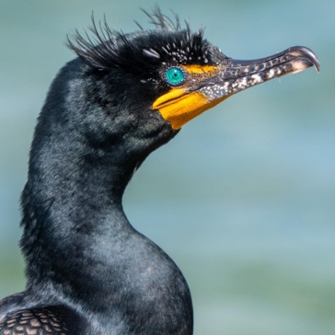

**Abstract:**

**During 16 of 21 consecutive annual breeding seasons, two diseases, Newcastle disease and avian cholera, killed approximately 50% of juvenile Double-crested Cormorants (*Phalacrocorax auritus*) in a large nesting colony in Canada.** From 1994 to 2014, we recorded data annually on disease occurrence, causal pathogens, species and age classes affected, total number of breeding pairs of cormorants on the colony site, and other biological parameters. A mathematical model of pathogen transmission was constructed to assess the potential importance of transmission parameters and to test a hypothesis regarding the potential effect of the **observed progressive loss of nest trees and the consequent shift from tree-nesting to ground-nesting behavior**. The model indicated that **juveniles from ground nests were 14 times more likely to die from epidemic disease (50.14% mortality) than were juveniles from nests in trees (3.57% mortality).** Additive disease-related mortality of juvenile cormorants in the observed range of 40–60% would reduce a closed cormorant population over time. **There was no directional change in the colony population during the study period, suggesting that immigration had compensated for disease-related mortality**. Our results highlight the preeminent influence of environmental factors on pathogen transmission and the value of long-term data sets.

Keywords: Avian cholera, Double-crested Cormorant, environmental determinant, Newcastle disease, *Phalacrocorax auritus*, population

**Key Points:**

* In 1990, an epidemic of Newcastle disease (ND), caused by avian paramyxovirus-1 (APMV-1), which is highly pathogenic in chickens, was discovered in cormorants in western Canada
* From 1994-2014, cormorants in a large nesting colony were monitored for occurrence and causes of diseases producing large-scale mortality (epidemics) during the breeding season. Outbreaks of ND and avian cholera (AC; infection with the bacterium *Pasteurella multocida)*, resulted in large-scale mortality on Island A in 16 of the 21 nesting seasons monitored in this study
* Nearly all cormorants dying in these epidemics were 6–8 wk old, fully feathered, and approaching adult size and independence. Adult cormorants were never found among the sick or dead in outbreaks of ND, and they were rare but present among dead birds observed during AC epidemics. Although ND affected only the cormorants, AC also affected a few of the other bird species
* From 1994 to 2003, the percentage of antibody prevalence to APMV-1 in the yolk of freshly laid cormorant eggs varied from 43% to 100%. There was no evident relationship among antibody prevalence, breeding population size, or occurrence of ND. Epidemics of ND occurred in cormorants hatched in years with the lowest and with the highest recorded antibody prevalence in the eggs sampled.
* In years with no additional mortality, there should be a surplus of birds to replace breeding pairs. In years with additional mortality among juveniles of 40, 50, or 60%, only 76, 63, and 50%, respectively, of the number of new breeders required to maintain the average breeding bird population size would be available 2 yr later.
* **Negative effects could not be detected in the actual population data.** Immigration of breeding birds probably compensated completely for the loss of replacement breeders because of epidemics on Island A.
* The transmission model developed for APMV-1 suggested that virus transmission and resulting mortality are limited during the first 10 d after juvenile cormorants leave the nest but increase rapidly thereafter until juveniles fledge, progressively gain independence, and begin to disperse from the colony site
* A mathematical model of ground-nesting vs. tree-nesting scenarios suggested that the earlier departure from the nest observed in ground-nesting cormorants has a significant effect on the occurrence of disease outbreaks. Juveniles from ground-nests that left the nest at 4 wk old suffered 14 times greater disease-induced mortality by the end of the nesting season (50.32% mortality) than did nestlings in tree-nests that left the nest at 6 wk old (3.56% mortality). **Increased contact period had an enormous effect on mortality.**
* Island A was colonized by cormorants in 1983 when it was forested. Initially, cormorants nested primarily in trees. Cormorant excrement is toxic to plants, and all trees were dead by 1992. Ground-nesting increased.
* APMV-1 was detected in only one of 1,650 samples of fresh excrement collected from adult birds between late May and early June. These data imply that shedding of this virus is not common, but can occur, among adult cormorants during the period of egg incubation.
  + According to our model, as few as eight to nine infectious adults in a breeding population of 13,700 birds is sufficient to initiate an epidemic.

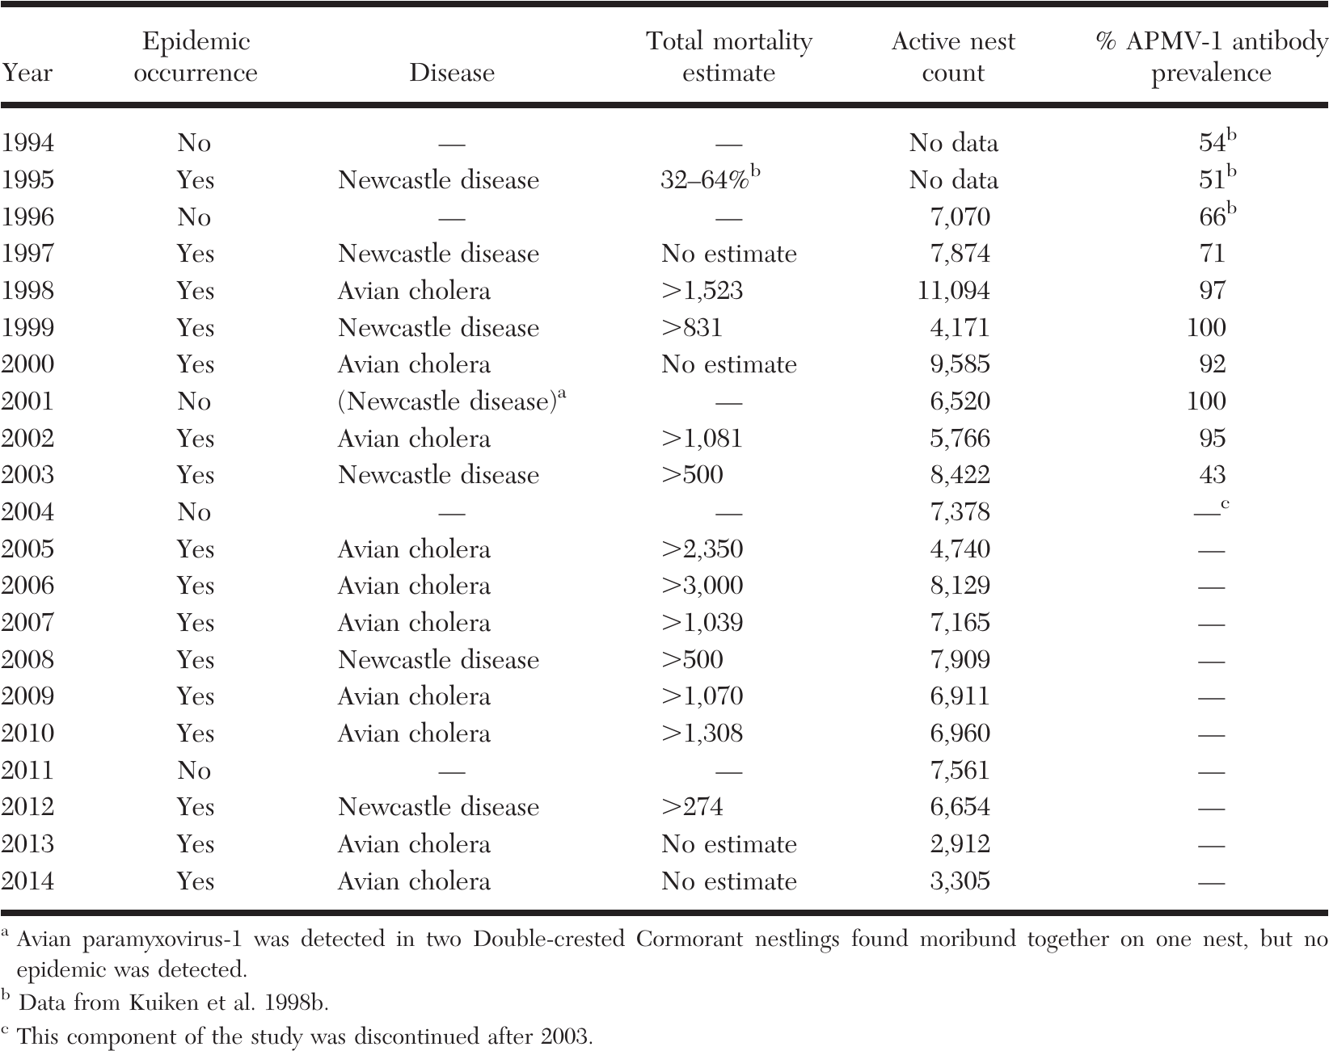

**Take-Home Message:**

* Model highly supports revenge-of-the-trees hypothesis, in which deforestation by cormorants resulted in ground nesting, which lead to epidemics of Newcastle disease and avian chloera in a breeding colony of double-crested cormorants in Canada

*Journal of Zoo and Wildlife Medicine 53(1): 11–18, 2022*

RETROSPECTIVE MORTALITY REVIEW OF TUFTED PUFFINS (*FRATERCULA CIRRHATA*) AT A SINGLE INSTITUTION (1982–2017)

Jessica Heinz, DVM, Kadie Anderson, DVM, Dipl ACZM, and Karen Wolf, MS, DVM, Dipl ACZM

Abstract: Tufted puffins (*Fratercula cirrhata*) are commonly exhibited in zoologic institutions across the world, yet there is a paucity of information on causes of mortality in managed populations. This retrospective review reports the pathologic findings associated with **91 tufted puffins at a single institution over 35 years from 1982 to 2017**. Common pathologic findings were evaluated by age at death, sex, year, and season. With the exception of neonates, the leading pathologic finding across all age classes was **aspergillosis, particularly in adults**. Hemoparasitism, predation, and trauma were also frequent causes of mortality. **Neonatal mortality was common and primarily caused by omphalitis, yolk sac disease, and bacterial septicemia, with most cultures revealing Escherichia coli**. This study also provides documentation of mortality in tufted puffins secondary to avian pox and suspected toxoplasmosis. Understanding morbidity and mortality trends within a population allows institutions to form management plans and implement practices to improve outcomes and survival.

**Summary:**

* Charadriiformes!
* Point Defiance Zoo: year-round outdoor management
* 35 yr M&M, single institution: Categorized by age and time of death
  + neonates were considered 7 d old or less, nestlings were between 8 and 60 d old, juveniles were between 2 and 12 mon old, and adults were 1 yr or older
* Average life expectancy 4.2 yr across all cases, median age 1.3 yr (likely due to disproportionate neonate loss)
* There was a high rate of neonatal death, accounting for 24.8% (n = 35) of overall mortalities.
  + Mortality was highest in the first year of life (47.5%, 67/141)
  + Compared with hatch rate, there was 32% mortality in neonates (35 deaths out of 107 chicks hatched).
  + Hatch July/August
  + Omphalitis or yolk sac disease and septicemia were major causes of death in neonates and nestlings
  + Yolk sac disease was characterized by retained yolk sac, ruptured yolk sac, or evidence of inflammation of yolk.
    - Note: we had one of these cases at NC Zoo this year, the umbilicus palpated “normally” ☹
    - *E. coli* most common
    - Of the nine septic neonates, six did not show gross evidence of omphalitis (66.7%).
* Aspergillosis was the leading cause of pathology (n = 38, 41.8%; Table 1) and was significant in all age groups except neonates.
  + Dx based on aspergillomas on gross necropsy, histopathology, or fungal culture
  + Most common in deaths July – October
  + Evenly distribute by year (1.2 +/- 1.5 SD) cases/yr
    - If you manage Charadriiformes [or Sphenisciformes] and your collection has a history of aspergillosis you may expect to manage 1+ case/yr
  + Of note: dirt/grass cliffs at this institution were not as easily disinfected as rocks/pool
  + As described in literature, the larger die-off in 2006 was possibly associated with adjacent exhibit construction that aerosolized fungal spores
* Hemoparasitism was the second most common disease identified in all individuals
  + 1 -5 years of age, avg. age of death 8.4 yr
  + All cases of malaria occurred between July and September, with the majority occurring in August
  + More clustered rather than evenly distributed by year

*Journal of Zoo and Wildlife Medicine 54(1): 94–101, 2023*

A RETROSPECTIVE ANALYSIS OF THE MORBIDITY AND MORTALITY OF CAPTIVE NORTHERN BALD IBIS (*GERONTICUS EREMITA*), AFRICAN SACRED IBIS (*THRESKIORNIS AETHIOPICUS*), AND SCARLET IBIS (*EUDOCIMUS RUBER*) HOUSED AT THE LONDON ZOO FROM 2000 TO 2020

Jessica Heinz, DVM, Kadie Anderson, DVM, Dipl ACZM, and Karen Wolf, MS, DVM, Dipl ACZM

Abstract: Necropsy (n = 144) and medical (n = 121) records of captive northern bald ibis (NBI; *Geronticus eremita*), African sacred ibis (ASI; *Threskiornis aethiopicus*), and scarlet ibis (SCI; *Eudocimus ruber*) housed at the Zoological Society of London’s London Zoo (LZ) from 2000 to 2020 were reviewed. **Pododermatitis** was a common cause of morbidity in all species (79 cases in 247 examinations). **Trauma** (58 of 144), the majority being caused by suspected collisions with stationary objects in the zoo’s habitats, **infectious diseases** (32 of 144), **predominantly valvular endocarditis** (10 of 32), and **aspergillosis** (9 of 32) were major causes of mortality. The odds of a morbidity being related to toxicosis were 4.4 times greater in NBI than for ASI (95% CI, 1.5–13.3; P , 0.05); all cases in the NBI were plumbism. Overall, **females** of all species had 3**.4 times greater odds** of undetermined morbidity than males (95% CI, 1.5–7.9; P , 0.05), and the majority (16 of 25) were birds that were thin without an apparent cause. **Nestlings had 11.3 times greater odds of nutritional morbidity** than adults (95% CI, 1.7–73.0) and 5.5 times greater than juveniles (95% CI, 0.7–41.0; P , 0.05). These data have identified areas that require further study in the population of NBI, ASI, and SCI held at LZ.

* Pelecaniformes
* 20 yr M&M: single institution: co-housed with overlapping husbandry
  + five age groups: 0–47 d (nestling); 48 d to 2 yr (juvenile); 2–4 yr (subadult); .4 yr (adult); and unknown (unk assigned age group by necropsy report or based on medical record comments)
  + Most morbidities identified on opportunistic health screenings
    - **Pododermatitis** most common in SCI > NBI or ASI
    - SI had 2.7 times greater odds of **traumatic morbidity** than SCI (95% CI, 1.5–5.0) and 2.1 times greater odds than NBI
      * **Impact collisions**
      * Wing (27.9%), head (18.6%), leg (16.3%), and beak (12.8%)
      * ibises are at risk of breaking their beaks when managed in hard-walled enclosures
    - Females were found to have 3.4 times greater odds of undetermined morbidity than males, commonly identified as thin with no obvious etiology.
  + **Trauma** (45%) and infectious (22%) most common mortalities
    - Valvular endocarditis (10/32)
      * mortality classified as degenerative was predominantly due to cardiovascular lesions
      * cardiac troponin has been validated in scarlet ibis
      * can be related to pododermatitis – wading species of ibis had less podo in this study, likely environmentally-related, feeding enrichment devices, neoprene or artificial turf perching surface
    - Aspergillosis (9/32)

Gastrointestinal Avian

* No teeth; beak is used for food prehension; feet also aid in this
  + Seedeaters: short, stout beaks
  + Psittacine: strong, hooked bills- used for climbing and cracking nut shells
  + Carnivorous: narrower, hooked bills
  + Waterfowl: broad bills for straining water
* Psittacine birds: fleshy sensitive tongue for moving food and other objects
* Lories and Lorikeets: erectile bristles on tongue for collection of pollen and nectar
* Saliva is just for lubrication with no enzyme function
* Esophagus is similar to mammals-evaginates to form a crop in some species
  + Passerines (canaries), owls, many wading birds, some others do not have a crop
  + Columbiformes= produce crop milk
* Stomach= secretory portion (proventriculus) and muscular portion (ventriculus)
* Herons and penguins: sac-like and large
* Chemical digestion: begins in proventriculus with hydrochloric acid then food passes through the isthmus into the ventriculus
* Ventriculus: has a koilin layer= touch, carb-protein material= helps grind the food
  + In hornbills- this layer is shed and is what males feed to the females on the nest
  + In birds that consume nectar primarily= have less muscular ventriculus
* Gastric reflux (egestion or casting): occurs in carnivores (Strigiformes and Falconiformes)
  + This helps indigestible material not enter the ventriculus; this is synchronized contractions of the proventriculus, ventriculus, and duodenum
  + Owls: bone and roughage in pellets
  + Falconiformes: only roughage
* From ventriculus: goes into the small intestine (duodenum) along with bile and pancreatic enzymes
* The presence of ceca vaires
  + Absent: psittacines and diurnal raptors
  + Rudimentary: passerines and pigeons
  + Most developed: ground feeding birds
  + Ceca may function in water conservation along with digestion of fibrinous material
  + Ostrich: ceca is large, saccular, and has some bacterial fermentation to help with fiber digestion
* Colon empties into the coprodeum of the cloaca (most cranial portion)
* A lot of the water reabsorption from the urine occurs within the GI tract NOT the kidneys
* Pancreas: lies close to the duodenum, has both endocrine and exocrine properties
  + Glucagon is important in regulation of blood glucose in granivorous birds
* Liver: dark red and composed of a right and left lobe (right side is slightly larger)
  + Lack biliverdin reductase an cannot produce bilirubin
  + Feces=green in color is normal
  + If liver fails to conjugate and excrete biliverdin into the intestine then it will be excreted into the urine
* Gallbladder: varies if is present
  + Psittacine birds (EXCEPT COCKATOOS) lack a gallbladder

Reproductive- Avian

* Entirely Internal
* Sexed by DNA analysis (Antech) or endoscopic examination
* Some posses secondary sex characteristics
  + Eclectus: red/purple with black beak (female); green/yellow with “candy corn” beak (male)
  + Budgies: blue cere (males), grayer/white (females)
    - Cere can turn brown in female and become hyperplastic during reproductive activity
  + Wild type gray cockatiels: bars on the tail and primary flight feathers (females); orange bright patch on cheek (males)
* Reproductive tract is connected to the urodeum in the cloaca
* FEMALES:
  + Females reproductive tract is located on the left side
    - Right ovary and oviduct regress: raptors have vestigial remnants or could remain functional
  + Oviduct has 5 sections: infundibulum, magnum, isthmus, uterus (shell gland), and vagina
  + During breeding season- oviduct can take up the entire left coelom
  + There is a vaginal sphincter at the junction of uterus and vagina (where sperm is stored)
  + Uterus- site for shell production
* MALES
  + Paired testes on both right and left sides
  + Sperm formation: seminiferous and straight tubules
  + Last few millimeters of the ductus deferens protrude into the urodeum and form a papilla
  + No accessory sex glands
  + Copulation in birds (except waterfowl) involves eversion of the cloacal wall to exposed the raised papilla to transfer the semen to the orifice of the oviduct
  + Waterfowl: HAVE A PHALLUS- comprised of erectile tissue (lymphatic in origin) and an external groove that is used to transport semen
    - Purely reproductive in function
    - Lie on the ventral floor of the proctodeum
* Hormones:
  + Regulated by the hypothalamus- pituitary-gonadal axis (like all vertebrates)
  + Hypothalamus products GnRH-> stimulates pituitary gland-> produce LH and FSH
    - LH= increases with lengthening photoperiod as well as presence of mate and nest box access
  + FSH role is unclear in avian
  + Estrogens= responsible for secondary sex characteristics, stimulation of medullary bone production and a number of products used to form the egg
  + LH= stimulates progesterone production- with increased progesterone you get the LH surge
  + PGF2alpha coincides with shell gland contractions
  + PGF2alpha and PGE2 increase smooth muscle contractions= cause follicle to rupture
    - Mid-sequence oviposition= PGF2alpha is higher
      * PGF2 alpha binds at the shell gland receptor causing mobilization of calcium which causes shell gland muscle contractions; most likely has no ability to relax the uterovaginal sphincter
    - Terminal oviposition= PGE2 is higher
      * PGE2: binding sites in vagina thought to block binding of PGF2alpha: allow relaxation of the uterovaginal sphincter and vagina