**QUESTION:** A parakeet auklet in managed care with this disease process is most likely:

1. Over supplemented with thiamin
2. Receiving a vitamin A deficient diet
3. Young with congenital disease
4. Prone to lens rupture and luxation
5. Enduring conspecific trauma

Answer: D

Source: Phillips et al. JAMS 2021. Retrospective Analysis of Cataract Formation and Nutritional Etiology in a Managed Collection of Parakeet Auklets (*Aethia psittacula*).

**QUESTION:** A cattle egret chick in rehabilitation fed predominately capelin without vitamin D3 has developed the disease process in image on the right. Which long bone do you suspect to be most affected by deformity and folding fractures in this bird?

Answer: Tarsometatarsus

*Bonus:* What dietary change might you make to prevent this disease process from happening in subsequent egret chicks in rehab if you are going to use capelin?

Answer: Vitamin D3 supplementation

Source: Horgan et al. JZWM 2020. CLINICAL AND PATHOLOGIC FINDINGS OF AN OUTBREAK OF VITAMIN D3–RESPONSIVE METABOLIC BONE DISEASE IN HERON AND EGRET (FAMILY ARDEIDAE) CHICKS FED CAPELIN (MALLOTUS VILLOSUS).

**Question:** Which of the following was associated with increased odds of survival in oiled wild birds undergoing the decontamination process?

1. Sedation
2. Body condition score
3. Type of contaminant
4. Total wash time
5. Time spent drying

**Answer:** E

SOURCE: JAMS, 38(2): 67-74, 2024, COMPARISON OF MANUAL RESTRAINT WITH AND WITHOUT SEDATION ON OUTCOMES FOR WILD BIRDS UNDERGOING DECONTAMINATION

____________________________________________________________________________________

**Question:** A Northern Gannet is found in the field and its feet have the following appearance. Even if released, why would this individual likely be unsuccessful in reproducing?

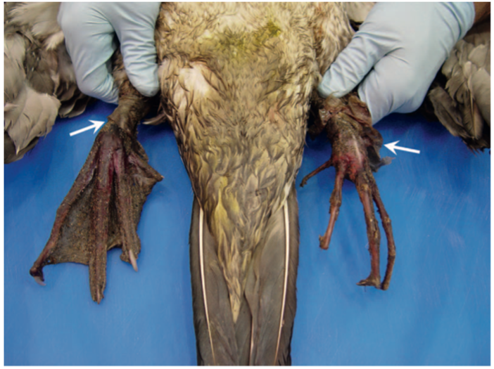

**Answer:** Northern Gannets have highly vascularized foot webs that BOTH males and females use to incubate a single egg. Without appropriate foot webbing, this bird could not incubate an egg appropriately, among many other behaviors it would not be able to perform.

SOURCE: JWD, 57(4): 865-873, 2021, A SYNDROME OF ISCHEMIC LEG NECROSIS IN NORTHERN GANNETS (MORUS BASSANUS)

Vanstreels, Ralph ET, et al. "Phthalate esters (plasticizers) in the uropygial gland and their relationship to plastics ingestion in seabirds along the coast of Espírito Santo, Eastern Brazil." *Journal of Zoo and Wildlife Medicine* 53.4 (2023): 733-743. – reviewed by HSS

Question:

The uropygial gland concentration of which of the following phthalate esters was positively associated with presence, mass, and number of ingested plastic items in seabirds along the coast of Espírito Santo, Eastern Brazil?

1. Di-n-butyl phthalate (DBP)
2. Di-n-octyl phthalate (DOP)
3. Bis(2-ethylhexyl) phthalate (DEHP)
4. Diethyl phthalate (DEP)
5. Dimethyl phthalate (DMP)

Answer: E

Leighton, Frederick A., et al. "Revenge of the trees: environmental determinants and population effects of infectious disease outbreaks on a breeding colony of double-crested cormorants (*Phalacrocorax auritus*) over a period of 21 years." *The Journal of Wildlife Diseases* 57.4 (2021): 773-783. – reviewed by HSS

Question:

Which of the following statements is most correct regarding epidemic mortalities of a breeding colony of Canadian double-crested cormorants (*Phalacrocorax auritus*) from 1990-2014?

1. Avian paramyxovirus-1 was detected in the majority of fresh fecal samples collected from adult double-crested cormorants
2. Juveniles raised in tree-nests were found to have significantly greater disease-induced mortality compared to ground-nests
3. During outbreaks of Newcastle disease, both juvenile and adult cormorants were found deceased during population surveys
4. Juveniles raised in ground-nests had longer contact periods with other juveniles compared to juveniles raised in tree-nests
5. The population of double-crested cormorants has steadily declined following repeated outbreaks of Newcastle disease and avian cholera

Answer: D

Explanation:

* Avian paramyxovirus-1 was rarely detected in feces of adults.
* Juveniles from ground-nests that left the nest at 4 wk old suffered 14 times greater disease-induced mortality by the end of the nesting season (50.32% mortality) than did nestlings in tree-nests that left the nest at 6 wk old (3.56% mortality)
* Adult cormorants were never found among the sick or dead in outbreaks of Newcastle disease, and they were rare but present among dead birds observed during avian cholera epidemics.
* Negative effects could not be detected in the actual population data.Immigration of breeding birds probably compensated completely for the loss of replacement breeders because of epidemics on Island A.

*Journal of Zoo and Wildlife Medicine 53(1): 11–18, 2022*

RETROSPECTIVE MORTALITY REVIEW OF TUFTED PUFFINS (*FRATERCULA CIRRHATA*) AT A SINGLE INSTITUTION (1982–2017)

Jessica Heinz, DVM, Kadie Anderson, DVM, Dipl ACZM, and Karen Wolf, MS, DVM, Dipl ACZM

In a recent morbidity and mortality study of tufted puffins at a single institution (*Fratercula cirrhata),* what was the overall leading cause of pathology?

1. Predation
2. Aspergillosis
3. Omphalitis
4. Hemoparasitism
5. Poxvirus

Correct answer: B) Aspergillosis –aspergillosis was a significant cause of pathology (42%) in all age groups except neonates. Omphalitis/yolk sac disease/septicemia was leading cause of mortality in neonates, accounting for 25% of mortalities overall in the study. The average life expectancy was quite low given the high rate of neonatal deaths.

*Journal of Zoo and Wildlife Medicine 54(1): 94–101, 2023*

A RETROSPECTIVE ANALYSIS OF THE MORBIDITY AND MORTALITY OF CAPTIVE NORTHERN BALD IBIS (*GERONTICUS EREMITA*), AFRICAN SACRED IBIS (*THRESKIORNIS AETHIOPICUS*), AND SCARLET IBIS (*EUDOCIMUS RUBER*) HOUSED AT THE LONDON ZOO FROM 2000 TO 2020

Jessica Heinz, DVM, Kadie Anderson, DVM, Dipl ACZM, and Karen Wolf, MS, DVM, Dipl ACZM

In a recent morbidity and mortality study of ibises at a single institution (*Geronticus eremita, Threskiornis aethiopicus,* and *Eudocimus ruber),* what was discussed as the most predominant morbidity and a possible predisposing factor for valvular endocarditis?

1. Impact collisions
2. Aspergillosis
3. Pododermatitis
4. Nutritional
5. Poor husbandry

Correct answer: C) Pododermatitis. Although pododermatitis is not primarily an infectious disease, secondary infections of the pedes occur; therefore, a risk of pododermatitis causing VVE exists. Citation: Greenwood AG, Marshall J, Tinsley EGF. Vegetative endocarditis in a Waldrapp ibis. Avian Pathol. 1996;5(2):387–391.

Questions

1. Which of the following Psittacine Birds lack a gallbladder?
2. Melopsittacus undulatus
3. Ara macao
4. Agapornis
5. Nymphicus hollandicus
6. Cacatuidae

Answer: E. Cacatuidae: cockatoos

1. Which of the following hormones is responsible for the stimulation of medullary bone production in the avian species?
2. LH
3. FSH
4. Estrogen
5. PGF2alpha
6. PGE2

Answer: C: estrogen