Question: Which of the following is considered a definitive host for Echinococcus granulosus?
- Domestic dog
- Domestic cattle
- Human
- Langur
- Wild ungulate
Answer: A
SOURCE: JZWM, 54(3): 645-650, 2023, ULTRASOUND-GUIDED PERCUTANEOUS TREATMENT O FHEPATIC HYDATIDOSIS IN TWO RED-SHANKED DOUC LANGURS (PYGATHRIX NEMAEUS)

Question: What two species of Campylobacter are specifically associated with human gastroenteritis and are a zoonotic concern in any zoologic/aquatic facility?
Answer: Campylobacter jejuni, Campylobacter coli
SOURCE: JZWM, 54(4): 810-816, 2024, CAMPYLOBACTER HYOINTESTINALIS ISOLATION FROM HOWLER (ALOUATTA CARAYA) AND SPIDER MONKEYS (ATELES FUSCICEPS ROBUSTUS) AT A ZOOLOGIC FACILITY IN CENTRAL ILLINOIS
- Which of the following along with mycolic acid within the cell wall allows mycobacteria to be acid fast staining?
  - Galactin
  - Arabinan
  - Peptidoglycan
  - Lipoarabinomannan
  - Acyl glycolipids

Answer: D. Lipoarabinomannan
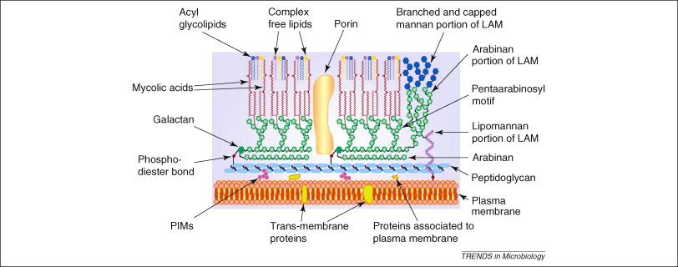

- Which of the following was found to be the greatest cause of mortality in captive langurs from six united kingdom institutions over a 19 year period?
  - Anthracosis
  - Interstitial Pneumonia
  - Linear Foreign Body
  - Cardiomyopathies
  - Hemosiderosis

Answer: C. Linear foreign body- most consistent with bark

Journal of American Veterinary Medical Association 253(4): 423-26. 2018

Pathology in Practice: Common Marmoset

- Which of the following primate alphaherpesviruses is defined as zooanthroponotic?
- Macacine herpesvirus 1
- Human herpesvirus 1
- Papiine herpesvirus 2
- Saimirine herpesvirus 1
- Callitrichine herpesvirus 3

Answer: B. Human herpesvirus 1 (HHV-1 or HSV-1). Zooanthroponosis is defined as reverse zoonoses, aka given to animals by humans. In current literature, HHV-1 has been reported in pet callitrichids that are kissed by, or share food with, owners. Macacine herpesvirus 1 (also known as herpes B virus) is a significant human zoonotic risk, causing fatal encephalomyelitis. Papiine and saimirine herpesviruses are non-zoonotic but can be lethal in other non-natural hosts. Callitrichine herpesvirus is a gammaherpesvirus and is not zoonotic.
- $α$-herpesviruses can infect a wide range of animal species and different cells (neurons, epithelial cells)
- $β$-herpesviruses can infect different cells within the same animal species
- $γ$-herpesviruses are the most species and cell specific

Journal of Zoo and Wildlife Medicine 51(4): 780–788, 2020

LEPTOSPIRA SPECIES STATUS OF CAPTIVE NONHUMAN PRIMATES AND FREE-RANGING RODENTS AT THE BARRANQUILLA ZOO, COLOMBIA, 2013
Danielle Woolf, DVM, Carlos Sanchez, DVM, MSc, Viviana Gonzalez-Astudillo, BVSc, MNR, PhD, Mauricio Navarro, DVM, MSc, PhD, Cristian Camilo Tapia, DVM, Mo ́nica Franco, DVM, Javier Andre ́s Bustamante, MS, Miryam Astudillo, MS, and Jean Mukherjee, DVM, Dipl, ACVM, PhD

- In a recent study evaluating prevalence of Leptospirosis in nonhuman primates (NHPs) in a Colombian Zoo, what was primarily implicated as a cause of exposure?
- Provision of unfiltered well water to NHPs
- Lack of rodent trapping practices
- Lack of vaccination protocols
- Poor cleaning practices at this zoo
- Food and water next to drains

Answer: A. Provision of unfiltered well water to NHPs. While water source did not significantly correlate to exposure, it was discussed in the paper that both (n = 2) seropositive NHPs were provided with unfiltered well water. Other recommended, but not implicated (ie also not notably lacking at this zoo), biosecurity practices included: vaccination; frequent cleaning; provision of elevated resting platforms; use of impermeable floor surfaces; proper drainage to limit standing water; providing food and water in elevated containers that are regularly cleaned; and provision of water from a treated source.

Sriningsih, Agnes P., et al. "Evaluating the efficacy of human bronchiectasis based antibiotic therapy in the treatment of orangutan respiratory disease syndrome." Journal of Zoo and Wildlife Medicine 52.4 (2021): 1205-1216. Reviewed by HSS

Question:

Which of the following treatment protocols, adapted from treatment of human cystic fibrosis, has shown improvement of clinical signs and CT appearance in orangutan respiratory disease syndrome (ORDS)?

- Enrofloxacin and amikacin
- Erythromycin and amoxicillin
- Azithromycin and levofloxacin
- Azithromycin and amikacin
- Levofloxacin and erythromycin

Answer: C

Epstein, Jenna, et al. "Global retrospective analysis of pathological findings in zoo-managed Goeldi's monkeys (Callimico goeldii), 1965–2018." Journal of Zoo and Wildlife Medicine 53.2 (2022): 339-348. Reviewed by HSS

Question:

Compared to male callimicos (Callimico goeldii), female callimicos are significantly predisposed to developing which of the following lesions?

- Renal disease
- Cardiac disease
- Hepatitis
- Neoplasia
- Enteritis

Answer: D

Q: What is the most common extended spectrum beta-lactamase (ESBL) producing bacteria you are likely to isolate from a chimpanzee in a managed care setting?
- Serratia marcescens
- Shigella dysenteriae
- Pseudomonas aeruginosa
- Escherichia coli
- Burkholderia cepacia
Answer: D

Source: Bager et al. JWD 2022. Genomic characterization of MDR extended spectrum beta lactamase producing e coli and klebsiella pneumoniae from chimps from wild and sanctuary locations in uganda.

Q: Surgery due to resistance of antiparasitics/medical management is a viable option for treatment of which parasite in squirrel monkeys with clinical infection?
- Prosthenorchis elegans
- Balantidium coli
- Strongyloides cebus
- Schistosoma haematobium
- Ancylostoma duodenale
Answer: A

Source: Rojas-Sánchez et al. JZWM 2024. MEDICAL–SURGICAL MANAGEMENT OF INTESTINAL INFECTION BY PROSTHENORCHIS ELEGANS IN NONHUMAN PRIMATES FROM COSTA RICA.

