Journal of Zoo and Wildlife Medicine, 54(3): 645-650, 2023.
ULTRASOUND-GUIDED PERCUTANEOUS TREATMENT OF HEPATIC HYDATIDOSIS IN TWO RED-SHANKED DOUC LANGURS (PYGATHRIX NEMAEUS
Szilvia K Kalogeropoulu, Elke Schwierz, Michael Meyerhoff, Radoslaw Ratjszczak, Tilo Nadler, Bonnie L Raphael – Reviewed by LMM
Abstract: Hydatid disease caused by Echinococcus ortleppi is a major cause of morbidity and mortality for critically endangered captive langurs in northern Vietnam. The most common sites for hydatid cyst development are the liver and the lungs. Chemotherapy trials with albendazole alone or in combination with praziquantel in these langurs had varying results and in most cases were ineffective. Ultrasound-guided percutaneous aspiration of cystic fluid followed by instillation and re-aspiration of a scolicidal agent (PAIR technique), has gained importance in the treatment of active hepatic cysts in humans and in many cases is preferred over surgical and endoscopic approaches. The PAIR technique was used in two red-shanked douc langurs (Pygathrix nemaeus) for the treatment of unilocular active hepatic cysts. The technique was found to be fairly easy to perform, safe, and effective and should be a useful treatment tool for hepatic hydatidosis in langurs and other nonhuman primate species.

Key Points:
- Cystic echinococcosis or hydatid disease is caused by the cystic development of larvae of the cestode Echinococcus granulosus
  - Zoonotic, worldwide distribution
  - Intermediate Hosts = domestic or wild ungulates
  - Aberrant Intermediate Hosts = human and non-human primates
  - Definitive Hosts = domestic or wild canids
  - Echinococcus ortleppi = “cattle strain” because it is passed preferentially between dogs and cattle
  - Life Cycle = Intermediate host gest infected by accidental ingestion of tapeworm eggs passed in feces of definitive host; after ingestion larvae migrate through intestinal wall typically to liver and lungs and develop hydatid cysts (metacestode stage); hydatid cysts act as space-occupying lesions that may cause severe symptoms and death
  - In liver hydatid cyst can compress bile ducts, hepatic vessels inducing cholestasis, portal hypertension, and Budd-Chiari syndrome
  - Cyst development is slow so animal can be asymptomatic for years – making antemortem diagnosis challenging; routine U/S is essential for early detection
  - Treatment = chemotherapy with albendazole alone or in combination with praziquantel has mixed and often ineffective results
  - New Experimental Treatment = PAIR (puncture, aspirate, instill, re-aspirate) has been used to aspirate cysts and instill cysts with scolicidal solution with success in humans; PAIR combined with benzimidazole administration has become the first line treatment for this disease in people (over surgery and laparoscopy)
- 22 yo female and 8 yo male red-shanked douc langurs found serologically positive for E. granulosus on ELISA and Western Blot and both had cystic changes to liver consistent with hydatidosis
  - Both underwent general anesthesia and PAIR was performed only on active unilocular hepatic cysts using an ultrasound-guided percutaneous transhepatic approach to prevent leakage into the abdomen
  - PAIR – Animal in left lateral, abdomen clipped and sterile prepared, ultrasound probe sterilized and used to investigate vasculature as well as cysts and guide safe puncture on active unilocular hepatic cysts, 22-gauge needle on extension set used, two 3 ml sterile syringes (one empty for aspiration and one with 95% ethanol serving as the scolicidal agent); cyst aspirated until collapsed and empty, then scolicidal agent instilled in the cysts (volume 1/3rd of that aspirated), and scolicidal agent left in cysts for 20 minutes with close monitoring for anaphylaxis, then scolicidal agent re-aspirated
  - Other options for scolicidal agents include hypertonic saline 20%, cetrimide 0.1%, povidone-iodine 10%
  - Note: Ethanol related side effects include sclerosing cholangitis and subsequent cystobiliary fistulation, ethanol intoxication and encephalopathy. Neither of which were seen in these cases.
  - Neither individual had anaphylaxis or cyst rupture during this process
  - On ultrasound 6 months post-procedure, no cystic regrowth or communication between cystic remnants and biliary system observed. Smaller cysts no longer visible with ultrasound and larger cysts displayed an inactive pseudotumor appearance
  - Significant clinical improvement post PAIR was observed with increased body condition and normalization of bloodwork parameters if they had been abnormal (specifically liver values or WBC count)
  - Preventative Measures the center instituted after these cases – leafe collection from higher tree sites, washing of leaves, placing collected leaves on platforms off the ground, and use of specific footwear when entering animal enclosures

Take Home Point: Percutaneous drainage of active hepatic unilocular echinococcus cysts in two langurs was therapeutically effective as well as easy and safe to perform.

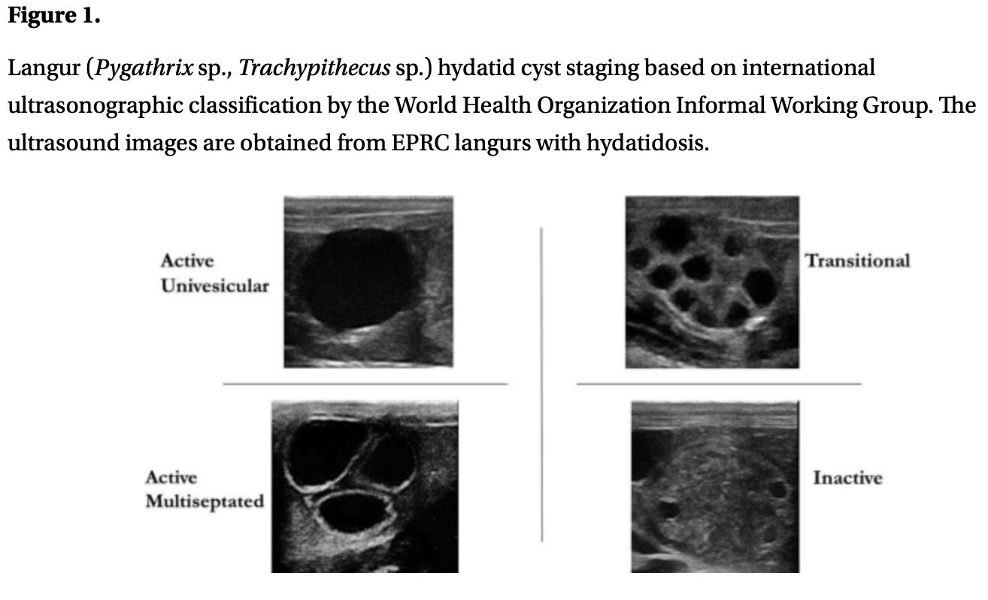
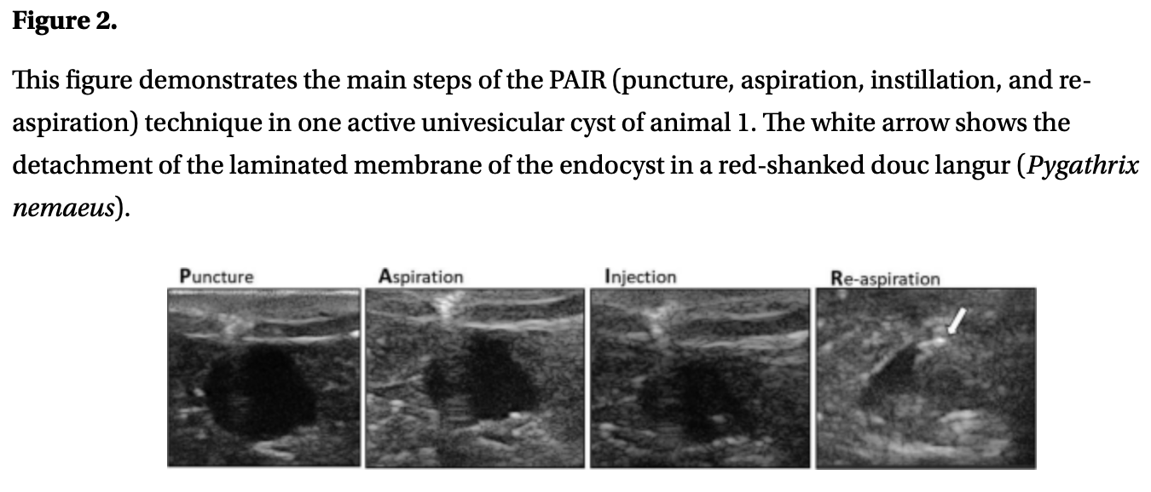
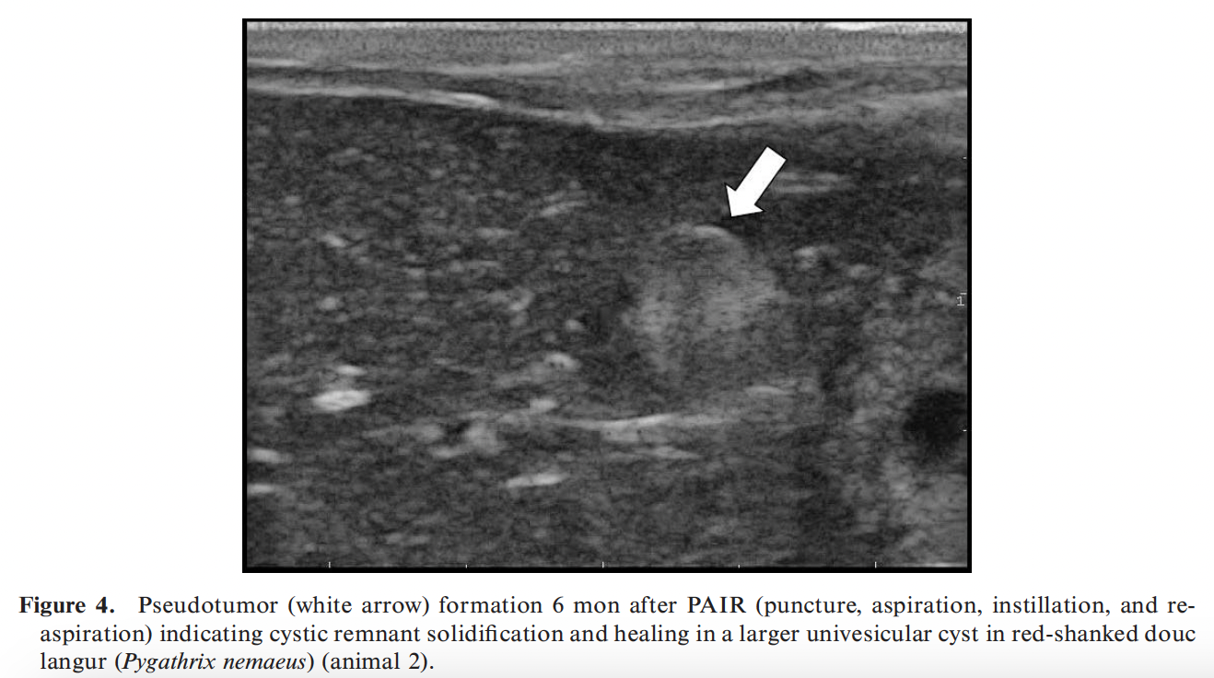
Journal of Zoo and Wildlife Medicine, 54(4): 810-816, 2024.
CAMPYLOBACTER HYOINTESTINALIS ISOLATION FROM HOWLER (ALOUATTA CARAYA) AND SPIDER MONKEYS (ATELES FUSCICEPS ROBUSTUS) AT A ZOOLOGIC FACILITY IN CENTRAL ILLINOIS
Siobhan NA Meadows, Chien-Che Hung, Jenn-Wei Chen, Samantha Soukup, Samantha J Sander – Reviewed by LMM
Abstract: Campylobacter hyointestinalis was initially isolated from an asymptomatic black howler monkey (Alouatta caraya) in a routine fecal culture examination. Fecal cultures from other individuals in this group and an adjacently housed black-headed spider monkey (Ateles fusciceps robustus) group recovered C. hyointestinalis from all but one of the individuals sampled (1.1 spider monkeys and 2.1 howler monkeys). Concurrently, one spider monkey presented with acute onset severe rectal prolapse and diarrhea. Whole-genome sequencing results of C. hyointestinalis isolates from all individuals were homologous and closely related to Campylobacter hyointestinalis subsp. hyointestinalis TTU_618, a strain typically associated with environmental samples. In addition, two cytolethal distending toxin (CDT) expressing gene clusters, cdt-I and cdt-II, were identified in all isolates. These results suggest C. hyointestinalis is transmissible to both howler monkeys and spider monkeys, though the origin of infection and whether it is transmissible between these species is undetermined.

Key Points:
- Campylobacter sp = gram-negative bacteria with spiral, s-shaped, or curved morphology
  - 37 recognized species
  - Campylobacter jejuni and Campylobacter coli are the most well-documented and associated with gastroenteritis in humans and animals
  - Due to specifics for isolation of C. hyointestinalis, it is suspected that prevalence of this organism is underestimated clinically
- Campylobacter hyointestinalis
  - Zoonotic pathogen
  - Identified in healthy reindeer and cattle; causes proliferative enteritis in pigs
  - Asymptomatic cases in hamsters, elephant, sheep, and dogs reported; in some dogs and Moluccan rusa deer clinical cases have been seen
  - Reports in humans increasing (usually incurred in people via occupational hazard such as close contact with livestock or ingesting contaminated food), causes diarrhea and in some instances fatal septicemia
  - To date, only three reports in non-human primates – all in Old World species
    - Asymptomatic Southern pig-tailed macaques (geography not reported)
    - Asymptomatic Chimpanzees, Japanese macaques, lowland Gorilla, Orangutan (Japanese facility)
    - Great apes (x4) WITH DIARRHEA (US facility)
- Howler monkey troop presented with intermittent diarrhea and one spider monkey presented with rectal prolapse, fecal cultures then performed on both troops; 4 howlers and 2 spider monkeys were culture positive for Campylobacter hyointestinalis (negative for Salmonella spp, Yersinia spp, and Shigella spp)
  - All cultured C. hyointestinalis consistent with Campylobacter hyointestinalis subsp. hyointestinalis TTU_618 with two cytolethal distending toxins (CDT) genes, cdt-I and cdt-II

Take Home Point: This is the first report of Campylobacter hyointestinalis in New World monkey species (Howler monkeys and Spider monkeys).

Tuberculosis detection in nonhuman primates is enhanced by use of testing algorithms that include an interferon-γ release assay

OBJECTIVE: To develop a testing algorithm that incorporates multiple assays to evaluate host cellular and humoral immunity and antigen detection concerning Mycobacterium tuberculosis complex (MTBC) infection in captive nonhuman primates.
ANIMALS: Cohorts of captive-bred and wild-caught macaques from 5 different geographic regions.
PROCEDURES: Macaques were tested for MTBC infection by use of a γ interferon tuberculosis (GIFT) assay, an interferon-γ release assay, and other assays. In the first 2 cohorts (n = 15 and 181), initial validation of the GIFT assay was performed by use of experimentally infected and unexposed control macaques. In the next 3 cohorts (n = 59, 42, and 11), results were obtained for opportunistically collected samples from macaques exposed during spontaneous outbreaks.
RESULTS: Sensitivity and specificity of the GIFT assay in the control cohorts were 100% and 97%, respectively, and were variable but enhanced by incorporating results from multiple assays in spontaneous outbreaks.
CLINICAL RELEVANCE: The detection and management of MTBC infection in captive nonhuman primate populations is an ongoing challenge, especially with animal imports and transfers. Despite standardized practices of initial quarantine with regular intradermal tuberculin skin testing, spontaneous outbreaks continue to be reported. Since infection encompasses a range of disease manifestations over time, a testing algorithm that incorporates multiple assays, such as the GIFT assay, to evaluate host cellular and humoral immunity in addition to agent detection is needed. Testing a combination of samples from controlled studies and spontaneous outbreaks of MTBC infection in nonhuman primates would advance the development and validation of a functional algorithm that incorporates promising tools such as the GIFT assay.

- Tuberculin skin test remains the primary tool for diagnosis and surveillance in nonhuman primates
- Some primates with negative TB tests will develop disease or be positive after shipment
- Tb is not biphasic but a continual disease spectrum
- Sensitivity and specificity of TST (84% and 87%)
  - Primagam test (68% and 97%)
- In some cases GIFT did identify infected animals that were deemed negative on the skin test
- Development of reliable algorithms for the diagnosis of TB is urgently needed and should be based on following:
  - Time course of cellular and humoral immune response
  - NHP species-specific differences
  - Source of the animals (captive vs wild caught vs imported)
  - Validation with data sets from both lab and field studies

A RETROSPECTIVE STUDY OF MORBIDITY AND MORTALITY IDENTIFIED AT POSTMORTEM EXAMINATION OF CAPTIVE LANGURS (TRACHYPITHECUS SPP) FROM SIX UNITED KINGDOM ZOOLOGICAL INSTITUTIONS: A 19-YEAR REVIEW

Abstract: Langurs are Asian primates belonging to the Colobinae subfamily. Langur populations are declining, with most species categorized as threatened by the International Union for Conservation of Nature. Investigation into the threats to population viability and sustainability would be beneficial but there is limited literature available on common diseases or causes of death in these species, either in captive or free-ranging settings. This study aimed to evaluate the most common causes of morbidity and mortality in Trachypithecus species submitted for postmortem examination by six United Kingdom zoological institutions between 2001 and 2020, to inform best practice husbandry guidelines. Necropsy and histopathology reports from 88 individuals of Trachypithecus species from six zoological organizations in the United Kingdom were analyzed. Species included Javan langurs (Trachypithecus auratus; n = 35), dusky langurs (Trachypithecus obscurus; n = 28), François' langurs (Trachypithecus francoisi; n = 16), purple-faced langurs (Trachypithecus vetulus; n = 4), silvered langurs (Trachypithecus cristatus; n = 4), and Phayre's langur (Trachypithecus phayrei; n = 1). Morbidities and causes of death were recorded. Gastrointestinal diseases and systemic infections were the leading causes of death (27.4% and 21.0% of cases where cause of death was known, respectively); linear foreign bodies were the most common cause of death. Interstitial pneumonia was frequently observed secondary to systemic infection. Heart abnormalities, anthracosis, and hemosiderosis were common but not directly associated with mortality. Further investigation is necessary to assess the importance of these conditions and whether they predispose to other diseases. This study provides a baseline for future research evaluating captive and free-ranging langur health and highlights husbandry practices that may decrease morbidity in these species.

Background:
- Langurs = Asian primates from subfamily Colobinae.
- Genus Trachypithecus includes 17 species of langur, all but one are IUCN listed as threatened.
- Previous health issues reported in Western zoos include gastrointestinal and nutritional disease.

Main points:
Retrospective review of morbidity and mortality as described by necropsy/histopathology for langurs in 6 UK zoos - most represented species were T. auratus (Javan), T. obscurus (dusky), T. francoisi (Francois).
Common morbidities:
- Most common organ system affected = GI - mostly inflammatory/infectious enteritis/colitis
  - Captive langurs have a humanized gut flora with more potentially pathogenic bacteria than wild counterparts - maybe due to difficulty of replicating folivorous diet in captivity
  - Odds of enteritis higher in older animals and females. Unknown why, but females of some other species (eg humans) have higher risk of auto-immune/inflammatory disease
- Hemosiderosis the most common morbidity - but no animals had hemochromatosis
  - Suspected to be within normal limits for species
- Hepatitis and splenitis relatively common - most cases either confirmed or suspected due to Yersenia pseudotuberculosis.
  - Y. pseudotuberculosis generally transmitted by wild rodents and birds - high incidence in this study may be due to exposure factors in included zoos
- Myocardial changes/cardiomyopathy were present in about half of animals, but generally not linked to cause of death/ seemed to be incidental.
  - Previous study reported clinically significant heart disease in Francois langurs in US
- Anthracosis was most common morbidity of respiratory system - black pigment in lung usually associated with air pollution, not clinically significant.
- Interstitial pneumonia the second most common morbidity of respiratory system - most cases secondary to extrapulmonary sepsis; yersiniosis suspect in several cases.
- Older animals more likely to have hemosiderosis, cardiomyopathy, anthracosis, hepatitis, splenitis, nephritis.

Common mortalities:
- Primary cause of death was infectious in almost half of cases - included infectious GI disease, pneumonia, sepsis.
- The most common primary cause of death by organ system was GI, followed by mixed, undetermined, respiratory, and genitourinary.
- Single greatest cause of mortality = linear foreign body - most consistent with bark
  - Linear FBs have been previously reported in langurs (‘Gastrointestinal linear foreign bodies in silver leaf langurs’, JZWM 1995) - should think about this with enclosure design.

Take home: Linear foreign bodies, other gastrointestinal disease, and systemic infections (especially Yersinia pseudotuberculosis) are important causes of mortality in captive langurs.

Journal of American Veterinary Medical Association 253(4): 423-26. 2018

Pathology in Practice

History
- 7 month-old, FI common marmoset (Callithrix jacchus), client-owned
- Sudden onset lethargy and inappetence
- Progression to ataxia and death (72 hours after onset of clinical signs)
- The conspecific marmoset died shortly after of similar clinical signs
- Housed indoor-outdoor, access to feral cats. Only human contact was owners and veterinary staff
Gross Findings
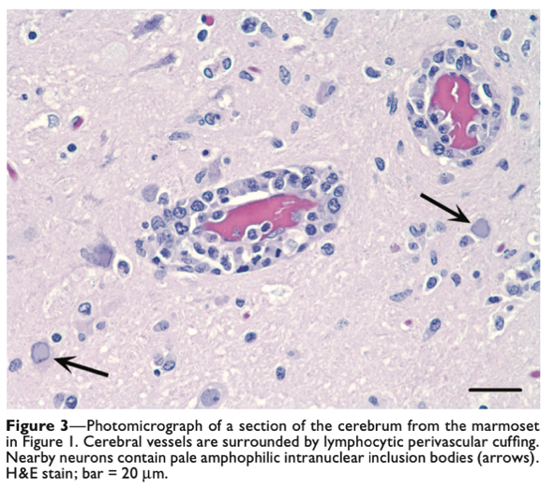
- Erythematous, raised lesions on the face, as well as 1-2mm wide vesicles on caudodorsal tongue
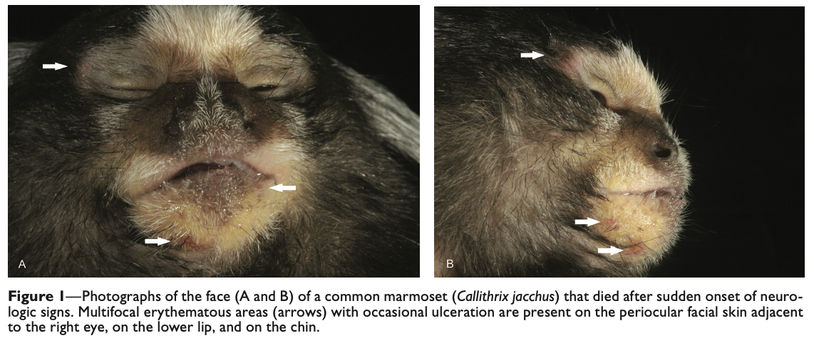
- Acute, moderate multifocal vesiculoulcerative glossitis
- Subacute, moderate multifocal lymphoplasmacytic meningoencephalitis
- Fresh frozen: PCR for Human herpesvirus-1: POSITIVE
Take Home Points: Several primate alphaherpesviruses exist that cross interspecies barriers, mild disease in natural hosts but fatal encephalitis in nonnatural hosts
- Also of note is Cercopithecine Macacine herpesvirus 1/Herpes B virus
- Additional DDx: trauma, toxoplasmosis, rabies virus infection, and neoplasia
- Pet marmosets are at high risk: kissing, sharing food, feeding from the mouth. Humans can be asymptomatic/latent
  - $α$-herpesviruses can infect a wide range of animal species and different cells (neurons, epithelial cells)
  - $β$-herpesviruses can infect different cells within the same animal species
  - $γ$-herpesviruses are the most species and cell specific

Journal of Zoo and Wildlife Medicine 51(4): 780–788, 2020

LEPTOSPIRA SPECIES STATUS OF CAPTIVE NONHUMAN PRIMATES AND FREE-RANGING RODENTS AT THE BARRANQUILLA ZOO, COLOMBIA, 2013
Danielle Woolf, DVM, Carlos Sanchez, DVM, MSc, Viviana Gonzalez-Astudillo, BVSc, MNR, PhD, Mauricio Navarro, DVM, MSc, PhD, Cristian Camilo Tapia, DVM, Mo ́nica Franco, DVM, Javier Andre ́s Bustamante, MS, Miryam Astudillo, MS, and Jean Mukherjee, DVM, Dipl, ACVM, PhD

Abstract: Leptospirosis is a zoonotic disease with worldwide distribution caused by pathogenic Leptospira spp. Pathogenic Leptospira spp. are shed in urine of infected hosts and transmitted via ingestion of contaminated food or water, inoculation, inhalation of aerosolized urine, and absorption through mucous membranes. Leptospirosis is of particular concern in tropical and subtropical regions such as Barranquilla, Colombia. Recent reports indicate that in Barranquilla, rodents, dogs, and humans have a high leptospiral seroprevalence; and amongst zoo mammals, nonhuman primates have a high prevalence of Leptospira spp. infection. We therefore sought to determine whether primates in captivity at the Barranquilla Zoo were exposed to Leptospira spp. and whether there was a probable causal transmission link between the primates and peridomestic rodents. Samples were collected from 29 captive nonhuman primates, 15 free-ranging rats (Rattus rattus), and 10 free- ranging squirrels (Sciurus granatensis). Serum samples from primates, rats, and squirrels were evaluated via microagglutination test (MAT) vs 24 reference Leptospira serovars. Blood and urine from the primates and kidney tissue from the rats and squirrels were cultured in Ellinghausen-McCullough-Johnson-Harris (EMJH) medium and polymerase chain reaction (PCR) of lipL32 was performed to determine whether active infection was present. Leptospiral seroprevalence was found to be 66.7% (10/15) in rats, 60% (6/10) in squirrels, and 6.9% (2/29) in neotropical primates. Ateles hybridus and Ateles fusciceps had positive titers to serogroups Cynopteri and Ictohaemorrhagiae, respectively. Of the rodents that had antibodies against Leptospira spp., 90% of the rats and 66.7% of the squirrels corresponded to the serovar australis. Interestingly, all animals were culture and PCR negative, indicating Leptospira spp. exposure in the absence of current infection. While their status as maintenance hosts needs to be investigated further, this is the first study to show leptospiral seropositivity in red-tailed squirrels (S. granatensis).
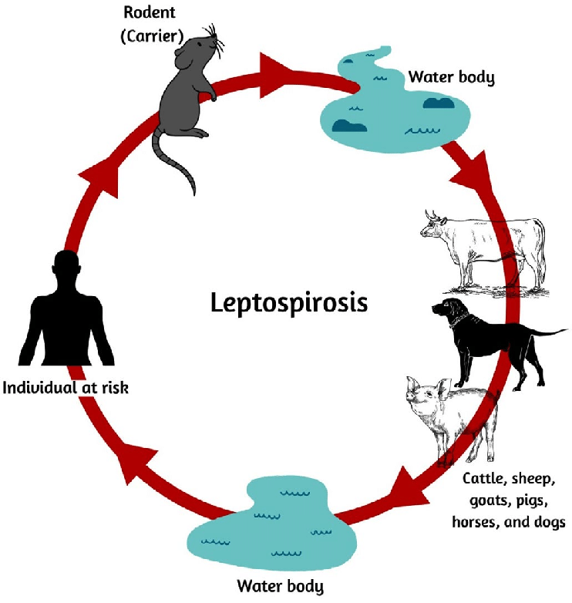
- Flu-like symptoms and jaundice in humans → liver and/or kidney failure
- Local prevalence of human and dog cases, and high prevalence of both rats and squirrels on grounds
- Capuchins, spider monkeys, woolly monkeys evaluated
- Serum samples tested for 24 Leptospiral antigens, blood and urine cultured in specialized media
- DNA extraction and PCR ID of kidney tissue from rats/squirrels
- Serum samples from 29 captive nonhuman primates, 15 black rats, and 10 red-tailed squirrels was examined via the MAT for presence of antibodies against viable Leptospira spp. antigen. A seroprevalence of 6.9%, 66.7%, and 60.0% was observed in captive nonhuman primates, black rats, and red-tailed squirrels, respectively
  - Seropositivity was defined for captive nonhuman primates and rodents, when at least 50% of the leptospires agglutinated at titers of >1 : 100 or >1 : 40, respectively
- Seroprevalence had no association to sex or age
- No statistically significant relationship between seropositivity and drinking water source was observed
Take Home Points
- Rodents on zoo grounds can be a vector of infectious disease, and with zoonotic diseases, create an occupational health risk
- Despite this, the study identified a relatively low seroprevalence compared to previous studies: 24.6-87.5%
- The two seropositive individuals were routinely given untreated well water, whereas other water was treated, despite the lack of statistical significance.
  - High importance preventative measures: vaccination; frequent cleaning; provision of elevated resting platforms; use of impermeable floor surfaces; proper drainage to limit standing water; providing food and water in elevated containers that are regularly cleaned; and provision of water from a treated source
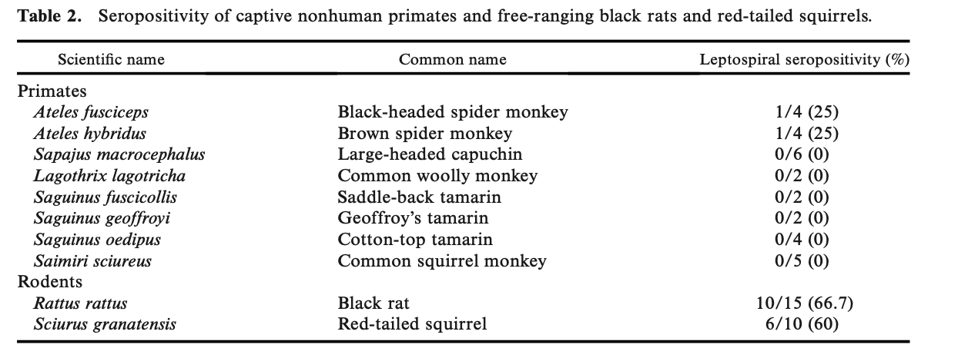

Sriningsih, Agnes P., et al. "Evaluating the efficacy of human bronchiectasis based antibiotic therapy in the treatment of orangutan respiratory disease syndrome." Journal of Zoo and Wildlife Medicine 52.4 (2021): 1205-1216. Reviewed by HSS
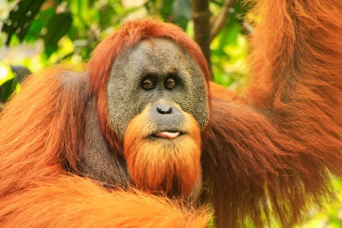
Abstract
Unique among apes, orangutans (Pongo spp.) develop a chronic respiratory disease called orangutan respiratory disease syndrome (ORDS). The authors define ORDS as intermittent bacterial infection and chronic inflammation of any region or combination of regions of the respiratory tract, including the sinuses, air sacs, cranial bones, airways, and lung parenchyma. Infection in any of these areas can present acutely but then becomes recurrent, chronic, progressive, and ultimately fatal. The closest model to this disease is cystic fibrosis (CF) in people. We hypothesized that use of a 4–8-wk course of combined oral antibiotics used in the treatment of bronchiectasis in CF patients would lead to prolonged symptomatic and computed tomography (CT) scan improvement in orangutans experiencing early signs of ORDS. Nine adult Bornean orangutans (Pongo pygmaeus, eight males, one female, 18–29 yr of age) diagnosed with early ORDS-like respiratory disease underwent CT scan before initiation of treatment. Each animal received a combined course of azithromycin (400 mg 3/wk, mean 7 mg/kg) and levofloxacin (500 mg PO q24h, mean 8.75 mg/kg) for a period of 4–8 wk. CT scan was repeated 6–14 mon after completion of antibiotic treatment. Pretreatment CT showed that six of nine animals had lower respiratory pathology (airway disease, pneumonia, or both). All six orangutans had concurrent sinusitis, mastoiditis, airsacculitis, or a combination of these conditions. Upper respiratory disease alone was observed in three animals. CT showed improvement or resolution in four of five sinusitis cases, improvement in one of two instances of mastoiditis, resolution in five of six instances of airsacculitis, improvement or resolution in six of six instance of lower airway disease (P = 0.03, 95% CI 0.54–1.0], and resolution in five of five cases of pneumonia. Resolution of pretreatment clinical signs was observed in all nine animals. Two developed signs not present at pretreatment. These results show that combination antibiotic therapy with azithromycin and levofloxacin provides improvement in clinical signs and CT evidence of ORDS-related pathology, resulting in symptom-free status in some animals for up to 33 mon.

Key Points:
- Respiratory illness = leading COD in juvenile/adolescent orangutans in NA zoos, equal to contributor to mortality as cardiac disease in adults
- ORDS consists of bacterial infection and chronic inflammation of any region or combination of regions of the respiratory tract. Infection in any of these areas can present acutely but then become recurrent, chronic, and progressive chronic sinusitis, mastoiditis, airsacculitis, pneumonia, and bronchiectasis. The irreversible changes to the respiratory architecture lead to death by a number of means, including loss of pulmonary function, sepsis, bacterial meningitis from boney destruction of the mastoid process, and other conditions.
- Dx typically based on Cx, respiratory culture, radiographs, and blood work. Tx typically includes surgical drainage of the air sac and antibiotics on the basis of sensitivity testing for airsacculitis, antihistamines for nasal discharge (with antibiotics if sinus infection is suspected), and longer term antibiotics with adjunctive therapy for pneumonia.
- Closet model = CF in people, mutation in CFTR gene thick respiratory mucus chronic infection/inflammation (both ORDS and CF have high prevalence of sinusitis, bronchiectasis, and prevalence gram-negative rods)
- Treatment guidelines for the treatment of acute exacerbations of infection in CF and non-CF bronchiectasis include prolonged combination antibiotic therapy directed at gram-negative bacteria
  - Azithromycin: macrolide antibiotic, anti-inflammatory properties
  - Levofloxacin: fluoroquinolone with good efficacy against Pseudomonas aeruginosa and other gram-negatives commonly isolated from people with CF/orangutans with ORDS. P. aeruginosa associated with decreased QoL, more severe disease, and greater M&M
- All nine orangutans had 1-3 Cx of respiratory disease before treatment, including nasal discharge (n=4), pendulous air sac or air sac pus (n = 7), coughing (n = 3), loss of body condition (n = 2), halitosis (n = 1), audible breathing sounds (n = 1), and heavy breathing (n = 1). All of the observed pretreatment Cx resolved post-treatment. Two animals developed new Cx, with one showing an episode of open-mouth breathing and one developing a pendulous air sac and anorexia within the 2-mon period before the follow-up CT scan
- Pretreatment CT findings included sinusitis (n= 5), mastoiditis (n = 2), airsacculitis (n = 6), airway disease (n = 6), and pneumonia (n = 5). 7/9 animals had pathology in multiple regions.
- Post-treatment CT scans showed improvement in 5/6 incidences of airsacculitis and full resolution in one. Sinusitis improved or resolved in 4/5 cases. Of the two pretreatment mastoiditis cases, one showed improvement, and the other remained unchanged. Additionally, one orangutan developed mastoiditis and one developed sinusitis on post-treatment CT. All cases of lower airway disease and pneumonia showed improvement or resolution. Of the six orangutans with airway wall thickening pretreatment, four resolved and two improved (P = 0.03, 95% CI 0.54–1.0). Post-treatment, 4/5 cases of pneumonia were resolved, and one improved
  - 2/2 animals diagnosed with mild bronchiectasis pretreatment were negative for bronchiectasis post-treatment, supporting the idea that mild bronchiectasis may be reversible with intervention in the mild stage.
- 0/5 animals for which this study was their first episode experienced recurrence during the multiyear post-treatment observation period. However, 3/4 animals with prior disease had recurrence of Cx warranting treatment. One animal had exacerbations at months 1 and 38. The other two animals experienced exacerbation at months 16 and 19, respectively. The mean time to recurrence was 12.1 mon
- Culture and PCR testing for Mycobacterium spp. from pre and post-treatment bronchial wash samples were negative for all animals. The most identified microorganisms from bronchoalveolar lavage or air sac purulence were gram-negative rods, including Klebsiella pneumoniae, Proteus mirabilis, and Pseudomonas sp. Other isolates included Morganella morganii, Enterobacter cloacae, and Aeromonas hydrophila.
- Culture of the respiratory tract is recommended during every orangutan health evaluation. Monitoring respiratory flora during periods of health vs. disease will help direct antibiotic selection

Take-Home Message:
- Combination antibiotic therapy with azithromycin and levofloxacin provides improvement in clinical signs and CT evidence of ORDS-related pathology in 9/9 orangutans, resulting in symptom-free status in some animals for up to 33 mon.

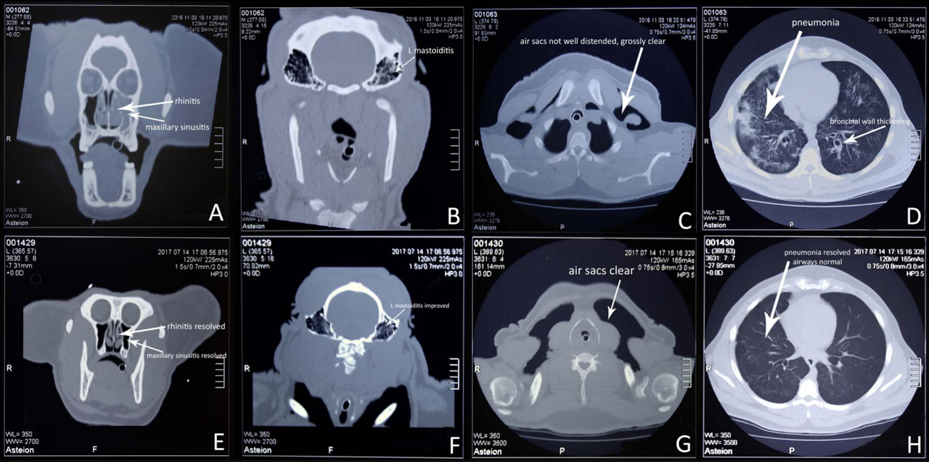
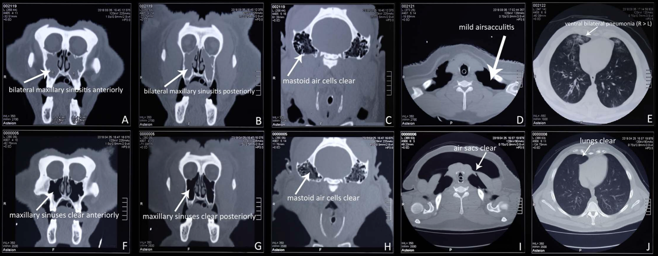

Epstein, Jenna, et al. "Global retrospective analysis of pathological findings in zoo-managed Goeldi's monkeys (Callimico goeldii), 1965–2018." Journal of Zoo and Wildlife Medicine 53.2 (2022): 339-348. Reviewed by HSS

Abstract:
As part of the collaborative efforts and goals of managing zoo-housed Goeldi's monkeys, or callimicos (Callimico goeldii), a retrospective review of gross and histopathological postmortem examination reports submitted to the International Studbook Coordinator was carried out by veterinary representatives of the Species Survival Plan to investigate disease trends. A total of 1,887 postmortem reports (1965–2018) collected from more than 150 institutions were reviewed. Histologic findings from 862 postmortem reports and primary causes of mortality were compiled to determine the most common findings. Within the study population, 419 individuals (48.6%) were male, 383 (44.4%) female, and the remaining 60 (7%) of undetermined sex. The primary lesion at death in adults was chronic renal disease. The other prevalent lesions included cardiac disease, myelolipomas, enteritis, colitis, and hepatitis. In Great Britain and mainland Europe, Yersinia spp. infection had significantly higher prevalence than in North American callimico populations. Multiple lesions affecting more than one organ system were identified in many animals of this study population. Results also showed that for adult callimicos in zoological institutions in North America, Europe, and Great Britain, life span has been increasing over the last 50 yr.

Key Points:
- The Goeldi's monkey or callimico (Callimico goeldii) is a New World primate in the family Callitrichidae.
- Renal disease is the most prevalent and important disease in callimicos >1 yr of age. Renal disease was most common Dx across NA, GB, and mainland Europe from 1980s through 2010s
  - More common in males & NA, but all populations affected
- Male callimicos ≥1 yr of age are significantly predisposed to developing renal disease, cardiac disease, and hepatitis
- Females ≥1 yr of age are significantly predisposed to developing myelolipomas, neoplasia, dystocia, and metritis
  - Myelolipomas most common in liver; also seen in spleen and adrenal gland
- Callimicos ≥9 yr old have a significantly higher prevalence of renal disease (including nephritis and glomerulonephritis), myelolipomas, neoplasia, and cardiac disease
- Callimicos 1–4 yr of age have a significantly higher prevalence of Yersinia spp. infection, trauma, and, for females, dystocia.
- In the 5–8 yr of age group, dystocia had the highest prevalence of all age classes in female callimicos. The prevalence of renal disease (including nephritis and glomerulonephritis), myelolipomas, neoplasia, and cardiac disease in callimicos between 5 and 8 yr was lower than the ≥9 yr of age group, but higher than the 1–4 yr of age group
- Infection, pneumonia, and trauma common in neonate (24 h to 30 d) and infant (>30 d to <1 yr of age) callimicos
- Adult callimicos (≥1 yr old) from North America are significantly predisposed to developing enteritis, colitis, peritonitis, renal disease (including nephritis and glomerulonephritis), myelolipomas, and cardiac disease, compared with adult callimicos in Great Britain, which are significantly predisposed to developing Yersinia spp. infections
- Prevalence of hepatitis, colitis, parasitic infections, and renal disease increased over time
- Yersinia spp. infection was 24.8 times more likely to be detected in GB and 7.8 times more likely in mainland Europe than NA (endemic to European countries)
- The mean age at death for adults >1 yr old under managed care in NA, mainland Europe, and GB increased over each decade evaluated. The mean life span for animals that died in the 1970s was <2–2.7 yr (1,000 d) and is currently (2010–2018) just under 9–9.5 yr (3,500 d)

Take-Home Message:
- Renal disease is the most common and important disease in callimicos >1 yr of age. The other prevalent lesions included cardiac disease, myelolipomas, enteritis, colitis, and hepatitis. A substantial prevalence of Yersinia spp. infections in Great Britain followed by mainland Europe was documented. The life span of callimicos has been increasing for adults in NA, Europe, and GB over the last 50 yr.

Genomic characterization of MDR extended spectrum beta lactamase producing e coli and klebsiella pneumoniae from chimps from wild and sanctuary locations in uganda. JWD 58.2 2022. Bager SL, Kakaala I, Kudirkiene E, Byarugaba DK, Olsen JE. review by LMumm

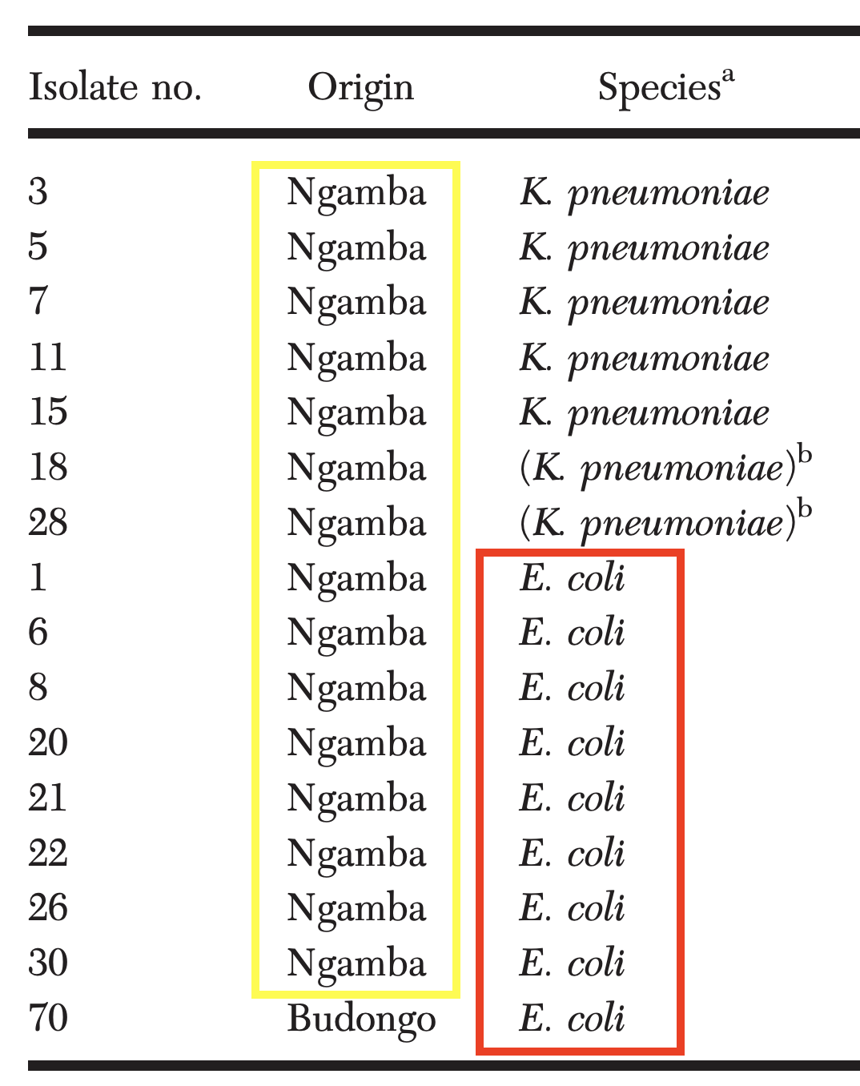
Abstract: Farm and wild animals may serve as reservoirs of antimicrobial-resistant bacteria of human health relevance. We investigated the occurrence and genomic characteristics of extended spectrum β-lactamase (ESBL)-producing bacteria in Ugandan chimpanzees (Pan troglodytes) residing in two environments with or without close contact to humans. The ESBL-producing Escherichia coli and Klebsiella pneumoniae were isolated from fecal material of chimpanzees from Budongo Forest and Ngamba Island Chimpanzee Sanctuary in Uganda and were more commonly isolated from chimpanzees in Ngamba Island Chimpanzee Sanctuary, where animals have close contact with humans. Selected ESBL isolates (E. coli n=9, K. pneumoniae n=7) were analyzed by whole-genome sequencing to determine the presence of resistance genes, as well as sequence type and virulence potential; the blaCTX-M-15 gene was present in all strains. Additionally, the ESBL genes blaSHV-11 and blaSHV-12 were found in strains in the study. All strains were found to be multidrug resistant. The E. coli strains belonged to four sequence types (ST2852, ST215, ST405, and ST315) and the K. pneumoniae strains to two sequence types (ST1540 and ST597). Virulence genes did not indicate that strains were of common E. coli pathotype, but strains with the same sequence types as isolated in the current study have previously been reported from clinical cases in Africa. The findings indicate that chimpanzees in close contact with humans may carry ESBL bacteria at higher frequency than those in the wild, indicating a potential anthropogenic transmission.

Background:
- ESBL (extended spectrum beta-lactamases) producing bacteria = confer resistance towards cephalosporins, monobactams, but not carbapenems or cephamycins
  - Often found in Enterobacter family; E. coli = primary ESBL-carrying pathogen
  - Most clinically relevant ESBLs: CTX-M, TEM, SHV
  - Identified in healthy populations of migratory birds/rodents suggesting carriers and dissemination of ESBL genes

Methods: determine occurrence ESBLs in chimps in sanctuaries (human care) and wild (reserves) via collected fecal samples (n=86) → culture, disk diffusion for sensitivity, whole genome sequencing

Key Points:
- 18/86 fecal samples harbored isolates with ESBL genes; E. coli > K. pneumoniae
  - Isolated more frequently from chimps in close contact with humans!
    - 17 from Ngamba sanctuary, only 1 from wild
- K. pneumoniae (n=7): 24 different antibiotic resistant genes from two sequence types, with resistance to 9 antibiotic classes
- E. coli (n=11): 20 different antibiotic resistant genes from four sequence types, with resistance to 7 antibiotic classes
- Gene “blaCTX-M-15” most commonly identified and detected in ALL strains
  - Historically identified as most common ESBL gene in world
  - Referred to as CTX-M pandemic; public health concern due to high antibiotic resistance
- All ESBL strains identified were multidrug resistant
- Fecal-oral transmission of E. coli and K. pneumoniae between humans/animals; likely indirect
  - Human pathogen transmission known as threat to wild chimp population during reintroductions and antimicrobial-resistance bacteria may also be transmitted
- Strict hygiene guidelines in chimp sanctuaries are recommended to limit spread of ESBL bacteria

MEDICAL–SURGICAL MANAGEMENT OF INTESTINAL INFECTION BY PROSTHENORCHIS ELEGANS IN NONHUMAN PRIMATES FROM COSTA RICA. JZWM 54.4 2024. Rojas-Sánchez E, Vega-Benavides K, Jiménez-Rocha AE, Rodriguez-Dorado E, Jimenez-Soto M. - review by LMumm

Abstract: Parasitism is one of the most important diseases in nonhuman primates (NHP). Parasitism by Prosthenorchis elegans can be a threat to health and conservation of NHP in Costa Rica. Surgical management of intestinal acanthocephalan infection in two squirrel monkeys (Saimiri oerstedii) and one white-faced monkey (Cebus imitator) is described as an alternative to the lack of pharmacologic control options when there is a high burden of parasites present. A complete physical evaluation, including medical ultrasound techniques, allow for diagnosis of the parasite and its lesions. When animals present with a high burden of parasites, surgical management has shown to promote good health outcomes and increase the probability of survival.
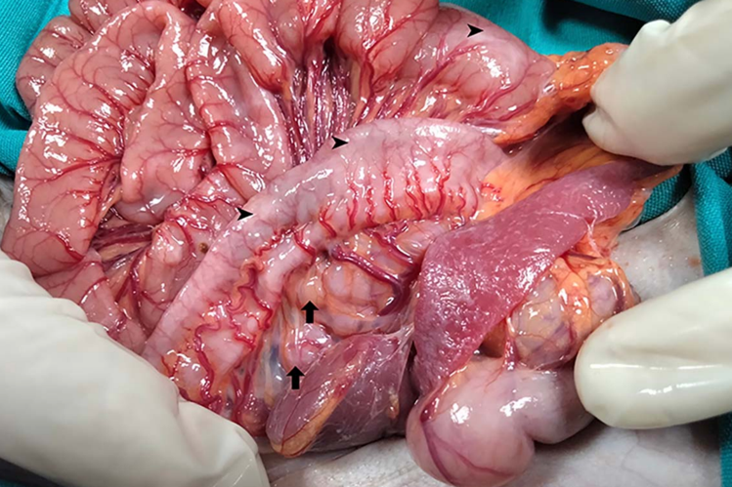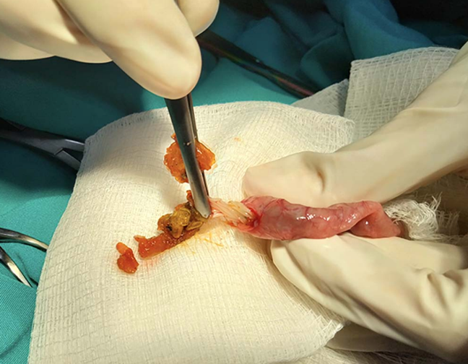

Cases (n=3): surgical management of acanthocephalan infection in managed care squirrel monkeys
- Initially evaluated for depression, progressive weight loss
  - Hx of 2 deaths from similar symptoms → intestinal perfs from P. elegans on necropsy
- No improvement despite ivermectin, prazi, pyrantel and febantel treatments
- PE: low BCS, palpable nodular structures in abdomen, parasites visible grossly in feces
- CBC: one animal had anemia, hypoalbuminemia
- Rads: NSF
- AUS: mesenteric lymphadenomegaly, nodules in intestine walls, lack of distinct intestinal layers
- Exploratory lap: marked lymphadenopathy of mesenteric LN, nodules of distal ileum and cecum, no other macroscopic organ lesions
  - Enterotomy: intestinal parasites attached to intestinal mucosa removed → P. elegans
  - Biopsy of mesenteric nodes and LN → lymphoplasmacytic and pyogranulomatous inflammation of intestine with parasite eggs in mucosa, eosinophilic inflammation of LN
- Gained weight within 3 weeks post-op, hypoalbuminemia resolved in affected animal
- No other clinical concerns for 1+ year

Key Points:
- Prosthenorchis elegans = highly pathogenic acanthocephalan of neotropical primates, one of the main causes of mortality under managed care
  - Intermediate hosts: cockroaches, beetles
  - Eggs require molecular ID; indistinguishable from other acanthocephalans on fecal
  - Clinical signs warrant PE/palpation, bloodwork, AUS to eval for parasites/lesions
  - Fixation of parasites in intestine can cause → perforation, peritonitis
  - Medical management/antiparasitics often ineffective
  - Surgery viable but only removes adults and reinfection is common

