McLelland DJ. Macropod Progressive Periodontal Disease (Lumpy Jaw). In: Miller RE, Fowler ME (eds.). Zoo and wild animal medicine, Volume 10, Current therapy. St. Louis (MO): Elsevier; 2022. p. 709-13.
Summarized by MR
- Polymicrobial disease associated with predominantly anaerobic opportunistic bacterial infection of the soft tissues and bony structures supporting the teeth, including gingivitis, periodontitis, and mandibular/maxillary osteomyelitis.
  - Fusobacterium necrophorum and Bacteroides spp. – transmitted thru oral secretions, feces
  - Significant cause of M&M in macropods under human care
- The prevalence of MPPD increases with age and is progressive in animals that have previously had episodes of the disease. Dental trauma, especially to the incisors, is possibly a contributing factor in some cases.
- Stressors that have been associated with MPPD include
  - cold and wet weather, inadequate shelter, high stocking density
  - conspecific aggression
  - inappropriate contact with zoo visitors
  - confinement, vehicle noise, and moves between enclosures or institutions.
- Effects of overcrowding and environmental changes (drought):
  - No MPPD was documented in 121 skulls of culled western grey kangaroos in Western Australia.
  - Deceased eastern grey kangaroos in Victoria had a relatively high (54%) prevalence of advanced MPPD where there is high pop. density and drought
Pathogenesis
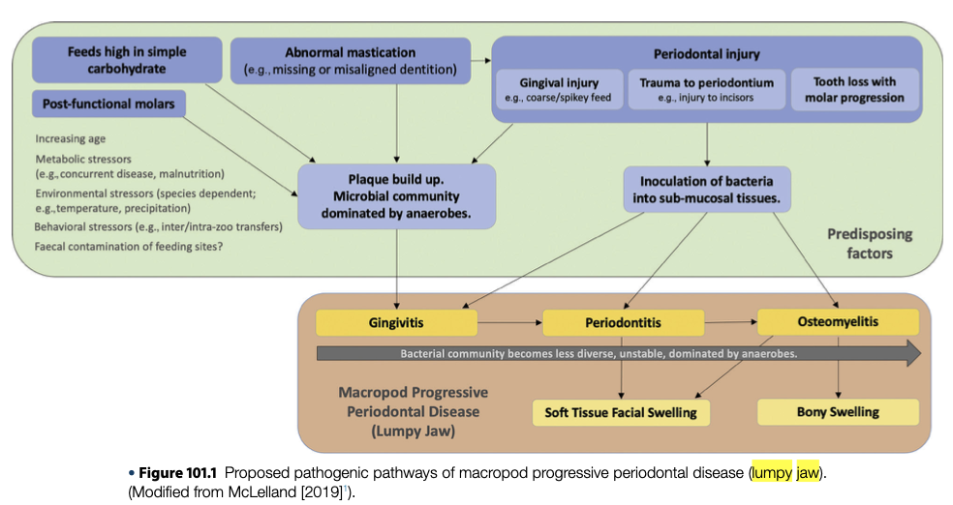

Diagnostics
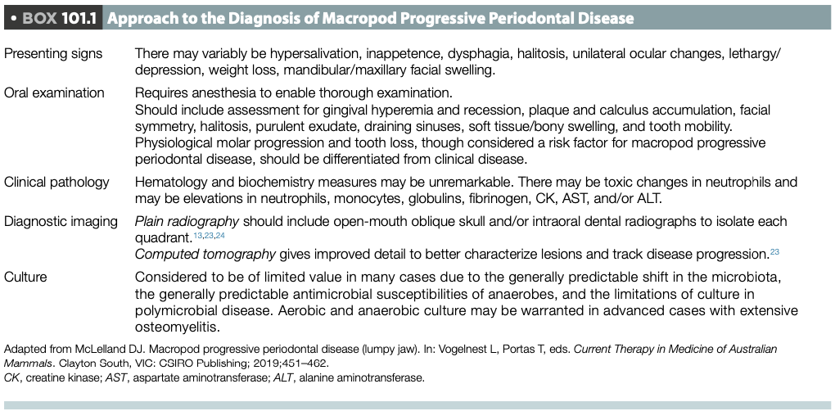

Treatments
- Treatment options have not been evaluated in controlled clinical trials (case reports, anecdotal experience)
  - One study reported that antibiosis alone was unsuccessful, and that removal of affected teeth was required to achieve resolution of lesions
  - Several vaccines have been trialed unsuccessfully
  - Oral prebiotics and probiotics have not been investigated in macropods but theoretically could be beneficial for the treatment and prevention of MPPD

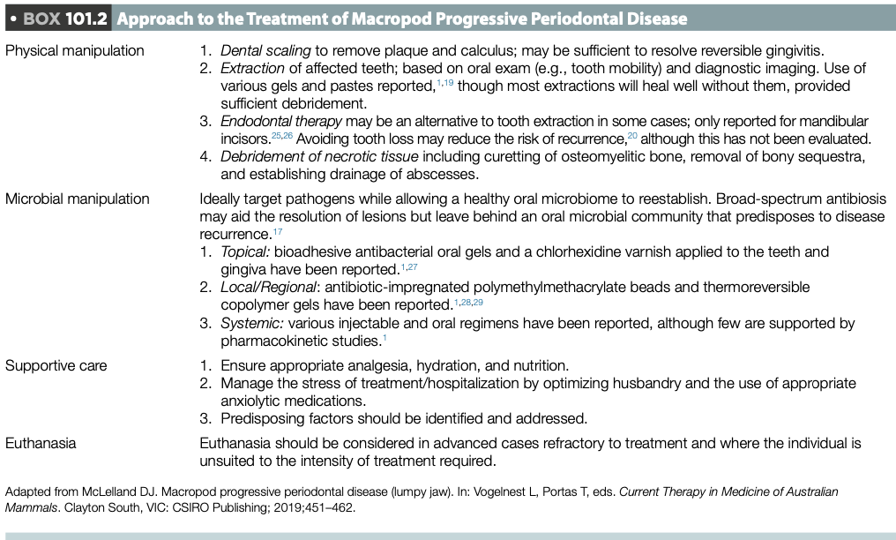
Journal of Zoo and Wildlife Medicine 53(2): 470–479, 2022

HYPERLIPIDEMIA AND XANTHOMATOSIS IN YELLOW-FOOTED ROCK WALLABIES (PETROGALE XANTHOPUS) UNDER MANAGED CARE.
Rachel L. Ferris, DVM, Samantha Darling, DVM, DACVP, Patricia A. Pesavento, DVM, PhD, DACVP, Geoffrey R. Browning, MS, DVM, DACZM, and Jenessa Gjeltema, DVM, DACZM
Summarized by MR

Abstract: Xanthomas are localized lipid deposits in organs with associated granulomatous inflammation. Xanthomatosis is a rare condition in both human and veterinary medicine and is often linked to inherited or acquired dyslipidemias. Three female yellow-footed rock wallabies (Petrogale xanthopus) at a single institution were diagnosed via biopsy with cutaneous xanthomas secondary to hypertriglyceridemia and hypercholesterol- emia, and an additional two female yellow-footed rock wallabies were diagnosed with xanthomas at a second institution. All cases presented with cutaneous masses at the haired skin and paw pad junctions of the extremities, and/or mucocutaneous junctions of the face or urogenital tract. The clinically affected individuals were over-conditioned or obese, had lipemic serum, and had elevations in blood cholesterol and triglyceride levels. When full lipid panels were performed, inverse high- and low-density lipoprotein fractions were observed. Six other individuals at the first institution had identical husbandry but were of more appropriate body condition, were normolipidemic, and had no xanthomas. One of the affected animals was also concurrently diagnosed with hepatic lipidosis via liver biopsy. Pedigree review and evaluation for underlying endocrine diseases such as hypothyroidism were performed. Because all affected animals were found to be related, a genetic predisposition is possible but requires further investigation. Consideration for the predisposition of some individuals for obesity, hyperlipidemia, and subsequent xanthoma formation should be factored in the husbandry and medical management of this species.

Key points:
- Four major classes of lipoproteins exist: chylomicrons, very low-density lipoproteins (VLDL), low-density lipoproteins (LDL), and high-density lipoproteins (HDL).
- Chylomicrons and VLDL are the components of serum triglycerides, and HDL and LDL mainly contain cholesterol.
- Chylomicrons are formed by enterocytes to transport exogenous dietary lipids, whereas VLDL, LDL, and HDL are formed during the metabolism of endogenously produced lipids
- Dyslipidemias → extravasation of lipids thru vessel walls into interstitium → taken up my macrophages → cutaneous xanthomas (extracutaneous disease documented)
- N = 5 young adult female individuals, overlapping features across two institutions:
  - ~20 – 35% weight gain since previous exam
  - During the course of the case series there was significant dietary modifications
    - provision of unlimited grass hay and removal of alfalfa
    - switch from Mazuri macropod pellet to wild herbivore pellet, decreasing pellet amount or complete removal of pellets
    - limit to provided produce
  - Possible genetic relationship?
  - “Pink fleshy masses near paws” “Smooth, raised pink dermal masses” “white – tan masses”
    - Bloodwork: hypercholesterolemia, hypertriglyceridemia, elevated ALT, GGT, t-bili
      - Grossly lipemic serum
      - Full lipid panels: inverse HDL:LDL ratio
    - Biopsies (some punch, some excisional):
      - inflammation and acellular material suggestive of amyloidosis or cholesterol clefts, no diagnosis made at that time
      - band of dermal collagen subtended by a mass of adipocytes, surrounded and separated by aggregates of wispy to stippled, amphophilic to basophilic, acellular material. Rare to small numbers of macrophages. Often contained the phagocytized material or abundant small, clear, well-defined vacuoles. Rare lymphocytes were scattered throughout. These findings were consistent with a xanthoma.
    - Necropsy:
      - Various dermal/epidermal masses around face and paws
      - Tracheal submucosal xanthoma, no other visceral organs affected
  - N = 1 hepatic lipidosis diagnosed on liver biopsy
  - Overgrooming and self-mutilation as QOL concerns

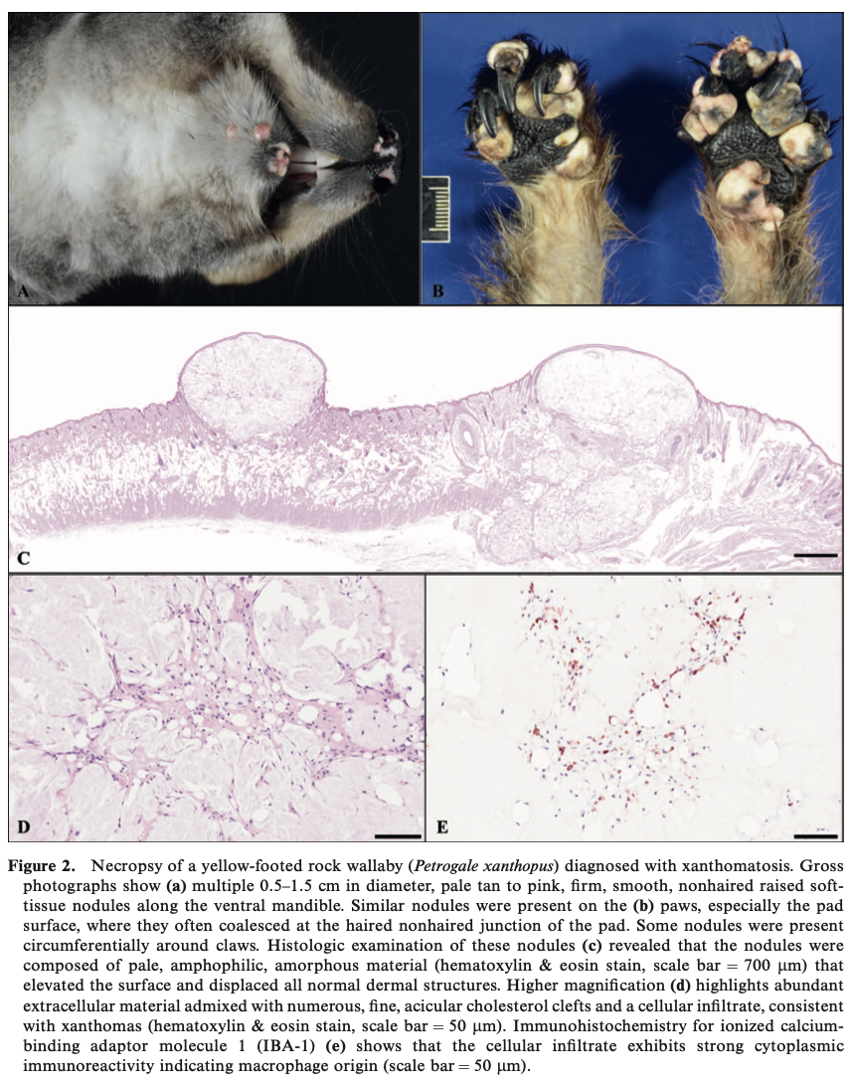

Journal of Zoo and Wildlife Medicine, 54(3): 511-519, 2023.
A RETROSPECTIVE ANALYSIS OF MORBIDITY AND MORTALITY IN THE CAPTIVE LEADBEATER'S POSSUM (GYMNOBELIDEUS LEADBEATERI) POPULATION FROM 1970 TO 2021 - reviewed by HSS
Chloe Steventon, Leanne Wicker, Alistair R. Legione, Joanne M. Devlin, Dan Harley, Elizabeth Dobson
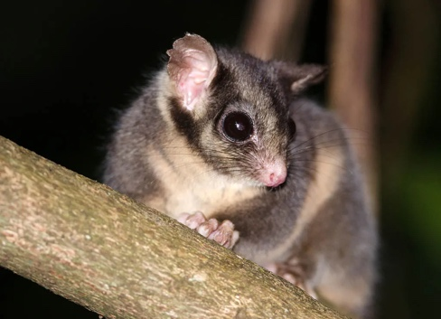
Abstract:
The Leadbeater's possum (Gymnobelideus leadbeateri) is a critically endangered nocturnal marsupial with a restricted range in the Central Highlands of Victoria, Australia. There are two genetically distinct populations divided by location: highland and lowland. Lowland possums exist in one remnant swamp forest and entered captivity in 2012 when ∼60 individuals remained. Today, with less than 20 lowland individuals remaining, any information that informs the yet-unsuccessful breeding program is critical. This study encompasses a retrospective analysis of the causes of mortality and significant histological lesions in captive highland and lowland individuals across seven institutions internationally from 1970 to 2021. During this time, 245 possums lived in captivity. Postmortem records exist for 99 animals, including 349 histopathology diagnoses from 80 reports and 264 gross necropsy diagnoses from 78 reports. Diagnoses were assigned into two categories based on the importance to the individual (causing death or morbidity to a single animal [n = 194]), or importance to the wider population (causing death or morbidity to more than one animal or was related to reproduction [n = 155]). Individual animals had multiple diagnoses, which were tallied as individual data points. Renal disease was diagnosed 57 times; the most common finding was chronic nephropathy (43/57). Cardiovascular disease was diagnosed 33 times; atherosclerosis associated with obesity was common (n = 10/33). Both categories suggest causal association with captive husbandry but elicit no comment on the lack of success of the breeding program. Reproductive disease was diagnosed 36 times in 24 animals (14 females and 10 males). In females, 11 cases of uterine inflammation and associated clinical signs were associated with ascending infection or neoplasia. Of the seven lowland male possums with mortality data, five were infertile (azoospermia or testicular atrophy). More investigation into the reproductive health of this population is indicated to understand the lack of success in the current breeding program.

Key Points:
- Fewer than 20 lowland individuals remain in the wild and captivity. The current cohort of Leadbeater's possums in captivity are all wild born. Captive breeding has not been successful.
- Highland possums were purposefully collected for the captive breeding program that has pivoted to a focus on genetic rescue, pairing highland and lowland possums together as part of wider translocation efforts
- The most common body system assigned a diagnosis was renal (n = 57, 51 animals), followed by reproductive (n = 36, 24 animals, F =14, M = 10) and cardiovascular (n = 33, 27 animals).
- Renal
  - The most common renal diagnosis was chronic nephropathy (43/51 individuals). Chronic nephropathies included interstitial nephritis, membranous change to glomeruli, degeneration and loss of tubules, interstitial fibrosis, and mixed interstitial inflammation
  - A single case of acute renal tubular necrosis was attributed to an iatrogenic aminoglycoside toxicity. Lower urinary tract obstruction (n = 4) was seen exclusively in lowland adult male animals
- Reproductive
  - Reproductive disease included bacterial infections, lower urinary tract obstruction, and male infertility.
  - Varied in females. Metritis was common, and in 7 cases it occurred concurrently with endometrial hyperplasia or ovarian cysts or both.
  - Seven male lowland animals had testicular atrophy and/or very low/absent sperm production on histopathology and/or gross pathology
- Cardiac
  - The most common diagnosis was cardiac necrosis and cardiomyopathy. Two cases of cardiac necrosis and one of epicarditis were associated with septicemia. The third most common findings of arteriosclerosis and atherosclerosis were observed more often in older animals
    - Obesity is common in the captive population

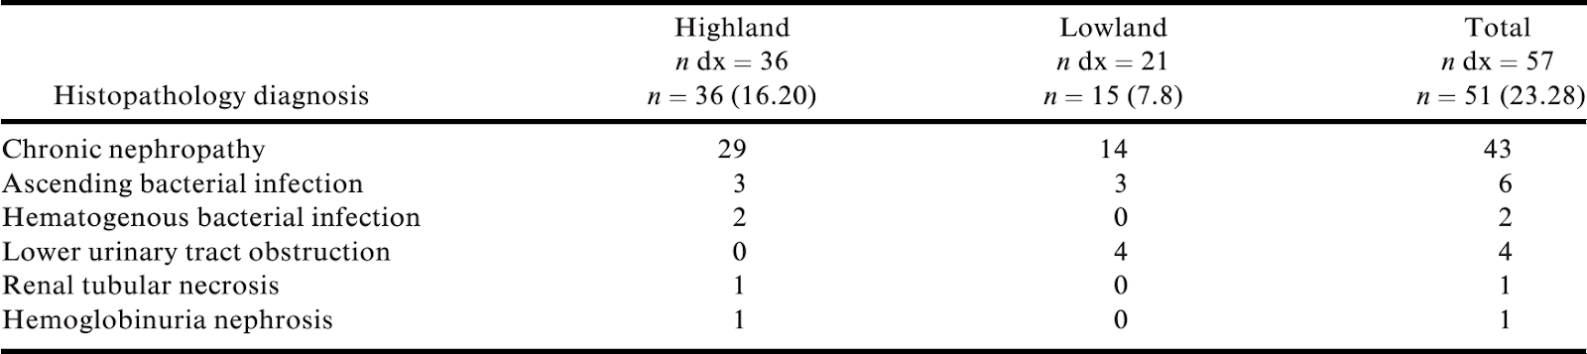
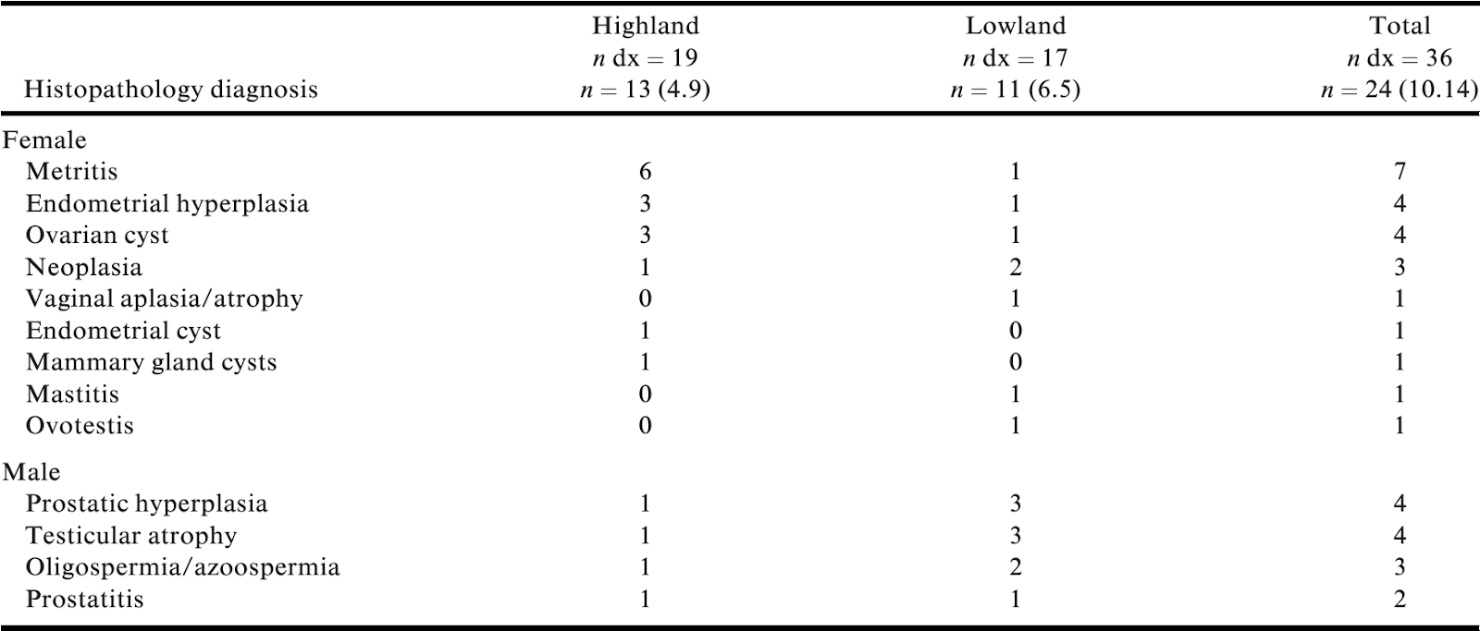
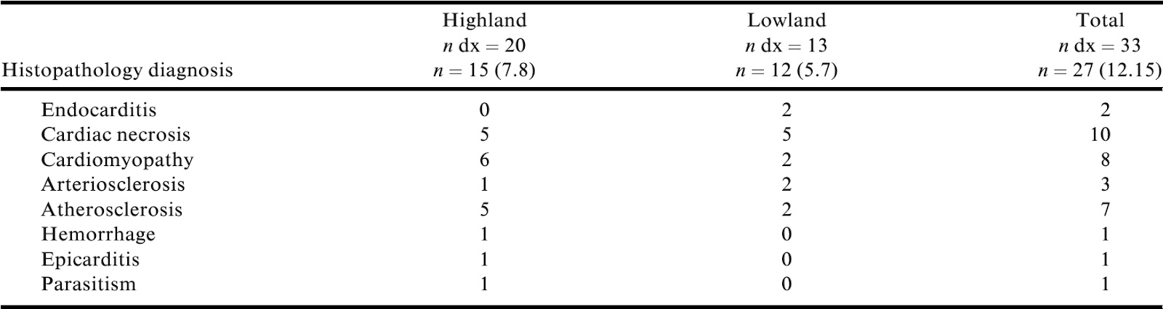

Take-Home Message:
- There is a species predilection towards chronic renal pathology, captive animals prone to obesity are vulnerable to cardiovascular disease, and more prospective research is needed into reproductive health, especially in males in this species if the breeding program is to succeed.

Chapter 69, Tasmanian Devil Facial Tumor Disease, Fowler 9 - reviewed by HSS
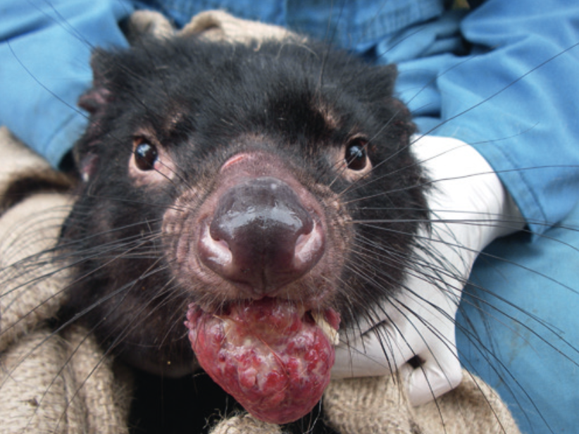
- Largest extant marsupial carnivore
- Populations have declined by 95% in some areas following emergence of infectious cancer, devil facial tumor disease (DFTD), in 1996. A second clonal infectious cancer has been described, DFT2
- Signs and Symptoms
  - Large, solid, soft tissue masses that ulcerate, first appearing on head/neck regions
  - Histopathology: subepithelial expansile masses of round spindloid cells with abundant eosinophilic cytoplasm encased in a pseudocapsule
    - DFFT2 – sheets of pleomorphic cells in a solid pattern
    - Periaxin is an immunohistochemical that is diagnostic for DFT1, absent in DFT2
  - Locally aggressive, metastasizes in 65% of cases, usually to local lymph nodes
  - Males and females equally affected, devils <2yo rarely affected
  - Once clinical, course of DFTD is rapid, small nodules progress to large masses over 2-3 months, death within 6 months
  - Mortality almost 100% due to starvation secondary to destruction of facial bones
  - No treatment at this time
- Cause
  - DFT1 – peripheral nerve sheath tumor, arose from Schwann cell or precursor
    - Cytogenetic profile differs markedly from normal devil karyotype (14 chromosomes)
    - Several strains now present
  - DFT2 – unknown, distinct cytogenetic profile from DFT1
  - Lymphocyte infiltration into tumors rarely observed
    - Tumor downregulates MHC so it is not detected by host immune system
  - For DFT1, direct exposure to tumor cells and damage to skin/mucous membranes of head/neck necessary for disease to occur
    - Most bite injuries between adults males and females during mating season
  - Incubation period unknown, but one devil developed DFT1 after 15 months in captivity
    - Stringent biosecurity categorization protocol that requires devils to be at each category for 15 months
- Devil Populations
  - Older devils first to die due to waning immune function
  - Usually breed between 2-5 yo. Where disease present, increase in precocial (1yo) females breeding
  - First observed in NE Tasmania, has spread S and W. NW is disease free. Occurrence of disease in SW is unknown. DFTD does not disappear at low population densities
  - Save the Tasmanian Devil Program (STDP) est. in 2003, intensive annual monitoring to determine if devil populations increasing, decreasing, or persisting
    - Concern for devil’s ability to recover due to small populations, low genetic diversity, and habitat fragmentation
      - Loss of devil would be catastrophic to Tasmanian ecosystem due to feral cats
        - In AU, 22 mammal extinctions attributed to feral cats, 75 mammals threatened
  - Ongoing work to develop vaccine
    - Trial of immunotherapy with deactivated DFTD cells has shown promising results
  - Studies to control disease through selective culling began in 2004
    - Analysis of tumors showed that culling enhanced disease evolution, making it more aggressive and difficult to identify
      - Culling efforts have now been abandoned
- Moving Forward
  - An insurance population of Tasmanian devils was started in 2006 to enable reintroduction once wild populations exist. Insurance population now >700 individuals
    - Recent studies have shown reduction in productivity, increased inbreeding, and decreased ability to avoid vehicle strikes when released back into the wild
AN ENDOSCOPY-GUIDED TECHNIQUE FOR THE COLLECTION OF MICROBIOLOGY SAMPLES FROM THE TRACHEA OF COMMON WOMBATS (VOMBATUS URSINUS). Journal of Zoo and Wildlife Medicine 53(4) 2022. Crosta L, Sawmy S, Schnitzer P. - review by LMumm
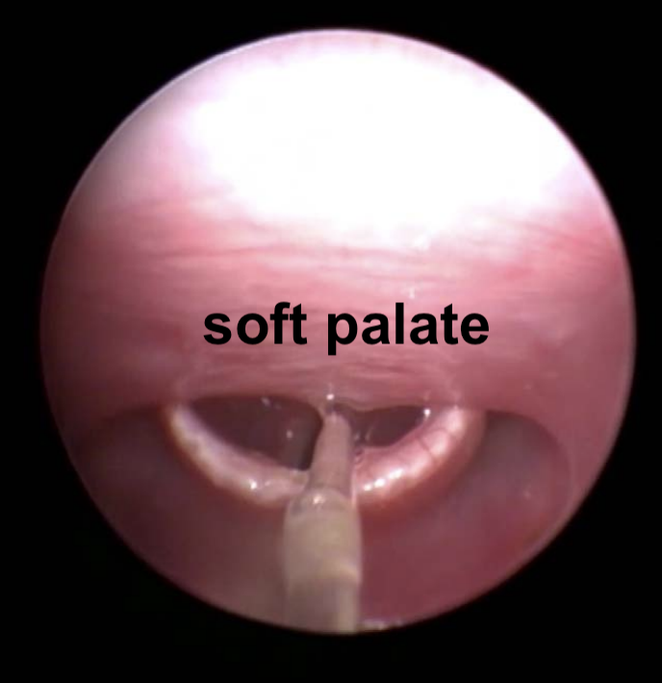
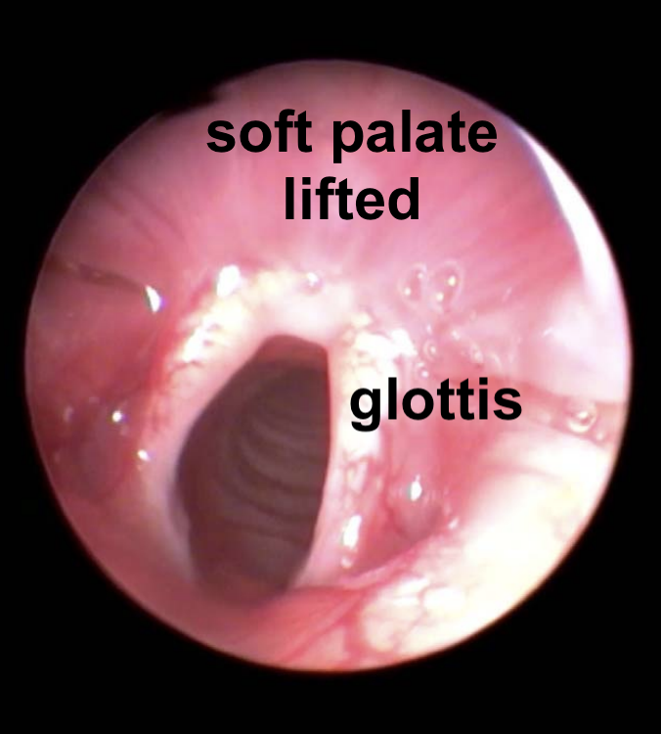
Abstract: Respiratory infections are common in young wombats and determining the causative agent is critical to establish an appropriate treatment. A group of 12 young, wild common wombats (Vombatus ursinus) ranging from 6 to 10 kg developed a range of respiratory signs after being in care following the severe bushfires in Australia in early 2020. The oral anatomy of wombats makes collection of tracheal samples difficult. An endoscopy-guided technique was established to collect microbiology samples aseptically from the anesthetized patients. A guarded, sterile swab was introduced in the mouth and inserted into the trachea of two wombats, visualizing the procedure with the endoscope. A similar technique is described for endotracheal intubation of small mammals. This approach allowed for a safe and aseptic sampling collection. A pure growth of Escherichia coli was cultured from the samples, and appropriate antibiotic treatment was established according to the antimicrobial sensitivity test.

Background:
- Wombats are marsupials belonging to order Diprotodontia (like koalas)
- Wombats = ONLY marsupial with aradicular (open-rooted), hypsodont (tall crown), elodont (continuously growing) dentition
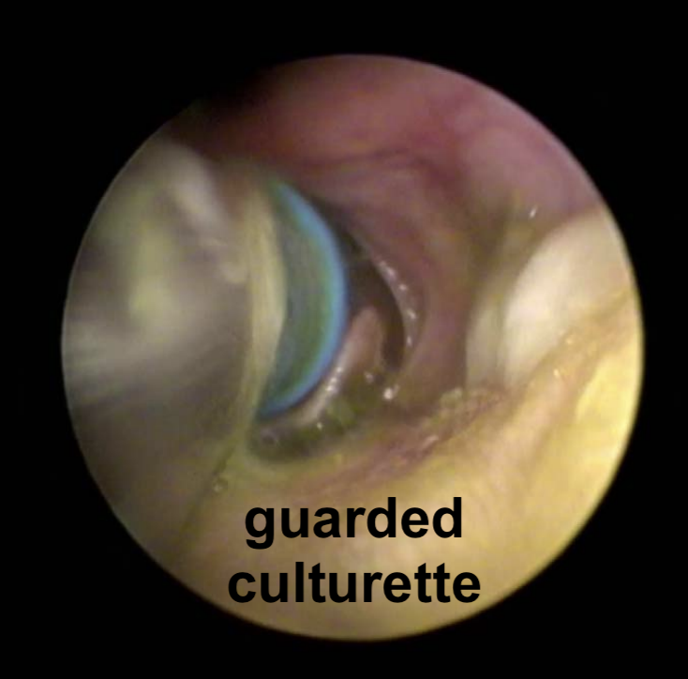
- Burrow strategy → makes adapted to acidemic (hypercapnic, hypoxic) conditions
  - Small respiratory reserve, some flow reserve (tachycardia), no erythropoietic reserve, some chemical reserve
  - Also may make them prone to respiratory disease
- Young wombats prone to lower resp disease - bacterial and fungal pneumonia
  - Antibiotic dysbiosis limits which abx are safe in this species
- “Peculiar anatomy of the wombat throat” makes intubation difficult
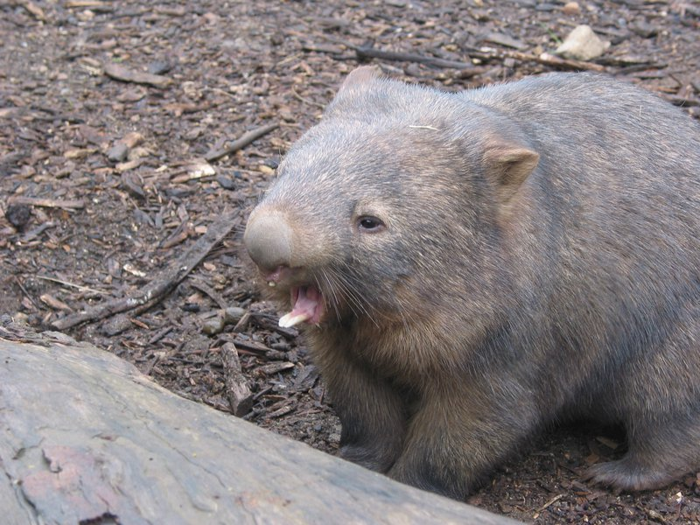
  - BAL or tracheal wash more risky when not intubated

Case series: n=12 young (10-12 mo old) common wombats rescued from Australia fires in 2020
- 9 of 12 developed resp signs within 1 mo of entering care
  - Sneezing, dyspnea, lower respiratory crackles, coughing + inappetence, lethargy
- Despite treatment with 2 different antibiotics, 5 died
- Radiographed 2 of 4 of most severe left → alveolar pattern (pneumonia)
- Developed safe and aseptic endoscopic-assisted technique to obtain tracheal cultures
  - Sternal recumbency, neck extended, head on towel
  - Rigid 2.7 mm endoscope (30°) over tongue until tip of epiglottis visible
  - Lift soft palate, epiglottis falls forward, draw back to visualize glottis
  - Guarded sterile swab used routinely in “equine and ostrich gynecology” passed through oral cavity and monitored via endoscopy to pass through glottal opening on inhale
- Performed culture on both animals → grew E. coli
  - Treated all four with CCFA x 3 weeks → full recovery for all animals
- Recommend also considering this technique for koalas

TLDR: Wombats are prone to pneumonia and since they are difficult to intubate can use a side-by-side endoscopic technique with a guarded swab and a rigid endoscope to safely and aseptically collect tracheal cultures for appropriate antibiotic selection.
ADVANCED DIAGNOSTIC IMAGING AND PATHOLOGIC FINDINGS OF THYROID LESIONS IN TWO SHORT-BEAKED ECHIDNAS (TACHYGLOSSUS ACULEATUS). JZWM 55.1 (2024).Vaasjo E et al.. - review by LMumm

Abstract: Two zoo-maintained short-beaked echidnas (Tachyglossus aculeatus) had long histories of intermittent anorexia and lethargy. Case 1 presented with a recurrence of these signs after transfer to another facility and died shortly after arrival. A focal area of hyperattenuation within the paratracheal tissue of the cranial mediastinum was noted antemortem on CT. Postmortem, this corresponded with severe thyroid follicular hyperplasia with lymphoplasmacytic thyroiditis. Additional findings included a systemic fungal infection without an inflammatory response, suggesting underlying factors such as torpor or immunosuppression. In Case 2, an intrathoracic mass was identified during a preshipment examination. CT confirmed a contrast-enhanced mass compressing the cranial vena cava and right atrium, and the animal was euthanized. The mass was diagnosed histologically as thyroid adenocarcinoma. These cases report thyroiditis and thyroid adenocarcinoma in echidna and describe the use of IV contrast and CT as a diagnostic aid in this species.

Background:
- Monotremes = 2 families of egg-laying mammals
  - Low metabolism relative to similar sized mammals
  - Hibernate or torpor below 12°C
- Trauma reported as most common M&M for free-ranging short beaked echidnas
  - Improper husbandry, salmonellosis and toxoplasmosis most common M&M in captivity
- Echidna anatomy makes radiographic evaluation of soft tissue structures challenging
  - Large pectoral girdle and radiopaque spines obscures soft tissue detail
- Thyroid anatomy/physiology in echidnas:
  - Thyroid gland resides in mediastinum
  - Paired intrathoracic parathyroid glands are associated with the thymus (not the thyroid!)
  - Thyroid hormones start to decrease pre-hibernation, lowest during hibernation
    - Different than eutherian hibernators - thyroid hormones decrease prior to hibernation and then rise progressively throughout hibernation
- Other unique anatomy:
  - Ovoid dorsal structure at dorsal pole of spleen - often mistaken for pathology

Key Points:
- Two cases of thyroid lesions in short-beaked echidnas
- Both could be seen as contrast-enhanced masses on CT antemortem
  - Dorsal beak sinus used for IV injection of nonionic contrast
- Case 1: thyroiditis, intermittent anorexia and lethargy - died shortly after transfer to a new facility
  - Fungal pneumonia and vasculitis
- Case 2 thyroid adenocarcinoma, incidental on preship exam - euthanized
  - Muffled heart sounds
  - ST opacity within thorax and decreased lung fields seen on rads

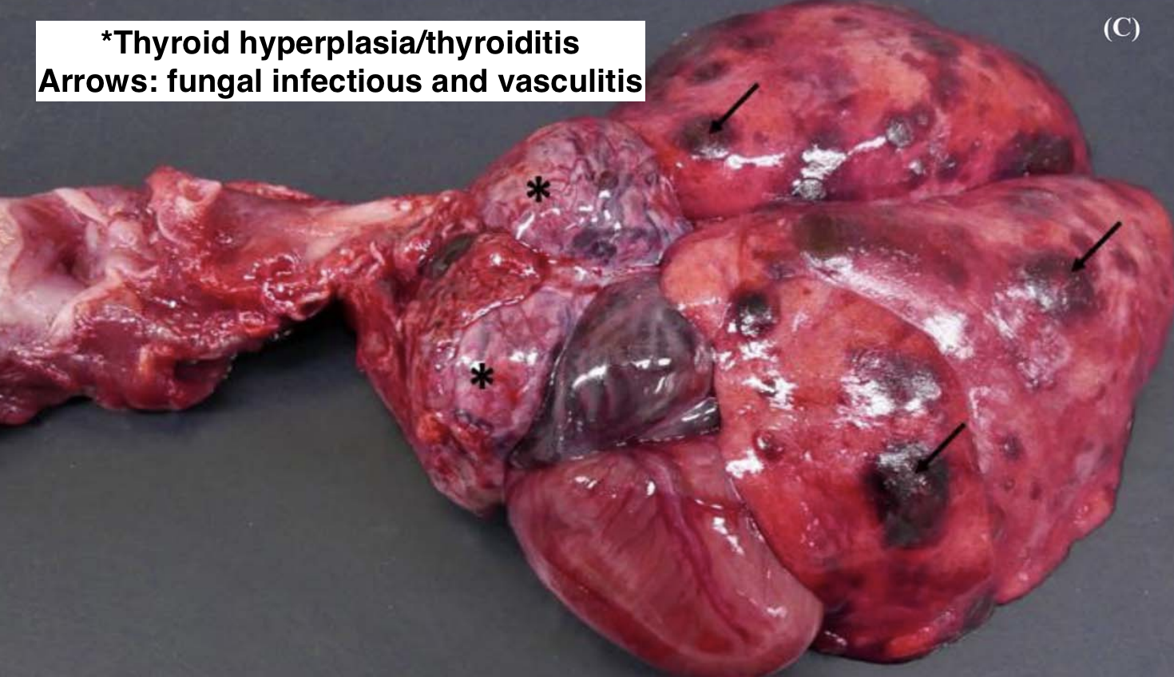
TLDR: Echidnas can get thyroid disease (hyperplasia/thyroiditis and adenocarcinoma reported here) and CT with IV contrast (via dorsal beak sinus) may be the best imaging modality for detection

Testis abnormalities in a population of south Australian koalas (Phascolarctos cinereus). Journal of Wildlife Diseases. 2022. 58(1): 158-167.

Laura Martinelli

Abstract: Testis asymmetry, in which the testes in an individual differ in size, has recently been reported in koalas (Phascolarctos cinereus) in the Mount Lofty Ranges population of South Australia. We describe the morphology and histology of both testes from affected individuals in this population (n=56) and the parameters of koalas with normal-sized testes based on age and breeding season (n=56). Morphologic measurements included testis weight, length, width, and volume; histologic parameters included seminiferous tubule diameter, seminiferous epithelial height, and seminiferous tubule (interstitial tissue ratio and presence or absence of spermatozoa). Of the 56 koalas with intraindividual variation in testes size, 47 were classified as asymmetric and nine as microtestes. For koalas with asymmetric testes, all morphologic parameters were significantly decreased in the smaller testes compared with normal-sized testes, but for the histologic parameters, only seminiferous tubule diameter was significantly less. Histopathologic examination of the asymmetric testes showed 38 with normal parenchyma histologically indistinguishable between intraindividual testes, four with degeneration and atrophy, and three with hypoplasia, whereas examination of microtestes showed degeneration and atrophy in seven, hypoplasia in one, and aplasia in one. No association of testis size difference with Chlamydia pecorum infection was found in a subset of animals. For the 56 koalas with normal-sized testes, morphologic parameters were found to increase with age, and juvenile and young adults were found to have smaller seminiferous tubule diameters than adults. No differences were found between testes of koalas in the breeding and nonbreeding season. Overall, these findings indicate that testis asymmetry in koalas from the Mount Lofty Ranges population is common but not associated with decreased function, except where testis malformations such as hypoplasia or aplasia occur or when parenchyma has been disrupted by acquired disease.

Key Points:
- Introduction
  - In the Mounty Lofty Ranges recent necropsy study of the koala population identified 11% of males had marked testes asymmetry and for that reason this study was initiated
  - Chlamydia pecorum causes disease to the male repro tract (orchitis, epididymitis, and testis fibrosis)
  - Testis aplasia positively correlated with high inbreeding coefficients in some populations of koala in Australia, including some individuals that founded the population in the Mount Lofty Ranges – suspect these koala may be more predisposed to testis aplasia for that reason
- Left & Right testes from 112 male koalas from Mount Lofty Ranges from animals necropsied between 2012-2019 were assessed (animals grouped by age using tooth wear classification)
- Testis size from smallest to largest
  - Juvenile < Young Adult < Adult
- Presence of spermatozoa was significantly correlated with age, adults more likely to have spermatozoa than juveniles
- 56 koalas had abnormal testes
  - 47/56 asymmetric (both testes fully formed but of different size; 2 juveniles, 23 young adults, 22 adults)
  - 9/56 microtestes (one or both testes very small; 1 juvenile, 5 young adults, and 3 adults)
  - No cryptorchidism observed
- Overall prevalence of testis asymmetry was 17% and of microtestes was 3%
- For cases of testicular degeneration – changes were consistent with an ischemic event or chronic inflammation leading to parenchyma destruction and replacement fibrosis
- Mean size difference in asymmetric testes was 28% difference, however only 9% of the smaller testes showed histopathologic changes; Generally this means that it is unlikely to impact the overall fertility of the population
  - Notably, in nine koalas with “microtestes” degeneration and atrophy, hypoplasia, or aplasia were evident in all cases
- Unclear if testes asymmetry was inherited or acquired
- Koalas have a relative testis mass lower than many other marsupial species including the brushtail possum and the western grey kangaroo; the lower relative testis mass suggests low levels of intermale sperm competition and the possibility of a monogamous mating system – male koalas rarely exhibit physical aggression toward one another and female choice may be a key factor in mate selection

Take Home Point: Although testis asymmetry was considered common in the Mount Lofty Range koala population, it is unlikely to affect overall fertility, and testis malformations are rare.

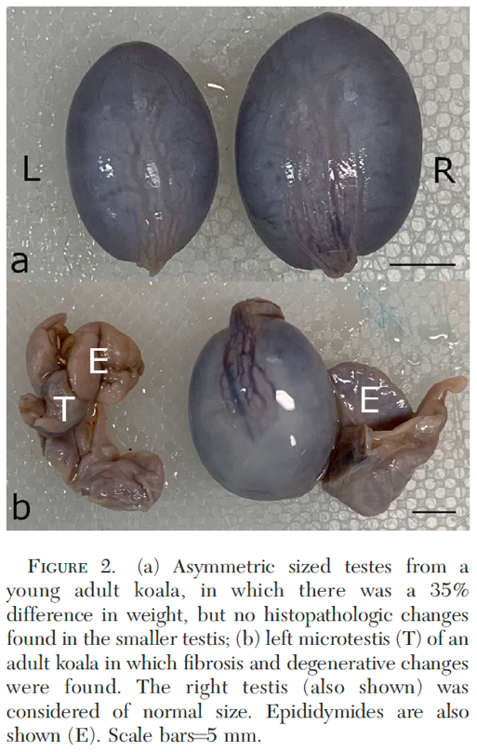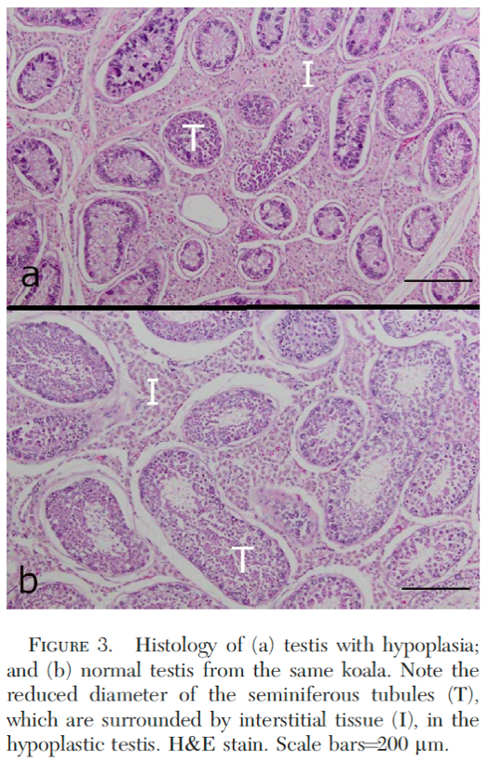

Lonepinella sp. isolated from wound infections of koalas. Journal of Wildlife Diseases. 2023. 59(3): 398-406.

Laura Martinelli

Abstract: We describe two cases of wound infections of koalas (Phascolarctos cinereus), one wild and one captive, in which Lonepinella-like organisms were involved. The wild adult koala was captured with bite wound injuries, as part of a koala population management program in Queensland, Australia. In both cases, there was evidence of physical trauma causing the initial wound. The captive koala suffered injury from the cage wire, and the wild koala had injuries suggestive of intermale fighting. Gram-negative bacteria isolated from both cases proved to be challenging to identify using routine diagnostic tests. The wound in the captive koala yielded a pure culture of an organism shown by whole genome sequence (WGS) analysis to be a member of the genus Lonepinella, but not a member of the only formally described species, L. koalarum. The wound of the wild koala yielded a mixed culture of Citrobacter koseri, Enterobacter cloacae and an organism shown by WGS analysis to be Lonepinella, but again not Lonepinella koalarum. Both cases were difficult to treat; the captive koala eventually had to have the phalanges amputated, and the wild koala required removal of the affected claw. The two Lonepinella isolates from these cases have a close relationship to an isolate from a human wound caused by a koala bite and may represent a novel species within the genus Lonepinella. Wound infections in koalas linked to Lonepinella have not been reported previously. Wildlife veterinarians need to be aware of the potential presence of Lonepinella-like organisms when dealing with wound infections in koalas, and the inability of commercial kits and systems to correctly identify the isolates.

Key Points:
- Introduction
  - Members of Pasteurellaceae are mainly present on the mucosal surfaces of the respiratory, alimentary, or genital tracts of mammals, including koalas
    - Lonepinella koalarum is a member of the family (first isolated from healthy koala feces at Lone Pine Sanctuary in Australia with no association with disease)
    - Genus Lonepinella, with only one named species (L. koalarum) characterized as facultatively anaerobic, Gram-negative, rod-shaped bacterium that is catalase negative with variable reports of cytochrome C oxidase
    - L. koalarum thought to be symbiotic with koala and help break down tannin protein complexes in Eucalyptus
  - Lonepinella-like isolates were found in human wounds following koala bites in 2019
- Based on this study, and others, Lonepinella-like organisms are prevalent in the oral cavity of koala populations and represent a zoonotic risk
- Both infections in the cases in this study were due to oral contamination of tissue damaged by physical insult (Case 1 trauma from cage wire, Case 2 trauma from suspected intermale fighting)
- If an organism is cultured from a koala and the following are identified, suspect Lonepinella:
  - Gram-negative
  - Oxidase positive (or weakly positive)
  - Catalase negative
  - Colony morphology similar to Pasteurellaceae
  - Failure of common commercial ID systems to identify an organism with the above listed phenotypic properties

Take Home Point: Lonepinella-like organisms occur in the oral cavity of koalas and are a potential opportunistic infectious agent as well as zoonotic agent.

MEDETOMIDINE-KETAMINE-MIDAZOLAM VERSUS MEDETOMIDINE-KETAMINE-BUTORPHANOL FOR IMMOBILIZATION OF RED KANGAROOS (OSPHRANTER RUFUS)
Anastasia G. Makrin-Dray, Roi Lapid, Amir Kafri, Yishai Kushnir, Yael Shilo-Benjamini
The objectives of this clinical study were to compare the effectiveness and safety of medetomidine-ketamine-midazolam (MKM) versus medetomidine-ketamine-butorphanol (MKB) for immobilization of captive red kangaroos (Osphranter rufus). Twenty red kangaroos were randomly immobilized for routine treatments using intramuscular injection of MKM (0.065 ± 0.004, 2.2 ± 0.3, and 0.12 ± 0.04 mg/kg, respectively) or MKB (0.070 ± 0.015, 2.3 ± 0.5, and 0.23 ± 0.05 mg/kg, respectively) (n = 10/group). Induction, immobilization, and recovery times were recorded; vital signs monitored; and quality of induction, immobilization, and recovery scored using a single-blinded design. Oxygen was not supplemented. For reversal, atipamezole at five times the medetomidine dosage was administered intramuscularly (both groups), and flumazenil (0.020 ± 0.003 mg/kg; MKM) or naltrexone (0.23 ± 0.05 mg/kg; MKB) were administered intravenously. Induction time was significantly shorter in the MKB group versus the MKM group (7:26 ± 04:22 and 11:54 ± 04:50 minutes, respectively). Induction quality in both groups was rated “excellent” and immobilization quality was “excellent” in MKM and “very good” in MKB. Heart rate was significantly lower and hemoglobin oxygen saturation (SpO2) was significantly higher in the MKM versus the MKB group. However, SpO2 < 90% occurred with both protocols. Following antagonists administration, recovery time and quality were 17:40 ± 08:33 minutes and “very good” in the MKM group, and 14:28 ± 05:27 minutes and “excellent” in the MKB group, respectively. Both protocols provided smooth induction, good immobilization, and generally quick recovery. MKB is recommended for shorter induction time. Oxygen supplementation should be available with both protocols.
Taxonomy: Order: Diprotodontia Family Macropodidae Genus/species: Osphranter rufus

Key points:
- Comparison of two IM anesthesia protocols in red kangaroos: medetomidine (0.06mg/kg), ketamine (2mg/kg) and either midazolam (0.1mg/kg) (MKM) or butorphanol (0.2mg/kg) (MKB).
- Induction:
  - Median quality excellent in both groups.
  - Time to induction significantly shorter with MKB (7.3 mins) than MKM (11.5 mins)
- No significant differences in muscle relaxation, loss of palpebral/withdrawal reflexes
  - About 50% of animals retained withdrawal reflex
    - These protocols did not achieve surgical plane of anesthesia.
- Physiologic parameters:
  - No differences in respiratory rate or blood pressures - only 1 animal in each group experienced hypotension at some point (BP was measured with oscillometry, not the most accurate).
  - Heart rate significantly lower with MKM.
  - SpO2 significantly lower with MKB, but hypoxemia (SpO2<90%) was common with both protocols
    - Supplemental oxygen not provided in this study, but recommended.
  - Mean rectal temperature lower in MKB group, but still within normal reference range.
- Recovery: reversed with atipamezole and naltrexone (MKB) or flumazenil (MKM)
  - 2 kangaroos from MKM required additional doses of flumazenil due to prolonged recovery
  - No significant differences in recovery quality or time (good-excellent quality and roughly 15 minutes for both protocols).
    - Quicker than reported recoveries for telazol, which can be up to several hours, and reported recoveries for medetomidine-ketamine protocols only (which require higher doses of ketamine)

Take home: Medetomidine-ketamine-midazolam and medetomidine-ketamine-butorphanol anesthesia in red kangaroos provides smooth induction (faster with MKB), good immobilization for non-invasive procedures, and quick recovery. Hypoxemia is common with both protocols so supplemental oxygen should be available.

Successful bilateral phacoemulsification and vitrectomy in a Bennett’s wallaby (Macropus rufogriseus)
Anaïs Sailler, DVM1*; Morgane Prieto, DVM2; Frédéric Goulle, DVM3

CASE DESCRIPTION: A 7-month-old hand-reared female Bennett’s wallaby (Macropus rufogriseus) was evaluated for bilateral ocular opacity of 3 months’ duration.
CLINICAL FINDINGS: On physical examination, the wallaby was in good overall condition. An ophthalmic examination revealed mature cataracts in both eyes (OU). The cataracts were suspected to have a nutritional origin as it has been described in hand-reared macropods. Results of tonometry were normal OU. Results of CBC and serum biochemistry were unremarkable. The wallaby was premedicated with medetomidine and ketamine hydrochloride. Ocular ultrasonography performed while the wallaby was anesthetized revealed a thickened and opaque lens, mildly heterogeneous vitreous humor, and no sign of retinal detachment OU. An electroretinogram confirmed functional retinae OU.
TREATMENT AND OUTCOME: Surgery was considered necessary for welfare reasons. Phacoemulsification and vitrectomy were performed without intraoperative complication. The wallaby recovered uneventfully, and systemic NSAID, topical corticosteroid, and systemic and topical antimicrobial therapy were prescribed. One year later, the animal had vision OU. Physical examination did not show any vision-threatening postoperative complications.
CLINICAL RELEVANCE: The etiology of nutritional cataracts is not fully understood in macropods, but this condition is rather common in these species. To our knowledge, this is the first detailed report of a successful bilateral phacoemulsification and vitrectomy in a Bennett’s wallaby.

- Diarrhea occurred with clavamox= resolved after stopping
- Cataracts are COMMON in macropods
  - Chronic trauma
  - Infectious: toxoplasma (cyst bradyzoites and free tachyzoites have been found)
- Wallaby was fed canine milk replacer after rescued (mother had died)
  - Canine: 29% carbs (lactose), 25% proteins, and 24% at- suspect lactose overload caused the cataracts (galactosemic induced)
- TS level in wallaby milk increases gradually, protein and lipids are low and carbs are high- BUT after 200-300 days of lactation the trend reverses (carbs fall below 2%)
  - Carbs are oligosaccharides before 200 days and then monosaccharides afterward
- Lactose is digested into galactose and glucose
  - Galactose is broken down by liver enzymes (galactokinase and galactose-1 phosphate uridyl transferase)
  - Suspected that wallabys lack these enzymes to break down galactose
- Other amino acid deficiences have caused cataracts= histidine, tryptophan, phenylalanine, and arginine
- Extensive bilateral vitreous humor opacification is seen in kangaroos as well as wallabies- requiring a vitrectomy (believed to be caused by a high vitreous humor concentration of galactose)
- Kangaroos- prone to developing glaucoma 2-12 weeks postop: which leads to evisceration or euthanasia (COMMON COMPLICATION)- cataract surgery is not recommended

