Hadfield, Clinical Guide to Fish Medicine, Chapter A13: Environmental Considerations of Immersion Medications - reviewed by HSS

- Introduction
  - Immersion with little organic material/no filtration predictable effects, lower cost, smaller volumes water for disposal
  - Immersion in established system can have unpredictable effects on filtration, animals, and medication
    - Monitor water quality, animal side effects
    - Common for pathogens such as Cryptocaryon, Neobenedenia, and Lepeophtheirus spp
  - Immersion of flow-through system uneven distribution, can be costly
- Impacts of Water Chemistry on Immersion Medications
  - Physical aspects of the water, such as temperature, pH, salinity, hardness, and total organic load, can have many effects on drugs. They can impact the dissolution of medications, the forms that are available (speciation), and the rate of degradation
    - Ex. Copper binding decreases as salinity increases
    - Ex. high levels of magnesium and calcium ions in salt water bind/neutralize tetracyclines and bind copper
- Effects of Water Clarification and Disinfection on Immersion Medications
  - Water clarity is often improved for aesthetic reasons using activated carbon filtration, ozone, and ultraviolet (UV) light. Disinfection in fish systems commonly involves UV and/or ozone. May need to be discontinued during immersion treatment
    - GAC (granular activated carbon) is most effective against carbon-based molecules (e.g. organics, formalin, praziquantel). It can also adsorb heavy metals, although less effectively
    - In-line UV disinfection can degrade many medications including praziquantel, chloroquine, tetracycline, and oxy-tetracycline. Natural sunlight can also cause deterioration of these chemotherapeutics and some systems may need to be protected from direct sunlight during treatment.
    - Activated carbon, UV, and ozone should all be removed from a system during immersion treatment. Can be useful for removing medications from system following treatment.
- Effects of Immersion Medications on the Biological Filtration
  - Any chemical addition to a system could damage or destroy the bacteria that are critical to the biological filtration.
  - Impact is hard to predict, as it depends on the drug concentration and sensitivity of the ammonia-oxidizing bacteria (AOB) and nitrite-oxidizing bacteria (NOB) in that particular system.
    - By destroying some of the AOB or NOB, medication can select for other bacteria.
  - Monitor drug concentration, ammonia, and nitrite levels daily, helpful to maintain a biofarm for recolonization of AOB and NOB
- Effects of the Microbiome
  - The high standards for water clarity and clean surfaces within aquaria essentially starve microbes into inactivity. When the microbes are provided with a nutrient that was previously limited (e.g. carbon, phosphate), they can show rapid blooms.
    - Many common immersion medications are carbon based and can trigger this bloom
    - This can lead to rapid drop in DO used by microbes, turbidity (often transient) caused by microbial blooms, degradation of medication (ex. exponential decay of formalin, praziquantel)
- Effects on Target and Non-Target Species
  - Both target and nontarget species are exposed to the medication and its by-products. Morbidity and mortality may be seen in either group because of potential sensitivity to the medications and the unpredict-able effects discussed above.
  - Deaths of small invertebrates and microbes can release nutrients that affect ammonia and DO
  - Consider bioassay to test for negative impacts
- Medication Assays
  - With bulk immersion medications, the clinician should question the composition, purity, and/or expiration of pharmaceuticals. Medications can be submitted to a pharmaceutical lab for analysis
  - Recommended to repeatedly assess drug concentrations in the water to ensure appropriate levels are present throughout and following treatment.
- Diving or Swimming in Medicated Water
  - All diving in medicated water must be considered “polluted water diving”, and the institution must ensure that steps are taken to protect individuals exposed from the affected water
  - Diving in medicated water should be avoided wherever possible
  - If diving cannot be avoided, there should be a specific plan for diver health and safety. The plan should include assessment of hazards, PPE, work plan, diver decontamination plan, when normal operations are safe to resume
- Disposal of Medicated Water
  - 5 basic methods:
    - Municipal sanitary sewer (most common in aquaria)
    - Natural body of water
    - Return to institutions water system
    - Biotic or abiotic removal or destruction of the compound
      - Less convenient, more expensive
      - Biotic elimination is a process of biodegradation by microbes, including bacteria, protists, algae, or fungi. Not well studied.
      - Common abiotic methods include adsorption, photolysis, oxidation, and reduction. Nanofiltration and ultrafiltration methods show promise.
        - Adsorption typically accomplished with activated carbon, effective at removing many organic compounds
        - Drugs that are known to be degraded by UV light include praziquantel, chloroquine, tetracycline, and oxytetracycline
        - While effective at degrading organic compounds, ozone and other potent oxidizers can react with compounds to create toxic by-products
    - Transfer to an evaporation pond with removal of the resulting sludge
      - Shallow, artificial ponds with a large sur-face area that enhances water evaporation by sunlight and high temperatures. This results in the pollutants accumulating in either a crystalline or concentrated sludge form. The sludge then requires proper handling, treatment, and disposal.
      - Expensive
- Record-Keeping
  - Best practices, as well as regulatory and accreditation standards, require proper documentation of all drug prescriptions, including immersion medications, within the VCPR
- Specific Drug Examples
  - Formalin
    - Formalin is used commonly to treat ectoparasites and oomycetes. Doses are usually given in mg/L. Prolonged immersion doses range from 12.5 to 25 mg/L. Higher doses are used for shorter duration, e.g.100–250 mg/L for 60 minutes
    - Can cause rapid decrease in DO, can combine with organic matter, more toxic at higher H2O temperature, more toxic in soft, low pH water, rapidly degraded by bacteria within microbiome
    - Many reports of toxicity. Scaleless fish, elasmobranchs particularly susceptible. Signs of toxicity may include dyspnea, tachypnea, pallor, excess mucous, erratic swimming, inappetence, and death, often within 24–48 hours. Formalin is also toxic to many invertebrates, algae, and vascular plants. Toxicity increases with increasing water temperature and decreasing pH
  - Trichlorfon or Metrifonate
    - Trichlorfon may be used to treat copepods, branchiurans, leeches, and monogeneans. Typical doses are reported as 0.25–0.50 mg/L
    - Very susceptible to microbial digestion. Microbial digestion and/or possible parasite resistance can increase over time in a system, so it should not be used routinely as a prophylactic
    - Dichlorvos is major transformation product and is at least 100x more toxic that trichlorfon. The rate of trichlorfon transformation to dichlorvos increases with increasing alkalinity and increasing temperature
    - The primary MoA is inhibition of the enzyme cholinesterase (ChE) that breaks down acetylcholine. It leads to an accumulation of acetylcholine, causing disruptions in the CNS
    - Moderately toxic to most fish, particularly elasmobranchs, and highly toxic to invertebrates and waterfowl. Symptoms of toxicity include hyperactivity, tremors, seizures, and death
    - Absorbed transdermally in humans
  - Praziquantel
    - Praziquantel immersion is often used for the treatment of monogeneans and it has activity against digenes, cestodes, and acanthocephalans. Typical immersion doses are 2–20 mg/L
    - Praziquantel is lipophilic and dissolves poorly in water. Two methods are commonly used to improve dissolution, but the effective dose can be hard to estimate due to this solubility issue. Praziquantel can be manually dissolved by squeezing it through a very fine mesh net or filter material. Alternatively, it can be dissolved in just enough ethyl alcohol to form a thick paste (~1 mL/g praziquantel) prior to dosing. Ethanol can lead to bacterial bloom
      - If not dissolved properly, can be irritating to gills and lead to fatal gill damage
    - Praziquantel is also subject to rapid degradation by the microbiome
    - Wide safety index for fish and plants when used properly
  - Cooper Sulfate, Chelated Copper
    - Copper immersion is often used to treat ectoparasites (particularly Cryptocaryon spp.) and oomycetes. Copper may also be used as an algaecide and to eradicate snails. The therapeutic range depends on the salinity, alkalinity, product, and parasite
    - High temperatures, low alkalinity, and low pH increase the risk of toxicity by increasing the pro-portion of ionic copper and the uptake of copper by fish
    - Bacteria will exponentially increase uptake rate during the course of treatment and are instrumental in the eventual reduction of copper back to trace levels.
    - Copper may be acutely toxic to some species of finfish, most elasmobranchs, and most invertebrates. Signs of toxicity may include inappetence, changes in coloration, lethargy, and acute mortalities.
    - A slow increase to reach the therapeutic concentration is recommended.
    - Copper can cause an increase in ammonia and nitrite due to the inhibition of nitrifying bacteria. It can also lead to increased ammonia and decreased DO due to the death and decay of invertebrates, algae, and vascular plants
    - Activated carbon and water changes are typically used to remove copper, but copper concentration may need to be checked regularly for several weeks after cessation of treatment, as it may leach back into the system from adsorbent surfaces.
  - Chloroquine
    - Chloroquine immersion is typically used to treat external protozoa such as Cryptocaryon irritans, Amyloodinium ocellatum, trichodinids, and scuticociliates. A common therapeutic dose for prolonged bath treatmentis 10 mg/L, based on drug weight. This is equivalent to a chloroquine (base salt) dose of 6.2 mg/L
    - Increasing toxicity with increasing pH, stable in aquatic systems, readily degraded by UV light
    - Toxic to some invertebrates and algae, anecdotal reports of toxicity in some teleost species
    - Chloroquine can cause a nincrease in ammonia and nitrite due to inhibition of nitrifying bacteria. It can also lead to increased ammonia and decreased DO due to the death and decay of invertebrates and algae.
Chapter 12: Elasmobranch Quarantine. Elasmobranch Husbandry Manual II. 2017: 113-133.
Laura Martinelli
Abstract: Quarantine reduces the risk of introducing infectious diseases into collections and allows close monitoring while animals adjust to new environmental conditions and diets. Common infectious diseases that represent a risk to aquarium collections include monogeneans, copepods, leeches, and coccidia. Bacterial and fungal infections are more likely to be a problem in individual animals, and are often secondary to trauma or other stressors. Emerging infectious diseases include Scuticociliatida-like ciliates and Chlamydiales. Common non-infectious problems in quarantine include inappetence and trauma. Some species, particularly aquarium-bred animals, present few challenges during quarantine, while others frequently require intensive nutritional support or medical management. Good record keeping is essential during quarantine and allows evaluation of management, diagnostic and treatment plans.
Key Points:
- Quarantine systems should be run as ‘all in/all out’ groups
- Can quarantine for minimum 30 days but some institutions go longer (i.e. 90 days) and base time of quarantine on potential for various expected possible disease or parasite outbreaks
- In your quarantine system, jump barriers are required for elasmobranchs
- Do not house elasmobranchs and teleosts together in quarantine as this limits the medications that can be used to manage outbreaks
- Animal identification
  - PIT tags are used and AZA recommends IM placement of PIT tags on the left and side
  - Typically place PIT tags in the epaxial muscles of sharks and the pectoral fins of batoids
- Water quality
  - Recommendations included in Table 1 below
  - Automated sensors for water level, temperature, and DO can be helpful
  - UV and ozone disinfection can reduce water-borne pathogen levels and the goitrogenic effects of ozone use and high nitrates are unlikely to be an issue in short-term quarantine systems, but diets should include routine supplementation of iodide
- Feeding
  - Various supplements have been used to encourage feeding but typically show no effect on appetite (Vit B complex, Vit C, Vit E, garlic, diazepam, mirtazapine, megestrol acetate, low-dose dexamethasone, dronabinol extract, levothyroxine)
  - Evaluate BCS with visual and U/S view of liver, healthy animal with good BCS should have a large lipid-laden liver
  - During inappetence, urea and total protein tend to decrease but the literature is mixed on this
  - Glucose and other electrolytes tend to be well-regulated during prolonged fasting
  - Can force feed if necessary either a slurry (this chapter identifies a paper with a slurry recipe) or whole fish
    - Recommend 2-4% body weight per feeding
    - Frequency of feeding is species dependent
      - Juvenile or small stingrays = daily to EOD
      - Large stingrays = 2x/week
      - Fast-swimming sharks and rays = frequent, daily to EOD
      - Slow-swimming, demersal, and cold-water elasmobranchs = 1x/1-2 weeks
  - Gastritis and enteritis are common in elasmobranchs under stress, can develop ulcers in stomach and proximal intestine; In theory this is more common in elasmobranchs that continuously secrete gastric acid, i.e. in species that normally feed frequently
- Infectious Diseases
  - Parasites
    - Monogeneans
      - Monogeneans are common, particularly on skin and gills, associated with significant morbidity and mortality
      - Common monogeneans are the monopisthocotylean Monocotylidae; Capsalidae; Microbothriidae; and polyopisthocotylean Hexabothriidae
      - Monogeneans are typically host-specific but can take on wider host ranges in aquaria
      - Treatment of monogeneans involves praziquantel immersion, organophosphate immersion, or temperature or salinity changes
    - Nematodes
      - Typically present and commensal but some exceptions
      - Orders Spirurida and Dracunculoidea have been linked to vasculitis, branchitis, pancreatitis, meningoencephalitis, oophoritis, and metritis
      - Treatment is difficult as low safety of dewormers in elasmobranchs
    - Copepods, typically more an aesthetic issue but can cause issues in certain situations
    - Marine leeches, have a broad host range, hide in buccal and branchial cavities
    - Coccidia
      - Most common and problematic is Eimeria southwelli in the coelom and GI tract of myliobatid rays
      - E. southwelli can be commensal but can cause significant morbidity and mortality under stress
      - Treatment can involve sulfadimethoxine, clindamycin, toltrazuril, or ponazuril but total elimination of the parasite is difficult
  - Bacteria
    - Sepsis often secondary to transport, trauma, or poor water quality
    - Common agents include Vibrio spp, Photobacterium damselae, Aeromonas spp, Pseudomonas spp, Citrobacter spp, Flavobacterium spp, Streptococcus agalactiae, and Serratia marcescens
    - Chlamydiales have been associate with branchial epitheliocystis lesions and morbidity and mortality
    - Mycobacteriosis is rare in elasmobranchs
  - Fungi
    - Most common = dermatitis secondary to Fusarium solani
    - Oomycetes (water molds) have been reported
    - Early and prolonged voriconazole treatment, usually not rewarding
  - Protozoa
    - Less common in elasmobranchs than in teleosts
    - Invasive Scuticociliatida-like (Uronema-like) ciliates have been associate with morbidity and mortality
    - Protozoa have been reported in skin, gills, brain, and liver of skates and demersal sharks
    - Amyloodinium-like dinoflagellates have been associated with acute mortality during quarantine of sharks maintained with bony fishes
- Non-Infectious Diseases
  - Trauma
  - Hook entanglement –
    - swallowed hooks tend to be found in distal esophagus or gastric wall and may perforate the liver or pericardium
    - hooks are typically not found in the spiral valve
    - Species that chew up food typically get hooked in the buccal or branchial cavities
  - Water quality related disease
- Diagnostic Notes
  - Gill biopsies are less commonly done in elasmobranchs compared to teleosts due to potential for hemorrhage and lower diagnostic value
  - Coelomic flushes or aspirates are recommended in cownose rays (Rhinoptera bonasus) to look for coccidia
  - Venipuncture
    - Elasmobranch skin is sensitive to rigorous disinfection so only a single alcohol swipe or rinse with sterile saline are recommended prior to venipuncture
    - Site used for sampling affects PCV, ventral tail vein seems the least affected and is likely the most diagnostic
    - Heparin is the recommended anti-coagulant but can use formalin to preserve cells for later reading
    - Modified Natt-Herrick technique used for manual WBC counts
- Common anti-parasitic treatments
  - Repeated praziquantel baths for monogeneans, need to monitor dissolved oxygen before, during, and after treatment
  - Salinity changes but some elasmobranchs extremely sensitive so use caution
  - Organophosphates (trichlorfon) for monogeneans, copepods, and leeches but side effects include skin changes, inappetence, and mortality
    - Particularly sensitive species are Eagle rays and Guitarfish
    - Chitin inhibitors can be used for copepods and leeches
  - Copper immersion is typically not used due to concern for toxicity but it can be used and has been in some species
  - Fenbendazole can be used but mortalities have been seen in zebra sharks, yellow stingrays, cownose rays, and freshwater stingrays among others; Death is either related to the drug itself or the massive die-off of nematode parasites leading to an inflammatory reaction
- Taxa Specific Quarantine Notes
  - Odontospididae (Sand Tiger shark family)
    - C taurus (sand tiger shark) typically hardy
    - Can see scoliosis (unknown etiology), consider baseline radiographs in quarantine of the spine just caudal to dorsal fin
    - U/S typically not helpful in sand tigers because they are an air-swallowing species; Note after handling you may need to decompress the stomach
    - Gastric prolapse through the mouth or gill slit has been seen in sand tigers but not in quarantine
  - Carcharhinidae
    - Sandbar sharks also called Brown sharks – hardy, can have self-limiting cloacal prolapses, also get Huffmanella markgracei which can cause black tracts within the buccal cavity (successfully treat with levamisole)
    - Blacktip reef sharks – sensitive, may have monogeneans that cause focal dermatitis, can have cloacal prolapses
    - Whitetip reef sharks – pack hunters and conspecific aggression reported
    - Blacknose sharks – high prevalence of intravascular nematodiasis
    - Lemon sharks – hardy, commonly have monogeneans best treated with trichlorfon immersion
  - Triakidae
    - Leopard sharks
    - Dusky smooth-hound or Smooth dogfish – an iridovirus causing intravascular hemolysis (viral erythrocytic necrosis) has been identified in this species and is associated with mortality; intralesional ciliates and septicemia are also common in this species
  - Scyliorhinidae
    - Lesser spotted dogfish – hardy
    - Chain catshark
    - Nursehound
    - Cloudy Catshark
    - Swell shark - Can have Scuticociliatida-like ciliates; May take several hours to deflate their stomachs after handling – recommend keeping this shark submerged at all times during exams so air is not swallowed
  - Sphyrnidae
    - Bonnethead sharks – can be difficult to maintain, often hyporexic to anorexic post-transport, prone to Fusarium solani dermatopathy (white pustules, ulcers along lateral line system and cephalofoil; lesions are progressive and disease typically fatal); quarantine in isolation or small groups as prone to bites from others
  - Heterodontidae
    - All have a prominent spine on their dorsal fin that are dangerous during handling
    - Horn sharks
    - Japanese bullhead sharks
    - Port Jackson sharks
  - Ginglymostomatidae
    - Nurse sharks – hardy, rarely have quarantine issues
  - Hemiscylliidae
    - Epaulette sharks
    - Whitespotted bamboosharks
    - Brownbanded bamboosharks
    - Bamboosharks are generally tolerant of low dissolved oxygen concentrations and are relatively tolerant of freshwater dips
  - Stegostomatidae
    - Zebra shark
  - Orectolobidae
    - Wobbegongs – high prevalence of sepsis, require refugia or “hides” and a complex substrate to reduce stress, difficult to transfer from live diet to frozen diet, tend to prey on other exhibit fishes, need to ultrasound if wild caught because usually gravid, can be difficult to restrain as they have a rolling response
  - Squalidae
    - Spiny or piked dogfish – high prevalence of biliary myxosporeosis and pancreatic nematodes and chronic pancreatitis, high prevalence of mononuclear inflammation of the ampullae of Lorenzini
  - Rhinidae and Rhinobatidae
    - Bowmouth guitarfish – Hardy
    - Atlantic, Common, and Shovelnose guitarfish – can be challenging in quarantine and have leeches
  - Rajidae
    - Skates
  - Dasyatidae
    - Southern stingrays, common stingrays, Atlantic stingrays, etc.
    - Dasyatids commonly carry Monocotyle, Dendromonocotyle, Entobdella spp, and Neoentobdella spp monogeneans
    - High rate of conspecific aggression, high rate of female reproductive tract pathology
    - One or more venomous spines on the dorsal tail
    - Many species secrete abundant mucus
  - Myliobatidae
    - Myliobatids have one or more venomous spines on the tail
    - Spotted Eagle rays and Ocellated Eagle rays – difficult to maintain in aquaria, commonly have heavy loads of gill monogeneans that can be hard to eliminate (sometimes need treatment for the entire time in the collection), Eimeria southwelli observed in spiral valve of asymptomatic and thin animals, can have dental plate overgrowth if not fed clams and bivalves
    - Cownose rays – hardy but often have significant paristes, commonly infected with Benedeniella posterocolpa monogeneans particularly on the ventral surface, clinical signs of Benedeniella include anemia hypoproteinemia, inappetence, lethargy, secondary infections, and mortalities, also carry Eimeria southwelli in the GI tract that can be commensal or cause morbidity and mortality (need to do a coelomic aspirate and flush)
  - Urotrygonidae
    - One or more venomous spines on the tail
    - Females often gravid so ultrasound of repro tract warranted
    - Yellow stingrays – hardy, can have Dendromonocotyle octodiscus monogeneans that cause morbidity and mortality
  - Gymnuridae
    - Japanese and Spiny butterfly rays – difficult to maintain
  - Potamotrygoniade
    - South American freshwater ray and other freshwater rays
    - One or more venomous spines on the tail and venom is more potent than that of marine stingrays
    - Prone to water mold infections on the skin and around dental plates, treat with salt immersion
  - Chimaeridae
    - Spotted ratfish – common, often infected with copepods and leeches, do best in darkened aquarium with strict temperature control, have a venomous dorsal spine and should be handled with care
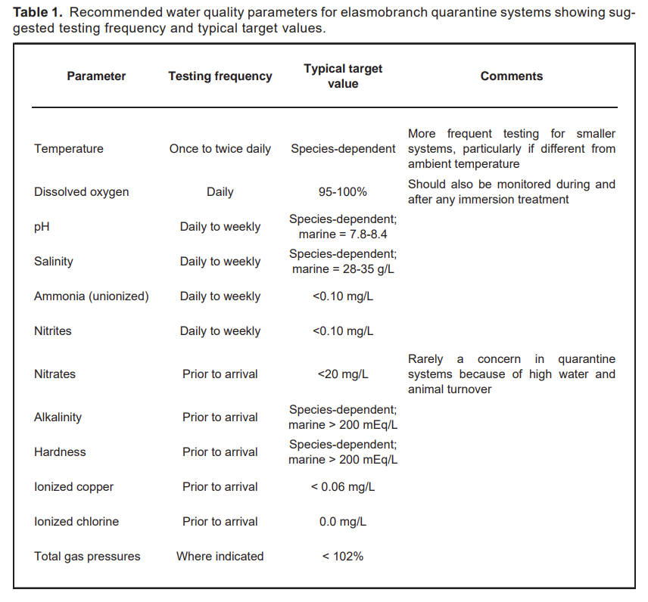
------------------------------------------------------------------------------------------------------------------
Chapter 29: Pharmacology of Elasmobranchs: updates and techniques. Elasmobranch Husbandry Manual II. 2017: 289-300.
Laura Martinelli
Abstract: There is little information on pharmacotherapeutics in elasmobranchs, with much of veterinary clinical practice relying on extrapolation from other species. While this action is often our only recourse, it can be augmented with knowledge of elasmobranch anatomy and physiology, environmental influences and the properties of the drugs themselves. The experiences of veterinary and husbandry colleagues adds to the databank of therapeutics that have been used without negative consequence, and that, in some cases, have desired effects. However, actual biologic drug levels and safety studies are lacking in most cases. Despite these shortcomings, a number of drugs have been successfully used to treat elasmobranch maladies.
Key Points:
- Pharmacodynamics = What the drug does to the body
- Pharmacokinetics = How the body processes the drug
- Immersion not a great route of drug administration in elasmobranchs – they drink very little water and gill absorption is not likely as they have tight and relatively impermeable gill epithelia
- Have both red muscle (myotomal) and white muscle (“slow twitch”) and with IM injections aim for red muscle but can be difficult to achieve because it is a small proportion
- Drug leakage at injection sites is an issue for both teleosts and elasmobranchs as their muscle is not elastic and does not retain fluid like a mammal. To manage this in elasmobranchs, recommend longer needles or sealing the injection site with tissue glue or bone wax
- Intracoelomic administration is possible and can be injected or administered via abdominal pore. If low pH, then recommend administered with fluids.
- Topical treatments/products can work well (see list of products in Table 1) but recommend against topical iodinated products or alcohol
- Sulfa drugs may cause death or ulcerative necrosis in elasmobranchs – use with caution
- If force-feeding squid, remove the ‘pen’ as accumulation of pens can lead to impaction
- Praziquantel works well in mixed species aquaria but does not always get tenacious monogeneans; Works by paralyzing the adult parasite and facilitates their removal or clean up
- Goiter continues to be a problem in aquaria, outside of nutrition, high nitrates and ozone have lead to development of goiter
  - Current recommendation for iodine water supplementation: 0.01-0.02 mg/L (if no ozone) and for dietary supplementation is 10-30 mg/kg/week dry diet
- Adverse Drug Effects that can occur in Elasmobranchs
  - Osmolality shifts and sudden death in stenohaline species when placed in different salinity
  - Reaction or focal irritation to topical medication
  - Reaction or focal irritation to IV medication
  - Injection site abscess reaction (i.e. IM enrofloxacin if not diluted or even when diluted)
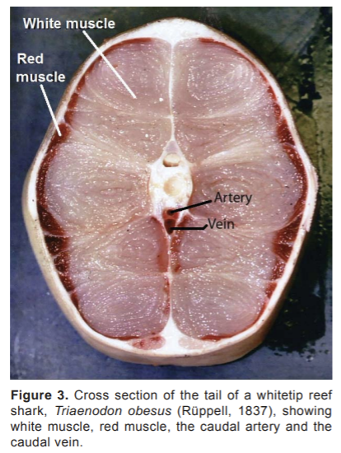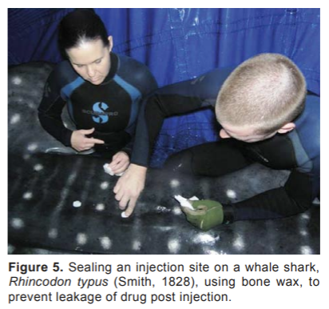

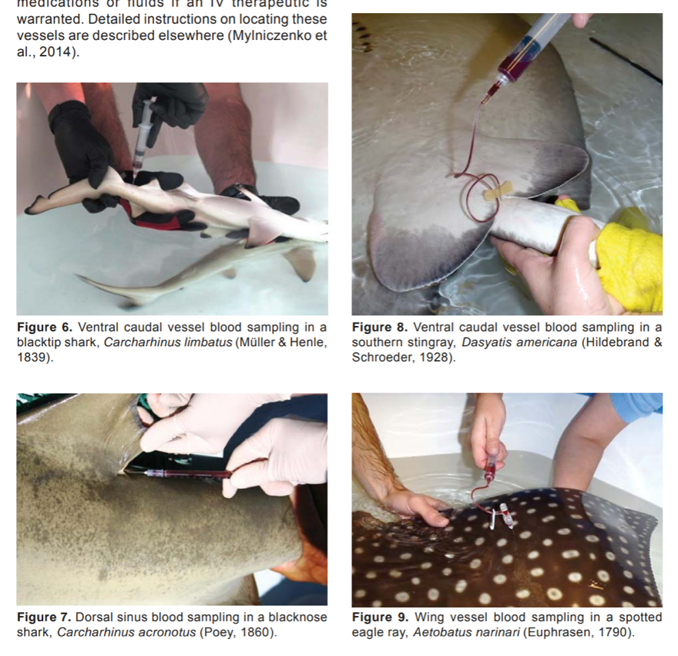
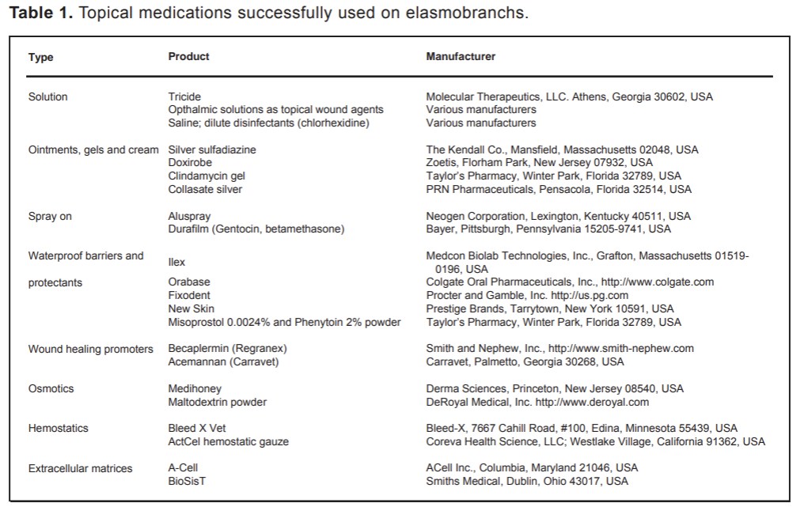
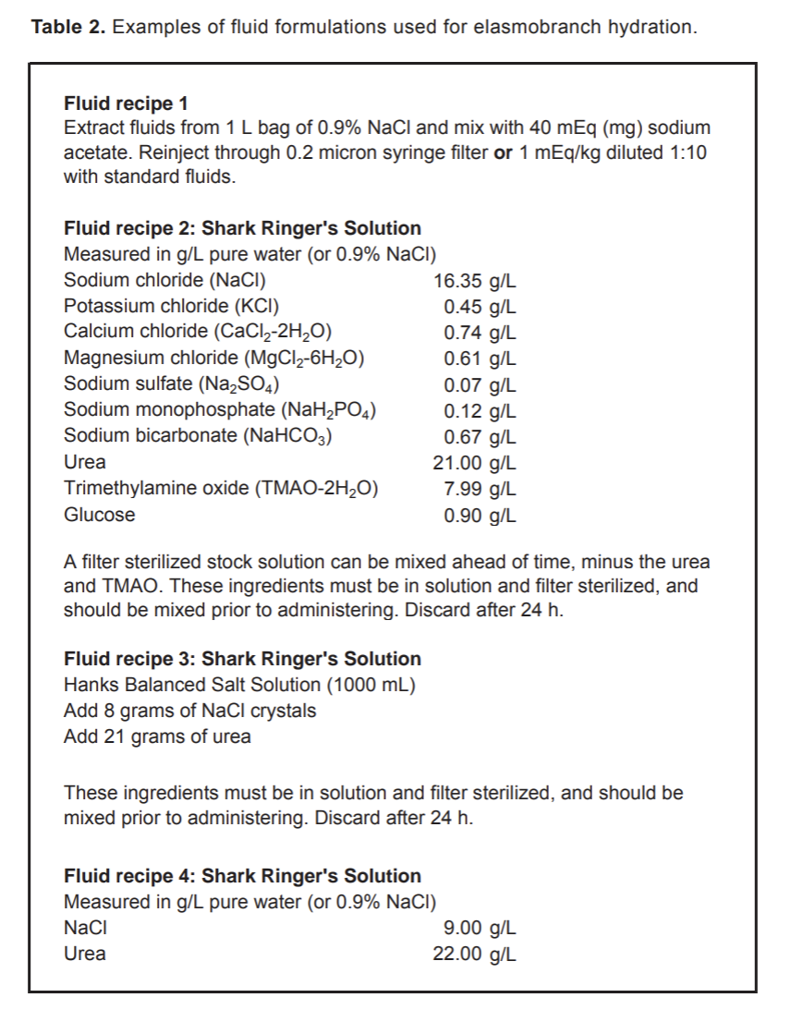
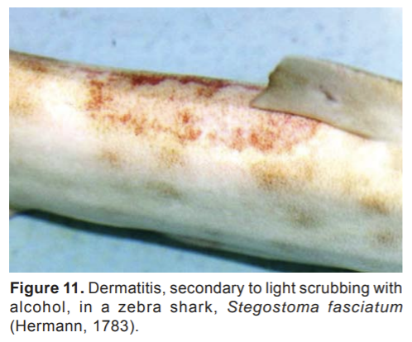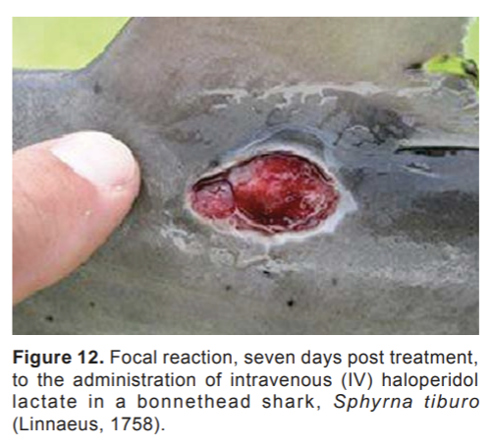
Fowler 10 Ch 59 - Antibiotic Resistance in Public Aquariums
Pereira & David - review by LMumm

Common Abbreviations
- AMR = antimicrobial resistance
- AMD = antimicrobial drugs
- ARG = antimicrobial resistance genes
- MDR = multidrug resistance

Resistance Mechanisms of Bacteria
- Innate AMR (slow adaptive evolutionary process) vs. adaptive AMR (quick adaptive process to selective AMD pressure)
- Two main genetic strategies for bacterium to gain AMR in their DNA
  - Mutation in bacteria’s genome
  - Acquisition of foreign DNA material (horizontal transfer) encoding AMR resistant genes
- Allows bacteria to modify AMD molecule, decrease penetration, and/or change AMDs target site
- ARG can be transmitted vertically (to bacteria offspring) or horizontally (via water, plasmids, etc)

Multidrug Resistance Organisms
- AMR enhanced by AMD misuse (human and vet med) → results in MDR organisms
  - MDR = In vitro resistance to more than one AMD
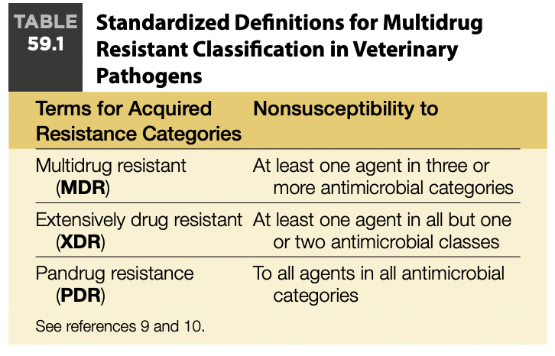
Testing
- AMD rx should be backed by antimicrobial susceptibility tests (AST)
- Common methods for ASTS
  - Disk diffusion
    - Reliability decreases at lower temps
  - MIC (minimum inhibitory conc) tests
    - Preferred for cultures at <28°C
- Bacterial clinical breakpoint = MIC (or disc zone size) value utilized to classify a bacterial strain as susceptible, intermediate, nonsusceptible, or resistant
  - Based on AST values for the pathogen, the PK and PD in that species, AMD dose, and specific host species
  - Breakpoints are RARE in vet med due to lack of species specific AMD PK/PD data
  - Veterinary labs often use a combo of human and vet breakpoints
- Ecological perspectives ECVs (epidemiological cut-off values) which determine susceptibility to an AMD from different isolates of a specific bacteria species regardless of the animal species affected; should not be determined to be “sensitive, intermediate, resistant”
  - Not appropriate for AMR classification in a clinical perspective

Antimicrobial Stewardship - antimicrobial advice from the EU for AMD in aquatic animals
- Category A: AMD that should be avoided in vet med (authorized for human med)
  - Rifampicin
- Category B: AMD that are restricted (high priority by WHO):
  - 3rd gen cephalosporins (ceftaz, ceftiofur), fluoroquinolones (cipro, dano, enro, marbo, flumequine, polymyxin B, oxolinic acid
- Category C: AMD that should be used with caution (if no category D are effective):
  - 1st gen cephalosporins (cephalexin), chloramphenicol/florfenicol, aminoglycosides (amikacin, gentamicin, neomycin, tobramyin)
- Category D: low risk but use with prudence
  - Metronidazole, nitrofurantoin, sulfas (TMS), tetracyclines (doxy, oxytet)

Public Aquarium Antimicrobial Resistance Cycle
- Water supply (e.g., municipal/tap water and seawater) may be a source of resistant elements and should be treated/disinfected to minimize risk of AMR
  - Difficult to assess AMR risk but there is always risk present
  - Water treatments/disinfection methods: activated carbon, chlorination, UV, ozone decreases the presence of ARBs, ARGs, AMD residues
    - Chlorination eliminates ampicillin, tetracycline, cephalexin, cefotaxime
    - UV removes flumequine but NOT macrolides
    - Ozone can reduce ofloxacin, TMS, sulfapyridine, clarithromycin
- Food (live animals, raw fish feed, dry pelleted food, veggies) can also carry resistance
- Staff can be a source of ARBs and ARGs for animals (and vice versa)
  - Mitigate with biosecurity measures i.e. footbaths, handwashing, disinfection protocols, work clothes/shoes, baths prior to and after diving
- Routine bacterial cultures and ASTs should be part of the diagnostic testing performed under the health control program
- Antimicrobial susceptibility results from 20 years…
  - Vibrio species most common species isolated (zoonotic)
  - Aeromonas sp. had highest resistance
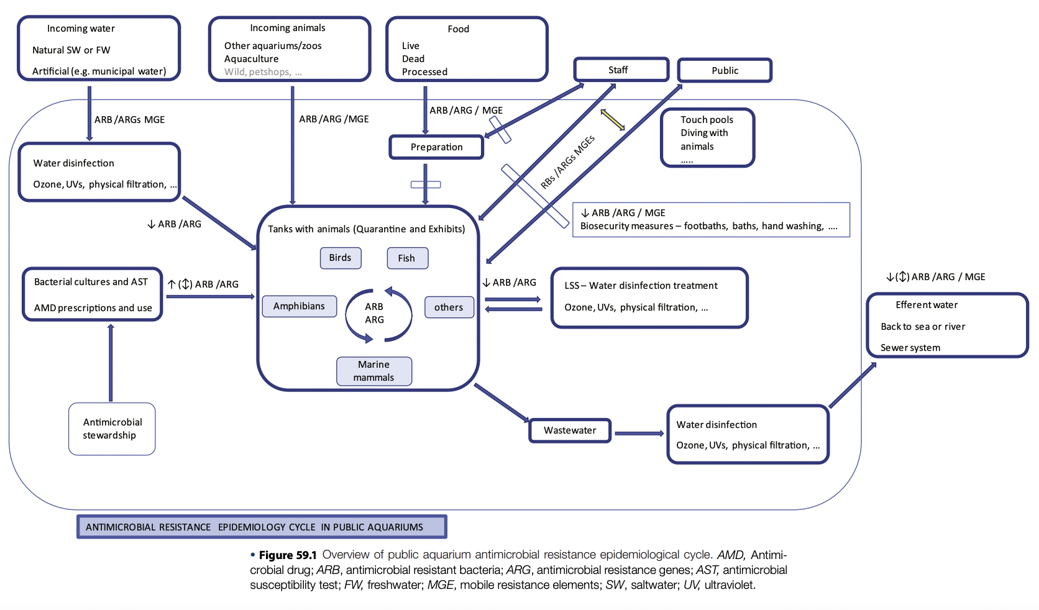
  - Most isolates are gram negative

Fowler 9 Ch 17 - Disease Risks to Native Wildlife from Zoos and Aquariums
Review by LMumm

TLDR: There are risks of disease transmission to native wildlife from zoos and aquariums, thus biosecurity and risk analysis are important to minimize risk.

Introduction
- Most potential pathogens pose low risk in native hosts but anthropogenic activities increase opportunities for host switching → thus, zoos/aquariums offer new species to facilitate pathogen host switching/disease amplification and increase risk of pathogen spillover to wildlife
- Characteristics of the best equipped pathogens:
  - Broad range of hosts (generalist or multi-host) - better at invading new hosts due to ability to infect multiple species
    - T. gondii, M. bovis or M. tuberculosis, HPAI, morbilliviruses etc.
  - Establish reservoirs in nonnative ecosystems
    - Allows pathogen to persist when population size drops
    - P. destructans (white-nose syndrome)
  - Long infectious periods = prolonged transmission opportunity
  - Evolve rapidly, and rapidly adapt new hosts i.e. RNA viruses, avian influenza
  - Transmitted by vectors - does not rely on host density
    - Can drive small populations to extinction due to efficient transmission
    - Depends on frequency of encounters between vector and host (not host density)
- Biosecurity measures + targeted risk analysis = crucial in mitigating the risk of disease spillover

Risk Analysis
- Pathogen characteristics more likely to get through quarantine
  - Long incubation period, carrier state, lack of screening test, inconsequential host
- Risk analysis in zoos should focus on pathogens alien to native wildlife and involve a multidisciplinary team of expertise (i.e. husbandry, management, nutrition etc)
  - Determine problem definition, hazard identification, and ranking of agents based on likelihood of spillover and negative impact
  - Consider probability of each step in pathogen spillover process
    - Create mitigation steps for agents with probability greater than risk tolerance
  - International Union for Conservation of Nature (IUCN) Manual of Procedures for Wildlife Disease Risk Analysis = useful tool for conducting risk analysis
- Biosecurity measures should focus on specific transmission pathways to mitigate the risk of spillover of unknown pathogens
  - Urban-adapted wildlife can be inadvertently subsidized by zoos → increasing the risk of disease transmission
  - Determine critical points of pathogen escape i.e. water runoff, fecal compost, food waste, fomites, areas where wildlife are in close proximity, etc.
    - Targeted risk mitigation efforts include i.e. minimizing food waste access for wildlife, eliminating pathogen vector breeding sites, etc.
  - No published reports of significant pathogen spillover from zoos to native wildlife, risks from non-zoo sources exist and need to be addressed
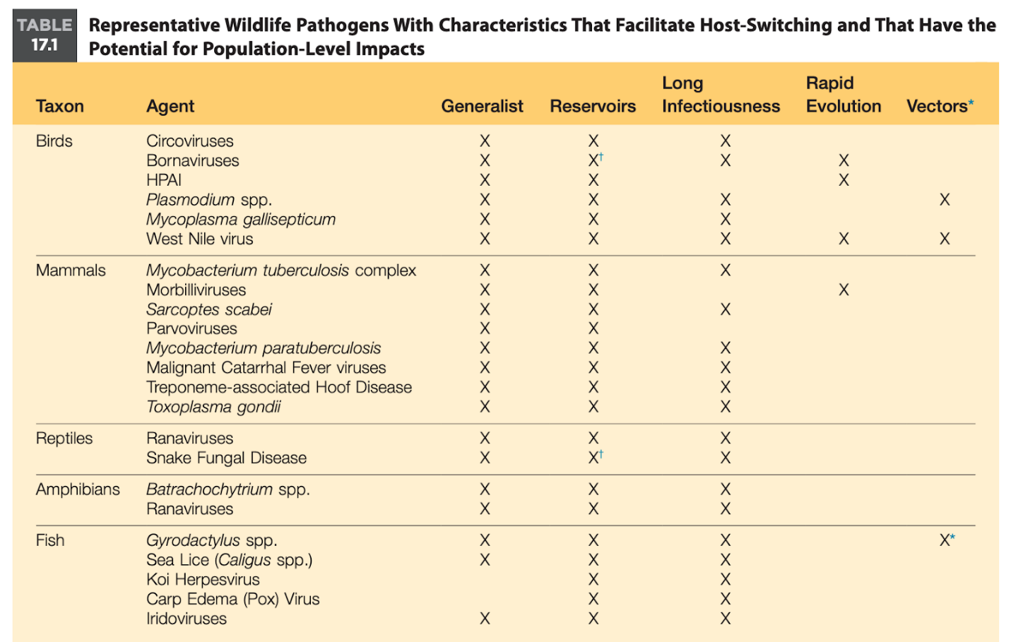

Hadfield CA. Fish Quarantine. In: Hadfield CA, Clayton LA (eds.). Clinical Guide to Fish Medicine, 1st ed. Hoboken (NJ): John Wiley & Sons, Inc; 2021. p. 298-311.
Chapter A15. Fish Quarantine
Goals: mitigate risk of wide range of opportunistic and environmental pathogens, especially with stress of transport
- Adapt to new environment and diet
- Core concepts:
  - Acquisition planning
    - Review natural history and recommended husbandry care
    - Review history of source collection
    - Capture and transport planning
    - Discuss available quarantine spaces
      - Systems should be cycled at preferred parameters: For example, if striped bass (Morone saxatilis) are held at a salinity of 5g/L pre-transport but are destined to be held at 25g/L, the quarantine system should be cycled at 5g/L, then the salinity gradually increased after the fish have been introduced.
    - Other planning includes diet, medications expected, and general contingency planning for life support system failures
  - Appropriate isolation
    - All-in-all-out practices: a quarantine system is used for a single group, then remains empty until the next group arrives. Cleaning and disinfection used between groups.
    - Two tanks within one quarantine system allows for movement of fish while being in the same water and under the same treatments
  - Ideal environmental conditions
    - Stocking densities of >1.0 cm/L (or >1.5 in./gallon), based on estimated total lengths, led to higher mortality
    - Social incompatibility is a common source of trauma and stress
    - Offer variety of foods that match both the natural diet and diet from previous source even if slowly transitioning
  - Monitoring
    - Water quality monitoring: temperature, dissolved oxygen, salinity, pH, ammonia, and nitrite, chlorines (freshwater)
    - Clinical signs to investigate:
      - Dyspnea, tachypnea, e.g. increased opercular flaring, piping at the surface, gathering at areas of turbulence
      - Pruritus, e.g. flashing, agitated swimming, clamped fins; Skin changes, particularly hyperemia, pallor, darkening, ulceration, white spots, black spots, visible parasites, or trauma
      - Poor food intake, decreased food intake, poor body condition.
      - Abnormal posture or position, e.g. increased hiding, isolated schooling fish, recumbency of mid-water fish.
      - Abnormal swimming, e.g. fast swimming, whirling.
      - Mortalities.
  - Reactive diagnostics
    - Risk-assessment approach: plan ahead based on anticipated risks of acquisition, less rigid rules of quarantine to fit specific situation
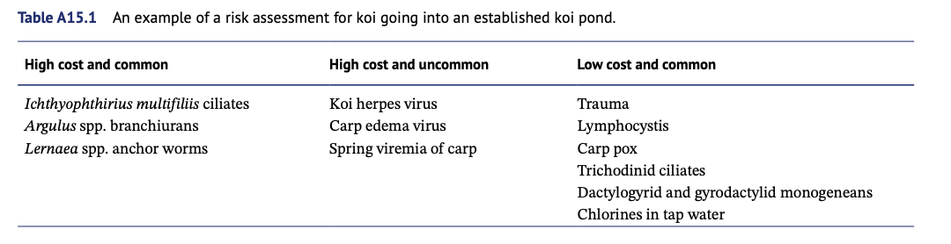
    - Evaluate cost (or risk) and probability of said cost
    - Common categories of problems during quarantine:
      - Trauma, often from catch, transport, decor, or cohorts
      - Ammonia toxicity, often due to naïve or damaged biological filtration;
      - Poor feeding response
      - Protozoal ectoparasites, particularly the ciliates Cryptocaryon irritans in salt water and Ichthyophthirius multifiliis in freshwater
      - Monogenean ectoparasites, particularly Capsalidae and Gyrodactylidae
      - Opportunistic bacteria, such as Vibrio and Aeromonas spp., particularly soon after transport
      - Viral infections, e.g. nervous necrosis virus, herpesvirus, lymphocystivirus;
      - Oomycetes, often secondary to skin damage
      - Metazoan endoparasites, e.g. digenes, nematodes
      - Crustaceans and other large ectoparasites, e.g. copepods, leeches, branchiurans.
  - Treatments
    - Always consider what supportive care can be provided at the time of handling for diagnostics
    - Necropsies always: key to look for external trauma, skin scrape, fin clip, gill biopsy, assess GI contents and coelomic fat stores, and eval for evidence of systemic inflammation
    - Remember that juvenile fish, elasmobranchs, and some teleosts have greater sensitivity to immersion meds
    - Fish with skin lesions will have greater sensitivity to immersion meds
    - Consider a “bioassay”: test treatment on a small subset of the population
- Very important to facilities with re-circulating systems using municipal water or artificial seawater: effectively “closed off” to pathogens until introductions occur
- Quarantine success of 90-95% or greater is the goal
Additional Rules of Quarantine
  - AZA: 30 days of isolation (or longer if high risk)
  - Keep bony fish, cartilaginous fish, and invertebrates in separate systems for quarantine. → different tolerances for common medications
  - Only add animals to systems with established biological filtration
    - Three weeks is the minimum time required to cycle a new system, or system with major environmental change
  - Avoid shipments around holidays, closures, or reduced staffing.
  - Fish should ideally arrive in mornings for appropriate monitoring
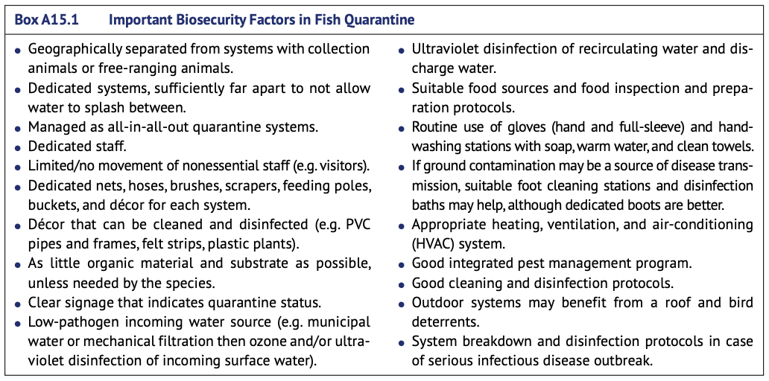
Clearing Quarantine
- Visual examination to ensure that the fish look healthy and show no visible signs of disease.
- Review of the quarantine records.
- A set period of time from any morbidity or mortality (e.g. seven days) to reduce the risk that it represented the start of an outbreak.
- A set period of time free from medications (e.g. 7–14 days) in case of adverse reaction to the medication or in case the medications were suppressing but not clearing an infectious disease of concern.
- Diagnostic testing results, if indicated based on the risk assessment.

Water Disinfection
- ultraviolet (UV) filtration can help reduce pathogen load, particularly viruses and bacteria.
- It is less effective against larger parasites at typical doses.
- UV disinfection is simple and safe, but the filters do require regular maintenance including bulb replacements and cleaning of the bulb sleeves.
- Ozone disinfection is also effective but can be hard to manage: variation in the bioload.
- Disinfection of water discharged from fish quarantine systems is also recommended to reduce the risk of transferring pathogens.
- ultraviolet and ozone disinfection, activated carbon filtration, and foam fractionation should be discontinued or taken off-line for the duration of an immersion treatment.
- Risk of toxic byproducts!
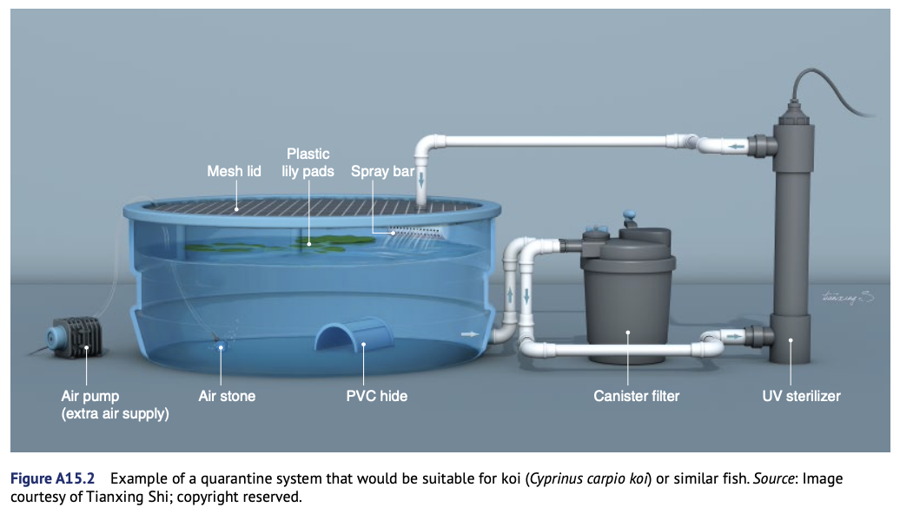
Handling Fish Fed to Fish Eating Animals
Background:
- Most captive fish-eating animals (including cetaceans, pinnipeds, penguins, etc.) are fed frozen, thawed fish
- Since daily food availability is crucial, most fish purchases are made in bulk
- Fish are perishable, appropriate food-handling procedures are crucial to the nutritive quality of the food and to the successful management/welfare of the animals
Definitions
- Thawing: the process of taking frozen product from frozen to a temperature (usually above 0 °C) where there is no residual ice (i.e. “defrosting”).
- Tempering: the process of taking frozen food to a higher temperature, it is still firm but can be further processed. Partially thawed. Multiple stages
- IQF: individually quick frozen; frozen into individual units- easily facilitating individual unit use
- Block frozen: multiple/many units quickly frozen together as a block, maximizing uniformity and minimizing individual unit use
- Must: imperative need, duty, necessity. Requirement because of legality or best practice
- Should: advice or desirable goal. A recommendation- not a requirement
- Best practice: has been shown, by research and experience, to produce optimal results
- Fish: mean all fish, including freshwater and saltwater fish, and other seafood

Ordering & Purchasing
- Must:
  - Identify the species and catch/harvest date
  - Do not maintain inventory older than 18 months from catch date
  - Fish must be packaged in containers that minimize air exposure (plastic or wax wrappings) and marked with the date of catch on the package
- Should:
  - Ask questions about history of fish and to learn about fishery conditions
- Additional Info:
  - Fish vendors do not always produce or catch the fish themselves
  - Often, commercial fish vendors work as brokers- purchase from fishers, fish farmers, and/or processors ( catch locally, regionally, and/or globally)
    - These brokers coordinate the sale and transportation of the fish
  - Knowledge of the harvest/production/catch date allows determination of the previous storage time of the fish (how long was it stored before you purchased it)
    - Some species of fish are harvested once per year; whereas some continuously throughout the year
    - For fish harvested annually: know your annual need and, if storage space allows, purchase the amount you need ASAP
  - The goal should be to purchase freshest fish possible (used 12-18 months post-harvest)
  - All fish should be of the same quality as those intended for humans
    - Fish fed to animals should be supplied from fisheries that have caught, processed, and stored the fish as if they were intended for human use
    - Primary difference between fish for human use and those for animals is that whole fish are usually fed to animals
  - Avoid dependence on one particular food item- offer a variety of fish, do not rely on a single type or species
    - Objective = provide a balanced diet using the freshest fish possible, and minimize overall quality and nutrient loss during the period of frozen storage
  - Commercial package size is 10-20 kg to allow appropriate freezing and thawing
    - Package size provide 1 day’s supply without leftovers (difficult to achieve)
  - Size of individual fish may be important to avoid cutting
    - Cutting fish = greater nutrient loss and increased time for prep
    - Cutting fish = increases the risk of contamination (surfaces and equipment)
    - If purchased processed fish (e.g. fileted) the nutrient content is altered
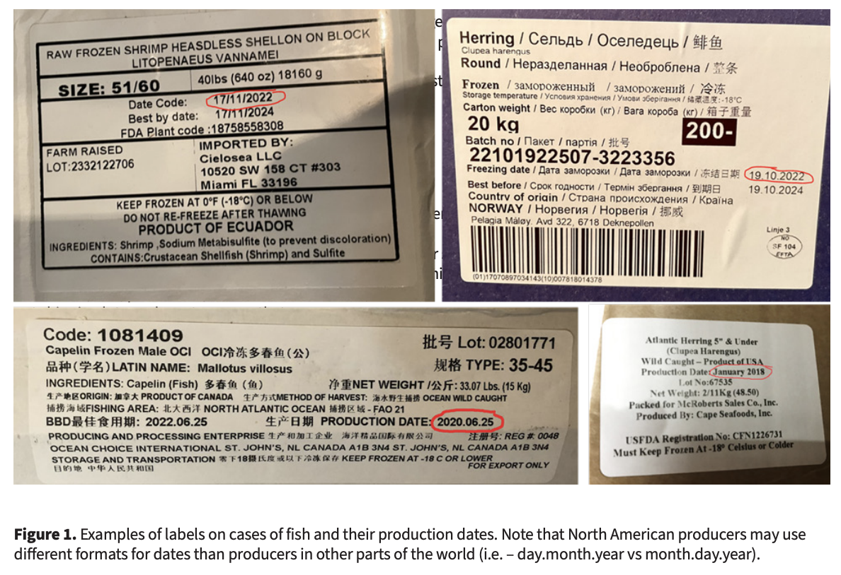
Example Questions For Seafood Vendors
- What is species, catch/harvest date, catch/ harvest location, and harvest method?
- How was the fish handled from live state through frozen storage and how long did it take to get from fresh to frozen?
- In what form is the fish frozen and what is the case weight? How is fish packaged?
- What is anticipated delivery time?
- What is the identity of the actual catch/harvest company and do they have HACCP plan in place?
- What is the status of this fish species and the fishery where it is managed?
- Is this fish species included in the Seafood Watch (or similar) program, and what is its status?
- Do you have a readily available nutrient/energy profile specific to this lot of fish (not the generic, but this specific catch date)?
- How is this fish transported from the port of arrival to the institution?
- Do you have references of current customers you can share?
Inspection
- Must: Fish must be visually inspected prior to feeding by staff trained in proper inspection techniques and fish quality and appropriate actions taken if needed
- Should:
  - Fish shipments should be visually inspected prior to accepting the shipment, ideally using a case from every lot or from different locations within the shipment when > 2 pallets
  - Inspection is a process that starts prior to ordering and ends upon feeding the fish to the animal
- Additional Info:
  - To ensure that fresh fish are handled appropriately, the fisheries (processing plant or location) should be visited during all phases of processing
  - Since the above is impractical: should ask pertinent questions (example questions above)
  - Often, the first opportunity to examine the fish is at the point of delivery
    - Products should be inspected and stored immediately, schedule deliveries during business hours
    - An inspection should occur at the place of receipt (storage site) before unloading from the delivery vehicle so a representative number of boxes can be examined
    - Inspection must be performed by one of the institution’s employees who is familiar with proper inspection techniques and fish quality
  - Check supplier’s documents to ensure that the shipment corresponds to the fish ordered
  - Observe the overall condition of the shipping vehicle and its contents
    - Sometimes shippers may transport other items in the same truck as the fish order to save costs. There should be no non-food items shipped with the fish
  - Check the temperature gauge in the storage area of the vehicle
    - If there is any question, use a portable thermometer to check the temperature inside several of the containers
  - Visually inspect contents of enough packages to ensure that entire shipment is suitable.
    - The number of packages to be inspected depends on the size of the shipment-at minimum, open and examine at least three packages – one each from the front, middle, and end of the load
    - If there are different lots of fish in the load, try to examine one box from each lot
  - Visually inspect the fish to make sure that the product is the correct species and size of fish, as well as the size and type of packaging that was ordered
  - Look for evidence of fish being thawed and refrozen
    - i.e: water or ice buildup on boxes or floor; wrappings that are moist, slimy, or discolored; fish with soft flesh, a sour odor and/or an “off” color
    - If any of these indicators are present= do not accept the load
  - Examine individual fish in each inspected box
    - Bodies should be whole (no tears in skin), healthy looking, and clear eyes
    - Inspect the fish on the bottom of the package; there should be no blood
  - If the fish have been found unsatisfactory, refuse the shipment!
  - If quality is questionable- thaw a few fish from several packages for determination
  - If the order is acceptable, a sample of fish should be taken for nutrient analyses
Storage
- Must:
  - Frozen storage facility must be able to ensure and present evidence that the fish remains free of physical, chemical, and biological contaminants and safe by maintaining freezers in proper mechanical working order
  - Move to the destination freezer as quickly as possible
  - Individual catch lots must be identifiable on each unit (box, etc.) by catch/harvest date
  - A log of freezer temperatures must be maintained, monitored, and recorded
    - These apply to on- and off-site storage facilities
- Should:
  - Stored such that a first-in, first-out (FIFO, by catch date) rotation can be employed
  - Regular monitoring of humidity, air flow, ice buildup, defrost cycles, etc., should occur and storage areas should be regularly inspected by a trained HVAC professional
- Additional Info:
  - While various nutrients may decline over time during frozen storage, there are no studies that define a time point at which well-stored frozen fish become harmful
  - Fish frozen and stored under ideal conditions for up to 18 months are routinely fed
  - It should be clear when one harvest date has been exhausted and the next has begun circulating at the institution (understanding that there can be several catch dates represented within a single shipment or delivery)
  - Frozen storage temperatures of -22 to 0 °F (-30 to -18 °C) are recommended
  - Refrigeration is used only for thawing of fish and short-term storage until fish are fed
  - Storage freezers must be monitored at least once daily and findings documented
  - Cold air ducts should be checked regularly- at least two feet of clearance between the air ducts and frozen inventory, as this can affect temperature control
  - Thermometers and tempe sensors should be located centrally (not near a door)
  - At least annual inspection of freezer units by a professional is also recommended
Transportation Within The Facility
- Must:
  - During transport, fish must be maintained at the appropriate temperature for the desired state (frozen, tempered, or thawed)
- Should:
  - Transportation procedures should be verified once per year using temperature/data loggers that are transported with the fish
- Additional Info:
  - If fish is transported in a tempered or thawed state, it should be done so in a manner which maintains appropriate and safe fish temperatures
  - If fish arrived thawed, it should not be refrozen it needs to be used within 24 hours
Tempering & Thawing
- Must:
  - Fish must be thawed under refrigeration except in emergent situations
  - If not fed, fish must be discarded within 24 hours of reaching the thawed stage
- Additional Info:
  - Incorrect thawing increases the potential for nutrient loss, lipid peroxidation (rancidity), microbial buildup and loss of palatability
  - The safest and most preferable way to thaw fish is in a refrigerated space
  - Perishable foods should never be thawed on the counter or in hot water and must not be left at room temperature for more than two hours
  - The USDA outlines three methods for tempering and thawing frozen seafood:
    - Refrigerator Thawing: Frozen seafood- tempered and thawed gradually under refrigeration or in such a manner that the external temperature of the fish does not exceed 40°F
      - In refrigerator thawing=fish should be kept in wrapping or in a container which provides insulation, prevents air exposure, and allows the fish to thaw uniformly
      - Do not thaw fish above other food items to avoid cross-contamination
      - The use of fans to increase airflow in the cooler is supported, but only if fish are covered and protected from direct wind
        - High speed air flow causes loss of fluid through dehydration and oxidation
    - Cold Water Thawing: Although not recommended as a standard practice, if seafood must be thawed quickly, it can be thawed under cold running water
      - The fish should be sealed in a plastic bag and immersed in cold running water
    - Microwave Thawing: Although not recommended as a standard practice, food may be thawed in the microwave on the defrost setting, using caution not to partially cook the item
  - Rinsing: Fish may be quickly rinsed by agitating in cold running water to remove thawing juices and other debris, and to minimize dangerous bacteria (e.g., Erysipelothrix rhusiopathiae)
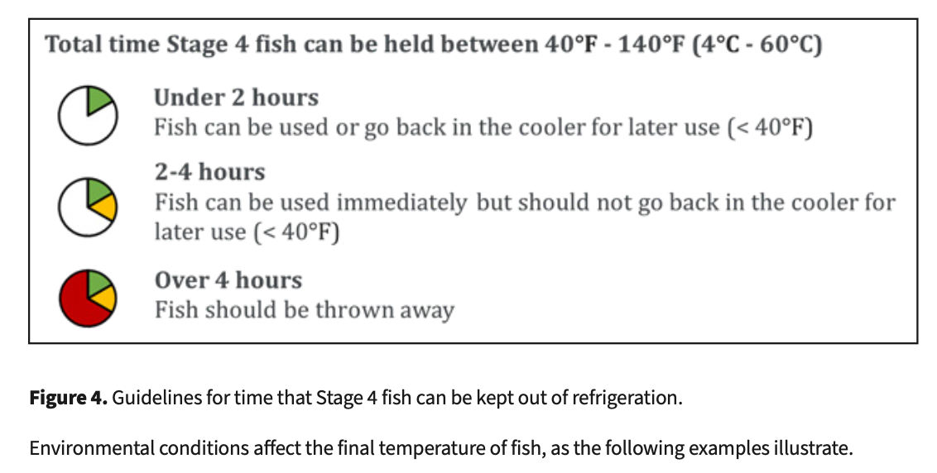
    - The rinsing process should be completed quickly to avoid nutrient losses from soaking the fish
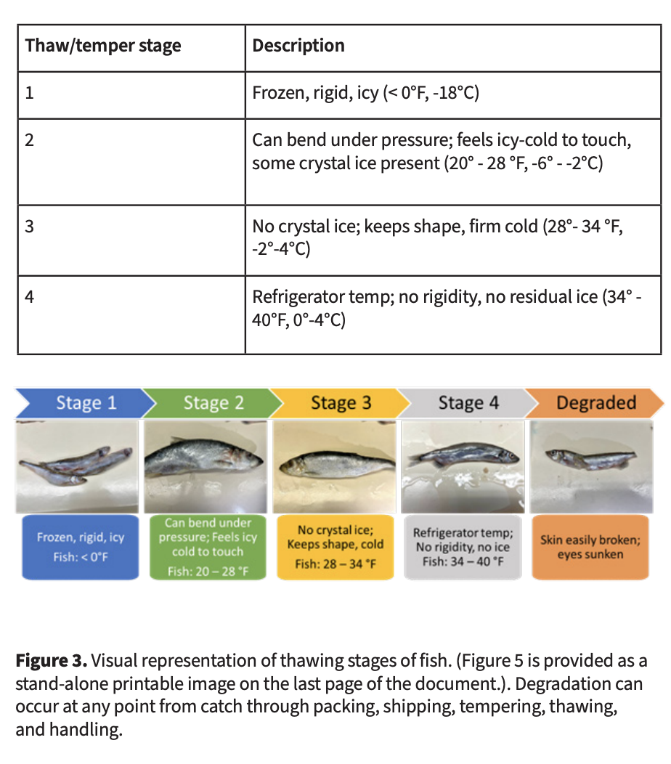
  - Refreezing: It is sometimes necessary to temper large blocks of fish in order to repackage and refreeze them in smaller quantities
    - Purchasing IQF (individually quick-frozen) fish or purchasing smaller package sizes may avoid the need for this
    - Fish should be tempered as minimally as possible before refreezing
    - Fish that have reached Stage 4 (completely thawed, refrigerator temp) should not be refrozen
    - Repackaged portions should be labeled with the item name, original catch date, and re-freeze date (or updated expiration date) on either the package itself or on an enclosing container
    - Repackaged, refrozen portions will have a reduced shelf life
    - When refrozen fish is later thawed, it should be used immediately and never refrozen

Handling, Preparing, and Feeding Thawed Fish
- Must:
  - Fish must be processed (weighed, cut) immediately upon removal from the thawing stage and as close as possible to feeding time
  - Time spent at room temperature must be minimized
  - All fish handlers must wash their hands both before and after handling fish
  - Food must be wholesome, palatable, free from contamination, and of sufficient quality/nutrition
- Should:
  - Fish should be fed cold but not frozen
  - Feeding procedures should be validated
  - Fish should be inspected again for quality prior to feeding
  - Diets of animals fed frozen fish should include supplementation to make up for nutrient losses during frozen storage and thawing
  - Animal feeding should be overseen by an employee managing the species in question
  - Employees should be trained to notice changes and issues when feeding
- Additional Info:
  - Public feeding of fish is allowable if the food is provided by the holding institution, held under proper conditions, and feeding is supervised by a qualified employee
  - When thawed, fish have prominent clear eyes, and firm elastic flesh
    - Old or thawed and refrozen fish are dull, have cloudy and red-bordered eyes, and have soft flesh (finger impressions are made easily and remain)
  - USDA defines the temperature danger zone as 40°F - 140°F (4°C - 60°C)
  - Processing of thawed fish may consist of weighing fish, removing fins with potentially harmful spines, and cutting whole fish into appropriate sizes for an animal to consume
    - The goal is to perform these processes while minimizing bacterial contamination, maintaining temperature guidelines, minimizing time spent in the “Danger Zone” and assuring wholesomeness and nutritive value
  - Utensils and processing surfaces to be used must be cleaned and sanitized prior to fish processing
  - Care should be taken to minimize surface contamination
  - Reasonable precautions should be taken when handling raw fish
    - Gloves serve to protect the wearer from zoonotic diseases and bacteria that can exist in fish
    - If the gloves are changed regularly, they can help minimize surface contamination of the fish, thereby protecting the animals as well
  - The USDA requires that marine mammals be fed at least once daily unless otherwise indicated by veterinary treatment or accepted practice
  - All feeding receptacles must be cleaned and sanitized after each use
  - When animals are fed individually, USDA requires an employee or attendant responsible for management to perform or directly oversee the feeding
    - The employee must be able to recognize alterations from a normal state of health in order to adjust food intake
Vitamin Supplementation
- Diets should include sufficient vitamin or mineral supplements to make up for nutrient losses
- Typically, thiamin and vitamin E are necessary to supplement
  - Vitamin E is destroyed during fat breakdown (oxidation) during storage. The extent to which this occurs depends on the fat content of the fish and length of storage
  - Enzymes (thiaminases) naturally present in fish tissue may destroy thiamine during storage
  - Supplementation should be documented as part of the diet record
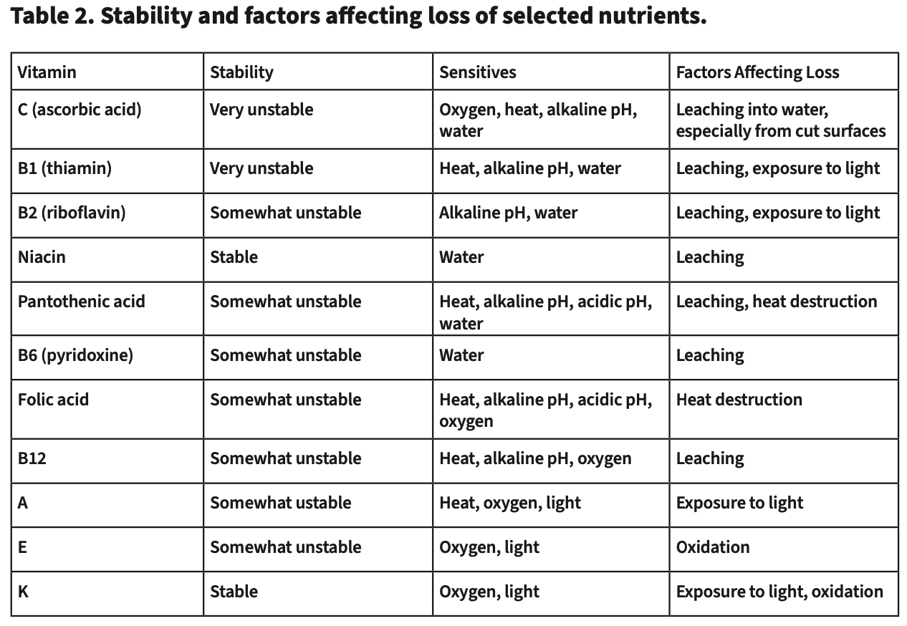
Cleaning & Sanitation
- Must:
  - Sanitize all equipment that contacts food items
  - Ensure a pest mitigation plan is in place
  - All chemicals and non-animal food items must be safely stored separately from or below animal food and food prep areas
- Additional Info:
  - USDA requires food-contact surfaces must be cleaned at least once daily
  - Surfaces within the preparation area not directly in contact with fish such as floors, doors, and handles should be cleaned and sanitized as frequently as appropriate
  - Sanitation can be accomplished by one of the following methods using a final sanitizing rinse:
    - Contact with a solution of 100 parts per million (ppm) available chlorine for 20 seconds or 50 ppm for at least a minute
    - Contact with a solution of 25 ppm available iodine for 1 minute
    - Contact with a solution of 200 ppm quaternary ammonium for 1 minute
    - Contact with water of at least 170° to 180°F (77°C to 82°C) for at least 15 minutes
    - Use of a dishwashing machine with approved sanitizing methods (chemical or hot water).
    - Washing all surfaces with a detergent solution followed by a safe and effective disinfectant following the manufacturer’s directions
Validating Procedures
- Must:
  - Procedures and processes used to handle fish must be validated (proven effective)
- Should:
  - Validation is an ongoing evaluation- periodic intervals (annually) or when a procedure is changed
- Additional Info:
  - Nutritional composition of fish can be determined by periodic sampling of the fish at any stage
  - Fish can be analyzed for nutrient content, toxins, or specific microbes, as well as visually inspected for quality
  - Temperature control can be validated by documenting temperatures and storage compartments at key points in the process
  - For validation, the temperature of the fish should be recorded at critical control points throughout processing and delivery, including receipt, storage, thawing, preparation, and before feeding
Analyses of Fish Quality
- Must:
  - Safety and appropriateness of fish must be ensured through testing or collaboration with vendors
- Should:
  - The processes to assess quality of fish should reflect the institutional needs and risks to animals
- Additional Info:
  - A minimum of annual nutritional analysis on a representative sample, with an ideal level of sampling of every new catch used
  - A basic nutritional analysis includes moisture, protein, and fat
  - Additional analyses of interest may include mineral content
  - Vitamin A analysis may be indicated in some situations
    - Apex predator fish species can accumulate high levels of vitamin A, which can be problematic if animals are eating a limited or single-species diet
  - When taking samples for nutrient analyses that samples represent what is consumed
    - Ex: if only the filet is fed, sampling the whole fish would not be an accurate representation of the nutrients consumed
  - Algal toxins may be found in invertebrate seafood taxa and some vertebrate taxa
    - Algal toxins biomagnify in food webs, peaking in higher trophic levels
    - Few labs test for these toxins, so evaluate the risks to your collection and the sensitivity of your species being fed the fish
    - Various state and national government websites can be used to track outbreaks, and reputable fish vendors will be aware of the issues and avoid purchasing fish caught in these areas during outbreaks
  - While measuring microbial load (measurement of colony forming units (CFU)) is possible, fish are not sterile, and a high number CFUs does not indicate compromised or poor quality
    - This analysis is best used as a possible way to validate fish handling procedures
    - Ex: large increase in CFU from storage to feeding- contamination or poor handling
  - Organisms need water to grow. Salt dissolved in water draws water from the cells, and freezing may damage tissue, causing a release of juices when thawed
    - The emulsions of fat and water caused by the breakdown of tissue and denatured protein are more readily available for organisms
  - Measuring oxidation (thiobarbituric acid, TBA) is tested as a proxy for rancidity or degradation
    - However, interpreting the results is difficult - there are no standards for acceptable levels
