PHYSIOLOGICAL EFFECTS OF AZAPERONE AND MIDAZOLAM ON NETGUN-CAPTURED MULE DEER (ODOCOILEUS HEMIONUS)

ABSTRACT: Netgun capture is a commonly used capture method for mule deer (Odocoileus hemionus) in North America. Mortalities during netgun captures are generally low, and most often caused by direct trauma and occasionally fatal capture myopathy. Capture is a stressful event for a wild animal, and subclinical capture myopathy is difficult to measure. The use of tranquilizers during netgun capture is not widespread. We compared physiologic variables from 250 netgun-captured deer (57 males and 193 females) that did or did not receive midazolam and azaperone (mean, 0.14 mg/kg; SD, 0.02 mg/kg; range, 0.08–0.21 mg/kg) at time of capture and before transporting to a processing location, with the goal of evaluating whether drug administration would improve or worsen the physiologic state of the animal. Deer were captured in association with management activities between December 2018 and March 2020, with 132 deer receiving midazolam and azaperone at time of capture. Variables recorded included chase times, time from capture to arrival at the processing location, time from capture to release, serial rectal temperatures, heart rates, respiratory rates, body condition, age, sex, O2 administration, creatine kinase, aspartate aminotransferase, packed cell volume, red blood cell concentration, and hemoglobin, as well as serial venous pH, pCO2, HCO3, and base excess. All animals were collared with GPS tracking devices and monitored after release. There was no difference in survival after capture between deer that did or did not receive midazolam and azaperone. All animals experienced severe metabolic lactic acidosis, which generally worsened with increasing chase time, highlighting the critical importance of limiting chase times during captures. Drug administration did not influence the degree of metabolic acidosis; however, it appeared to have a favorable effect on several stress-related indices, including rectal temperature, heart rate, respiratory rate, and packed cell volume.

- Netgun: considered one of the safest and most efficient way of capturing mule deer and bighorn sheep
- Mortality rate of netgun captures are low- but causes include direct trauma and capture myopathy
  - Which can be reduced by limiting chase time, efficiently securing the animal in the net, avoiding capturing in warm weather and unsuitable terrain, limiting transport time after capture and reducing handling time
- Capture myopathy: metabolic acidosis, muscle necrosis, and myoglobinuria= preacute or delayed death
- Netgun captured bighorn sheep: severe lactic acidosis, elevated CK, AST, LDH and reduced WBC counts
- In a study evaluating red deer- those that were injected with xylazine and ketamine had lower physiological derangements than those that were not
- Midazolam: benzodiazepine; Azaperone: butyrophenone (antidopaminergic and antagonistic to alpha 1 receptors); both have minimal cardiovascular effects
- 250 deer: 132 received 7-15 mg of both midazolam and azaperone at time of capture; two venous blood gas measurements were performed on 194 deer
- Tranquilized deer appeared subjectively calmer however ALL deer were released without complications
- 7 deer died within 3 week of capture: one had a large cranial hematoma and the others were suspected capture myopathy- 3 of these deer (including the hematoma one received drugs)
- 69% of deer (even those given drugs) had a lactate of above 20
- Respiratory rate were significantly lower in deer that got drugs; increasing drug doses resulted in lower HR
- HR, RR, temperature, BUN, CK, and AST increased with increasing chase time and pH pCO2 and HCO3 and BE became lower
- All deceased deer had a higher neutrophil count
- Those deer given drugs= either dropped or remained unchanged in temperature

Take home: Drug administration at the time of capture DID NOT influence mortality rates after release. All deer had varying degrees of lactic acidosis (which was associated with longer chase times), and drugs did not influence the degree of metabolic acidosis- but these animals did appear calmer (temperature did not change, lower HR, RR, and PCV)

THE RELATIONSHIP BETWEEN HARVEST MANAGEMENT AND CHRONIC WASTING DISEASE PREVALENCE TRENDS IN WESTERN MULE DEER (ODOCOILEUS HEMIONUS) HERDS

We analyzed retrospective data on harvest management practices and corresponding
chronic wasting disease (CWD) prevalence trends in 36 western US and Canadian mule deer (Odocoileus hemionus) management units (units). Our analyses employed logistic regression and model selection, exploiting variation in practices within and among jurisdictions to examine relationships between harvest management and apparent prevalence (the proportion of positive animals among those sampled). Despite notable differences in hunting practices among jurisdictions, our meta-analysis of combined data revealed strong evidence that the amount of harvest was related to CWD prevalence trends among adult male mule deer in the 32 units where prevalence at the start of the analysis period was 5%. All competitive models included the number of male deer harvested or number of hunters 1–2 yr prior as an explanatory variable, with increasing harvest leading to lower prevalence among males harvested in the following year. Competitive models also included harvest timing. Although less definitive than the number harvested, median harvest dates falling closer to breeding seasons were associated with lower prevalence in the following year. Our findings suggest harvest—when sufficient and sustained—can be an effective tool for attenuating CWD prevalence in adult male mule deer across western ranges, especially early in the course of an epidemic. Evidence of a broad relationship between the amount of harvest and subsequent changes in CWD prevalence among adult male mule deer provides an empirical basis for undertaking adaptive disease management experimentation aimed at suppressing or curtailing CWD epidemics.

- Chronic wasting disease (CWD); infectious prion disease of multiple cervid species
- Difficult to detect emergent epidemics in natural systems combined with protracted infectious period and environmental persistence of the prion precludes eradication
- The amount of harvest and timing relative to breeding season have the potential to influence CWD epidemics
- Increasing harvest and hunter numbers led to lower prevalence in the following year
- Median harvest date closer to peak breeding date led to lower prevalence the following year
- Status quo harvest level was 1000 males; for every 100 additional males harvested the estimated effect was 2% decreased in CWD prevalence
- Focus harvesting closer to mule deer breeding - shortly before, during or after- could help lower prevalence because it is maximizing harvest of the prime age class males that disproportionately harbor high prevalence
- Affected deer also appear more vulnerable to harvest

Journal of Wildlife Diseases, 58(4), 2022, pp. 803–815

CAUSE OF DEATH, PATHOLOGY, AND CHRONIC WASTING DISEASE STATUS OF WHITE-TAILED DEER (ODOCOILEUS VIRGINIANUS) MORTALITIES IN WISCONSIN, USA
Marie L. J. Gilbertson,1,8 Ellen E. Brandell,1 Marie E. Pinkerton,2 Nicolette M. Meaux,1 Matthew Hunsaker,1,3 Dana Jarosinski,3,4 Wesley Ellarson,3 Daniel P. Walsh,5 Daniel J. Storm,6 and Wendy C. Turner7

Abstract: White-tailed deer (WTD; Odocoileus virginianus) are a critical species for ecosystem function and wildlife management. As such, studies of cause-specific mortality among WTD have long been used to understand population dynamics. However, detailed pathological information is rarely documented for free-ranging WTD, especially in regions with a high prevalence of chronic wasting disease (CWD). This leaves a significant gap in understanding how CWD is associated with disease processes or comorbidities that may subsequently alter broader population dynamics. We investigated unknown mortalities among collared WTD in southwestern Wisconsin, USA, an area of high CWD prevalence. We tested for associations between CWD and other disease processes and used a network approach to test for co-occurring disease processes. Predation and infectious disease were leading suspected causes of death, with high prevalence of CWD (42.4%; of 245 evaluated) and pneumonia (51.2%; of 168 evaluated) in our sample. CWD prevalence increased with age, before decreasing among older individuals, with more older females than males in our sample. Females were more likely to be CWD positive, and although this was not statistically significant when accounting for age, females were significantly more likely to die with end-stage CWD than males and may consequently be an underrecognized source of CWD transmission. Presence of CWD was associated with emaciation, atrophy of marrow fat and hematopoietic cells, and ectoparasitism (lice and ticks). Occurrences of severe infectious disease processes clustered together (e.g., pneumonia, CWD), as compared to noninfectious or low-severity processes (e.g., sarcocystosis), although pneumonia cases were not fully explained by CWD status. With the prevalence of CWD increasing across North America, our results highlight the critical importance of understanding the potential role of CWD in favoring or maintaining disease processes of importance for deer population health and dynamics.

Summary:
- Among captive and free-ranging deer, pneumonia has been a leading infectious cause of death: pathologic assessment of free-ranging deer is limited
- Increasing prevalence of chronic wasting disease (CWD) in N. American cervids
  - First detected in 2001 → understanding transmission dynamics
  - State DNRs (WI) capture/fit with GPS collars for CWD surveillance, or VHF transmitter in neonates
  - Collared deer were monitored until death or lack of signal → “mortality signal” (lack of motion) → submit for VDL necropsy unless significantly scavenged (field necropsy) or certain cause of death (witnessed hit by car)
  - All mortalities with available lymphoid or brain tissues underwent post-mortem CWD testing via immunohistochemistry.
- N = 1065 collared, n = 645 (60.5%) died/95% of those received a necropsy, n = 278 (26.1%) collar failure, n = 142 (13.3%) still alive
- Predation and infectious disease were the top suspected causes of death, followed by trauma
- MC cause of mortality in deer <1 YO was predation
- N = 245 (42.4%) were CWD positive, across age classes
  - Increasing prevalence with increased age up to 6 YO, then declined at older ages
  - Females > males (1.6X more likely to be CWD positive)
- N = 86 diagnosed with pneumonia, 59.3% of those moderate to severe
  - Bronchopneumonia was the most common type identified, and lesions were most often multifocal and/or cranioventral
  - NOTE: only aerobic cultures were performed!!
  - Etiologic agents unclear, ID’ed in n = 15 cases, mixed infections
    - 100% Trueperella pyogenes identified
      - Other non-contaminants: Bibersteinia trehalosi, Pasteurella multocida subsp. multocida
- Other notable conditions ID’ed: serous atrophy of fat/hematopoietic atrophy, myocardial denegeration or necrosis, enterocolitis, parasitism: ectoparasites (lice/ticks; 22.5%), endoparasites: haemonchosis, GI nematodiasis, pulmonary nemotodiasis, skeletal muscle sarcocystosis
- While a broad classification of ‘‘any pneumonia’’ was not associated with CWD status, evaluating only cases specified as bronchopneumonias found a stronger relationship with CWD (odds ratio, OR= 3.22, P= 0.032, though not statistically significant with a Bonferroni correction)
- Nutritional condition was consistently poor among deer diagnosed with CWD, regardless of pneumonia status (expected)
  - among pneumonia-negative individuals, those that were CWD-positive were eight times more likely to be in poor body condition than those that were CWD-negative
- Top GI and cardiac lesions did not show associations with CWD status

Key Points:
- CWD prevalence increased with age before decreasing among older classes (finding is consistent across studies in this region)
- Females > males: prevalence, severity??
  - Of note: hunter harvested males were obviously lacking in this sample, so older males were disproportionally missing from the sample
  - This sex-based difference was not statistically significant when we accounted for age of individuals
- CWD associated with poor body condition and ectoparasitism
- Cranioventral bronchopneumonia:
  - Aspiration pneumonia is expected to be associated with late-stage CWD as motor function declines
  - Deer with CWD could act as reservoirs or maintenance hosts for transmissible pneumonias

Journal of Wildlife Diseases, 59(1), 2023, pp. 61–70

EVALUATING THE EFFICACY OF NONINVASIVE FECAL SAMPLING FOR PREGNANCY DETECTION IN ELK (CERVUS CANADENSIS)
Eryn M. Watson,1 Katherine A. Kurth,1 Dailee L. Metts,1 Sarah E. Moorey,2 Bradley F. Miller,3 Richard W. Gerhold,4 and Lisa I. Muller1,5
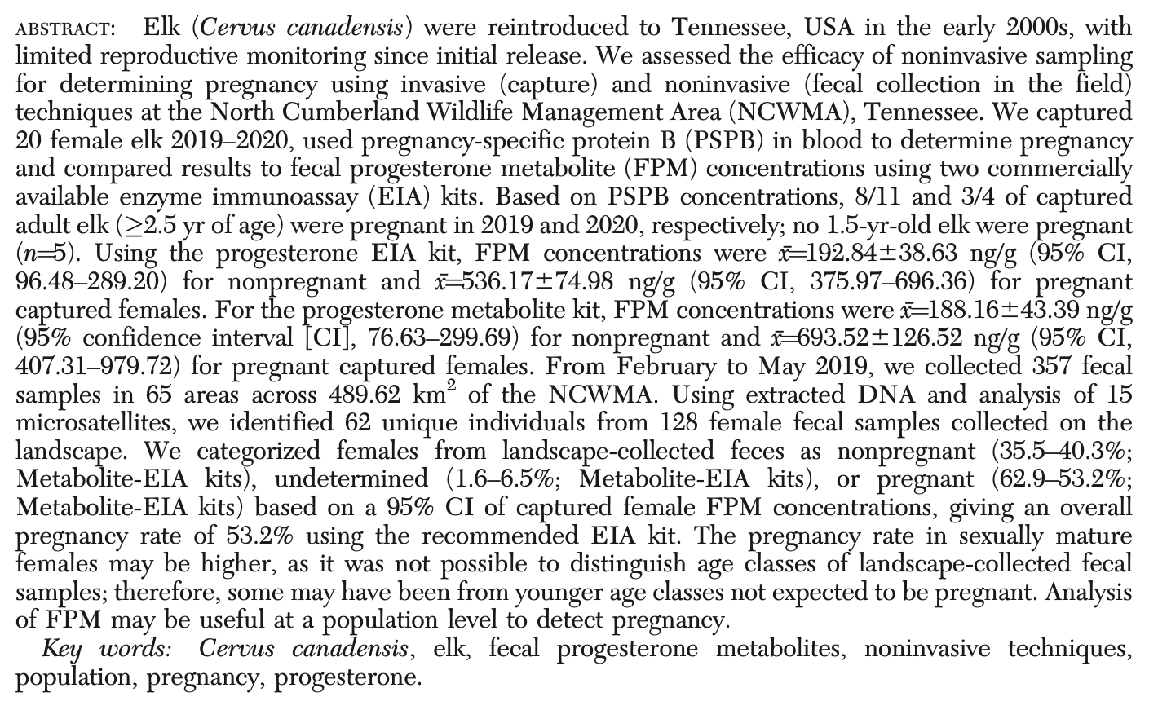

Review:
- Pregnancy specific protein B (PSPB):
  - A protein hormone secreted by the placenta in ruminants
  - High accuracy when evaluated in elk and white-tailed deer (and giraffe!)
  - Requires a blood sample: impractical for wildlife, pop. mgmt. settings
- Fecal progresterone metabolites (FPM):
  - Progesterone is produced by the CL after ovulation, then the CL, placenta, and adrenal gland during pregnancy
  - Elk: progesterone levels increase after conception and remain high throughout gestation before declining shortly before parturition
  - Blood samples may reflect stress due to adrenal involvement
  - Alternatively, steroid metabolites are stable in feces, and unaffected by stress

Summary:
- Objectives: compare PSPB to FPM concentrations in feces; compare two enzyme immunoassay kits for FPM analysis; evaluate fecal sampling for pregnancy determination on population scale
- Genotyping was performed to ensure fecal samples were from females: fecal genotyping success rate of 44%. Hair was used from immobilized elk
- Captured 21 female elk (16 adults and five yearlings), collected a blood sample from 20 females, and collected a fecal sample from 17 females. From noninvasive fecal sampling: identified 128 female samples (62 unique individuals).
- Using PSPB from blood (n=20; 15 adults and five yearlings), we categorized 77% (8/11) adults in 2019 and 75% (3/4) adults in 2020 as pregnant. No yearling females (n=5) were pregnant.
- Used 16 of the 21 captured females (12 adults and four yearlings) with both a blood and fecal sample collected at the time of capture to establish FPM concentration reference ranges for nonpregnant and pregnant females.
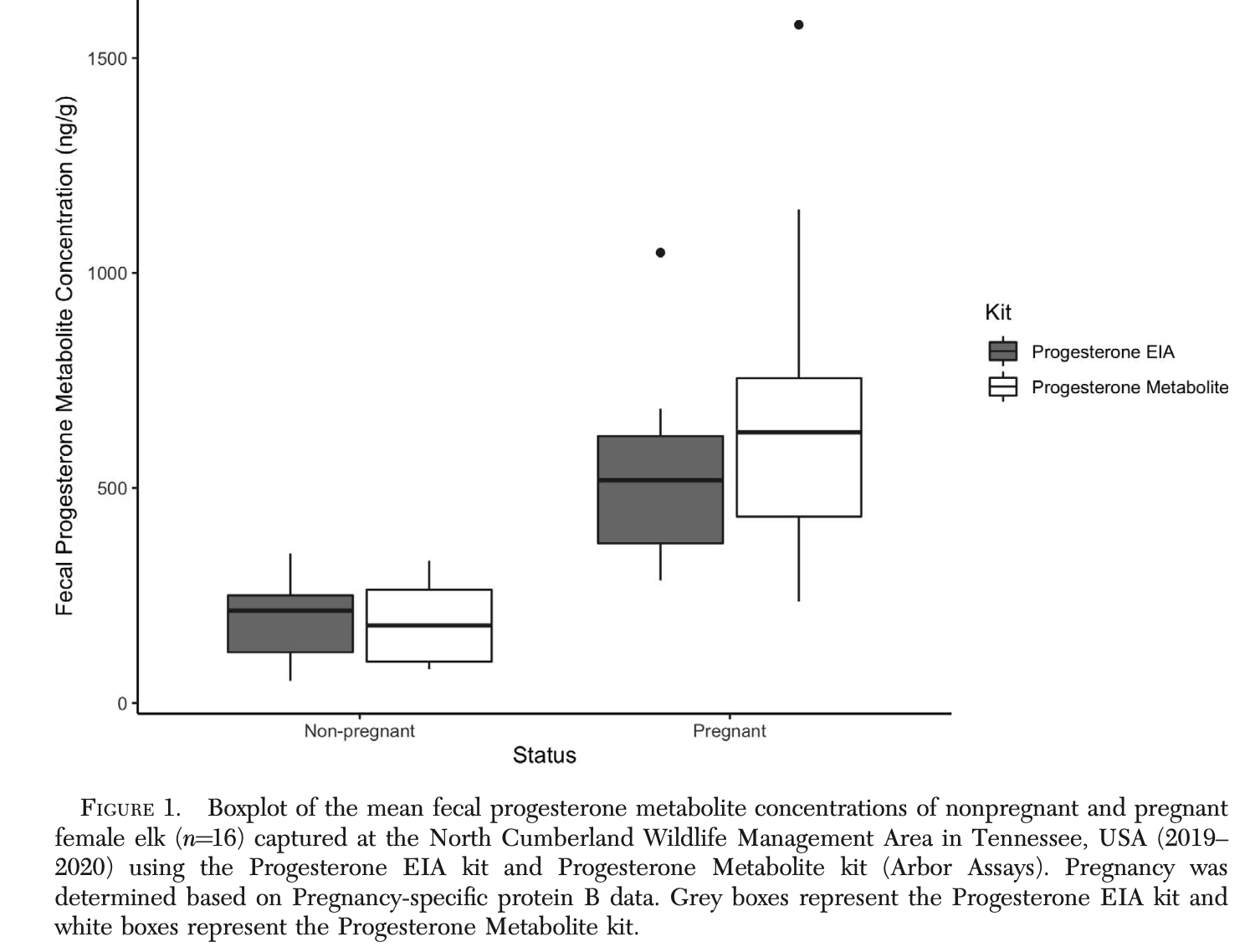

Key Points:
- Pregnancy rates below 80% in adult elk 3.5–7.5 yr of age may indicate reproductive issues within the population, as adult females are expected to be highly fertile (previous pubs)
  - For fecal sampling: We were unable to differentiate between age classes; therefore, we may have inadvertently included female calves and yearlings in our analysis, and this may have inflated the number of females categorized as nonpregnant.
- females with multiple fecal samples collected during our study had no change in pregnancy status and relatively similar FPM concentrations across individual samples.
  - consistently categorizes pregnancy status for 71% of females with the Progesterone EIA kit and 83% of females with the Progesterone Metabolite kit using at least two samples collect- ed from an individual.
- It is possible that the Progesterone Metabolite kit may be more sensitive to human error occurring in the assay based on higher coefficient of variation in duplicates for that kit
- comparison of the two EIA kits indicated no significant difference in FPM concentrations between results of the Progesterone EIA kit and the Progesterone Metabolite kit.
- The Progesterone EIA kit showed higher precision compared to the Progesterone Metabolite kit.
- the Progesterone EIA kit had lower intraassay and interassay %CV between replicates, indicating a potentially better option for FPM evaluation
Utilizing smartphone-based electrocardiography and thoracic radiography to evaluate cardiac function and morphology in geriatric Sika deer (Cervus nippon). AJVR 2021. Hugo A Gonzalez-Jassi; Nicole LeBlanc; Benjamin E. Alcantar; Rodrigo S. Garces Torres. - review by LMumm

OBJECTIVE: To describe qualitative and quantitative cardiothoracic values in geriatric Sika deer (Cervus nippon) using digital radiography, 6-lead ECG (sECG), and smartphone-based ECG (aECG).
ANIMALS: 10 healthy geriatric Sika deer (9 females and 1 male).
PROCEDURES: Deer were chemically immobilized (telazol/xylazine), thoracic radiographs (r lateral and VD) were obtained, and inhalant anesthesia was initiated. An sECG and aECG were simultaneously recorded for each animal using the same ECG specifications. Results were compared between devices.
RESULTS: Radiographically, no deer had any cardiopulmonary abnormalities. Median (range) values for the most important cardiac measurements were 170 (153–193) mm for cardiac height, 135 (122–146) mm for cardiac width, 9 (8–9) for vertebral heart score, and 99 (69–124) mm for cardiosternal contact. All deer had a normal sinus rhythm with no pathological arrhythmias noted. A significant difference between sECG and aECG was identified for minimum heart rate (49 vs 51 beats/min, respectively), P wave duration (0.05 vs 0.03 seconds), P wave amplitude (0.28 vs 0.10 mV), PR interval (0.15 vs 0.12 seconds), and QT interval (0.39 vs 0.30 seconds).
CLINICAL RELEVANCE: Thoracic radiographs were suitable to evaluate basic cardiothoracic morphology in Sika deer. The aECG was useful for assessing heart rate and rhythm but, compared with sECG, proved no substitute for evaluating duration and amplitude of ECG waveforms.

Background:
- Cervids high risk species for immobilization due to capture myopathy
- Alterations in contractility and cardiac electrical activity common in aged domestic ruminants and common to have geriatric population in captivity
- Distribution of Purkinje cells in ruminant heart is diffuse (compared to non-ruminants) thus MEA axis range and QRS morphology can be variable and often shorter than non-ruminant species
- ECG can be challenging in free range setting thus goal to investigate smartphone/rads

Key Points:
- All deer appeared healthy with no evidence of cardiac disease (no arrhythmias/HM)
- Phone ECG is an affordable and feasible option for measuring HR and rhythm in field BUT is not a valid substitute for evaluation of waveforms, amplitudes, durations or timing intervals
  - No significant differences between 6 lead ECG and smartphone ECG for maximum HR, QRS duration and amplitude, and T wave amplification
  - There was significant difference between minimum HR, P wave duration and amplitude, PR interval and QT interval
- Thoracic radiographs were suitable to evaluate basic cardiothoracic morphology in sika deer
  - VHS (8.6 +/- 0.5) and cardiosternal contact (3 sternebrae) similar to other ruminants
- Limitations: geriatric but young geriatric ages range, no echocardiograms for comparison, lack of comparison to younger animals

TLDR: Smartphone ECG is accurate for HR and rhythm but not for ECG waveforms in sika deer
- R lateral thoracic radiograph appropriate for evaluating cardiothoracic anatomy in sika

DETECTION OF SARS-COV-2 NEUTRALIZING ANTIBODIES IN RETROPHARYNGEAL LYMPH NODE EXUDATES OF WHITE-TAILED DEER (ODOCOILEUS VIRGINIANUS) FROM NEBRASKA, USA. JWD 59(4), 702-708, 2021. Korakrit Poonsuk, Duan Loy, Rachael Birn, Bryan Buss, Matthew Donahue, Todd Nordeen, Kylie Sinclair, Luke Meduna, Bruce Brodersen, John Dustin Loy. - review by LMumm

Abstract: Disease surveillance testing for emerging zoonotic pathogens in wildlife is a key component in understanding the epidemiology of these agents and potential risk to human populations. Recent emergence of SARS-CoV-2 in humans, and subsequent detection of this virus in wildlife, highlights the need for developing new One Health surveillance strategies. We used lymph node exudate, a sample type that is routinely collected in hunter-harvested white-tailed deer (WTD, Odocoileus virginianus) for surveillance of chronic wasting disease, to assess anti-SARS-CoV-2 neutralizing antibodies. A total of 132 pairs of retropharyngeal lymph nodes collected from Nebraska WTD harvested in Nebraska, US, in 2019 (pre–SARS-CoV-2 pandemic) and 2021 (post–SARS-CoV-2 pandemic) were tested for SARS-CoV-2 with reverse transcription PCR. Thereafter, exudates obtained from these same lymph nodes were tested for SARS-CoV-2 neutralizing antibodies using a surrogate virus neutralization test. Neutralizing antibodies were detected in the exudates with high diagnostic specificity (100% at proposed cutoff of 40% inhibition). Application of this testing approach to samples collected for use in other disease surveillance activities may provide additional epidemiological data on SARS-CoV-2 exposure, and there is further potential to apply this sample type to detection of other pathogens of interest.

Background:
- Natural infections with SARS-CoV-2 reported in dogs, cats, minks, tigers, lions, snow leopards, gorillas, otters, spotted hyena, mule deer and WTD
  - Deer to human transmission has been confirmed
  - WTD may act as reservoirs or play role in driving variation of strains
  - SARS-CoV-2 specific Ab have been detected in captive WTD 13 mo post-exposure
    - Detection of Ab may persist longer than detection of virus itself thus Ab serology may be viable test for surveillance
- Serum is specimen of choice for detecting Ab, often impractical with post-mortem sampling
  - LN routinely collected from harvested WTD for CWD testing thus can be alternative
  - Concentrations of Ab in LN likely lower than serum but are detectable

Methods: tested RLN from 2019 (pre-pandemic) and 2021 (post-pandemic) for SARS-CoV-2 via RT-PCR then tested subset of RLN exudate for Ab to validate neutralizing Ab test as surveillance for SARS-CoV-2

Key Results/Points:
- RLN tested for SARS-CoV-2 with reverse transcription PCR
  - 2019 samples (n=500) all PCR negative
  - 2021 samples (n=489): n=79 PCR positive, n=410 PCR negative
- Sub-sample of LN exudates tested for neutralizing antibodies using virus neutralization
  - 2019 samples (n=40): all PCR negative, all Ab negative
  - 2021 PCR positive samples (n=52): 85% seropositive (44/52)
  - 2022 PCR negative samples (n=39): 36% seropositive (14/39)
    - Potentially indicates high level of exposure
  - Neutralizing Ab detected in exudates with high diagnostic specificity
    - 100% at proposed cutoff of 40% inhibition

TLDR: Ab can be detected in LN exudates of WTD with high specificity, thus neutralizing Ab test may be useful for post-mortem SARS-CoV-2 immunosurveillance in WTD
Wild, Margaret A., et al. "Surveillance for an emergent hoof disease in elk (Cervus elaphus) in the US Pacific West supplemented by 16S rRNA gene amplicon sequencing." The Journal of Wildlife Diseases 58.3 (2022): 487-499. - reviewed by HSS

Abstract:
A novel hoof disease of elk (Cervus elaphus) was described in southwestern Washington, US, in 2008 and was subsequently diagnosed in an adjacent area in northwestern Oregon in 2014. The disease, currently referred to as treponeme-associated hoof disease (TAHD), is characterized by lesions ranging from mild erosions, to severe ulcers with underrunning of the hoof capsule and heel-sole junction, to overgrown and avulsed hoof capsules. Histologically, lesions exhibit epithelial erosion or ulceration, suppurative inflammation, and the presence of argyrophilic spirochetes. We used data collected by the Washington Department of Fish and Wildlife and Oregon Department of Fish and Wildlife from 2008 to 2017 as reference for disease distribution. We then conducted enhanced surveillance in 2018–20 by obtaining 164 submissions from four US Pacific West states. We detected TAHD for the first time in Idaho and northern California, as well as in multiple counties in Washington and Oregon where it had not been previously reported. Given the unexpectedly broad disease distribution, continued surveillance is warranted to determine the full geographic extent of TAHD. From samples of 22 elk, we investigated 16S rRNA gene amplicon sequencing as a technique that could be used to supplement TAHD surveillance. Operational taxonomic units of the family Spirochaetaceae were identified in 10 of 12 histologically diagnosed TAHD-positive cases and two of 10 TAHD-negative cases. Phyla Spirochaetae (P<0.008), Fusobacteria (P<0.006), and Tenericutes (P<0.01) were overrepresented in samples from TAHD-positive feet when compared with TAHD-negative elk. A unique spirochete, PT19, was detected in hooves of 11 elk and from at least one elk in each state. Results support the use of 16S rRNA gene amplicon sequencing as a reliable and informative tool to supplement investigations into distribution and etiology of this presumed polybacterial disease.

Background:
- In the early 2000s, a novel hoof disease of elk (Cervus elaphus) emerged in southwestern Washington, US.
- Treponema spp. were cultured by specialized techniques from foot lesions of most affected elk, but not from control elk. Treponema isolates similar to those associated with cattle and sheep digital dermatitis lesions were detected by PCR and sequence analysis of the 16S rRNA gene
- Lesions range from mild erosions, to severe ulcers with underrunning of the hoof capsule and heel-sole junction, to overgrown and avulsed hoof capsules.
- Histologically, epithelial erosion and ulceration, suppurative inflammation, and invasive spirochetes were common in more severe lesions. Spirochetes were identified in some samples as Treponema spp. by immunohistochemistry and PCR.
- Next generation sequencing-based pathogen detection allows culture-independent identification of a broad range of known organisms, as well as discovery of novel organisms.

Key Points:
- 2018-2020, enhanced surveillance targeting areas where TAHD had not been previously diagnosed. Samples were obtained through submission of hooves from elk harvested by hunters, culled for management purposes, and found dead.
- Sampled locations support Roosevelt elk (Cervus elaphus roosevelti) west of the Cascade Mountain Range and Rocky Mountain elk (Cervus elaphus nelsoni) primarily adjacent to and east of the Cascades.
- Silver staining (Steiner or Warthin-Starry) was used to screen for the presence of spirochetes
- TAHD cases = those with suppurative inflammation with argyrophilic spirochetes on histologic evaluation
- TAHD diagnosed in submissions from Washington (31/106), Oregon (9/18), Idaho (9/34), and California (4/6)
- Phyla Fusobacteria, Spirochaetae, and Tenericutes were overrepresented in samples from lesioned feet. Families overrepresented in lesioned feet were Spirochaetaceae, Mycoplasmataceae, Porphyromonadaceae, Peptococcaceae, and Fusobacteriaceae.
- Spirochaetaceae were detected by 16S amplicon sequencing more frequently in biopsies collected from elk with lesioned feet (10/12) than normal feet (2/10). Spirochaetaceae were also detected by 16S amplicon sequencing in four control feet that exhibited either inflammation or spirochetes on histologic examination.
- A unique spirochete, PT19, was detected in 11 elk, including 9/12 TAHD-positive elk. Treponema spp. or PT19, a putative Treponema phylotype, were present in all TAHD-positive elk in which Spirochaetaceae were detected
- Spirochaetaceae and at least a few other bacterial families may contribute to lesion progression in TAHD, suggesting a polybacterial disease process similar to that hypothesized in digital dermatitis of livestock.

Take-Home Messages:
- Treponeme-associated hoof disease (TAHD), a novel hoof disease of elk, is more widespread in the Pacific West than initially thought
- 16S rRNA gene amplicon sequencing revealed phyla Fusobacteria, Spirochaetae, and Tenericutes were overrepresented in samples from lesioned feet
- Spirochaetaceae was diagnosed in 10/12 diagnosed as TAHD positive by histology. Treponema spp. or PT19, a putative Treponema phylotype, were present in all TAHD-positive elk in which Spirochaetaceae were detected
- Spirochaetaceae and at least a few other bacterial families may contribute to lesion progression in TAHD, suggesting a polybacterial disease process similar to that hypothesized in digital dermatitis of livestock.

Jones, Jennifer D., et al. "Reproductive Fate of Brucellosis-Seropositive Elk (Cervus canadensis): Implications for Disease Transmission Risk." The Journal of Wildlife Diseases 60.1 (2024): 52-63. - reviewed by HSS

Abstract:
Brucellosis is a disease caused by the bacterium Brucella abortus that infects elk (Cervus canadensis) and cattle (Bos taurus). There is the potential for transmission from wildlife to livestock through contact with infected material shed during abortions or live births. To understand the impact of exposure on pregnancy rates we captured 30–100 elk per year from 2011 through 2020, testing their blood for serologic exposure to B. abortus. Predicted pregnancy rates for seropositive animals were 9.6% lower in prime-age (2.5–15.5 yr; 85%, 95% confidence interval [CI]: 74–91%) and 37.7% lower in old (>15.5 yr; 43%, 95% CI: 19–71%) elk as compared with seronegative animals.1` To understand the risk of seropositive elk shedding B. abortus bacteria and the effects of exposure on elk reproductive performance, we conducted a 5-yr longitudinal study monitoring 30 seropositive elk. We estimated the annual probability of a seropositive elk having an abortion as 0.06 (95% CI: 0.02–0.15). We detected B. abortus at three abortions and two live births, using a combination of culture and PCR testing. The predicted probability of a pregnant seropositive elk shedding B. abortus during an abortion or live birth was 0.08 (95% CI: 0.04–0.19). To understand what proportion of seropositive elk harbored live B. abortus bacteria in their tissues, we euthanized seropositive elk at the end of 5 yr of monitoring and sampled tissues for B. abortus. Assuming perfect detection, the predicted probability of a seropositive elk having B. abortus in at least one tissue was 0.18 (95% CI: 0.06–0.43). The transmission risk seropositive elk pose is mitigated by decreased pregnancy rates, low probability of abortion events, low probability of shedding at live birth events, and reasonably low probability of B. abortus in tissues.

Background:
- Brucellosis is a zoonotic disease caused by the bacterium Brucella abortus, which is endemic in elk (Cervus canadensis) in the Greater Yellowstone Ecosystem (GYE). The disease is a significant management concern because of the potential for transmission between elk and domestic livestock. Brucellosis is characterized by abortions, usually early in the 3rd trimester, and primarily during the 1st pregnancy after infection
- The primary transmission route is through contact with contaminated fluids or tissues shed during abortions or live births. Previous work in the GYE showed that approximately 16% of seropositive pregnant elk have abortions
- Recent livestock outbreaks in the GYE were traced to transmission from elk, and surveillance of elk herds has shown an increasing seroprevalence across the GYE
- Brucella abortus can survive on reproductive tissues, vegetation, and soil for 21–81 d under moist and shaded conditions (e.g. snow), but sunlight and desiccation can kill the bacteria in a few days
- Although abortion is considered the hallmark clinical sign of recent brucellosis infection, the longer-term reproductive effects and risk of shedding infectious materials are unknown.

Key Points:
- Blood was tested for serologic exposure to brucellosis. Elk that field-tested seropositive received a GPS collar that remained on the animal permanently. During initial captures, any elk that field-tested positive was assessed for pregnancy by rectal palpation, and if pregnant outfitted with a vaginal implant transmitter to monitor and determine pregnancy outcome.
- If the Diagnostic Lab confirmed these elk as seropositive (n=45), they were recaptured and monitored annually for up to 5 years to assess pregnancy status and pregnancy outcome. At each capture, they were outfitted with a VIT if rectal palpation indicated they were pregnant. Final pregnancy determinations after each capture were based on levels of pregnancy-specific protein “b” (PSPB) in the blood serum.
- When the VITs were expelled, events were investigated and categorized as abortion, live birth, or unknown on the basis of inspection of the site, female elk behavior, and time of year.
- Seropositive status and age category both significantly influenced pregnancy rate. The predicted probability of pregnancy for a prime-age elk was 94% if the elk was seronegative and 85% if it was seropositive; an estimated 9.6% decline in pregnancy rate associated with B. abortus exposure. The predicted probability of pregnancy for an old elk was 69% if the elk was seronegative and 43% if it was seropositive.
- Of the 60 acceptably sampled events, B. abortus was detected at 3/3 abortions (100%) and 2/57 live births (4%)
- We estimated the annual probability of a seropositive elk having an abortion as 6%. The predicted probability of a pregnant seropositive elk shedding B. abortus during an abortion or live birth was 8%.
- Of the 45 seropositive elk captured from 2011 through 2015, 17 were available for a full necropsy
- Brucella abortus was detected in three seropositive individuals: by culture in two elk, and by PCR in one of those elk and in a third elk that was undetected by culture. Model results estimated the predicted probability of a seropositive elk having B. abortus in any tissue as 18%.
- Detection of B. abortus in live births for seropositive elk suggests a real, but very low, risk. Management actions designed to reduce transmission risk, such as separation of elk and livestock, are generally concentrated during the abortion period (March through May) and not the birthing period (15 May–30 June). Delaying livestock grazing turn-out dates until July may help reduce transmission risk.
- Using culture and PCR together may offer increased detection rates and serve as a better “gold standard.”
- Disease management paradigms often suggest the removal of seropositive individuals to reduce disease prevalence and transmission risk. However, limiting conditions that result in transmission of B. abortus to livestock from these low-probability events may be a more effective way of managing brucellosis risk than removing seropositive elk.

Take-Home Messages:
- The transmission risk seropositive elk pose is mitigated by decreased pregnancy rates, low probability of abortion events, low probability of shedding at live birth events, and reasonably low probability of B. abortus in tissues.
- Limiting conditions that result in transmission of B. abortus to livestock from these low-probability events may be a more effective way of managing brucellosis risk than removing seropositive elk.

Efficacy of tolazoline and vatinoxan in reducing adverse effects of butorphanol-azaperone-medetomidine immobilization in rocky mountain elk (Cervus canadensis). Journal of Zoo and Wildlife Medicine. 2024. 55(1): 136-142.
Laura Martinelli
Abstract
A mixture of butorphanol, azaperone, and medetomidine (BAM) is frequently used for immobilization of North American hoofstock. Common adverse effects include respiratory depression, hypoxemia, and bradycardia. In this nonblinded crossover study the efficacy of two a-2 adrenergic antagonists, tolazoline and vatinoxan, were evaluated in alleviating adverse effects of BAM in Rocky Mountain elk (Cervus canadensis). Early administration of these antagonists was hypothesized to cause an increase in heart rate, respiratory rate, partial pressure of oxygen (PaO2) and hemoglobin oxygen saturation (SpO2), as well as reduction in mean arterial blood pressure without affecting sedation levels. Eight captive adult female elk were immobilized on three separate occasions at least 14 d apart with 0.15 mg/kg butorphanol, 0.05 mg/kg azaperone, and 0.06 mg/kg medetomidine. Tolazoline (2 mg/kg IM), vatinoxan (3 mg/mg medetomidine IV) or sterile saline (2 ml IM) were administered 20 min postinduction. The BAM caused hypoxemia, bradycardia, and moderate hypertension, and because of the severe hypoxemia observed, all animals received intratracheal oxygen throughout immobilization. Heart rate, respiratory rate, rectal temperature, SpO2, PaO2, and systolic, diastolic, and mean arterial blood pressure were monitored every 5 min throughout the immobilization. Intramuscular tolazoline caused a brief but significant drop in mean arterial pressure compared with controls and a brief but nonsignificant increase in heart rate. Vatinoxan caused a significant drop in blood pressure and a brief significant increase in heart rate. Changes in respiratory rates and PaO2 were not observed with either antagonist; however, all animals received oxygen, which may have influenced this result. The depth of sedation was unchanged after administration of either drug.
Key Points
- BAM provides immobilization with low delivery volume, short induction time, and calm recoveries BUT hypoxemia and bradycradia are often reported (typically secondary to the alpha-2 agonist medetomidine)
- Tolazoline has a lower affinity as compared to atipamezole for alpha-2 receptors and therefore not as effective at reversing sedative effects of medetomidine but anecdotally improves cardiovascular and respiratory function without waking animal up when given early in anesthetic procedure prior to reversal with atipamezole
- Vatinoxan was developed for the purpose of alleviating adverse effects of alpha-2 agonists
  - Minimally penetrates the blood-brain barrier because of low lipophilicity and therefore acts primarily on peripheral receptors
  - Studies in sheep and dogs showed that it did not alter level of sedation but did alleviate negative cardiovascular effects of dexmedetomidine
- Results
  - Tolazoline Group - HR increased slightly after tolazoline administration but not significantly different from control at any time point; MAP was significantly decreased at (5 and 10 min post administration)
    - In general, tolazoline had minimal and very short-lived impacts
  - Vatinoxan significantly increased HR (5 min post administration) and SpO2 (10 min post administration), and significantly decreased MAP (5, 10, and 15 min post administration)
    - No effect on PaO2 in this study but in general, Vatinoxan mitigated some of the impacts of the alpha-2 agonist
Take Home Point: 3 mg Vatinoxan IV to 1 mg medetomidine significantly reduced blood pressure and elevated HR soon after administration and did not affect the level of sedation in rocky mountain elk
.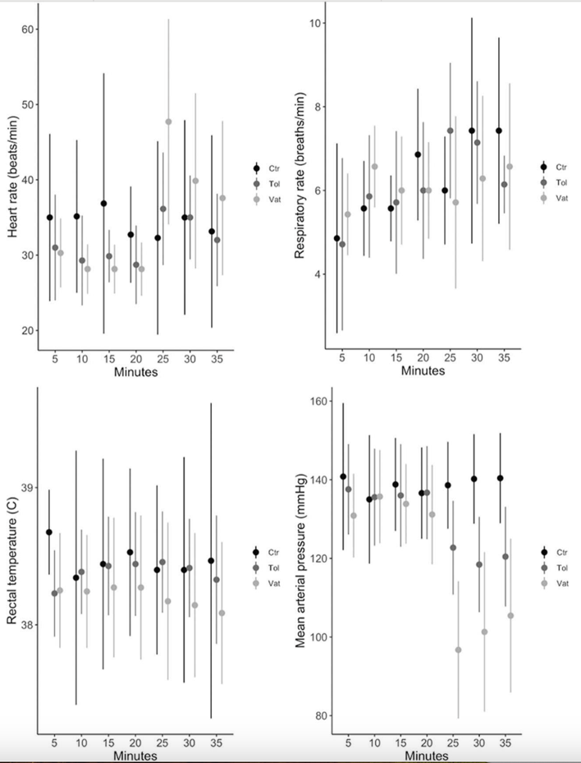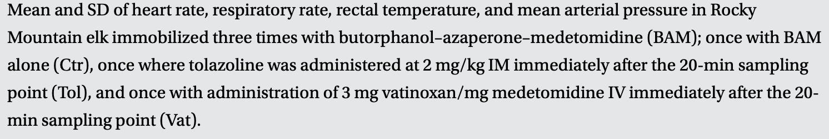
------------------------------------------------------------------------------------------------------------------------------
Lethal toxin neutralizing antibody response induced following oral vaccination with a microencapsulated Bacillus anthracis sterne strain 34F2 vaccine proof-of-concept study in white-tailed deer (Odocoileus virginianus). Journal of Zoo and Wildlife Medicine. 2024. 55(1): 212-218.
Laura Martinelli
Abstract
Improved methods are needed to prevent wildlife deaths from anthrax. Caused by Bacillus anthracis, naturally occurring outbreaks of anthrax are frequent but unpredictable. The commercially available veterinary vaccine is labeled for subcutaneous injection and is impractical for large-scale wildlife vaccination programs; therefore, oral vaccination is the most realistic method to control and prevent these outbreaks. We reported the induction of an anthrax-specific lethal toxin (LeTx) neutralizing antibody response in mice following oral vaccination with alginate microcapsules containing B. anthracis Sterne strain 34F2 spores, coated with poly-L-lysine (PLL) and vitelline protein B (VpB). We continued evaluating our novel vaccine formulation through this proof-of-concept study in white-tailed deer (WTD; Odocoileus virginianus; n = 9). We orally vaccinated WTD via needle-free syringe with three formulations of the encapsulated vaccine: 1) PLL-VpB–coated microcapsules with 10^{7–8} spores/ml (n = 5), 2) PLL-VpB–coated microcapsules with 10^{9–10} spores/ml (n = 2), and 3) PLL-coated microcapsules with 10^{9–10} spores/ml (n = 2). Although the limited sample sizes require continued experimentation, we observed an anthrax-specific antibody response in WTD serum following oral vaccination with PLL-coated microcapsules containing 10⁹spores/ ml. Furthermore, this antibody response neutralized anthrax LeTx in vitro, suggesting that continued development of this vaccine may allow for realistic wildlife anthrax vaccination programs.
Key Points
- Anthrax = Bacillus anthracis, causes large epizootics in herbivores, spores are extremely resilient in the environment
- Anthrax outbreaks in Texas and other regions are often seasonal, occurring in summers after cool, wet weather following hot, dry conditions. Since it is so seasonal, this disease could ideally be managed with routine vaccination.
- The Anthrax Spore Vaccine (ASV) is approved for use in domestic livestock via subcutaneous hand injection and extra-label use in white-tailed deer (effective) but hand injection not practical for free-ranging wildlife populations. Attempted to create an oral vaccine for anthrax for this reason.
- Poly-L-lysine coated microcapsules with a higher level of spores in D-alanine produced a significant antibody titer at 14, 28, and 42 days postvaccination (the third formulation of vaccine in this study, the other formulations did not produce a significant response)
  - This third formulation also produced a response to LeTx, the anthrax specific lethal toxin with 50% of animals having a protective level at days 28 and 42
Take Home Points: A Poly-L-lysine coated microcapsule with 10^{9–10} anthrax spores/ml produced a significant antibody titer to anthrax in White-tailed deer.

