MORBIDITY AND MORTALITY PATTERNS OF INDIAN RIVER LAGOON COMMON BOTTLENOSE DOLPHINS (TURSIOPS TRUNCATUS TRUNCATUS) 2002–2020
Wendy Noke Durden,1,6 Teresa Jablonski,1 Megan Stolen,1,4 Connie Silbernagel,1
David Rotstein,2 and Judy St. Leger3,5

ABSTRACT: Mortality patterns in cetaceans are critical to understanding population health. Common bottlenose dolphins (Tursiops truncatus truncatus) inhabiting the Indian River Lagoon (IRL), Florida have been subjected to four unusual mortality events (UMEs), highlighting the need to evaluate morbidity and mortality patterns. Complete gross examinations were conducted on 392 stranded dolphins and histopathological analyses were conducted for 178 animals (2002–2020). The probable causes of mortality were grouped by etiologic category: degenerative, metabolic, nutritional, inflammatory (infectious and noninfectious disease), and trauma. Probable cause of mortality was determined in 57% (223/392) of cases. Inflammatory disease (infectious/noninfectious) and trauma were the most common. Inflammatory disease accounted for 41% of cases (91/223), with the lungs (pneumonia) most commonly affected. Trauma accounted for 36% of strandings (80/223). The majority of trauma cases were due to anthropogenic activities (entanglement, fishing gear or other debris ingestion, and propeller strikes), accounting for 58% of trauma cases (46/80). Natural trauma (prey-associated esophageal obstruction or asphyxiation, shark bites, and stingray interactions) accounted for 12% of all cases (26/223), and trauma of undetermined
origin was identified in 4% of cases (8/223). Starvation or inanition (nutritional) were the probable cause of mortality in 17% of cases and peaked during the 2013 UME (61% of cases). Degenerative and metabolic etiologies accounted for 5% of cases. This study represents the most comprehensive evaluation of morbidity and mortality patterns in IRL dolphins. Because IRL dolphins are routinely exposed to anthropogenic threats and have endured multiple UMEs, these baseline data are critical to the conservation and management of this population.

- IRL dolphins are exposed to and accumulate persistent pollutants (papillomas and skin disease- paracoccidiodomycosis ceti)- immunocompromised population
- 2002-2020: 790 dolphins stranded (alive or dead) and needed intervention; 392 got complete gross and 178 received histo exam
- Stranding significantly more frequent in the summer; calves and adults stranded in nearly equal numbers with slightly fewer juveniles
- Calves stranded more frequently during fall; juveniles=winter
- Inflammatory disease and trauma were identified most commonly
  - Respiratory disease was most common (Pneumonia: parasitic, multiagent, bacterial, and fungal
- Calves commonly succumbed to inflammatory and metabolic diseases; juveniles most commonly was inflammatory
- Trauma (anthropogenic) was leading cause of mortality in mature animals= anthropogenic trauma occurred more frequently in the summer
- Trauma occurred more than expected in Banana River
- Season specific stressors may influence dolphin mortality
- Pneumonia common- lungworm infection being the common causative agent
- Fishing gear interaction (entanglement and ingestion) were the most common anthropogenic trauma
- 4 unusual mortality events: 3 were due to morbillivirus, the other undetermined
  - Suspect the undetermined event was associated with ecological factors preceding the event including phytoplankton blooms that yielded catastrophic seagrass loss
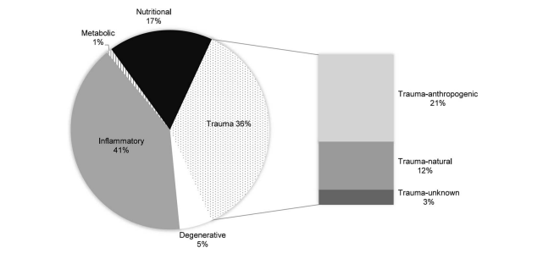

Russell JP, Osborn SD, Ivančić M, et al. Chronic nonchylous lymphatic pleural effusion in a bottlenose dolphin (Tursiops truncatus). Journal of the American Veterinary Medical Association. 2022;260(9)

Abstract:
CASE DESCRIPTION
A 19-year-old male bottlenose dolphin (Tursiops truncatus) presented with inappetence and avoidant behavior.
CLINICAL FINDINGS
Ultrasound revealed a large-volume left-sided pleural effusion, which was consistent with chronic nonchylous lymphatic effusion and mild chronic hemorrhage by cytology. Computed tomography identified ipsilateral rib fractures, atelectasis, nodular pleuritis, marginal lymph node enlargement, and suspected dilation of the thoracic duct and internal thoracic veins. Fifteen lipids were significantly higher in serum of the dolphin as compared with controls (n = 3) using nontargeted lipidomics.
TREATMENT AND OUTCOME
A series of thoracentesis procedures were performed. Follow-up CT demonstrated marked reduction in pleural effusion with persistence of thoracic duct dilation and mass-like areas of pleural thickening. Ultrasonographic resolution of pleural effusion occurred 14 months after presentation; however, recrudescence was noted 5 months later. Over a total of 24 months, 21.52 L of pleural effusion was removed. Despite the presence of pleural effusion, the patient was clinically stable during this time and quality of life was considered good on the basis of continuous animal welfare evaluations. Humane euthanasia was elected following acute clinical decline 27 months after initial diagnosis. Necropsy confirmed severe pleural effusion, chronic severe pleural fibrosis with chronic hemorrhage, and mediastinal fibrosis with entrapped lymph nodes and thymic tissue.
CLINICAL RELEVANCE
Pleuritis and effusion were suspected sequelae of previous rib fractures. To our knowledge, this is the first report of nonchylous lymphatic pleural effusion with repeated pleural drainage and diagnostic imaging for clinical management in a bottlenose dolphin.

Key Points:
- Changes in ALP, iron, and erythrocyte sedimentation rate are typical for systemic inflammation in marine mammals
- Levofloxacin (5 mg/kg PO q12h), metronidazole (7 mg/kg PO q12h), vitamin K (0.4 mg/kg PO q24h), nystatin (7,000 IU/kg PO q8h), and bismuth subsalicylate (525 mg total dose PO q12h) were prescribed empirically
- Diagnostic thoracocentesis: red and cloudy, PCV 5%, TS 6.3 g/dL, SG 1.036. Abundant RBCs and mononuclear cells. An unidentified gram-positive/catalase-positive coccobacillus and Staphylococcus capitis identified on culture. Doxycycline (1.5 mg/kg PO q12h) was added.
- Throughout treatment, SAA concentration was the only abnormal serum marker, and concentrations were positively associated with amount of pleural fluid
- In addition to pleural drainage, levofloxacin, voriconazole (2.5 mg/kg, PO, q 12 h for 3 days, followed by 2.5 mg/kg, PO, q 7 d), s-adenosylmethionine and silybin (1275 mg/360 mg total dose, PO, q 24 h), and tramadol (0.1 mg/kg, PO, q 12 h) were the mainstay of management until normalization of SAA and absence of pleural fluid 14 months after presentation.
- Drainage site selection was based on maximum depth of fluid on ultrasound (approx 20 cm), approximately between the 7th to 9th rib spaces, as for domestic mammals.
- Oil red O stain (for visualizing lipid) revealed frequent mononuclear phagocytes with mild diffuse or strong focal positive staining within vacuoles, consistent with phagocytized lipid material
- Nontargeted semiquantitative lipidomics of serum and thoracic fluid samples was; fifteen lipids were found to be significantly increased in patient serum samples, compared with the control samples
- CT identified ipsilateral rib fractures, atelectasis, nodular pleuritis, marginal lymph node enlargement, and suspected dilation of the thoracic duct and internal thoracic veins.
- The animal was humanely euthanized 27 months after presentation, following development of pericardial effusion and acute clinical decline
- Necropsy revealed healed mid-diaphyseal fractures of the fourth and fifth ribs. Final diagnoses were cranial mediastinal and pleural fibrosis with chronic hemorrhage and left pleural effusion, slight multifocal neutrophilic and histiocytic pneumonia of the left lung, chronic passive hepatic congestion with mild multifocal acute centrilobular necrosis, and incidental mitral valve blood cysts.
- Nonchylous effusions are characterized by increased cholesterol (> 200 mg/dL) relative to triglycerides (typically < 100 mg/dL) with a ratio of cholesterol to triglycerides > 1. Unlike chylothorax, nonchylous effusions do not result from thoracic duct leakage and are often unilateral. They are associated with chronic pleurisy.
- Pathogenesis of nonchylous effusions is not fully understood; it is generally accepted that the cholesterol originates from cellular degradation, becomes trapped in the pleural space due to poor reabsorption as a result of a chronically thickened pleura, and undergoes a change in lipoprotein binding characteristics. Nonchylous lymphatic effusions may result from damaged lymphatic vessels that are not located in the drainage path from intestines to the thoracic duct and therefore do not contain chyle or chylomicrons.
- Suspected that pleural effusion reoccurred due to severity of pleural fibrosis resulting in impaired lymphatic and venous return.

Take-Home Message:
- Pleuritis and effusion were suspected sequelae of previous rib fractures. This is the first report of nonchylous lymphatic pleural effusion with repeated pleural drainage and diagnostic imaging for clinical management in a bottlenose dolphin.
Respiratory changes in stranded Bottlenose dolphins (Tursiops truncatus). Journal of Zoo and Wildlife Medicine. 52.1. (2021): 49-56.
Abstract: Lung function (breath duration, respiratory flow [V ̇], and tidal volume [V_{T}]), and end-expiratory O₂ were measured in 19 adult bottlenose dolphins (Tursiops spp.) while at rest in water or beached for up to 10 min. The results show that inspiratory V_{T}, expiratory V_{T}, or inspiratory V ̇ did not differ on land or in water. The average expiratory V ̇ for all dolphins on land decreased by 16%, and the expiratory and total breath durations increased by 5% and 4%, respectively, compared with in water. There were temporal changes observed during beaching, where expired and inspired V_{T} and inspired V ̇ decreased by 13%, 16%, and 9%, respectively, after 10 min on land. These data suggest that dolphins compensate for the effect of gravity by adjusting respiration to maintain alveolar ventilation and gas exchange, but during extended durations, the increased work of breathing may impede ventilation and gas exchange. Continuous monitoring of lung function and gas exchange may help prevent long-term damage during out-of-water medical procedures, optimize animal transport conditions, and improve survival during stranding events.
Key Points:
- Cetacean stranding-associated health issues = hyperthermia, dehydration, suffocation, hypoxia, severe abrasions, sunburn, cardiomyopathies, or skeletal muscle myopathies
- Respiratory disease identified in ~20% of stranded dolphins
- Lung function testing (spirometry) can be an effective diagnostic tool for assessing stranded cetaceans, transported cetaceans, or during medical interventions
- Respiratory Cycle in dolphins
  - Expiration, followed immediately by Inspiration, then respiratory pause
  - Active recoil of chest responsible for emptying lungs
  - Expiration = Passive
  - Inspiration = Active, requires additional force to lift body against gravity to fill lungs
- 19 adult bottlenose dolphins from two species in this study (Tursiops truncatus truncatus = common bottlenose dolphin; and Tursiops aduncus = Indo-pacific bottlenose dolphin)
- Tidal volume expired and inspired decreased with time on land BUT no changes in end-expired O2 concentration
  - Suggests that despite tidal volume reduction, dolphins compensated their alveolar ventilation to prevent hypoxia at least during the first 10 minutes
- Decrease in expired tidal volume occurred because tidal volume was less; However decrease in inspired tidal volume occurred because inspired flow rate was decreased.

Take Home Point: There are progressive reductions over time in respiratory capacity during beaching in healthy bottlenose dolphins. However, there were no changes in end-expired O2 levels during the study time
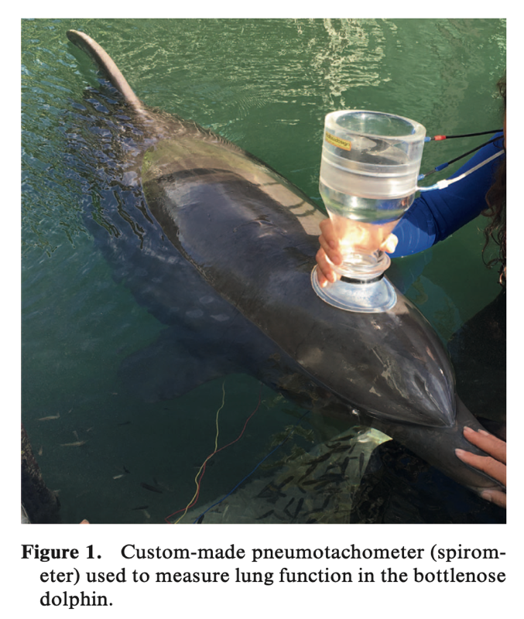

____________________________________________________________________________________
Efficacy of human recombinant granulocyte colony-stimulating factor (G-CSF, Filgrastim; Neupogen) in neutropenic cetaceans. Journal of Zoo and Wildlife Medicine. 52.3. (2021): 1042-1053.
Abstract: Neutrophils are one of the initial cell lines of protection against pathogens, and when their concentrations in the blood are low, animals are highly susceptible to infections. Neutropenia has been reported in cetaceans secondary to administration of systemic sulfa antibiotics or antifungal medications and severe, overwhelming infection. Filgrastim was administered to treat neutropenia over a 15-y period in 11 cetaceans comprising four species—beluga (Delphinapterus leucas, n = 1), bottlenose dolphin (Tursiops truncatus, n = 4), killer whale (Orcinus orca, n = 5), and short-finned pilot whale (Globicephala macrorhynchus, n = 1)] ranging in age from 1 wk to >24 y. Seven study animals received multiple doses (2–6). All animals responded to at least one dose (1–7 ug/kg) of parenteral filgrastim characterized by an increase in peripheral immature (band) neutrophils, segmented neutrophils, or both. In most cases (9/11), neutrophil counts increased within 48 h of a single dose. Duration of response varied but was at least 2 wk in eight of the 11 animals and 5–9 d in the remaining animals. No adverse reactions were observed in any cases.
Key Points:
- Neutrophils = phagocytic granulocyte, innate immune system, initial defense against pathogens
- Granulopoiesis in mammals occurs via mediators including granulocyte colony-stimulating factor or G-CSF
  - G-CSF = glycoprotein cytokine that can stimulate survival, proliferation, and terminal differentiation of neutrophils and improve neutrophil function; increases neutrophil production, shortens maturation time of neutrophilic precursors, increases release from bone marrow, and prevents neutrophilic apoptosis
  - G-CSF production markedly increases with endotoxins and inflammatory mediators
  - Filgrastim (brand name Neupogen) is a human recombinant G-CSF
- Neutropenia in cetaceans reported secondary to systemic sulfa antibiotics, ketoconazole, micafungin, and severe infections
  - In this study, 8 cases indeterminant cause of neutropenia, 3 cases presumed to be reaction to sulfa antibiotics
- All cetaceans responded to Filgrastim
  - In 9/11 cases response occurred within 24-48 hours of single dose
  - In 10/11 cases response characterized by initial moderate to robust increase in neutrophil progenitor cells (bands) in conjunction with or followed by an increase in segmented neutrophils
  - Duration of response 2 wk in 8/11 animals and 5-9 days in remaining animals
  - In 8/11 cases neutrophil counts remained normal or elevated for at least 2 wk after last Filgrastim dose
  - No immediate or long-term adverse effects were seen
  - Dogs and cats can develop neutralizing antibodies but after >17 days of daily tx. This was not observed in this case series but remains a concern.
Take Home Point: All cetaceans in this report responded to filgrastim, a recombinant human granulocyte colony-stimulating factor. Responses involved an elevation in bands and segmented neutrophils and these responses were neither species dependent nor dependent upon route (SC, IM or IV), order, or number of filgrastim doses.
____________________________________________________________________________________
Superficial cervical lymphadenitis associated with Streptococcus phocae in five common Bottlenose dolphins (Tursiops truncatus): A case series. Journal of Zoo and Wildlife Medicine. 54.1. (2023): 192-201.
Abstract: Between 2009 and 2018, five common bottlenose dolphins (Tursiops truncatus) at the US Navy Marine Mammal Program presented with superficial cervical lymphadenitis. Clinical findings included ultrasonographic evidence of cervical lymph node enlargement, severe leukocytosis, elevated erythrocyte sedimentation rates, and reduced serum iron. Three of the dolphins presented with clinicopathologic changes without presence of clinical signs, and the other two cases additionally presented with partial to complete anorexia, lethargy, and refusal to participate in training sessions. Ultrasound-guided fine needle aspiration or biopsy of the affected lymph nodes yielded Streptococcus phocae by PCR in all cases, and the organism was cultured in one of five cases. Animals were treated with a combination of enteral, parenteral, intralesional antimicrobial, or a combination of those therapies and supportive care. Time to resolution of clinical disease ranged between 62 and 188 days. To the authors’ knowledge, this is the first report of Streptococcus phocae cervical lymphadenitis in cetaceans. Streptococcus phocae lymphadenitis should be a differential for cervical lymphadenopathy in this species, especially when associated with pronounced systemic inflammation and a history of potential exposure.
Key Points:
- Streptococcus phocae = β-hemolytic streptococcal species
  - Reported in marine animals as a commensal, opportunistic, and primary pathogen but epidemiology and pathogenicity poorly understood
  - Clinical manifestations of disease include resp disease, abortion, pyometra, abscesses, speticemia, meningitis, and cellulitis
- This case series identifies S. phocae as a primary pathogen in these dolphins, with first three cases within one year of each other, and last two cases presented 10 yrs later
  - All cases presented with robust neutrophilia and inflammatory biomarker response and superficial cervical lymphadenitis (similar to equine strangles caused by β-hemolytic streptococcal species, Streptococcus equi ssp. equi)
  - Typically in equine strangles, antibiotics are not used in simple cases due to concern that it will prevent lymph node rupture and prolong disease. Treatment directed at lymph node drainage. In this case, due to dolphin skin, lymph node rupture and drainage not possible.
- Authors recommend cephalosporins and β-lactams for empirical mgmt of S. phocae
Take Home Point: Streptococcus phoacae lymphadenitis should be considered as a differential for cervical swelling (visible or identified on ultrasound) and inflammation in Tursiops truncatus.
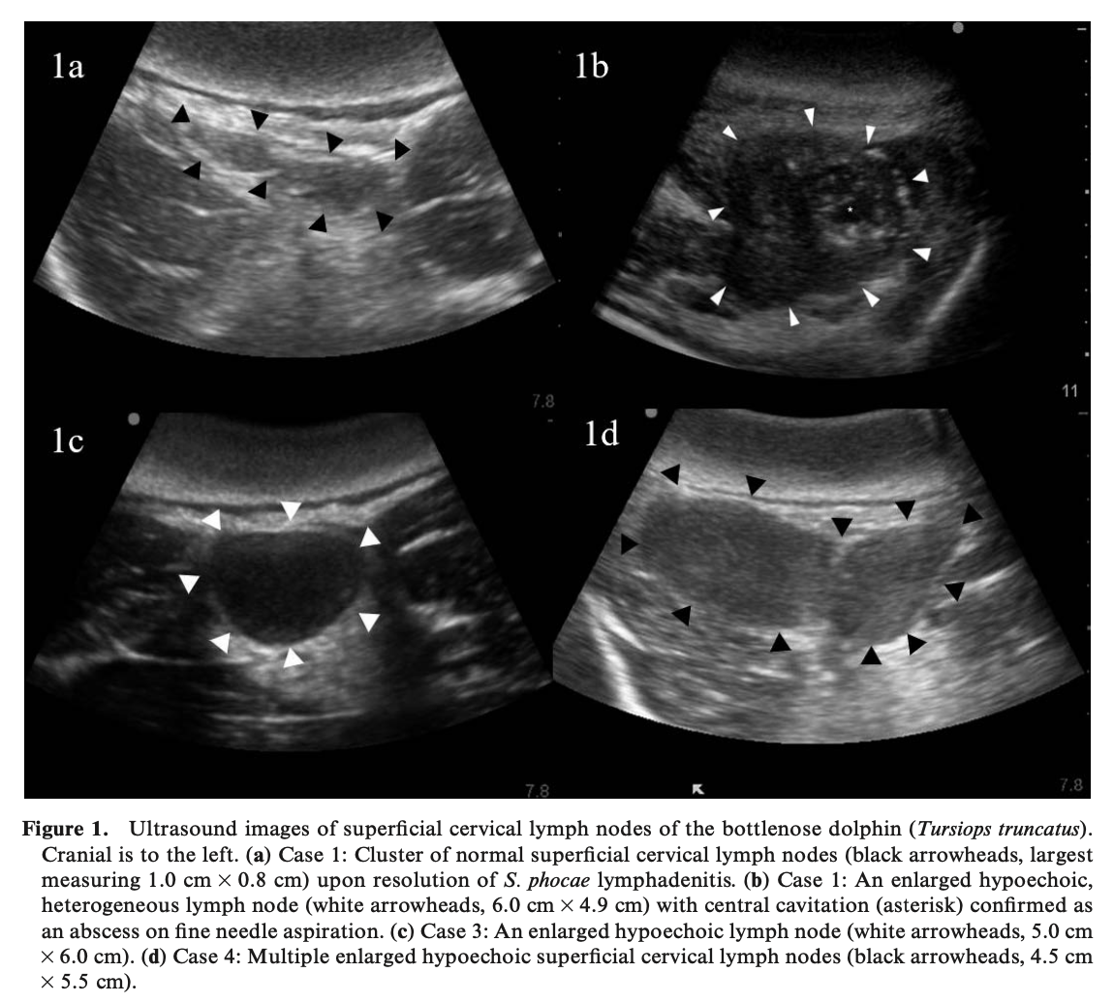
Investigation of the use of serum biomarkers for the detection of cardiac disease in marine mammals. JZWM 2022;53(2):373-382. Joblon MJ, Flower JE, Thompson LA, Biddle KE, Burt DA, Zabka TS, Adkesson MJ, Halaska B, Goertz CE, Rouse N, Cahoon SN. - review by LMumm

Abstract: Cardiac disease has been extensively documented in marine mammals; however, it remains difficult to diagnose antemortem. Assays measuring cardiac troponin I (cTnI) and N-terminal pro-brain natriuretic peptide (NT-proBNP) are used as sensitive and specific biomarkers of cardiac disease in many species, but have not been widely investigated in marine mammals. This study aimed to provide a set of reference values for cTnI and NT-proBNP in belugas (BW) (Delphinapterus leucas), sea otters (SO) (Enhydra lutris), Steller sea lions (SSL) (Eumetopias jubatus), and California sea lions (CSL) (Zalophus californianus) with and without cardiac disease (banked samples), and to determine if these biomarkers are useful indicators of cardiac disease in these species. First, existing immunoassays for cTnI and NT-proBNP were successfully validated utilizing species-specific heart lysate spiked serum. Cohorts were defined by histopathology as animals with no evidence of cardiac disease (‘‘control’’), with confirmed cardiac disease (‘‘disease’’), and with concurrent renal and cardiac disease (‘‘renal’’) for which serum samples were then analyzed. Serum concentration ranges for cTnI (ng/ml) and NT-proBNP (pmol/L) were determined for control and disease cohorts. There was significantly higher cTnI (P = 0.003) and NT-proBNP (P = 0.004) concentrations in the CSL disease cohort, as well as positive trends in BW, SO, and SSL disease cohorts that did not reach statistical significance. NT-proBNP concentrations were significantly higher in the CSL renal cohort compared with the control (P , 0.001) and disease (P = 0.007) cohorts. These results suggest that cTnI and NT-proBNP may be clinically useful in the antemortem diagnosis of cardiac disease in CSL, and warrant further investigation in BW, SO, and SL.

Background
- Cardiac troponin subunit I (cTnI) - protein specific to myocardium, released in circulation following cardiomyocyte injury
  - Considered gold standard in humans/vet med; diagnostic and prognostic value
  - Canine - normal <0.07 ng/mL, high >0.1 ng/ml, highly suggestive of cardiac disease >2
- N-Terminal pro-B-type Natriuretic Peptide (NT-proBNP) - prohormone increases in circulation with myocardial stretch
  - Correlates with degree of LV dysfunction, increasing heart size, CHF
  - Also elevated with renal disease (due to decreased renal excretion and potentially renal hypertension leading to ventricular hypertrophy and cardiomyocyte stretch)
  - Canine - normal < 800 pmol/L, high 800-1800, indicative of CHF > 2700 pmol/L
- Heart disease reported in marine mammals: myocardial fibrosis, myocarditis, HW, endocarditis (parasitic and bacterial), acute stranding, capture myopathy, and specifically DA associated DCM and Sarcocystis neurona in southern sea otters
  - cTnI previously promising in sea otters (Moriarty et al. AJVR 2021)
Methods: performed cTnI and NT-proBNP on stored frozen serum samples from captive and live-stranded belugas (n=12), sea otters (n=23), stellar sea lions (n=10), and CSLs (n=40)
- Deemed healthy “control” if no evidence on histopath or alive/healthy, “disease” if confirmed cardiac disease on histopath, and “renal” if cardiac and renal disease confirmed on histopath

Key Points
- cTnI and NT-proBNP assays were validated in all four species
- No difference in cTnI or NT-proBNP between sex or age class with any species
- All controls were below detectable limit (cTnI <0.03 ng/ml, NT-proBNP <200 pmol/L)
- Chronicity and severity of disease correlated with cTnI and NT-proBNP in CSLs only
  - No difference within diseased CSLs between chronicities (acute vs. chronic) or between severity (mild vs. moderate vs. severe)
- cTnI significantly higher in CSLs with confirmed cardiac disease vs. controls
  - No effect of renal disease on cTnI
  - Significantly higher in CSLs with acute disease vs. control
    - Trend toward higher cTnI with chronic disease seen (not stat sig)
  - Significantly higher in CSLs with moderate disease vs. control
    - Trend toward higher cTnI with severe disease seen (not stat sig)
  - Not significant but broader ranges and higher max concentrations of cTnI also seen in diseased belugas, sea otters, and stellar sea lions
- NT-proBNP significantly higher in CSL with confirmed cardiac/renal disease > cardiac disease > controls
  - Significantly higher in CSLs with both acute and chronic disease vs. control
  - Significantly higher in CSLs with mild disease vs. control
    - Trend toward higher NT-proBNP seen in mod and severe disease (not stat sig)
  - No difference between diseased and control stellar sea lions
  - Remained below detectable limit for all disease and control belugas and sea otters
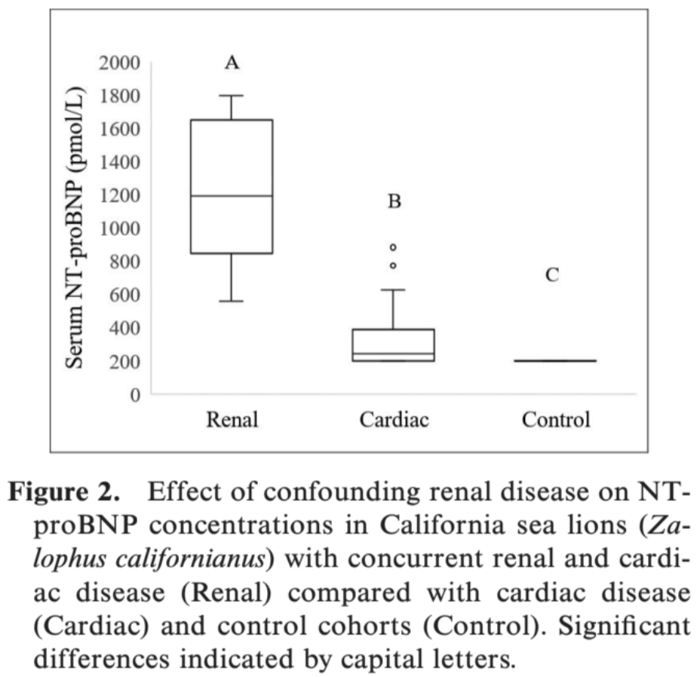
TLDR: cTnI and NT-proBNP may be useful in diagnosing cardiac disease antemortem in CSLs however concurrent renal disease can affect NT-proBNP thus should be interpreted with caution

JZWM 2021 52(1): 49–56

RESPIRATORY CHANGES IN STRANDED BOTTLENOSE DOLPHINS (TURSIOPS TRUNCATUS)
Fahlman A, Brodsky M, Rocho-Levine J, et al.

Abstract: Lung function (breath duration, respiratory flow [V˙], and tidal volume [VT]), and end-expiratory O2 were measured in 19 adult bottlenose dolphins (Tursiops spp.) while at rest in water or beached for up to 10 min. The results show that inspiratory VT, expiratory VT, or inspiratory V˙ did not differ on land or in water. The average expiratory V˙ for all dolphins on land decreased by 16%, and the expiratory and total breath durations increased by 5% and 4%, respectively, compared with in water. There were temporal changes observed during beaching, where expired and inspired VT and inspired V˙ decreased by 13%, 16%, and 9%, respectively, after 10 min on land. These data suggest that dolphins compensate for the effect of gravity by adjusting respiration to maintain alveolar ventilation and gas exchange, but during extended durations, the increased work of breathing may impede ventilation and gas exchange. Continuous monitoring of lung function and gas exchange may help prevent longterm damage during out-of-water medical procedures, optimize animal transport conditions, and improve survival during stranding events.

Background
- In cetaceans, when on land, the weight of the body pushes down on the highly compliant thorax which may have cardiorespiratory effects
  - Stranding associated health effects: hyperthermia, dehydration, suffocation, hypoxia, abrasions, sunburn, cardiomyopathy, skeletal muscle myopathy
  - Respiratory tract disease identified in as many as 20% of stranded dolphins
- Respiratory cycle: begins with expiration followed by immediate inspiration and respiratory pause
  - The elastic recoil of the chest is responsible for emptying the lung
    - On land would not require additional work to empty lung
  - Inhalation is an active process (would required additional muscle force to lift body on land)
- Lung function testing may be an effective diagnostic tool in stranding situations
- Previous studies found no short-term differences in lung function or metabolic cost in healthy bottlenose dolphins in water or on the deck of a boat on a foam mat
Key Points:
- No differences in the overall average inspiratory VT, expiratory VT, end expired O2, or inspiratory V between land and water, however significant temporal changes occurred
- Average expiratory V for all dolphins on land decreased and expiratory, total breath durations increased
- Expired and inspired VT and inspired V decreased after 10 min on land, but there were no changes in end-expired O2 concentration
  - Despite reduced tidal volume, dolphins compensated their alveolar ventilation to prevent hypoxia
  - The tidal volume decreased progressively with time
  - Reduced inspired tidal volume caused by reduction in inspired respiratory flow because of gravity
- Present study only beached dolphins for 10 minutes, may be able to compensate better during this time
- ETCO2 could have shown respiratory insufficiency and should be done in future
Take Home Message:
- Breaching a dolphin on land for 10 min:
  - Increases expiratory respiratory flow, expiratory duration, and total breath duration
  - Decreases inspired respiratory flow and expiratory and inspiratory tidal volumes
- Breaching a dolphin slows down their breathing and increases the effort required to breath
- However, there were no changes in expired O2 levels during the 10-minute time limit of this study, thus the dolphins were able to compensate for these reductions through their respiratory functional reserve.

Related Articles:
Borque-Espinosa A, Burgos F, Dennison S, et al. Pulmonary function testing as a diagnostic tool to assess respiratory health in bottlenose dolphins Tursiops truncatus. Dis Aquat Organ. 2020;138:17-27

JZWM 2023 54(1):119-130
VALIDATION OF ENZYME-LINKED IMMUNOSORBENT ASSAY TECHNIQUES TO MEASURE SERUM DEHYDROEPIANDROSTERONE (DHEA) AND DHEA-S IN NARWHALS (MONODON MONOCEROS)
Béland K, Lair S, Guay M, et al

ABSTRACT: Narwhals (Monodon monoceros) are increasingly exposed to anthropogenic disturbances that may increase their stress levels with unknown consequences for the overall population dynamics. The validation and measurement of chronic stress biomarkers could contribute toward improved understanding and conservation efforts for this species. Dehydroepiandrosterone (DHEA) and its sulfated metabolite DHEA-S are collectively referred to as DHEA(S). Serum DHEA(S) concentrations combined in ratios with cortisol [cortisol/DHEA(S)] have been shown to be promising indicators of chronic stress in humans, domestic animals, and wildlife. During field tagging in 2017 and 2018 in Baffin Bay, Nunavut, Canada, 14 wild narwhals were sampled at the beginning and end of the capture-tagging procedures. Serum DHEA(S) were measured with commercially available competitive enzyme-linked immunosorbent assays (ELISA) developed for humans. A partial validation of the ELISA assays was performed by the determination of the intra-assay coefficient of variation, confirmation of the DHEA(S) dilutional linearity, and the calculation of the percentage of recovery. Mean values (nanograms per milliliter ± standard error of the mean) of narwhal serum cortisol, DHEA(S), and cortisol/DHEA(S) ratios, at the beginning and at the end of handling, respectively, are reported (cortisol = 30.74 ± 4.87 and 41.83 ± 4.83; DHEA = 1.01 ± 0.52 and 0.99 ± 0.50; DHEA-S = 8.72 ± 1.68 and 7.70 ± 1.02; cortisol/DHEA = 75.43 ± 24.35 and 84.41 ± 11.76, and cortisol/DHEA-S = 4.16 ± 1.07 and 6.14 ± 1.00). Serum cortisol and cortisol/DHEA-S were statistically higher at the end of the capture (P= 0.024 and P= 0.035, respectively). Moreover, serum cortisol at the end of handling was positively correlated to total body length (P = 0.042) and tended to be higher in males (P = 0.086). These assays proved easy to perform, rapid, and suitable for measuring serum DHEA(S) of narwhals and that calculated cortisol/DHEA(S) are potential biomarkers for chronic stress in narwhals and possibly other cetaceans.

Introduction:
- Risks to narwhals: reduced sea ice, increased killer whale, tourism and cruise ships, shipping of natural resources
- Cortisol most common reported biomarker for physiologic stress in mammals
- Cortisol shown to be elevated in narwhal blubber with chronic stress (e.g., entrapped in ice)
  - Usually lower in cetaceans than stressed pinnipeds and terrestrial mammals
- Dehydroepiandrosterone (DHEA) and its sulfated metabolite, DHEA-S, collectively referred to as DHEA(S), are androgen hormone precursors
- Both cortisol and DHEA(S) are secreted by adrenal cortex following ACTH stimulation, but cortisol is a catabolic hormone, while DHEA(S) are anabolic hormones and have a protective and regenerative role
- Reported to have neuroprotective, antioxidative, anti-inflammatory, & antiglucocorticoid effects in humans
- Ratio of serum cortisol conc. to DHEA(S) reported to represent the balance btwn catabolic & anabolic activity
  - Cortisol/ DHEA(S) ratios are generally higher in chronically stressed animals, hence DHEA(S) and cortisol/ DHEA(S) ratios have the potential to discriminate acute from chronic stress responses
    - physiologic phenomenon of chronic stress seems to be the result of a dysregulation in the hypothalamic-pituitary-adrenal axis leading to chronically decreased DHEA(S).
- DHEA in killer whales was much higher than harbor and gray seals and humans
  - DHEA tends to increase during repro and gestation in killer whales but decreases with advanced age
Key Points
- Two commercially available ELISAs provide easy, rapid assays for measuring serum DHEA and DHEA-S in narwhals
- Cortisol and cortisol/DHEA-S were significantly higher at the end of the handling period compared to start
- DHEA(S) and cortisol/DHEA ratios did NOT differ significantly between the two sampling periods
- Serum cortisol at end of handling was positively correlated with body length (higher in longer individuals)
- Serum cortisol higher at end of handling in male, but not significant
- No statistically significant association between all other measured parameters and total handling time
- Serum cortisol in cetaceans is usually lower compared to pinnipeds and terrestrial mammals experiencing an important stress event such as capture and handling and the values obtained in this study are no exception.
  - Stressed narwhals were similar to “non stressed” seals
  - Narwhal cortisol was similar to belugas, but much lower than killer whales (no conclusion can be made)

TLDR:
- Commercially available ELISAs were partially validated for DHEA and DHEA-S in narwhals
- DHEA(S) and the cortisol:DHEA(S) ratios require further investigation to assess their relevance as chronic stress biomarkers in narwhal and other marine mammals
- Serum DHEA less affected by acute stress in narwhals

Related Articles:
Gundlach NH, Schmicke M, Ludes-Wehrmeister E, Ulrich SA, Araujo MG, Siebert U. NEW APPROACH TO STRESS RESEARCH IN PHOCIDS-POTENTIAL OF DEHYDROEPIANDROSTERONE AND CORTISOL/DEHYDROEPIANDROSTERONE RATIO AS MARKERS FOR STRESS IN HARBOR SEALS ( PHOCA VITULINA) AND GRAY SEALS ( HALICHOERUS GRYPUS). J Zoo Wildl Med. 2018;49(3):556-563

Miller LJ, Lauderdale LK, Walsh MT, et al. Reference intervals and values for fecal cortisol, aldosterone, and the ratio of cortisol to dehydroepiandrosterone metabolites in four species of cetaceans. PLoS One. 2021;16(8):e0250331

