Shusterman, Lauren, Antoinette E. Marsh, and Priscilla H. Joyner. "Detection and differentiation of Trichuris in giraffe (Giraffa camelopardalis) under human care." Journal of Zoo and Wildlife Medicine 53.2 (2022): 383-392.

Question:

Which of the following species of Trichuris is most similar to the Trichuris spp. found in the majority of giraffes sampled from The Wilds in Cumberland, Ohio; Fossil Rim Wildlife Center in Glen Rose, Texas; White Oak Conservation in Yulee, Florida; and Binder Park Zoo in Battle Creek, Michigan?

- Trichuris leporis
- Trichuris ovis
- Trichuris skrjabini
- Trichuris suis
- Trichuris vulpis

Answer: B

Which of the following is true in regards to neoplasia in managed giraffe (Giraffa camelopardalis)?
- Squamous cell carcinoma was found on the non pigmented regions of giraffe
- The most common tumor types were leiomyoma, adenoma, luteoma, and lymphoma
- Most neoplasms diagnosed within this retrospective study were malignant
- The most common demographic found were middle aged female giraffe
- Neoplasia was most common in the reproductive system followed by integument

Answer: B; SCC was not found on the non-pigmented area, most neoplasms were benign, common demographic was older female giraffe, and the most common is reproductive but followed closely by endocrine

QUESTION: Which type of feeding apparatus has been associated with mandibular fractures in young captive giraffe (Giraffa camelopardalis)?
- Mesh nets
- Feeding troughs
- Enrichment devices
- Metal racks
- Hanging branches
Answer: D
Source: MANDIBULAR FRACTURES IN GIRAFFES (GIRAFFA CAMELOPARDALIS) IN EUROPEAN ZOOS. JZWM 2022. Remport et al.

QUESTION: Which of the following is true regarding TEG assays in camelids?
- TEG results differ significantly between recombinant human tissue factor (rhTF) activated assays and kaolin activated assays
- Dromedary camels with increased factor VIII have significantly prolonged reaction time (R), compared to alpacas
- Camelids are expected to have faster clot formation time (K) and increased fibrin formation (alpha) compared to most species
- Due to low hematocrit and elliptical erythrocytes, TEG is not a reliable measure of coagulation kinetics in camelids
- Kaolin activator has less interassay variation thus may be preferred over recombinant human tissue factor (rhTF) for camelid TEG
Answer: E
Source: WHOLE BLOOD THROMBOELASTOGRAPHY IN HEALTHY ADULT CAMELIDS (VICUGNA PACOS AND CAMELUS DROMEDARIUS). JZWM 2022. Cummings et al.

NEONATAL INTENSIVE CARE OF 10 HOSPITALIZED GIRAFFE CALVES (GIRAFFA CAMELOPARDALIS) REQUIRING HAND-REARING
Practice Question: What is the recommended intake of milk per day for hospitalized neonatal giraffe?
- 1-2% BW
- 3-5% BW
- 6-10% BW
- 10-12% BW
- 15-20% BW

Answer: C. 6-10% BW

ON LIVER FLUKE (FASCIOLA HEPATICA) IN CAPTIVE VICUÑAS (VICUGNA VICUGNA) AT KNOWSLEY SAFARI, PRESCOT, UNITED KINGDOM
Practice Question: You see the following on a routine fecal sample from a vicuña in the UK. What is your diagnosis?
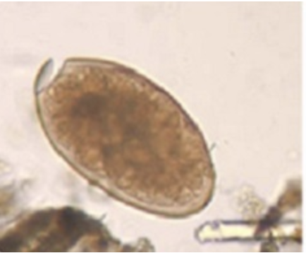

Answer: Fasciola hepatica

