Hayley Stratton
CBS 817
10/26/23

Tripinichgul, Suphawan, Sompoth Weerakhun, and Kwankate Kanistanon. "Prevalence and Risk Factors of Avian Chlamydiosis Detected by Polymerase Chain Reaction in Psittacine Birds in Thailand." Journal of Avian Medicine and Surgery 36.4 (2023): 372-379.

Practice Question:
Which of the following was a significant risk factor associated with C psittaci infection in psittacine birds kept in captivity in 2 regions of Thailand?

A. Age
B. Antibiotic use
C. Cage cleaning
D. Clinical status
E. Ventilation

Santos, Bernardo Mirabal, et al. "Determining the Prevalence of Avian Chlamydiosis in Wild Amazona Species From Brazil Using Molecular Testing and Clinical Signs." Journal of Avian Medicine and Surgery 37.1 (2023): 32-40.

Practice Question:
Which of the following statements is true regarding the prevalence of C psittaci and clinical disease signs for avian chlamydiosis in adult parrots (Amazona species) presented to Wild Animal Screening Centers in Brazil?

A. There was a significant association between positive PCR test results and biliverdinuria
B. There was a significant association between positive PCR test results and conjunctivitis
C. There was a significant association between positive PCR test results and nasal discharge
D. There was a significant association between positive PCR test results and malnutrition
E. There was no association between PCR test results and clinical disease signs

- West Nile virus belongs to which of the following?
  - Flavivirus
  - Rhabdovirus
  - Togavirus
  - Orthomyxovirus
  - Paramyxovirus

Answer: A; Rhabdovirus:rabies; Togavirus: EEE, VEE; Orthomyxovirus: Influenza; Paramyxovirus: Newcastle

- Which corvid species historically has the highest mortality rate from West Nile Virus?
  - House sparrow
  - Fishing crow
  - American crow
  - Common raven
  - Carrion crow

Answer: C

- Which corvid species has been adapting to West Nile Virus in North America?
  - House sparrow
  - Fishing crow
  - American crow
  - Common raven
  - Carrion crow
Answer: A

- Which corvid species has been know to have titers for West Nile Virus for up to 12 months?
  - House sparrow
  - Fishing crow
  - American crow
  - Common raven
  - Carrion crow
Answer: B

- Which of the following is the best sampling site for West Nile virus nucleic acid in corvids?
  - Conjunctiva
  - Cloaca
  - Choana
  - Conjunctiva-Cloaca
  - Choana- Cloaca
Answer: C

Žlabravec, Zoran, et al. "Detection of herpesviruses in passerine birds captured during autumn migration in Slovenia." The Journal of Wildlife Diseases 57.2 (2021): 368-375.
Laura Martinelli

Which of the following best describes herpesviruses in free-living passerines in Slovenia?
- Those herpesviruses detected were most consistent with a Gammaherpesvirus.
- Prevalence of herpesvirus in the population was high.
- Herpesvirus was detected in Eurasian Blackcap (Sylvia atricapilla), the Common Blackbird (Turdus merula), and the Eurasian Blue Tit (Cyanistes caeruleus).
- Detected herpesviruses in these passerines were not phylogenetically related to herpesviruses observed in Sulphur-crested Cockatoo and Neotropic Cormorants.
- Detected herpesviruses in these passerines were not phylogenetically related to gallid HV1, psittacid HV1 and HV2, and passerine HV1.

Answer: C

Potential diagnostic biomarkers for pulmonary tuberculosis in humans are not elevated in Mycobacterium tuberculosis culture–positive Asian elephants (Elephas maximus). Am J of Vet Resear. 83(8): 1-9. 2022.

Laura Martinelli

Question: Which of the following regarding Mycobacterium tuberculosis is false?
- Elephants are the natural host for M.tb and the main source of transmission to humans.
- M.tb has been observed in both wild and captive elephants.
- M.tb has been observed in both African and Asian elephants.
- A trunk was culture is the gold standard diagnostic test for M.tb in an elephant.
- M.tb can spread from elephant to elephant and from elephant to other mammals.

Answer: A

---------------------------------------------------------------------------------------------------------------------

Fowler Zoo and Wild Animal Medicine, 9th ed Chapter 85 - Mycobacterium pinnipedii by Alexis Lécu. Pages 603-609
Laura Martinelli

Question: What is the most effective disinfectant for reduction of mycobacterial species in the water, such as Mycobacterium pinnipedii?
- Sand filtration
- Bead filtration
- Ozone
- UV
- Chlorine

Answer: C

QUESTION: Which avian taxa would you expect to have the highest prevalence of chlamydia infection?
- Columbiformes
- Passeriformes
- Galliformes
- Falconiformes
- Charadriiformes
Answer: A – Columbiformes and Psittaciformes are most commonly infected; likely reservoirs of several species

Source: Sandro JAMS 2021. Falcons From the United Arab Emirates Infected With Chlamydia psittaci/C abortus Intermediates Specified as Chlamydia buteonis by Polymerase Chain Reaction.

JAMS 2021 35(3):325-332
Survey of Beak and Feather Disease Virus (BFDV) in Guatemalan Neotropical Psittacine Birds

Practice Question: What is your top differential diagnosis for this young African grey parrot’s bilateral symmetric feather loss and color change?
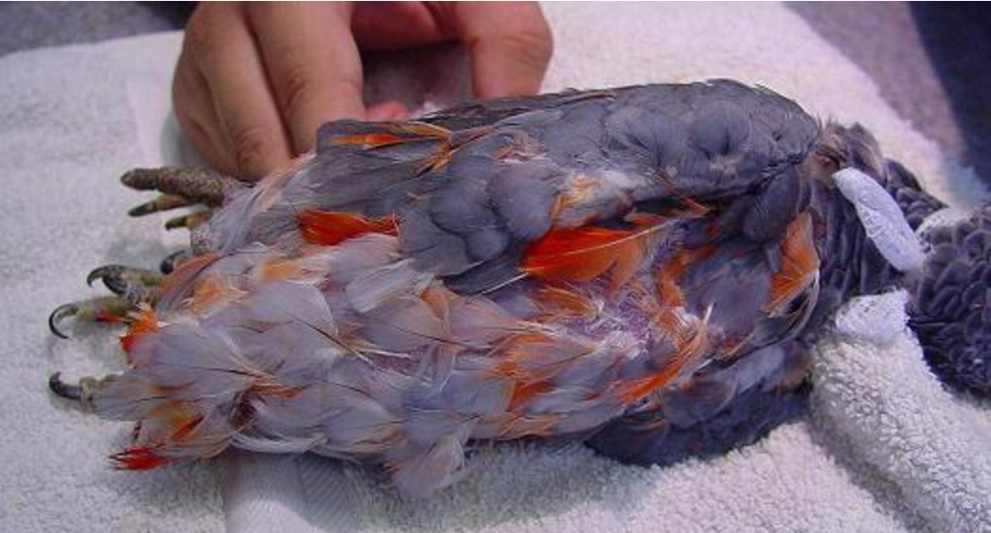

Answer: (Psittacine) beak and feather disease virus

