HEMATOLOGY AND BLOOD CHEMISTRY VALUES IN CUBAN CROCODILES (CROCODYLUS RHOMBIFER) HOUSED AT THE ZAPATA SWAMP CROCODILE FARM, CUBA. Journal of Zoo and Wildlife Medicine 54.2 (2023): 301-309. Jamie L. Palmer, Ainoa Nieto-Claudín, Gustavo Sosa Rodriguez, Etiam Perez Fleitas, Lauren Augustine, Sharon L. Deem.

Abstract: We report hematology and biochemistry reference intervals (RI) for the critically endangered Cuban crocodile (Crocodylus rhombifer). In November 2019, we sampled 43 adult crocodiles (6 male, 37 female) under human care at the Zapata Swamp Crocodile Farm in Matanzas, Cuba. These crocodiles are part of a breeding program for the species registered by the Convention on International Trade in Endangered Species (CITES). Visual health evaluations were performed immediately after manual restraint, and blood was collected from the postoccipital sinus. We performed packed cell volume (PCV), total solids (TS), complete blood counts (CBC), and biochemistry profiles for each crocodile on the day of sampling. Mean PCV (n = 42) was 21.1 ± 5.0% and TS (n = 42) 7.3 ± 1.2 mg/dl, respectively. Absolute white blood cell (WBC) (n = 40) was 9.6 ± 5.7 ｘ 109/L. Similar to other crocodilian species, the dominant leukocyte was lymphocytes (70.7 ± 10.4%), followed by heterophils (18.7 ± 9.7%). Two of the crocodiles had a high heterophil:lymphocyte ratio (0.87 and 0.74), although on visual exam they were both considered healthy. The range of creatine kinase was 41–1,482 U/L, and the higher values may be a reflection of muscle exertion at time of handling. Limitations to the study included skewed sex ratios and high lipemia and hemolysis in most samples collected. These are the first reference intervals reported for this species, including the first descriptions of WBC morphology. These data are valuable for the management of animals at the Zapata Swamp Crocodile Farm, for comparison with free-living Cuban crocodiles in Cuba, and for comparison with those managed under human care outside of Cuba.

Methods: establish RI for CBC/chem in Cuban crocs, n=43 adults (6.37) mostly captive bred
- Venipuncture post-occipital sinus under manual restraint (obtained within <20 min of restraint)
- Fasted for 4 days prior; apparently healthy based on PE
- ~50% had “flopped tails” of unknown etiology - posterior tail tip flat instead of erect; no stat sig

Background:
- Cuban crocodile (Crocodylus rhombifer) - critically endangered; 2400 left in wild
- High levels of hybridization with American crocodiles in wild and captivity
- Current conservation management: population augmentation with reintroduction into areas where extinct, genetic and behavioral studies
- Importance of baseline biomedical data = provides info to compare to similar sp, between populations of same species, and within populations over time

Key Points:
- First RI and descriptions of WBC morphology reported for this species
- Lymphocyte (>hets) dominant species - like other crocodilian species
- Two apparently healthy animals had high H:L ratio (0.87 and 0.74); outliers removed for stats
- No blood parasites or cell toxicity seen in any smear
- Hemolysis and/or lipemia in 41/43 samples
  - Hemolysis increased AST, P, hets and decreased lymphs
  - Lipemia decreased ALB, P and eos
  - Analytes most commonly affected by hemolysis/lipemia in other reptiles: AST, UA, Glu, Ca, P, TP, Alb, Glob
- Many limitations: drying artifact on some slides due to high humidity environment, performed WBC estimate at 100x (40x was broken on field microscope), counted azurophils as monocytes due to difficulty discerning the two, lipemia/hemolysis, skewed sex ratio (6.37), sampled during single season (dry season)

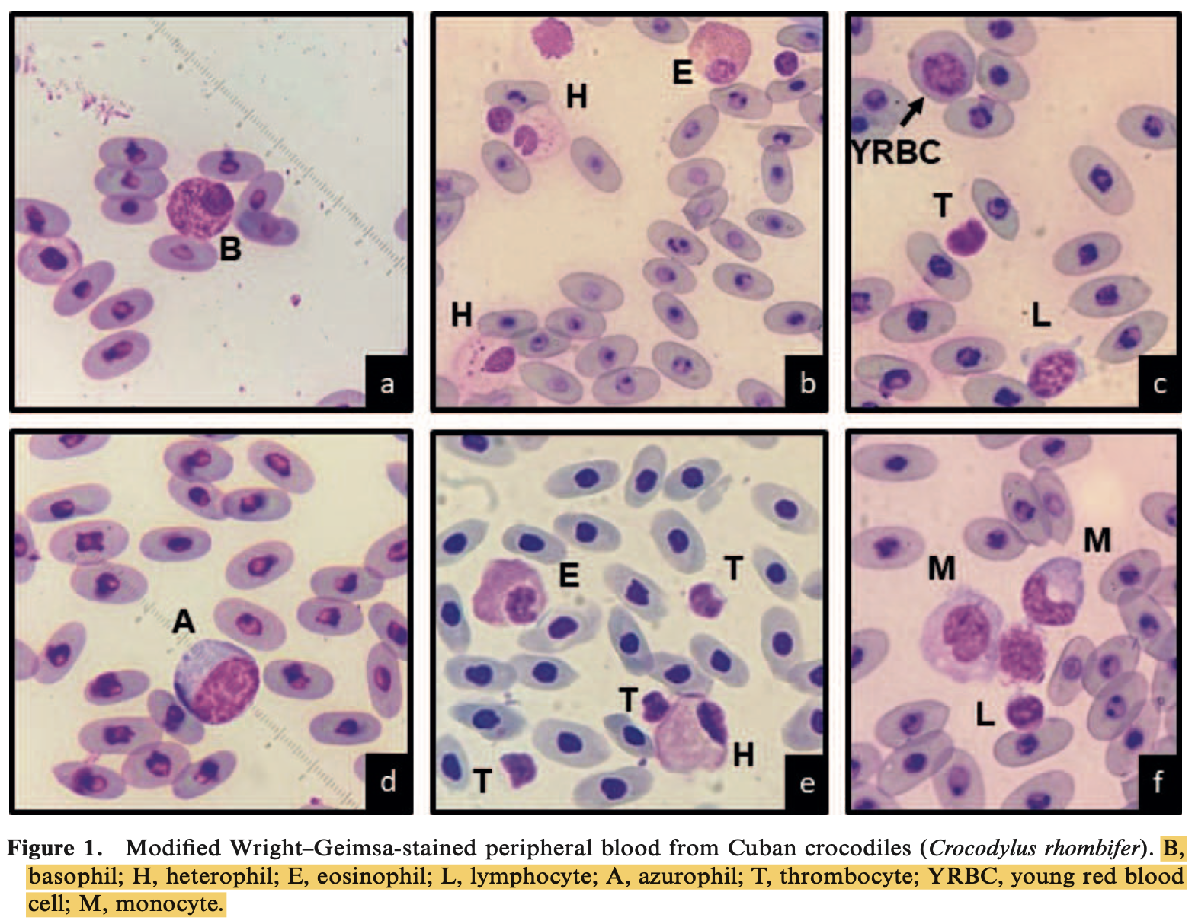
Cell Descriptions:
- Clear cytoplasm in thrombocytes (T), blue cytoplasm in lymphocytes (L)
- Hets (H): round to oval with offset nucleus and poorly differentiated rod-shaped granules (generalized pink refractile smooth surface); small basophilic granules sets apart from other granulocytes
- Eos (E): round, oval, bilobed eccentric nuclei darker than heterophils with round, plump granules
- Monos (M): classic kidney shaped nuclei and light gray purple cytoplasm and cytoplasmic vacuoles
- Azuros (A): large round cells with oval nuclei, clumped chromatin similar to mons
- Basos (B): compact with dark, densely packed granules throughout including in nucleus, pink cytoplasm if visible

Pathology of Wildlife and Zoo Animals. Ch. 35: Crocodilia. Laura Martinelli.

NON-INFECTIOUS DISEASES
- Nutritional (largely reported in captive setting)
  - Hypovitaminosis E associated with (pan)steatitis and fat necrosis
    - Etiology diet with fish high in polyunsaturated fatty acids, feed rancidity, or both
    - Discrete or diffuse firm yellow/brown fat that fluoresces yellow/orange under UV light
    - May cause immobility as lesions most severe in tail and cause impingement, can also impact GI motility
  - Hypovitaminosis A
    - Vit A stored in liver mainly, meat-only diets can be deficient if not supplemented
    - Squamous metaplasia, nodules on surface of tongue, Impacts collecting ducts in kidney renal and visceral gout and secondary tubulonephritis, and impact on corneal epithelia
  - Thiamine (Vit B1) Deficiency
    - Neurologic Disease abnormal buoyancy, head tilt, limb paresis, anisocoria, lethargy, lack of vocalization, stargazing
    - Deficiency Occurs Because:
      - Degradation from repeat freeze and thaw cycles
      - Enzymatic destruction by thiaminases
    - No gross lesions
    - Histologically gray matter necrosis, denervation atrophy of skeletal muscle in hindlimbs and fibrosis of sciatic nerve
- Metabolic
  - Gout
    - Crocodilians are ammono-uricotelic – predominantly liquid nitrogenous waste as ammonia, but uric acid goes up during fasting
    - Uric acid precipitates in tissues kidneys, serosa, joints, pericardium
    - Predisposing factors low enviro temps, dehydration, bacterial nephritis, sepsis, squamous metaplasia of collecting ducts, nephrotoxicosis
    - Farmed crocodilians can have this when overfed without intervening fasts (protein overload)
    - Histologically – “star-burst” appearance of mixed inflammatory cells with central core of eosinophilic material (needle-like crystals may be lost during the process)
  - Metabolic Bone Disease
    - Same as MBD in companion exotic reptiles
    - Additional lesions cystic degeneration, parathyroid gland hyperplasia
- Toxic (uncommon in Crocodilians)
  - Lead Toxicity
    - High tissue and blood lead levels reported in both wild and captive but associated clinical signs and pathologic lesions rare
    - Typically consumed in prey killed by lead shot
    - Histology renal tubular epithelial cell necrosis, enlarged tubular cell nuclei with marginated chromatin
    - Note: Reduced reproduction due to embryonic death may be only sign
- Neoplastic
  - Rarely reported (chapter has a list)

INFECTIOUS DISEASES
- DNA Viruses
  - Poxvirus
    - Multiple recognized
      - Caiman poxviral infection – young animals <1 yo, gray-white circular papules flat or depressed, on head, body oral mucosa, palpebrae, limbs
        - Lesions can regress uneventfully or coalesce
        - Histology Intracytoplasmic inclusion bodies in keratinocytes
        - Note Estuarine + FW Crocs have similar presentation of poxvirus
      - Nile Crocodile poxviral infection – young animals <1 yo, brown, raised, ulcerated lesions anywhere but usually on head and ventrum
        - Histology Intracytoplasmic inclusion bodies in keratinocytes
        - Morbidity high, mortality low
        - Alternate presentation “pit holes” – small deep holes on scales of ventral coelom, histologically cysts
  - Herpesvirus
    - Crocodyline herpesvirus 1,2, and 3
    - CrHV-1 and CrHV-2 three disease syndromes in estuarine crocs
      - Systemic Lymphoproliferative Syndrome w/ Encephalitis (SLPE)
        - Effects juveniles recognized by increased mortality, poor growth, and ill thrift; Gross lesions typically limited to thin body condition; Histologically lymphohistiocytic infiltrates in numerous tissues, pulmonary edema
      - Conjunctivitis/pharyngitis (CP) (loosely tied to herpesvirus)
      - Lymphonodular Skin Lesions (LNS) (loosely tied to herpesvirus)
    - CrHV-3 one disease syndrome in FW crocs
      - Lymphoproliferative syndrome
  - Adenovirus
    - Infection in young (<1 yo, often <5 months), Nile crocs
    - Hepatic or intestinal disease, moribund or dead w/o premonitory signs
    - Gross necropsy Mottling and liver enlargement, thickened intestinal wall w/ bloody contents, or no gross lesions
    - Histology acute necrosis with lymphocytic (liver) or mixed inflammatory cell infiltrates (intestine), basophilic intranuclear inclusion bodies in hepatocytes or GI epithelial cells
- RNA Viruses
  - West Nile Virus
    - Mortality rates 3 to 60% in SE farms
    - Hatchlings and juveniles most severely effected
    - Acute death or neuro signs and death
    - Gross coelomic effusion, oropharyngeal inflammation, colitis, intestinal hemorrhage, tan foci, mottled organs
    - Histology heterophilic to lymphoplasmacytic meningoencephalitis +/- spinal cord involvement, +/- myocarditis, interstitial pneumonia, necrosis of palatine tonsils, and adrenalitis
    - Note – high viral shedding from cloaca and horizontal transmission suspected
    - WNV associated w/ Lymphohistiocytic proliferative syndrome
      - Gross Spherical opaque lesions in fresh skin, pit-like scars in tanned skin
      - Histology Nodules of lymphocytes and macrophages
- Bacteria (just common presentations)
  - Mycoplasma
    - Nile crocs, American alligators
    - Clinical Signs arthritis, pneumonia (both species), pericarditis and polyserositis (alligators)
    - Mycoplasma crocodyli etiology in Nile crocs
      - Only young (1-3 yo)
      - Morbidity + mortality <10%
      - Marked joint enlargement, lameness + paresis, +/- pneumonia
      - Culture likely only successful in earlier stages
      - Histology fibrinonecrotic synovitis w/ lymphocytic infiltrate, lung consolidation w/ mononuclear + heterophilic infiltrates
    - Mycoplasma alligatoris etiology in American Alligators
      - Fatal, widespread disease, only in experimentally induced and zoological collections
      - Gross cloudy joint effusion, fibrinous epicarditis w/ adhesions to pericardial sac
      - Histology fibrinonerotic synovitis + epicarditis with lymphocytic + heterophilic to granulomatous infiltrates
  - Chlamydiosis
    - Suspected disease in farmed Nile, estuarine, and Siamese crocodiles; Large scale outbreaks or isolated cases
    - Clinical Signs conjunctivitis, hepatitis (predominant lesion), and systemic infection
    - Gross Liver is large, pale, mottled; Spleen enlarged; pericardial effusion, coelomic effusion
    - Histology organism seen in touch prep of liver in hepatocyte cytoplasm, Lymphoplasmacytic + histiocytic inflammation w/ hepatocellular necrosis
  - Dermatophilus spp.
    - Skin lesions caused by bacteria morphologically consistent with Dermatophilus identified predominantly in farmed American alligators, estuarine crocs, and FW crocs
    - Grossly red or brown flat maculae, irregular brown ulcerations, erosions particularly along jaw, SC granulomas may underly ulcerations
    - Histology lymphohistiocytic and perivascular, gram-positive filaments and coccoid structures (zoospores?) in stratum corneum
  - Mycobacteriosis
    - Etiology is a nontuberculous mycobacteria (like other reptiles)
    - Examples M. chelonae, M. fortuitum, M. marinum among others
    - Typically granulomatous disease and it is usually opportunistic
  - Gram-negative Septicemia
    - Stress (temperature or other-related) and trauma usually contributing factors
    - Many etiologies (usually opportunists) Salmonella, Edwardsiella, Proteus, Klebsiella, Citrobacter, Enterobacter, Morganella, Serratia
    - Aeromonas hydrophila one of the most common
      - A. hydrophila septicemia impacts farmed croc hatchlings, and see fibrinous polyserositis, hepatitis, pneumonia, SC edema, and ventral skin erosions
    - Providencia rettgeri (Previously Proteus rettgeri)
      - Motile, gram-negative bacillus, ubiquitous in environment
      - Significant cause of gram-negative septicemia in farmed croc hatchlings and juveniles (2-8 months old)
      - Same lesions as other gram-negative septicemia cases but clinically see CNS disease more consistently than with other bacteria and heterophilic meningitis
  - Necrotizing Fasciitis
    - Etiology (gram positive) Streptococcus agalactiae
    - Seen in farmed juvenile estuarine crocodiles
    - Gross necrosis and ulceration of body wall, limbs exposing muscle and soft tissue, fasciitis, polyarthritis – multiple swollen joints with caseous exudate
    - Histology necrosis, edema, fibrin deposition in through fascial planes and has heterophilic and granulomatous inflammation with intralesional gram-positive cocci
  - Yolk Sac Infections
    - Common in farmed crocs
    - Predisposing factor poor hygiene in first week of hatching

- Fungi
  - Most common locations skin or lungs but can occur in any tissue
  - Clinical sign change in skin color and texture OR proliferative granulomatous inflammation on croc feet housed in abrasive surfaces
  - Histology heterophilic inflammation predominates, fungal species many similar with narrow, septate, and nonpigmented parallel walls (hyalohyphomycosis) so morphology is not a good determinant
  - Nannizziopsis crocodili
    - Specific + non-opportunistic fungi of crocodilians
    - Dull to leathery and plaque-like appearance on skin of estuarine croc hatchlings
- Metazoa
  - Gastric ascaridiasis
    - Etiology Dujardinascaris or Brevimulticaecum spp.
    - Does not always cause clinical disease
    - Severe infection gastric ulceration and granulomas in stomach of wild and captive crocs
  - Paratrichosomiasis
    - Etiology Paratrichosoma crocodylus (New Guinea, estuarine, and FW crocs), Paratrichosoma recurvum (American and Morelet’s crocs)
    - Not clinically significant, impacts hide and commercial value
    - “Zigzag trails” trails on skin (migrating nematodes)
  - Pentastomiasis
    - Common parasite of crocs
    - Hematophagous, vermiform arthropods, two hooks around mouth
    - Indirect life cycle w/ intermediate (usually fish) and definitive hosts
    - Usually do not cause significant disease but predispose to bacterial sepsis
- Protozoa
  - Coccidiosis
    - Etiology Goussia spp.
    - Life cycle unknown
    - Occurs in Nile, estuarine, and NG crocodiles
    - Fatal form can occur sporulation in many organs systems, +/- pneumonitis, intestinal villous loss and fusion with necrotizing enteritis

PRESUMED INFECTIOUS DISEASE WITH UNCERTAIN ETIOLOGY
- Two disease syndromes of farmed crocs that are well-described but lack an etiology
- Conjunctivitis with or without Pharyngitis (CP)
  - Nile, Siamese, and estuarine crocs
  - Thought to be associated with Chlamydiaceae but recent evidence suggests may be multi-factorial and include herpesviruses (CrHV-1, CrHV-2)
- Lymphnodular Skin Lesions (LNS)
  - 2-4 yo estuarine crocs
  - CrHV-2 suspected but not confirmed
  - Pale nodules on skin of lateral body wall (typically)
- Giant Cell Enteritis
  - Farmed estuarine crocs in Australia
  - Thickening, reddening, and ulceration of proximal intestinal tract
  - Multinucleated giant cells transmurally
  - Presumptively protozoan but not confirmed

JHMS 2021 31(2):132-40
Comparison of Ketamine–Dexmedetomidine–Midazolam Versus Alfaxalone–Dexmedetomidine–Midazolam Administered Intravenously to American Alligators (Alligator mississippiensis)
Aymen J, Queiroz-Williams P, Hampton CC, Cremer J, Liu CC, Nevarez JG

ABSTRACT: Crocodilians often require chemical immobilization for safe restraint and veterinary procedures, but there is a paucity of anesthetic studies for these species. The aim of this study was to compare the ability of ketamine (5 mg/kg) versus alfaxalone (5 mg/kg), in combination with dexmedetomidine (50 µg/kg) and midazolam (1 mg/kg) (KDM, ADM), to provide a loss of reflexes and safe orotracheal intubation without producing apnea in American alligators (Alligator mississippiensis). Six 22-month-old captive-hatched American alligators (4.75 ± 0.48 kg and body length of 111.1 ± 9.9 cm) were administered KDM and ADM in the lateral occipital venous sinus in a randomized, crossover design with a 72–80 h washout period between treatments. Physiologic parameters (heart rate, respiratory rate, esophageal and cloacal temperatures, end-tidal CO₂) and reflexes (palpebral, cloacal, corneal, righting, withdrawal) were serially assessed throughout the anesthetic episode. Alligators were intubated, and assisted ventilation was provided to apneic animals. Intubation was safely performed within 10 min of administration of ADM and KDM. Respiratory rate was the only physiological parameter to differ between ADM and KDM. The majority (5/6, 83.3%) of alligators administered KDM maintained spontaneous ventilation (P = 0.016) and withdrawal reflexes (P = 0.031), and all alligators (6/6, 100%) given ADM became apneic and lost their withdrawal reflexes in all four limbs. Palpebral, cloacal, and righting reflexes were consistently lost in all animals with both combinations. Recovery time ranged from 5 to 35 min following administration of the reversal agents. Although KDM and ADM both permitted orotracheal intubation, KDM produced less apnea and a lighter plane of anesthesia compared to ADM.
Background:
- Alfaxalone = synthetic neuroactive steroid, not reversible
  - In mammals, can produce both cardiovascular and respiratory depression including dose and rate dependent apnea in dogs
- Dexmedetomidine = α-2-adrenergic agonist, reversible
- Ketamine = blocks NMDA receptors, not reversible
  - Historically, a wide range of doses have been used in crocodilian anesthesia
  - Often given with a benzodiazepine, α-2-adrenergic agonist, or inhalant
Key Points:
- Two protocols compared via a randomized, crossover design with a 72–80 h washout period
  - KDM: 5 mg/kg ketamine + 50 mcg/kg dexmedetomidine + 1 mg/kg midazolam IV
  - ADM: 5 mg/kg alfaxalone + 50 mcg/kg dexmedetomidine + 1 mg/kg midazolam IV
- Both produced rapid induction (~10 min)
  - Palpebral, cloacal, and righting reflexes consistently lost in all animals for both
- ADM: surgical anesthesia, shorter duration (60 min), lost withdrawal reflexes, became apneic
- KDM lighter anesthesia, longer duration (150min), maintained breathing & withdrawal reflexes
- Most required reversals in both groups
  - Both protocols recovered rapidly post reversals
  - Unlikely ketamine or alfaxalone the sole driver of anesthesia
TLDR: KDM produced less apnea and a lighter plane of anesthesia compared to ADM in American alligators
Related Articles:
Monticelli P, Ronaldson HL, Hutchinson JR, Cuff AR, d'Ovidio D, Adami C. 2019. Medetomidine–ketamine–sevoflurane anaesthesia in juvenile Nile crocodiles (Crocodylus niloticus) undergoing experimental surgery. Vet Anaesth Analg, 46(1):84–89

Fowler 8 Chapter 5: Crocodilians

ANATOMY

Respiratory System:
- Nostrils are water-proof valves that close with a muscular flap during submersion
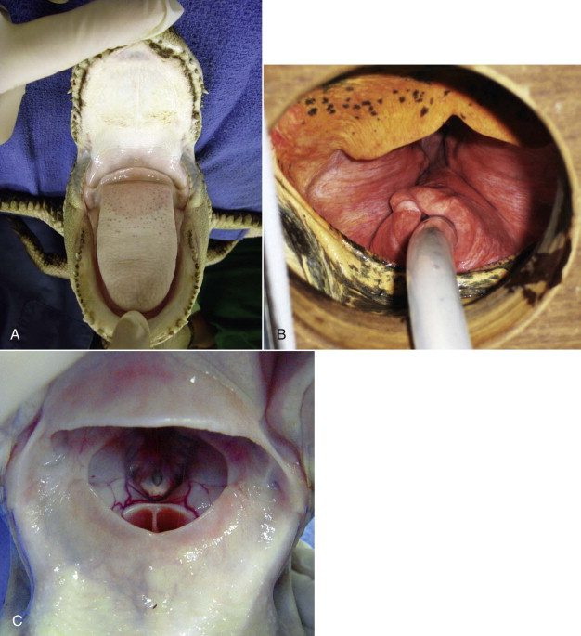
- Elongated palate (palatine flap) presses down against the dorsal flap of the tongue forming the gular valve (helps when the croc opens mouth to stop water from rushing in to the nares and glottis underwater)
- Trachea bends to left (not alligators) before bifurcation
- Post Pulmonary membrane: separates the lungs from liver
- If the thoracic cavity is compressed= animal cannot breathe
- Post Pulomary and Post hepatic membranes=diaphragm

Cardiovascular System:
- Only reptile with a four chambered heart
- Differences between mammals:
  - Right Aorta, and Left Aorta (right goes to lungs and left bypasses)
  - Connective tissue extensions into the pulmonary outflow tract of the right ventricle which will restrict blood to lungs during diving and shunt blood from left to right sides
  - Foramen of Panizza: opening between the left and right aortic arches allowing pressure equalization during diastole
- Foramen of Panizza: pressure valve that allows blood flow between arterial and venous systems
  - During diving: increased pulmonary tension which increases right ventricular and pulmonary arterial pressures so blood will flow from right to left through the foramen- deoxygenated blood flows to the organs that are not sensitive to low oxygen levels and oxygenated blood is diverted to heart and brain
  - Due to this system the croc can be submerged for 5-6 hours
- NOTE: due to this system- shunting of the blood away from lungs will delay inhalant anesthetic uptake and removal- importance of assisted ventilation during immobilizations

Blood Volume
- Total: 3.5-5.5%
- Max to remove: 0.03-0.05% by weight

Renal Portal System
- They have to avoid injections in back end - however author has continued to use tail and hindlimbs for safety reasons and hasn't had issues
- Care should be taken when administering nephrotoxic drugs in hindlimbs- renal first pass

Eyes, Ears, Skin, Teeth
- Three eyelids: upper, lower and nictitating membrane; eyeball can retract into socket during eating and they have a tapedum lucidum
- Bilateral ear openings; covered by flap in diving- inner ear infections are not common but can result in neurologic signs
- Skin has scales, scutes but no sweat glands; have osteoderms over head and back; some have glandular secretions (gular glands on mandible, lips or in Chinese alligators beneath scales on dorsum)
- Pointed conical teeth that are replaced; starts back to front in alternating teeth in young and reverse in older (can happen every 3-4 months); certain number of replacements
- Two first mandibular incisors can grow long enough to penetrate the upper maxilla in front of the nostrils (apparently normal and isnt a problem)

HUSBANDRY
- Poikilothermic; like temps between 25-35C
- Might decrease or stop eating in winter
  - Common for American and Nile to stop for 4 to 5 months during winter (wild or housed outdoor)
- Not eating within the optimal temp range= workup
- Slower digestion times and decreased metabolism at lower temps
- Temps above 35= lead to overwhelming infection and death
- Crocs under general should be kept around 29-30C

ENCLOSURE DESIGN
- Should have CLEAN water (water source should undergo water quality testing routinely) and they should have a dry basking haul out area
- Dominance and interspecies aggression should be considered when housing crocs together and Chinese alligators should be housed individually
- Pica is a common behavior; gastroliths are nonpathogenic
  - Greater concern: larger rocks (less than 20 cm), pieces of PVC pipe, life support system components, coins, or metal foreign bodies
- Endoscopy for bigger objects, stomach lavage for smaller

NUTRITION
- wild=opportunistic carnivorous feeders: young= fish and inverts, bigger=whole ruminants
- Whole prey= most common food source
- Those that eat a lot of fish (caimans and gharials) may need supplemental vitamins or other whole prey items- frozen fish have thiaminase and can result in hypovitaminosis B
- Mineral powders and calcium should be stored in freezer- stable environment and kept no more than 6 months
- Concern for prepared food items (skinned organ removed prey): results in vitamin A and E deficiency as well as other issues: swellings, tooth loss
- Pellets diets: accepted by most- gharials being exception
- Pellets are easy to make crocs obese

INFECTIOUS AND NONINFECTIOUS DISEASES
- Captive crocs in zoos seem to have minimal infectious disease (IF held in appropriate social and environmental settings)
- Nutritional issues and disease related appear most commonly, trauma is also common

BACTERIAL

Salmonella enteritidus and S. typhimurium | Hatchling enteritis and septicemia, adult carrier state | Culture and histo | Tx hatchlings based on culture; monitor adults
Mycoplasma alligatoris, M. drocodyli | Polyarthritis, pneumonia, death | Culture, PCR, screen with ELISA | Tetracycline (not 100% efficacious)
Chlamydia Sp. | TWO FORMS:  Blepharoconjunctivitis, acute hepatitis  juveniles | Culture of eye swab, histo of liver | Tetracycline 1 g/1kg of dry feed
Dermatophilus sp | Brown discoloration of ventral scutes | Cytology, histo, or culture of lesions | Tetracycline 1 g/1kg dry feed, copper sulfate, hygienic conditions

VIRAL

Pox: Parapox | Juveniles; white to brown crusts in oral cavity and ventral scutes | Histo with bollinger bodies and borrel bodies | Self limiting- may need surgical debridement
Adenoviral Hepatitis | Hatchlings (<5 months of age); hepatitis | Liver, lung, pancreas, intestines | No tx, supportive care
Eastern Equine Encephalitis | No clinical signs | Winter reservoir for virus | Monitor titers for spikes
West Nile Virus | Range from no clinical signs, neurologic disease, lymphohistiocytic proliferative syndrome (in farmed crocs) |  | Monitor titers: does not cause mortalities

FUNGAL

Mucor, Aspergillus, Fusarium, Cladosporium | Dermatitis, gastric, oral and resp mycosis- related to poor sanitation and environment | Culture and histopath | Antifungal tx, sanitary conditions; poor prognosis if systemic mycosis occurs

PARASITIC

Eimeria and Isospora | Intestinal coccidiosis with secondary bacterial infection: can result in a blockage | Direct saline fecal exam; histopath | Screening incoming animals; treat with sulfa derivative drugs
Hepatozoonosis | Asexual schizonts may be in liver; gametes in blood | Blood smears; usually not pathologic unless immunosuppressed | Cannot control in outdoor setting
Ascarids | No clinical signs: maybe stomach ulcers, mucosal lesions of GIT | Fecal exam | Fenbendazole, freezing food for 72 hours may eliminate larva
Trematodes | Limited path with the exception of concurrent infection with other disease | Direct visualization on antemortem and postmortem | Reduce feeding fresh water fish from same habitat
Pentastomes: Sebekia, Alofia, Liperia | Inhabit upper resp tract and lungs (some are zoonotic); may cause morbidity and mortality in young crocs | Eggs seen in feces, direct exam via endoscopy | Endoscopic removal

PREVENTATIVE MEDICINE
- Baseline PE and blood work; routine health program in place
- Routine training for wellness exams
- Young crocs: annual for 3-4 years= manual restraint: PE, transponder placement, weighing, blood collection (CBC/Chem and maybe trace minerals, fatty acids, EEE and WNV titers), whole body rads
- Adults: exam every 2-3 years; hopefully with behavioral husbandry program: PE, transponder confirmation, weight, blood (CBC, Chem, trace min, fatty acids, EEE and WNV titers, whole blood lead and zinc panels), rads of stomach (esp if history of eating FB)

BEHAVIORAL CONDITIONING
- SPIDER framework: Setting goals, Planning, Implementation, Documentation, Evaluating, and Readjusting
- Crate training and making it part of the husbandry routine

ANESTHESIA AND RESTRAINT
- Anesthetized croc: cover eyes with damp towel, jaw tapped shut or tapped open with oral speculum for intubation and ventilation; DO NOT TAPE NOSTRILS, do not pull on legs (use slings along chest and pelvic area, or place on aluminum ladder)
- IM: hindlimb, forelimb, base of tail lateral aspect caudal to hind leg
- IV: internal jugular (occipital sinus), ventral coccygeal vein, lateral coccygeal vein
- Protocols:
  - Adult: medetomidine, ketamine- intubation and isoflurane- forced ventilation with 3-4 breaths a min; once at desired state of anesthesia may reverse medetomidine
  - Young: propofol IV; additional propofol to effect; maintain with iso via ETT with PPV 3-4 breaths/min
- Pulse ox does not calculate oxygen saturation in reptiles
- Doppler is very reliable at heart rate

ANALGESIA
- Opioids (Morphine and Meperidine) and NSAIDS tend to show best results
- Caution against butorphanol

Hayley Stratton
CBS 817
9/28/23
Chapter 59: Medical evaluation of Crocodilians, Fowler 9
- History
  - Species’s normal habitats and behaviors for a given sex and age?
  - History of previous diseases and current complaint?
  - Admission and quarantine protocols? Standards of hygiene and biosecurity practices?
  - Seasonal air and water temperatures and rainfall?
  - Physical and chemical water quality? Where does water come from?
  - Enclosure design, including land and water surfaces and water depth? Are there adequate visual barriers, basking sites, nesting sites, etc.?
  - Diet and how is it presented: frequency, locations, time of day?
  - Size and gender composition (social structure) and stocking density acceptable? Signs of runting, competition, or fighting?
- Physical examination – general considerations
  - Skin is inelastic, and the vertebral ribs and the abdominal ribs (gastralia) prevent thorough palpation of internal organs.
  - Ultrasonography is an integral part of the general examination
  - Fast for 3-5 days because a full stomach interferes with ultrasound, and postprandial increases in lipemia, plasma bicarbonates, and uric acid interfere with blood tests
- Sex
  - Sex is incubation temperature dependent
  - The cliteropenis is located at the cranial commissure of the cloaca. Cliteropenis dimorphism increases with age
- Age
  - Curves relating age to length exist for a number of species
  - Abnormally slow growth (runting) is associated with adrenal and osseous pathologies, immune deficiency, and chronic stress
- Body score
  - Crocodiles possess an intracoelomic well-vascularized sack of readily available adipose tissue, known as the steatotheca or fat body, which mobilizes promptly in response to metabolic requirements
  - A steatotheca to heart ventricle (S:V) mass ratio of 5 or greater indicates excess energy store. An S:V ratio lower than 0.5 indicates very poor body condition.
  - The steatotheca is visible by ultrasound against the abdominal wall of the right flank. The volume or maximum dimensions of the steatotheca are compared with the ventricular measurements to estimate the state of nutrition, using the previous ratio
- Integumentary system
  - Healthy crocodile skin is smooth, shiny, and dry
  - Scale morphology and the distribution of osteoderms and integumentary sense organs (ISOs) vary between species
- Immune system
  - Lack lymph nodes; accessible lymphoid organs = tonsils, thymus, spleen
  - The tonsils can be visualized by lifting the soft palate and using an angled mirror or telescope. Tonsils become reactive in a number of infectious diseases, including chlamydiosis and herpesvirosis (epidemic diseases of hatchlings)
  - The spleen can be evaluated by ultrasound. It is a well-defined oval organ with a homogeneously granular texture. The spleen reacts to sepsis by enlarging, deforming (budding), and changing texture
- Circulatory system
  - HR 30-50 bpm on land, 5-8 bpm when diving
  - Ultrasound allows clear cardiac visualization and measurements
  - Pericardial effusion occurs with chlamydiosis or septicemia
  - Visceral gout can be diagnosed and sampled via ultrasound
- Respiratory system
  - Two symmetrical, saccular lungs with unidirectional air flow
  - Respiratory disease often not apparent until advanced
  - Cx: reduced stamina, listing in the water, abnormal swimming, foul smell on exhalation, nasal expulsion of stained exudate, and gurgling rales
  - Radiographs okay for obvious disease, CT diagnostic of choice
  - Bacterial and fungal pneumonia typically present as focal or disseminated granulomatous disease – can perform bronchoscopy or BAL
  - Pentastomidae infect crocodiles through the consumption of fish and may cause verminous pneumonia.
- Digestive system
  - Teeth are replaced continuously
  - Routinely ingest stones and other foreign bodies
  - Ultrasound
    - Stomach visible from left flank; wall is thick with identifiable layers
    - Duodenum is a double loop; duodenum and pancreas medial to stomach
    - Intestines uniformly thick and widen when reaching rectum
    - Yolk sac occupies large part of coelom in hatchlings and yearlings. Healthy yolk sac has a homogenous appearance
  - Large, symmetrical, bilobed liver envelops the heart laterally and dorsally. Crocodiles have a gallbladder.
    - Ddx for severe diffuse hepatitis: Herpes virus, WNV, chlamydiosis, and mycoplasmosis
    - Sepsis causes focal or diffuse hepatitis
- Urinary system
  - Crocodiles excrete ammonia, uric acids, and small amounts of urea.
  - Kidney does not concentrate urine. Water conservation takes place in the mucosal lining of the distal intestines or in the urodeum
  - Isoechoic with fat and difficult to identify on ultrasound
  - In fasted crocodiles, serum uric acid values higher than 12 mg/dL (750 µmol/L) accompanied by a calcium and phosphorus ratio less than 1 suggest renal disease
  - Gout is a common manifestation of renal dz; bacterial/parasitic nephritis reported
    - Predisposed to gout in winter b/c urate crystals less soluble at low temps
- Reproductive system
  - Assess by ultrasound
    - Ovaries present as clusters of anechoic or hypoechoic spheres of variable size depending on reproductive status
      - Eggs elongated and calcified, easy to distinguish from follicles
    - Oophoritis presents as clusters of thick-walled heterogeneous cysts.
    - Testicles are elongated homogeneous organs visible from both flanks
  - Gestation or egg retention diagnosed by radiographs
- Nervous system
  - Cx: unusual resting positions, listlessness, opisthotonos, excitability, tremors, and convulsions
  - Thiamine deficiency (from consumption of fish rich in thiaminase) is a common cause of neuropathy in crocodilians, captive or wild
  - Meningoencephalitis from crocodile herpes virus, WNS, parasites, septicemia
- Laboratory examination
  - Blood collection sites: ventral tail vein, supravertebral venous sinus in the cervical spine or in the dorsal tail, venous sinus located in the mandibular shelf at the tip of the lower jaw
  - Hematology and biochemistry do not reliably reveal inflammation or organ damage
  - Hemoparasites common and do not appear to cause disease
  - Improvement in PCV, TP, and albumin, in the absence of leukopenia, is a positive prognostic indicator in patients recovering from long-term debilitating conditions
