Yanong R. 2023. Fish medicine updates. In: Miller RE, Callet PP, Lamberski N (eds.). Fowler's Zoo and Wild Animal Medicine Current Therapy 10. Elsevier, St. Louis, pp. 389-393.
Laura Martinelli
Focus: Chapter summarizes “newer” or more emergent fish pathogens.
Megalocytiviruses
- Background
  - Globe problem today, affecting wide range of fish families in aquaculture
  - Family Iridoviridae (6 genera in the family listed below), icosahedral structure, double-stranded DNA viruses
    - Iridovirus, Chloriridovirus, Decapodiridovirus insects, crustaceans
    - Ranavirus herptiles, fish
    - Lymphocystivirus, Megalocytivirus (MCV) teleost fish
  - MCV two species
    - Infectious spleen and kidney necrosis virus (ISKNV), 3 genotypes
      - ISKNV REPORTABLE
      - Red seabream iridovirus (RSIV) REPORTABLE
      - Turbot reddish body iridovirus (TRBIV)
    - Scale drop disease virus
- MCV’s lack host specificity
- Clinical signs abnormal swimming or position, anorexia, lethargy; either no external lesions or color change, ascites, ulceration, hemorrhages, anemia, fin erosion, and/or white feces
- Necropsy enlarged spleen w/ reddening of adjacent intestine, pale heart + spleen w/ petechiae, amber or hemorrhagic ascites
- Histopathology Inclusion body bearing cells (IBC’s or Megalocytes), virus-laden hypertrophied cells with large foamy or granular basophilic inclusions that can be widespread in multiple organs and associated with regional necrosis
  - Megalocytes typically leucocytes, possibly monocytes or macrophages and plasma cells
- Environmental Warm temperatures facilitate outbreaks
- Transmission cohabitation, contaminated water, consumption of infected tissue
- Treatment None, potentially depopulation and disinfection
- Prevention Commercial vaccine for RSIVD
Betanodavirus
- Background
  - Family Nodaviridae
  - Common viral names in the industry Viral Nervous Necrosis (VNN), viral encephalopathy and retinopathy, and Vacuolating Enceophalopathy and Retinopathy (VER)
  - Significant aquaculture and wild fish concern, up to 100% mortalities in cultured larvae + juveniles
  - Virus targets CNS in susceptible finfish, 180 different marine and freshwater fish, global concern
  - Small, spherical, non-enveloped, single strand positive sense RNA virus
  - Genus Betanodavirus (4 species included)
    - Red-spotted Grouper Nervous Necrosis Virus (RGNNV) warm water fish
    - Barfin Flounder Nervous Necrosis Virus (BFNNV) cold water fish
    - Striped Jack Nervous Necrosis Virus (SJNNV) mostly Striped Jack
    - Tiger Puffer Nervous Necrosis Virus (TPNNV) Mostly Tiger Puffers
  - Virus typically affects younger stages but can cause disease in older stages
- Clinical Signs anorexia, abnormal swimming/movement, lack of swim bladder control including hyperinflation, abnormal vision, dark or light coloration, mortality rates may reach 100%
- Incubation Period 2-7 days, death can be within 1-2 days of clinical sign onset
- Transmission Horizontal and vertical transmission, exposure to contaminated feces, water, or vectors
- Vectors wild marine crustaceans and mollusks, live zooplankton, frozen fish or mollusks used as food
- Treatment None, no antivirals exist for this
- Prevention Good husbandry and biosecurity, challenging because subclinical carriers, invertebrate vectors, and virus highly stable in environment, can disinfect fish eggs with ozone or chemicals, vaccines exist but impractical for early life stages (most affected group)
Picornaviruses
- Background
  - Novel picornavirus linked to chronic mortalities at clownfish production facilities in US based on histopathology, viral isolation, and sequencing related to Bluegill picornavirus
  - Picornaviruses are small, non-enveloped, round to icosahedral, RNA viruses
  - Family Picorniviridae, fish picornaviruses new to family but well established in other vertebrate groups, few well-established
    - Bluegill Picornavirus (Lepomis macrochirus)
      - Inflammation/erythema at fin bases, external and internal hemorrhage, exophthalmia, ascites
    - European Eel Picornavirus (Anguilla Anguilla)
      - Concurrent Aeromonas infection, increased mucus, ulcers, erythema
    - Various picornaviruses identified in a number of species when subclinical, suggests wide host range
- Clinical signs nonspecific, lethargy, color changes, respiratory distress, abnormal positioning
- Histopathology Scattered single-cell necrosis or small necrotic foci, mild liver inflammation, renal tubular vacuolization, hyaline droplet degeneration, necrotic foci in renal interstitium
- Limited information on pathogenicity, host-specificity, control, and prevention
Tilapia Lake Virus
- Background
  - Impacts tilapia (Oreochromis spp) and mango tilapia (Saratherodon galilaeus) in NA, SA, Africa, and Asia
  - Causative agent Tilapia tilapinevirus
  - Orthomyxo-like virus, negative sense RNA
  - Not reportable at this time, but many countries have import restrictions/requirements
- Clinical Signs darkening, skin erosions, ocular lesions, ascites, lepidorthosis, pale gills, hemorrhages, +/- emaciation, lethargy, exophthalmia, scale loss, secondary bacterial infections of skin
- Histopathology Brain, focal hemorrhages in leptomeninges, vascular congestion, perivascular cuffing of lymphocytes, liver syncytial cell formation, hepatocellular necrosis with eosinophilic intracytoplasmic inclusion bodies in hepatocytes, spleen increased melanomacrophage centers with foamy lymphocytes and eosinophilic intracytoplasmic inclusion bodies, ocular pathology, kidney multifocal necrosis and increased melanomacrophage centers
- Transmission contact with diseased fish via gill exposure or oral routes, and vertical transmission; shed in mucus, feces, or fertilized eggs
- Treatment No antiviral drugs or commercial vaccines, 1-2 vaccines in development
Erysipelothrix Species
- Background
  - Gram-positive bacillus
  - Causes disease in many taxa
  - Ubiquitous in the environment
  - Associated with decomposition of nitrogenous substances, including spoiled fish, as it is often in fish mucus
- E. Rhusiopathiae outbreaks
    - Short-fin eels (Anguilla australis) in Australia
    - Long-fin eels (Anguilla reinhardsii) in Australia
    - Barramundi (Lates calcarifer) in North America
  - Clinical Signs/Necropsy all eels exhibited hemorrhages and erosion of skin and/or tail and liver noted in both eel species during outbreak
  - Additional specific signs for short-fin eels congested, hemorrhagic gills, hemorrhagic caudal kidney, and loss of heart muscle tone
  - Additional specific signs for long-fin eels pale gills w/ distal filament erosion, hemorrhagic gill arches and operculum, corneal opacity, hemorrhagic intestine w/ blood loss via vent
- E. piscisicarious outbreaks
  - Observed in Tiger barb (Puntigrus tetrazona), other barbs (Cyprinidae), and tetras (Characidae) mostly; isolated from Western Mosquitofish (Gambusia affinis) and Channel catfish ponds (Poeciliidae)
  - Clinical signs spiral swimming, equilibrium loss, severe erosion and ulceration of the mouth and surrounding tissues
  - Histopathology Brain + kidney cultures identify slow-growing, gram positive bacillus, necrotizing facial dermatitis w/ bacterial colonies and skeletal muscle and connective tissue involvement
  - Treatment antibiotics achieve limited success but autogenous oral vaccine reduced incidence of disease
  - Prevention remove/clean biofilms as more difficult to disinfect if bacteria living in the biofilm
Fusaporis stethaprioni
- Background
  - Novel microsporidium
  - Gram-positive spores
  - Etiology for Tetra Disseminated Microsporidiosis (TDM)
  - Observed in two species:
    - Black Tetra (Gymnocorymbus ternetzi)
    - Cardinal Tetra (Paracheirodon axelrodi)
- Clinical Signs limited, some exhibit spinning or circular swimming
- Histopathology H&E stain identified microsporidium spores; necrosis + disruption of visceral organs w extensive infiltration by macrophages and some lymphocytes, particularly in liver, intestinal wall, and interstitium of gonadal tissue; Macrophages preferred cell type of the agent
- Note Form paired spores within sporophorous vesicles in infected cells BUT do not form xenomas like other closely related organisms (i.e. Glugea spp. and Loma spp.)
- Diagnosis Gram stain, Giemsa stain, or Toluidine Blue stain
- Treatment Experimental chemotherapy, spores hardy and resistant to common disinfectants, drugs used with varying success include fumagillin, benzimidazole derivatives, and toltrazuril; more research needed

Hepps Keeney CM, Waltzek TB, de Oliveira Viadanna PH, Frasca S, Reinhardt E, Lovy J, Lewbart GA. 2023. Myxobolus lentisuturalis infection in a farmed population of goldfish Carassius auratus from the USA. Dis Aquat Org 154:7-14. https://doi.org/10.3354/dao03735.
Laura Martinelli
Abstract
Myxobolus lentisuturalis is a myxozoan parasite of piscine muscle that has been described in goldfish Carassius auratus and Prussian carp Carassius gibelio. This report documents a naturally occurring infection of M. lentisuturalis in a population of farmed goldfish in the USA. Postmortem examination was performed on 4 affected goldfish. Gross findings included large cystic cavities along the dorsal midline filled with caseous exudate. Histopathology revealed myxozoan plasmodia and spores in the epaxial muscles with varying degrees of granulomatous and necrotizing myositis accompanied by lymphohistiocytic meningoencephalitis. Spore morphology and dimensions were consistent with M. lentisuturalis, as observed by light microscopy. PCR and sequence analysis of the small subunit ribosomal DNA of infected muscle samples from 2 goldfish confirmed the parasite to have 99−100% nucleotide identity to M. lentisuturalis sequences recovered from similar cases of this parasite infecting goldfish in China and Italy and Prussian carp in China. This is the first reported case of M. lentisuturalis in the USA and furthers the understanding of the pathogenicity of this under-described parasite.
Key Points
- Myxozoa metazoan parasites of vertebrates and invertebrates
- M. lentisuturalis first identified in Prussian carp, tropism for muscle and nervous tissue
- Indirect life cycle Invertebrate oligochaete host Branchiura sowerbyi
- Spore development alternates between invertebrate and vertebrate host
- Characteristic epaxial muscle bumps/humps deforming lesions, impact goldfish sales
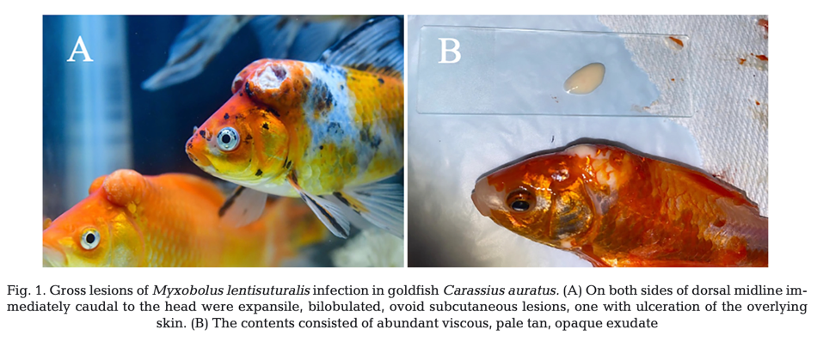
- No mortalities directly from organism but significant infection, with implications for ornamental fish trade
- All affected individuals were culled and seemingly was curative, no new lesions over the last two years from outbreak to writing of paper, notably did not attempt to remove intermediate host so recurrence of infection possible as this was suspected to the source at this farm
Take Home Point: M. lentisuturalis is an uncommonly reported piscine parasite and this paper represents the first report in the USA. Culling affected individuals seems to have been an effective management strategy. Consideration for this parasite should be taken when importing goldfish because they can be asymptomatic.

Sun FJ, Crim MJ, Leblanc M. 2021. Edwardsiella ictaluri in a colony of zebrafish (Danio rerio) used in a teaching laboratory. Comp Med 71:318-322.
Abstract
A small colony of zebrafish (Danio rerio) experienced 30% acute mortality within a few days after receipt from a commercial source. A few fish presented with small areas of raised scales or tissue necrosis, primarily near the caudal peduncle. Edwardsiella ictaluri (E. ictaluri) was identified by real-time PCR of pooled zebrafish and swabs of the pre-filter and fine filter pads, with subsequent sequence analysis. E. ictaluri is most commonly associated with an enteric septicemia in catfish species and can have significant economic impact on commercial catfish fisheries. However, several references report naturally occurring E. ictaluri infection of nonictalurid fishes, including zebrafish. Ours is the first report demonstrating the use of environmental sampling to identify E. ictaluri in a zebrafish colony by real-time PCR. Moreover, our report indicates that E. ictaluri is a relevant disease for institutions using zebrafish as research species and emphasizes the importance of carefully considering importation and quarantine practices.

Background:
- Edwardsiella ictaluri is a gram-negative facultatitive intracellular bacteria known primarily for economic impact on catfish (Ictalurus spp.) in the U.S.
- Causative agent for Enteric Septicemia of Catfish (ESC) or Hole-in-the-Head disease of catfish
- Transmission occurs via direct contact through fecal-oral route, nasal passages, and gills
- In catfish, E. ictaluri infection can present as areas of hemorrhage around the base of fins, skin ulceration in various locations, bulging eyes, and a distended abdomen, with mortality of 10 to 50% in populations of pond-raised channel catfish (Ictalurus punctatus).
- Nonictalurid fish that are susceptible to E. ictaluri infection are phylogenetically diverse; has been reported as cause of morbidity/mortality in zebrafish colonies
- Clinical presentation of edwardsiellosis caused by E. ictaluri in zebrafish can include tissue necrosis, abdominal distention, general lethargy, raised scales, and skin hemorrhage, although acute mortality without clinical signs is also common.
- Multiple organs affected including kidney, spleen, and brain, with large quantities of bacteria present, often within macrophages

Key Points:
- 24 zebrafish 1 fish dead 2d after arrival by 6d after arrival 5 fish had raised scales and tissue necrosis near the caudal peduncle moved into quarantine tank and found dead the next morning along with 2 additional dead fish in primary tank 4 more died over following week 19d after arrival, remaining 12 fish euthanized (all asymptomatic)
  - 5 fish in quarantine tank (Batch A) sent for pooled RT-PCR for infectious disease panel
    - Strongly positive for E. ictaluri by RT-PCR. Confirmed via sequence analysis of amplicon and sequence analysis of bacterial genes (gyrA and gyrB)
  - 2 euthanized fish (Batch B) sent for microbiologic culture and real-time PCR analysis, along with swabs of the feed and the pre-filter and fine filter pads
    - Batch B was negative for E. ictaluri by microbial culture. Both the Batch B zebrafish and feed samples were also negative for E. ictaluri by RT-PCR; however, the filter swabs tested positive for E. ictaluri by RT-PCR
  - 2 euthanized fish (Batch C) submitted for necropsy and histologic evaluation.
    - External examination of Batch B and Batch C fish revealed a small, irregular, 1 to 2 mm diameter, slightly gelatinous and hemorrhagic area at the base of the tail and rare small hemorrhages caudal to the operculum
    - Histology of Batch C fish revealed no evidence of edwardsiellosis or other significant lesions was observed
- First report demonstrating the use of environmental sampling to detect E. ictaluri in zebrafish

Takeaway:
Zebrafish are susceptible to E. ictaluri infection. Biologic supply companies are high-risk vendors. Quarantine protocols and biosecurity practices are critical to preventing an outbreak of edwardsiellosis. Environmental sampling can be used to detect E. ictaluri in zebrafish

Highly Pathogenic Avian Influenza A(H5N1) Virus Outbreak in New England Seals, United States. Puryear W, Sawatzki K, Hill N, et al. Emerging Infectious Diseases (CDC.gov). 2023;29(4):786-791.

Abstract: Highly pathogenic avian influenza (HPAI) viruses are of concern because of their pandemic potential, socioeconomic impact during agricultural outbreaks, and risks to wildlife conservation. Since October 2020, HPAI A(H5N1) virus, belonging to the goose/Guangdong H5 2.3.4.4b clade, has been responsible for >70 million poultry deaths and >100 discrete infections in many wild mesocarnivore species (1). As of January 2023, H5N1 infections in mammals have been primarily attributed to consuming infected prey, without evidence of further transmission among mammals. We report an HPAI A(H5N1) virus outbreak among New England harbor and gray seals that was concurrent with a wave of avian infections in the region, resulting in a seal unusual mortality event (UME); evidence of mammal adaptation existed in a small subset of seals. Harbor (Phoca vitulina) and gray (Halichoerus grypus) seals in the North Atlantic are known to be affected by avian influenza A virus and have experienced previous outbreaks involving seal-to-seal transmission (2–7). Those seal species represent a pathway for adaptation of avian influenza A virus to mammal hosts that is a recurring event in nature and has implications for human health.

Background:
- HPAI A(H5N1) virus - genetically distinct clade goose/Guangdong 2.3.4.4b H5
  - First detected in NA in wild and domestic birds in CA Nov 2021 and US Dec 2021
  - Responsible for >70m poultry deaths and discrete infections in mesocarnivore species
    - First wave March 2022 - lots of raptor deaths
    - Second wave June 2023 - more sea bird deaths
- Infections in mammals primarily attributed to consuming infected prey
- Harbor seal (Phoca vitulina) and gray seal (Halichoerus grypus) in N Atlantic waters
  - Known to have experienced previous outbreaks and seal-to-seal transmission
  - Represent pathway for adaptation of avian influenza A virus to mammal hosts

Report: Opportunistic sampling Jan-July 2022 in stranded seals on Atlantic coast (region of known/suspected HPAI outbreaks in terns, eiders, cormorants, gulls)
- Increased seal standing correlated with 2nd wave June 2023 and increase in HPAI-positive seals
- CS: most found deceased; otherwise respiratory and subset of neuro
- Dx: PCR - resp tract most consistent source of positive samples
  - Detected 71 avian and 13 seal derived virus genomes

Conclusions:
- Outbreak of HP avian influenza-A (H5N1) in Atlantic marine mammals in NE US causing UME (unusual mortality event) coincided with H5N1 in sympatric wild birds
- Inferred that >2 spillover events occurred in seal population due to two detected lineages
- Transmission from wild birds to seals likely occurred through environmental shedding of virus (not likely acquired through predation or scavenging - birds not typical food source; not likely seal-to-seal transmission)
- Outbreaks in wildlife difficult to control; difficult to enact biosecurity or depopulations
- Avian influenza in wildlife could enable ongoing circulation between and within species providing opportunity for reassortment of novel strains
- Monitoring of wild coastal birds and marine mammals is critical to determine pandemic potential

Fresh water skin disease in dolphins: a case definition based on pathology and environmental factors in Australia

Abstract: A distinct ulcerative dermatitis known as “freshwater skin disease” is an emerging clinical and pathological presentation in coastal cetaceans worldwide. In Australia, two remarkably similar mortality events enabled the creation of a case definition based on pathology and environmental factors. The first affected a community of endemic Tursiops australis in the Gippsland Lakes, Victoria, while the second occurred among T. aduncus resident in the Swan-Canning River system, Western Australia. The common features of both events were (1) an abrupt and marked decrease in salinity (from > 30ppt to < 5ppt) due to rainfall in the catchments, with hypo-salinity persisting weeks to months, and (2) dermatitis characterized grossly by patchy skin pallor that progressed to variable circular or targetoid, often raised, and centrally ulcerated lesions covering up to 70% of the body surface. The affected skin was often colonized by a variety of fungal, bacterial and algal species that imparted variable yellow, green or orange discoloration. Histologic lesions consisted of epidermal hydropic change leading to vesiculation and erosion; alternately, or in addition, the formation of intra-epithelial pustules resulting in ulceration and hypodermal necrosis. Thus, the environmental factors and characteristic pathologic lesions, are necessary components of the case definition for freshwater skin disease.

- Orange algal and fungal mats along skin noted along dolphins which waxes and waned seasonally pending salinity
- Evaluated dolphins to define “fresh water skin disease” in Australia
- All skin samples were taken at the junction of normal skin and fixed in 10% neutral buffered formalin
- 4 cases: first site: 1 male and 1 female; 2nd site: 2 females
- On boat based photography: 40% of dolphins had a range of epidermal lesions (varying degrees of severity); prior to this (4 months prior) dolphins were not noted to have lesions, which was prior to a flood event
- Skin lesions varied in severity from localized patchy areas of pallor or discoloration to elevated pale vesicles, multifocal to coalescing, irregularly shaped, raised, umbilicated pale-gray to yellow tinged plaques that frequently had central erosion or ulceration and necrosis (conferring a targetoid appearance)
- On cut surface: lesions were on epidermis only, and only occasionally seen in the superficial dermis/hypodermis
- Histopath: hydropic swelling of acanthocytes, as welling went on, acanthocytes became distended and pale eosinophilic cytoplasm leading to cell rupture and formation of intraepithelial vesicles
  - Degrading acanthocytes= prominent eosinophilic cytoplasmic bodies characteristic of keratohyalin granules and tonofibrils (might even resemble pox viral eosinophilic intracytoplasmic inclusion bodies)
- Morphologic diagnosis: multifocal, vesiculo-pustular and ulcerative dermatitis with hydropic degeneration of the stratum spinosum and secondary bacterial and fungal infection-granulation tissue was not observed in the samples by these cases
- Bacteria: gram negative, Virbrio spp. And Shewanella putrefaciens
- Fungi: Saprolegnia spp, Candida spp., mixed non pathogenic fungi
  - PCR for Aphanomyces invadens was negative
- Eosinophilic inclusion like bodies in acanthocytes were negative for pox and herpes virus by PCR
- Suspect that bottlenose dolphins have salinity threshold tolerance of ~8 ppt: which both areas evaluated in this study had prolonged hyposalinity (~4.8ppt and then <10 ppt)
  - Animals maintained in fresh water OR hyposaline water for extended periods were consistently manifesting severe skin lesions that progressively worsened with prolonged exposure
  - Animals also had electrolyte abnormalities: decreased osmolality, and sodium/chloride levels associated with overhydration; corneal opacity was also seen
- Pathophys- not known- but limited to cetaceans that evolved in marine environments
- While coastal bottlenose dolphins have been the focus species, other delphinids and baleen whales are potentially susceptible (reported in a humpback whale mother and calf that were stranded in the Sacramento River in N. Cali for a prolonged period)
- Common elements of this disease:
  - Sudden (within days) and marked (from >25 ppt to <5 ppt) fall in salinity,
  - Prolonged (weeks to months) exposure to hypo-saline conditions
  - Development of skin lesions characterized by hydropic degeneration and epidermal expansion leading to vesicle formation and resulting in gross pallor, erosion and ulceration
    - Often with intra--epidermal pustules and eruption that grossly appears as exudation and secondary bacterial, fungal, and algal infection or overgrowth (green, brown or orange mats or plaques)
- Depending on severity of lesion, duration of exposure, intercurrent disease (renal dysfunction) and ambient temp= outcome could be complete resolution or death
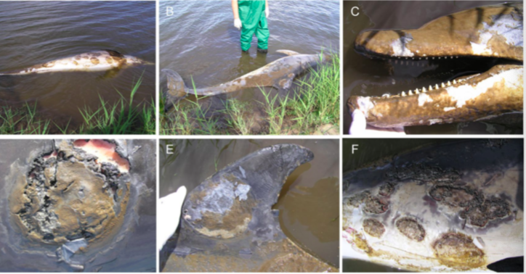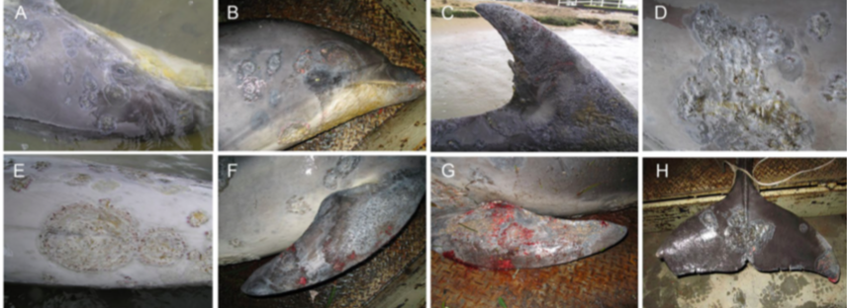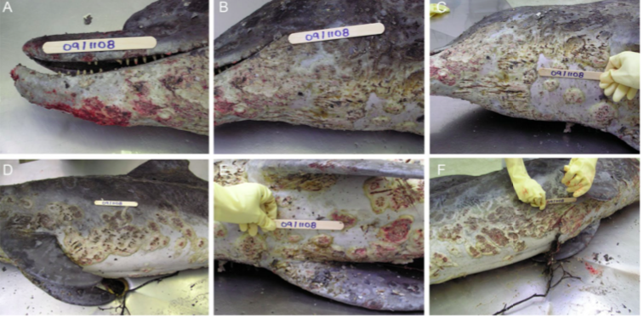

JWD 2021 57(2):292-302
Influence Of Pathogens, Fish-Related Characteristics, And Environmental Factors On The Development Of Skin Ulcerations In Wild Common Dab (Limanda limanda) From The North Sea
Vercauteren M, Van Hoey G, Decostere A, et al.

ABSTRACT: Environmental changes or stressors can result in the development of diseases. Through regular fish disease surveys in the Belgian part of the North Sea, attention was drawn to a sudden increase of skin ulceration prevalence between 2011 and 2014 in common dab (Limanda limanda). Information on prevalence, ulceration, bacteriology, fish-related (e.g., length, age, and sex) and (spatial and temporal) environmental factors, and fishing intensity were gathered. This detailed investigation was framed within a long-term monitoring program, executed every spring–autumn from 2000 to present. Ulcerations were observed in 1.3% of fish (n=3,999). Spatial and temporal differences were evident, and highest prevalence was found in summer. Vibrio was the dominant cultivated bacterial genus present in the lesions. Skin ulcerations appeared to be correlated with length and body condition of the fish, as well as with temperature and pH of the seawater and fishing vessel density. Our research suggested the involvement of multiple factors in the development of skin ulcerations in common dab and endorsed the effects of changing environment and human influence on the marine ecosystem through activities such as fishing.
Background:
- Belgian part of the North Sea influence by human activities and climate change
  - Fish diseases can be relevant as bio-markers of environmental quality and health
  - Monitoring of fish diseases has been carried out since 1985 in the North Sea
    - Sudden increase of skin ulceration prevalence observed in 2011-2014
- The cause of these skin ulcerations are complex, and a multifactorial etiology is suspected
  - Fish-related characteristics, environment, and pathogens play a direct or indirect role
  - Flatfish are more vulnerable to the development of these lesions than are round fish
  - In 2015, two bacteria, Vibrio tapetis and Aeromonas salmonicida, were isolated from active skin ulcerations in dab
Key Points:
- Multidisciplinary, 4-yr-long survey evaluated correlation between risk factors and skin ulcerations
  - Prevalence of ulceration found in this study (approximately 1.3%)
    - Lower than the skin ulceration prevalences (5%) observed in 2011–14
  - Explained by fish-related characteristics, environmental factors, and fishery activity
  - Confirming the presumed multifactorial etiology of skin ulceration
- Skin ulceration increased with:
  - Increasing length
  - Lower body condition
  - Increasing temperature
  - Increasing pH
  - Increased fishing vessel density
- No association between sex and development of skin ulcerations
- Vibrio spp. seem to be important pathogens regularly isolated from these lesions
- Highest prevalence mostly observed in the spring and summer

TLDR: Multiple risk factors involved in the etiology of skin ulcerations in dab, including fish-related (length and condition), temporal, and spatial (temperature, pH, and fishing intensity) factors

Related Articles: None on the current ACZM reading list
JAAH 2023 35(1):20-33
Cutaneous ulcerative lesions of unknown etiology affecting lionfish Pterois spp. in the Gulf of Mexico
Cody TT, Kiryu Y, Bakenhaster MD, et al

Objective: Cutaneous ulcerative skin lesions in a complex of invasive Gulf of Mexico lionfish (Red Lionfish Pterois volitans, Devil Firefish P. miles, and the hybrid Red Lionfish × Devil Firefish) became epizootic beginning in mid-August 2017. Herein, we provide the first pathological descriptions of these lesions and summarize our analyses to elucidate the etiology of the disease.
Methods: We examined ulcerated and normal fish through gross pathology and histopathology, bacterial sampling, and unbiased metagenomic next-generation sequencing. We tracked prevalence of the disease, and we used biological health indicators (condition factor, splenosomatic and hepatosomatic index) to evaluate impacts to health, while considering sex and age as potential risk factors.
Result: Typical ulcerative lesions were deep, exposing skeletal muscle, and were bordered by pale or reddened areas often with some degree of scale loss. Only incidental parasites were found in our examinations. Most fish (86%; n = 50) exhibited wound healing grossly and histologically, confirmed by the presence of granulation tissues. A primary bacterial pathogen was not evident through bacterial culture or histopathology. Metagenomic next-generation sequencing did not reveal a viral pathogen (DNA or RNA) but did provide information about the microbiome of some ulcerated specimens. Compared with clinically healthy fish, ulcerated fish had a significantly lower condition factor and a higher splenosomatic index. Disease prevalence at monitored sites through July 2021 indicated that ulcerated fish were still present but at substantially lower prevalence than observed in 2017.
Conclusion: Although some common findings in a number of specimens suggest a potential role for opportunistic bacteria, collectively our suite of diagnostics and analyses did not reveal an intralesional infectious agent, and we must consider the possibility that there was no communicable pathogen.

Background:
- Invasive lionfish are a major threat to native reef fish in the western Atlantic Ocean
- Epizootic of cutaneous ulcerative skin disease first observed in August 2017 off the coast of Florida
  - Ulcers since reported from multiple localities in the Caribbean Sea and US Atlantic Coast
Key Points:
- Investigating chronic cutaneous ulcers in lionfish over a 4-year period did not consistently identify a communicable pathogen from skin samples associated with any significant host response
- Histopathology of cutaneous ulcers of 58 lionfish did not reveal an intralesional infectious agent
  - Found lionfis in various stages of healing
  - However, varying degrees of pyknosis and karyorrhexis observed in the posterior kidney
    - May indicate a potential infectious pathologic association
  - Similarly, splenic vacuolation found suggesting macrophages clearing necrotic debris
  - These changes were also observed in normal fish and could be a subclinical response
- Parasites not observed grossly or microscopically with wet mounts
- No indications of a viral primary pathogen
- The role of bacteria in the epizootic remains enigmatic, warrants further investigation
  - Bacteria were sometimes observed in histological sections
    - Never with signs of inflammation, considered postmortem contamination
  - Vibrio harveyi was isolated the most often, followed by P. damselae
    - Both species ubiquitous in the marine environment and cause skin ulcers in fish
- Possible one or more noninfectious factors could well lead to induction of skin ulcers
- Low genetic diversity in lionfish populations in the northwestern Atlantic Ocean and GoM may potentially result in greater susceptibility to disease
- Ulcerated fish were on average 1 year older than normal conspecifics
  - Possible age effects on immune competence or other factors?
- Data from subclinical infections are necessary for fully understanding a disease
- Field survey data show a steep decline in prevalence following the initial epizootic
  - May signify potential environmental factor(s) affecting lionfish across the GoM dissipated
  - May also suggest the disease has become endemic if low levels persist

Related Articles:
Harris, H. E., Fogg, A. Q., Yanong, R. P., Frasca, S., Jr., Cody, T., Waltzek, T. B., & Patterson, W. F., III. (2018). First report of an emerging ulcerative skin disease in invasive lionfish (University of Florida/IFAS Extension Publication FA209). University of Florida.

Harris, H. E., Fogg, A. Q., Allen, M. S., Ahrens, R. N. M., & Patterson, W. F., III. (2020). Precipitous declines in northern Gulf of Mexico invasive lionfish populations following the emergence of an ulcerative skin disease. Scientific Reports, 10, Article 1934.

