Yanong R. 2023. Fish medicine updates. In: Miller RE, Callet PP, Lamberski N (eds.). Fowler's Zoo and Wild Animal Medicine Current Therapy 10. Elsevier, St. Louis, pp. 389-393.
Laura Martinelli
Question: Select the correct pairing regarding emerging fish viruses below:
- Megalocytivirus DNA Viral Nervous Necrosis
- Betanodavirus RNA Red Seabream Iridovirus
- Picornavirus DNA Bluegill Picornavirus
- Betanodadvirus RNA Barfin Flounder Nervous Necrosis Virus
- Megalocytivirus RNA Infectious Spleen and Kidney Necrosis Virus

Answer: D

Hepps Keeney CM, Waltzek TB, de Oliveira Viadanna PH, Frasca S, Reinhardt E, Lovy J, Lewbart GA. 2023. Myxobolus lentisuturalis infection in a farmed population of goldfish Carassius auratus from the USA. Dis Aquat Org 154:7-14. https://doi.org/10.3354/dao03735.
Laura Martinelli
Question: Myxobolus lentisuturalis has a particular tropism for which of the following tissues in Goldfish (Carassius auratus) and Prussian Carp (Carassius gibelio)?
- Muscle and Spleen
- Muscle and Liver
- Gastric and Spleen
- Gastric and Nervous
- Muscle and Nervous

Answer: E

Sun FJ, Crim MJ, Leblanc M. 2021. Edwardsiella ictaluri in a colony of zebrafish (Danio rerio) used in a teaching laboratory. Comp Med 71:318-322.
Practice Question:

Which of the following bacterial organisms is the causative agent of Enteric Septicemia of Catfish?

A. Aeromonas hydrophila
B. Edwardsiella ictaluri
C. Francisella orientalis
D. Nocardia asteroides
E. Yersinia ruckeri

Question: Which taxa is known to be susceptible to both influenza A and influenza B viruses?
- Cats
- Ferrets
- Ducks
- Seals
- Bats

Answer: D
Source: Highly Pathogenic Avian Influenza A(H5N1) Virus Outbreak in New England Seals, United States. Puryear W, Sawatzki K, Hill N, et al. Emerging Infectious Diseases (CDC.gov). 2023;29(4):786-791.
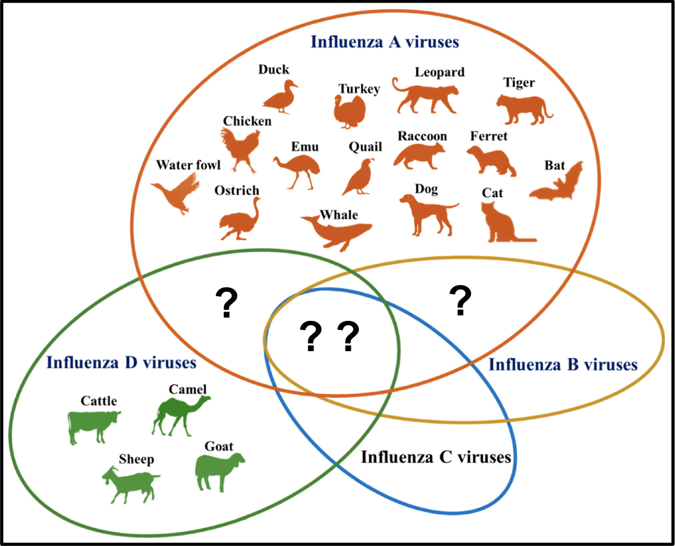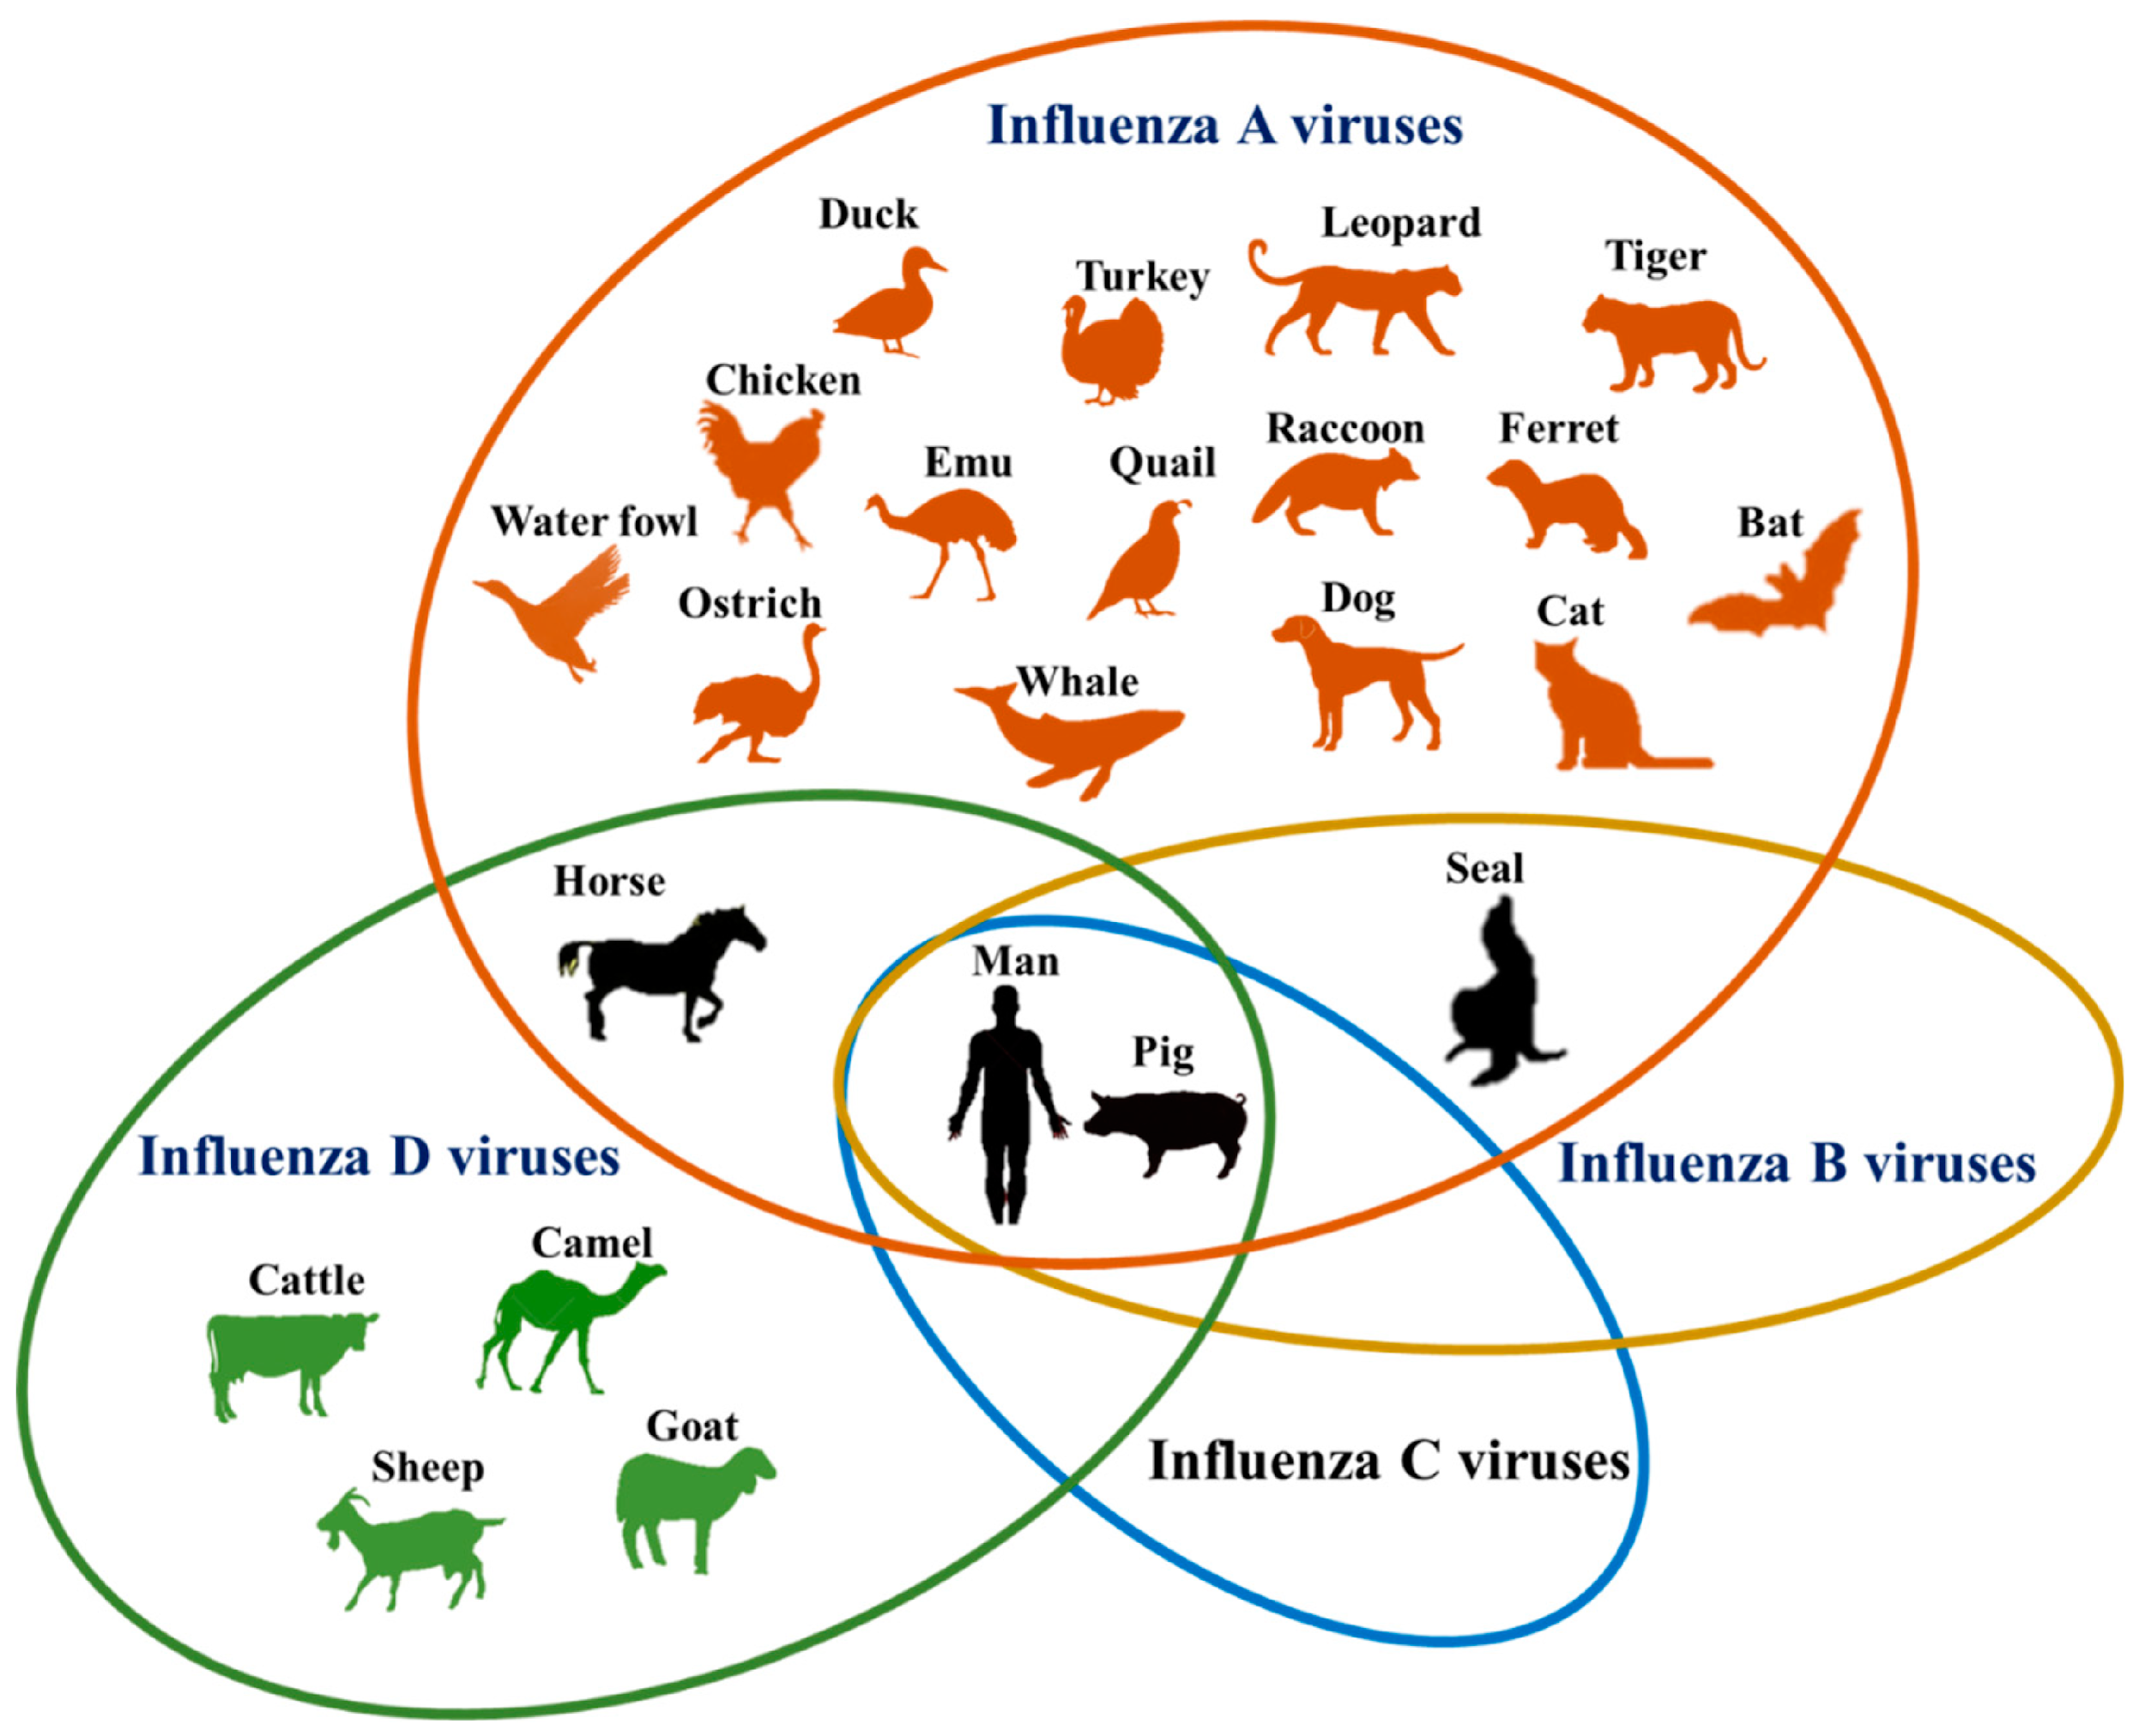

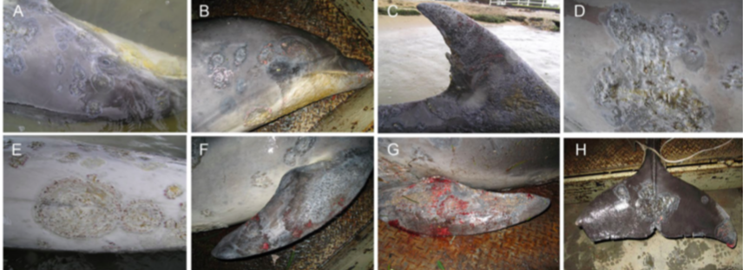

1A) Name a viral, bacterial, and fungal cause for the above lesions found on this cetacean, in addition, name a possible environmental cause.

Answer:
- Viral: Caliciviridae, Herpesviridae, Papillomaviridae, Poxviridae
- Bacterial: Dermatophilus, Erysipelothrix rhusiopathiae, Mycobacterium marinum, Pseudomonas spp., Streptococcus iniae, Vibrio spp.
- Fungal: Candida albicans, Fusarium spp., Trichophyton spp.
- Environmental: Acute hypo-salinity for prolonged period of time (“Fresh Water Skin Disease”)

1B) On further evaluation, eosinophilic inclusion like bodies in acanthocytes are seen- what are two differentials for this finding?

Answer:
- Poxvirus and Fresh Water Skin Disease

Note: Poxvirus- usually in younger animals; Fresh Water Skin Disease- mature or young, found in acute hypo-salinity for prolonged periods of time; however, pox lesions can lead to fresh water skin disease under the right circumstances

Practice Question: Which of the following is associated with increased risk of skin ulceration in common dab (Limanda limanda) from the North Sea?
- Smaller total length
- Higher body condition
- Increasing temperature
- Lower pH
- Decreased fishing density

Answer: C

Practice Question: What is the etiology of the following condition observed in a wild ionfish (Pterois spp.)?
