Chapter 6 – Cardiology
Anatomy & Physiology
- Unique Avian Features
  - HR relative to body mass is lower in birds vs mammals
  - Heart is relatively larger; subsequently, stroke volume & CO greater
  - HR can increase 2-4x during flight
  - MAP higher vs mammals, but total peripheral resistance is lower
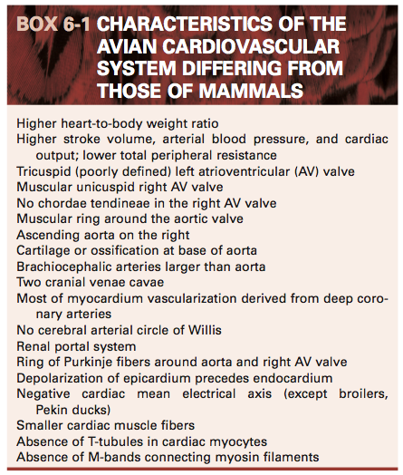
- Heart
  - Located in cranioventral coelom next to sternum
  - Surrounded by cervical, clavicular, & cranial thoracic air sacs
  - Intrathoracic diverticula of clavicular air sac surround heart & great vessels
    - Also pneumatize sternum & suspend esophagus, trachea, syrinx
  - 4 chambered hearts composed of endocardium, myocardium, epicardium
    - Cardiac cartilage forms fibrous rings around aorta & pulmonary arteries
    - Some have sinus venosus prior to RA (ex: chickens, crows, ostriches, kiwis)
  - Right AV valve lacks chordae tendinae (unique to birds)
    - Spiral muscular flap composed of atrial myocardium & ventricular myocardium
  - Avian cardiomyocytes are smaller & more numerous than mammalian
    - T-tubule system is absent lacking in birds
    - Sarcolemma & sarcoplasmic reticulum occur at cell surface
    - Lack M-bands that connect myosin filaments in mammalian cardiac muscle
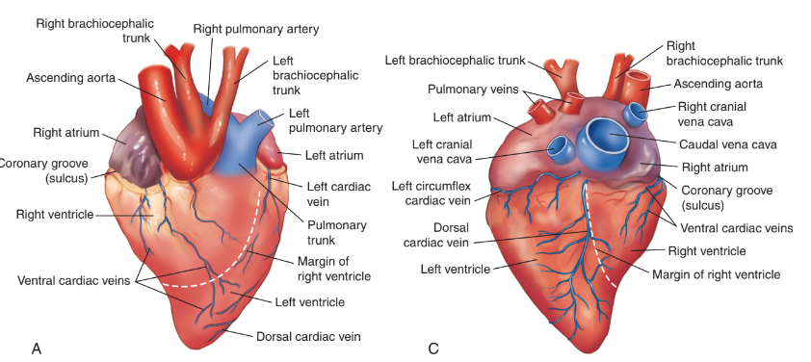

- Cardiac conduction system
  - Three bundle branches (left, right, middle)
  - AV ring of Purkinje fibers surround right AV opening, connected to right AV valve
  - Ventricular depolarization begins subepicardially & spreads to endocardial surface
    - Reason for negative ECG in lead II
    - Different from mammals whose depolarization starts at endocardium
- Pericardium = non-compliant sac
  - Outer layer is continuous with adventitia of great vessels
  - Attachments exist to sternal plate, hilus of lungs, adjacent air sacs, & liver
- Vascular Anatomy
  - Vena Cava
    - Paired crania venae cavae enter at sinoatrial valve
      - Septum sinus venosi separates LCrVC & RCrVC
    - Single caudal vena cava empties into right atrium
  - Coronary Arteries & Cardiac Veins
    - Unlike mammals, ascending aorta gives rise to L & R coronary arteries
    - R coronary is largest in most spp. & anastomose frequently
    - Left, right, middle, & left circumflex cardiac veins
      - Middle & left circumflex = largest
  - Ascending aorta – supply of head, neck & thoracic limbs
    - Large, paired brachiocephalic trunks brach simultaneously from ascending aorta
    - Subclavian arteries supply flight muscles, so they are larger than aorta
    - Intercarotid anastomosis at base of brain, present in virtually all bird spp.
      - No circle of Willis
  - Descending aorta – supply of trunk, viscera & pelvic limbs
    - Major branches: Coeliac, cranial mesenteric, pair cranial renal, external iliac, ischiatic, caudal mesenteric, internal iliac
    - Testicular arteries arise from cranial renal arteries
    - Single (or multiple) ovarian artery arise from left cranial renal artery or aorta
  - Pulmonary vasculature
    - RV → pulmonary trunk → R & L pulmonary arteries → intraparabronchial arteries → intraparabronchial arterioles
  - Venous System
    - Right jugular larger than left
    - Receives blood from left via anastomosis at base of head
  - Renal Portal System = cranial & caudal renal portal veins ventral to kidneys
    - Receives blood from gut & pelvic region
    - Passes through renal parenchyma mixing with post-glomerular efferent arteriolar blood → renal veins→ common iliac veins & CdVC
    - Renal portal valve = smooth muscle sphincter in external iliac v.
      - Sympathetic & parasympathetic control of venous blood
    - Venous flow can be shunted into internal vertebral venous sinus or to hepatic portal system
      - Through caudal mesenteric vein (bidirectional flow)
  - Vascular microanatomy
    - 2 classifications for arterial structure: elastic & muscular arteries
    - Resilience of avian elastic arteries are superior to mammals
- Cardiovascular Control Systems
  - Systemic arterial blood pressure is function of cardiac output & resistance of arterial system
  - Both epinephrine & norepinephrine act on beta-adrenergic receptors
  - Positive inotropic, chronotropic, & lusitropic effects
  - Unlike in mammals, norepinephrine believed to be more potent stimulant

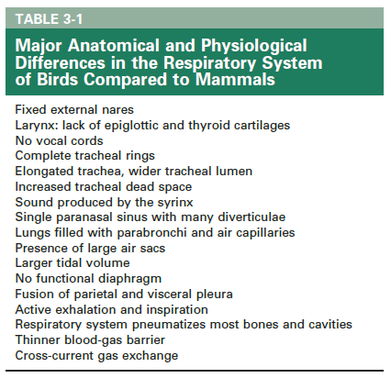
Mitchell & Tully, Current Therapy in Exotic Pets Practice
Chapter 3 - Respiratory System (pages 88-93; Avian)

General
Avian respiratory system = most efficient gas exchange system of animal kingdom
- Large surface exchange areas and thinner blood-gas barriers than other vertebrates
Many unique anat/phys differences compared to mammals

Upper Respiratory System
Nasal cavity
- Nares and nasal septum - wide variety of across birds
- Three regions of nasal cavity with concha (increases surface area to limit heat and H20 loss during ventilation):
  - Nasal vestibule with rostral concha
    - Concha visible through nostrils in Falconiformes and occludes much of opening
  - Respiratory region with middle concha
    - Largest region, defense against infections
  - Olfactory chamber with caudal concha that connects with infraorbital sinus
    - Absent in African gray parrots
    - Musical fold/nasal valve in aquatic sp to deflect H20 away from olfactory
    - Kiwis, turkey vultures, petrels, albatrosses have exceptional sense of smell
- Nasal gland (salt gland in marine sp): discharges salt into nasal vestibule
- Nasolacrimal duct: empties into nasal cavity
- Communicates with oropharynx through choana in roof of mouth for air filtration
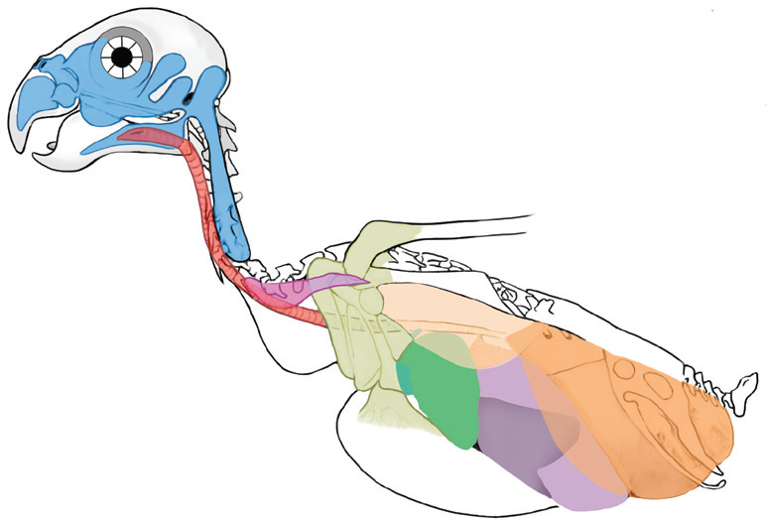
- Birds lack a soft palate

Infraorbital sinus + associated diverticula
- Pneumatizes most structures of the head and neck
- Particularly well developed in psittaciformes
  - Cervicocephalic = largest diverticulum that extends to shoulders
    - Do not mistake for an air sac
- Absent in some cormorants

Larynx, Trachea, Syrinx
- Larynx: four cartilages - cricoid, procricoid, two arytenoid
  - Laryngeal dilator and constrictor muscles control glottal opening
  - Crista ventralis crest in some sp (pelicans, hornbills, kiwi, penguin, some ducks etc)
    - Arises ventrally from cricoid cartilage in glottis; avoid during intubation
- Trachea: complete rings → use uncuffed ET tubes
  - Long and wide trachea → 4x dead space, compensated by larger tidal volume
  - Tracheal loops in keel in swans, whooping cranes, etc.
  - SQ trachea in helmeted curassow, birds of paradise etc.
  - Tracheal sacs in emu, male ruddy ducks
  - Double trachea from extended septum from bronchial bifurcation in penguins, petrels
- Syrinx: complex structure of voice production, unique to birds
  - Location at bronchial bifurcation, surrounded by interclavicular air sac
- No epiglottic cartilage, thyroid cartilage, or vocal cords in birds
- Many species-specific anatomic variations in airway muscles, cartilages, etc.

Lung-Air Sac System
Bronchial system:
- Primary bronchi (x2) bifurcate at syrinx and end at abdominal air sacs
- Secondary bronchi (four groups) arise from primary
- Parabronchi branch off secondary bronchi to lungs and lead to air capillaries
- Air capillaries anastomose freely with each other (different than dead end mammalian alveoli)
  - Responsible for gas exchange in the lungs
  - Intertwined with blood capillaries in cross-current pattern allowing blood to become oxygenated at different degrees along the parabronchus
Lungs: dorsal, not lobed, do not enclose heart, indented by vertebral ribs, responsible for gas exchange
- Pelopulmo lungs: unidirectional ventilation
- Neopulmo: bidirectional ventilation (absent in Sphenisciformes)
Air sacs: extrapulmonary thin-walled transparent chambers responsible for ventilation
- Usually 9: 2 cervical, 1 interclavicular, 2 cranial thoracic, 2 caudal thoracic, 2 abdominal
  - Exceptions: passerines 7, chickens 8, storks 11, turkeys 5
- Interclavicular → diverticula pneumatizes sternum, coracoids, humerus
- Abdominal → diverticula pneumatizes femurs
  - Often largest in most sp, but smallest in penguins
- Walls composed of squamous cells and connective tissue with minimal vascularization
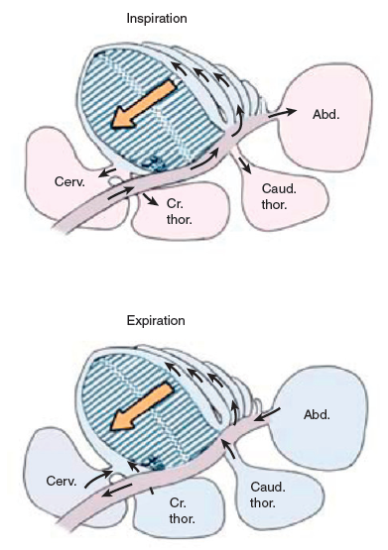
- Connections to airways:
  - Primary bronchi bifurcate at syrinx, end at caudal abdominal air sac
  - Connected to lungs via ostia

Respiratory Mechanics and Regulation
- Ventilation performed by air sacs (not lung)
  - Tidal like in mammals (bidirectional) and through-flow (unidirectional)
  - Caudal air sacs (caudal thoracic, abdominal) receive inspiratory air
  - Cranial air sacs (cervical, interclavicular, cranial thoracic) receive expiratory air
- Gas exchange performed by lungs (not air sacs)
- Inspiration and expiration both ACTIVE processes
- Many muscles participate in ventilation
  - Intercostal muscles main inspiratory
  - Abdominal muscles are main expiratory
  - Wingbeats assist respiratory ventilation during flight
- Two respiratory cycles needed for a given volume of inspired air to move through system
  - (1) Inspiration: air goes to caudal air sacs → (2) Expiration: air moves to lungs →
(3) Inspiration: air moves to cranial air sacs → (4) Expiration: air moves to trachea/exits

CBS Summaries; 08-24-2023; Laura Martinelli

Avian Neurology (363-371): Speer, Current Therapy in Avian Medicine and Surgery
CLINICAL NEUROANATOMY
- Central Nervous System (brain + spinal cord) 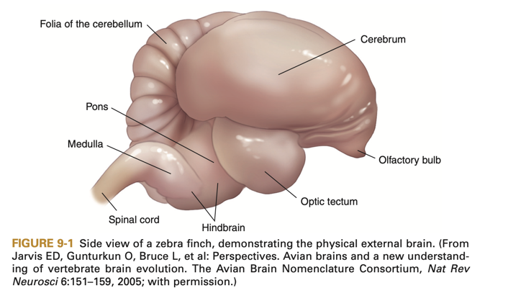
  - 3 divisions
    - Prosencephalon (forebrain) – divergent from mammal
      - Composed of the telencephalon + diencephalon
      - Telencephalon – responsible for memory, behavior, integration of motor + sensory info
      - Diencephalon – mostly thalamus + hypothalamus; visual, adutory input, spinal + visceral pathways
    - Mesencephalon (midbrain) – homologous to mammal
      - Prominent feature: Optic tectum or Optic Lobe – visual reflex info
    - Rhombencephalon (hindbrain) – homologous to mammal
      - Composed of metencephalon + myelencephalon
      - Responsible for motor movement
      - Myelencephalon becomes medulla and medulla has CN VII to XII coming off of it, reflex center for respiration, and conduction center for many tracts from spinal cord
  - Cerebrum has NO neocortex, corresponding structure is the telencephalic complex deep in the cerebral hemispheres
  - Cerebral cortex is lissencephalic (aka no gyri or sulci)
  - Cistern present btwn cerebellum and medulla but also prominent venous sinus in region – CSF collection = high risk of hemorrhage
  - No lateral foramina (mammalian structure connecting fourth ventricle to subarachnoid space) so transfer of water/solutes occurs via diffusion through wall of the fourth ventricle itself
- Peripheral Nervous System (cranial nerves, spinal nerves, visceral ganglia + plexi)
  - No pons but there are pontine fibers
  - CN V-XII from medulla oblongata
  - CN III from mesencephalon
- Cerebellum
  - Vermis (center) + paired cerebellar hemispheres
  - Regulates motor activities – posture + movement
  - Lesions = tremors, nystagmus, increased muscle tone, etc.
- Optic Lobe
  - Synonyms = optic tectum, mesencephalic colliculus, mesencephalic tectum
  - CN III and IV emerge from optic lobe
  - Auditory + vestibular components that coordinate eye and head movements via vestibular nuclei
  - Red nucleus in mesencephalon ultimately connected to structures responsible for motor control of respiratory + syringeal muscles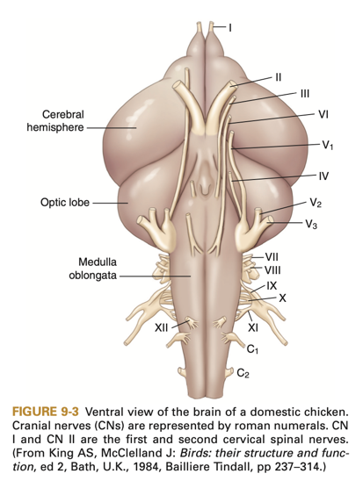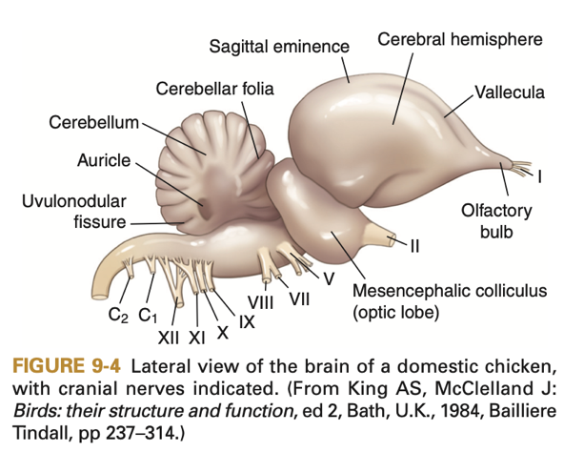
- Hypothalamus
  - Preoptic, paraventricular, supraoptic, and infundibular nuclei
  - Responsible for autonomic function, thermoregulation, respiration, reproduction, eating and drinking, and defensive reactions
- Epithalamus
  - Region of the pineal gland involved in reproductive function
  - Strongly light responsive (even after eyes removed experimentally)
- Olfactory Lobe
  - Smaller as compared to mammals
  - No neocortex in the avian cerebrum (telencephalic complex kind of similar and no comparative structure in mammals)
- Spinal Cord Anatomy
  - Gray matter + white matter arranged the same as mammals
  - Central gray matter (butterfly shape) + white matter surrounds the gray matter
  - White matter = Dorsal, lateral, and ventral columns, the lateral and ventral columns are much larger and dorsal smaller as compared to mammals
  - Spinal cord SAME length as vertebral column – so spinal segment same as vertebral segment (spinal nerves pass laterally rather than caudally like mammals)
  - 2 spinal cord enlargements = cervical + lumbosacral enlargements
  - Glycogen Body = unique structure in lumbosacral cord, regulates vascular reflexes and potential neurosecretory role (both functions presumed?)
  - Meninges = pia mater, arachnoid, and dura mater
  - Note: dura mater separated from periosteal lining = epidural space in cervical and thoracic regions – this space filled with gelatinous tissue believed to be a shock absorber
  - Internal vertebral venous plexus runs length of vertebral column – connected to venous drainage of kidney
Long Ascending Pathways
- Dorsal Column (fasciculus gracilis + fasciculus cuneatus in mammals) is white matter fibers originating from afferent neurons (cell bodies in dorsal root ganglion); transmits touch, pressure, kinesthesia or proprioception of joints; tract decussates in the medulla; Conscious proprioception; Contralateral
- 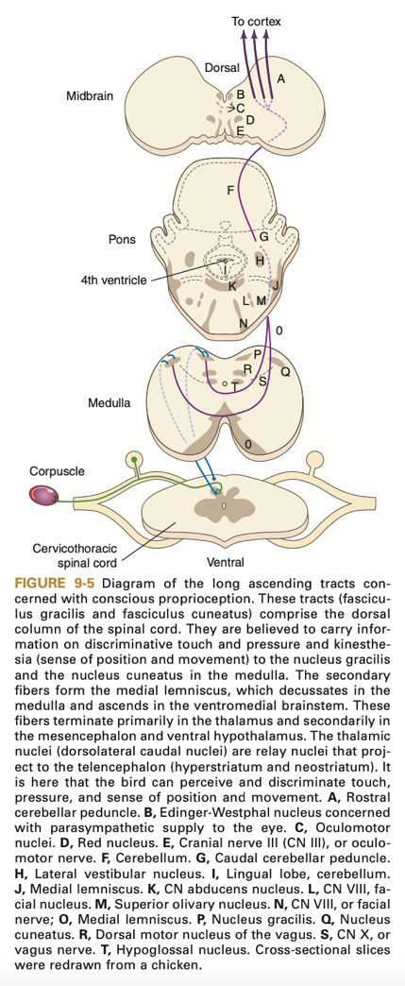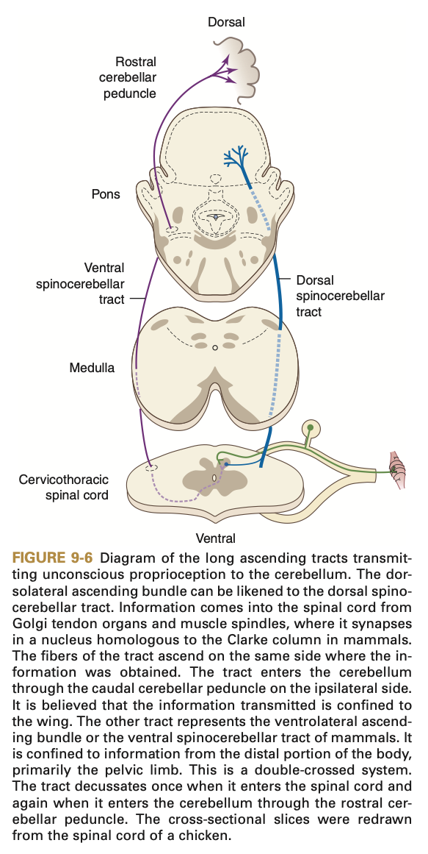
- Dorsal Ascending Bundle (dorsal spinocerebellar tract of mammals) responsible for unconscious proprioception (in the wing); ipsilateral
- Ventral Ascending Bundle (ventral spinocerebellar tract of mammals) = muscle afferents of the hindlimb; decussate to ascend as ventrolateral ascending bundle and decussate a second time at cerebellar peduncle; unconscious proprioception, ipsilateral (to cerebellar hemispheres)
- Dorsolateral fasciculus (tract of Lissauer or lateral spinothalamic tract); transmits pain, temperature, and light touch; decussate in the substantia gelatinosa and then ascend to thalamus; in pigeons, only transmits tactile information; Contralateral
- Propriospinal System (fasciculus proprius); vague sensations of nonlocalized pain
Long Descending Pathways
- Not as well-known as the ascending pathways
- Lateral reticular tract (lateral reticulospinal tract of mammals) – visceral motor function
- Rubrospinal tract (rubrospinal tract of mammals) – enhance flexor tone of skeletal muscles
- Corticospinal tract (pyramidal tract of mammals) – Upper Motor Neuron input to motor neurons in ventral horn of cervical region only
- Vestibulospinal tract (vestibulospinal tracts of mammals) – two tracts (medial and lateral), extensor tone of skeletal muscles (arise partially from medial longitudinal fasciculus, tract that coordinates eye movement), helps coordinate flight and mobility in 3-D space
- Reticulospinal tract (medial reticulospinal tract of mammals) – alters somatic and visceral motor tone
- Tectospinal tract (tectospinal tract of mammals) – originates in optic tectum, coordinates reflex movement btwn eyes + upper body, particularly neck
- Spinal Nerves
  - Ventral motor root, dorsal sensory root for each nerve, fuse and exit spinal canal, then dividing into dorsal ramus (supplies muscles on back, dorsal musculature, and skin) and ventral ramus (supplies muscles of the ventral body wall, ventral musculature, and skin, also communicates with sympathetic portion of autonomic nervous system)
  - Sensory ganglia present in each dorsal root
  - Spinal nerves (once exited the spinal canal) are mixed sensory + motor nerves
    - Sensory – General Somatic Afferents (impulses to CNS from surface receptors and proprioceptors in muscles + tendons)
    - Sensory – General Visceral Afferents (from visceral organs)
    - Motor – General Somatic Efferents (from CNS to skeletal muscle)
    - Motor – General Visceral Efferents (autonomic fibers conduct impulses to smooth muscle, cardiac muscle, and glands)
  - Number of spinal nerves varies among birds; always one more cervical spinal nerve than total number of cervical spinal vertebrae (last one exits caudal to last cervical spinal vertebral segment, all others exit cranial)
  - Thoracic spinal nerves always exit caudal to corresponding vertebral segment
  - Intercostal nerves run caudal to the border of the rib
AVIAN NEUROLOGIC EXAM
- Mentation
  - Assess level + content of consciousness (appropriate for surroundings?)
  - Level example: fluffed, hiding when stranger enters room; mediated by brainstem
  - Content example: delirium or lack of recognition of owner; mediated by cerebral cortex
  - Levels of consciousness
    - Alert – normal awareness
    - Lethargic – aware but sluggish responses
    - Depressed – decreased responses to enviro stimuli, sleeping when undisturbed
    - Obtunded – decreases responses to enviro stimuli, sleeping even in strange surroundings but can be roused
    - Stuporous – requires noxious stimuli to elicit awareness of surroundings
    - Comatose – no awareness of surroundings, voluntary responses cease, only reflex activity remains
    - NOTE: Depression and lethargy are generally metabolically induced changes, whereas obtunded, stuporous, or comatose states indicate changes to the cerebrum or brainstem
  - Content of consciousness (3 states)
    - Confusion
    - Dementia – little awareness of or concern for surroundings (i.e. flying into walls)
    - Delirium – overresponsiveness to stimuli (i.e. hyperexcitable reaction to owner or familiar situations)
    - These states may indicate structural or metabolic damage to cerebrum
    - Suspect that reticular activating system, cerebral cortex, and subcortical nuclei alter state of awareness (like in mammals)
    - Intracranial disease affecting structures = depression
    - Extracranial causes (hypoglycemia, hepatoencephalopathy) can impact content of consciousness
    - Hyperexcitability is nonspecific but can occur with meningoencephalitis, (a potential consequence of avian bornavirus)
- Cranial Nerve Examination
  - Clinical Notes:
    - Visual system includes CN II, III, IV, and VI, adding on the menace test, CN V is included
    - Birds have voluntary control of pupillary constriction and dilation – mauy need to inhibit skeletal muscle with inhibitor (example tubocurarine) to see retina or can try just turning out the lights
    - Excited Amazon parrots will often constrict and dilate their pupils
    - Pupil constriction = controlled by voluntary motor and parasympathetic portions of CN III; Pupil dilation = voluntary and sympathetic control; therefore, may have no direct PLR when shining light
    - Anisocoria may be result of lesion in optic or oculomotor nerve
    - Vertical nystagmus associated with brainstem lesions
    - Peripheral vestibular signs often restricted to horizontal or rotary nystagmus with no change when position of head changed
    - Often slow phase of nystagmus ipsilateral to lesion
  - CN I – Olfactory: rarely assessed, maybe change in appetite can occur?
  - CN II – Optic:
    - Sensory for vision
    - Menace response: difficult to interpret in birds, blink mediated by mandibular branch of CN V and CN VII
    - PLR – requires intact CN III for iris constriction, can override b/c striated muscle in iris and voluntary constriction and dilation of pupil but can still assess this response
    - Note – consensual PLR absent in birds due to complete decussation of optic nerves at the chiasm

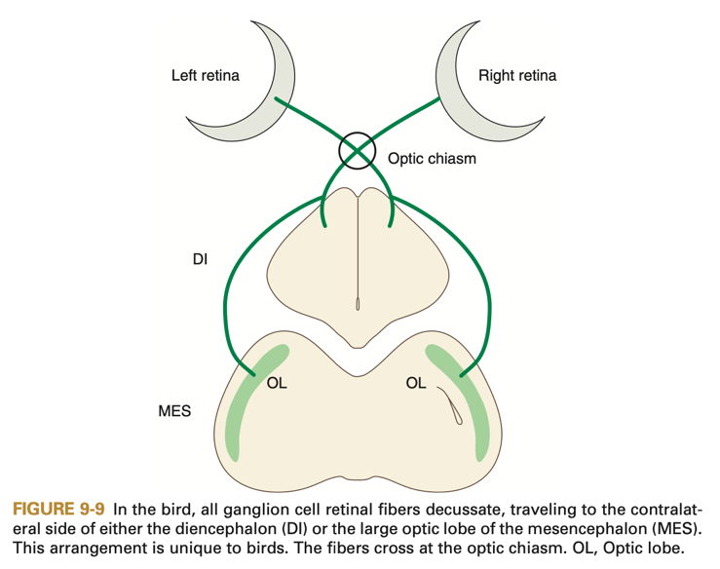

  - CN III – Oculomotor:
    - Motor and sensory to upper eyelid
      - Dysfunction = drooping of upper eyelid
    - Motor to extrinsic ocular muscle (dorsal)
      - Dysfunction = ventrolateral deviation of globe
    - Parasympathetic to intrinsic ocular muscle (iris constriction), involved in PLR
      - Dysfunction = suspected if patient seems visual but iris does not constrict
  - CN IV – Trochlear:
    - Motor and sensory to extrinsic ocular muscle (ventromedial)
      - Dysfunction = dorsolateral deviation of globe
  - CN V – Trigeminal:
    - Sensory to head and motor innervation to muscles of mastication
    - Ophthalmic Branch
      - Sensory facial sensation eye, upper eyelid, cornea, forehead, nares, upper beak
      - Dysfunction = loss of sensation to face or beak
    - Maxillary Branch
      - Sensory to muscles of face, mouth, both eyelids, hard palate, nasal cavity
      - Dysfunction = lack of sensation to face, beak, mouth, or palate
    - Mandibular Branch
      - Motor to lower eyelid, chewing muscles, commissures of beak
      - Dysfunction = inability to close eye or beak, reduced beak strength
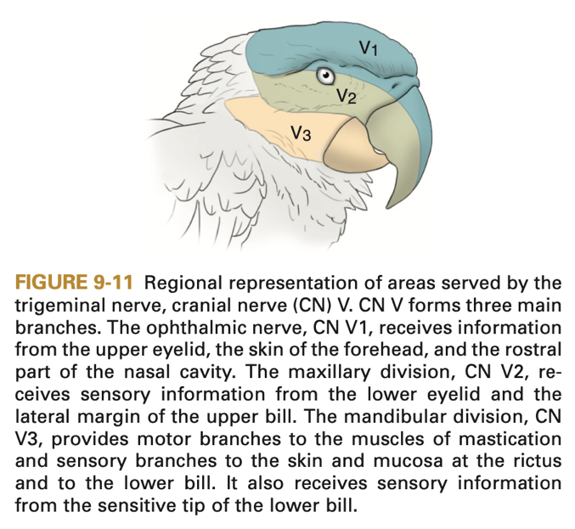

  - CN VI – Abducens:
    - Motor and sensory to lateral extrinsic ocular muscles and 3rd eyelid
    - Dysfunction = loss of function of 3rd eyelid, medial deviation of globe
    - NOTE: 3rd eyelid dysfunction or prolapse does not indicate Horner syndrome or loss of sympathetic innervation
  - CN VII – Facial:
    - Mixed motor and sensory innervation
    - Motor to muscles of facial expression in mammals but NOT birds
      - Dysfunction = lack of response to touch/facial sensation, facial droop, asymmetry
    - Sensory innervation to taste (shared with CN IX) may be difficult to evaluate
    - Parasympathetic for glands of head (tears, mucous)
      - Dysfunction = decreased secretions
  - CN VIII – Vestibulocochlear:
    - Sensory to hearing, balance, coordination
      - Dysfunction = difficult to assess hearing in birds, whistle in room may be enough stimuli to check
    - Sensory to vestibular system
      - Dysfunction = loss of equilibrium
    - Involved in oculocephalic reflex
      - Dysfunction = spontaneous horizontal nystagmus, fast phase away from side of lesion, may also have head tilt and circling toward affected side
  - CN IX – Glossopharyngeal:
    - Sensory to tongue, taste, trachea
      - Dysfunction = decrease/loss of taste (unreliable to test), lack of tongue sensation
    - Motor to pharynx, larynx, crop, syrinx
      - Dysfunction = dysphagia, possible loss of voice and gag reflex (difficult to assess)
    - NOTE: Anastomoses with CN X, assess together
  - CN X – Vagus:
    - Sensory to larynx, pharynx, and viscera
      - Dysfunction = Regurgitation
    - Motor to larynx, pharynx, esophagus, and crop
      - Dysfunction = Regurgitation, vocal dysphonia, possible loss of voice, and loss of gag reflex (difficult to assess)
    - Parasympathetic to glands and viscera
      - Dysfunction = lack of rhythmic visceral or gastric contractions or increased heart rate
    - NOTE: Anastomoses with CN IX, assess together
  - CN XI – Accessory:
    - Motor to superficial neck muscles + cranial scapular muscles
      - Dysfunction = poor neck mobility and lateral deviation of scapula (generally not clinically detectable)
  - CN XII – Hypoglossal:
    - Motor to tongue, trachea, syrinx
      - Dysfunction = deviation of tongue, decreased tone of tongue, change in or absence of song
- Posture & Gait
  - Posture change can occur with vestibular or cerebellar disease, or asymmetrical lesions of the cervical spinal cord
  - Lesions from brainstem caudally result in gait disturbances (ataxia, paresis, or even paralysis)
  - Ataxia can result from lesions in proprioceptive (conscious or unconscious) or sensory pathways, vestibular system, or cerebellum
    - Example: Knuckling typically lesions in conscious proprioceptive pathways
    - Ataxia worse with lesion in spinocerebellar tract
    - Ataxia typically not seen with lesions in motor systems
  - Lower Motor Neuron
    - Lesion = loss of muscle power, decreased or absent reflexes, and flaccidity
  - Upper Motor Neuron
    - Lesion in CNS = increased muscle tone + rigidity in muscles distal to lesion
    - Lesion in Cervical Spinal Cord = hyperreflexia + rigidity of pelvic limbs and wings
    - Lesion in Thoracic Spinal Cord = hyperreflexia + rigidity of pelvic limbs but wings remain normal
  - Brain
    - UMN lesion of cerebellum or brainstem = opisthotonos
    - Lesion of rostral brainstem = decerebrate rigidity (extension of all four limbs and trunk)
  - Vestibular System
    - Note: Lesions result in nystagmus, head tilt, rolling, circling, leaning to one side, wide-based stance
    - Central Vestibular Disease
      - Nystagmus is positional
      - Vertical or rotary nystagmus only present with central vestibular disease
      - Proprioceptive deficits and sometimes change in mentation occur
    - Peripheral Vestibular Disease
      - Horizontal nystagmus – fast phase away from lesion
      - NO change in proprioception or mentation
      - May have head tilt and circling
  - Cerebrum
    - Lesion = lack of precise or finely tuned voluntary movement, may miss perch or unable to go a certain direction; involuntary movement – may have seizures, muscle tremors
  - Cerebellum
    - Lesion = hypermetric or hypometric voluntary movements; intention tremors for involuntary movements
  - Vestibular lesion – falling, loss of balance, circling
  - Proprioceptive lesion – paralysis or paraplegia of limbs
- Postural Reaction
  - Not studied in birds but generalities assumed
  - Foot placement tests performed with perches, both blinded-folded and non-blind folded
  - Pull wing away from body and see if bird can replace in normal position
- Spinal Reflexes
  - Independent of the brain but brain may modify response
  - LMN = lesion in final common pathway or ventral gray horn of spinal cord (reflex arc), leads to hyporeflexia and diminished or absent responses
  - UMN = lesions involve CNS proximal to reflex arc, lead to hyperreflexia
  - Tests: Wing withdrawal, hindlimb withdrawal, crossed extensor reflex (associated with UMN lesions and severe lesion of spinal cord), cloacal reflex (flexion of vent sphincter and ventral flexion of tail)
  - Spinal cord divided into anatomical regions
    - Cervical region, brachial plexus, and caudal region
    - Brachial plexus innervates wing
    - Distal spinal cord includes lumbosacral plexus, a structure composed of three plexi
      - Lumbar plexus – innervates leg
      - Sacral plexus – innervates leg
      - Pudendal plexus – innervates tail, vent sphincter, cloaca
- Sensation (cutaneous sensation + deep pain)
  - Loss of deep pain associated with severe spinal cord disease (most commonly occurring with compression)
  - Compressive lesions – cause loss of conscious and unconscious proprioception first, then loss of motor function, then loss of superficial pain, and finally loss of deep pain
  - Panniculus reflex may not be present in bird – but can try pricking along trunk to see if bird responds to localize lesion; Avian dermatomes have nto been described
  - Note – non-localized pain can occur with diffuse inflammatory disease of CNS or PNS
  - Deep pain assessment – to assess, must be conscious awareness of the stimulus, withdrawal alone is a reflex arc and does not indicate intact deep pain pathways
    - Lack of withdrawal and presence of conscious awareness do indicate deep pain neurons are intact and better prognosis than withdrawal alone

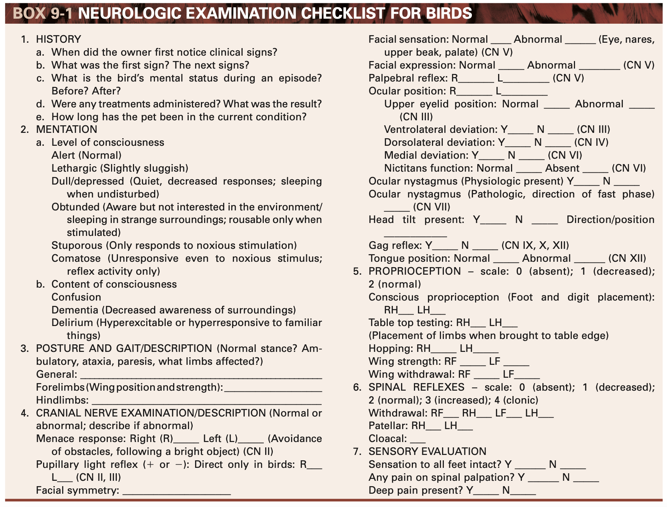

SEIZURES
- Three phases – preictal phase or aura (behavior change), ictal or seizure, postictal phase (abnormal behavior)
- Tests may include … CBC, chemistry, radiographs, blood lead and zinc levels, acetyl cholinesterase activity, insecticide residues, inhibition of amino levulinic acid dehydratatse activity and blood protoporphyrins, tests for chlamydiosis, Aspergillus serologic assays, avian bornavirus testing, electroencephalography, CT, MRI
- Acute Tx for Status Epilepticus or Multiple Seizures in Short Period
  - Diazepam or midazolam administration
    - If IV or IM access difficult, can consider cloacal administration but double the dose if doing this route
    - Can repeat q2 minutes up to 3x PRN
    - Can then move to CRI if needed
  - Check blood glucose, consider dextrose bolus of 1-2 ml/kg of 50% dextrose
  - If benzodiazepine CRI not effective, then can consider phenobarbital bolus (2-5 mg/kg), can be repeated q30 min up to total dose of 20 mg/kg
  - Can consider propofol if airway control and ventilation at the ready (bolus or CRI)
  - Mannitol can be used for cerebral edema
  - Author does NOT recommend steroids
  - Once seizures have stopped for ~6-12 hours, the CRI infusion can be tapered slowly over another 12-24 hours
- Long-Term Seizure Control
  - Phenobarbital (potentially lower dose than mammals)
  - Potassium bromide
  - Levetiracetam (Keppra)
  - Zonisamide (Zonegran)
  - Gabapentin or pregabalin (pregabalin has fewer side effects)
- Seizure Etiologies
  - Lead toxicosis (acute or chronic)
    - May present with clenched feet, bloody urine (Amazon parrots, conures), or seizures
    - Supportive care and chelation therapy
    - Gavage with bulk feeding, peanut butter, and psyllium can eliminate metal from GI tract but use extreme caution if patient regurgitating or vomiting
  - Renal disease or failure
  - Hepatic disease
    - Hepatic encephalopathy still debated in birds, nitrogenous waste not end-product of hepatic metabolism in birds, but still get neurologic signs with severe hepatic disease
    - Supportive care including B vitamins + lactulose, and maybe milk thistle and S-adenosylmethionine
  - Chlamydophila psittaci infection (psittacosis)
    - Affects liver, resp system, and CNS
    - Classic description = ocular and nasal discharge, green urates, leukocytosis, and hepatic enzyme elevations
    - Note that neurologic signs can occur alone
    - Treat with doxycycline for 6 weeks or with azithromycin
  - Proventricular dilatation disease
    - Immune-mediated inflammatory viral disease – affects ganglia and nerve fibers with predilection for proximal GI tract, cerebellar nuclei, and brain or brainstem components
    - Avian bornavirus implicated
    - Clinical signs: whole seeds passing in droppings, weight loss, sometimes regurgitation, enlarged proventriculus
    - Atypical form: CNS manifestations alone or with GI signs and proventriculus may or may not be enlarged
  - Atherosclerosis
    - Cause unknown but predisposing factors = obesity and high fat (all-seed) diet
    - Common in Amazon parrots, sometimes seen in macaws and Grey parrots
    - May or may not see cholesterol and tryglyceride elevations
    - Waxing and waning focal or grand mal seizures, maybe mental dullness
  - Hyperlipidemic Syndrome or Lipid Emboli
    - Linked to hyperestrogenism in reproductively active femailes
    - Excessive lipid in bloodstream = vascular sludging and lipid emboli
    - Lay term = “yolk stroke” = but NOT truly a yolk embolus
    - Blood strawberry milkshake or creamy tomato soup appearance, be careful because may have concurrent clotting disorder!
    - Cholesterol and triglycerides consistently elevated in this disease
  - Hypocalcemia
    - Most common in Grey parrots (genetic) or egg-laying hens of any species, as well as columbiforms on poor diets
    - Clinical signs: Seizures, muscle fasciculation, pathologic fractures, ataxia, and posterior paresis
    - Ionized calcium most useful for diagnosis
  - Hypoglycemia
    - Most common in weaning young, or rarely debilitated, anorexic birds
    - Blood glucose less than 150 mg/dL in clinical bird indicate medical intervention

Chapter 8: CNS (396-398, avian section): Mitchell-Tully, Current Therapy in Exotic Pet Practice

AVIAN CNS
- Avian brain consists of proencephalon (telencephalon and diencephalon) and the caudal brain (medulla, pons, and mesencephalon)
- Caudal brain similar to mammals
- Proencephalon anatomically different but functionally the same as mammals
- Cortical cells necessary for processing sensory information are in cerebral cortex not on surface like a mammal
- Cerebral cortex lissencephalic
- Spinal cord same length as vertebral column, spinal cord segment same point as vertebral column segment
- No cauda equina
- Brachial and lumbosacral plexuses present
- Glycogen body in lumbosacral plexus – collection of periependymal glycogen cells with nests of argentaffin cells – involved in sensory and neurosecretory functions
- Dura mater separate from periosteal lining – this epidural space filled with gelatinous tissue
- Internal vertebral venous plexus length of vertebral column

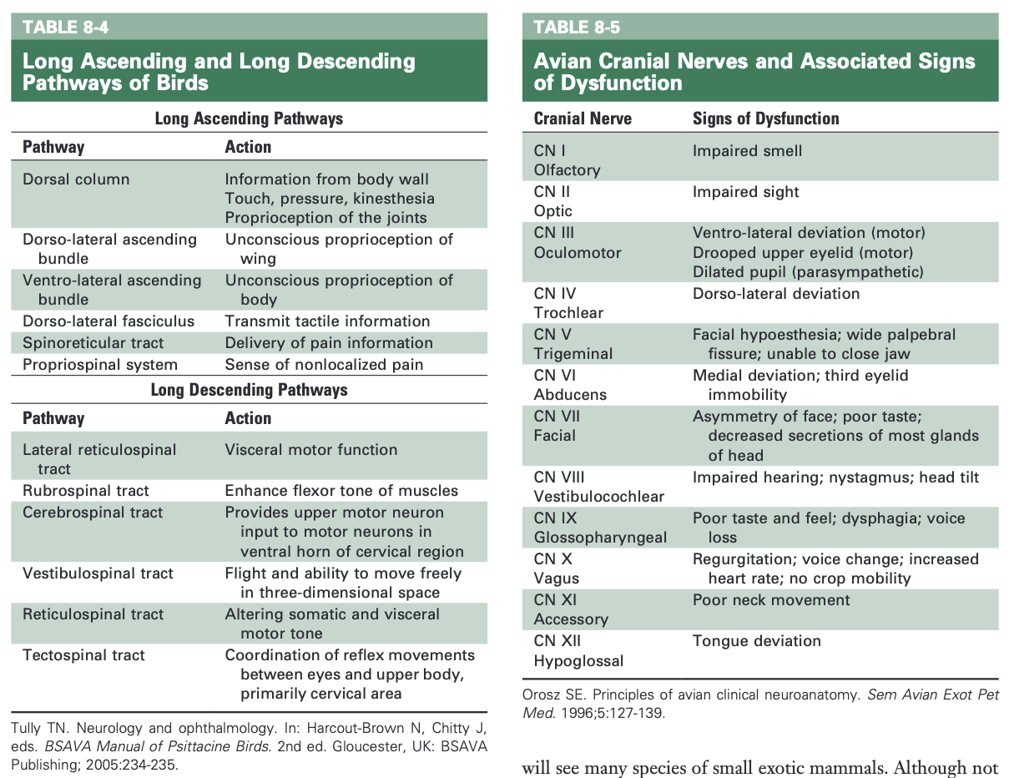

Hayley Stratton
CBS 817
8-24-23

Orosz, Susan E., and M. Scott Echols. "The Urinary and Osmoregulatory Systems of Birds." The veterinary clinics of North America. Exotic animal practice 23.1 (2020): 1-19.

KEY POINTS
- The kidneys of birds are fixed under the area of the synsacrum and are composed of divisions not lobes.
- Birds osmoregulate using their kidneys; intestinal tract; and, in some birds, salt glands.
- Avian nephrons are of 2 main types: the cortical, loopless, or reptilian nephrons and the medullary or looped nephrons. Knowing this anatomy, along with that of the renal portal system, is important in understanding the pharmacodynamics of drugs in birds.
- The kidney filters up to 11 times the total body water per day. Although the nephrons do not concentrate urine to the extent of mammals, they use the large intestine and/or the colon for resorption of ureteral urine. In addition, urates are modified by special colonic bacteria and some products produced are recycled through the renal portal system.
- There are some birds, particularly marine species, that are able to remove excess sodium through a countercurrent system in the salt glands. Angiotensin II has been shown to inhibit secretion of sodium chloride, whereas atrial natriuretic peptide enhances secretion.

Background:
- Birds are between mammals and nonmammalian vertebrates with respect to osmoregulation. Many avian species have salt glands that perform an important osmoregulatory function, particularly in a marine environment. Like reptiles, birds also use the lower portion of the GI tract as an important component for osmoregulation. In addition, birds have a unique kidney that plays an important role in osmoregulation.

Summary:
- External anatomy of the kidney
  - Renal divisions
    - Fixed, retroperitoneal, renal fossae of ventral synsacrum
    - Diverticula of abdominal air sacs can extend between the kidneys and the pelvis
    - 3 regions, not lobes (cranial, middle, caudal) formed by external iliac artery cranially and ischiatic artery caudally
    - Spinal nerves from lumbar and sacral plexuses run through renal parenchyma
      - Renal enlargement non-weight bearing lameness in budgerigar
  - Renal lobule
    - Basic unit avian kidney
    - Pear shaped and wedged between interlobular veins of renal portal system
      - Widest portion near surface
      - Narrow end = medullary cone, which consists of collecting tubules and loops of Henle from medullary type nephrons
      - Superficial portion = cortical region, contains both cortical and medullary type nephrons
    - Arteries intralobular, collecting ducts interlobular
  - Nephrons
    - 2 types of nephrons: the cortical, loopless, or reptilian nephrons and the medullary or looped nephrons
      - Cortical nephrons make up majority, secrete primarily uric acid
      - Medullary nephron has potential for producing and to an extent concentrating urine
      - New proposed terminology = loopless nephron (LLN), transitional nephron (TN), and looped nephron (LN)
        - Estimated that total nephron population contains between 10-30% looped nephrons
    - All nephrons have renal corpuscle (glomerular capsule, glomerulus), proximal and distal portion, and juxtaglomerular apparatus (macula densa, afferent arteriole, extraglomerular mesangium)
- Arterial supply to the kidneys
  - Branches from abdominal aorta intralobular arteries short afferent glomerular arteries afferent arteriole glomerulus efferent arteriole peritubular capillary plexus in cortical region or arteriolar recta to venulae recta in medullary region
    - Capillary tufts of glomerulus large to accommodate larger RBCs than mammals
    - Tuft folds into Bowman’s capsule, which represents beginning of nephron
      - Capsule has podocytes, which move solutes from blood into nephron
        - Ureteral urine of birds has 100x protein compared to mammals (larger fenestrations, greater flow)
- Venous supply to the kidneys
  - Venulae recta intralobular veins efferent renal veins cranial region: cranial renal veins common iliac vein after renal portal valve or abdominal vena cava OR middle and caudal regions: caudal renal vein common iliac vein after renal portal valve
  - Renal portal system
    - Secretion of urates into blood so uric acid can be secretes by kidneys
    - Supplies venous blood to the peritubular capillary plexuses that surround the proximal convoluted tubules at the periphery of the lobule. These tubules are responsible for the secretion of urates.
    - Renal portal system provides two-thirds of blood supply to the kidneys that bypasses the glomeruli
    - Forms venous ring with both kidneys (right and left cranial and caudal renal portal veins)
      - At cranial end, the right and left cranial renal portal veins are connected via the internal vertebral venous sinus, which drains the vertebral column. The caudal end of the ring is completed by its anastomoses with the caudal mesenteric vein
    - Numerous small venous branches that enter kidney from ring and join interlobular veins peritubular capillary plexus
      - Each afferent renal branch has muscular sphincter at base to control blood volume entering kidney
    - Renal portal valves
      - Within the lumen of the common iliac veins between the renal and portal veins.
      - Blood can enter the portal venous ring from the external iliac veins, the internal iliac veins, the caudal mesenteric vein, and the ischiatic veins.
      - Innervated by adrenergic and ACh receptors. Valve closure is inhibited by NE and epinephrine. ACh stimulates closure
      - When the valve is closed, blood flows into the parenchyma of the kidney. If the valves are open, blood flows directly into the CdVC and not the kidney (ex. greater venous return to heart during flight)
- Functional anatomy of the renal corpuscle
  - Juxtaglomerular apparatus consists of JG cells in afferent arteriole and macula densa in distal convoluted tubule
  - Macula densa in distal convoluted tubule
    - Detect sodium concentration as fluid leaves renal corpuscle relaxation/constriction of afferent arteriole to change glomerular flow, hydrostatic pressure, and filtration rate
    - Signal release of renin from JG cells in afferent arteriole increased BP via RAAS
      - Baroreceptors in afferent arterioles can cause JG cells to release renin
- Glomerular filtration
  - GFR of individual nephrons lower in birds than mammals, but greater number of nephrons, so total GFR similar
  - Whole kidney GFR variable, depends on hydration status
  - GFR regulated by arginine vasotocin (AVT, antidiuretic hormone of birds) alters tone of renal vasculature and tubular epithelium
    - Released by neurohypophysis in response to increased extracellular fluid osmolality
    - Increased AVT decreased GFR
  - Mechanism of increased GFR in states of fluid overload is not known
  - Autoregulation of renal blood flow over wide range of systemic blood pressure
- Nitrogen excretion and uric acid in avian urine
  - End product of nitrogen catabolism = uric acid
  - 70-80% nitrogen excreted in urine (minor amounts of creatinine, amino acids, and urea)
  - Urate freely passes through glomerulus, excreted by renal tubules
- Intake of water and solutes
  - Birds with salt glands need an increased volume of water
  - Physiologic stimuli to drink are cellular dehydration, extracellular dehydration, and angiotensin II
- Regulation of water excretion
  - The kidney filters up to 11 times the total body water per day
  - Concentrate urine by varying the degree of tubular reabsorption, with a range of less than 70% to more than 99% of total body water filtered.
  - Tubular reabsorption depends on active sodium reabsorption. Reabsorption depends on a countercurrent multiplier system of the loop of Henle that is produced by an osmolality gradient in the medullary region
  - Further concentration of the urine can occur by retroperistalsis into the coprodeum and large intestine
- Retroperistalsis and the lower GIT
  - Urine and urates are excreted via ureter into urodeum
  - Retroperistalsis moves from urodeum into colon and cecum
    - Controleld by tonicity of fluid in GIT. When tonicity 200 mOsm/kg H₂O higher than plasma, retroperistalsis is stopped or slowed
  - Sodium transport occurs in the coprodeum and colon. Low-sodium diet increases plasma aldosterone, which results in increased absorption of sodium in the coprodeum and colon
  - Because the avian kidney has a limited capacity to concentrate urine, the GI tract plays a significant role in producing hyperosmolar urine in relation to plasma.
- Avian salt gland
  - Allow for excretion of hyperosmolar fluid (predominantly sodium)
  - Located close to nasal cavity or orbit
  - Highly secretory blind-ended tubules with countercurrent blood flow
  - Chloride excreted actively, sodium follows
  - Hormones modulate rate of excretion
    - Angiotensin II inhibits secretion, atrial natriuretic peptide enhances secretion
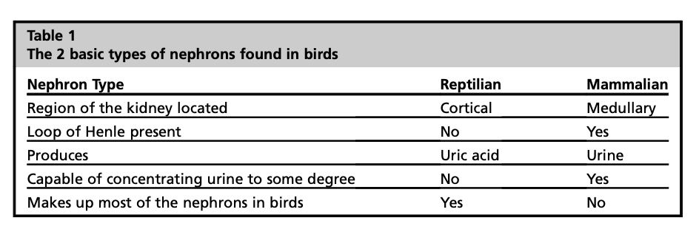
Takeaway:
Although the avian kidney is not able to concentrate water as effectively as that of mammals, the use of the lower GI tract to absorb water and increase the osmolality of urine and the salt glands’ ability to secrete excess osmotically active ions allows birds to inhabit a wide range of ecological niches that have limited amounts of fresh water. The kidney filters up to 11 times the total body water per day using both cortical (reptilian-type or loopless) and medullary (mammalian-type or looped) nephrons. Changes in GFR are regulated by the antidiuretic hormone of birds, AVT.
Mitchell-Tully, Current Therapy in Exotic Pet Practice – Chapter 11: Urinary system (page 498)

Summary:
- Kidney structure
  - Three lobes: cranial, middle, caudal (some species only have two i.e. passerines, hornbills)
  - Retroperitoneal, renal fossae of ventral synsacrum, can extend from caudal synsacrum to lungs
  - Associated with nerves and vessels of the lumbar and sacral plexuses (often pass through renal parenchyma)
  - Lack renal pelvis; urine carried in collecting ducts that connect to branches of the ureters dorsal wall of urodeum urine can be retrograded into colon and rectum for fluid reabsorption
    - Some species have rectocoprodeal sphincter; coprodeum acts as bladder (i.e. ostrich)
  - No corticomedullary definition
  - Nephrons
    - Cortical nephrons, 90%, lack loop of Henle
    - Medullary nephrons, 10%, contain loop of Henle
    - Individual nephrons have lower GFR than mammalian nephrons, but avian kidneys have more nephrons than mammalian kidneys
      - Nephron loops allow urine concentration above plasma osmolality water conservation
- Perfusion
  - Caudal renal arteries supply glomeruli
  - Caudal renal-portal vein
    - Perfuses renal tubules
    - Primary route of uric acid excretion
    - Blood flow controlled by valves; shunts to heart and brain in dehydration
- Nitrogenous waste uricotelic (uric acid)
  - Ammonia amino acids uric acid via purine synthetic pathway
    - More energy demanding than mammalian urea cycle, but more insoluble (can’t be reabsorbed in cloaca or allantois within egg)
- Water and electrolyte regulation
  - RAAS: Juxtaglomerular apparatus renin converts angiotensin I to angiotensin II aldosterone sodium absorption, potassium excretion, decreased GFR
  - Atrial natriuretic peptide increases sodium and water excretion
Gastrointestinal Avian

- No teeth; beak is used for food prehension; feet also aid in this
  - Seedeaters: short, stout beaks
  - Psittacine: strong, hooked bills- used for climbing and cracking nut shells
  - Carnivorous: narrower, hooked bills
  - Waterfowl: broad bills for straining water
- Psittacine birds: fleshy sensitive tongue for moving food and other objects
- Lories and Lorikeets: erectile bristles on tongue for collection of pollen and nectar
- Saliva is just for lubrication with no enzyme function
- Esophagus is similar to mammals-evaginates to form a crop in some species
  - Passerines (canaries), owls, many wading birds, some others do not have a crop
  - Columbiformes= produce crop milk
- Stomach= secretory portion (proventriculus) and muscular portion (ventriculus)
- Herons and penguins: sac-like and large
- Chemical digestion: begins in proventriculus with hydrochloric acid then food passes through the isthmus into the ventriculus
- Ventriculus: has a koilin layer= touch, carb-protein material= helps grind the food
  - In hornbills- this layer is shed and is what males feed to the females on the nest
  - In birds that consume nectar primarily= have less muscular ventriculus
- Gastric reflux (egestion or casting): occurs in carnivores (Strigiformes and Falconiformes)
  - This helps indigestible material not enter the ventriculus; this is synchronized contractions of the proventriculus, ventriculus, and duodenum
  - Owls: bone and roughage in pellets
  - Falconiformes: only roughage
- From ventriculus: goes into the small intestine (duodenum) along with bile and pancreatic enzymes
- The presence of ceca vaires
  - Absent: psittacines and diurnal raptors
  - Rudimentary: passerines and pigeons
  - Most developed: ground feeding birds
  - Ceca may function in water conservation along with digestion of fibrinous material
  - Ostrich: ceca is large, saccular, and has some bacterial fermentation to help with fiber digestion
- Colon empties into the coprodeum of the cloaca (most cranial portion)
- A lot of the water reabsorption from the urine occurs within the GI tract NOT the kidneys
- Pancreas: lies close to the duodenum, has both endocrine and exocrine properties
  - Glucagon is important in regulation of blood glucose in granivorous birds
- Liver: dark red and composed of a right and left lobe (right side is slightly larger)
  - Lack biliverdin reductase an cannot produce bilirubin
  - Feces=green in color is normal
  - If liver fails to conjugate and excrete biliverdin into the intestine then it will be excreted into the urine
- Gallbladder: varies if is present
  - Psittacine birds (EXCEPT COCKATOOS) lack a gallbladder

Reproductive- Avian

- Entirely Internal
- Sexed by DNA analysis (Antech) or endoscopic examination
- Some posses secondary sex characteristics
  - Eclectus: red/purple with black beak (female); green/yellow with “candy corn” beak (male)
  - Budgies: blue cere (males), grayer/white (females)
    - Cere can turn brown in female and become hyperplastic during reproductive activity
  - Wild type gray cockatiels: bars on the tail and primary flight feathers (females); orange bright patch on cheek (males)
- Reproductive tract is connected to the urodeum in the cloaca
- FEMALES:
  - Females reproductive tract is located on the left side
    - Right ovary and oviduct regress: raptors have vestigial remnants or could remain functional
  - Oviduct has 5 sections: infundibulum, magnum, isthmus, uterus (shell gland), and vagina
  - During breeding season- oviduct can take up the entire left coelom
  - There is a vaginal sphincter at the junction of uterus and vagina (where sperm is stored)
  - Uterus- site for shell production
- MALES
  - Paired testes on both right and left sides
  - Sperm formation: seminiferous and straight tubules
  - Last few millimeters of the ductus deferens protrude into the urodeum and form a papilla
  - No accessory sex glands
  - Copulation in birds (except waterfowl) involves eversion of the cloacal wall to exposed the raised papilla to transfer the semen to the orifice of the oviduct
  - Waterfowl: HAVE A PHALLUS- comprised of erectile tissue (lymphatic in origin) and an external groove that is used to transport semen
    - Purely reproductive in function
    - Lie on the ventral floor of the proctodeum
- Hormones:
  - Regulated by the hypothalamus- pituitary-gonadal axis (like all vertebrates)
  - Hypothalamus products GnRH-> stimulates pituitary gland-> produce LH and FSH
    - LH= increases with lengthening photoperiod as well as presence of mate and nest box access
  - FSH role is unclear in avian
  - Estrogens= responsible for secondary sex characteristics, stimulation of medullary bone production and a number of products used to form the egg
  - LH= stimulates progesterone production- with increased progesterone you get the LH surge
  - PGF2alpha coincides with shell gland contractions
  - PGF2alpha and PGE2 increase smooth muscle contractions= cause follicle to rupture
    - Mid-sequence oviposition= PGF2alpha is higher
      - PGF2 alpha binds at the shell gland receptor causing mobilization of calcium which causes shell gland muscle contractions; most likely has no ability to relax the uterovaginal sphincter
    - Terminal oviposition= PGE2 is higher
      - PGE2: binding sites in vagina thought to block binding of PGF2alpha: allow relaxation of the uterovaginal sphincter and vagina

