What structure is denoted by the asterisk?
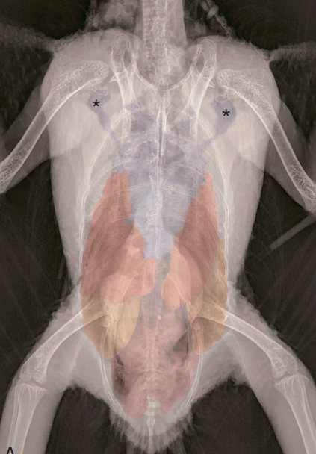

Answer: Axillary diverticula of the clavicular air sac

Which structure is paired in psittacines?
- Clavicular air sac
- Intestinal peritoneal cavity
- Cranial vena cava
- Coeliac artery
- Syrinx

Answer: Cranial vena cava

Accumulation of caseous debris in which air sac can cause compression of the great vessels?
- Cranial Thoracic
- Abdominal
- Clavicular
- Caudal Thoracic
- Cervical

Answer: Clavicular

Mitchell & Tully, Current Therapy in Exotic Pets Practice
Chapter 3 - Respiratory System (pages 88-93; Avian)
Q: Which infraorbital sinus diverticulum is most likely to be mistaken for an air sac?
- Cervicocephalic diverticulum
- Rostral diverticulum
- Preorbital diverticulum
- Postorbital diverticulum
- Mandibular diverticulum
Answer: A
Source: Mitchell and Tully, Current Therapy in Exotics Pet Practice
Chapter 3 – Respiratory System (pg 88-93; Avian)

Q: Which best describes the mechanics of avian respiration?
- Inspiration and expiration are active processes, and ventilation is performed by the lungs
- Inspiration and expiration are both active processes, and ventilation is performed by air sacs
- Only inspiration is an active process, and ventilation is performed by air sacs
- Only expiration is an active process, and gas exchange is performed by the lungs
- Inspiration and expiration are both passive processes, and gas exchange is performed by air sacs
Answer: B
Source: Mitchell and Tully, Current Therapy in Exotics Pet Practice
Chapter 3 – Respiratory System (pg 88-93; Avian)

Q: Which anatomical features are present in avian but not mammalian respiratory systems?
- Incomplete tracheal rings and a syrinx
- Epiglottic and thyroid cartilages
- Vocal cords and pneumatized bones
- Functional diaphragm and fixed external nares
- Single paranasal sinus and air sacs
Answer: E
Source: Mitchell and Tully, Current Therapy in Exotics Pet Practice
Chapter 3 – Respiratory System (pg 88-93; Avian)

CBS Questions; 08-24-2023; Laura Martinelli

Avian Neurology (363-371): Speer, Current Therapy in Avian Medicine and Surgery

QUESTION: An ill bird arrives to the hospital and in the exam room continues to sleep even while staff walking around and talking to the owner. However, when auscultated or talked to bird will rouse and interact with owner and veterinary staff. This represents what level of consciousness?

- Lethargic
- Depressed
- Obtunded
- Stuporous
- Comatose

Answer: C. Obtunded, decreased responses to environmental stimuli; sleeping even in strange surroundings, but easily roused.

Chapter 8: CNS (396-398, avian section): Mitchell-Tully, Current Therapy in Exotic Pet Practice

QUESTION: Which of the following is NOT an anatomical component of the avian CNS?
- Dura mater
- Cauda equina
- Glycogen body
- Lumbosachral plexus
- Proencephalon

Answer: B. Cauda equina, the avian spinal cord extends the full length of the vertebral column and therefore does not have a cauda equina structure.

Hayley Stratton
CBS 817
8-24-23

Orosz, Susan E., and M. Scott Echols. "The Urinary and Osmoregulatory Systems of Birds." The veterinary clinics of North America. Exotic animal practice 23.1 (2020): 1-19.

Practice Question:

Which of the following is true regarding cortical and medullary nephrons?

A. Cortical nephrons have a loop of Henle and medullary nephrons do not
B. Medullary nephrons make up most of the nephrons in birds
C. Both cortical and medullary nephrons are capable of concentrating urine to some degree
D. Cortical nephrons produce uric acid and medullary nephrons produce urine
E. Cortical nephrons are capable of concentrating urine to some degree and medullary nephrons are not

Mitchell-Tully, Current Therapy in Exotic Pet Practice – Chapter 11: Urinary system (page 498)

Practice Question:

What percentage of avian nephrons contain a loop of Henle?

A. 10%
B. 30%
C. 50%
D. 70%
E. 90%

Questions

- Which of the following Psittacine Birds lack a gallbladder?
- Melopsittacus undulatus
- Ara macao
- Agapornis
- Nymphicus hollandicus
- Cacatuidae

Answer: E. Cacatuidae: cockatoos

- Which of the following hormones is responsible for the stimulation of medullary bone production in the avian species?
- LH
- FSH
- Estrogen
- PGF2alpha
- PGE2

Answer: C: estrogen

