QUESTION: What is the mechanism of action of voriconazole?
- Inhibit squalene epoxidase
- Binds to ergosterol
- 14 𝛂-demethylase inhibitor
- Binds to beta tubulin
- Adenosine uptake inhibition

Answer: C
A = terbinafine, B = amphotericin B/nystatin, D = fenbendazole/albendazole, E = praziquantel

Source: Safety of an Intravenous Formulation of Voriconazole as an Intramuscular Injection in Pigeons (Columba livia f. domestica). Journal of Avian Medicine and Surgery 36.3 (2022): 262-271.

QUESTION: Which is true regarding radiographic diagnosis of pectoral girdle fractures in passerines?
- There are more false positives than false negatives diagnosed via radiographs
- Coracoid fractures are more commonly diagnosed than clavicular or scapular fractures
- H view has similar accuracy as standard VD and DV views
- Seven views should be performed for most accurate diagnosis
- Slanting the x-ray tube is more accurate than slanting the patient for H view

Answer: C

Source: Diagnostic accuracy of seven radiographic views, alone and in combination, for diagnosis of pectoral girdle fractures in wild passerines after window collisions. Journal of the American Veterinary Medical Association (2022). 260(6):1-6.

- Which of the following is true in regards to morbidity and mortality in captive Blue Crested LaughingThrush (BCLT)?
  - Age is not a significant factor in regards to mortality
  - BCLT’s are not readily susceptible to coccidiosis
  - Systemic isosporiasis (SI) was the primary cause of mortality
  - Treatment for coccidiosis is generally poor
  - Mortality for SI peaked in the spring (April to June)

Answer: D: Treatment is generally poor for coccidiosis.
Age is a significant factor in regards to mortality (lots of neonates and juveniles)
BCLT’s like most passerines are susceptible to coccidiosis
Trauma was the primary cause of mortality followed (super) closely by SI
Mortality for SI peaked in the fall September/October

- Name four differentials for the birds in the following image:

- 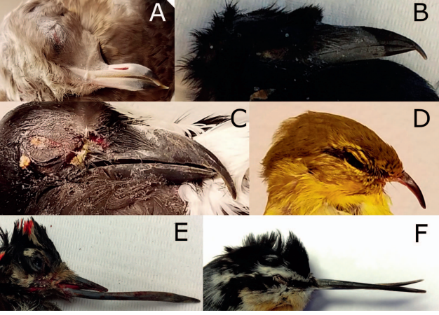

Avian Keratin Disorder- possibly caused by poecivirus
Environmental Contaminants- possibly organochlorine compounds
Nutritional Deficiencies- such as vitamin A or vitamin B2
Trauma

What drug has been shown to protect against acetaminophen-induced hepatotoxicity in Domestic Pigeons (Columba livia)?

Answer: Silymarin

Which of the following anticoagulants is most appropriate for running a biochemistry panel on Domestic Pigeons (Columba livia domestica) plasma?

- Sodium citrate
- Lithium heparin
- Sodium heparin
- Ethylenediaminetetraacetic acid (EDTA)
- Any of these anticoagulants are acceptable

Answer; B

Sources for environmental contaminant:
Handel CM, Van Hemert C. Environmental contaminants and chromosomal damage associated with beak deformities in a resident North American passerine. Environ Toxicol Chem. 2015 Feb;34(2):314-27. doi: 10.1002/etc.2799. Epub 2015 Jan 6. PMID: 25376148.

The effect of dexamethasone on hematologic profiles, hemosporidian infection, and splenic histology in house finches (haemorhous mexicanus).
Crouch EE, Reinoso-Perez MT, Vanderstichel RV, Dhondt KV, Dhondt AA, Cruz Otero JD, Piech T, Forzán MJ.
The Journal of Wildlife Diseases. 2022;58(3):512-523.

Research on host response to infectious disease often involves pharmacological induction of immunosuppression, frequently through administration of dexamethasone. Reports on the effect of dexamethasone in birds are largely restricted to poultry and pigeons. This study describes changes in white blood cell (WBC) differentials, hemoparasite counts, splenic histology, and splenic CD3 immunoreactivity in House Finches (Haemorhous mexicanus). Experimental group birds (n=9) were treated with a daily intramuscular injection of 25 µg of dexamethasone for 8 d; a control group (n=9) received daily saline solution. Smears were made with blood collected immediately before the first dose (day 0) and on d 4, 8, and 9, and stained with modified Wright. The WBC differential counts were performed by three blinded observers, parasite counts by two blinded observers, and histology by one blinded observer. Dexamethasone-treated birds experienced relative heterophilia and lymphopenia on d 4 (P=0.008); heterophilia was also present at d 8 (P=0.018). Hemosporidian counts were significantly increased in dexamethasone-treated birds on d 4 and 8 (P=0.048 and P=0.031, respectively). In contrast with control birds, all dexamethasone-treated birds lacked histologically apparent splenic lymphoid follicles (P<0.001). No significant difference was observed in splenic CD3 immunoreactivity between groups. Our results indicate that dexamethasone has an effect on the hematologic profile of House Finches and suggest that it may be a useful method to induce immunosuppression in this species.

Background
- Corticosteroid production in birds is regulated by the HPA axis – impt for stress response, immune function and inflammation
- Dexamethasone is a long acting synthetic glucocorticoid that suppresses the HPA axis to a greater degree and for a longer time period in common pigeons vs mammals; also documented in turkeys and chickens
- H:L ratios used to assess stress, with elevated ratios indicating acute stress, chronic stress
  - Racing pigeons, chickens: dex injection has induced heterophilia and lymphopenia
  - Chickens: involution of the cloacal bursa, spleen and thymus
Key points
- 2 birds from the treatment group and 1 control bird died prior to conclusion of the study
  - One definitive cause of death in a treated bird was intestinal coccidiosis
- Hematology:
  - treated birds had a 3-fold increase in relative heterophils and 55% decrease in lymphocytes, when comparing day 0 and day 4 smears
    - Heterophilia was sustained to d 8 but diminished at d 9
    - Lymphopenia was absent at d 8 and d 9.
      - Suggests that initial dexamethasone-induced leukocytic changes waned despite continued daily dexamethasone administration
  - a relative lymphocytosis was seen in the control group at day 8 - likely clinically insignificant
  - relative eosinopenia at day 4 and day 8, when compared to d 0 counts in both the treated and control groups, only sustained by d 9 in the treated group, and represented a 50-61% decrease compared to d0 values
  - monocytes were doubled in the control group at d8 and 9 compared to d0 counts
    - No change in treated group.
  - in most blood smears, saw immature erythrocytes indicating mild regenerative anemia seen d/t blood collection
- Hemoparasitism
  - mean hemosporidian (Plasmodium and Hemoproteus sp) counts comparing d0 to d4 and d8 showed sig. increase
  - 36-76% infected birds in treatment group vs 0.9-3.6% in control group
  - low #s of Leukocytozoan seen only sporadically in treated birds
  - Suggests immunosuppression in dexamethasone-treated birds
- Histology
  - all birds in treatment group lacked splenic lymphoid follicles vs control group (1-1+ follicles in each bird) suggesting decrease in B cell population
  - No significant difference was observed in splenic CD3 immunoreactivity between groups - no apparent effect on T cells
Conclusions
- Dexamethasone treatment appears to change the hematologic profile, natural hemoparasite infection rate, and splenic histology of House Finches. These changes were compatible with immunosuppression and may mimic a stress response.

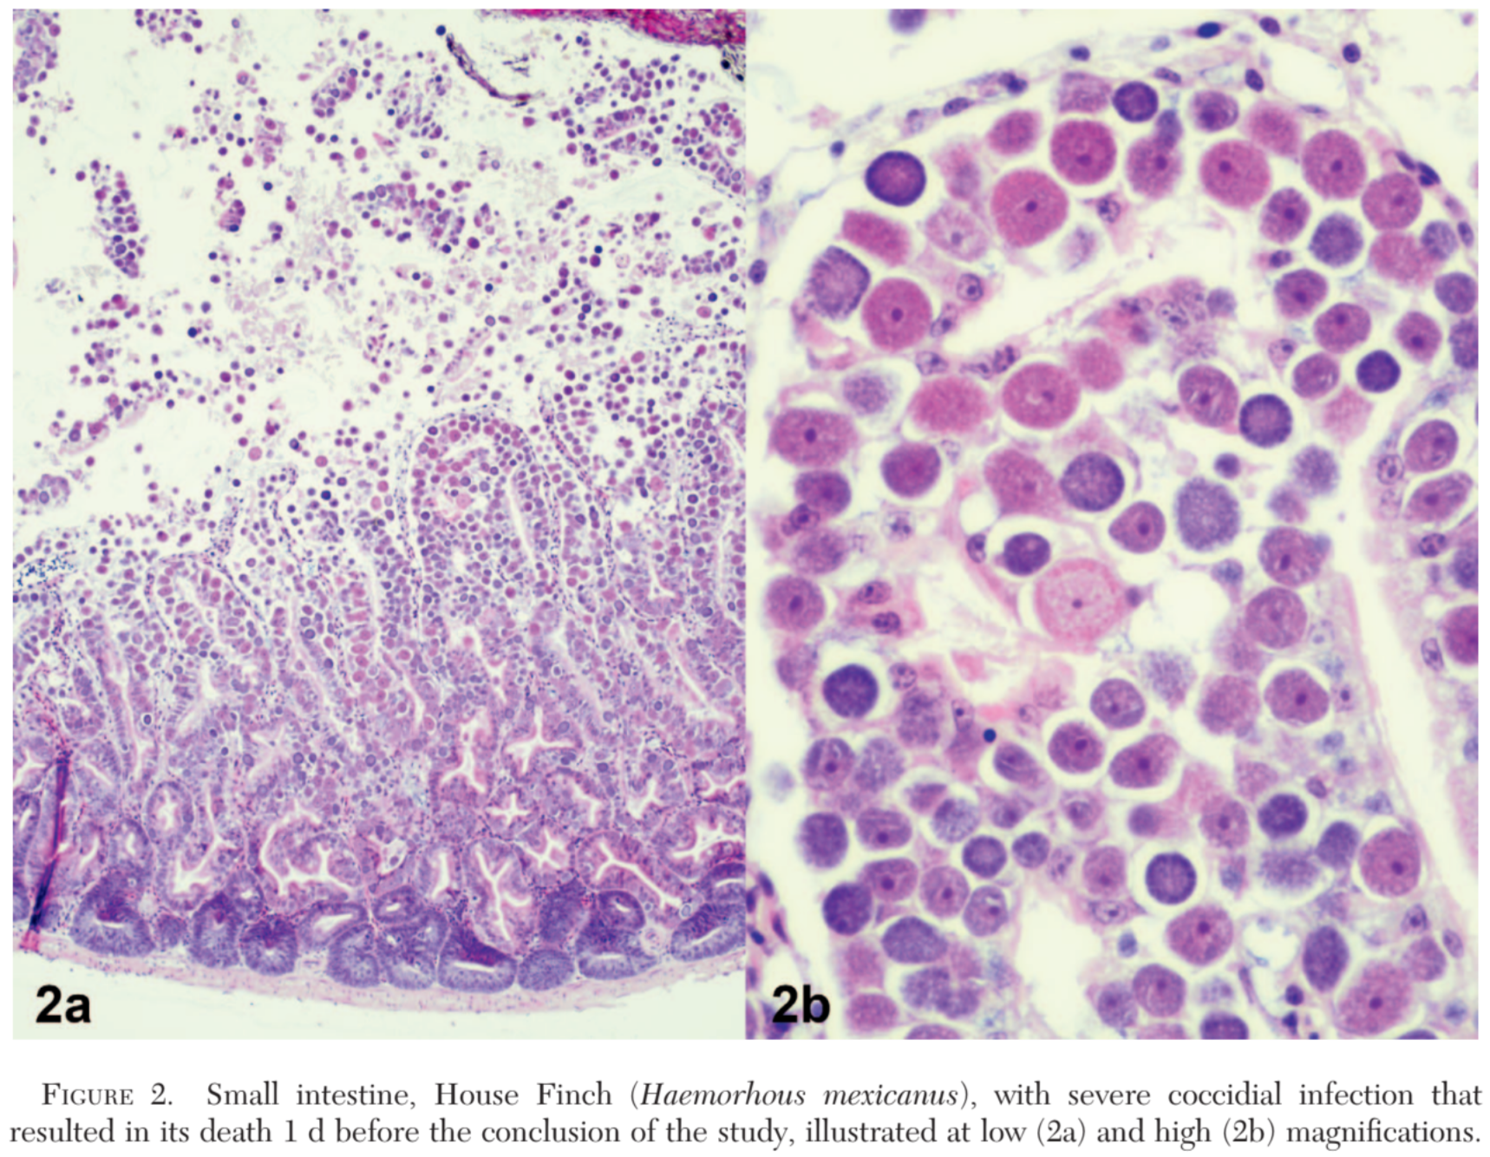
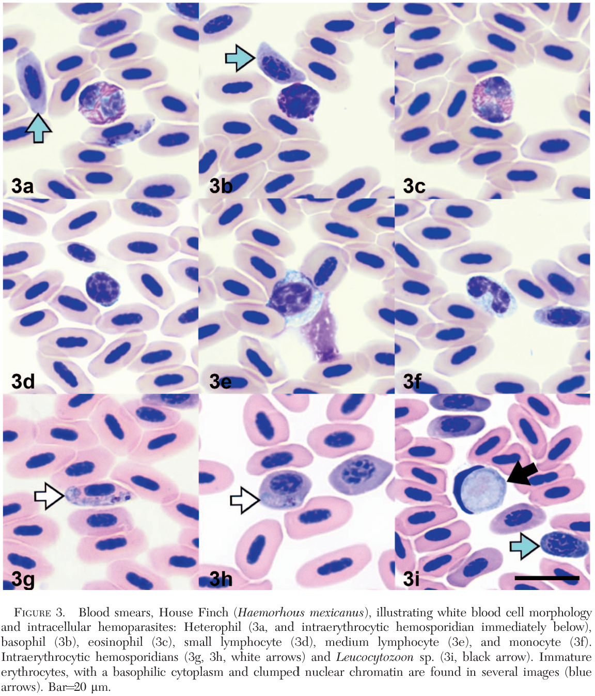

Knemidokoptes Mites And Their Effects On The Gripping Position Of The Feet Of Steller's Jays (Cyanocitta stelleri)
Burris WM, Kinziger AP, Black JM, Brown RN
JWD 2022 58(4):859-868.

Steller's Jays (Cyanocitta stelleri) with swollen legs and feet resembling the signs of scaly leg have been commonly seen around Arcata, California, US. The clinical signs are thought to be caused by knemidokoptic mites, a group of parasites specialized on avian hosts. Between February 2019 and March 2020, we analyzed the long-term database of Steller's Jays collected by Humboldt State University for trends in the prevalence of signs of scaly leg, compared the gripping position in the feet of Steller's Jays with variable signs of this condition as an index of their ability to perch, identified the mites using a partial sequence of the cytochrome oxidase subunit I gene, and examined genetic distances between mites collected from different host species both sequenced in this study and from GenBank. Overall, 27% of jays recorded in the long-term database had shown signs of scaly leg. Jays with signs captured in this study had greater variability in and a reduced degree of contraction in the gripping position of their feet compared to jays without signs, suggesting that infestation may have an impact on the host's ability to perch. The cytochrome oxidase subunit I sequence (578 base pairs) from mites collected from Steller's Jays was compared to sequences from Knemidokoptes jamaicensis, Knemidokoptes derooi, and to unidentified Knemidokoptes spp. collected from different hosts. The mites from Steller's Jays were most closely related to Knemidokoptes jamaicensis but had a relatively high sequence divergence, 7.8%, supporting the possibility that the form infesting these jays may be an undescribed species.

Background:
- Knemidokoptes spp. contains five species of avian ectoparasitic mites distributed globally
  - 3-week direct life cycle; transmission via direct contact or fomites (nests, roost sites)
  - Mites infest stratum corneum of the face/cere & under the scales of legs and feet
  - Pathogenesis of knemidokoptiasis resembles that of sarcoptic mange in mammals
  - Three most common species: K. mutans, K. jamaicensis, K. intermedius
    - K. mutans commonly associated with domestic chickens
    - K. jamaicensis common on wild birds globally
- Although knemidokoptiasis may cause debilitation in individual birds and is occasionally responsible for mortality, epizootic knemidokoptiasis is unlikely to have long-term effects on avian populations
Key Points:
- 27% of Steller's Jays recorded in long-term data from this population had signs of scaly leg
  - 44% of the jays captured during this study showed signs
  - Wide range of prevalences reported in other avian species due to host, pathogen, and environmental factors
- No difference in prevalence between male and female Steller’s Jays
  - Previous studies found higher prevalence in males
- Signs of scaly leg more common in older Steller’s Jays
  - 20% prevalence in juvenile jays vs. 32% prevalence in adult jays
  - Infestations may require time to develop clinical signs or not all nestlings exposed to mites will become clinically infested
- Mites were only detected in skin scrapings from 1/14 sampled individuals with clinical signs
  - Detection probability would be higher with deeper skin scrapings or biopsy/necropsy
- Models suggest that there is a reduced degree of contraction in D1 and D3 of birds with signs of scaly leg and that the gripping position of Steller's Jay feet is highly variable
  - Greater variability and reduced degree of contraction in in feet with signs of scaly leg suggests that infestation impacts the way birds are able to grip a perch
  - Effects of an altered perching position on host fitness likely have some energetic cost
- Based on sequencing, the 7.8% divergence between Steller’s Jay mites and their closest species match to K. jamaicensis from a Pine Grosbeak suggest they may be separate species
  - Lack of reports of scaly leg in other species of birds that frequent the same feeding stations as infested Steller's Jays supports the likelihood of host specificity
  - If Knemidokoptes spp. transmission is restricted to direct contact or through fomites, interspecific transmission may be limited, creating fragmented populations of mites
Conclusions
- Knemidokoptes spp. is the causative agent of scaly leg in domestic and wild birds; the three most common species are K. mutans (chickens), K. jamaicensis (wild birds), K. intermedius (wild birds).
- Signs of scaly leg in Steller’s Jays are associated with changes in perch gripping that may increase the energetic cost.

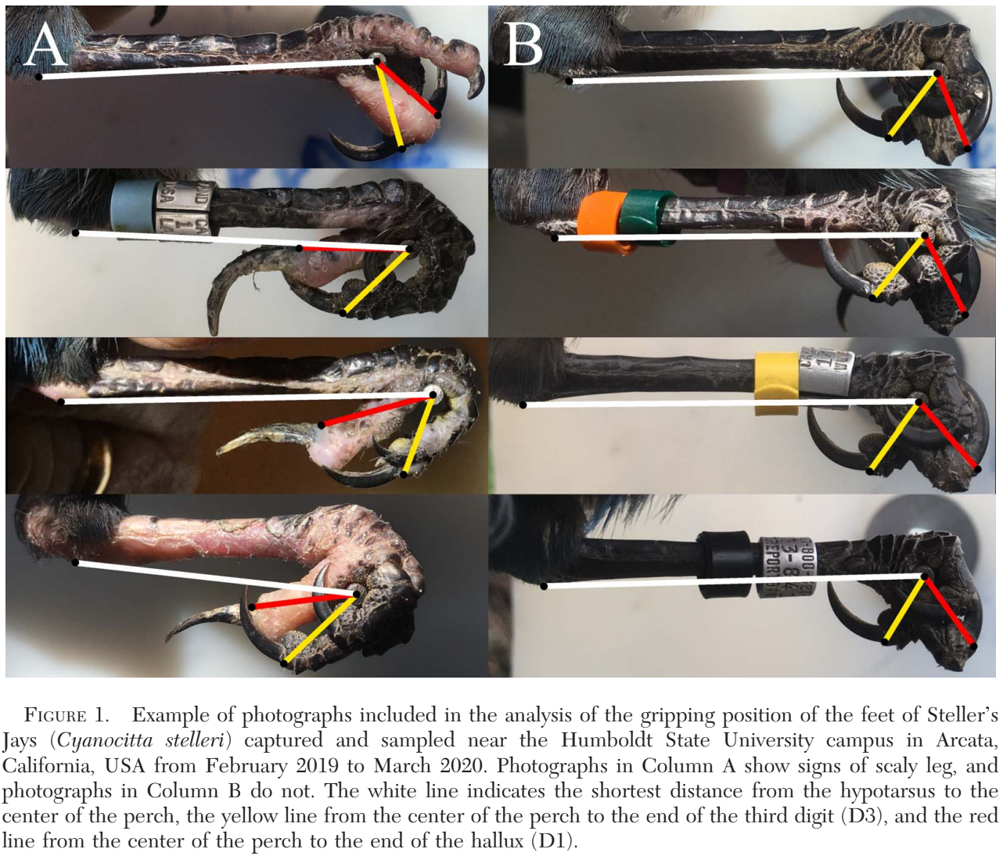

West Nile Virus Seroconversion In Eastern Loggerhead Shrike (Lanius ludovicianus migrans) After Vaccination With A Killed Vaccine
Practice Question: Name five viruses for which passerines can be subclinical reservoirs

Answer:
- Eastern Equine Encephalitis
- Western Equine Encephalitis
- Venezuelan Equine Encephalitis
- West Nile Virus
- St. Louis Encephalitis

Retrospective Review Of Mortality In Captive Pink Pigeons (Nesoenas mayeri) Housed In European Collections: 1977-2018
Practice Question: What is the most common fatal infectious disease diagnosed in captive pink pigeons in a retrospective study?

Answer: Yersinia pseudotuberculosis

