Safety of an Intravenous Formulation of Voriconazole as an Intramuscular Injection in Pigeons (Columba livia f. domestica). Journal of Avian Medicine and Surgery 36.3 (2022): 262-271. Carneiro de Castro, Isadora Fontenelle, Schmidt, Volker, Silvanose, Christu-Das, Binoy, Ambily, and Azmanis, Panagiotis N. -Review by LEM

Abstract: Aspergillosis is a common disease in birds. Currently, avian aspergillosis is treated with voriconazole administered orally, although intramuscular (IM) administration increases bioavailability and is more effective in treating generalized aspergillosis. The objective of this study was to evaluate the safety of the intravenous formulation of voriconazole as an IM injection in the pectoral muscles of pigeons (Columba livia f. domestica) as a model for other avian species. Sixteen healthy pigeons received IM injections of voriconazole (12.5 mg/kg) and sterile saline in the right and left pectoral muscles, respectively, twice a day for 7 days. Additionally, 4 birds acted as controls (no injections). Eight birds in the treatment group and 2 of the control pigeons were humanely euthanized 1 day (group 1) and 14 days (group 2) after the final injection. Hematologic and plasma biochemistry panels were performed prior to the birds being euthanized. Gross and histopathological evaluations of the pectoral muscles were completed postmortem. Statistical analysis revealed significant differences in multiple parameters, including aspartate aminotransferase and lactate dehydrogenase, but all biochemical analytes remained within the reference intervals for the species. The group 1 birds had advanced gross and histopathological pectoral muscle lesions associated with the voriconazole injections compared with the contralateral side, the group 2 birds, and the negative controls. After 14 days, the pectoral muscles did not reveal any gross or histopathological changes associated with the voriconazole or sterile saline injections. These results indicate that the intravenous formulation is safe for IM use twice per day for 1 week in pigeons. Further investigation is needed to extrapolate these findings to other avian species and to evaluate the roles of longer treatment periods and higher doses of voriconazole.

Background:
- Aspergillus = ubiquitous fungus, can cause invasive infections in mammals, birds, humans
- Voriconazole = triazole, lanosterol 14 𝛂-demethylase inhibitor (prevents lanosterol to ergosterol)
  - Ergosterol = important part of fungal cell membrane
  - Adverse effects in birds: liver function compromise, GI signs, neuro signs
  - Single dose IM showed higher bioavailability than PO in falcons
- Pectorals important muscle group for flight → need to evaluate injection safety in this muscle

Objective: evaluate safety of voriconazole IM due to potential for higher bioavailability vs. PO
Methods: administered voriconazole (12.5 mg/kg) IM BID x 7 days; n=16
- Euthanized 8 birds after 7d of treatment (group 1), and other 8 birds 14d after last injection (group 2) for gross and histopath analysis of muscle → compared to contralateral side that received saline, and 4 birds that received no injections; and monitored CBC/chem

Key Points:
- No clinical adverse effects during study; no injuries from capture/manual restraint
- Gross lesions: majority of birds from both groups had macroscopic edema/erythema during the 7 day treatment at voriconazole injection site and saline injection site
  - Voriconazole sites were more severe for all days
- Bloodwork: no clinically relevant findings
  - CK remained within RR for this species (potential for shorter half life)
  - LDH, AST, ALT, UA increased but remained within RR
  - WBC and globulins decreased in group 2; suspect stress rather than immunosuppression from voriconazole as controls also had decreased globulins
- Histopathology:
  - All pigeons in group 1 (euthanized day 8) had histopath lesions injection sites (more at voriconazole site n=6, than saline site n=3)
    - Hemorrhage, inflammatory reactions with lymphocytes, plasma cells, heterophils; some had histiocytes with brown pigment (suspect hemosiderin)
    - No myodegeneration, fibrosis or myositis found
  - No pigeons in control group (no injections) or group 2 (euth day 21) had histopath lesions
Take Home:
- Voriconazole IM 1.5 mg/kg (10 mg/ml, 0.5 ml mean injection volume) BID x 7 days resulted in mild macroscopic and histologic lesions in the pectoral muscles, that were similar to a saline control, of pigeons however by 14 days post-injection the lesions were no different than saline injected controls

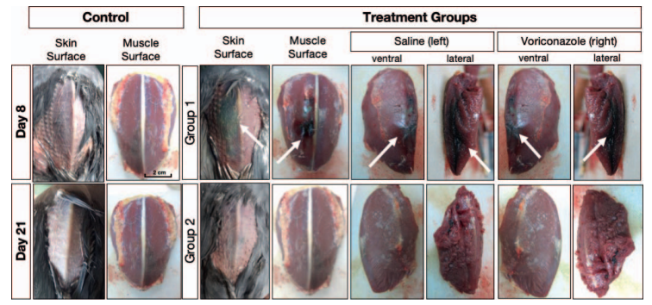

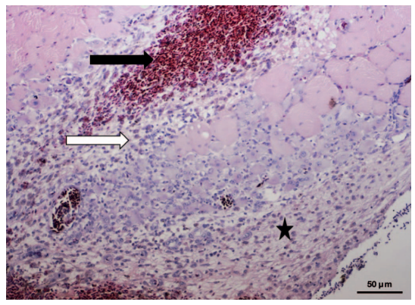
Figure 2: Pectoral muscle after last IM voriconazole injection (group 1) showing hemorrhage (black arrow) and inflammatory reaction with hets, lymphs, plasma cells, histiocytes (white arrow), and histiocytes with hemosiderin (black star)

Diagnostic accuracy of seven radiographic views, alone and in combination, for diagnosis of pectoral girdle fractures in wild passerines after window collisions. Journal of the American Veterinary Medical Association (2022). 260(6):1-6. Matt, Crystal L., Girolamo N, Hallman RM, Bailey KL, O’Connell TJ, Brandao J. -Review by LEM

OBJECTIVE: To determine the prevalence of pectoral girdle fractures in wild passerines found dead following presumed window collision and evaluate the diagnostic accuracy of various radiographic views for diagnosis of pectoral girdle fractures. SAMPLE: Cadavers of 103 wild passerines that presumptively died as a result of window collisions. PROCEDURES: Seven radiographic projections (ventrodorsal, dorsoventral, lateral, and 4 oblique views) were obtained for each cadaver. A necropsy was then performed, and each bone of the pectoral girdle (coracoid, clavicle, and scapula) was evaluated for fractures. Radiographs were evaluated in a randomized order by a blinded observer, and results were compared with results of necropsy. RESULTS: Fifty-six of the 103 (54%) cadavers had ≥ 1 pectoral girdle fracture. Overall accuracy of using individual radiographic projections to diagnose pectoral girdle fractures ranged from 63.1% to 72.8%, sensitivity ranged from 21.3% to 51.1%, and specificity ranged from 85.7% to 100.0%. The sensitivity of using various combinations of radiographic projections to diagnose pectoral girdle fractures ranged from 51.1% to 66.0%; specificity ranged from 76.8% to 96.4%. CLINICAL RELEVANCE: Radiography alone appeared to have limited accuracy for diagnosing fractures of the bones of the pectoral girdle in wild passerines after collision with a window. Both individual radiographic projections and combinations of projections resulted in numerous false negative but few false positive results.

Background: Window collisions among leading cause of trauma in wild birds → often causes fractures or luxations of pectoral girdle bones
- Anatomy of pectoral girdle: coracoid, clavicle, scapula → form triosseal canal
  - Coracoids: struts for wings and prevent collapse of thoracic cavity during down strokes
  - Clavicles: struts for shoulder joints, act as elastic springs to assist in flight/respiration
  - Scapulae: support for thoracic cavity during flight, angled with coracoids
  - Principle muscle group (supracoracoideus muscle) tendons run though canal
  - Humerus articulates with pectoral girdle to form shoulder
- Pectoral girdle fractures typically diagnosed with palpation and/or radiography
- Recent study (2015) showed addition of caudoventral-to-craniodorsal oblique view (Cd45V-CrD oblique view or “H view”) made at 45 degrees to frontal plane, to standard VD view, would increase chance of identifying pectoral girdle fractures
- Objective: determine prevalence of pectoral girdle fractures in wild passerines found dead following presumed window Collison; evaluate diagnostic accuracy of rads/confirm with necropsy

Methods: n=103 cadavers; median weight 14g; lincoln's sparrows, painted buntings, etc.
- Seven rad views: VD, DV, right lateral, 4 oblique views
  - Obliques: bird slanted on foam block vs. x-ray tube slanted

Key Points:
- Confirmed at necropsy: 56/103 birds had at least 1 fracture of the pectoral girdle (54%)
  - 41 had scapula fracture(s) > 18 had clavicle fracture(s) >14 had coracoid fracture(s)
  - Most birds have unilateral fractures; right side more affected than left
- Similar accuracy between standard VD and DV views vs. additional oblique view
  - Overall accuracy of individual rad views 63-74% vs. combo views 68-80%
- Both individual and combo rads had several false negatives (>20%), few false positive (~5%)
  - Several views had >20% false negatives (1 in 5 patients incorrectly declared fx free)
- Combination with the highest accuracy = right lateral, VD, and Cr45V-CdD oblique views
- Similar accuracy between raising bird to 45 degree angle (with wedge) vs. slanting x-ray tube
  - Suggests H view can be performed without moveable x-ray generator

Take Home:
- Radiography resulted in many false negatives (few false positives) in diagnosis of pectoral girdle fractures in passerines after window collisions → thus, limited accuracy
- 45° oblique views, independent of recumbency or generator orientation, had similar accuracy in identifying fractures of the pectoral girdle when compared with standard VD and DV views

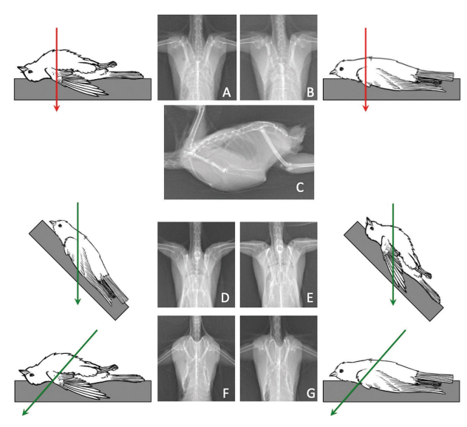

A RETROSPECTIVE ANALYSIS OF MORBIDITY AND MORTALITY IN CAPTIVE BLUE-CROWNED LAUGHING THRUSHES (PTERORHINUS COURTOISI): 1998–2018
Luke O’Connor, BSc (Hons), BVSc, MRCVS, Sophie Vines, BSc (Hons), MSc, Lewis J. Rowden, BSc (Hons), ResM, and Amanda Guthrie, DVM, DACZM, DECZM (ZHM), MRCVS

Abstract: The blue-crowned laughingthrush (BCLT) (Pterorhinus courtoisi) is a species of critically endangered passerine that is part of a Global Species Management Plan and experiences high mortality rates in some collections. Complete necropsy and medical records from 15 European institutions that housed BCLT between 1998 and 2018 were assessed to evaluate morbidity and mortality in the captive population. Medical records for 407 BCLT were received; a total of 191 morbidity events were recorded from 111 individual BCLT. The most common cause of morbidity was coccidial disease, including systemic isosporosis (30.4%, n 1⁄4 58). Age was a significant factor contributing to mortality, with 53% of deaths occurring between 0 and 14 d old and 78% by 1 yr of age. The most common cause of death was trauma (22.8%, n 1⁄4 31), followed by systemic isosporosis (22%, n 1⁄4 30). Of the 343 deceased birds for which records were provided, 50.4% had a necropsy performed and 40.5% had histopathology carried out postmortem. Based on these findings, BCLT should be managed carefully to mitigate risk of trauma, and screening for isosporosis should be performed. Institutions should carry out standardized necropsies and histopathology on every BCLT that dies in their collection to elucidate the etiology of disease in this critically endangered species.

- Looked at records from 15 European institutions that housed blue crowned laughingthrush between 1998-2018 were assessed to evaluate morbidity and mortality in the captive population
- Necropsies were performed on 50% of BCLTthat died within the study period
- Age was a significant factor contributing to death- mean age of death being 1 year
- Mortality was highest in the 0-14 days age class
- The primary cause of death found was trauma followed by systemic isosporosis
  - Mortality caused by systemic isosoporosis- peaked between September and October
- Morbidity events ranges from 1-7 pending individual
- Primary cause of morbidity was infectious coccidial disease, followed by other infectious parasitic, and then trauma
- BCLT are endangered and some institutions report 100% mortality in chicks within a year of hatching
- BCLT are susceptible to coccidial infection: cause hepatomegaly, splenomegaly, coelomic distention and pectoral myositis; treatment is poor
  - Disease can be confirmed only through PCR or histopathologic investigation- presence of merozoites in lymphocytes is diagnostic
- Institutions are encouraged to regularly check nest boxes of BCLTs- expedite any necessary postmortem investigations into nestling mortality
  - High definition nest box cameras
Conclusions:
Trauma and systemic isosporiasis are the leading causes of morbidity and mortality in BCLT’s
Institutions should be aware of the most prevalent diseases in this species to enable early diagnosis and treatment along with prophylactic treatment of common infectious diseases, including SI and aspergillosis during times of stress
Perform thorough necropsy and histopath on any deceased BCLT’s particularly neonates and juveniles to advance knowledge in etiology of disease processes

POECIVIRUS IS PRESENT IN INDIVIDUALS WITH BEAK DEFORMITIES IN SEVEN SPECIES OF NORTH AMERICAN BIRDS
Maxine Zylberberg,1,4 Caroline Van Hemert,2 Colleen M. Handel,2 Rachel M. Liu,1 and Joseph L. DeRisi1,3,4

ABSTRACT: Avian keratin disorder (AKD), a disease of unknown etiology characterized by debilitating beak overgrowth, has increasingly affected wild bird populations since the 1990s. A novel picornavirus, poecivirus, is closely correlated with disease status in Black-capped Chickadees (Poecile atricapillus) in Alaska, US. However, our knowledge of the relationship between poecivirus and beak deformities in other species and other geographic areas remains limited. The growing geographic scope and number of species affected by AKD-like beak deformities require a better understanding of the causative agent to evaluate the population-level impacts of this epizootic. Here, we tested eight individuals from six avian species with AKD-consistent deformities for the presence of poecivirus: Mew Gull (Larus canus), Hairy Woodpecker (Picoides villosus), Black-billed Magpie (Pica hudsonia), American Crow (Corvus brachyrhynchos), Red-breasted Nuthatch (Sitta canadensis), and Blackpoll Warbler (Setophaga striata). The birds were sampled in Alaska and Maine (19992016). We used targeted PCR followed by Sanger sequencing to test for the presence of poecivirus in each specimen and to obtain viral genome sequence from virus-positive host individuals. We detected poecivirus in all individuals tested, but not in negative controls (water and tissue samples). Furthermore, we used unbiased metagenomic sequencing to test for the presence of other pathogens in six of these specimens (Hairy Woodpecker, two American Crows, two Red-breasted Nuthatches, Blackpoll Warbler). This analysis yielded additional viral sequences from several specimens, including the complete coding region of poecivirus from one Red-breasted Nuthatch, which we confirmed via targeted PCR followed by Sanger sequencing. This study demonstrates that poecivirus is present in individuals with AKD-consistent deformities from six avian species other than Black-capped Chickadee. While further investigation will be required to explore whether there exists a causal link between this virus and AKD, this study demonstrates that poecivirus is not geographically restricted to Alaska, but rather occurs elsewhere in North America.

- Investigating widespread epizootic of beak deformities consistent with avian keratin disorder (AKD)- beak deformities- elongation, often crossing and marked curvature which result in decreased fitness and survival
- AKD observed in Alaskan Black-CappedChickadees in south central Alaska
- Deformities appear in clustered geographically- Alaska, the Pacific Northwest of North America and the South of England
- Other beak deformities: environmental contaminants, nutritional deficiencies, trauma, and exposure to infectious disease
- Objective: use targeted PCR followed by Sanger sequencing to test for the presence of poecivirus in the beak and cloacal tissue of four opportunistically collected individuals with deformed beaks- they then used unbiased metagenomic sequencing to analyze tissues of six birds: Hairy Woodpecker, Blackpoll Warbler, American Crows, Red-breasted Nuthatches
- Detected poecivirus in 8/8 specimens that displayed AKD consistent beak deformities
- Poecivirus was not detected in negative controls
- More positive samples ⅞ were achieved via cloacal sample compared to beak tissue 6/8
  - Warbler detected in beak but not cloaca
- After sequence analysis- revealed that viruses from Hairy Woodpecker, red breasted nuthatch and an American crow were closely related to the virus sampled from the black capped chickadees
- This study demonstrated the presence of poecivirus in additional species, families and orders of bids, and recommend screening large number of individuals of each species including those with no signs of AKD

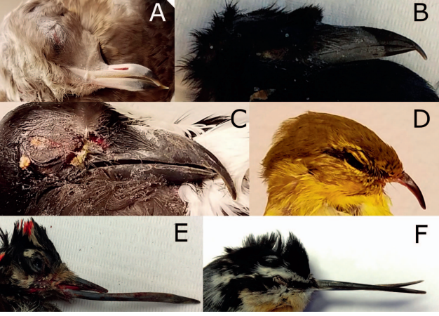

Ihedioha, John I., Davinson C. Anyogu, and Martin E. Ogbonna. "The Effects of Silymarin on Acetaminophen-Induced Acute Hepatic and Renal Toxicities in Domestic Pigeons (Columba livia)." Journal of Avian Medicine and Surgery 34.4 (2020): 348-357.

Abstract: This study evaluated the effects of silymarin on acetaminophen-induced acute liver and kidney toxicities in domestic pigeons (Columba livia). Standard colorimetric methods with commercial kits were used to measure the serum activities or levels of biomarkers associated with liver and kidney damage, such as aspartate aminotransferase, alanine aminotransferase, alkaline phosphatase, urea, uric acid, total protein, albumin, and total cholesterol, in 21 pigeons randomly assigned into 3 groups (A, B, and C). Groups A and B were administered acetaminophen 3000 mg/ kg PO q24h at the beginning of the experiment (hour 0). Group B pigeons were further treated with silymarin 35 mg/kg, starting at 12 hours after acetaminophen exposure (post-AA), with the silymarin treatment continuing q12h for 3 days. Group C pigeons served as the control group and were given tap water as the placebo. Blood was collected from the pigeons at hours 0, 12, 24, 48, and 72 of the experiment for serum biochemistry analyses. The results showed that treatment of group B pigeons with silymarin decreased the serum levels of aspartate aminotransferase, alanine aminotransferase, urea, and uric acid compared with the untreated control (group A). It also prevented decreases in serum alkaline phosphatase, total protein, albumin, and cholesterol seen in Group A. Mortality, which was 86% in the untreated control (group A), was completely prevented in group B. It was concluded that silymarin remediated the effects of acetaminophen-induced acute toxic liver and kidney injuries, which may result in pigeon mortality.

Intro
· Very few therapeutics in birds for liver damage
· Silymarin is a widely studied plant derivative that has antioxidant, anti-inflammatory, immunomodulatory, anti-fibrotic, antiviral and hepato-protective properties
· Derivative of milk thistle
· This study evaluated the effects of silymarin on acetaminophen-inducted acute toxic liver and kidney injuries in pigeons
M&M
· N = 21 adult pigeons
· 3 groups: A received 3000 mg/kg acetaminophen, group B got 3000 mg/kg acetaminophen pls silymarin 35 mg/kg PO BID at 12 hrs post administration, Group C got water placebo
· Compared various bloodwork parameters and survival between groups
· At 72 hours 2 pigeons per group were euthanized and a necropsy was performed
Results and discussion
· Signs of acute toxicity were observed in groups A and B (vomiting, weakness, dec appetite)
· Group B birds appeared to recover after being treated with silymarin
· 86% of group A died between 48-86 hors post AA, none in group B died
· Group B pigeons decreased the serum levels of AST, ALT, urea, and uric acid compared with Group A
· Silymarin also prevented decreases in serum alkaline phosphatase, total protein, albumin, and cholesterol seen in Group A.
· Histopath of group A showed severe and diffuse vacuolation of the hepatocytes, hepatocellular necrosis and mononuclear inflammatory infiltration
· In group B hepatocellular vacuolation and necrosis were absent
· No lesions in group C
· Takeaway: Silymarin was protective against both hepatic and possibly renal toxicity from acetaminophen in pigeons, may also be useful for liver disease in general

Heidarpour, Mohammad, et al. "Effects of Various Anticoagulants on Biochemistry Analytes From Domestic Pigeons (Columba livia domestica)." Journal of Avian Medicine and Surgery 36.2 (2022): 173-177.

ABSTRACT: The objective of this study was to compare the effects of anticoagulant and no anticoagulant on routine biochemical analytes in domestic pigeons (Columba livia domestica). Blood samples were obtained from 8 clinically healthy pigeons. The sample obtained from each bird was divided into 4 blood collection tubes containing either ethylenediaminetetraacetic acid (EDTA), lithium heparin, sodium citrate, or no anticoagulant. The concentrations of creatinine, uric acid, triglyceride, total cholesterol, glucose, phosphorus, calcium, magnesium, total protein, albumin, and iron, and the activities of alkaline phosphatase (ALP), alanine aminotransferase (ALT), and aspartate aminotransferase (AST), were measured in blood from each of the blood collection tubes. The values of the measured parameters, with the exception of iron, were significantly lower in the citrated plasma samples compared with the serum samples, even after correcting for dilution. In the lithium heparin plasma samples, significant decreases in albumin, triglyceride, calcium, total cholesterol, and ALP, and a significant increase in iron, were observed compared with the values in the serum samples. The concentrations of total protein, creatinine, glucose, total cholesterol, triglyceride, magnesium, calcium, and phosphorus, as well as the activities for AST and ALP, were significantly lower in the EDTA plasma samples compared with the serum samples. In conclusion, the anticoagulants had significant effects on most of the measured parameters compared with serum. The findings of the present study suggest that a lithium heparin sample is the most appropriate plasma sample for the measurement of blood biochemical parameters in the domestic pigeon.

Key Points:
- Prospective anticoagulant comparison study (n = 8 adult domestic pigeons)
  - Blood samples collected from right basilic vein
- Majority of biochemical tests in birds are conducted using plasma (vs. serum in mammals)
- Significant decreases for many biochemical parameters in the sodium citrate & EDTA plasma
  - Not resolved by applying a correction factor for the dilution
  - Alterations of biochemical analytes in EDTA plasma have been described in humans, cattle, dogs, horses, cats, and sheep
- Lithium heparin plasma samples and serum samples demonstrated similar results
  - Except for significant decreases in ALP, albumin, triglyceride, calcium, and cholesterol
  - Statistically significant reductions for triglyceride, calcium, cholesterol, and ALP may not be clinically significant because all values were within reference intervals
  - However, the reduction of albumin may affect clinical decisions
Takeaway: Lithium heparin = most appropriate anticoagulant for domestic pigeon biochemistry panel

The effect of dexamethasone on hematologic profiles, hemosporidian infection, and splenic histology in house finches (Haemorhous mexicanus).
Crouch EE, Reinoso-Perez MT, Vanderstichel RV, Dhondt KV, Dhondt AA, Cruz Otero JD, Piech T, Forzán MJ.
The Journal of Wildlife Diseases. 2022;58(3):512-523.

Which of the following was appreciated in house finches treated repeatedly with dexamethasone?
A. Complete loss of B cells
B. Complete loss of T cells
C. An increase in the heterophil:lymphocyte ratio
D. No effect on hemoparasite prevalence
E. No mortalities in the treated group

Answer: A

Knemidokoptes Mites And Their Effects On The Gripping Position Of The Feet Of Steller's Jays (Cyanocitta stelleri)
Burris WM, Kinziger AP, Black JM, Brown RN
JWD 2022 58(4):859-868.

Which of the following is true of knemidokoptiasis in Steller’s Jays?
- Prevalence is higher in female Steller’s Jays
- Lesions are more common in younger Steller’s Jays
- Knemidokoptes mutans was the most common species identified
- Mites were detected in skin scrapings from a majority of Steller’s Jays
- The mites’ direct life cycle occurs over 3 weeks

Answer: E

Name each foot conformation and give an example of one species of bird that falls in each category.

Answer:

JZWM 2021 52(1):185-191
West Nile Virus Seroconversion In Eastern Loggerhead Shrike (Lanius ludovicianus migrans) After Vaccination With A Killed Vaccine
Schutten K, Chabot A, Wheeler H

ABSTRACT: The loggerhead shrike (Lanius ludovicianus migrans) is a migratory songbird that has undergone massive population declines in Ontario since the 1950s. As part of a broad strategy of recovery, a captive breeding population was established in the late 1990s. This species appears to be extremely sensitive to West Nile virus (WNV) infection, with prior outbreaks at Ontario breeding facilities reaching a 100% mortality rate. This study aimed to investigate the humoral response to vaccination in juvenile birds given single versus serial booster vaccinations, as well as to assess the duration of protective virus-neutralizing titers in annually vaccinated adult birds, by measuring WNV-neutralizing antibodies via the Plaque Reduction Neutralization Test. Twenty-two adult birds and forty 18-22-day-old chicks were included in the study. Annual vaccination resulted in serum neutralizing antibody against WNV for only 59% of adult individuals 1 yr following vaccination. These results, coupled with the death of one vaccinated adult individual due to WNV infection, suggest that a second booster vaccination may be required to adequately protect adult individuals throughout the WNV transmission season. The results of the trial involving juvenile birds indicate that vaccination does not effectively stimulate the immune system of naïve juveniles to produce serum-neutralizing antibodies against WNV in the majority of tested birds, although serial booster vaccination appears to provide a level of improved seroconversion. However, the loss of 19% of naïve juveniles to natural WNV infection versus a less than 3% loss of juveniles that received at least one vaccination suggests some level of cell-mediated immunity and protection against infection takes place in juvenile birds postvaccination. The deaths of several nonvaccinated juveniles and one vaccinated adult at this study facility suggest that WNV continues to be a pathogen of high risk in this species in captivity, and likely in the wild as well.

Background:
- Loggerhead shrikes extremely sensitive to WNV, with outbreak mortality approaching 100%
- Prior report of series of three WNV vaccines in Loggerhead shrikes during outbreak
  - Seroconversion of 80% of vaccinated loggerhead shrikes 1 week after completing series
- Flamingos with WNV vaccine had lower titers than those with historical natural infection

Key Points:
- Vaccination protocol = 0.5 ml killed equine WNV vaccine in pectoral muscles
  - At 0, 14, 28 days old plus annual boosters
- Adults: only 60% had titers 1 yr after booster
  - Consider 2nd booster during WNV season
- Juveniles: low seroconversion
  - Single vaccination does not effectively stimulate the immune system of naïve juveniles
    - Serial vaccination improved seroconversion but not titer level
  - However, still reduced WNV mortality
- Maternal antibodies may interfere with vaccination and likely isn’t protective alone
  - Vaccination in shrikes older than 3wo may lead to better seroconversion
    - Not practical due to age of fledging and release in the wild

TLDR: WNV vaccination in loggerhead shrikes produces variables titers in adults and low titers in juveniles. Serial vaccination improves juvenile seroconversion.

JZWM 2020 51(1):159-169
Retrospective Review Of Mortality In Captive Pink Pigeons (Nesoenas mayeri) Housed In European Collections: 1977-2018
Shopland S, Barbon AR, Cotton S, Whitford H, Barrows M

ABSTRACT: The Mauritian pink pigeon (Nesoenas mayeri) is vulnerable, with only 400 individuals remaining in the free-living population. A European captive population was established in 1977 and a European Endangered Species Program (EEP) in 1992. The EEP long-term management plan recommends integrating the EEP and free-living Mauritius populations through pigeon transfers. A retrospective mortality review of the captive population was performed as part of a disease risk assessment process and to inform infectious disease screening prior to exporting captive birds to Mauritius. Six hundred pink pigeons from 34 institutions died from 1977 to 2018. Each individual was categorized according to age at time of death. Records from 404 individuals were categorized according to cause of death. Neonatal mortality (39%) and juvenile mortality (10.8%) were most commonly caused by noninfectious diseases (52% and 54.4%, respectively), including parental neglect and failure to thrive in neonates and nutritional secondary hyperparathyroidism in juveniles. Trauma (43.1%) was the most common cause of mortality in adults, with significantly higher mortality in males from interspecific aggression and in females due to intraspecific aggression. Yersinia pseudotuberculosis, Mycobacterium avium, and Escherichia coli were the most common infectious causes of adult mortality, and E. coli was the most common infectious cause in neonates. The following infectious diseases were identified as priorities for pre-export disease risk analysis, though not all caused mortality: Y. pseudotuberculosis, M. avium, Trichomonas spp., Chlamydia psittaci, and Coccidia spp. Husbandry changes have been made over the years to mitigate many of the noninfectious causes of mortality. These include alterations to nest sites to reduce neonatal trauma and abandonment, ultraviolet light supplementation and diet optimization to reduce metabolic disorders, improving enclosure design to reduce impact trauma, allowing females rest periods during breeding season, and avoiding housing with certain species.

Key Points:
- Neonates died from parental neglect > trauma
  - Inbred squabs were more likely to die
  - Trichomonas spp. was very rare
- Juveniles died from NSHP and musculoskeletal disorders
  - NSHP was most common in winter (low UVB exposure)
- Adults died most commonly from trauma, followed by infectious diseases
  - Males lived longer than females
  - Death from intraspecific aggression more common in females
- Yersinia pseudotuberculosis = most common infectious disease in adults
  - Rodent reservoirs
  - Clinical signs: anorexia, lethargy, sudden death
- Mycobacterium avium = 2nd most common infectious disease in adults
  - Poor BCS was commonly associated
- Other infectious diseases documented = C. psittaci, Eimeria spp., Trichomonas spp.

TLDR: In pink pigeons, neonatal mortality is high due to parental neglect, while trauma and infectious diseases were most common in adults

