Prevalence of Mycoplasma spp. in the Respiratory Tract of Healthy North American Bison (Bison bison) and Comparison with Serum Antibody Status
Karen B. Register,1,10 Lee C. Jones,2 William D. Boatwright,1 Todd K. Shury,3 Murray Woodbury,4 Robert G. Hamilton,5 John Treanor,6 Neil Dyer,7 and Pauline Nol8,9 1

ABSTRACT: Mycoplasma bovis is a primary cause of respiratory and reproductive diseases in North American bison (Bison bison), with significant morbidity and mortality. The epidemiology of M. bovis in bison is poorly understood, hindering efforts to develop effective control measures. Our study considered whether healthy bison might be carriers of M. bovis, potentially serving as unrecognized sources of exposure. We used culture and PCR to identify mycoplasmas in the nasal cavity or tonsil of 499 healthy bison from 13 herds and two abattoirs in the US and Canada. Mycobacterium bovis was detected in 15 bison (3.0%) representing two herds in the US and one in Canada, while M. bovirhinis, M. bovoculi, M.
arginini, or M. dispar was identified from an additional 155 bison (31.1%). Mycoplasma bovir-
hinis was identified most frequently, in 142 bison (28.5%) representing at least 10 herds. Of the 381 bison for which serum was available, only 6/13 positive for M. bovis (46.2%) tested positively with an M. bovis ELISA, as did 19/368 negative for M. bovis (5.2%). Our data reveal that M. bovis can be carried in the upper respiratory tract of healthy bison with no prior history or clinical signs of mycoplasmosis and that a large proportion of carriers may not produce detectable antibodies. Whether carriage of other mycoplasmas can trigger cross-reactive antibodies that may confound M. bovis serology requires further study.

- Efforts to control Mycoplasma are only marginally successful- antibiotic treatment is frequently ineffective
- Cattle vaccines stimulate measurable immune responses but offer limited efficacy under feild conditions- but not recommended for bison
- Question: do healthy bison harbor M. bovis with absence of clinical signs and are a source of transmission
- 2012-2019: deep nasal swabs from 391 bison (11 locations in US and 2 locations in Canada); all appeared healthy and non had been vaccinated for M.bovis and 12 herds had no prior history of mycoplasmosis
- Swabs inoculated selective PPLO broth- every culture was tested in an M.bovis specific PCR, as well as PCR for other mycoplasma spp known to infect cattle
- Collected lung tissue postmortem from 25 bison culled from herd in USA- lungs appeared normal grossly, but also cultured and tested
- Collected serum from 381 bison at time of swab- eah tested twice for M. bovis on ELISA (not validated for use in bison, but performed well in a prior study with bison with known exposure history to M bovis)
- Overall 3.6% were positive for M. bovis- viable colonies recovered from each sample
- Culture results from BOTH nasal swabs and tonsils- M. bovis was isolated from 3% while M. bovirhinis was detected 28.5% of the time
Conclusions:
- M. bovis may reside in the upper respiratory tract of healthy bison with no apparent history or clinical signs of mycoplasmosis and that carriers may not produce detectable antibodies
- 5.2% of M bovis- negative bison were seropositive - most with moderate to high levels of antibody suggests possible cross reactivity between antibodies elicited by other mycoplasmas and the ELISA capture antigen
- Cannot rule out that that those tested positively on ELISA were negative at the time of sampling but were seropositive due to an unrecognized infection.

CHRONIC PANCREATIC DISEASE IN THE LESSER KUDU (TRAGELAPHUS IMBERBIS): A REPORT OF 16 CASES IN THE UNITED STATES
Michael M. Garner, DVM, Dipl ACVP, Scott B. Citino, DVM, Dipl ACZM, Wm. Kirk Suedmeyer,
DVM, Dipl ACZM, Kimberly L. Rainwater, DVM, Jorge A. Hernandez, DVM, PhD, Gabriel A.
Duarte, and Nicole I. Stacy, DVM, Dr Med Vet, Dipl ACVP

Abstract: A review of archival cases at Northwest ZooPath from 1995–2018 identified 16/96 (17%; eight females, eight males) lesser kudus (Tragelaphus imberbis) with chronic pancreatic disease (CPD) from three institutions, all of which originated from an initial founder stock of 12 animals. Ages at time of death or euthanasia ranged from 2 to 132 mo (average age 1⁄4 69 mo). All cases had varying degrees of pancreatic acinar cell depletion, ductular hyperplasia, and fibrosis. Serum fructosamine, glucose, insulin, and insulin to glucose ratio collected close to time of death from 13 affected animals were not significantly different from controls (n 1⁄4 19). Of these analytes, receiver operating characteristic analysis identified fructosamine as the best-performing analyte with an area under the curve 0.671 (95% confidence interval 1⁄4 0.480–0.828; sensitivity 1⁄4 58.3%, specificity 1⁄4 84.2%; cutoff
point .352 lmol/L) in the diagnosis of CPD. With a 15% prevalence, there was a positive predictive value of 41% and a negative predictive value of 92%, indicating that the probability of false positives is high, but of false negatives is low. An etiologic agent was not identified by histology (n 1⁄4 16), transmission electron microscopy (n 1⁄41), or enterovirus PCR (n 1⁄4 2). Serum zinc and hepatic heavy metal analyses were judged to be within normal limits. Chronic pancreatic disease is considered an important cause of morbidity and mortality in the lesser kudu; serum chemistry analysis warrants further investigation in its use for diagnosis. The etiopathogenesis is not understood, but the absence of obvious causes, the occurrence also in very young animals, and the inbred lineage of lesser kudus in the United States suggest a genetic basis for this disease.

- Lesser kudu are highly inbred- the US population coming from 12 original founder stock
- Causes of pancreatic disease in cattle-> pancreatolithiasis, intraductal trematode Eurytrema coelomaticum; also associated with natural and experimental Zn toxicosis
- Primary objective: describe the anatomic and clinicopathologic features of CPD associated with morbidity or mortality in 16 lesser kudus from three US zoologic institutions
  - Secondary objective: assess diagnostic performance of investigated serum analytes for diagnosis of CDP in lesser kudus with or without a diagnosis of CDP
- Necropsy and histological for kudu populations in 3 different institutions
- Bloodwork was also performed- samples taken from as close to death as possible
- Heavy metal analysis of banked frozen liver (dry weight) was obtained
- Frozen pancreas from 2 cases were screened for enterovirus RNA by PCR
- Most common findings included weight loss or emaciation, poor coat/hooves, lethargy/ataxia, hyperglycemia
- Most frequent gross lesions were atrophy of fat, small, firm or nodular pancreas and ascites
- Hepatic heavy metal and serum Zn- were within normal limits
- Histo lesions in pancreas: multifocal intralobular to diffuse severe lobular acinar cell dropout, severe ductular hyperplasia or apparent acinar cell to ductular metaplasia
- Frozen pancreas from two lesser kudu tested negative for picornavirus RNA by PCR
- Fructosamine offered the highest accuracy for diagnosis of CPD in lesser Kudu
- Ductular dilatation and increased tortuosity of the ducts was a common feature of the lesser kudu with pancreatic disease
- Lack of significance between insulin in affected and control animals- may suggest that confounding factors in CPD may play a role and result in variations of glucose, insulin, and/or fructosamine
- Ibred lineage= possible genetic cause; detecting affected dam/sire and removing from breeding stock

"RETROSPECTIVE ANALYSIS OF MORTALITY CAUSES IN MANAGED KIRK'S DIK-DIKS (MADOQUA KIRKII) IN NORTH AMERICA FROM 1988 to 2019." Journal of Zoo and Wildlife Medicine 53.2 (2022): 349-356. Daniela Yuschenkoff, Charlotte Bolch, Kristen Phair, Gary West, Alexandra Goe, Rachel E. Burns. -Review by LEM

Abstract: Kirk's dik-diks (Madoqua kirkii) are the most common dik-dik species managed in North American zoological institutions, but their numbers are declining at a concerning rate, with less than 40 individuals currently housed in accredited institutions. This retrospective study reports the causes of mortality in Kirk's dik-diks in North American zoological institutions from 1988 to 2019. Out of 15 institutions accredited by the Association of Zoos and Aquariums (AZA) currently housing Kirk's dik-diks, nine contributed to this study (60% participation). Eighty-four necropsy records were reviewed to determine the primary affected body system and etiological cause of death across and within age categories. Neonatal death (prior to 1 mon of age) was most common (38.1%), followed by death in adults (29.8%), geriatric animals (19.0%), and juveniles (13.1%). As a whole population, causes of death by body system were multisystemic (47.6%), musculoskeletal (15.5%), respiratory (8.3%), and digestive (8.3%). Neonatal complications accounted for 50.0% of all deaths in animals prior to 1 mon of age. In juveniles, a nutritional cause of death was most common (27.3%) and significantly higher compared to measures of this cause within other age categories. In adults, metabolic etiologies and trauma each accounted for 28.0% of deaths. Degenerative etiologies were most common in geriatric individuals, representing 31.3% of the deaths. Death from infectious disease was found across all ages, representing 11.9% of all mortalities. Results from this study provide a baseline reference for this species and may aid clinicians in decision-making as it relates to the medical care and management of this species during different life stages.

Taxonomy: Order: Artiodactyla, Family: Bovidae, Genus: Madoqua

Background:
- Methods: retrospective review of captive dik-dik mortality (n=84 necropsy records) in 30 years in North American AZA institutions
- Kirk’s dik dik (Madoqua kirkii): small elusive antelope of Kenya, Tanzania, Namibia

Key Points:
- Age: Neonatal death (<1 month old) accounted for greater than ⅓ of all deaths (38%) > adults > geriatrics > juveniles (13%)
  - Neonates: neonatal complications (maternal neglect, failure to nurse, dystocia, stillbirth etc) most common cause of death
  - Adults: metabolic etiologies and trauma most common cause of death
  - Geriatrics: degenerative disease most common cause of death
  - Juveniles: nutritional (vit E deficiency, inanition) most common cause of death
- Body system: multisystemic (48%) > musculoskeletal (13%) including trauma > respiratory (8%), digestive (8%)
- Infectious disease found across all ages = 12% of total mortalities
- Conclusions: age-based protocols can be considered to reduce most common causes of death observed in certain age groups
  - Hand-rearing may improve neonatal survival
  - Monitoring during weaning process to abate nutritional deficiencies in juveniles
  - Careful planning of anesthetic procedures/transfers, enclosure design to avoid trauma/anesthetic deaths in adults
  - Degenerative diseases can be anticipated in geriatrics

"Morbidity and mortality of takin (budorcas taxicolor) in north american zoological institutions from 1997 to 2017." Journal of Zoo and Wildlife Medicine 52.1 (2021): 157-165. Balbine Jourdan, Michael M. Garner, Priscilla H. Joyner, Jan Ramer, Dawn Zimmerman. -Review by LEM

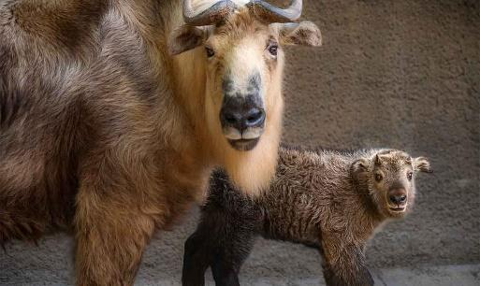
Abstract: Takin (Budorcus taxicolor) are classified as ‘‘Vulnerable’’ on the International Union for the Conservation of Nature Red List. Thus, ex situ conservation efforts provide assurance populations for future survival of this species. The objective of this study was to identify common causes of morbidity and mortality in takin populations in human care. Twenty North American institutions that housed takin from 1997 to 2017 completed a survey requesting medical and husbandry data. Data were examined broadly, by sex and age groups. There were 206 morbidity events (male = 133; female = 73) submitted across 102 takin (male = 62; female = 40). The most common causes of morbidity were infectious or inflammatory diseases (50%; 104/206), degenerative diseases (22%; 46/206), and traumatic events (17%; 34/206). Necropsy reports were provided for 42 takin that died during the study period. The most common causes of mortality were infectious or inflammatory diseases (26%; 11/42), traumatic events (24%; 10/42), and degenerative disease (12%; 5/42). Sixty-two percent of infectious or inflammatory diseases causing morbidity were associated with endoparasites (64/104). Degenerative joint diseases more commonly affected males (78%; 36/46) as well as forelimbs (48%; 22/46) when compared to hindlimbs (30%; 14/46) and unspecified limbs (22%; 10/46). The prevalence of trauma as a cause of morbidity and mortality was higher in neonate and juvenile takin groups combined (morbidity = 19%; mortality = 50%) as compared to adult and senior takin groups combined (morbidity = 15%; mortality = 11%). Older takin were euthanatized more often (57%; 16/28) than younger takin (29%; 4/14). Correlations between husbandry and health were difficult as a result of the inherent limitations of the survey. These data will inform takin-holding zoologic institutions and contribute to the successful management of takin in human care.

Taxonomy: Order: Artiodactyla, Family: Bovidae, Genus: Budorcus

Background:
- 4 subspecies of takin; Sichuan takin by far most common in zoos
- Goal: identify most common causes of m&m in takin housed in NA zoos via survey of medical records and husbandry data (26/29 institutions; 206 morbidity events across 106 individuals)

Key Points:
- Top causes of morbidity: infectious/inflamm (endoparasitism), degenerative dz, trauma
  - Infectious/inflamm morbidity mostly endoparasitism (70%)
- Top causes of mortality: infectious/inflamm (NOT endoparasitism), trauma, degenerative dz
  - Infectious/inflamm mortality was never due to endoparasitism; usually other things like sepsis, pneumonia, osteomyelitis, laminitis, enterocolitis, endocarditis, nephritis
- Degenerative joint dz: males > females, and forelimbs > hindlimbs
  - DJD likely an important aspect of takin health management; mortality in senior takin most commonly associated with degenerative joint dz (30%) due to poor mobility/QOL
- Trauma as a cause of morbidity/mortality higher in neonate and juveniles vs. adults
  - Trauma highest cause of mortality in neonates
- 20/102 cases of hoof cracks/hoof care needs
- Neoplasia not common

Parameters for identifying failure of passive transfer in sitatunga (Tragelaphus spekii).
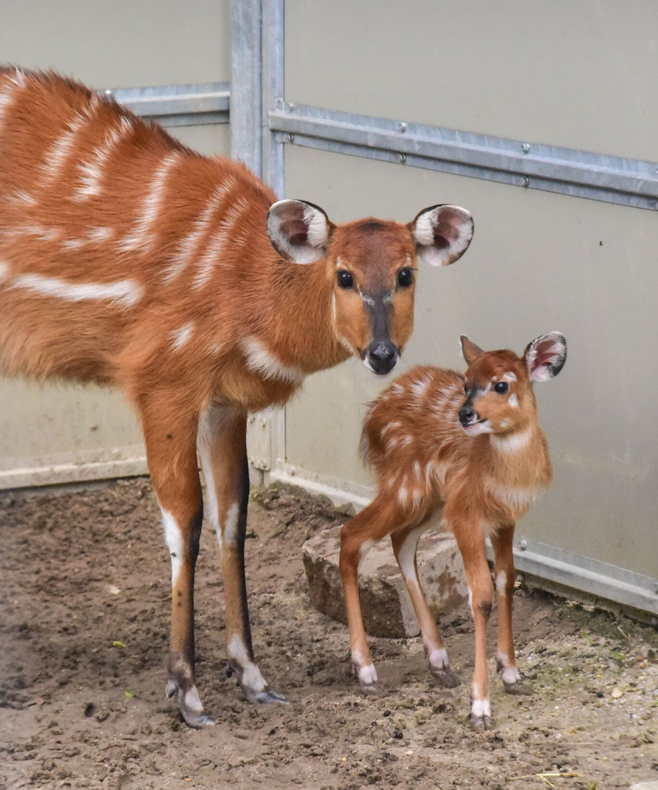
Fraess, G.A., Sander, S. and Bronson, E.
Journal of Zoo and Wildlife Medicine, 2020;51(2):259-264.

Failure of passive transfer of immunity (FPT) leads to increased calf morbidity and mortality and requires intensive, time-sensitive, and often expensive management for nondomestic ruminants. Without species-specific information with which to make informed decisions, neonatal data from domestic ruminants are often extrapolated to nondomestic zoo-housed species. To date, there have been no studies evaluating FPT in sitatunga (Tragelaphus spekii). The goal of the present study was to establish parameters to characterize adequate passive transfer in sitatunga calves and compare them to published reference intervals in other species. Medical records of 22 sitatunga calves (12 female, 10 male) were reviewed. Seventeen of these calves were defined as “healthy,” having survived at least 60 days without colostrum administration or a plasma transfusion. Calf weight, serum glucose, serum gamma-glutamyl transferase (GGT), total protein (TP), globulin concentrations, and results of a zinc sulfate turbidity test (ZSTT) were noted where possible. Mean birth weight of healthy calves at 24 hr was 4.5 kg (range: 3.76.5 kg, n = 12). The mean blood glucose in healthy calves was 152 mg/dl (range: 80–182, n = 16), mean serum TP concentration was 5.9 g/dl (range: 4.9–7.5, n = 16), mean serum globulin concentration was 3.3 g/dl (range: 1.7–4.7, n = 17), and mean serum GGT concentration was 466 U/L (range: 91–1901, n = 16). A ZSTT was performed for 10 healthy calves, resulting in four negative ZSTT results despite having no clinical signs of FPT and the calves having been observed nursing before testing. Sitatunga appear to have lower values for normal FPT parameters than those developed for domestic cattle. This study illustrates the difficulty of cross-species comparisons, as even closely related species can vary greatly in biologic parameters.

Background
- Ruminants: epitheliochorial placentation; maternal IgG transferred in colostrum; passive transfer window closes 6-24 hours after parturition
- Zinc sulfate turbidity test (ZSTT): positive for passive transfer if test tube with serum becomes opaque within the 1 hr incubation period, so that you can’t read a newspaper through it
- GGT correlates with PT in ruminants and is unaffected by hydration status
- Lab methods: EPH (gold-standard), single radial immunodiffusion (species-specific), ELISA
Key Points
- Serum TP was the only value significantly lower in FPT calves vs healthy
  - Birth weight, BG, globulin, and GGT not statistically different
  - GGT varied greatly between individuals
- ZSTT: 4 ‘false’ negatives - low specificity
- Most closely related RR for FPT were in greater kudu (also Tragelaphus) except TP
  - FPT parameters were generally lower than other Bovidae species
Conclusions
- ZSTT had low specificity in sitatunga and should not be used as a sole marker of FPT
- TP is the only FPT marker significantly lower in FPT sitatunga calves compared to healthy

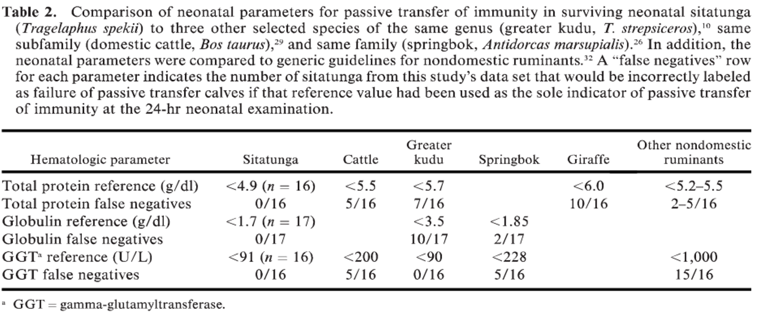

Related articles:
Thompson KA, Lamberski N, Rayburn M, Chigerwe M. Validation of immunocrit as a diagnostic test to detect failure of passive transfer of immunity in hand-reared nondomestic ruminant neonates. Journal of Zoo and Wildlife Medicine. 2019;50(3):627-33.
Take-home: Immunocrit method had high accuracy for diagnosis of FPI in multiple non-domestic ruminant species, lowest accuracy was in springbok. Advantages: not species-specific, semiquantitative results, quick and simple, can be performed at any facility

Comparison Of Diagnostic Predictors Of Neonatal Survivability In Nondomestic Caprinae
Bliss TN, Marinkovich MJ, Burns RE, Carroll C, Clancy MM, Howard LL
Journal of Zoo and Wildlife Medicine 2022;53(1):31-40

This retrospective study evaluated whether six methods (glutamyltransferase, glutaraldehyde coagulation test, sodium sulfite precipitation test, total serum protein, glucose, and fibrinogen) used to assess passive transfer status in ruminants were predictive of survival of nondomestic Caprinae neonates in a zoological collection. A total of 184 neonates from 10 nondomestic Caprinae species had one or more testing methods performed within 7 d of birth. Results of each test were compared with the clinical condition (alive or dead) at 7, 30, and 90 d of age. Total protein (TP) results were not considered for statistical significance in this study. No statistical correlations between results of the serum gamma glutamyltransferase (GGT), glutaraldehyde coagulation test, or sodium sulfite precipitation test (BOVA-S) and survival at any age were found. A higher glucose level within 7 d of birth was associated with a greater probability of survival. Fibrinogen levels were found to have a strong negative association with survival at 30 and 90 d. Increased glucose concentration was negatively associated with the probability of an infectious cause of mortality and the need for medical intervention. In contrast, increased fibrinogen levels were associated with higher probabilities of infectious death and the need for major medical care. Neonates who were confirmed to have nursed had a lower likelihood of requiring major medical intervention. These findings suggest that glucose and fibrinogen levels are better predictors of neonatal survival in nondomestic Caprinae when compared to the other three tests reviewed in this study. Using survival as an indicator of adequate passive transfer in this group of neonates failed to identify a gold standard of diagnosis of failure of passive transfer, so more than one diagnostic test should be utilized.

Key Points:
- FPT in domestic ruminants = inadequate immunoglobulins using RID and ELISAs
  - Use in nondomestic ruminants limited due to lack of species-specific antibodies and RIs
  - Given lack of a single ideal FPT testing method, other less-specific techniques have been utilized inconsistently and in different combinations
- Serum GGT is acceptable for assessing FPT in domestic Caprinae species (e.g. lambs)
  - Positive predictor for neonatal viability in greater kudu, gazelles, muntjac, and springbok
  - Results are fast, inexpensive, and do not appear to be affected by dehydration
  - In this study, GGT was not a predictor of neonatal survival in nondomestic Caprinae
  - Like domestic calves, GGT may not indicate the amount of colostrum consumed
- Gutaraldehyde coagulation utilizes serum-clotting time to evaluate hypogammaglobulinemia
  - Can identify passive transfer in giraffe, banteng, American bison, and Congo buffalo
  - Inexpensive and has provided rapid screening in a zoo or field scenarios
  - Glutaraldehyde coagulation wasn’t a predictor of neonatal survival in nondomestic Caprinae; may be due to species differences in hypogammaglobulinemia
- Sodium sulfite precipitation test (BOVA-S) has identified FPT in domestic Caprinae
  - Allows for qualitative evaluation of immunoglobulins through precipitation and turbidity
  - Serum is added to different concentrations of sodium sulfite and allowed to precipitate
  - Turbidity in each concentration indicates a certain amount of immunoglobulins
  - BOVA-S wasn’t a predictor of neonatal survival in nondomestic
  - However, performed least frequently in the study (n = 40)
- Total serum protein results were not considered for statistical significance in this study
- The 50% mark of neonatal infectious mortality was correlated with fibrinogen ≥ 600 mg/dl
  - Such cases were rare (n = 4) in this study
Conclusions
- Glucose (pos association) and fibrinogen (negative association) were found to be the best predictors of neonatal survivability, infectious disease mortality, and the need for medical intervention.
JZWM 2020 51(2):416-425
Suspected Moxidectin Toxicosis In A Roan Antelope (Hippotragus equinus), A Sable Antelope (Hippotragus niger), And An Arabian Oryx (Oryx leucoryx) At A Semi-Free Range Zoological Park
Swenson J, Haefele HJ, Poppenga RH

ABSTRACT: Moxidectin is a commonly used lipophilic anthelmintic with activity against a wide range of nematodes. It is labeled for use in cattle by oral, topical, and subcutaneous routes. In semi-free ranging conditions, many anthelmintics are remotely administered intramuscularly due to an inability to administer by other routes without restraint. During 2015-2016, three animals including a roan (Hippotragus equinus), sable (Hippotragus niger), and Arabian oryx (Oryx leucoryx) treated with moxidectin developed clinical signs consistent with toxicosis. The primary sign was severe neurologic depression within 12 to 24 hr. Based on recommendations in domestic cases, animals were treated with intravenous lipid therapy and supportive care while diagnostic testing was performed. All three initially improved prior to succumbing to secondary problems associated with prolonged recumbency. Moxidectin has been administered remotely on 97 occasions in eight different exotic ruminant species at Fossil Rim, with only the above three cases showing clinical signs of toxicosis. Two potential causes in these cases include poor body condition leading to a smaller volume of distribution, thus allowing higher concentrations to overwhelm the blood-brain barrier, or a genetic defect similar to some herding dog breeds. Given that cases were seen in three different species at an overall low incidence within a given species, a genetic defect is considered unlikely. The animals affected did have significantly lower body condition score than conspecifics, and it is considered likely that this predisposed these animals to toxicosis. Therefore, caution should be used when administering moxidectin intramuscularly in animals in poor body condition.

Background:
- Moxidectin: macrolide endectocide against nematodes & arthropods
  - Wide safety margin
  - Highly lipophilic so slow release (long duration)
  - Usually unable to cross mammalian blood-brain barrier
- Used in semi-free ranging zoo ruminant collection due to widespread resistance of Haemonchus
  - Labeled for SQ, given IM via dart or pole syringe
- Toxicity in other species: > 1 mg/kg, onset < 24 hr, lasts 36-168 hr
  - Primarily neurologic clinical signs
  - Treatment of choice: ILE therapy
Key Points:
- Moxidectin IM (not an approved route) in 8 species → 3 cases of fatal neurologic disease
  - All 3 had poor BCS at time of administration
  - Improved with lipid therapy but still died
  - All eventually died/euthanized
    - Necropsy found hemorrhage, exertional myopathy, & renal tubular necrosis
    - No Haemonchus in any animals
  - Toxicity most likely from overwhelming of blood-brain barrier due to emaciation

TLDR: Moxidectin should not be administered IM in thin ungulates b/c fatal neurologic toxicity can occur

JZWM 2022 53(2):259-265
Effect Of Sustained-Release Trace Element Ruminal Bolus On Plasma Trace Mineral Profiles In Captive Blesbok Antelopes (Damaliscus pygargus phillipsi)
Potier R, Blanc B, Braud C, Freret S, Cesbron N

ABSTRACT: Nutritional deficiencies in mineral metabolism have been described or suspected in managed and wild ungulate populations. In blesboks (Damaliscus pygargus phillipsi), clinical signs of copper deficiencies have been described in the wild as well as in captivity. Plasma concentrations of cobalt (Co), copper (Cu), iodine (I), manganese (Mn), selenium (Se), and zinc (Zn) were measured over a 6-mon period by inductively coupled plasma mass spectrometry in two groups of five apparently healthy blesboks from a single zoological collection. The control group did not receive any treatment, whereas animals from the treatment group were given an oral drench in October with two sustained-release trace element ruminal boluses (Oligovet ovin-caprin 6 g bolus, Vetalis, 16100 Château Bernard, France). Plasma samples were obtained prior to the start of treatment (October) and in November, February, and April following treatment. No significant differences were found between treatment and control groups for any of the measured minerals over the course of the study. The plasma concentrations of Co, Cu, Se, and Zn were significantly different (P < 0.05) over time for all individuals, but this effect could not be linked to a change in the diet or husbandry. Copper plasma values fluctuated between deficient and normal ranges for cattle. Zinc plasma values were within a range consistent with deficiency in cattle. The great variability of these results should prompt caution in the interpretation of the efficacy of oral trace mineral intake or the expected effect of a dietary modification on trace mineral status based on plasma values.

Background:
- Mineral deficiencies have been described in a variety of hoofstock
  - Cu deficiency in blesbok -> hair coat bleaching, ataxia, & poor hair quality and BCS
Key Points:
- Control group (n = 5): no mineral supplementation
- Treatment group (n = 5): oral drench w/ two 6 gram boluses of Oligovet ovin-caprin
  - Contains iodine, cobalt, copper, manganese, zinc and selenium
- No significant differences groups for any of the measured minerals
  - All trace mineral plasma concentrations measured in our study showed high variation
  - Age/sex heterogenicity could account for some of the variation observed
- Season had a significant impact on plasma mineral profiles
  - Co, Cu, Se, and Zn plasma values differed significantly between OCT and APR
  - Iodine and manganese values are the only values without any significant time effect

TLDR: Oligovet ruminal bolus is not an effective oral supplement in blesboks; plasma may be unreliable method to monitor trace mineral concentrations.

Hee, Olivia, et al. "A preliminary study to evaluate the effectiveness of laryngeal mask airways in anesthetized bighorn sheep (ovis canadensis) lambs." Journal of Zoo and Wildlife Medicine 53.3 (2022): 537-544.

Abstract: Chemical immobilization of wildlife, required for many biological studies and management events, often induces hypoxemia and respiratory depression. Laryngeal mask airways (LMAs) have shown promise as an efficient method of airway protection during anesthesia. Nineteen wild bighorn sheep (Ovis canadensis) lambs were immobilized using an IM combination of medetomidine (0.16 6 0.062 mg/kg), azaperone (0.20 6 0.058 mg/kg), and alfaxalone (0.54 6 0.21 mg/kg) via remote injection. Upon recumbency, arterial blood gas parameters, minute ventilation (VE), tidal volume (VT), and respiratory rate were measured before and after LMA placement. The VE and VT were measured via respirometer. Time to LMA placement, cuff pressure, cuff volume, and ease of placement were measured. Medetomidine was reversed with IM atipamezole at five times the medetomidine dose upon completion of procedures. Pre- and post-LMA measurements were compared using a t test or a Wilcoxon signed-rank test based on normality of the data. The LMA provided a patent airway in all lambs with a significant (P , 0.0001) increase in VE (mean [95% CI]; pre-LMA: VE = 17.3 [16.2–18.5] L/min, post-LMA: VE = 19.8 [18.6– 21.0] L/min) but did not have a significant impact on partial pressure of oxygen (PaO2; pre-LMA: corrected PaO2 = 45.2 [41.2–49.2] mm Hg, post-LMA: corrected PaO2 = 47.5 [43.3–51.7] mm Hg; P = 0.19) or partial pressure of carbon dioxide (PaCO2; pre-LMA: PaCO2 = 50.4 [46.6–53.2] mm Hg, post-LMA: PaCO2 = 51.6 [48.8–55.7] mm Hg; P = 0.035) following placement. This study demonstrated that the LMA is a viable option for airway protection in wild bighorn sheep

Intro
- The aim of this study was to determine the effectiveness of the LMA for airway protection, ventilation, and oxygenation in wild Canadian Rocky Mountain bighorn sheep during immobilization.
M&M
- 19 lambs approx 5-6 months old
- medetomidine, azaperone, and alfaxalone (MAA) immobilization
- Arterial blood gas parameters, minute ventilation (VE), tidal volume (VT), and respiratory rate were measured before and after LMA placement
- Time to LMA placement, cuff pressure, cuff volume, and ease of placement were measured
- At least five lambs developed ruminal tympany during anesthesia, but this was not quantified or qualified consistently throughout the study
Results
- Most attempts for LMA placement required only one try and ranged from one to two (n = 19)
- Feed material was obstructing the inside of the tube following placement in four of the five instances where there were two insertion attempts
- All lambs had a patent airway with the LMA in place.
- Lambs had a significant increase in respiration rate, VE, and corrected PaCO2, TCO2, HCO3, and BE after the LMA was placed compared to pre-LMA placement
- There was no significant change in corrected PaO2
- There was a significant decrease in body temperature from before to after LMA placement
Discussion
- LMA can be easily placed to provide a patent airway that does not hinder oxygenation in wild bighorn sheep lambs during anesthesia.
- Although patency does not necessarily result in an airtight seal, the device is a promising method of airway management, because the LMA did not diminish the lambs’ ability to oxygenate or ventilate compared with an unsupported airway.
- However, the animals consistently had low corrected PaO2 values whether there was an unsupported airway or a LMA in place.
- The lambs experienced a significant increase in their respiratory rate and VE, but there was no change in VT following LMA placement.
  - With an increase in respiratory rate, and thus an increased VE, it would be expected that the PaCO2 would decrease, but the lambs showed a slight concurrent increase in PaCO2. PaO2 did not chang significantly in response to the rise in PaCO2
  - This paradoxical result is possibly due to increased dead space, ruminal tympany causing V/Q mismatch, measurement error etc
- PaCO2 levels not clinically significantly different before and after LMA placement
- Lambs showed, on average, a statistically significant decrease in body temperature and increase in BE and HCO3 after LMA placement. While these changes were statistically significant, they were minor and likely not of physiologic significance.
- Takeaway: the LMA is a valid option for airway management in bighorn sheep during immobilization in the field. Although physiologic parameters were not improved, they were not hindered to any biologically relevant level.

Mathieu, Amélie, et al. "Fascioloides magna in free-ranging rocky mountain bighorn sheep (ovis canadensis)." The Journal of Wildlife Diseases 58.3 (2022): 592-598.

ABSTRACT: From February to May 2021, four nonmigratory rams from the Radium-Stoddart bighorn sheep (BHS; Ovis canadensis) herd in the Rocky Mountains of southeastern British Columbia, Canada, died from infection with the giant liver fluke, Fascioloides magna. Affected animals were emaciated, weak, and lethargic or were found dead. Gross lesions, histopathology, and parasite burdens were consistent with those reported in experimentally infected BHS, domestic sheep, and other aberrant hosts. Although BHS range does not typically overlap with fluke-contaminated aquatic habitats, the change in migratory behavior recently observed in some Radium-Stoddart rams may have exposed the affected animals to F. magna. We describe clinical signs and gross and histopathologic findings of hepatobiliary trematodiasis associated with F. magna in free-ranging BHS. From experimental data and our findings, giant liver fluke is pathogenic and is a threat to the conservation of the Radium-Stoddart BHS herd and other BHS herds in endemic F. magna regions.

Background:
- Giant liver fluke (Fascioloides magna) = digenetic trematode, wide ungulate host range
- Definitive hosts: elk, white-tailed deer, and caribou
  - Mature flukes encapsulate within liver -> eggs carried to GI tract in bile -> shed in feces
  - Eggs hatch in water/moist feces into miracidia -> enter aquatic snail intermediate host
  - Develop into cercariae -> leave snail and encyst on aquatic and semiaquatic vegetation
  - Susceptible ungulates consume vegetation contaminated with encysted metacercariae
  - Activated larvae migrate through the intestinal wall ultimately to the liver
  - Infections are generally benign because of host adaptation and encapsulation
- Dead-end hosts: moose, bison, domestic cattle, and horses
  - Fluke eggs trapped in the liver and are not shed into the environment
- Aberrant hosts: domestic sheep, domestic goats, and bighorn sheep
  - Immature flukes penetrate the intestinal wall, do not encapsulate in the liver, and can migrate extensively within the abdominal and pleural cavities
  - This can contribute to severe liver and multisystemic pathology, and even death
- BHS face difficult challenges, including enzootic verminous pneumonia; epizootic bacterial pneumonia; predation; human disturbance; and habitat loss, fragmentation, and alienation
Key Points:
- Four BHS rams (3-9yo) died with findings consistent with fulminant giant liver fluke infections (fascioloidiasis)
- Low incidence of F. magna in the Radium-Stoddart BHS herd before 2021
  - May reflect historical lack of overlap between BHS range and fluke-contaminated aquatic habitats
  - In recent years, an increasing number of rams have failed to migrate into high-elevation habitats in May
  - Instead, they have remained in Radium year-round, and occasionally visit the Columbia Wetlands
  - This shift in seasonal migration pattern and habitat use may explain exposure to F. magna
  - Habituation of these male BHS to human presence may have increased their risk for infection
- Given the high conservation priority of BHS, treatment options for F. magna were explored but foregone
  - Challenges included: limited drug accessibility, difficulties associated with repeated oral drug administration in free-ranging wildlife, and concerns regarding emergence of triclabendazole resistance
- F. magna preventive measures may include:
  - Reducing contamination of areas frequented by BHS by lowering or eliminating the environmental risk associated with infected snails (e.g., by cutting periaquatic vegetation, burning the wetland or using molluscicides)
  - Reducing access of either BHS to areas contaminated with F. magna, cervids to areas transited by BHS (e.g., by hazing animals or using fencing), or both
  - Attracting BHS to a less contaminated area (e.g., by enhancing the nearby restoration area or providing alternate water sources elevated off the ground)

Takeaway: Giant liver flukes are pathogenic in BHS and represent a threat to conservation in F. magna–enzootic regions

